**Lab 8**

Please download the starter code here. Save it as lab9.m. It has two parts. If you run it, it should run without error and produce two unfinished/blank-ish figures.

**Participation Activity (Part 1) - Line Animation**

Create the following line animation. To do this, use the following formula:

x goes from 1 to 50 with a step size of 1

y should be the cos(x/pi) for each x value

You will not be able to test this on Grader. So just get it working in Figure 1 and try to understand all the parts, then move on to the next part. Part 2 will use Figure 2 (it is already programmed for you).

**Lab Code (Part 2) - 2D Array and Imagesc Plots**

Write the findNeighbors function inside the starter code. See the comments above the header for details. But basically, the function will return the south, north, east, and west neighbors of a given point. Here is the figure that will be generated once you complete the function:

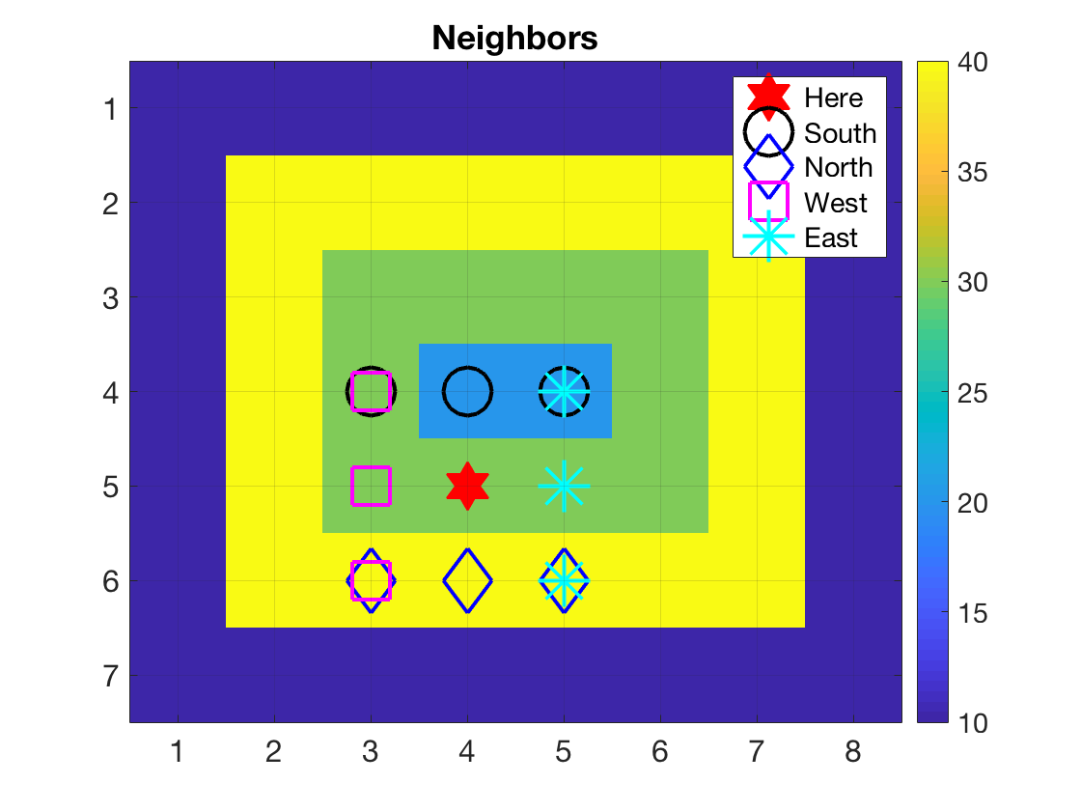

You are not writing any of the plotting code, it is already provided in the starter code. But once you write the function correctly, that is what the plot will look like. The goal of this part of the lab is to make sure you understand how to move around a 2D array in the four cardinal directions AND how those translate to a imagesc plot. To get started, read the function header which provides an example of how to the "east", you should be able to do the other three after seeing this example.

You can test the function from Part 2 here in Grader. To test, submit only the function portion of your code. When you are done, submit your entire code (which should produce the animation, Part 1, and the second plot, Part 2).

**\*\*\*PLEASE READ\*\*\***

Copyright 2020 Shanon Reckinger. This assignment description is protected by U.S. copyright law. Reproduction and distribution of this work, including posting or sharing through any medium, such as to websites like chegg.com is explicitly prohibited by law and also violates UIC's Student Disciplinary Policy (A2-c. Unauthorized Collaboration; and A2-e3. Participation in Academically Dishonest Activities: Material Distribution).

Material posted on any third party sites in violation of this copyright and the website terms will be removed. Your user information will be released to the author.