

**USER MANUAL**

**PCB shield for ESP8266 module**

**Name of students:**

* Nguyen Tien Anh: 1752076
* Nguyen Duc Khoi: 1752302
* Nhan Phu Vinh:

**Course:** Computer Hardware Lab

**Lecturer:** Nguyen Tran Huu Nguyen

Table of Contents

1 Introduction 3

*1.1 ESP8266 module 3*

*1.2 SIM800L GSM module 3*

*1.3 LCD module 3*

*1.4 RFID module 4*

*1.5 LM2596 module 4*

*1.6 Capacitors and Buttons 4*

2 Design 5

3 Implement 5

*3.1 Module Instruction Memory 5*

***3.1.1******Interface*** *5*

***3.1.2******Description:*** *6*

*3.2 Module Register File 6*

***3.2.1******Interface:*** *6*

***3.2.2******Description:*** *6*

*3.3 Module ALU 6*

***3.3.1******Interface*** *6*

***3.3.2******Description*** *7*

*3.1 Module Control unit 7*

# **Introduction**

## **ESP8266 module**

The ESP8266 is a low-cost Wi-Fi microchip with full TCP/IP stack and microcontroller capability. ESP8266 is integrated with a 32-bit Tensilica processor, standard digital peripheral interfaces, antenna switches, RF balun, power amplifier, low noise receive amplifier, filters and power management modules. The ESP8266 microcontroller integrates a Tensilica L106 32-bit RISC processor, which achieves extra-low power consumption and reaches a maximum clock speed of 160 MHz. The Real-Time Operating System (RTOS) and Wi-Fi stack allow about 80% of the processing power to be available for user application programming and development.

## **SIM800L GSM module**

SIM800L is a miniature cellular module which allows for GPRS transmission, sending and receiving SMS and making and receiving voice calls. Low cost and small footprint and quad band frequency support make this module perfect solution for any project that require long range connectivity. After connecting power module boots up, searches for cellular network and login automatically. On board LED displays connection state (no network coverage - fast blinking, logged in - slow blinking).

## **LCD module**

This is an 16x2 LCD display screen with I2C interface. It is able to display 16x2 characters on 2 lines, white characters on blue background. This I2C 16x2 Arduino LCD Screen is using an I2C communication interface. It means it only needs 4 pins for the LCD display: VCC, GND, SDA, SCL. 16x2 LCD Displays are built-in controller ST7066 or equivalent. It is optional for + 5.0 V or + 3.0 V power supply.

## **RFID module**

The MF RC522 uses advanced modulation and demodulation concept which fully presented in all types of 13.56MHz passive contactless communication methods and protocols. In addition, it supports rapid CRYPTO1 encryption algorithm to verify MIFARE products. MFRC522 also supports MIFARE series of high-speed non-contact communication, with a two-way data transmission rate of up to 424kbit/s. As a new member of the 13.56MHz highly integrated reader card series, MF RC522 is much similar to the existing MF RC500 and MF RC530 when there are also great differences. It communicates with the host machine via the serial manner which needs less wiring.

## **LM2596 module**

The LM2596 series of regulators are monolithic integrated circuits that provide all the active functions for a step-down (buck) switching regulator, capable of driving a 3A load with excellent line and load regulation. These devices are available in fixed output voltages of 3.3 V, 5 V, 12 V, and an adjustable output version. In this project, we use this module to switch the 12V input of a power supply into 4.5V output.

## **Capacitors and Buttons**

In this project, we use three capacitors to reduce the noise in three modules: SIM800L, RFID and LCD. Moreover, we also use three push buttons and appropriate resistors to communicate with the modules above via the analog signal.

# **Schematic**

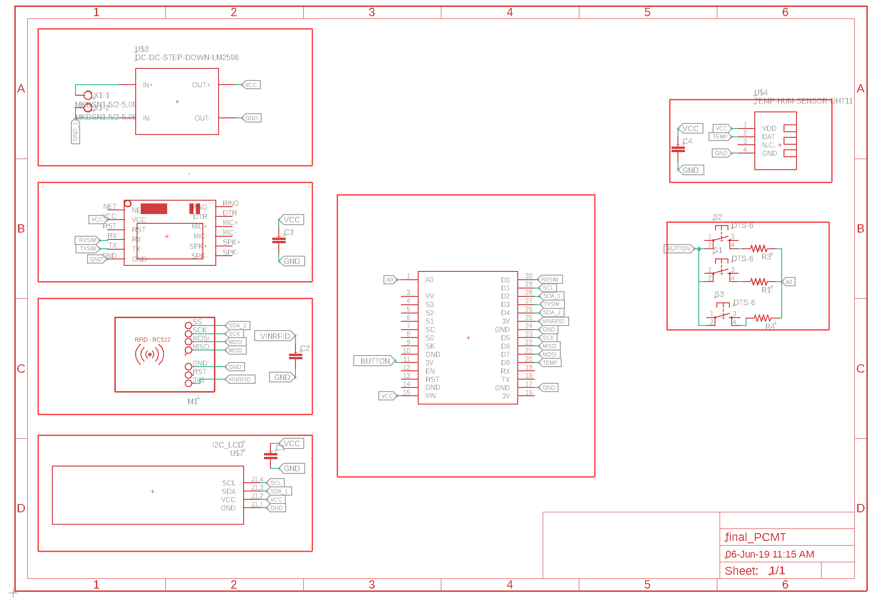

Figure 1: Schematic

# **Board**

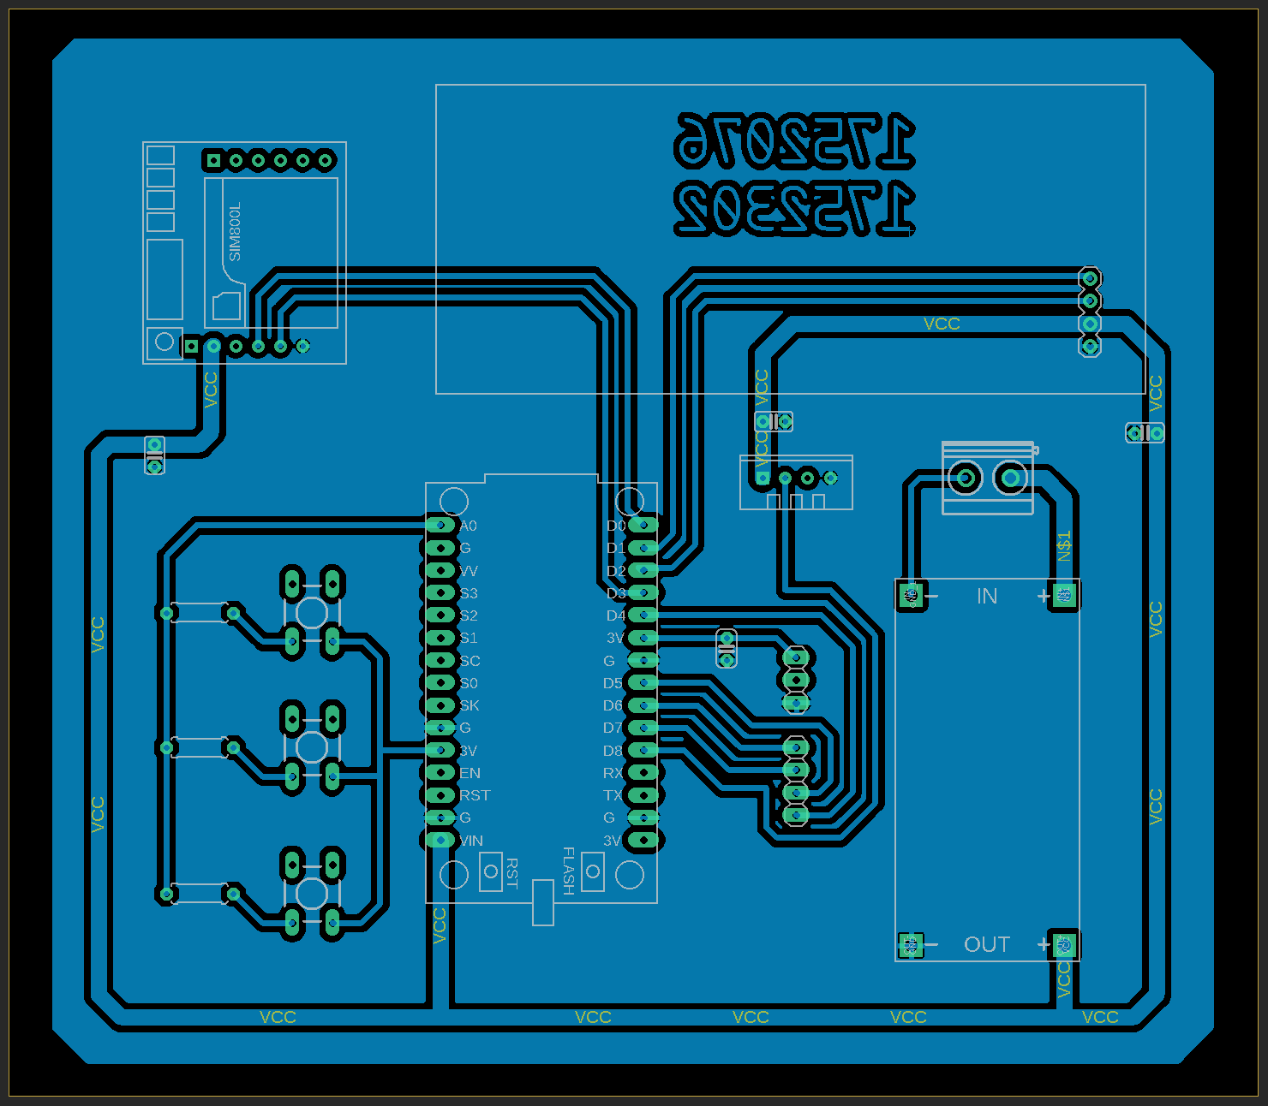

Figure 2: Board

# **User guide**

## **Power supply**

## **Buttons**

## **Functions**

### **Connect to Wi-Fi:**

### **Log in:**

### **Display the temperature and humidity:**

### **Send data via SMS:**

### **Add a new member card:**

### **Delete a member card:**

### **Send data to a server:**

### **Sleep mode:**