NGUYỄN TIẾN ANH

Mssv: 20064861

Git: https://github.com/tienanhhm/STT03_NguyenTienAnh_20064861

Cau 2: Show screen:



a.1.

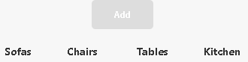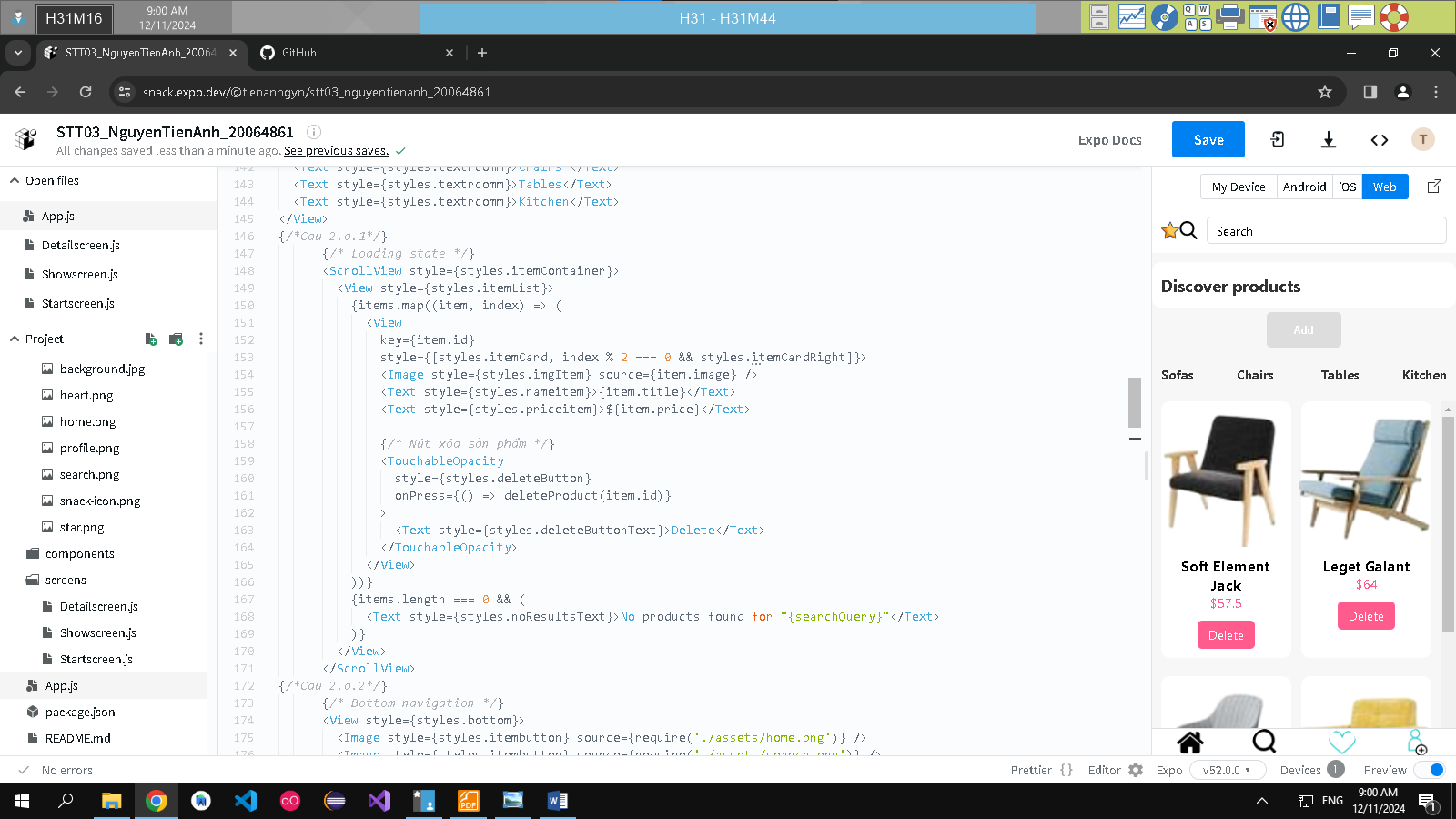

a.2.

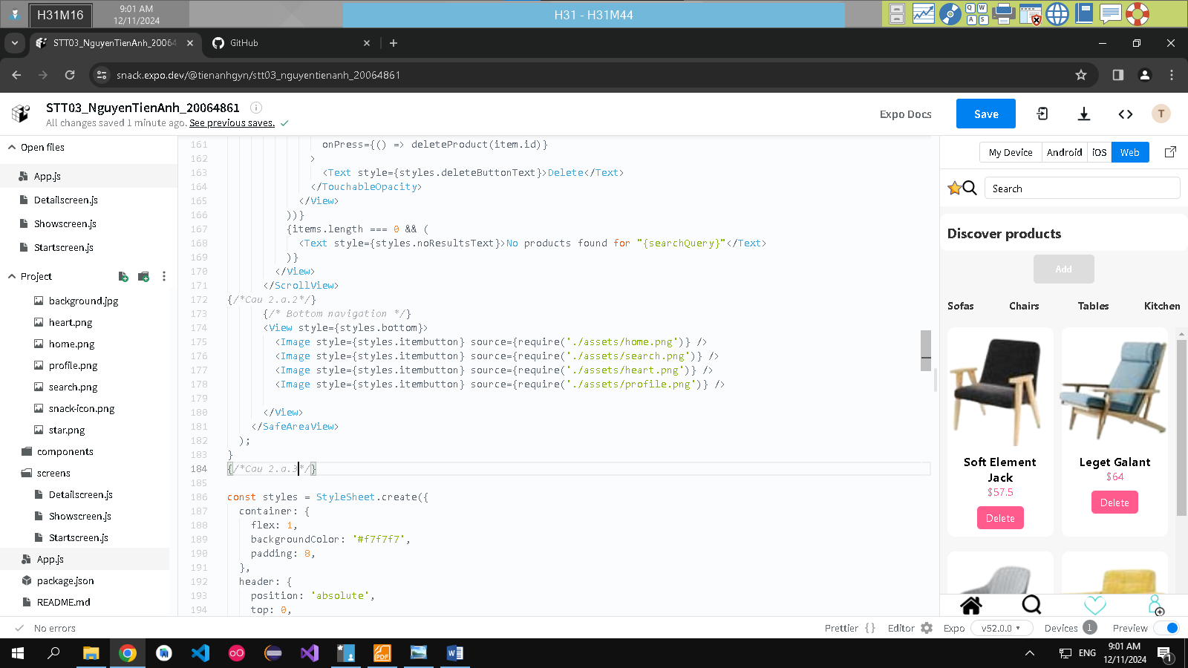

a.3.

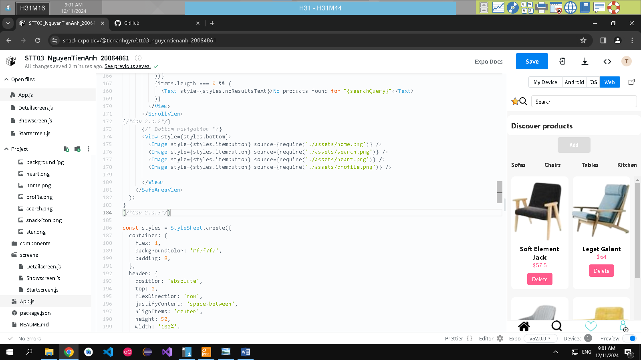

Cau 2.b

