**<Employee> Login**

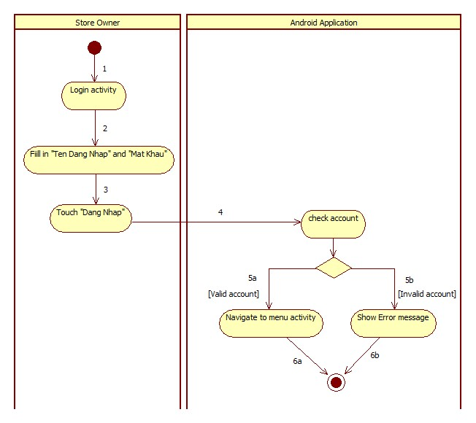

|  |  |  |
| --- | --- | --- |
| 1. Start | 2. Store Owner Enter “Tên Đăng Nhập” and “Mật Khẩu” | 3. Store Owner “Đăng Nhập” button |
| 4. Call checkAccount() | 5a. Navigate to menu activity | 5b. Show error message |
| 6a. Finish | 6b. Finish |  |

**<Employee> Receive Notification**

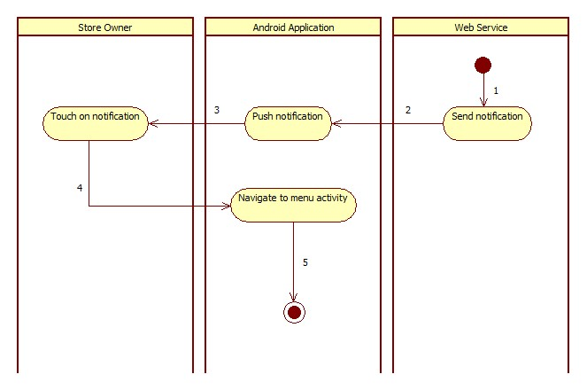

|  |  |  |
| --- | --- | --- |
| 1. Send Notification | 2. Push Notification | 3. Store Owner touch on notification |
| 4. Navigate to menu activity | 5. Finish |  |

**<Employee> View Task**

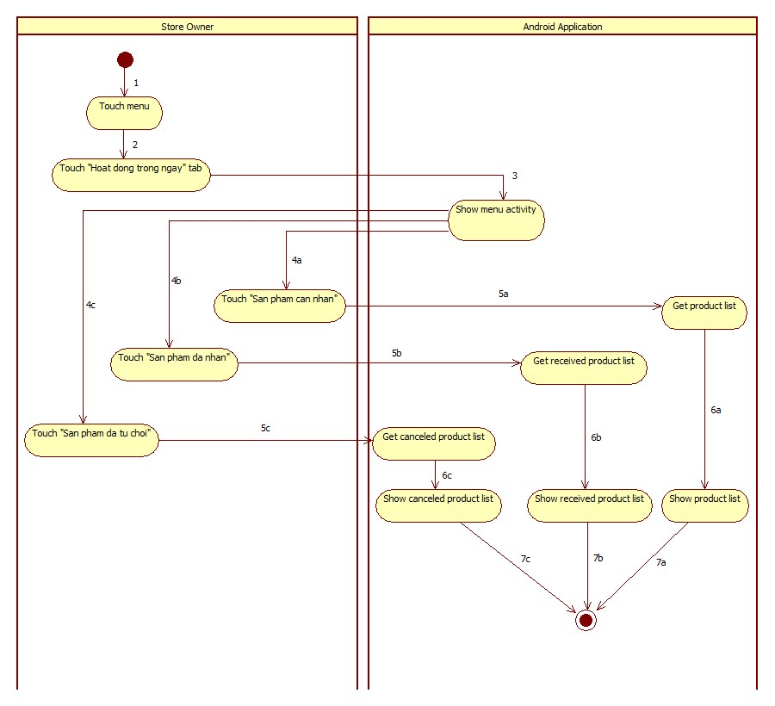

|  |  |  |
| --- | --- | --- |
| 1. Start | 2. Touch tab | 3. Call menu activity |
| 4a. Store Owner touch “Sản phẩm cần nhận” | 4b. Store Owner touch “Sản phẩm đã nhận” | 4b. Store Owner touch “Sản phẩm đã từ chối” |
| 5a. Call getProduct() | 5b. Call getReceivedProduct() | 5c. Call getCanceledProduct() |
| 6a. Show product list | 6b. Show received product list | 6c. Show canceled product list |
| 7a. Finish | 7b. Finish | 7c. Finish |

**<Employee> Auto Synchronize**

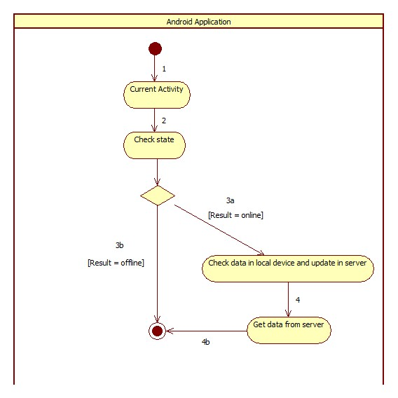

|  |  |  |
| --- | --- | --- |
| 1. Start | 2. Call checkState() | 3a. Check data in local device, if exist data have not committed, update to server. |
| 3b. Finish | 4. Call service to get data from server and insert to local device. | 4b. Finish |

**<Employee> Accept Product**

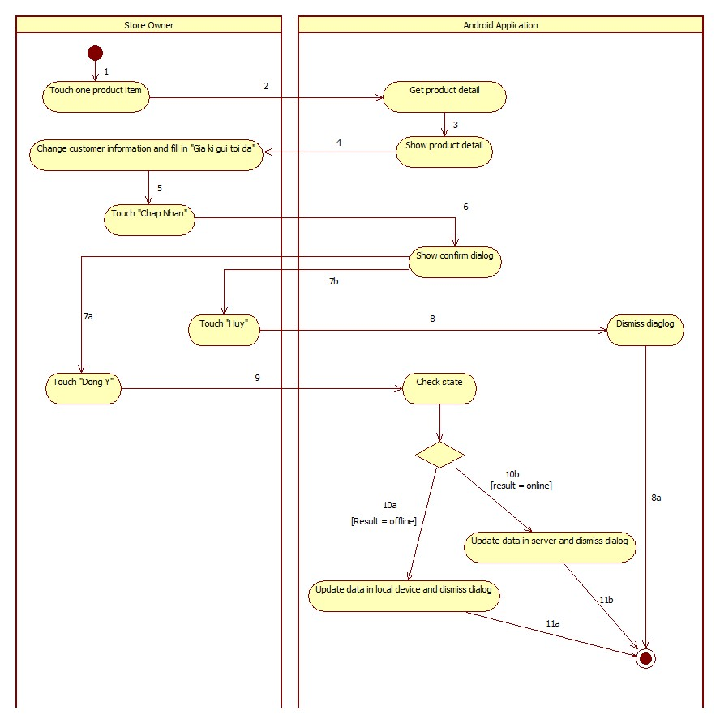

|  |  |  |
| --- | --- | --- |
| 1. Start | 2. Call getProductDetail() | 3. Show product detail |
| 4. Store Owner change customer information and enter “Giá kí gửi tối đa”. | 5. Store Owner touch “Chấp Nhận” button. | 6. Show confirm dialog |
| 7a. Store Owner touch “Đồng ý” button. | 7b. Store Owner touch “Hủy” button to cancel action. | 8. Dismiss confirm dialog |
| 8a. Finish | 9. Call checkState() | 10a. Update data in local device and dismiss dialog |
| 10b. Call service to update data in server and dismiss dialog. | 11a. Finish | 10b. Finish |

**<Employee> Cancel Product**

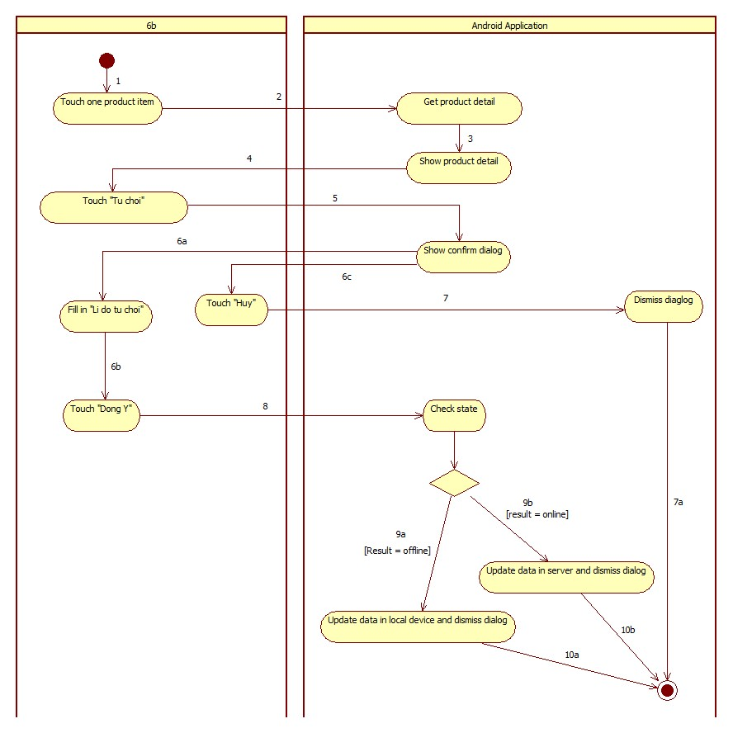

|  |  |  |
| --- | --- | --- |
| 1. Start | 2. Call getProductDetail() | 3. Show product detail |
| 4. Store Owner touch “Từ chối” button. | 5. Show confirm dialog | 6a. Store Owner enter “Lí do từ chối”. |
| 6b. Store Owner touch “Đồng ý” button. | 6c. Store Owner touch “Hủy” button to cancel action. | 7. Dismiss confirm dialog |
| 7a. Finish | 8. Call checkState() | 9a. Update data in local device and dismiss dialog. |
| 9b. Call service to update data in server and dismiss dialog. | 10a. Finish | 10b. Finish |

**<Employee> View History**

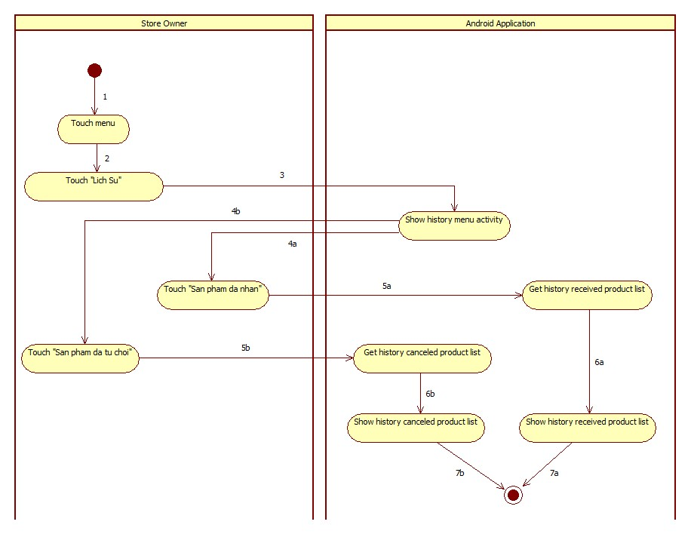

|  |  |  |
| --- | --- | --- |
| 1. Start | 2. Touch tab | 3. Call history menu activity |
| 4a. Store Owner touch “Sản phẩm đã nhận” | 4b. Store Owner touch “Sản phẩm đã từ chối” | 5a. Call getHistoryReceivedProduct() |
| 5c. Call getHistoryCanceledProduct() | 6a. show history received product list | 6b. show history canceled product list |
| 7a. Finish | 7b. Finish |  |

**<Employee> Logout**

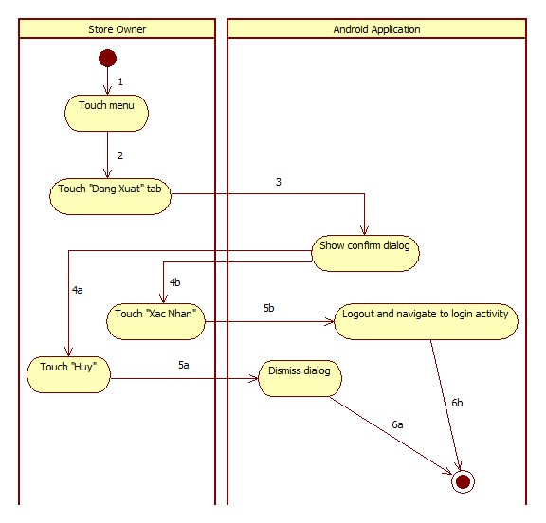

|  |  |  |
| --- | --- | --- |
| 1. Start | 2. Store Owner touch “Đăng Xuất” tab | 3. Show confirm dialog |
| 4a. Store Owner touch “Hủy” button | 4b. Store Owner touch “Xác Nhận” button | 5a. Dismiss dialog |
| 5b. call logout() and navigate to login activity | 6a. Finish | 6b. Finish |