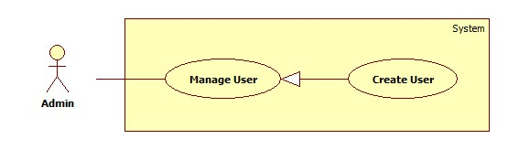

|  |  |  |  |
| --- | --- | --- | --- |
| **USE CASE –** HPS001 | | | |
| **Use Case No.** | HPS001 | Use Case Version | 2.0 |
| **Use Case Name** | Create User | | |
| **Author** | Nguyen Huy Hoang | | |
| **Date** | August 7, 2015 | Priority | High |
| **Actor**:   * Admin   **Summary**:   * This use case allows admin add new user.   **Goal**:   * New user is added to database.   **Triggers**:   * Admin send “add new user” command.   **Preconditions**:   * Guest must login with role Admin.   **Post Conditions**:   * Success: New user is inserted to database. * Fail: Show an error message, nothing is changed in database.   **Main Success Scenario**:   |  |  |  | | --- | --- | --- | | Step | Actor Action | System Response | | 1 | Admin send “add new user” command. | System pop-up for admin input include the following information:   * “Tên Đăng Nhập”: free text input, min length: 6, max length: 50, required. * “Mật Khẩu”: free text input, min length: 8, max length: 20, required. * “Điện Thoại: free text input, format: number, * “Email”: free text input, regular expression: “^[a-zA-Z0-9_.+-]+@[a-zA-Z0-9-]+\.[a-zA-Z0-9-.]+$". * “Tên”: free text input. Max length : 50. * “Đia Chỉ”: free text input. * “Tài Khoản Paypal”: free text input. * “Quyền Hạn”: select option include: “Chủ Cửa Hàng” and “Thành Viên”, required. * A command to finish action. | | 2 | Admin input information and send command to finish add new user.  [Alternative 1] | [Exception 1,2]  Add new user to database and show list new user. |   **Alternative Scenario**:   |  |  |  | | --- | --- | --- | | No | Actor Action | System Response | | 1 | Admin dismiss pop-up. | Nothing to change. |   **Exceptions**:   |  |  |  | | --- | --- | --- | | No | Actor Action | System Response | | 1 | User not fills all required field. | Show message: “Vui lòng nhập thông tin vào nhưng ô bắt buộc.” | | 2 | User invalid format | Show message: “Vui lòng nhập đúng thông tin”. |   **Relationships**: N/A  **Business Rules**:   * Status of new user is set to “active”. | | | |

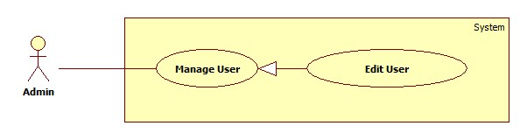

|  |  |  |  |
| --- | --- | --- | --- |
| **USE CASE –** HPS002 | | | |
| **Use Case No.** | HPS002 | Use Case Version | 2.0 |
| **Use Case Name** | Edit User | | |
| **Author** | Nguyen Huy Hoang | | |
| **Date** | August 7, 2015 | Priority | High |
| **Actor**:   * Admin   **Summary**:   * This use case allows admin edit user information.   **Goal**:   * User information is updated to database.   **Triggers**:   * Admin send “edit user” command.   **Preconditions**:   * Guest must login with role Admin.   **Post Conditions**:   * Success: User information is updated to database. * Fail: Show an error message, nothing is changed in database.   **Main Success Scenario**:   |  |  |  | | --- | --- | --- | | Step | Actor Action | System Response | | 1 | Admin send “edit user” command. | System pop-up for admin input include the following information:   * “Điện Thoại: free text input, format: number, * “Email”: free text input, regular expression: “^[a-zA-Z0-9_.+-]+@[a-zA-Z0-9-]+\.[a-zA-Z0-9-.]+$". * “Tên”: free text input. Max length : 50. * “Đia Chỉ”: free text input. * “Tài Khoản Paypal”: free text input. * A command to finish action. | | 2 | Admin change information and send command to finish edit user.  [Alternative 1] | [Exception 1]  Add new user to database and show list new user. |   **Alternative Scenario**:   |  |  |  | | --- | --- | --- | | No | Actor Action | System Response | | 1 | Admin dismiss pop-up. | Nothing to change. |   **Exceptions**:   |  |  |  | | --- | --- | --- | | No | Actor Action | System Response | | 1 | User invalid format | Show message: “Vui lòng nhập đúng thông tin”. |   **Relationships**: N/A  **Business Rules**:   * Admin can’t change username and password of user. * Old information of user will be filled. | | | |

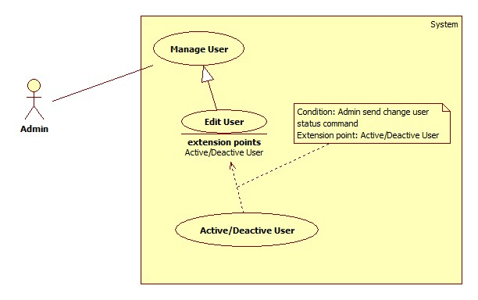

|  |  |  |  |
| --- | --- | --- | --- |
| **USE CASE –** HPS003 | | | |
| **Use Case No.** | HPS003 | Use Case Version | 2.0 |
| **Use Case Name** | Active/Deactive User | | |
| **Author** | Nguyen Huy Hoang | | |
| **Date** | August 7, 2015 | Priority | High |
| **Actor**:   * Admin   **Summary**:   * This use case allows admin change user status.   **Goal**:   * User status is updated to database.   **Triggers**:   * Admin send “change user status” command.   **Preconditions**:   * Guest must login with role Admin.   **Post Conditions**:   * Success: User status is updated to database. * Fail: Show an error message, nothing is changed in database.   **Main Success Scenario**:   |  |  |  | | --- | --- | --- | | Step | Actor Action | System Response | | 1 | Admin send “change user status” command. | System show new status of user. |   **Alternative Scenario**: N/A  **Exceptions**: N/A  **Relationships**:   * Extending Use-cases: Extend from Edit User (Admin send “change user status” command).   **Business Rules**:   * If current status of user is Active, change to Deactivate, and if current status of user is Deactivate, change to Active. | | | |