#### <Store Owner> Use case

##### <Store Owner> View Available Product

**Use Case diagram**

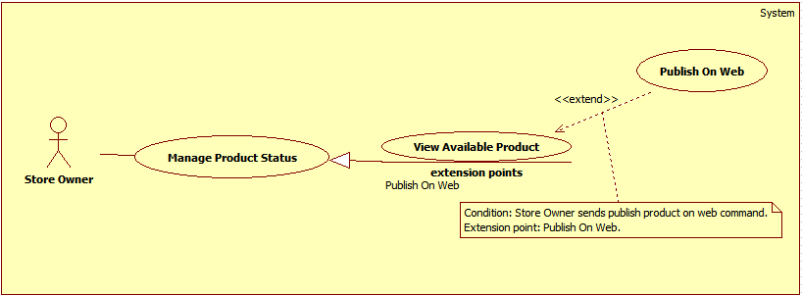

Figure 1: <Store Owner> View Available Product

**Use Case Specification**

|  |  |  |  |
| --- | --- | --- | --- |
| **USE CASE – DQT01** | | | |
| **Use Case No.** | **DQT01** | Use Case Version | 2.0 |
| **Use Case Name** | View Available Product | | |
| **Author** | DanQT | | |
| **Date** | May 26, 2015 | Priority | High |
| **Actor**:   * Store Owner   **Summary**:   * This use case allows store owner to view products which was received from consignor.   **Goal**:   * Successfully view available products so they can publish them on web.   **Triggers**:   * Store owner sends view available product command.   **Preconditions**:   * Guest is logged in as Store Owner.   **Post Conditions**:   * **Success**: Available products is display to store owner. * **Fail**: Show error message.   **Main Success Scenario**:   |  |  |  | | --- | --- | --- | | Step | Actor Action | System Response | | 1 | Store owner sends view available product command. | System loads and displays information of available products in table with following information:  + STT : label.  + Tên sản phẩm: label.  + Mã kí gửi: label.  + Chi tiết : send command to view detail.  [Exception 1] |   **Alternative Scenario**: N/A  **Exceptions**:   |  |  |  | | --- | --- | --- | | No | Actor Action | System Response | | 1 | Error occurs during get available product information phase. | System shows error. |   **Relationships**: N/A  **Business Rules**:   * Only product in “In Inventory” status can be displayed in this table. * List are sorted action date in chronological order. The most recent received product will appears first in the list, while the oldest one appears last. * System will display the first 10 available products. * System will display available product which belongs to this store owner. | | | |

##### <Store Owner> Publish On Web

**Use Case diagram**



Figure 2: <Store Owner> Publish On Web

**Use Case Specification**

|  |  |  |  |
| --- | --- | --- | --- |
| **USE CASE – DQT02** | | | |
| **Use Case No.** | **DQT02** | Use Case Version | 2.0 |
| **Use Case Name** | Publish On Web | | |
| **Author** | DanQT | | |
| **Date** | May 26, 2015 | Priority | High |
| **Actor**:   * Store Owner   **Summary**:   * This use case allows store owner to publish product on web.   **Goal**:   * Successfully publish product so it can be found on “Home page”.   **Triggers**:   * When store owner publish product on web command.   **Preconditions**:   * Guest is logged in as Store Owner and is on view available product detail page.   **Post Conditions**:   * **Success**: Product status is changed to “On Web” and can be found by search function. * **Fail**: Show error, no information has been changed.   **Main Success Scenario**:   |  |  |  | | --- | --- | --- | | Step | Actor Action | System Response | | 1 | Store owner send view available product detail command. | System load product detail information into pop-up with following information:   * Tên sản phẩm:   + Free text input.   + Min-length: 5 characters.   + Max-length: 50 characters.   + Required. * Số seri:   + Free text input.   + Min-length: 5 characters.   + Max-length: 50 characters.   + Required. * Độ mới:   + Free text input.   + Number (0-100). * Loại sản phẩm:   + Single choice option. * Hãng:   + Min-length: 5 characters.   + Max-length: 50 characters.   + Required. * Mùa:   + Multi-choice option. * Tự động gửi giá:   + Single choice option. * Mô tả:   + Free textarea. * Ảnh sản phẩm:   + Image. | | 2 | Store owner enters or modifies product detail information.  Store owner sends publish product on web command.  [Alternative 1] | System validates inputted data. [Exception 2,3,4]  System update product detail information in database.  System notifies store owner after complete.  System redirects to view available product page. |   **Alternative Scenario**:   |  |  |  | | --- | --- | --- | | Step | Actor Action | System Response | | 1 | Store owner sends cancel command. | System redirects to view available product page.  No information is recorded. |   **Exceptions**:   |  |  |  | | --- | --- | --- | | Step | Actor Action | System Response | | 1 | Tên sản phẩm is empty. | System show message “Vui lòng nhập tên sản phẩm”. | | 2 | Hãng sản phẩm is empty. | System show message “Vui lòng nhập hãng sản phẩm”. | | 3 | Độ mới is not a number or less than 0 or greater than 100. | System show message “Vui lòng nhập đúng độ mới của sản phẩm”. |   **Relationships**: Extended by View Available Product (Send view detail command).  **Business Rules**:   * Only product in “In Inventory” status can be published on web. * System will change product status on database base on product id. * If store owner chooses seasons for product, it will be display on home page during those season. If store owner doesn’t choose any season, it will display in “Sản phẩm nổi bật” category. * If store owner chooses “Tự động gửi giá” is “Có”, when product is ordered, system will automatic send product price to customer. * If store owner doesn’t choose new image for product, product image will remain as the image at beginning. | | | |

##### <Store Owner> View Sold Product

**Use Case diagram**

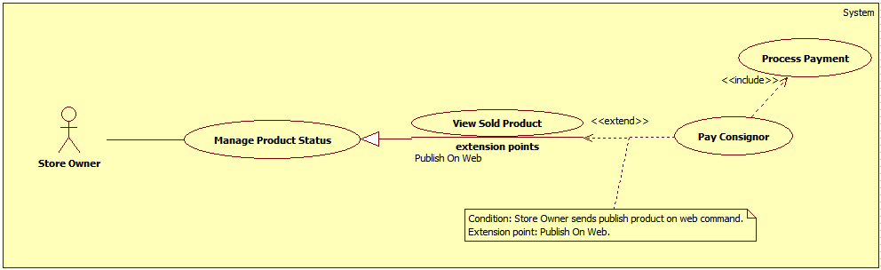

Figure 3: <Store Owner> View Sold Product

**Use Case Specification**

|  |  |  |  |
| --- | --- | --- | --- |
| **USE CASE – DQT03** | | | |
| **Use Case No.** | **DQT03** | Use Case Version | 2.0 |
| **Use Case Name** | View Sold Product | | |
| **Author** | DanQT | | |
| **Date** | May 26, 2015 | Priority | High |
| **Actor**:   * Store Owner   **Summary**:   * This use case allows store owner to view products which was.   **Goal**:   * Successfully view sold products so they can pay consignor.   **Triggers**:   * Store owner sends view sold product command.   **Preconditions**:   * Guest is logged in as Store Owner.   **Post Conditions**:   * **Success**: Sold products is display to store owner. * **Fail**: Show error message.   **Main Success Scenario**:   |  |  |  | | --- | --- | --- | | Step | Actor Action | System Response | | 1 | Store owner sends view available product command. | System loads and displays information of available products in table with following information:  + STT : label.  + Tên sản phẩm: label.  + Mã kí gửi: label.  + Chi tiết : send command to view detail.  [Exception 1] |   **Alternative Scenario**: N/A  **Exceptions**:   |  |  |  | | --- | --- | --- | | No | Actor Action | System Response | | 1 | Error occurs during get available product information phase. | System shows error. |   **Relationships**: N/A.  **Business Rules**:   * Only product in “Sold” status can be displayed in this table. * List are sorted action date in chronological order. The most recent received product will appears first in the list, while the oldest one appears last. * System will display the first 10 available products.   System will display available product which belongs to this store owner. | | | |

##### <Store Owner> Pay Consignor

**Use Case diagram**



Figure 4: <Store Owner> Pay Consignor

**Use Case Specification**

|  |  |  |  |
| --- | --- | --- | --- |
| **USE CASE – DQT04** | | | |
| **Use Case No.** | **DQT04** | Use Case Version | 2.0 |
| **Use Case Name** | Pay Consignor | | |
| **Author** | DanQT | | |
| **Date** | May 26, 2015 | Priority | High |
| **Actor**:   * Store Owner   **Summary**:   * This use case allows store owner to pay consignor after sell their product.   **Goal**:   * Complete consignment and return money to consignor.   **Triggers**:   * When store owner send pay consignor command.   **Preconditions**:   * Guest is logged in as Store owner and is on view sold product page.   **Post Conditions**:   * **Success**: Change product and consignment status to “completed”. Completed return money to consignor. * **Fail**: Show error message. No information has been changed.   **Main Success Scenario**:   |  |  |  | | --- | --- | --- | | Step | Actor Action | System Response | | 1 | Store owner sends view product detail command. | System loads information about the product into pop-up with following information.   * Họ tên:   + Label. * Địa chỉ:   + Label. * Số điện thoại:   + Label. * Email:   + Label. * Tài khoản Paypal:   + Label. * Tên sản phẩm:   + Label. * Mã kí gửi:   + Label. * Giá kí gửi:   + Label. * Giá thực bán:   + Label. * Ngày kí gửi:   + Label. * Tiền trả khách hàng:   + Input field.   + Editable | | 2 | Store owner sends process normal payment command.  [Alternative 1] | System displays pop-up and asks store owners to enter return price. | | 3 | Store owners enters return price and send pay command.  [Alternative 2] | System validated inputted data. [Exception 1].  System update database.  System notifies after complete.  System redirects to view sold product page. |   **Alternative Scenario**:   |  |  |  | | --- | --- | --- | | Step | Actor Action | System Response | | 1 | Store owner sends cancel command | System forwards to view sold product page. No information is recorded. | | 2 | Store owner sends cancel command | System forwards to view sold product detail pop-up. |   **Exceptions**:   |  |  |  | | --- | --- | --- | | Step | Actor Action | System Response | | 1 | If inputted value is not valid. | System shows notification and requests store owner to re-enter the value. |   **Relationships**: Extended by View Sold Product (Send view sold product detail command).  **Business Rules**:   * The money which return to consignor must be greater than 0. * The money is negotiated by consignor and store owner. | | | |

##### <Store Owner> Process Payment

**Use Case diagram**



Figure 5: <Store Owner> Process Payment

**Use Case Specification**

|  |  |  |  |
| --- | --- | --- | --- |
| **USE CASE – DQT05** | | | |
| **Use Case No.** | **DQT05** | Use Case Version | 2.0 |
| **Use Case Name** | Process Payment | | |
| **Author** | DanQT | | |
| **Date** | May 26, 2015 | Priority | Normal |
| **Actor**:   * Store Owner   **Summary**:   * This use case allows store owner pay consignor via payment service.   **Goal**:   * Pay consignor with online payment.   **Triggers**:   * When store owner send pay consignor via payment service command.   **Preconditions**:   * Consignor has provided online payment account and guest is logged in as store owner and is on view sold product detail pop-up.   **Post Conditions**:   * **Success**: Change product and consignment status to “completed”. Completed return money to consignor. * **Fail**: Show error message. No information has been changed.   **Main Success Scenario**:   |  |  |  | | --- | --- | --- | | Step | Actor Action | System Response | | 1 | Store owner sends pay consignor via payment service. | System loads information online payment with following information.   * Cmd: text, hidden. * Business: text, hidden. * ReturnURL: text, hidden. * Rm: number, hidden. * Item_name: text, hidden. * Item_number: number, hidden. * Currency_code: text, hiddent. * Amout : number, hidden.   System redirect to payment service page. | | 2 | Store owner processes payment on payment service page.  Store owner send return to HPS website | System retrieves return value of payment process. [Exception 1]  System updates database.  System redirects to view sold product page. |   **Alternative Scenario**: N/A  **Exceptions**:   |  |  |  | | --- | --- | --- | | Step | Actor Action | System Response | | 1 | Error occurs during pay consignor phase. | System cancel payment, redirect to view sold product page. |   **Relationships**: Included from Pay Consignor.  **Business Rules**:   * Store owner can not change receiver’s information. * System will load payment information from database. * Store owner has to provide right information about their online payment account. * Only consignment which has consignor online payment account can performance this use case. * When payment is completed, system will send sms or email to consignor to notify them about the payment. | | | |

##### <Store Owner> View Canceled Product

**Use Case diagram**

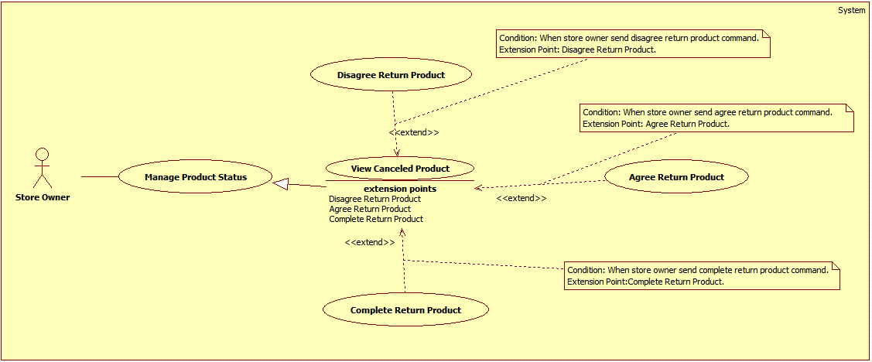

Figure 6: <Store Owner> View Canceled Product

**Use Case Specification**

|  |  |  |  |
| --- | --- | --- | --- |
| **USE CASE – DQT06** | | | |
| **Use Case No.** | **DQT06** | Use Case Version | 2.0 |
| **Use Case Name** | View Canceled Product | | |
| **Author** | DanQT | | |
| **Date** | May 26, 2015 | Priority | High |
| **Actor**:   * Store Owner   **Summary**:   * This use case allows store owner to view products which was requested cancel from consignor.   **Goal**:   * Successfully view canceled products.   **Triggers**:   * Store owner sends view canceled product command.   **Preconditions**:   * Guest is logged in as Store Owner.   **Post Conditions**:   * **Success**: Cancled products is display to store owner. * **Fail**: Show error message.   **Main Success Scenario**:   |  |  |  | | --- | --- | --- | | Step | Actor Action | System Response | | 1 | Store owner sends view available product command. | System loads and displays information of canceled products in table with following information:  + STT : label.  + Tên sản phẩm: label.  + Mã kí gửi: label.  + Chi tiết : send command to view detail.  [Exception 1] |   **Alternative Scenario**: N/A  **Exceptions**:   |  |  |  | | --- | --- | --- | | No | Actor Action | System Response | | 1 | Error occurs during get available product information phase. | System shows error. |   **Relationships**: N/A  **Business Rules**:   * Only product in “Canceled” or “NotYetReceive” status can be displayed in this table. * List are sorted action date in chronological order. The most recent received product will appears first in the list, while the oldest one appears last. * System will display the first 10 available products. * System will display available product which belongs to this store owner. | | | |

##### <Store Owner> Agree Return Product

**Use Case diagram**



Figure 7: <Store Owner> Agree Return Product

**Use Case Specification**

|  |  |  |  |
| --- | --- | --- | --- |
| **USE CASE – DQT07** | | | |
| **Use Case No.** | **DQT07** | Use Case Version | 2.0 |
| **Use Case Name** | Agree Return Product | | |
| **Author** | DanQT | | |
| **Date** | May 26, 2015 | Priority | High |
| **Actor**:   * Store Owner   **Summary**:   * This use case allows store owner to review cancel product request from consignor.   **Goal**:   * Agree consignor cancel product request and notifies them to take back their product.   **Triggers**:   * When store owner send agree return product.   **Preconditions**:   * Users has logged in as “Store Owner” role and is in view canceled product page.   **Post Conditions**:   * **Success**: Product status is changed to “NotYetReceive”, system notifies to consignor. * **Fail**: Show error message. No information has been changed.   **Main Success Scenario**:   |  |  |  | | --- | --- | --- | | Step | Actor Action | System Response | | 1 | Store owner send view canceled product detail command. | System load product’s information into pop-up with following information:   * Họ tên : label. * Địa chỉ : label. * Số điện thoại : label. * Email : label. * Tên sản phẩm : label. * Mã hàng kí gửi: label. * Giá kí gửi : label. * Ngày nhận hàng : label. * Ngày đăng kí hủy kí gửi : label. | | 2 | Store owner send agree return product command.  [Alternative 1] | System update database.  System notifies to consignor via SMS or email. [Exception 1]  System shows success message.  System redirects to view canceled product page. |   **Alternative Scenario**:   |  |  |  | | --- | --- | --- | | Step | Actor Action | System Response | | 1 | Store owner send cancel command. | System redirects to view canceled product page. No information is changed. |   **Exceptions**:   |  |  |  | | --- | --- | --- | | Step | Actor Action | System Response | | 1 | Errors occurs during update database phase. | System displays error.  System redirects to view canceled product page. |   **Relationships**: Extended to View canceled product.  **Business Rules**:   * Product status will be changed to “NotYetReceive”. * If consignor has both phone and email information. System will send SMS and email to consignor. If not system will send SMS to consignor. | | | |

##### <Store Owner> Disagree Return Product

**Use Case diagram**



Figure 8: <Store Owner> Disagree Return Product

**Use Case Specification**

|  |  |  |  |
| --- | --- | --- | --- |
| **USE CASE – DQT08** | | | |
| **Use Case No.** | **DQT08** | Use Case Version | 2.0 |
| **Use Case Name** | Disagree Return Product | | |
| **Author** | DanQT | | |
| **Date** | May 26, 2015 | Priority | High |
| **Actor**:   * Store Owner   **Summary**:   * This use case allows store owner to refuse cancel product request from consignor.   **Goal**:   * Refuse consignor cancel product request and notifies them about the cancellation.   **Triggers**:   * When store owner send disagree return product.   **Preconditions**:   * Users has logged in as “Store Owner” role and is in view canceled product page.   **Post Conditions**:   * **Success**: Product status is changed to “OnWeb”, and can be found by search funtion. * **Fail**: Show error message. No information has been changed.   **Main Success Scenario**:   |  |  |  | | --- | --- | --- | | Step | Actor Action | System Response | | 1 | Store owner send view canceled product detail command. | System load product’s information into pop-up with following information:   * Họ tên : label. * Địa chỉ : label. * Số điện thoại : label. * Email : label. * Tên sản phẩm : label. * Mã hàng kí gửi: label. * Giá kí gửi : label. * Ngày nhận hàng : label. * Ngày đăng kí hủy kí gửi : label. | | 2 | Store owner send disagree return product command.  [Alternative 1] | System update database.  [Exception 1]  System shows success message.  System redirects to view canceled product page. |   **Alternative Scenario**:   |  |  |  | | --- | --- | --- | | Step | Actor Action | System Response | | 1 | Store owner send cancel command. | System redirects to view canceled product page. No information is changed. |   **Exceptions**:   |  |  |  | | --- | --- | --- | | Step | Actor Action | System Response | | 1 | Errors occurs during update database phase. | System displays error.  System redirects to view canceled product page. |   **Relationships**: Extended to View canceled product.  **Business Rules**:   * Product status will be changed to “OnWeb”. * If consignor has both phone and email information. System will send SMS and email to consignor. If not system will send SMS to consignor to notifies about the cancellation. | | | |

##### <Store Owner> Complete Return Product

**Use Case diagram**



Figure 9: Complete Return Product

**Use Case Specification**

|  |  |  |  |
| --- | --- | --- | --- |
| **USE CASE – DQT09** | | | |
| **Use Case No.** | **DQT09** | Use Case Version | 2.0 |
| **Use Case Name** | Complete Return Product | | |
| **Author** | DanQT | | |
| **Date** | May 26, 2015 | Priority | High |
| **Actor**:   * Store Owner   **Summary**:   * This use case allows store owner to return canceled product to consignor.   **Goal**:   * Return product and complete consignment.   **Triggers**:   * When store owner send complete return product.   **Preconditions**:   * Users has logged in as “Store Owner” role and is in view canceled product page.   **Post Conditions**:   * **Success**: Product status is changed to “completed”, and update this consignment to completed. * **Fail**: Show error message. No information has been changed.   **Main Success Scenario**:   |  |  |  | | --- | --- | --- | | Step | Actor Action | System Response | | 1 | Store owner send view canceled product detail command. | System load product’s information into pop-up with following information:   * Họ tên : label. * Địa chỉ : label. * Số điện thoại : label. * Email : label. * Tên sản phẩm : label. * Mã hàng kí gửi: label. * Giá kí gửi : label. * Ngày nhận hàng : label. * Ngày đăng kí hủy kí gửi : label. | | 2 | Store owner sends complete return product command.  [Alternative 1] | System shows pop-up requires store owner to enter cancel product fee. | | 3 | Store owner enter cancel product fee.  [Alternative 2] | System validates inputted data.  [Exception 1]  System update database.  [Exception 2]  System shows success message.  System redirects to view canceled product page. |   **Alternative Scenario**:   |  |  |  | | --- | --- | --- | | Step | Actor Action | System Response | | 1 | Store owner send cancel command. | System redirects to view canceled product page. No information is changed. | | 2 | Store owner send cancel command. | System redirects to view canceled product detail pop-up. |   **Exceptions**:   |  |  |  | | --- | --- | --- | | Step | Actor Action | System Response | | 1 | Cancel product fee is not valid | System show message “Vui lòng nhập tiền phạt” and requires store owner to re-enter. | | 2 | Errors occurs during update database phase. | System displays error.  System redirects to view canceled product page. |   **Relationships**: Extended to View canceled product.  **Business Rules**:   * Product status will be changed to “completed”. * If consignor has both phone and email information. System will send SMS and email to consignor. If not system will send SMS to consignor to notifies about the cancellation. | | | |

##### <Store Owner> View Ordered Product

**Use Case diagram**

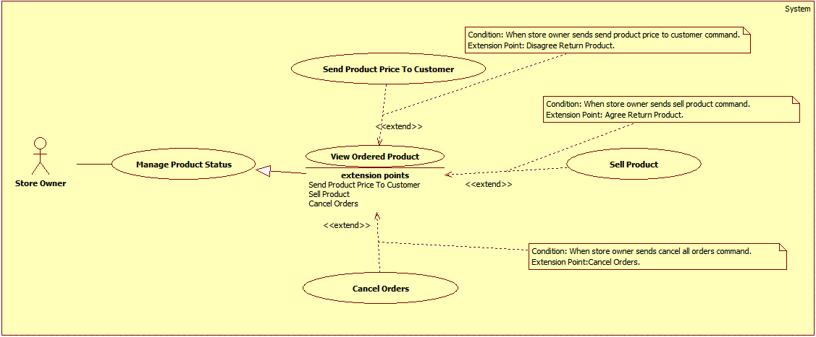

Figure 10: <Store Owner> View Ordered Product

**Use Case Specification**

|  |  |  |  |
| --- | --- | --- | --- |
| **USE CASE – DQT10** | | | |
| **Use Case No.** | **DQT10** | Use Case Version | 2.0 |
| **Use Case Name** | View Ordered Product | | |
| **Author** | DanQT | | |
| **Date** | May 26, 2015 | Priority | High |
| **Actor**:   * Store Owner   **Summary**:   * This use case allows store owner to view products which was ordered by customer.   **Goal**:   * Successfully view ordered products.   **Triggers**:   * Store owner sends view ordered product command.   **Preconditions**:   * Guest is logged in as Store Owner.   **Post Conditions**:   * **Success**: Ordered products is display to store owner. * **Fail**: Show error message.   **Main Success Scenario**:   |  |  |  | | --- | --- | --- | | Step | Actor Action | System Response | | 1 | Store owner sends view ordered product command. | System loads and displays information of ordered products in table with following information:  + STT : label.  + Tên sản phẩm: label.  + Mã kí gửi: label.  + Số người đặt: label  + Chi tiết : send command to view detail.  [Exception 1] |   **Alternative Scenario**: N/A  **Exceptions**:   |  |  |  | | --- | --- | --- | | No | Actor Action | System Response | | 1 | Error occurs during get ordered product information phase. | System shows error. |   **Relationships**: N/A  **Business Rules**:   * Only product in “Ordered” status can be displayed in this table. * List are sorted action date in chronological order. The most recent received product will appears first in the list, while the oldest one appears last. * System will display the first 10 available products. * System will display available product which belongs to this store owner. | | | |

##### <Store Owner> Sell Product

**Use Case diagram**



Figure 11: <Store Owner> Sell Product

**Use Case Specification**

|  |  |  |  |
| --- | --- | --- | --- |
| **USE CASE – DQT11** | | | |
| **Use Case No.** | **DQT11** | Use Case Version | 2.0 |
| **Use Case Name** | Sell Product | | |
| **Author** | DanQT | | |
| **Date** | May 26, 2015 | Priority | High |
| **Actor**:   * Store Owner   **Summary**:   * This use case allows store owner to sell product to customer who ordered this product.   **Goal**:   * Successfully view sell product.   **Triggers**:   * Store owner sends sell product command.   **Preconditions**:   * Guest is logged in as Store Owner.   **Post Conditions**:   * **Success**: Product status is changed to “Sold”. * **Fail**: Show error message.   **Main Success Scenario**:   |  |  |  | | --- | --- | --- | | Step | Actor Action | System Response | | 1 | Store owner sends view ordered product detail command. | System loads and displays information of ordered products in table with following information:   * Giá kí gửi: Label. * Giá gửi khách hàng: Free input text. * Danh sách người đặt mua: table with 5 columns:   + checkbox   + Tên khách hàng : label   + Ngày đặt mua: label   + Thông tin liên hệ : label   + Chi tiết : label | | 2 | Store owner chooses 1 customer and send sell product command.  [Alternative 1] | System validates inputted data. [Exception 1] | | 3 | Store owner enters selling price and send complete sell product command.  [Alternative 2] | System validates inputted data. [Exception 2]  System updates database.  [Exception 3]  System shows success message.  System redirects to view canceled product page. |   **Alternative Scenario**:   |  |  |  | | --- | --- | --- | | No | Actor Action | System Response | | 1 | Store owner send cancel command. | System redirects to view ordered product page. No information is changed. | | 2 | Store owner send cancel command. | System returns to view ordered product detail pop-up. |   **Exceptions**:   |  |  |  | | --- | --- | --- | | No | Actor Action | System Response | | 1 | Store doesn’t choose any customer or choose more than one customer. | System shows error message “Vui lòng chỉ chọn một khách hàng”. | | 2 | Selling price is not number or less than 0 or is empty. | System shows error message “Vui lòng nhập giá bán”. | | 3 | Error occurs during process sell product phase. | System shows error. |   **Relationships**: Extended to View Ordered Product (send Sell Product command).  **Business Rules**:   * Other orders will be cancel and system will send nofitication to customer who has ordered this product. * System will notify consignor that his/her product has been sold. * Product status will be changed to “Sold”. | | | |

##### <Store Owner> Send Product Price To Customer

**Use Case diagram**



Figure 12: <Store Owner> Send Product Price To Customer

**Use Case Specification**

|  |  |  |  |
| --- | --- | --- | --- |
| **USE CASE – DQT12** | | | |
| **Use Case No.** | **DQT12** | Use Case Version | 2.0 |
| **Use Case Name** | Send Product Price To Customer | | |
| **Author** | DanQT | | |
| **Date** | May 26, 2015 | Priority | Normal |
| **Actor**:   * Store Owner   **Summary**:   * This use case allows store owner to send product price to customer who ordered this product.   **Goal**:   * Successfully send product information to customer.   **Triggers**:   * Store owner sends send product price to customer command.   **Preconditions**:   * Guest is logged in as Store Owner. Product has been ordered by at least 1 customer, and product “IsSpecial” is 1.   **Post Conditions**:   * **Success**: Send SMS or email to customer about product price. * **Fail**: N/A.   **Main Success Scenario**:   |  |  |  | | --- | --- | --- | | Step | Actor Action | System Response | | 1 | Store owner sends view ordered product detail command. | System loads and displays information of ordered products in table with following information:   * Giá kí gửi: Label. * Giá gửi khách hàng: Free input text. * Danh sách người đặt mua: table with 5 columns:   + checkbox   + Tên khách hàng : label   + Ngày đặt mua: label   + Thông tin liên hệ : label   + Chi tiết : label | | 2 | Store owner chooses 1 or more customer.  Store enter price which is sent to customer.  Store owner sends send product price to customer command.  [Alternative 1] | System validates inputted data. [Exception 1,2]  System notifies to customer.  System updates database.  [Exception 3]  System shows success message.  System redirects to view ordered product page. |   **Alternative Scenario**:   |  |  |  | | --- | --- | --- | | No | Actor Action | System Response | | 1 | Store owner send cancel command. | System redirects to view ordered product page. No information is changed. |   **Exceptions**:   |  |  |  | | --- | --- | --- | | No | Actor Action | System Response | | 1 | Store doesn’t choose any customer or choose more than one customer. | System shows error message “Vui lòng chỉ chọn một khách hàng”. | | 2 | Selling price is not number or less than 0 or is empty. | System shows error message “Vui lòng nhập giá bán”. | | 3 | Error occurs during process sell product price phase. | System shows error. |   **Relationships**: Extended to View Ordered Product (send Sell Product command).  **Business Rules**:   * Other orders will be cancel and system will send nofitication to customer who has ordered this product. * System will notify consignor that his/her product has been sold. * Product status will be changed to “Sold”. | | | |

##### <Store Owner> Cancel Orders

**Use Case diagram**



Figure 13: <Store Owner> Send Product Price To Customer

**Use Case Specification**

|  |  |  |  |
| --- | --- | --- | --- |
| **USE CASE – DQT13** | | | |
| **Use Case No.** | **DQT13** | Use Case Version | 2.0 |
| **Use Case Name** | Send Product Price To Customer | | |
| **Author** | DanQT | | |
| **Date** | May 26, 2015 | Priority | Normal |
| **Actor**:   * Store Owner   **Summary**:   * This use case allows store owner to cancel all orders which relates to this product.   **Goal**:   * Successfully cancel all orders.   **Triggers**:   * Store owner sends cancel all orders command.   **Preconditions**:   * Guest is logged in as Store Owner. Product has been ordered by at least 1 customer.   **Post Conditions**:   * **Success**: Send SMS or email to customer about order cancellation. * **Fail**: N/A.   **Main Success Scenario**:   |  |  |  | | --- | --- | --- | | Step | Actor Action | System Response | | 1 | Store owner sends view ordered product detail command. | System loads and displays information of ordered products in table with following information:   * Giá kí gửi: Label. * Giá gửi khách hàng: Free input text. * Danh sách người đặt mua: table with 5 columns:   + checkbox   + Tên khách hàng : label   + Ngày đặt mua: label   + Thông tin liên hệ : label   + Chi tiết : label | | 2 | Store owner sends cancel all orders command.  [Alternative 1] | System updates database.  System notifies to customer.  [Exception 1]  System shows success message.  System redirects to view ordered product page. |   **Alternative Scenario**:   |  |  |  | | --- | --- | --- | | No | Actor Action | System Response | | 1 | Store owner send cancel command. | System redirects to view ordered product page. No information is changed. |   **Exceptions**:   |  |  |  | | --- | --- | --- | | No | Actor Action | System Response | | 1 | Error occurs during process cancel orders product phase. | System shows error. |   **Relationships**: Extended to View Ordered Product (send Sell Product command).  **Business Rules**:   * Other orders will be cancel and system will send nofitication to customer who has ordered this product. * System will notify consignor that his/her product has been sold. * Product status will be changed to “Sold”. | | | |

##### <Store Owner> View Expired Product

**Use Case diagram**

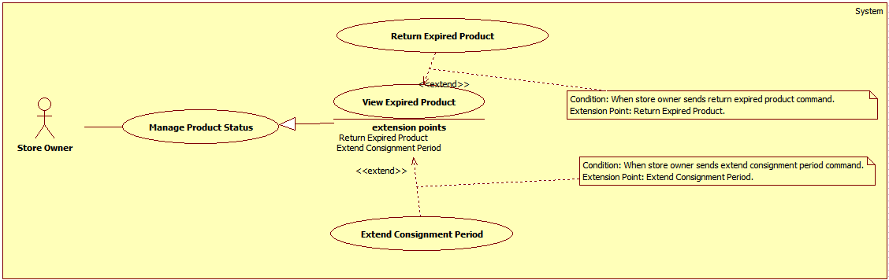

Figure 14: <Store Owner> View Expired Product

**Use Case Specification**

|  |  |  |  |
| --- | --- | --- | --- |
| **USE CASE – DQT14** | | | |
| **Use Case No.** | **DQT14** | Use Case Version | 2.0 |
| **Use Case Name** | View Expired Product | | |
| **Author** | DanQT | | |
| **Date** | May 26, 2015 | Priority | High |
| **Actor**:   * Store Owner   **Summary**:   * This use case allows store owner to view products which was expired.   **Goal**:   * Successfully view expired products.   **Triggers**:   * Store owner sends view expired product command.   **Preconditions**:   * Guest is logged in as Store Owner.   **Post Conditions**:   * **Success**: Expired products is display to store owner. * **Fail**: Show error message.   **Main Success Scenario**:   |  |  |  | | --- | --- | --- | | Step | Actor Action | System Response | | 1 | Store owner sends view ordered product command. | System loads and displays information of ordered products in table with following information:  + STT : label.  + Tên sản phẩm: label.  + Mã kí gửi: label.  + Ngày hết hạn: label  + Chi tiết : send command to view detail.  [Exception 1] |   **Alternative Scenario**: N/A  **Exceptions**:   |  |  |  | | --- | --- | --- | | No | Actor Action | System Response | | 1 | Error occurs during get expired product information phase. | System shows error. |   **Relationships**: N/A  **Business Rules**:   * Only product in “Expired” status can be displayed in this table. * List are sorted action date in chronological order. The most recent received product will appears first in the list, while the oldest one appears last. * System will display the first 10 available products. * System will display available product which belongs to this store owner. | | | |

##### <Store Owner> Extend Consignment Period

**Use Case diagram**



Figure 15: <Store Owner> Extend Consignment Period

**Use Case Specification**

|  |  |  |  |
| --- | --- | --- | --- |
| **USE CASE – DQT15** | | | |
| **Use Case No.** | **DQT15** | Use Case Version | 2.0 |
| **Use Case Name** | Extend Consignment Period | | |
| **Author** | DanQT | | |
| **Date** | May 26, 2015 | Priority | High |
| **Actor**:   * Store Owner   **Summary**:   * This use case allows store owner to extend consignment period which was expired.   **Goal**:   * Successfully view extend consignment period. Product is displayed on web.   **Triggers**:   * Store owner sends extend consignment period command.   **Preconditions**:   * Guest is logged in as Store Owner.   **Post Conditions**:   * **Success**: Product status is changed to “OnWeb”. * **Fail**: N/A.   **Main Success Scenario**:   |  |  |  | | --- | --- | --- | | Step | Actor Action | System Response | | 1 | Store owner sends view expired detail product command. | System loads information of expired products into pop-up with following information:   * Họ tên:   + Label. * Địa chỉ:   + Label. * Số điện thoại:   + Label. * Email:   + Label. * Tên sản phẩm:   + Label. * Mã hàng kí gửi:   + Label. * Ngày kí gửi:   + Label. * Giá thỏa thuận:   + Label. * Số ngày quá hạn:   + Label. | | 2 | Store owner sends extend consignment period command.  [Alternative 1] | System show suggest stored fee.  System asks store owner to confirm about the extension. | | 3 | Store owner enter stored fee and send complete command. | System updates database.  [Exception 1]  System shows success message.  System redirects to view expired product page. |   **Alternative Scenario**:   |  |  |  | | --- | --- | --- | | No | Actor Action | System Response | | 1 | Store owner send cancel command. | System redirects to view expired product page. No information is changed. |   **Exceptions**:   |  |  |  | | --- | --- | --- | | No | Actor Action | System Response | | 1 | Error occurs during get expired product information phase. | System shows error. |   **Relationships**: Extended to View Expired Product (send extend consignment period command).  **Business Rules**:   * After extend consignment period, this consignment will be expired after 30 days later. * If consignor is late to extend consignment period, they have to pay stored fee. * Stored fee is suggest by system by this formula :   + If negotiated price >= 1.000.000 vnd. Stored fee = 10.000 x expiredDays (vnd).  + If negotiated price < 1.000.000 vnd. Stored fee = 5.000 x expiredDays (vnd). | | | |

##### <Store Owner> Return Expired Product

**Use Case diagram**



Figure 16: <Store Owner> Return Expired Product

**Use Case Specification**

|  |  |  |  |
| --- | --- | --- | --- |
| **USE CASE – DQT16** | | | |
| **Use Case No.** | **DQT16** | Use Case Version | 2.0 |
| **Use Case Name** | Return Expired Product | | |
| **Author** | DanQT | | |
| **Date** | May 26, 2015 | Priority | High |
| **Actor**:   * Store Owner   **Summary**:   * This use case allows store owner to return expired to consignor.   **Goal**:   * Successfully return expired product.   **Triggers**:   * Store owner sends return expired product command.   **Preconditions**:   * Guest is logged in as Store Owner, product status is “expired”.   **Post Conditions**:   * **Success**: Product status is changed to “NotAvailable”. * **Fail**: N/A.   **Main Success Scenario**:   |  |  |  | | --- | --- | --- | | Step | Actor Action | System Response | | 1 | Store owner sends view expired detail product command. | System loads information of expired products into pop-up with following information:   * Họ tên:   + Label. * Địa chỉ:   + Label. * Số điện thoại:   + Label. * Email:   + Label. * Tên sản phẩm:   + Label. * Mã hàng kí gửi:   + Label. * Ngày kí gửi:   + Label. * Giá thỏa thuận:   + Label. * Số ngày quá hạn:   + Label. | | 2 | Store owner sends return expired product command.  [Alternative 1] | System show suggest stored fee.  System show remain stored fee if exist.  System asks store owner to confirm. | | 3 | Store owner enter total stored fee and send complete command. | System updates database.  [Exception 1]  System shows success message.  System redirects to view expired product page. |   **Alternative Scenario**:   |  |  |  | | --- | --- | --- | | No | Actor Action | System Response | | 1 | Store owner send cancel command. | System redirects to view expired product page. No information is changed. |   **Exceptions**:   |  |  |  | | --- | --- | --- | | No | Actor Action | System Response | | 1 | Error occurs during get expired product information phase. | System shows error. |   **Relationships**: Extends to View Expired Product (send return expired product command).  **Business Rules**:   * Stored fee is suggest by system by this formula :   + If negotiated price >= 1.000.000 vnd. (Stored fee = 10.000 x expiredDays ) + remain extend fee (vnd).  + If negotiated price < 1.000.000 vnd. (Stored fee = 5.000 x expiredDays ) + remain extend fee (vnd). | | | |

##### <Store Owner> View On Web Product

**Use Case diagram**

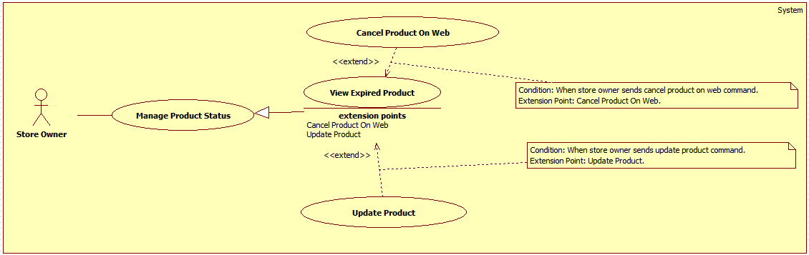

Figure 17: <Store Owner> View On Web Product

**Use Case Specification**

|  |  |  |  |
| --- | --- | --- | --- |
| **USE CASE – DQT17** | | | |
| **Use Case No.** | **DQT17** | Use Case Version | 2.0 |
| **Use Case Name** | View On Web Product | | |
| **Author** | DanQT | | |
| **Date** | May 26, 2015 | Priority | High |
| **Actor**:   * Store Owner   **Summary**:   * This use case allows store owner to view products which was received from consignor.   **Goal**:   * Successfully view available products so they can publish them on web.   **Triggers**:   * Store owner sends view available product command.   **Preconditions**:   * Guest is logged in as Store Owner.   **Post Conditions**:   * **Success**: Available products is display to store owner. * **Fail**: Show error message.   **Main Success Scenario**:   |  |  |  | | --- | --- | --- | | Step | Actor Action | System Response | | 1 | Store owner sends view available product command. | System loads and displays information of available products in table with following information:  + STT : label.  + Tên sản phẩm: label.  + Mã kí gửi: label.  + Chi tiết : send command to view detail.  [Exception 1] |   **Alternative Scenario**: N/A  **Exceptions**:   |  |  |  | | --- | --- | --- | | No | Actor Action | System Response | | 1 | Error occurs during get available product information phase. | System shows error. |   **Relationships**: N/A  **Business Rules**:   * Only product in “On Web” status can be displayed in this table. * List are sorted action date in chronological order. The most recent received product will appears first in the list, while the oldest one appears last. * System will display the first 10 available products. * System will display available product which belongs to this store owner. | | | |

##### <Store Owner> Update Product

**Use Case diagram**

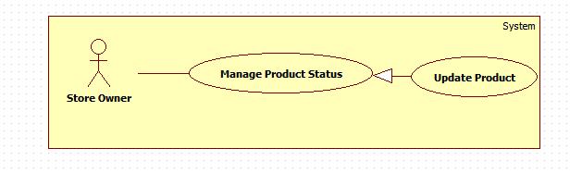

Figure 18: <Store Owner> Update Product

**Use Case Specification**

|  |  |  |  |
| --- | --- | --- | --- |
| **USE CASE – DQT18** | | | |
| **Use Case No.** | **DQT18** | Use Case Version | 2.0 |
| **Use Case Name** | Update Product | | |
| **Author** | DanQT | | |
| **Date** | May 26, 2015 | Priority | High |
| **Actor**:   * Store Owner   **Summary**:   * This use case allows store owner to update product information after publish product.   **Goal**:   * Change product information bases on information that was given by store owner.   **Triggers**:   * When store owner send update product command.   **Preconditions**:   * Product status must be “On Web”.   **Post Conditions**:   * **Success**: Product information is changed. * **Fail**: Product information remains like the beginning. No information has been changed   **Main Success Scenario**:   |  |  |  | | --- | --- | --- | | Step | Actor Action | System Response | | 1 | Store owner sends view product detail command. | System loads and displays product information with following information:   * Tên sản phẩm:   + Free text input.   + Min-length: 5 characters.   + Max-length: 50 characters.   + Required. * Số seri:   + Free text input.   + Min-length: 5 characters.   + Max-length: 50 characters.   + Required. * Ngày mua hàng:   + Label.   + Not editable. * Loại sản phẩm:   + Single choice option. * Hãng:   + Min-length: 5 characters.   + Max-length: 50 characters.   + Required. * Mùa:   + Multi-choice option. * Tự động gửi giá:   + Single choice option. * Mô tả:   + Free textarea. * Ảnh sản phẩm:   + Image. | | 2 | Store owner enters product’s information to fields. | System validates inputted values. [Exception 1,2,3] | | 3 | Store owner sends update command.  [Alternative 1]. | System changes product information.  [Exception 4].  System redirects to view on web product page. |   **Alternative Scenario**:   |  |  |  | | --- | --- | --- | | Step | Actor Action | System Response | | 1 | Store owner sends cancel command | System forwards to view on web product page. No information is recorded. |   **Exceptions**:   |  |  |  | | --- | --- | --- | | Step | Actor Action | System Response | | 1 | Tên sản phẩm is empty. | System show message “Vui lòng nhập tên sản phẩm”. | | 2 | Hãng sản phẩm is empty. | System show message “Vui lòng nhập hãng sản phẩm”. | | 3 | Độ mới is not a number or less than 0 or greater than 100. | System show message “Vui lòng nhập đúng độ mới của sản phẩm”. | | 4 | Error occurs during change product information phase. | System displays error detail. System forwards to view on web product page. |   **Relationships**: Extended to View On Web Product (send update product command).  **Business Rules**:   * System will change product information bases on the information which is given by store owner. * If store owner chooses seasons for product, it will be display on home page during those season. If store owner doesn’t choose any season, it will display in “Sản phẩm nổi bật” category. * If store owner chooses “Tự động gửi giá” is “Có”, when product is ordered, system will automatic send product price to customer. * Only product has “On Web” status can be update. | | | |

##### <Store Owner> Cancel Product On Web

**Use Case diagram**



Figure 19: <Store Owner> Cancel Product On Web

**Use Case Specification**

|  |  |  |  |
| --- | --- | --- | --- |
| **USE CASE – DQT19** | | | |
| **Use Case No.** | **DQT19** | Use Case Version | 2.0 |
| **Use Case Name** | Cancel Product On Web | | |
| **Author** | DanQT | | |
| **Date** | May 26, 2015 | Priority | High |
| **Actor**:   * Store Owner   **Summary**:   * This use case allows store owner to cancel product when consignor come to store and ask to take back product.   **Goal**:   * Change product and consignment status to complete. Sucessfully return product to consignor.   **Triggers**:   * When store owner send cancel product on web command.   **Preconditions**:   * Product status must be “On Web”.   **Post Conditions**:   * **Success**: Product information is changed. * **Fail**: Product information remains like the beginning. No information has been changed   **Main Success Scenario**:   |  |  |  | | --- | --- | --- | | Step | Actor Action | System Response | | 1 | Store owner sends view product detail command. | System loads and displays product information with following information:   * Tên sản phẩm:   + Free text input.   + Min-length: 5 characters.   + Max-length: 50 characters.   + Required. * Số seri:   + Free text input.   + Min-length: 5 characters.   + Max-length: 50 characters.   + Required. * Ngày mua hàng:   + Label.   + Not editable. * Loại sản phẩm:   + Single choice option. * Hãng:   + Min-length: 5 characters.   + Max-length: 50 characters.   + Required. * Mùa:   + Multi-choice option. * Tự động gửi giá:   + Single choice option. * Mô tả:   + Free textarea. * Ảnh sản phẩm:   + Image. | | 2 | Store owner sends cancel product on web command.  [Alternative 1] | System shows pop-up requires store owner to enter cancel product fee. | | 3 | Store owner enter cancel product fee.  [Alternative 2] | System validates inputted data.  [Exception 1]  System update database.  [Exception 2]  System shows success message.  System redirects to view on web product page. |   **Alternative Scenario**:   |  |  |  | | --- | --- | --- | | Step | Actor Action | System Response | | 1 | Store owner sends cancel command | System forwards to view on web product page. No information is recorded. |   **Exceptions**: N/A  **Relationships**: Extended to View On Web Product (send cancel product on web command).  **Business Rules**: | | | |

##### <Store Owner> View Consignment Statistic

**Use Case diagram**

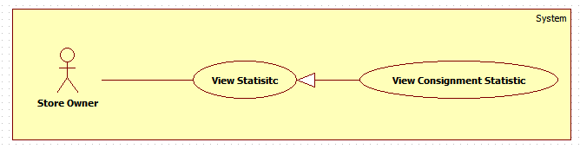

Figure 20: <Store Owner> View Consignment Statistic

**Use Case Specification**

|  |  |  |  |
| --- | --- | --- | --- |
| **USE CASE – DQT20** | | | |
| **Use Case No.** | **DQT20** | Use Case Version | 2.0 |
| **Use Case Name** | View Consignment Statistic | | |
| **Author** | DanQT | | |
| **Date** | May 26, 2015 | Priority | Normal |
| **Actor**:   * Store Owner   **Summary**:   * This use case allows store owner to view consignment statistic.   **Goal**:   * Give store owner the overall view of the works in their store.   **Triggers**:   * When store owner send view consignment statistic.   **Preconditions**:   * Users has logged in as “Store Owner” role and is in statistic page.   **Post Conditions**:   * **Success**: View all consignment status of the store. * **Fail**: N/A   **Main Success Scenario**:   |  |  |  | | --- | --- | --- | | Step | Actor Action | System Response | | 1 | Store owner sends view consignment statistic command. | System loads information about the consignments of their store. [Exception 1] | | 2 | Store owner sends view detail of consignment statistic command. | System loads detail information about the consignment with following format.  [Exception 2]   * Tên sản phẩm:   + Label. * Loại sản phẩm:   + Label. * Hãng:   + Label. * Người kí gửi:   + Label * Điện thoại:   + Label. * Email:   + Label. * Ngày tạo ký gửi:   + Label. * Ngày từ chối sản phẩm:   + Label. * Ngày nhận sản phẩm:   + Label. * Ngày trả tiền khách hàng:   + Label. * Ngày hủy kí gửi:   + Label. * Ngày bán sản phẩm:   + Label. * Ngày duyệt yêu cầu:   + Label. * Ngày từ chối yêu cầu:   + Label. * Ngày đăng lên web:   + Label. * Ngày hoàn trả sản phẩm:   + Label. * Tiền trả khách hàng:   + Label. |   **Alternative Scenario**: N/A  **Exceptions**:   |  |  |  | | --- | --- | --- | | Step | Actor Action | System Response | | 1 | Store owner confirm error and send return to management page command. | Error occurs during get detail of consignment statistic information phase. System display error detail.  System forwards to “Management Page”. | | 2 | Store owner confirm error and send return to management page command. | Error occurs during get consignment statistic information phase. System display error detail.  System forwards to “Management Page”. |   **Relationships**: N/A  **Business Rules**:   * Consignment is displayed 10 items per page. * List are sorted created date in chronological order. The most recent appears last in the list, while the oldest one appears first. * Store owner can view information of other consignment status by change the value of “Trạng thái” drop down list. * Store owner can view consignment status information of the other days by change the value of “Từ ngày” and “Đến ngày” datetime picker. * When store owner clicks on see detail, depends on consignment status, and product status system will display detail information differently:  |  |  |  |  |  |  |  |  |  |  |  | | --- | --- | --- | --- | --- | --- | --- | --- | --- | --- | --- | |  | Ngày duyệt yêu cầu | Ngày từ chối yêu cầu | Ngày từ chối sản phẩm | Ngày nhận sản phẩm | Ngày trả tiền khách hàng | Ngày hủy kí gửi | Ngày bán sản phẩm | Ngày đăng lên web | Ngày hoàn trả sản phẩm | Tiền trả khách hàng | | ProductStatus : NotAvailable  ConsignmentStatus : Waiting | x |  |  |  |  |  |  |  |  |  | | ProductStatus : Available  ConsignmentStatus : Accepted | x |  |  | x |  |  |  |  |  |  | | ProductStatus : OnWeb  ConsignmentStatus : Accepted | x |  |  | x |  |  |  | x |  |  | | ProductStatus : Sold  ConsignmentStatus : Accepted | x |  |  | x |  |  | x | x |  |  | | ProductStatus : NotAvailable  ConsignmentStatus:Completed | x |  |  | x | x |  | x | x |  | x | | ProductStatus : NotAvailable  ConsignmentStatus : Refuse | x | x | x |  |  |  |  |  |  |  | | ProductStatus : Cancel  ConsignmentStatus : Cancel | x |  |  | x |  | x |  | x | x |  | | | | |

#### <Store Owner> Sequence diagram

##### <Store Owner> Publish On Web

**Summary**: This diagram shows how store owner publish a product to website.

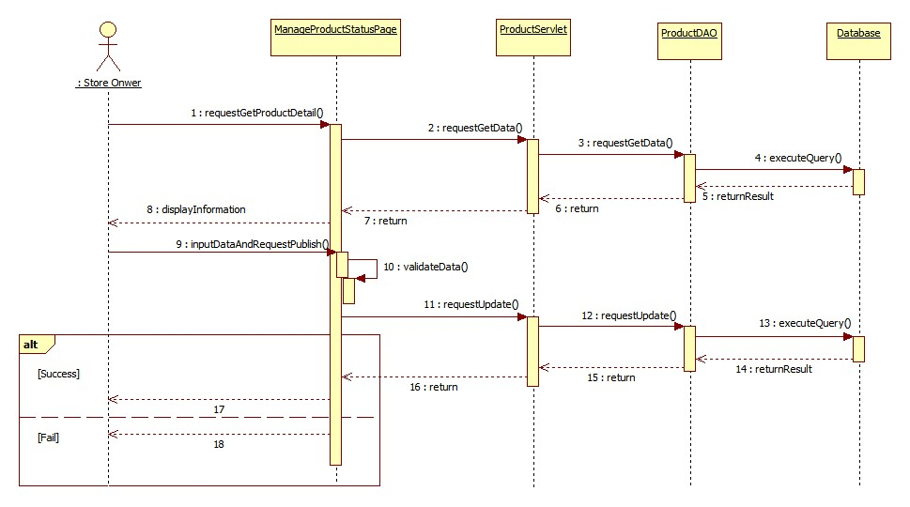

Figure 21: <Store Owner> Publish On Web

##### <Store Owner>Pay Consignor

**Summary**: This diagram shows how store owner pay consignor without online payment method.

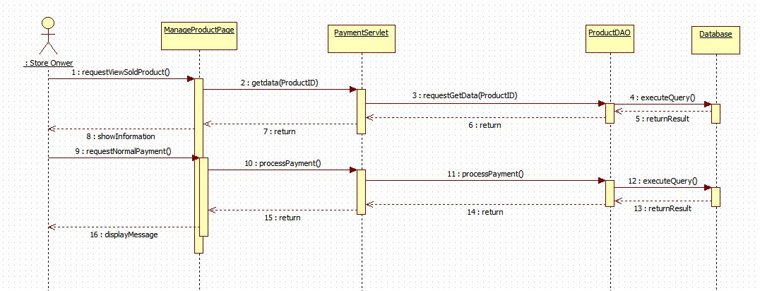

Figure 22: <Store Owner> Pay Consignor

##### <Store Owner> Process Payment

**Summary**: This diagram shows how store owner pay consignor via payment service.

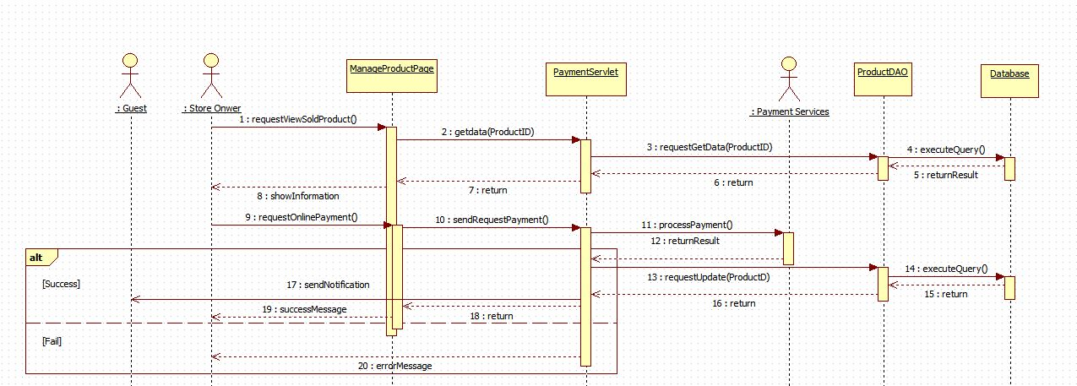

Figure 23: <Store Owner> Process Payment

##### <Store Owner> Agree Return Product

**Summary**: This diagram shows how store owner agree a cancel consignment request.

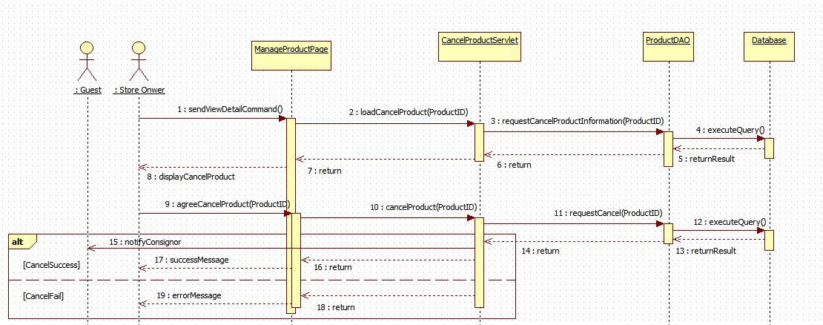

Figure 24: <Store Owner> Agree Return Product

##### <Store Owner> Disagree Return Product

**Summary**: This diagram shows how store owner refuse a cancel consignment request.

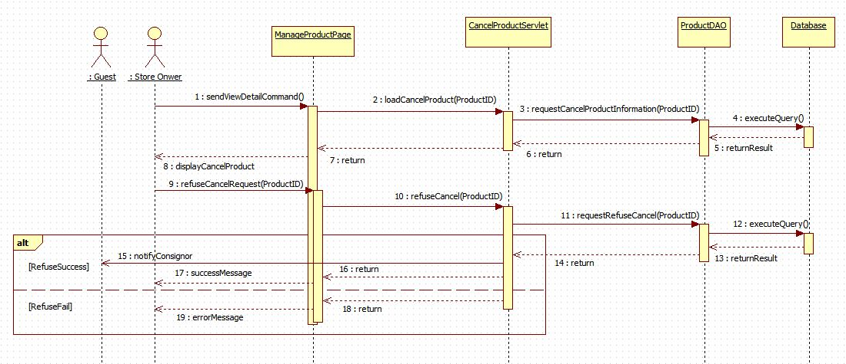

Figure 25: <Store Owner> Disagree Return Product

##### <Store Owner> Sell Product

**Summary**: This diagram shows how store owner sell a product which ordered by one or more customer.

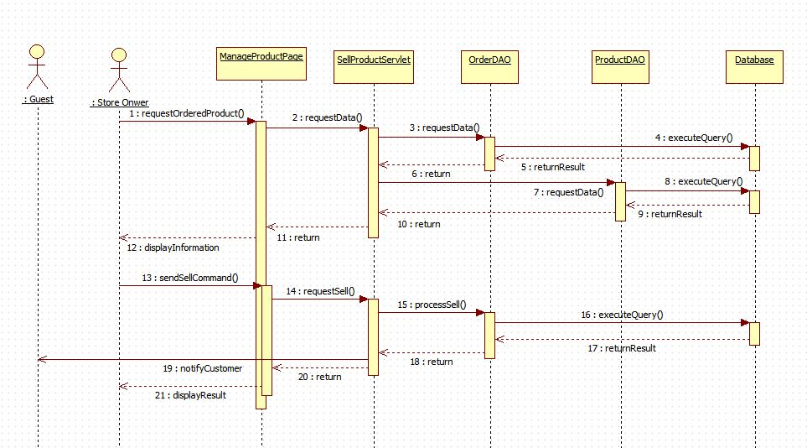

Figure 26: <Store Owner> Sell Product

##### <Store Owner> Send Product Price To Customer

**Summary**: This diagram shows how store owner send product price to customer who has ordered product.

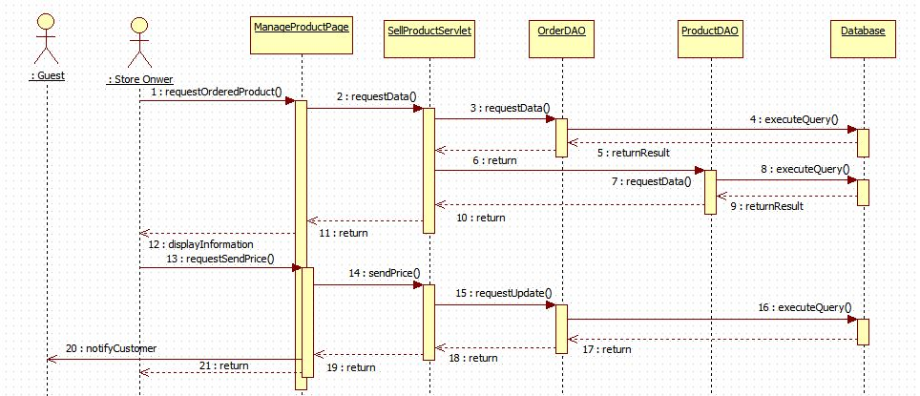

Figure 27: <Store Owner> Send Product Price To Customer

##### <Store Owner> Cancel Orders

**Summary**: This diagram shows how store owner cancel all orders which relates to their product.

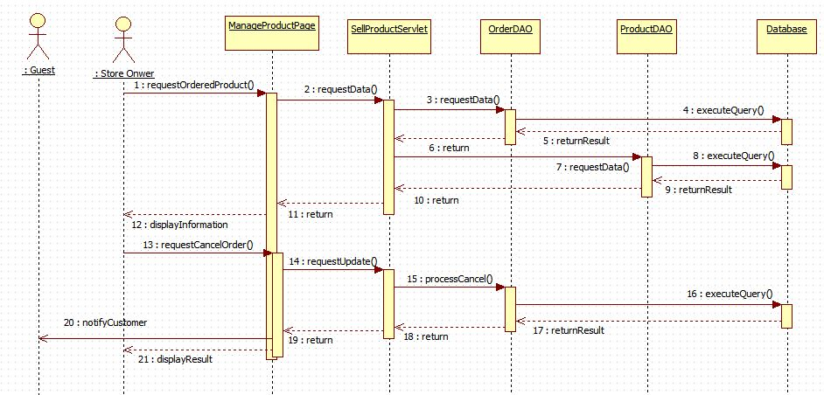

Figure 28: <Store Owner> Cancel Orders

##### <Store Owner> Extend Consignment Period

**Summary**: This diagram shows how store owner help consignor to extend consignment period after it’s over.

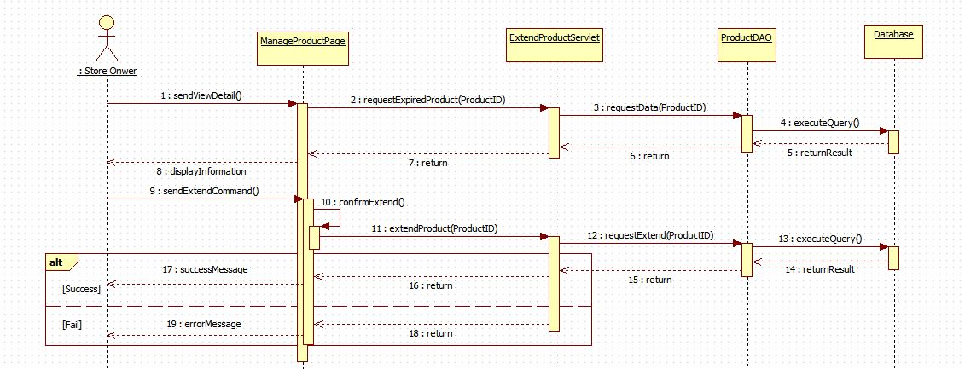

Figure 29: <Store Owner> Extend Consignment Period

##### <Store Owner> Update Product

**Summary**: This diagram shows how store owner update product information after publish product on web.

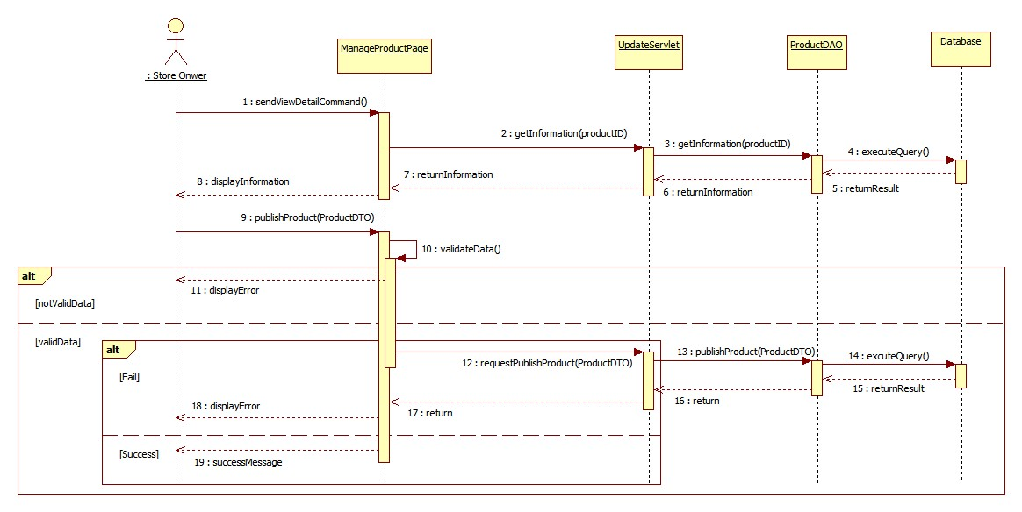

Figure 30: <Store Owner> Update Product

##### <Store Owner> View Available Product

**Summary**: This diagram shows how store owner view received product of their store.

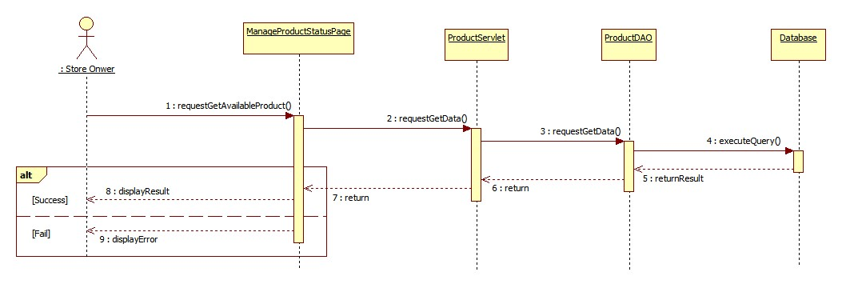

Figure 31: <Store Owner> View Available Product

##### <Store Owner> View Consignment Statistic

**Summary**: This diagram shows how store owner view consignment statistic of their store.

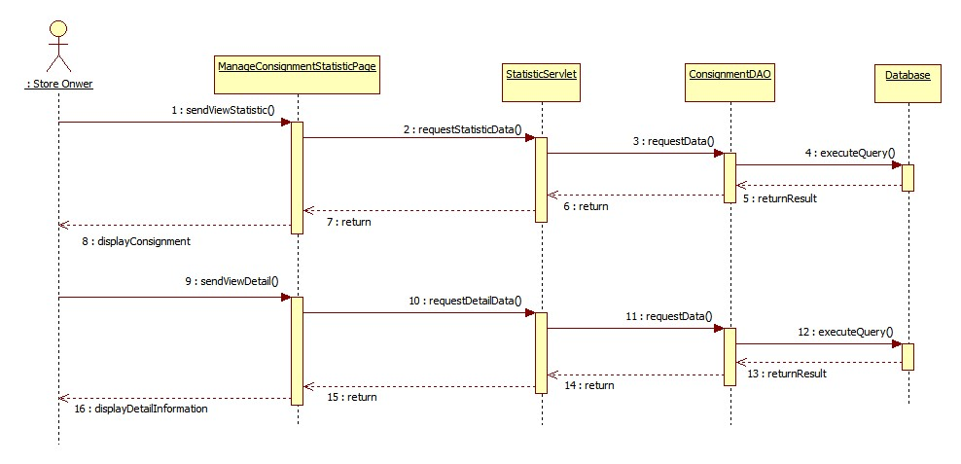

Figure 32: <Store Owner> View Consignment Statistic

#### <System> Use Case

##### <System> Search Product Online

**Use Case diagram**

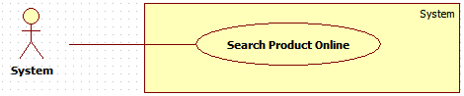

Figure 33: <System> Search Product Online

**Use Case Specification**

|  |  |  |  |
| --- | --- | --- | --- |
| **USE CASE – DQT21** | | | |
| **Use Case No.** | **DQT21** | Use Case Version | 2.0 |
| **Use Case Name** | Search Product Online | | |
| **Author** | DanQT | | |
| **Date** | May 26, 2015 | Priority | High |
| **Actor**:   * System   **Summary**:   * This use case allows system search product based on information that was given by consignor.   **Goal**:   * System return list of product which match with information that consignor has provided.   **Triggers**:   * When consignor send consign command.   **Preconditions**:   * Guest consigns product and has inputted necessary information.   **Post Conditions**:   * **Success**: Return list of products. * **Fail**: Return nothing.   **Main Success Scenario**:   |  |  |  | | --- | --- | --- | | Step | Actor Action | System Response | | 1 | System gets data which is provided by consignor.  System send search product command. | System sends search product detail to price suggestion services.  [Exception 1]  System gets return value.  System parses return value to list of products.  [Exception 2]  System returns result. |   **Alternative Scenario**: N/A  **Exceptions**:   |  |  |  | | --- | --- | --- | | Step | Actor Action | System Response | | 1 | System returns empty list. | Error occurs during search product detail phase. | | 2 | System returns message “Too many result” | Return result has more than 10 items |   **Relationships**: N/A  **Business Rules**:   * Product name or UPC (Universal Product Code) information must be provided to system. * If return result is more than 10 items, system will return empty list. * If return result is less than 10 items, system will return list of product which contain those items. * If return result is empty, system will return empty list. * Product price is the lowest new price of the product. * Product has following information: Product name, lowest new price of the product, product image. | | | |

#### <System> Sequence diagram

##### <System> Search Product Online

**Summary**: This diagram shows how system find product with information that was given by consignor.

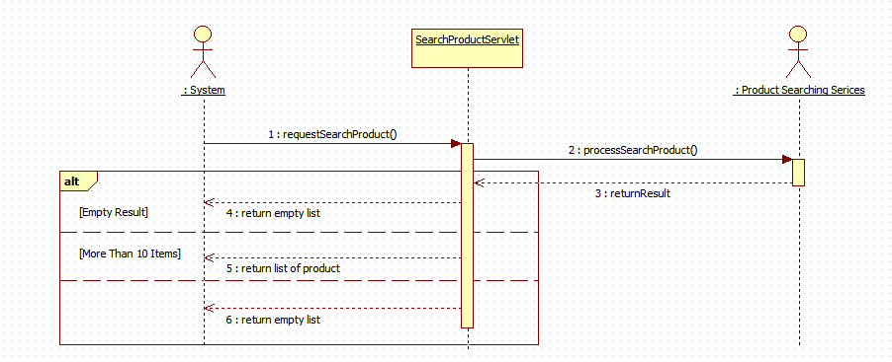

Figure 34: <System> Search Product Online