**Overview use case**

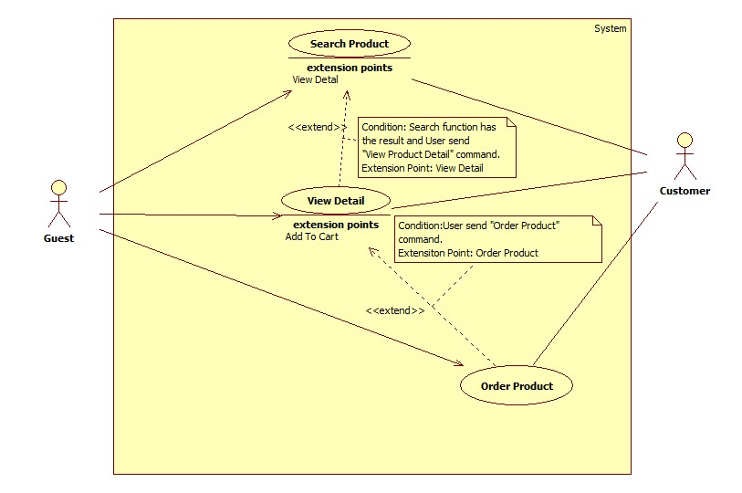

**Search Product Use Case**

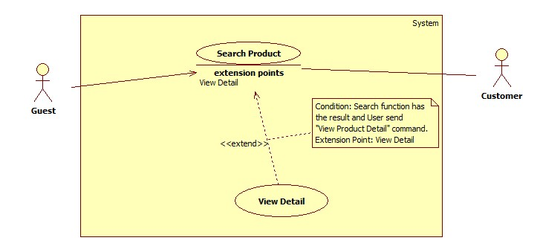

|  |  |  |  |
| --- | --- | --- | --- |
| **USE CASE –** HPS001 | | | |
| **Use Case No.** | HPS001 | Use Case Version | 2.0 |
| **Use Case Name** | Search Product | | |
| **Author** | HoangNH | | |
| **Date** | May 22, 2015 | Priority | High |
| **Actor**:   * Guest/Customer   **Summary**:   * This use case allows user to search product information by its name and category.   **Goal**:   * A list of products will be shown to user.   **Triggers**:   * User can search product to get product’s information. * User can choose top product’s category include: “Nam”, “Nữ”, “Trẻ em” or “Tất cả”, inputs to a free text input and send “Search Product” command.   **Preconditions**:   * User is in home page or category page.   **Post Conditions**:   * Success: Show search results which include a list of product. * Fail: Show an error message.   **Main Success Scenario**:   |  |  |  | | --- | --- | --- | | Step | Actor Action | System Response | | 1 | User choose product’s category include: “Nam”, “Nữ”, “Trẻ em” or “Tất cả”. |  | | 2 | User inputs the product’s name into free text input. |  | | 3 | User send “Search Product” command. | System will show a list of product as a grid and order by product name.  [Alternative 1] |   **Alternative Scenario**:   |  |  |  | | --- | --- | --- | | No | Actor Action | System Response | | 1 | Search not found | System will show a message: “Không tìm thầy sản phẩm nào phù hợp.” |   **Exceptions**: N/A  **Relationships**:   * Extending Use-cases: Extended by View Detail (Search function has the result and user send “View Product Detail” command).   **Business Rules**:   * Search by product name and category. * All products with relative name which user inputted will be show. The results will show list of product as a gird. | | | |

**View Detail Use Case**

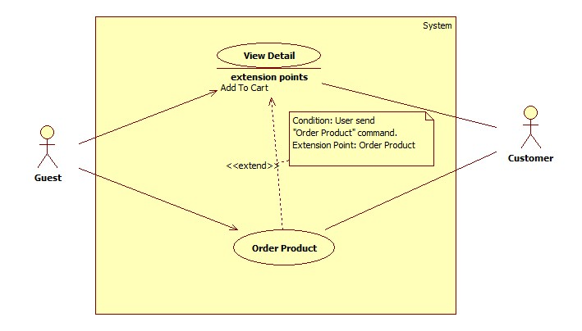

|  |  |  |  |
| --- | --- | --- | --- |
| **USE CASE –** HPS002 | | | |
| **Use Case No.** | HPS002 | Use Case Version | 2.0 |
| **Use Case Name** | View Detail | | |
| **Author** | HoangNH | | |
| **Date** | May 22, 2015 | Priority | High |
| **Actor**:   * Guest/Customer   **Summary**:   * This use case allows user to view product detail information.   **Goal**:   * A product detail will be shown to user.   **Triggers**:   * User send “View Product Detail” command.   **Preconditions**:   * At least 1 product item available.   **Post Conditions**:   * Success: Show product detail information in detail page. * Fail: Show an error message.   **Main Success Scenario**:   |  |  |  | | --- | --- | --- | | Step | Actor Action | System Response | | 1 | User click “XEM CHI TIẾT” button. | System will show product information which contains:   * “Tên” : Label * “Số Serial” : Label * “Mô tả”: textarea * “Hình ảnh”: Image * “Tên chủ cửa hàng”: Label * “Email”: Label * “Số điện thoại”: Label * “Địa chỉ”: Label * “ĐẶT HÀNG” Button. |   **Alternative Scenario**: N/A  **Exceptions**: N/A  **Relationships**:   * Extending Use-cases: Extend from Search Product (Search keyword has the result and user click a result item). Extended by Order Product(User send “Order Product” command).   **Business Rules**:   * Details of product will be displayed to user. | | | |

**Order Product Use Case**

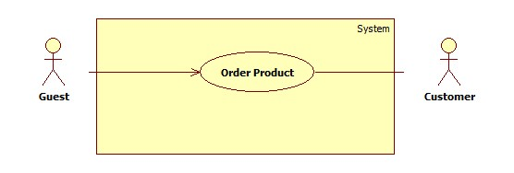

|  |  |  |  |
| --- | --- | --- | --- |
| **USE CASE –** HPS003 | | | |
| **Use Case No.** | HPS003 | Use Case Version | 2.0 |
| **Use Case Name** | Order Product | | |
| **Author** | HoangNH | | |
| **Date** | May 22, 2015 | Priority | High |
| **Actor**:   * Guest/Customer   **Summary**:   * This use case allows user order product.   **Goal**:   * Product will be ordered by user.   **Triggers**:   * User send “Order Product” command.   **Preconditions**:   * User is in product detail page.   **Post Conditions**:   * Success: Show success message, create an order of this product with user information * Fail: Show an error message.   **Main Success Scenario**:   |  |  |  | | --- | --- | --- | | Step | Actor Action | System Response | | 1 | User send “Order Product” command. | System will navigate to enter user’s information include:   * “Tên”: Textbox, max length: 50. * “Email”: Textbox, regurlar expression: “^[a-zA-Z0-9_.+-]+@[a-zA-Z0-9-]+\.[a-zA-Z0-9-.]+$". * “Địa Chỉ”: Textbox. * “Số Điện Thoại”: min length: 9, max length: 11. * “Xác Nhận”: Button.   [Alternative 1] | | 2 | User input information. |  | | 3 | User send “Confirm Information” command. | [Exception 1,2]  [Alternative 2]  System create an order of this product with user information. | |  |  |  |   **Alternative Scenario**:   |  |  |  | | --- | --- | --- | | No | Actor Action | System Response | | 1 | If product have been ordered | System will show message: “Món hàng này đã có A người đặt, có thể bạn sẽ không mua được món hàng, vui lòng liên hệ với chủ cửa hàng để biêt thêm." With A is number of orders. | | 2 | If product is not special product. | System will send sms to notify price to user. |   **Exceptions**:   |  |  |  | | --- | --- | --- | | No | Actor Action | System Response | | 1 | User not fills all required textbox | Show message: “Vui lòng nhập thông tin vào nhưng ô bắt buộc.” | | 2 | User enter phone number is existed in another order of this product. | Show message: “Số điện thoại đã sử dụng để đặt món hàng này”. |   **Relationships**:   * Extending Use-cases: Extend from Product Detail (Search function has the result and user send “View Product Detail” command).   **Business Rules**:   * All require fill must be filled. * User can’t use same phone number to order same product. | | | |