OPENAI AZURE SETUP

## 1. Register account:

[Link Register](https://azure.microsoft.com/en-us/)

## 2. Register subscription

[Link Register subscription](https://learn.microsoft.com/en-us/azure/cost-management-billing/manage/create-subscription)

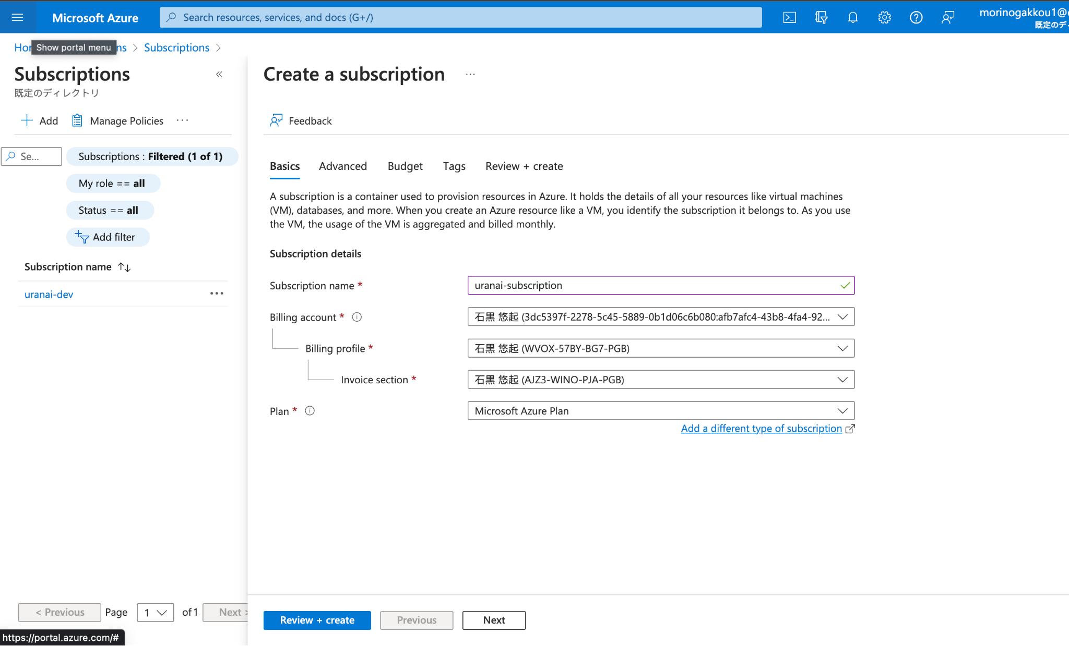

## 3. Create resource group

- Create resource group

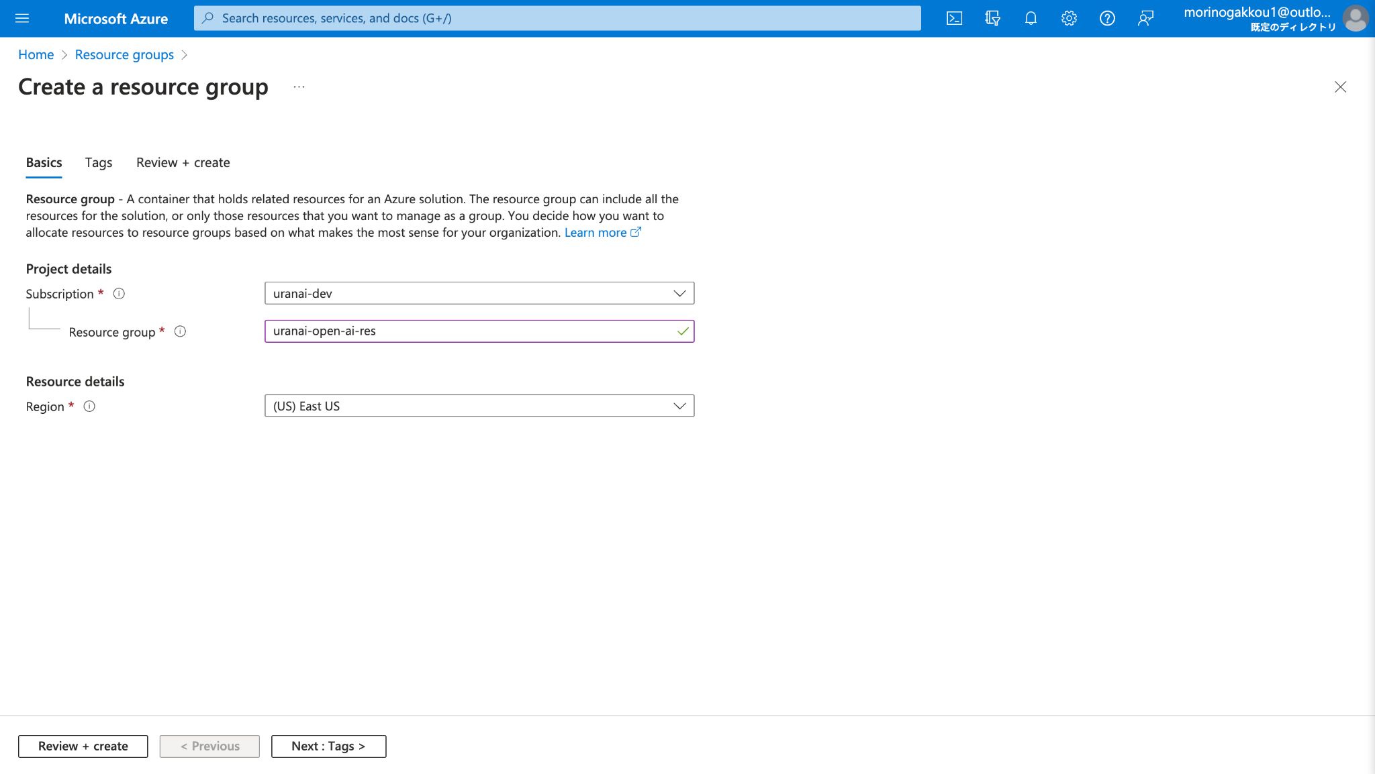

- Create open ai service :

1. Sign in with your Azure subscription in the Azure portal.　[Link](https://learn.microsoft.com/en-us/azure/ai-services/openai/how-to/create-resource?pivots=web-portal)

2. Select Create a resource and search for the Azure OpenAI Service. When you locate the service, select Create.

3. On the Create Azure OpenAI page, provide the following information for the fields on the Basics tab

After creating the resource group, Azure will automatically generate 2 API keys (only need to get 1 or 2 to call the API) and endpoint.

### 3.1 Create and deploy an Azure OpenAI Service resource - Basics:

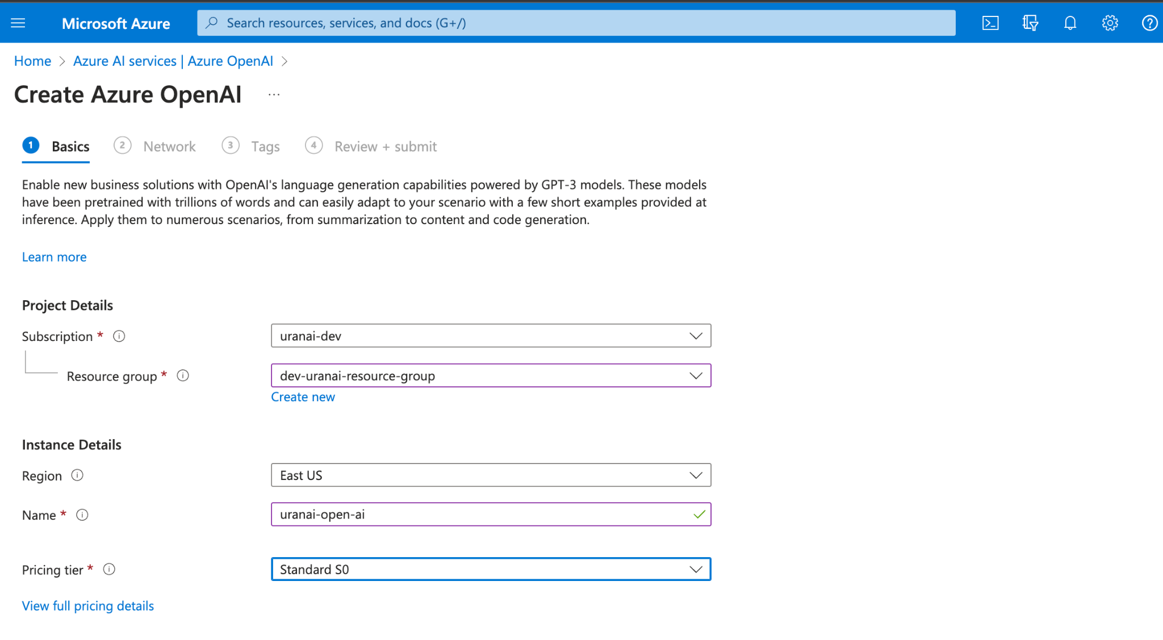

### 3.2 Configure network security (Security)：

Option 1: All networks, including the internet, can access this resource.

Option 2: Selected networks, configure network security for your Azure AI services resource.

Option 3: Disabled, no networks can access this resource. You could configure private endpoint connections that will be the exclusive way to access this resource.

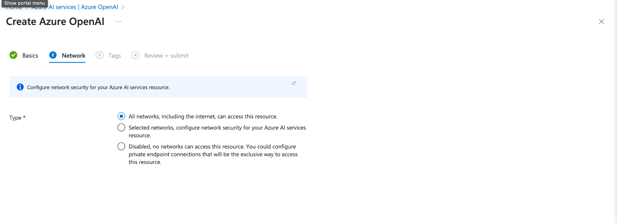

* If Select option 1 from the 3 options above. When call Azure API, Use Endpoint, Manage keys and Deployment name to create security.　＜現在＞

Access the [link](https://portal.azure.com/#@morinogakkou1outlook.onmicrosoft.com/resource/subscriptions/8652ced7-2684-4399-b338-5d3bd8b877ec/resourceGroups/dev-uranai-resource-group/providers/Microsoft.CognitiveServices/accounts/dev-uranai-ca-openai/overview) to review Endpoints and Manage keys

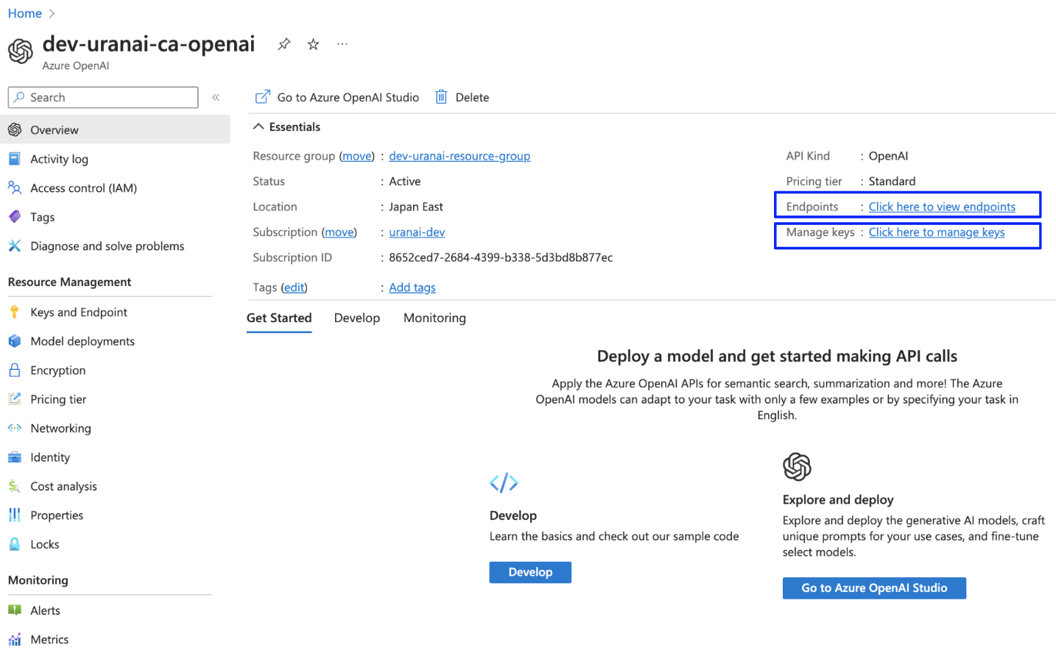

Access the [link](https://oai.azure.com/portal/e2c8eecd95ad4db1aad1eab6f8940d41/deployment/dev-uranai-cd-gpt-35-turbo-16k?tenantid=1a8707fc-5e36-4f34-a916-57a64b2d095f) to review Deployment name

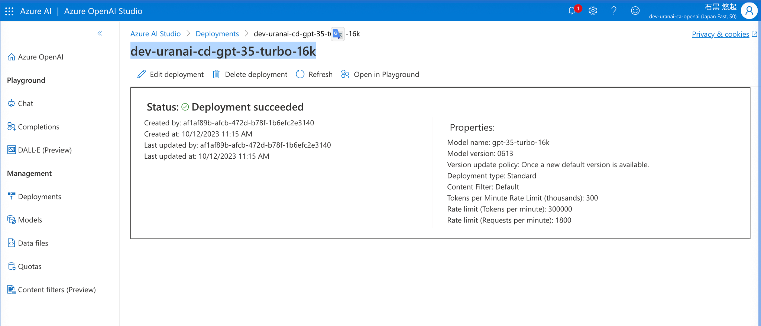

* If select option 2 from the 3 options above. Selected networks, configure network security for your Azure AI services resource)

1. Go to the Azure AI services resource you want to secure.
2. Select Resource Management to expand it, then select Networking.
3. Confirm that you selected Selected Networks and Private Endpoints.
4. Under Firewalls and virtual networks, locate the Address range option. To grant access to an internet IP range, enter the IP address or address range (in [CIDR format](https://tools.ietf.org/html/rfc4632)). Only valid public IP (nonreserved) addresses are accepted.

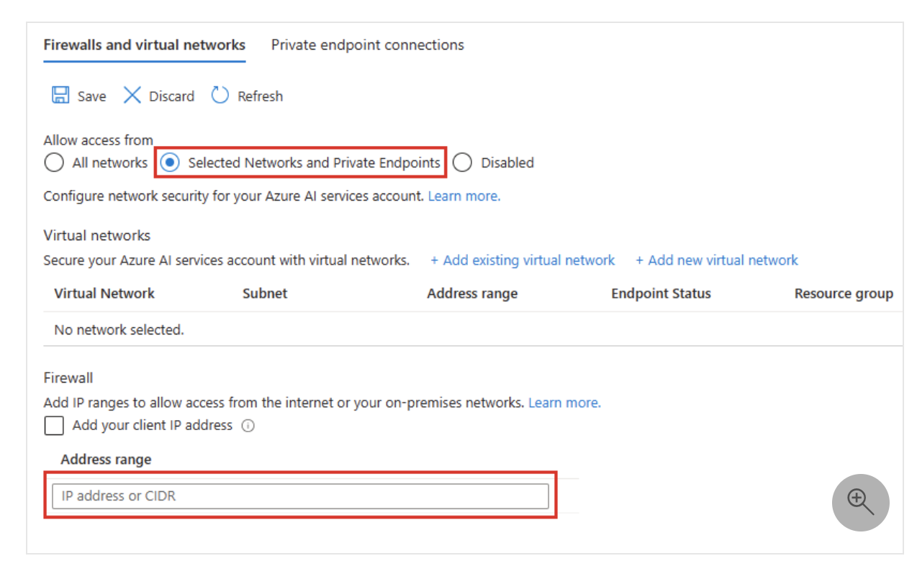

To remove an IP network rule, select the trash can 🗑 icon next to the address range.

1. Select Save to apply your changes. (this take about 3 minutes to take effect)

[Link - **Managing IP network rules**](https://learn.microsoft.com/en-us/azure/ai-services/cognitive-services-virtual-networks?context=%2Fazure%2Fcognitive-services%2Fopenai%2Fcontext%2Fcontext&tabs=portal#managing-ip-network-rules)

**アスミル Case:**

1.Access the link below:

[アスミルのAzure](https://portal.azure.com/#@morinogakkou1outlook.onmicrosoft.com/resource/subscriptions/8652ced7-2684-4399-b338-5d3bd8b877ec/resourceGroups/dev-uranai-resource-group/providers/Microsoft.CognitiveServices/accounts/dev-uranai-ca-openai/accessControl)

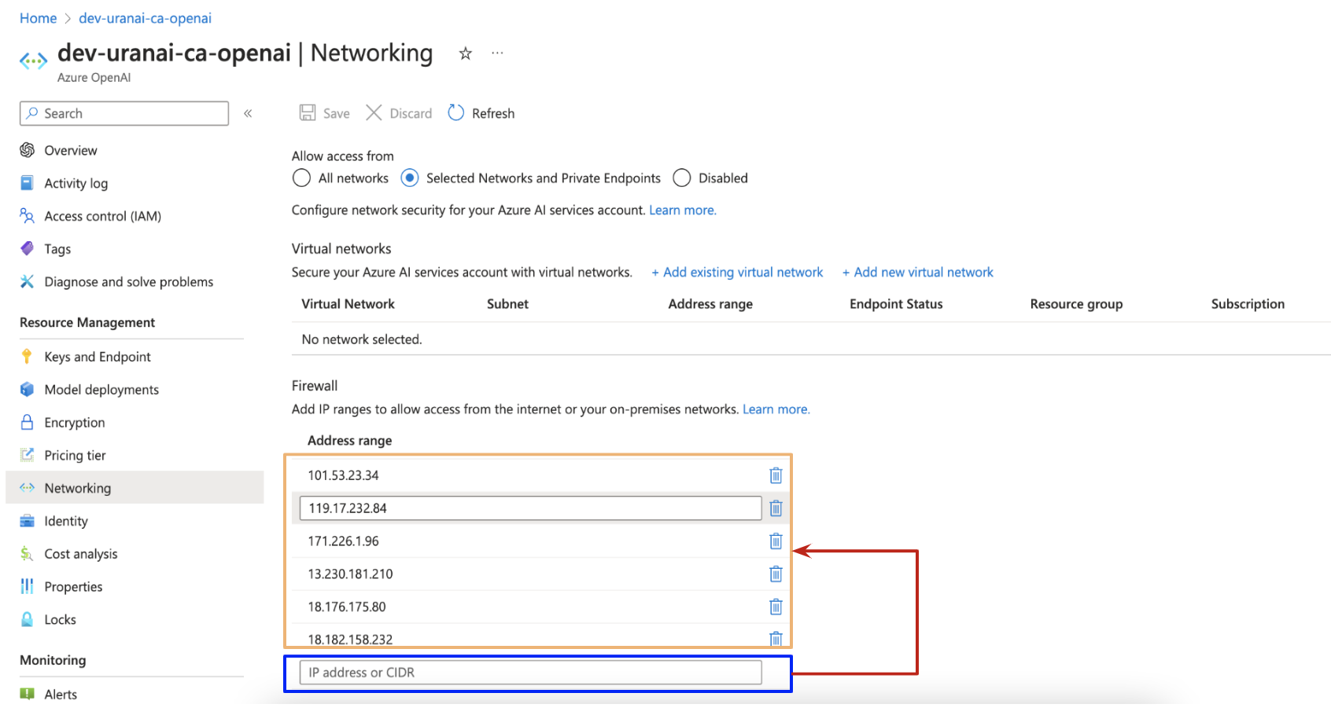

List IP access of Asumiru app:

| Local | 101.53.23.34  119.17.232.84 |
| --- | --- |
| Server- DEV | 13.230.181.210  18.176.175.80  18.182.158.232 |
| Server - PROD |  |

## 4. Create deploy model

1. Sign in to Azure OpenAI Studio.

2. Choose the subscription and the Azure OpenAI resource to work with, and select Use resource.

3. Under Management select Deployments.

4. Select Create new deployment and configure.

5. Select Create.

[Link](https://learn.microsoft.com/en-us/azure/ai-services/openai/how-to/create-resource?pivots=web-portal)

<https://oai.azure.com/portal>

- Create model :

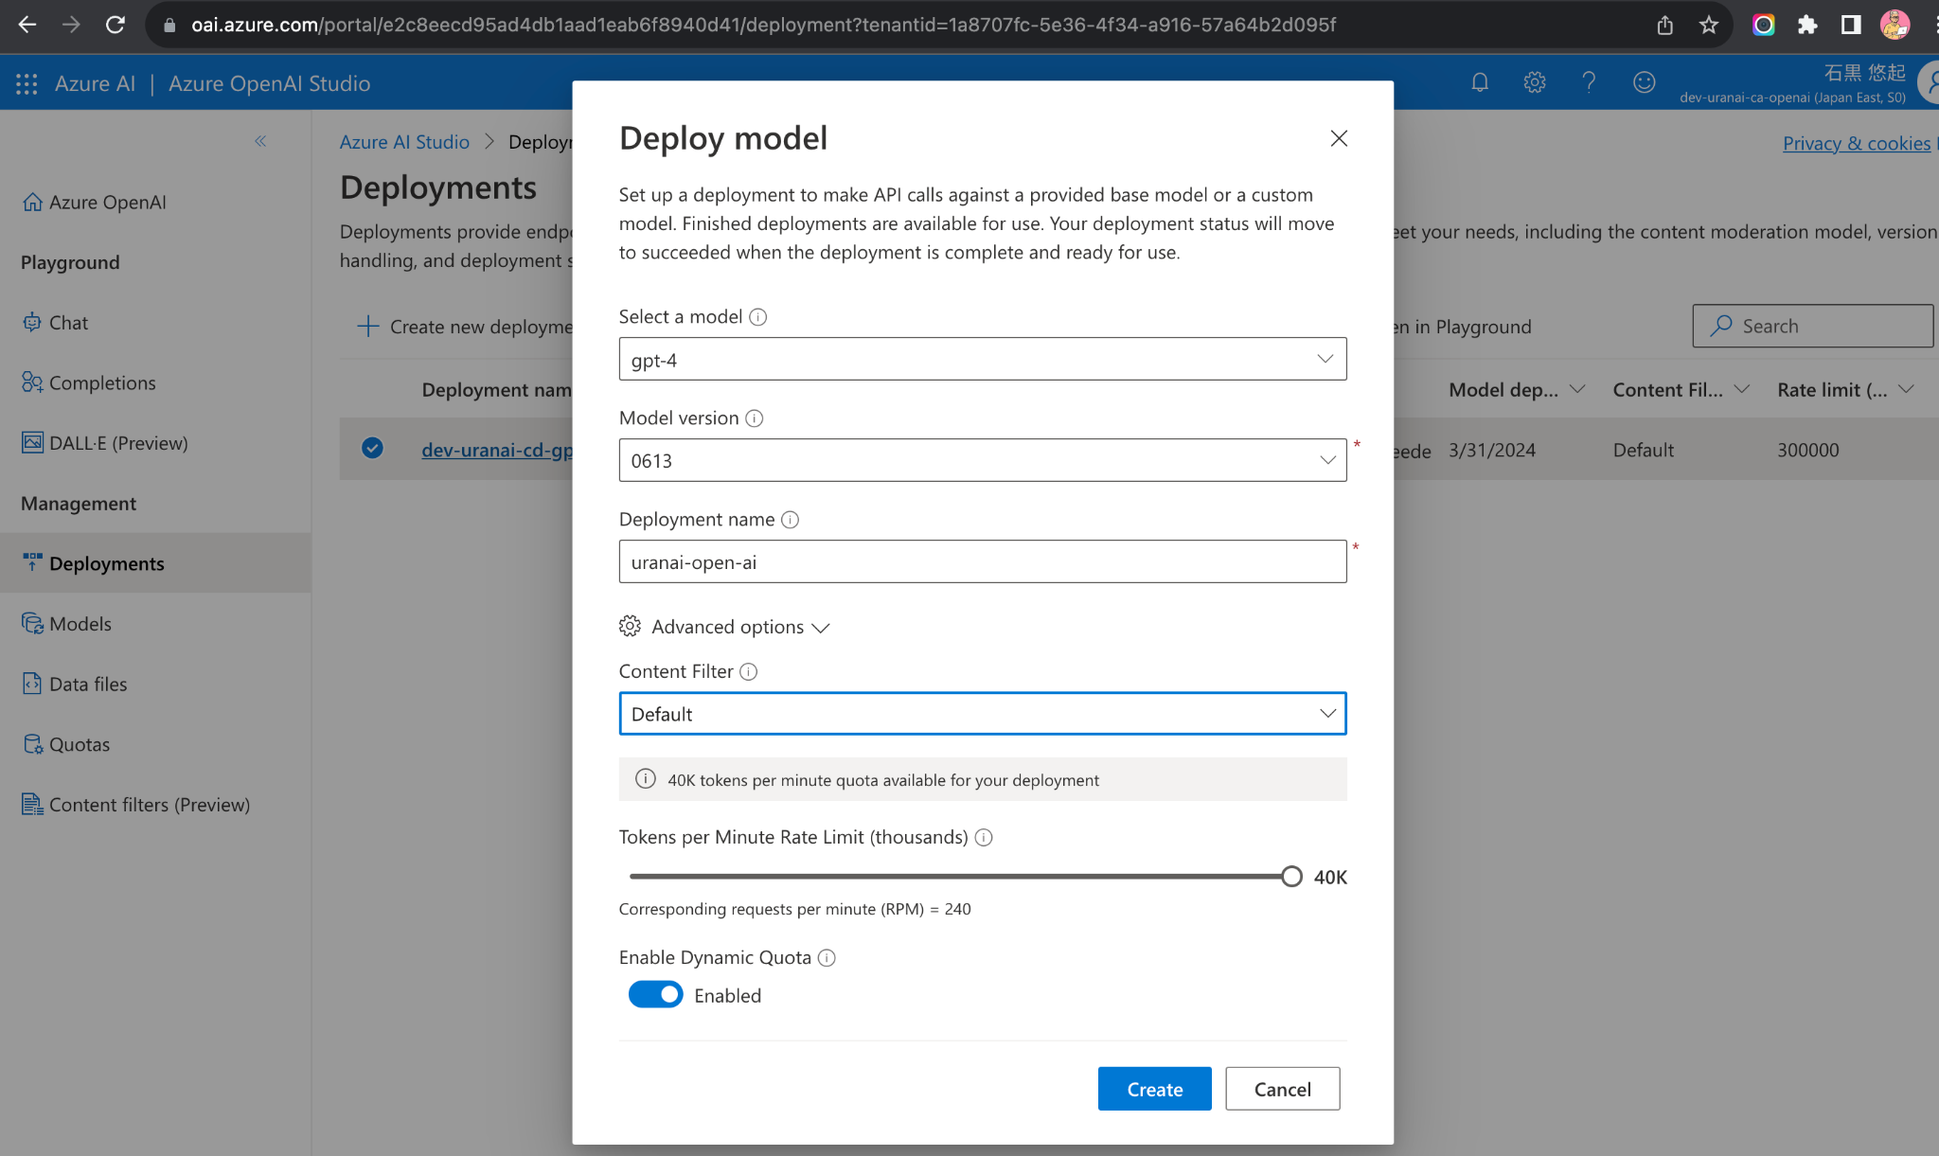

## 5. Package [BE- Nodejs]

<https://www.npmjs.com/package/@azure/openai>

- Endpoints

- Manage keys

- Deployment name

## 6. ( AI chat ) Azure OpenAI x AWS Architecture

