1150070007-Nguyễn Hoàng Duy-Lab 3

Bài làm

Bước 1:Tạo một lớp Databasehelper.java cung cấp truy cập SQLite Database 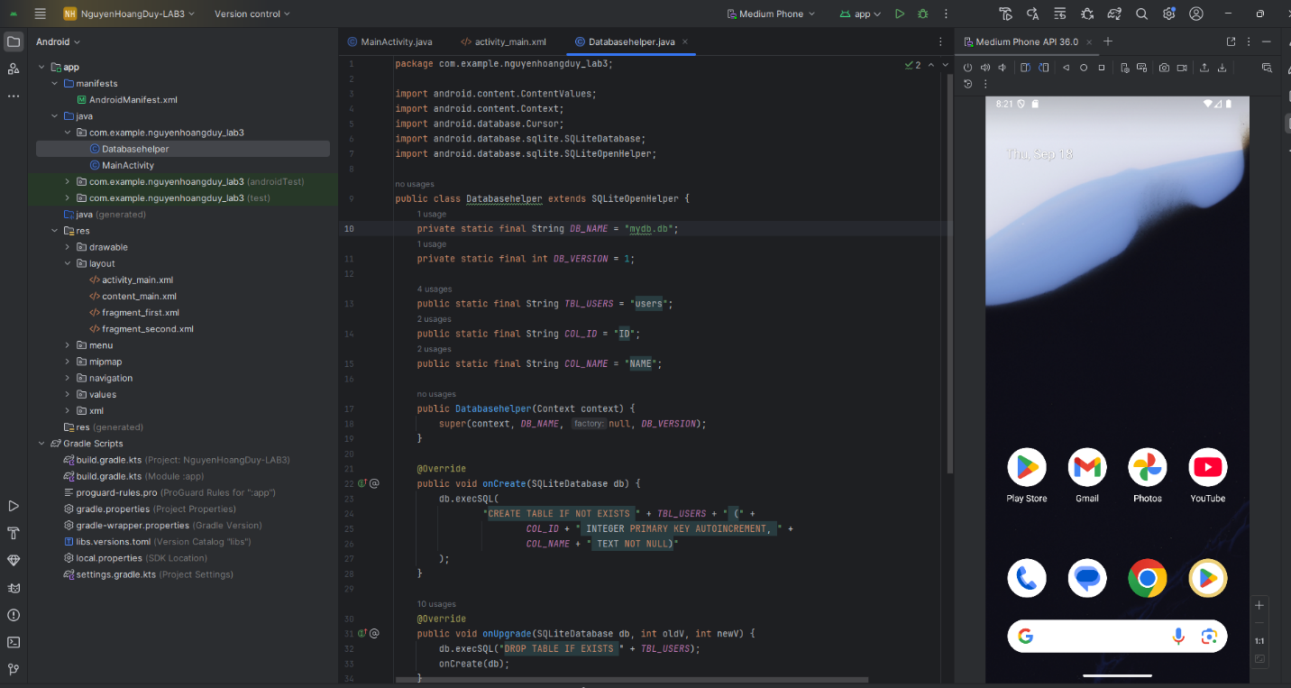

package com.example.nguyenhoangduy_lab3;  
  
import android.content.ContentValues;  
import android.content.Context;  
import android.database.Cursor;  
import android.database.sqlite.SQLiteDatabase;  
import android.database.sqlite.SQLiteOpenHelper;  
  
public class Databasehelper extends SQLiteOpenHelper {  
 private static final String *DB_NAME* = "mydb.db";  
 private static final int *DB_VERSION* = 1;  
  
 public static final String *TBL_USERS* = "users";  
 public static final String *COL_ID* = "ID";  
 public static final String *COL_NAME* = "NAME";  
  
 public Databasehelper(Context context) {  
 super(context, *DB_NAME*, null, *DB_VERSION*);  
 }  
  
 @Override  
 public void onCreate(SQLiteDatabase db) {  
 db.execSQL(  
 "CREATE TABLE IF NOT EXISTS " + *TBL_USERS* + " (" +  
 *COL_ID* + " INTEGER PRIMARY KEY AUTOINCREMENT, " +  
 *COL_NAME* + " TEXT NOT NULL)"  
 );  
 }  
  
 @Override  
 public void onUpgrade(SQLiteDatabase db, int oldV, int newV) {  
 db.execSQL("DROP TABLE IF EXISTS " + *TBL_USERS*);  
 onCreate(db);  
 }  
  
 public boolean insertUser(String name) {  
 SQLiteDatabase db = getWritableDatabase();  
 ContentValues cv = new ContentValues();  
 cv.put(*COL_NAME*, name);  
 return db.insert(*TBL_USERS*, null, cv) != -1;  
 }  
  
 public Cursor getAllUsers() {  
 SQLiteDatabase db = getReadableDatabase();  
 return db.rawQuery("SELECT * FROM " + *TBL_USERS* + " ORDER BY " + *COL_ID* + " DESC", null);  
 }  
}

Bước 2: Trong mainactivity.xml tạo giao diện cho layout giao diện chính

<?xml version="1.0" encoding="utf-8"?>  
<LinearLayout xmlns:android="http://schemas.android.com/apk/res/android"  
 android:orientation="vertical"  
 android:padding="16dp"  
 android:layout_width="match_parent"  
 android:layout_height="match_parent">  
  
 <!-- Nhập tên và nút thêm/refresh -->  
 <LinearLayout  
 android:orientation="horizontal"  
 android:layout_width="match_parent"  
 android:layout_height="wrap_content">  
  
 <EditText  
 android:id="@+id/edtName"  
 android:hint="Nhập tên..."  
 android:layout_weight="1"  
 android:layout_width="0dp"  
 android:layout_height="wrap_content"/>  
  
 <Button  
 android:id="@+id/btnAdd"  
 android:text="Thêm"  
 android:layout_marginStart="8dp"  
 android:layout_width="wrap_content"  
 android:layout_height="wrap_content"/>  
  
 <Button  
 android:id="@+id/btnRefresh"  
 android:text="Làm mới"  
 android:layout_marginStart="8dp"  
 android:layout_width="wrap_content"  
 android:layout_height="wrap_content"/>  
 </LinearLayout>  
  
 <!-- Bảng dữ liệu: đặt trong ScrollView để cuộn -->  
 <ScrollView  
 android:layout_width="match_parent"  
 android:layout_height="0dp"  
 android:layout_weight="1"  
 android:fillViewport="true"  
 android:layout_marginTop="12dp">  
  
 <TableLayout  
 android:id="@+id/tableUsers"  
 android:stretchColumns="0,1"  
 android:layout_width="match_parent"  
 android:layout_height="wrap_content">  
  
 <!-- Header -->  
 <TableRow  
 android:background="#EEEEEE"  
 android:padding="8dp">  
  
 <TextView  
 android:text="ID"  
 android:textStyle="bold"  
 android:padding="4dp"  
 android:layout_width="wrap_content"  
 android:layout_height="wrap_content"/>  
  
 <TextView  
 android:text="NAME"  
 android:textStyle="bold"  
 android:padding="4dp"  
 android:layout_width="wrap_content"  
 android:layout_height="wrap_content"/>  
 </TableRow>  
  
 <!-- Dòng dữ liệu sẽ được thêm bằng code -->  
 </TableLayout>  
 </ScrollView>  
</LinearLayout>

Bước 3: File MainActivity.java để tạo màn hình chính của ứng dụng, nơi bạn viết code điều khiển giao diện (XML) và gọi hàm xử lý dữ liệu SQLite

package com.example.nguyenhoangduy_lab3;  
  
import androidx.appcompat.app.AppCompatActivity;  
  
import android.database.Cursor;  
import android.os.Bundle;  
import android.text.TextUtils;  
import android.view.Gravity;  
import android.view.ViewGroup;  
import android.widget.Button;  
import android.widget.EditText;  
import android.widget.TableLayout;  
import android.widget.TableRow;  
import android.widget.TextView;  
import android.widget.Toast;  
  
public class MainActivity extends AppCompatActivity {  
 private Databasehelper db;  
 private TableLayout table;  
 private EditText edtName;  
 private Button btnAdd, btnRefresh;  
  
 @Override  
 protected void onCreate(Bundle savedInstanceState) {  
 super.onCreate(savedInstanceState);  
 setContentView(R.layout.*activity_main*);  
  
 db = new Databasehelper(this);  
  
 table = findViewById(R.id.*tableUsers*);  
 edtName = findViewById(R.id.*edtName*);  
 btnAdd = findViewById(R.id.*btnAdd*);  
 btnRefresh = findViewById(R.id.*btnRefresh*);  
  
 // Tải dữ liệu vào bảng khi mở app  
 loadTable();  
  
 btnAdd.setOnClickListener(v -> {  
 String name = edtName.getText().toString().trim();  
 if (TextUtils.*isEmpty*(name)) {  
 Toast.*makeText*(this, "Nhập tên !", Toast.*LENGTH_SHORT*).show();  
 return;  
 }  
 if (db.insertUser(name)) {  
 Toast.*makeText*(this, "Đã thêm!", Toast.*LENGTH_SHORT*).show();  
 edtName.setText("");  
 loadTable();  
 } else {  
 Toast.*makeText*(this, "Thêm thất bại!", Toast.*LENGTH_SHORT*).show();  
 }  
 });  
  
 btnRefresh.setOnClickListener(v -> loadTable());  
 }  
  
 private void loadTable() {  
 // Xóa các dòng cũ nhưng giữ lại header (index 0)  
 int childCount = table.getChildCount();  
 if (childCount > 1) {  
 table.removeViews(1, childCount - 1);  
 }  
  
 Cursor c = db.getAllUsers();  
 if (c == null) return;  
  
 while (c.moveToNext()) {  
 int id = c.getInt(c.getColumnIndexOrThrow(Databasehelper.*COL_ID*));  
 String name = c.getString(c.getColumnIndexOrThrow(Databasehelper.*COL_NAME*));  
 addRow(String.*valueOf*(id), name);  
 }  
 c.close();  
 }  
  
 private void addRow(String id, String name) {  
 TableRow row = new TableRow(this);  
 row.setLayoutParams(new TableRow.LayoutParams(  
 ViewGroup.LayoutParams.*MATCH_PARENT*,  
 ViewGroup.LayoutParams.*WRAP_CONTENT*));  
 row.setPadding(8, 8, 8, 8);  
  
 TextView tvId = makeCell(id, true);  
 TextView tvName = makeCell(name, false);  
  
 row.addView(tvId);  
 row.addView(tvName);  
  
 // viền mỏng mỗi hàng (tuỳ thích)  
 row.setBackgroundColor(0xFFEFEFEF);  
 TableRow spacer = new TableRow(this);  
 spacer.setLayoutParams(new TableRow.LayoutParams(  
 ViewGroup.LayoutParams.*MATCH_PARENT*, 1));  
 spacer.setBackgroundColor(0xFFCCCCCC);  
  
 table.addView(row);  
 table.addView(spacer);  
 }  
  
 private TextView makeCell(String text, boolean center) {  
 TextView tv = new TextView(this);  
 tv.setText(text);  
 tv.setPadding(8, 8, 8, 8);  
 tv.setLayoutParams(new TableRow.LayoutParams(  
 0, ViewGroup.LayoutParams.*WRAP_CONTENT*, 1f));  
 tv.setGravity(center ? Gravity.*CENTER* : Gravity.*START*);  
 return tv;  
 }  
}

