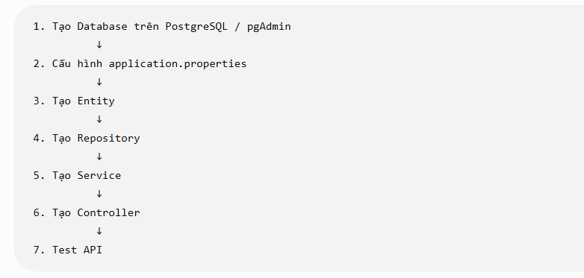
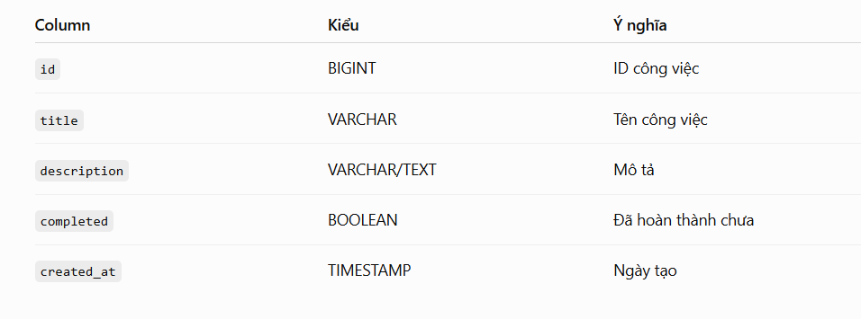
CREATE TABLE todos(
todo_id BIGSERIAL PRIMARY KEY,
title VARCHAR(255) NOT NULL,
description VARCHAR(255),
completed BOOLEAN NOT NULL DEFAULT FALSE,
created_at TIMESTAMP DEFAULT CURRENT_TIMESTAMP
updated_at TIMESTAMP DEFAULT CURRENT_TIMESTAMP
);
