Tên: Võ Tiến Dũng
MSV: 4551050033

Lab 4. Sử dụng mẫu thiết kế cho Hệ thống phân phối tin tức trực tuyến (Online News Distribution Platform)

Sơ đồ
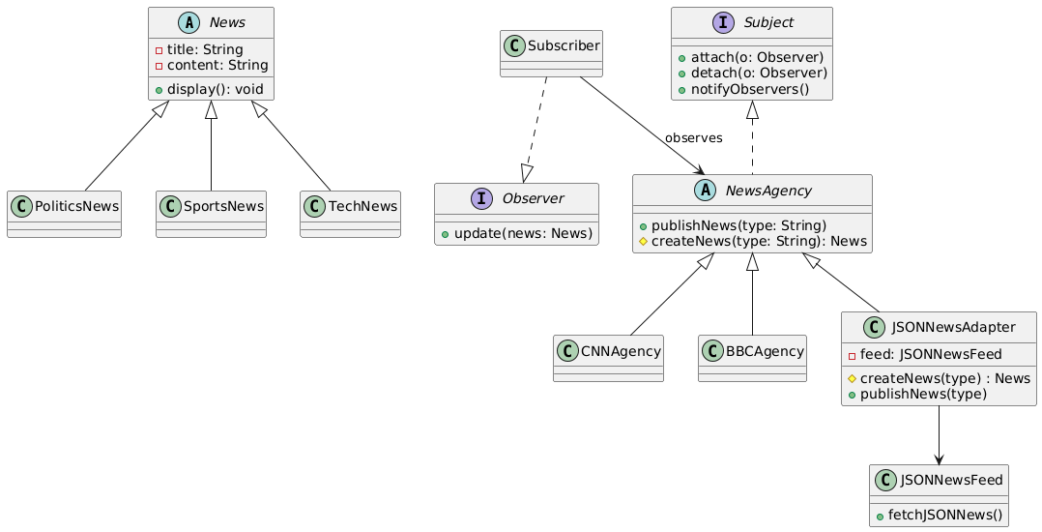

Script PlantUML
@startuml
' ===== Product hierarchy (Factory Method products) =====
abstract class News {
-title: String
-content: String
+display(): void
}

class PoliticsNews
class SportsNews
class TechNews

' ===== Concrete Observer =====
class Subscriber

interface Observer {
+update(news: News)
}

interface Subject {
+attach(o: Observer)
+detach(o: Observer)
+notifyObservers()

}

abstract class NewsAgency {
+publishNews(type: String)
#createNews(type: String): News
}

class CNNAgency extends NewsAgency
class BBCAgency extends NewsAgency

class JSONNewsAdapter {
-feed: JSONNewsFeed
#createNews(type) : News
+publishNews(type)
}

class JSONNewsFeed {
+fetchJSONNews()
}

' ===== Relationships (clean) =====
Subscriber --> NewsAgency : observes
Subscriber ..|> Observer
Subject <|.. NewsAgency
News <|-- PoliticsNews
News <|-- SportsNews
News <|-- TechNews

' Adapter
JSONNewsAdapter --> JSONNewsFeed
NewsAgency <|-- JSONNewsAdapter
@enduml

