**ĐẠI HỌC QUỐC GIA TP. HỒ CHÍ MINH**

TRƯỜNG ĐẠI HỌC BÁCH KHOA

KHOA ĐIỆN – ĐIỆN TỬ

**BỘ MÔN ĐIỆN TỬ**

---------------o0o---------------



**BÀI TẬP LỚN MÔN THIẾT KẾ VI MẠCH NÂNG CAO**

**LAB 5**

**VERILOG LANGUAGE**

**Họ và Tên: Tiến Hoàng Trí Nghĩa**

**MSHV: 1870048**

**TP. HỒ CHÍ MINH, THÁNG 12 NĂM 2018**

**MỤC LỤC**

1. Exercise 1 4

1.1 Requirement 4

1.2 Source code 5

1.3 Simulation 9

2. Exercise 2 10

2.1 Requirement - Develop the following hardware with Verilog HDL 10

2.2 Source code 10

2.3 Simulation 16

3. Exercise 3 16

3.1 Requirement - Develop the following hardware with Verilog HDL 16

3.2 Source code 16

3.3 Simulation 19

4. Exercise 4 19

4.1 Requirement - Develop the following hardware (4 bits addition) with Verilog HDL 19

4.2 Source code 19

4.3 Simulation 22

5. Exercise 5 22

5.1 Requirement - Develop the following hardware (4 bits multiplier) with Verilog HDL 22

5.2 Source code 22

5.3 Simulation 25

6. Exercise 6 25

6.1 Requirement - Develop the following hardware (Simple state machine) with Verilog HDL 25

6.2 Source code 25

6.3 Simulation 28

7. Exercise 7 29

7.1 Requirement - Develop the following hardware (4 bits addition) with Verilog HDL 29

7.2 Source code 29

7.3 Simulation 32

# Exercise 1

## Requirement

* Develop the following hardware (for every figure) with Verilog HDL.

1. 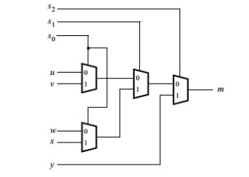
2. 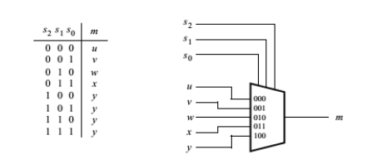
3. 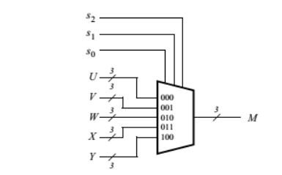

## Source code

**File ex01.v**

module ex01_a(s, u, v, w, x, y, m);

parameter MUX_WIDTH = 3;

input [MUX_WIDTH-1:0] s;

input u;

input v;

input w;

input x;

input y;

output m;

wire uv;

wire wx;

wire uvwx_s1;

assign uv = s[0] ? v : u ;

assign wx = s[0] ? x : w ;

assign uvwx_s1 = s[1] ? wx : uv ;

assign m = s[2] ? y : uvwx_s1 ;

endmodule

module ex01_b(s, u, v, w, x, y, m);

parameter MUX_WIDTH = 3;

parameter DATA_WIDTH = 1;

input [MUX_WIDTH-1:0] s;

input [DATA_WIDTH-1:0] u;

input [DATA_WIDTH-1:0] v;

input [DATA_WIDTH-1:0] w;

input [DATA_WIDTH-1:0] x;

input [DATA_WIDTH-1:0] y;

output [DATA_WIDTH-1:0] m;

reg [DATA_WIDTH-1:0] m;

always @(*)

begin

case(s)

3'b000: begin

m = u;

end

3'b001: begin

m = v;

end

3'b010: begin

m = w;

end

3'b011: begin

m = x;

end

default: begin

m = y;

end

endcase

end

endmodule

module ex01_c(s, u, v, w, x, y, m);

parameter MUX_WIDTH = 3;

parameter DATA_WIDTH = 3;

input [MUX_WIDTH-1:0] s;

input [DATA_WIDTH-1:0] u;

input [DATA_WIDTH-1:0] v;

input [DATA_WIDTH-1:0] w;

input [DATA_WIDTH-1:0] x;

input [DATA_WIDTH-1:0] y;

output [DATA_WIDTH-1:0] m;

reg [DATA_WIDTH-1:0] m;

always @(*)

begin

case(s)

3'b000: begin

m = u;

end

3'b001: begin

m = v;

end

3'b010: begin

m = w;

end

3'b011: begin

m = x;

end

default: begin

m = y;

end

endcase

end

endmodule

## Simulation a) Techbench File t_ex01.v

`timescale 1ns/1ns

module t_ex01;

wire [2:0] s;

wire u;

wire v;

wire w;

wire x;

wire y;

wire m_a;

wire m_b;

wire [2:0] m_c;

wire [2:0] u_c;

wire [2:0] v_c;

wire [2:0] w_c;

wire [2:0] x_c;

wire [2:0] y_c;

reg [2:0] t_s;

reg [6:0] t_data;

assign s = t_s;

assign u = t_data[0];

assign v = t_data[1];

assign w = t_data[2];

assign x = t_data[3];

assign y = t_data[4];

assign u_c = t_data[2:0];

assign v_c = t_data[3:1];

assign w_c = t_data[4:2];

assign x_c = t_data[5:3];

assign y_c = t_data[6:4];

ex01_a ex01_a_01 (.s(s), .u(u), .v(v), .w(w), .x(x), .y(y), .m(m_a));

ex01_b #(.DATA_WIDTH(1))

ex01_b_01 (.s(s), .u(u), .v(v), .w(w), .x(x), .y(y), .m(m_b));

ex01_c #(.DATA_WIDTH(3))

ex01_c_01 (.s(s), .u(u_c), .v(v_c), .w(w_c), .x(x_c), .y(y_c), .m(m_c));

initial begin

# 10 t_s = 3'b000;

t_data = 7'b0000000;

# 10 t_data = 7'b0000001;

# 10 t_data = 7'b1110001;

# 10

# 10 t_s = 3'b001;

t_data = 7'b0000000;

# 10 t_data = 7'b0000010;

# 10 t_data = 7'b1100011;

# 10 t_s = 3'b010;

t_data = 7'b0000000;

# 10 t_data = 7'b0000011;

# 10 t_data = 7'b1000111;

# 10 t_s = 3'b011;

t_data = 7'b0000000;

# 10 t_data = 7'b0000100;

# 10 t_data = 7'b0001111;

# 10 t_s = 3'b100;

t_data = 7'b0000000;

# 10 t_data = 7'b0000101;

# 10 t_data = 7'b0011110;

# 10 t_s = 3'b101;

t_data = 7'b0000000;

# 10 t_data = 7'b0000110;

# 10 t_data = 7'b0111100;

# 10 t_s = 3'b110;

t_data = 7'b0000000;

# 10 t_data = 7'b0000111;

# 10 t_data = 7'b1111000;

# 10 t_s = 3'b111;

t_data = 7'b0000000;

# 10 t_data = 7'b0000001;

# 10 t_data = 7'b1110001;

# 20 $finish;

end

initial begin

$vcdplusfile ("Ex01_Waveform.vpd");

$vcdpluson();

end

endmodule  
  
**b) Waveform**

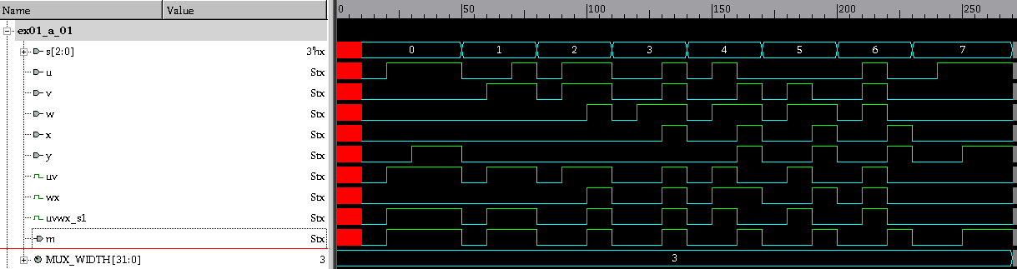**ex01_a waveform**

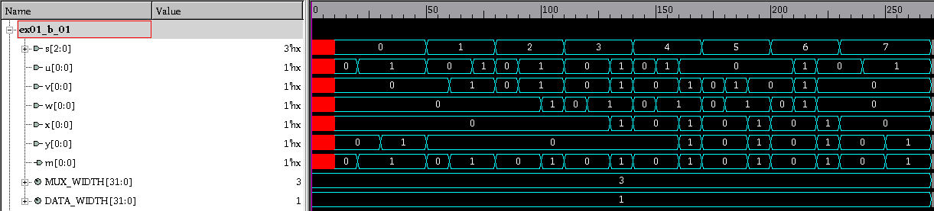**ex01_b waveform**

**ex01_c waveform**

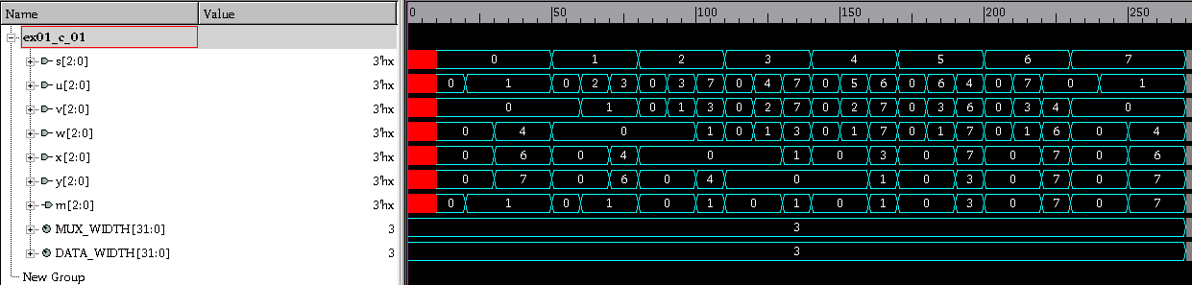

## Đánh giá kết quả

# Exercise 2

## Requirement - Develop the following hardware with Verilog HDL

## Source code

**File ex02.v**

module ex02 (s, u, v, w, x, y, clk, led7_out);

parameter MUX_WIDTH = 3;

parameter DATA_WIDTH = 3;

input [MUX_WIDTH-1:0] s;

input [DATA_WIDTH-1:0] u;

input [DATA_WIDTH-1:0] v;

input [DATA_WIDTH-1:0] w;

input [DATA_WIDTH-1:0] x;

input [DATA_WIDTH-1:0] y;

input clk;

output [6:0] led7_out;

wire [DATA_WIDTH-1:0] m;

wire [DATA_WIDTH-1:0] led7_in;

mux_5 #(.DATA_WIDTH(3))

mux_5_01 (.s(s), .u(u), .v(v), .w(w), .x(x), .y(y), .m(m));

signal signal (.clk(clk), .d(m), .qa(led7_in));

led7_segment_decoder led7_segment_decoder (.in(led7_in), .out(led7_out));

endmodule

module signal (clk, d, qa);

input clk;

input [2:0] d;

output [2:0] qa;

reg [2:0] qa;

initial

begin

qa = 3'b000;

end

always @(posedge clk)

begin

qa <= d;

end

endmodule

module mux_5 (s, u, v, w, x, y, m);

parameter MUX_WIDTH = 3;

parameter DATA_WIDTH = 3;

input [MUX_WIDTH-1 :0] s;

input [DATA_WIDTH-1:0] u;

input [DATA_WIDTH-1:0] v;

input [DATA_WIDTH-1:0] w;

input [DATA_WIDTH-1:0] x;

input [DATA_WIDTH-1:0] y;

output [DATA_WIDTH-1:0] m;

reg [DATA_WIDTH-1:0] m;

always @(*)

begin

case(s)

3'b000: begin

m <= u;

end

3'b001: begin

m <= v;

end

3'b010: begin

m <= w;

end

3'b011: begin

m <= x;

end

default: begin

m <= y;

end

endcase

end

endmodule

module led7_segment_decoder (in , out);

input [2:0]in;

output [6:0]out;

reg [6:0]out;

always @(*)

begin

case(in)

3'b000: begin

out = 7'b0111111;

end

3'b001: begin

out = 7'b0000110;

end

3'b010: begin

out = 7'b1011011;

end

3'b011: begin

out = 7'b1001111;

end

3'b100: begin

out = 7'b1100110;

end

3'b101: begin

out = 7'b1101101;

end

3'b110: begin

out = 7'b1111101;

end

3'b111: begin

out = 7'b0000111;

end

default: begin

out = 7'b0000000;

end

endcase

end

endmodule

## 2.3 Simulation a) Techbench File t_ex02.v

`timescale 1ns/1ns

module t_ex02;

wire [2:0] s;

wire [2:0] u;

wire [2:0] v;

wire [2:0] w;

wire [2:0] x;

wire [2:0] y;

wire [6:0] led;

reg [2:0] t_s;

reg [2:0] t_data;

reg t_clk;

assign s = t_s;

assign u = t_data;

assign v = t_data;

assign w = t_data;

assign x = t_data;

assign y = t_data;

always begin

#0 t_clk = 0;

#10 t_clk = 1;

#10;

end

ex02 ex02 (.s(s), .u(u), .v(v), .w(w), .x(x), .y(y), .clk(t_clk), .led7_out(led));

initial begin

# 20 t_s = 3'b000;

t_data = 3'b000;

# 20 t_data = 3'b001;

# 20 t_data = 3'b010;

# 20 t_s = 3'b001;

t_data = 3'b011;

# 20 t_data = 3'b100;

# 20 t_data = 3'b101;

# 20 t_s = 3'b010;

t_data = 3'b110;

# 20 t_data = 3'b111;

# 20 t_data = 3'b000;

# 20 t_s = 3'b011;

t_data = 3'b001;

# 20 t_data = 3'b010;

# 20 t_data = 3'b011;

# 20 t_s = 3'b100;

t_data = 3'b100;

# 20 t_data = 3'b101;

# 20 t_data = 3'b110;

# 20 t_s = 3'b101;

t_data = 3'b111;

# 20 t_data = 3'b000;

# 20 t_data = 3'b001;

# 20 t_s = 3'b110;

t_data = 3'b010;

# 20 t_data = 3'b011;

# 20 t_data = 3'b100;

# 20 t_s = 3'b111;

t_data = 3'b101;

# 20 t_data = 3'b110;

# 20 t_data = 3'b111;

# 40 $finish;

end

initial begin

$vcdplusfile ("Ex2_WaveForm.vpd");

$vcdpluson();

end

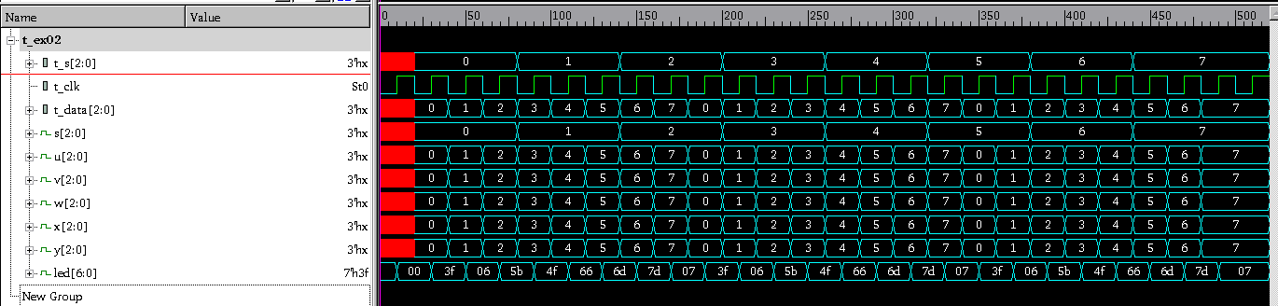endmodule  
  
**b) Waveform  
ex02 waveform**

## Đánh giá kết quả

# Exercise 3

## Requirement - Develop the following hardware with Verilog HDL

## Source code

**File ex03.v**

module ex03 (ena, clk, rst_n, trigger);

input clk;

input rst_n;

input ena;

output trigger;

wire [3:0] w_ena;

wire [3:0] w_q;

assign w_ena[0] = ena;

d_ff d_ff_01(.clk(clk), .rst_n(rst_n), .d(w_ena[0]), .q(w_q[0]) );

assign w_ena[1] = w_ena[0] && w_q[0];

d_ff d_ff_02(.clk(clk), .rst_n(rst_n), .d(w_ena[1]), .q(w_q[1]) );

assign w_ena[2] = w_ena[1] && w_q[1];

d_ff d_ff_03(.clk(clk), .rst_n(rst_n), .d(w_ena[2]), .q(w_q[2]) );

assign w_ena[3] = w_ena[2] && w_q[2];

d_ff d_ff_04(.clk(clk), .rst_n(rst_n), .d(w_ena[3]), .q(w_q[3]) );

assign trigger = w_q[3];

endmodule

module d_ff (clk, rst_n, d, q);

input clk;

input rst_n;

input d;

output q;

reg q;

always @(posedge clk or negedge rst_n)

begin

if (!rst_n) begin

q <= 0;

end

else begin

q <= d;

end

end

endmodule

## Simulation a) Techbench File t_ex03.v

`timescale 1ns/1ns

module t_ex03;

reg t_clk;

reg t_rst_n;

reg t_ena;

wire t_trigger;

always begin

#0 t_clk = 0;

#10 t_clk = 1;

#10;

end

ex03 ex03_01(.clk(t_clk), .rst_n(t_rst_n), .ena(t_ena), .trigger(t_trigger));

initial begin

#0 t_rst_n = 0;

t_ena = 0;

#20 t_rst_n = 1;

t_ena = 0;

#20 t_ena = 1;

#200 t_rst_n = 0;

#20 t_rst_n = 1;

#20 t_ena = 0;

#20 t_ena = 1;

#180 t_ena = 0;

#20 t_ena = 1;

#160 t_ena = 0;

#20 t_ena = 1;

#140 t_ena = 0;

#20 t_ena = 1;

#120 t_ena = 0;

#20 t_ena = 1;

#100 t_ena = 0;

#20 t_ena = 1;

#80 t_ena = 0;

#20 t_ena = 1;

#60 t_ena = 0;

#20 t_ena = 1;

#40 t_ena = 0;

#20 t_ena = 1;

#20 t_ena = 0;

#20 t_rst_n = 0;

t_ena = 0;

#20 t_rst_n = 1;

t_ena = 0;

#20 $finish;

end

initial begin

$vcdplusfile ("Ex3_WaveForm.vpd");

$vcdpluson();

end

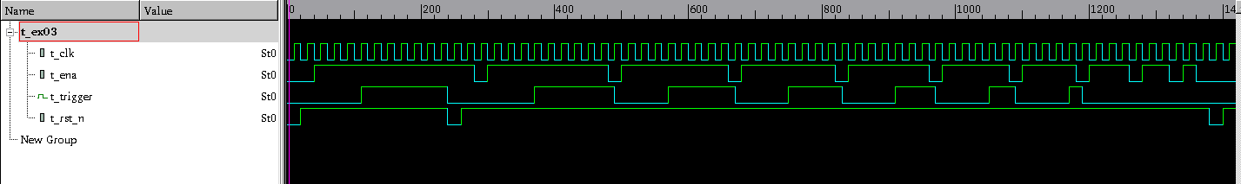endmodule  
  
**b) Waveform  
ex03 waveform**

## Đánh giá kết quả

# Exercise 4

## Requirement - Develop the following hardware (4 bits addition) with Verilog HDL

## Source code

**File ex04.v**

module ex04 (a, b, cin, s, cout);

input [3:0] a;

input [3:0] b;

input cin;

output [3:0] s;

output cout;

wire [4:0] c;

assign c[0] = cin;

f_adder f_adder_01(.a(a[0]), .b(b[0]), .c_in(c[0]), .s(s[0]), .c_out(c[1]));

f_adder f_adder_02(.a(a[1]), .b(b[1]), .c_in(c[1]), .s(s[1]), .c_out(c[2]));

f_adder f_adder_03(.a(a[2]), .b(b[2]), .c_in(c[2]), .s(s[2]), .c_out(c[3]));

f_adder f_adder_04(.a(a[3]), .b(b[3]), .c_in(c[3]), .s(s[3]), .c_out(c[4]));

assign cout = c[4];

endmodule

module f_adder(a, b, c_in, s, c_out);

input a;

input b;

input c_in;

output s;

output c_out;

assign s = a ^ b ^ c_in;

assign c_out = (a & b)|(b & c_in)|(a & c_in);

endmodule

## Simulation a) Techbench File t_ex04.v

`timescale 1ns/1ns

module t_ex04;

reg [3:0] a;

reg [3:0] b;

reg cin;

wire [3:0] s;

wire cout;

ex04 ex04_01(.a(a), .b(b), .cin(cin), .s(s), .cout(cout));

initial begin

#0 cin = 0;

a = 0;

b = 0;

#20 a = 1;

b = 0;

#20 a = 0;

b = 1;

#20 a = 1;

b = 1;

#20 a = 1;

b = 2;

#20 a = 3;

b = 4;

#20 a = 5;

b = 6;

#20 a = 7;

b = 8;

#20 a = 9;

b = 10;

#20 a = 11;

b = 12;

#20 a = 13;

b = 14;

#20 a = 15;

b = 15;

#20 cin = 1;

a = 0;

b = 0;

#20 a = 1;

b = 0;

#20 a = 0;

b = 1;

#20 a = 1;

b = 1;

#20 a = 1;

b = 2;

#20 a = 3;

b = 4;

#20 a = 5;

b = 6;

#20 a = 7;

b = 8;

#20 a = 9;

b = 10;

#20 a = 11;

b = 12;

#20 a = 13;

b = 14;

#20 a = 15;

b = 15;

#20 $finish;

end

initial begin

$vcdplusfile ("Ex4_Waveform.vpd");

$vcdpluson();

end

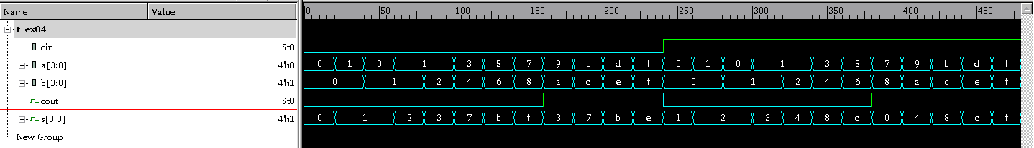endmodule  
  
**b) Waveform  
ex04 waveform**

## Đánh giá kết quả

# Exercise 5

## Requirement - Develop the following hardware (4 bits multiplier) with Verilog HDL

## Source code

**File ex05.v**

module ex05 (m, q, p);

input [3:0] m;

input [3:0] q;

output [7:0] p;

wire [4:0]c_in[0:4];

wire [4:0]m_in[0:4];

assign m_in[0][4:0] = 5'b00000;

assign c_in[0][0] = 1'b0;

m_adder m_adder_01(.a(m[0]), .b(q[0]), .m_in(m_in[0][1]), .c_in(c_in[0][0]), .m_out(m_in[1][0]), .c_out(c_in[0][1]));

m_adder m_adder_02(.a(m[0]), .b(q[1]), .m_in(m_in[0][2]), .c_in(c_in[0][1]), .m_out(m_in[1][1]), .c_out(c_in[0][2]));

m_adder m_adder_03(.a(m[0]), .b(q[2]), .m_in(m_in[0][3]), .c_in(c_in[0][2]), .m_out(m_in[1][2]), .c_out(c_in[0][3]));

m_adder m_adder_04(.a(m[0]), .b(q[3]), .m_in(m_in[0][4]), .c_in(c_in[0][3]), .m_out(m_in[1][3]), .c_out(c_in[0][4]));

assign m_in[1][4] = c_in[0][4];

assign p[0] = m_in[1][0];

assign c_in[1][0] = 1'b0;

m_adder m_adder_05(.a(m[1]), .b(q[0]), .m_in(m_in[1][1]), .c_in(c_in[1][0]), .m_out(m_in[2][0]), .c_out(c_in[1][1]));

m_adder m_adder_06(.a(m[1]), .b(q[1]), .m_in(m_in[1][2]), .c_in(c_in[1][1]), .m_out(m_in[2][1]), .c_out(c_in[1][2]));

m_adder m_adder_07(.a(m[1]), .b(q[2]), .m_in(m_in[1][3]), .c_in(c_in[1][2]), .m_out(m_in[2][2]), .c_out(c_in[1][3]));

m_adder m_adder_08(.a(m[1]), .b(q[3]), .m_in(m_in[1][4]), .c_in(c_in[1][3]), .m_out(m_in[2][3]), .c_out(c_in[1][4]));

assign m_in[2][4] = c_in[1][4];

assign p[1] = m_in[2][0];

assign c_in[2][0] = 1'b0;

m_adder m_adder_09(.a(m[2]), .b(q[0]), .m_in(m_in[2][1]), .c_in(c_in[2][0]), .m_out(m_in[3][0]), .c_out(c_in[2][1]));

m_adder m_adder_10(.a(m[2]), .b(q[1]), .m_in(m_in[2][2]), .c_in(c_in[2][1]), .m_out(m_in[3][1]), .c_out(c_in[2][2]));

m_adder m_adder_11(.a(m[2]), .b(q[2]), .m_in(m_in[2][3]), .c_in(c_in[2][2]), .m_out(m_in[3][2]), .c_out(c_in[2][3]));

m_adder m_adder_12(.a(m[2]), .b(q[3]), .m_in(m_in[2][4]), .c_in(c_in[2][3]), .m_out(m_in[3][3]), .c_out(c_in[2][4]));

assign m_in[3][4] = c_in[2][4];

assign p[2] = m_in[3][0];

assign c_in[3][0] = 1'b0;

m_adder m_adder_13(.a(m[3]), .b(q[0]), .m_in(m_in[3][1]), .c_in(c_in[3][0]), .m_out(m_in[4][0]), .c_out(c_in[3][1]));

m_adder m_adder_14(.a(m[3]), .b(q[1]), .m_in(m_in[3][2]), .c_in(c_in[3][1]), .m_out(m_in[4][1]), .c_out(c_in[3][2]));

m_adder m_adder_15(.a(m[3]), .b(q[2]), .m_in(m_in[3][3]), .c_in(c_in[3][2]), .m_out(m_in[4][2]), .c_out(c_in[3][3]));

m_adder m_adder_16(.a(m[3]), .b(q[3]), .m_in(m_in[3][4]), .c_in(c_in[3][3]), .m_out(m_in[4][3]), .c_out(c_in[3][4]));

assign m_in[4][4] = c_in[3][4];

assign p[3] = m_in[4][0];

assign p[4] = m_in[4][1];

assign p[5] = m_in[4][2];

assign p[6] = m_in[4][3];

assign p[7] = m_in[4][4];

endmodule

module m_adder(a, b, m_in, c_in, m_out, c_out);

input a;

input b;

input m_in;

input c_in;

output m_out;

output c_out;

wire c;

assign c = a & b;

assign m_out = c ^ m_in ^ c_in;

assign c_out = (c & m_in)|(m_in & c_in)|(c_in & c);

endmodule

## Simulation a) Techbench File t_ex05.v

`timescale 1ns/1ns

module t_ex05;

reg [3:0] a;

reg [3:0] b;

wire [7:0] p;

ex05 ex05_01(.m(a), .q(b), .p(p));

initial begin

#0 a = 0;

b = 0;

#50 a = 1;

b = 0;

#50 a = 2;

b = 6;

#50 a = 1;

b = 8;

#50 a = 1;

b = 1;

#50 a = 7;

b = 2;

#50 a = 4;

b = 5;

#50 a = 1;

b = 8;

#50 a = 3;

b = 6;

#50 a = 8;

b = 7;

#50 a = 8;

b = 8;

#50 a = 10;

b = 7;

#50 a = 11;

b = 9;

#50 a = 14;

b = 10;

#50 a = 15;

b = 0;

#50 a = 4;

b = 11;

#50 a = 15;

b = 15;

#50 $finish;

end

initial begin

$vcdplusfile ("Ex5_Waveform.vpd");

$vcdpluson();

end

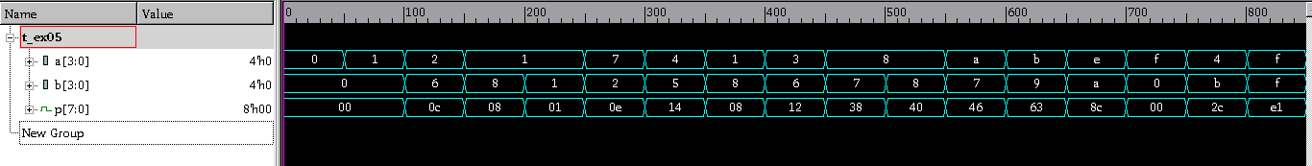endmodule  
  
**b) Waveform  
ex05 waveform**

## Đánh giá kết quả

# Exercise 6

## Requirement - Develop the following hardware (Simple state machine) with Verilog HDL

## Source code

**File ex06.v**

module ex06 (clk, rst_n, w, out);

input clk;

input rst_n;

input w;

output out;

parameter ST_A = 2'b00;

parameter ST_B = 2'b01;

parameter ST_C = 2'b10;

parameter ST_F = 2'b11;

reg out;

reg [1:0] next_state;

reg [1:0] state;

always @(posedge clk or negedge rst_n) begin

if (!rst_n) begin

state <= ST_A;

end

else begin

if(state != next_state) begin

state <= next_state;

end

end

end

always @(*) begin

case (state)

ST_A: begin

next_state = w ? ST_F : ST_B;

end

ST_B: begin

next_state = w ? ST_F : ST_C;

end

ST_C: begin

next_state = w ? ST_F : ST_C;

end

ST_F: begin

next_state = w ? ST_F : ST_B;

end

default: begin

next_state = ST_A;

end

endcase

end

reg [7:0] STATE_CHAR;

always @*begin

case(state)

ST_A: begin

STATE_CHAR = "A";

end

ST_B: begin

STATE_CHAR = "B";

end

ST_C: begin

STATE_CHAR = "C";

end

ST_F: begin

STATE_CHAR = "F";

end

default: begin

STATE_CHAR = "X";

end

endcase

end

always @(*) begin

case (state)

ST_C, ST_F: begin

out = 1'b1;

end

default: begin

out = 1'b0;

end

endcase

end

endmodule

## Simulation a) Techbench File t_ex06.v

`timescale 1ns/1ns

module t_ex06;

reg t_clk;

reg t_rst_n;

reg t_w;

wire t_out;

always begin

#0 t_clk = 0;

#10 t_clk = 1;

#10;

end

ex06 ex06(.clk(t_clk), .rst_n(t_rst_n), .w(t_w), .out(t_out));

initial begin

#0 t_rst_n = 0;

t_w = 0; // ST_A

#20 t_rst_n = 1;

t_w = 0; // ST_B

#20 t_w = 1; // ST_F

#20 t_w = 0; // ST_B

#20 t_w = 0; // ST_C

#20 t_w = 0; // ST_C

#20 t_w = 1; // ST_F

#20 t_rst_n = 0;

t_w = 0; // ST_A -> ST_A

#40 t_rst_n = 1;

t_w = 0; // ST_B -> ST_C

#40 t_w = 1; // ST_F

#20 t_w = 1; // ST_F -> ST_F -> ST_F

#60 t_w = 0; // ST_B

#20 t_w = 0; // ST_C -> ST_C -> ST_C -> ST_C

#80 t_w = 1; // ST_F

#100 $finish;

end

initial begin

$vcdplusfile ("Ex6_Waveform.vpd");

$vcdpluson();

end

endmodule  
  
**b) Waveform  
ex06 waveform**

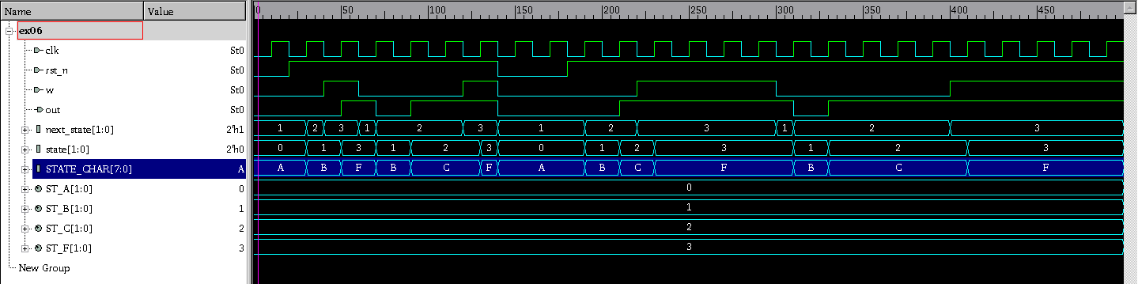

## Đánh giá kết quả

# Exercise 7

## Requirement - Develop the following hardware (Complicated State Machine) with Verilog HDL

## Source code

**File ex07.v**

module ex07 (clk, rst_n, w, out);

input clk;

input rst_n;

input w;

output out;

parameter ST_A = 4'b1111;

parameter ST_B = 4'b0000;

parameter ST_C = 4'b0001;

parameter ST_D = 4'b0010;

parameter ST_E = 4'b0011;

parameter ST_F = 4'b1000;

parameter ST_G = 4'b1001;

parameter ST_H = 4'b1010;

parameter ST_I = 4'b1011;

reg out;

reg [4:0] next_state;

reg [4:0] state;

always @(posedge clk or negedge rst_n) begin

if (!rst_n) begin

state <= ST_A;

end

else begin

if(state!=next_state) begin

state <= next_state;

end

end

end

always @(*) begin

case(state)

ST_A: begin

next_state = w ? ST_F : ST_B;

end

ST_B,ST_C,ST_D: begin

next_state = w ? ST_F : (state + 1'b1);

end

ST_F,ST_G,ST_H: begin

next_state = w ? (state + 1'b1) : ST_B;

end

ST_E: begin

next_state = w ? ST_F : ST_E;

end

ST_I: begin

next_state = w ? ST_I : ST_B;

end

default: begin

next_state = ST_A;

end

endcase

end

reg [7:0] STATE_CHAR;

always@*begin

case(state)

ST_A: begin

STATE_CHAR = "A";

end

ST_B: begin

STATE_CHAR = "B";

end

ST_C: begin

STATE_CHAR = "C";

end

ST_D: begin

STATE_CHAR = "D";

end

ST_E: begin

STATE_CHAR = "E";

end

ST_F: begin

STATE_CHAR = "F";

end

ST_G: begin

STATE_CHAR = "G";

end

ST_H: begin

STATE_CHAR = "SH";

end

ST_I: begin

STATE_CHAR = "I";

end

default: begin

STATE_CHAR = "X";

end

endcase

end

always @(*) begin

case(state)

ST_I,ST_E: begin

out = 1'b1;

end

default: begin

out = 1'b0;

end

endcase

end

endmodule

## Simulation a) Techbench File t_ex07.v

`timescale 1ns/1ns

module t_ex07;

reg t_clk;

reg t_rst_n;

reg t_w;

wire t_out;

always begin

#0 t_clk = 0;

#10 t_clk = 1;

#10;

end

ex07 ex07(.clk(t_clk), .rst_n(t_rst_n), .w(t_w), .out(t_out));

initial begin

#0 t_rst_n = 0;

t_w = 0; // ST_A

#20 t_rst_n = 1;

t_w = 0; // ST_B

#20 t_w = 0; // ST_C

#20 t_w = 1; // ST_F

#20 t_w = 0; // ST_B -> ST_C

#40 t_w = 1; // ST_F

#20 t_w = 0; // ST_B -> ST_C -> ST_D

#60 t_w = 1; // ST_F

#20 t_w = 0; // ST_B -> ST_C -> ST_D -> ST_E

#80 t_w = 0; // ST_E

#20 t_rst_n = 0;

t_w = 1; // ST_A -> ST_A

#40 t_rst_n = 1;

t_w = 1; // ST_F

#20 t_w = 0; // ST_B

#20 t_w = 1; // ST_F -> ST_G

#40 t_w = 0; // ST_B

#20 t_w = 1; // ST_F -> ST_G -> ST_H

#60 t_w = 0; // ST_B

#20 t_w = 1; // ST_F -> ST_G -> ST_H -> ST_I

#80 t_w = 1; // ST_I -> ST_I -> ST_I

#60 $finish;

end

initial begin

$vcdplusfile ("Ex7_Waveform.vpd");

$vcdpluson();

end

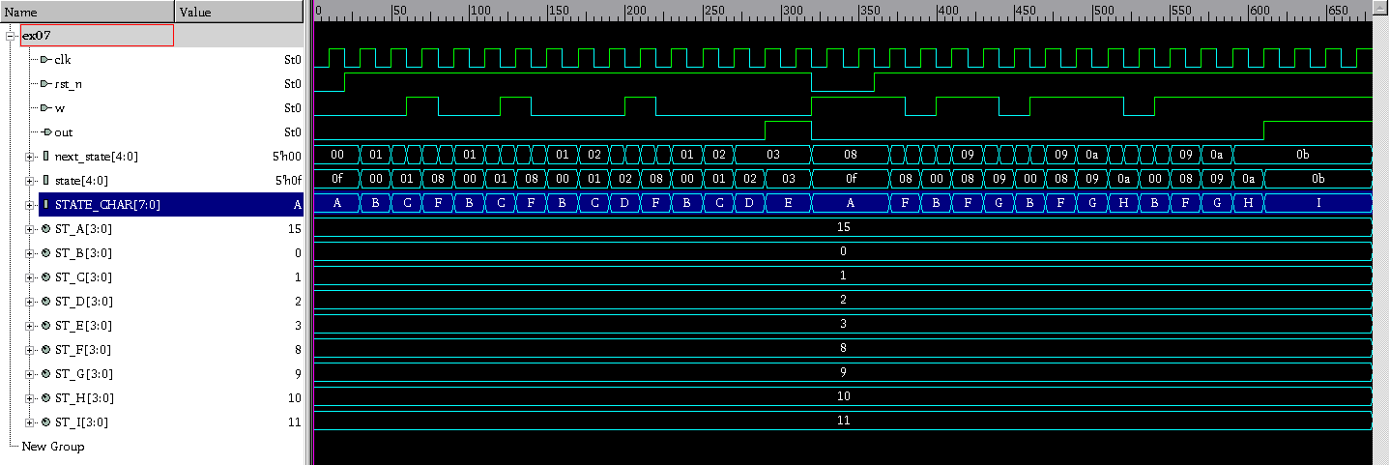endmodule  
  
**b) Waveform  
ex07 waveform**

## Đánh giá kết quả