##### <Customer> View Result Request Office

**Use Case Diagram**

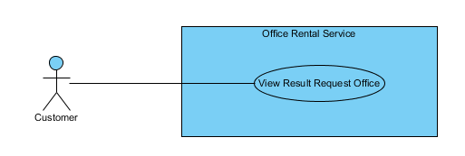

Figure 12: <Customer> View Result Request Office

**Use Case Specification**

|  |  |  |  |  |
| --- | --- | --- | --- | --- |
| **USE CASE VIEW RESULT REQUEST OFFICE** | | | | |
| **Use-case No.** | UC025 | **Use-case Version** | | 2.0 |
| **Use-case Name** | View Result Request Office | | | |
| **Author** | Nguyễn Vũ Hoàng Quốc | | | |
| **Date** | 31/05/2015 | **Priority** | Normal | |
| **Actor:**   * Customer   **Summary:**   * This use case allows customer to see all his/her requests office and offices that is suggest for them   **Goal:**   * All request office and suggest office of customer are shown   **Triggers:**   * Click “Yêu cầu văn phòng của bạn” in menu after login.   **Preconditions:**   * Customer must have an available request office.   **Post Conditions:**   * **Success**: All request and office suggest of this customer will be shown. * **Fail:** Cannot load request and office.   **Main Success Scenario:**   |  |  |  | | --- | --- | --- | | Step | Actor Action | System Response | | 1 | Click “Yêu cầu văn phòng của bạn” in menu after login. | Show page display all request and  office includes:   * Details of request: * Loại văn phòng [text] * Diện tích [number] * Giá [number] * Địa chỉ [text] * Ngày tạo [Date] * “Hủy yêu cầu” button * List of office that suitable of the request   [Exception 1], [Exception 2] | |  |  |  |   **Alternative Scenario:**   |  |  |  | | --- | --- | --- | | No. | Actor Action | System Response | |  |  |  |   **Exceptions:**   |  |  |  | | --- | --- | --- | | No. | Actor Action | System Response | | 1 | Cannot get request office | Show error message: “Có lỗi xảy ra, xin thử lại.” | | 2 | Cannot get suggest office | Show error message: “Có lỗi xảy ra, xin thử lại.” |   **Relationships:** RequestOffice  **Business Rules:**   * Customer can see all request office themselves and suggest offices that suitable with their request. * Customer also can remove their request. | | | | |