##### <Manager> View Appointment Request List

**Use Case Diagram**

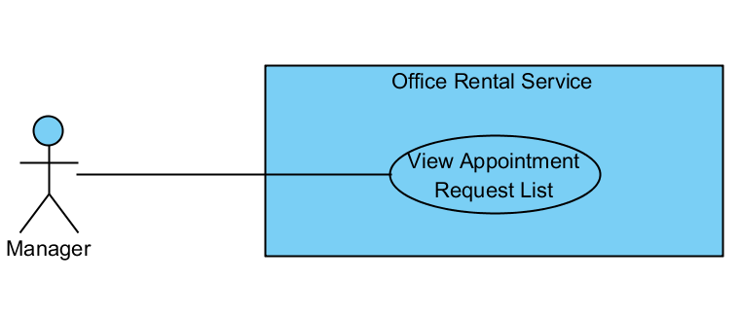

Figure : <Manager> View Appointment Request List

**Use Case Specification**

|  |  |  |  |
| --- | --- | --- | --- |
| **USE CASE VIEW APPOINTMENT REQUEST LIST** | | | |
| **Use Case No.** | UC041 | **Use Case Version** | 1.0 |
| **Use Case Name** | View Appointment Request List | | |
| **Author** | Nguyễn Vũ Hoàng Quốc | | |
| **Date** | 31/05/2015 | **Priority** | Normal |
| **Actor:**   * Manager   **Summary:**   * This use case allows manager see all appointment request   **Goal:**   * Show all appointment request   **Triggers:**   * From the menu bar on admin page:   + Select “ Lịch hẹn ” menu.   **Preconditions:**   * There are at least request appointment from customer * Requests from customers are valid and send successful   **Post Conditions:**   * **Success:** All appointment request are shown * **Fail:** Cannot get appointment list from database.   **Main Success Scenario:**   |  |  |  | | --- | --- | --- | | Step | Actor Action | System Response | | 1 | Click “Appointment” button from menu bar on admin page | * Show all request appointment list in which includes:   + Khách hàng   + Văn phòng   + Thời gian gặp   + Đề xuất nhân viên   [Exception 1] |   **Alternative Scenario:**   |  |  |  | | --- | --- | --- | | No | Actor Action | System Response | |  | . |  |   **Exceptions:**   |  |  |  | | --- | --- | --- | | No | Actor Action | System Response | | 1 | Cannot load appointment list from database | Display error message: “Cannot get request appointment list. Please try again” |   **Relationships:** Delete Appointment request, Assign Appointment, View Customer Info  **Business Rules:**   * Manager can view all list appointment from customer’s request. * On list appointment system will suggest staff suitable. | | | |

##### <Manager> Cancel Appointment request

**Use Case Diagram**

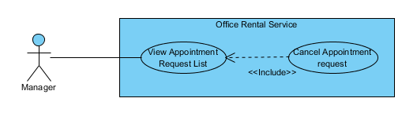

Figure : <Manager> Cancel Appointment request

**Use Case Specification**

|  |  |  |  |
| --- | --- | --- | --- |
| **USE CASE CANCEL APPOINTMENT REQUEST** | | | |
| **Use Case No.** | UC042 | **Use Case Version** | 1.0 |
| **Use Case Name** | Cancel Appointment request | | |
| **Author** | Nguyễn Vũ Hoàng Quốc | | |
| **Date** | 31/05/2015 | **Priority** | Normal |
| **Actor:**   * Manager   **Summary:**   * This use case allows manager cancel appointment request which is not suitable.   **Goal:**   * Cancel appointment request successful * Customer receive SMS with reject message   **Triggers:**   * From the menu bar:   + Select “Lịch hẹn” menu.   + Choose appointment   + Click “Hủy lịch hẹn” button on appointment detail page   **Preconditions:**   * There are request appointment from customer * Requests from customers are valid and send successful * Status of request is ‘Chờ xử lý’ or ‘Chấp nhận’   **Post Conditions:**   * **Success:** Appointment request is cancel successful * **Fail:** Cancel error.   **Main Success Scenario:**   |  |  |  | | --- | --- | --- | | Step | Actor Action | System Response | | 1 | Click “Lịch hẹn” button from menu bar on admin page | * Show all request appointment list   + Khách hàng   + Văn phòng   + Thời gian gặp   + Đề xuất nhân viên   [Exception 1] | | 2 | Choose the appointment in appointment list. | * Show detail of this appointment   + Khách hàng   + Tên văn phòng   + Nhân viên được giao   + Thời gian gặp   + Tình trạng   [Exception 2] | | 3 | Click “Hủy lịch hẹn” button on appointment detail page | * Show popup input comment | | 4 | Input comment and click “Yes” button on warning popup  [Alternative 1] | * Return to appointment list   [Exception 3] |   **Alternative Scenario:**   |  |  |  | | --- | --- | --- | | No | Actor Action | System Response | | 1 | Click “No” button on warning popup | * Close comment popup |   **Exceptions:**   |  |  |  | | --- | --- | --- | | No | Actor Action | System Response | | 1 | Cannot load appointment list from database | Display error message: “Cannot get request appointment list. Please try again” | | 2 | Cannot get detail of chosen appointment from database | Display error message: “Cannot get data this appointment. Please try again” | | 3 | Delete error | Display error message: “Cannot delete this appointment. Please try again” |   **Relationships:** Appointment Request List  **Business Rules:**   * Manager can cancel appointment from customer’s request if there are some error with customer’s error. * When cancel, system will send sms to customer. * Manager only cancel appointment which is have status ‘Chờ xử lý’ or ‘Chấp nhận’ | | | |

##### <Manager> Assign Appointment

**Use Case Diagram**

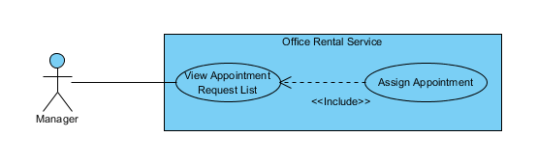

Figure : <Manager> Assign Appointment

**Use Case Specification**

|  |  |  |  |
| --- | --- | --- | --- |
| **USE CASE ASSIGN APPOINTMENT** | | | |
| **Use Case No.** | UC043 | **Use Case Version** | 1.0 |
| **Use Case Name** | Assign Appointment | | |
| **Author** | Nguyễn Vũ Hoàng Quốc | | |
| **Date** | 31/05/2015 | **Priority** | Normal |
| **Actor:**   * Manager   **Summary:**   * This use case allows manager assign appointment request to staff   **Goal:**   * Assign appointment to staff successful   **Triggers:**   * From the menu bar:   + Select “Lịch hẹn” menu.   + Click “Giao việc”   **Preconditions:**   * There are request appointment from customer * Requests from customers are valid and send successful * Manager checked the appointment is suitable   **Post Conditions:**   * **Success:** Appointment request is assign successful * **Fail:** Assign error.   **Main Success Scenario:**   |  |  |  | | --- | --- | --- | | Step | Actor Action | System Response | | 1 | Click “Lịch hẹn” button from menu bar on admin page | * Schedule staff who suitable * Show all request appointment list   + Khách hàng   + Văn phòng   + Thời gian gặp   + Đề xuất nhân viên   [Exception 1] | | 2 | Click “Giao việc” button on each row of appointment | [Exception 2] |   **Alternative Scenario:**   |  |  |  | | --- | --- | --- | | No | Actor Action | System Response | | 1 | Click “close” button on list staff | * Show appointment detail page |     **Exceptions:**   |  |  |  | | --- | --- | --- | | No | Actor Action | System Response | | 1 | Cannot load appointment list from database | Display error message: “Cannot get request appointment list. Please try again” | | 2 | Cannot get detail of chosen appointment from database | Display error message: “Cannot get data this appointment. Please try again” | | 3 | Assign error | Display error message: “Cannot assign this appointment to staff. Please try again” |   **Relationships:** Appointment Request List  **Business Rules:**   * Manager can assign appointment from customer’s request to staff if the request is suitable. * When assign, system will send email to staff’ and add the request to staff’s task list. | | | |

##### <Manager> View Contract List

**Use Case Diagram**

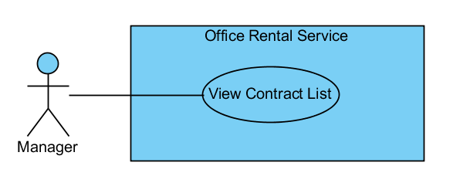

Figure : <Manager> View Contract List

**Use Case Specification**

|  |  |  |  |
| --- | --- | --- | --- |
| **USE CASE VIEW CONTRACT LIST** | | | |
| **Use Case No.** | UC045 | **Use Case Version** | 1.0 |
| **Use Case Name** | View Contract List | | |
| **Author** | Nguyễn Vũ Hoàng Quốc | | |
| **Date** | 31/05/2015 | **Priority** | Normal |
| **Actor:**   * Manager   **Summary:**   * This use case allows manager view contract list   **Goal:**   * Show all contract list   **Triggers:**   * From the menu bar on admin page:   + Click “Lịch hẹn” menu.   **Preconditions:**   * Login as manager role * There is at least one contract create successful   **Post Conditions:**   * **Success:** Show all contracts in database * **Fail:** Cannot get data of the contract in database.   **Main Success Scenario:**   |  |  |  | | --- | --- | --- | | Step | Actor Action | System Response | | 1 | Click “Lịch hẹn” button on menu bar of manager role | * Show all contract in list:   + Khách hàng [text]   + Văn phòng [text]   + Ngày bắt đầu [Date]   + Ngày kết thúc [Date]   + Giá [Number]   + Thời hạn thanh toán [text]   [Exception 1] |   **Alternative Scenario:**   |  |  |  | | --- | --- | --- | | No | Actor Action | System Response | |  |  |  |     **Exceptions:**   |  |  |  | | --- | --- | --- | | No | Actor Action | System Response | | 1 | Cannot load contract list from database | Display error message: “Cannot get contract list. Please try again” |   **Relationships:** Contract  **Business Rules:**   * Only manager can see all contracts in database | | | |

##### <Manager> View Contract Detail

**Use Case Diagram**

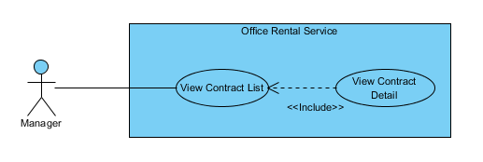

Figure : <Manager> View Contract Detail

**Use Case Specification**

|  |  |  |  |
| --- | --- | --- | --- |
| **USE CASE VIEW CONTRACT DETAIL** | | | |
| **Use Case No.** | UC046 | **Use Case Version** | 1.0 |
| **Use Case Name** | View Contract Detail | | |
| **Author** | Nguyễn Vũ Hoàng Quốc | | |
| **Date** | 31/05/2015 | **Priority** | Normal |
| **Actor:**   * Manager   **Summary:**   * This use case allows manager view contract detail   **Goal:**   * Show contract detail   **Triggers:**   * From the menu bar:   + Select “Lịch hẹn” menu.   + Click button “Thông tin” on each row   **Preconditions:**   * Contract is not out of date   **Post Conditions:**   * **Success:** Show detail of chosen contract * **Fail:** Cannot get data of the contract in database.   **Main Success Scenario:**   |  |  |  | | --- | --- | --- | | Step | Actor Action | System Response | | 1 | Click “Lịch hẹn” button on menu bar of manager role | * Show all contract in list   [Exception 1] | | 2 | Choose contract in contract list and click button “Thông tin” | * Show all detail of the contract includes:   + Khách hàng [text]   + Văn phòng [text]   + Ngày bắt đầu [Date]   + Ngày kết thúc [Date]   + Giá [Number]   + Thời hạn thanh toán [text]   [Exception 2] |   **Alternative Scenario:**   |  |  |  | | --- | --- | --- | | No | Actor Action | System Response | |  |  |  |     **Exceptions:**   |  |  |  | | --- | --- | --- | | No | Actor Action | System Response | | 1 | Cannot load contract list from database | Display error message: “Cannot get contract list. Please try again” | | 2 | Cannot load data of the chosen contract | Display error message: “Cannot get data of this contract. Please try again” |   **Relationships:** Contract  **Business Rules:**   * Manager can see detail of the contract * The contract is still have time if not system will change status of contract in database and send email to customer | | | |

##### <Manager> Create Contract

**Use Case Diagram**

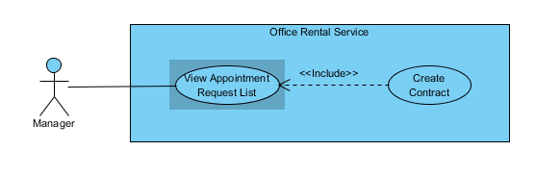

Figure : <Manager> Create Contract

**Use Case Specification**

|  |  |  |  |
| --- | --- | --- | --- |
| **USE CASE CREATE CONTRACT** | | | |
| **Use Case No.** | UC048 | **Use Case Version** | 1.0 |
| **Use Case Name** | Create Contract | | |
| **Author** | Nguyễn Vũ Hoàng Quốc | | |
| **Date** | 31/05/2015 | **Priority** | Normal |
| **Actor:**   * Manager   **Summary:**   * This use case allows manager create contract   **Goal:**   * Contract is create and add to database   **Triggers:**   * From the menu bar:   + Click “Lịch hẹn” on menu.   + On “Chấp nhận” tab click “Đến kí/ hủy hợp đồng”   + Click “Tạo hợp đồng” button   + Click “Tạo mới” button after input information   **Preconditions:**   * Appointment has been accepted by customer and status is accepted   **Post Conditions:**   * **Success:** Contract is saved to database * **Fail:** Create fail   **Main Success Scenario:**   |  |  |  | | --- | --- | --- | | Step | Actor Action | System Response | | 1 | Click “Lịch hẹn” on menu | * Show all appointment list   [Exception 1] | | 2 | On “Chấp nhận” tab click “Đến kí/ hủy hợp đồng” | * Show detail of the appointment   + Khách hàng [text]   + Văn phòng [text]   + Nhân viên được giao [text]   + Thời gian gặp [Date]   + Tình trạng [Text] * Group button:   + Tạo hợp đồng   + Hủy lịch hẹn [Alternative 1]   + Quay về [Alternative 2] | | 3 | Click “Tạo hợp đồng” | * Show input field and detail of contract:   + Khách hàng [text]   + Văn phòng [text]   + Ngày bắt đầu [Date]   + Ngày kết thúc [Date]   + Giá [Number]   + Thời hạn thanh toán [text] * Button “Tạo mới” | | 4 | Input information and click “Tạo mới” button | * Validate input data [Exception 2] * Show successful message [Exception 3] |   **Alternative Scenario:**   |  |  |  | | --- | --- | --- | | No | Actor Action | System Response | | 1 | Click “Hủy lịch hẹn” button | * Show popup input comment and return to appointment list page after manager input comment | | 2 | Click “Quay về” button | * Return to appointment list page |     **Exceptions:**   |  |  |  | | --- | --- | --- | | No | Actor Action | System Response | | 1 | Cannot load contract list from database | Display error message: “Cannot get contract list. Please try again” | | 2 | From date > End Date | Display error message: “From date or end date is invalid. Please check again” | | 3 | Cannot save new contract to database |  |   **Relationships:** Contract  **Business Rules:**   * Manager will meet customer after customer decide to rent office * Manager will create contract after the meeting | | | |

##### <Manager> Edit Contract

**Use Case Diagram**

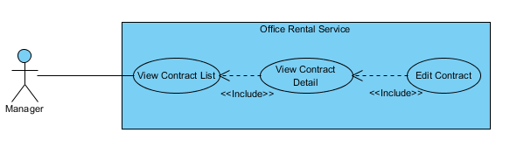

Figure : <Manager> Edit Contract

**Use Case Specification**

|  |  |  |  |
| --- | --- | --- | --- |
| **USE CASE EDIT CONTRACT** | | | |
| **Use Case No.** | UC047 | **Use Case Version** | 1.0 |
| **Use Case Name** | Edit Contract | | |
| **Author** | Nguyễn Vũ Hoàng Quốc | | |
| **Date** | 31/05/2015 | **Priority** | Normal |
| **Actor:**   * Manager   **Summary:**   * This use case allows manager edit contract   **Goal:**   * Contract is edited   **Triggers:**   * Click “Chỉnh sửa” button on contract detail page   **Preconditions:**   * Contract is not out of date   **Post Conditions:**   * **Success:** Edit contract successful * **Fail:** Edit error   **Main Success Scenario:**   |  |  |  | | --- | --- | --- | | Step | Actor Action | System Response | | 1 | Click “thông tin” button on contract list page | * Show all detail of the contract   + Khách hàng [text]   + Văn phòng [text]   + Ngày bắt đầu [Date]   + Ngày kết thúc [Date]   + Giá [Number]   + Thời hạn thanh toán [text]   [Exception 1] | | 2 | Click “Chỉnh sửa” button | * Show field to edit information   + Khách hàng [text]   + Văn phòng [text]   + Ngày bắt đầu [Date]   + Ngày kết thúc [Date]   + Giá [Number]   + Thời hạn thanh toán [text] * Button group:   + Cập nhật   + Hủy [Alternative 1] | | 3 | Edit contract info | * Validate input show error if data invalid   [Exception 2] | | 4 | Click “Cập nhật” button | * Save to database * Return to contract list |   **Alternative Scenario:**   |  |  |  | | --- | --- | --- | | No | Actor Action | System Response | | 1 | Click “Hủy” button | * Return to contract list page |     **Exceptions:**   |  |  |  | | --- | --- | --- | | No | Actor Action | System Response | | 1 | Cannot load contract list from database | Display error message: “Cannot get contract list. Please try again” | | 2 | Cannot load data of the chosen contract | Display error message: “Cannot get data of this contract. Please try again” | | 3 | From date > End Date | Display error message: “From date or end date is invalid. Please check again” |   **Relationships:** Contract  **Business Rules:**   * Manager edit contract when there is error in contract. * Manager only edit contract which is not expired. | | | |

##### <Manager> View Repair Request List

**Use Case Diagram**

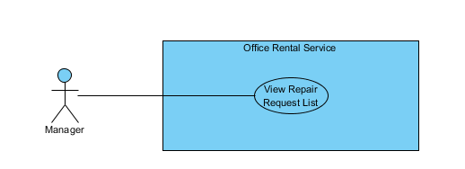

Figure : <Manager> View Repair Request List

**Use Case Specification**

|  |  |  |  |
| --- | --- | --- | --- |
| **USE CASE VIEW REPAIR LIST** | | | |
| **Use Case No.** | UC141 | **Use Case Version** | 1.0 |
| **Use Case Name** | View Repair Request List | | |
| **Author** | Nguyễn Vũ Hoàng Quốc | | |
| **Date** | 31/05/2015 | **Priority** | Normal |
| **Actor:**   * Manager   **Summary:**   * This use case allows manager see all repair requests   **Goal:**   * Show suggest staff and suggest time * Show all repair request   **Triggers:**   * From the menu bar on admin page:   + Select “ Sửa chữa ” on the menu.   **Preconditions:**   * At lease exist one repair request in database   **Post Conditions:**   * **Success:** All request repair are shown * **Fail:** Cannot get repair list from database.   **Main Success Scenario:**   |  |  |  | | --- | --- | --- | | Step | Actor Action | System Response | | 1 | Click “Sửa chữa” button on menu bar of manager role | * Show all repair requests list in which includes:   + Tên văn phòng [text]   + Khách hàng [text]   + Ngày tạo yêu cầu [Date]   + Mô tả [text]   + Đề xuất nhân viên [dropdown list]   + Đề xuât thời gian [Date]   [Exception 1]   * Button group   + Giao việc   + Chi tiết | |  |  |  |   **Alternative Scenario:**   |  |  |  | | --- | --- | --- | | No | Actor Action | System Response | |  | . |  |   **Exceptions:**   |  |  |  | | --- | --- | --- | | No | Actor Action | System Response | | 1 | Cannot load repair request list from database | Display error message: “Không lấy được dữ liệu toàn bộ yêu cầu sửa chữa. Xin vui lòng thử lại” |   **Relationships:** Request repair  **Business Rules:**   * Manager can view all request repair for assigning to staff | | | |

##### <Manager> Assign Repair

**Use Case Diagram**

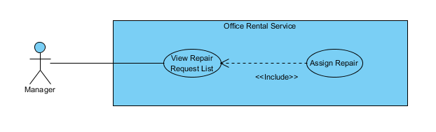

Figure : <Manager> Assign Repair

**Use Case Specification**

|  |  |  |  |
| --- | --- | --- | --- |
| **USE CASE ASSIGN REPAIR** | | | |
| **Use Case No.** | UC141 | **Use Case Version** | 1.0 |
| **Use Case Name** | Assign Repair | | |
| **Author** | Nguyễn Vũ Hoàng Quốc | | |
| **Date** | 31/05/2015 | **Priority** | Normal |
| **Actor:**   * Manager   **Summary:**   * This use case allows manager assign repair to staff   **Goal:**   * Show suggest staff and suggest time * Request is assigned to staff successful   **Triggers:**   * From the menu bar on admin page:   + Select “Sửa chữa ” on the menu.   + Click “Giao việc” button   **Preconditions:**   * At lease exist one repair request in database * At lease exist one staff in database   **Post Conditions:**   * **Success:** Request is assigned to staff successful * **Fail:** Assign failed   **Main Success Scenario:**   |  |  |  | | --- | --- | --- | | Step | Actor Action | System Response | | 1 | Click “Sửa chữa” button on menu bar of manager role | * Show all repair requests list in which includes:   + Tên văn phòng [text]   + Khách hàng [text]   + Ngày tạo yêu cầu [Date]   + Mô tả [text]   + Đề xuất nhân viên [dropdown list]   + Đề xuât thời gian [Date]   [Exception 1]   * Button group   + Giao việc   + Chi tiết | | 2 | Click “Giao việc” button | * Change status of request repair * Change detail of request repair   [Exception 2] |   **Alternative Scenario:**   |  |  |  | | --- | --- | --- | | No | Actor Action | System Response | |  | . |  |   **Exceptions:**   |  |  |  | | --- | --- | --- | | No | Actor Action | System Response | | 1 | Cannot load repair request list from database | Display error message: “Không lấy được dữ liệu toàn bộ yêu cầu sửa chữa. Xin vui lòng thử lại” | | 2 | Cannot assign to staff |  |   **Relationships:** Request repair  **Business Rules:**   * Manager can view staff is suggested for the repair request and can change staff manually | | | |

##### <Manager> Cancel Repair

**Use Case Diagram**

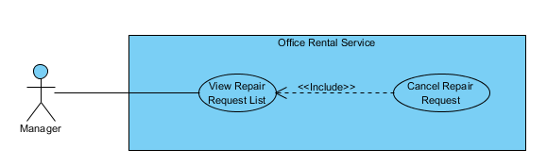

Figure : <Manager> Cancel Repair

**Use Case Specification**

|  |  |  |  |
| --- | --- | --- | --- |
| **USE CASE CANCEL REPAIR** | | | |
| **Use Case No.** | UC141 | **Use Case Version** | 1.0 |
| **Use Case Name** | Cancel Repair | | |
| **Author** | Nguyễn Vũ Hoàng Quốc | | |
| **Date** | 31/05/2015 | **Priority** | Normal |
| **Actor:**   * Manager   **Summary:**   * This use case allows manager cancel repair request   **Goal:**   * The request has been canceled.   **Triggers:**   * From the menu bar on admin page:   + Select “ Sửa chữa ” on the menu.   + Choose one request   + Click “Từ chối sửa chữa” button on repair detail page   **Preconditions:**   * At lease exist one repair request in database * The request status is “Cần giao việc”   **Post Conditions:**   * **Success:** Request is assigned to staff successful * **Fail:** Assign failed   **Main Success Scenario:**   |  |  |  | | --- | --- | --- | | Step | Actor Action | System Response | | 1 | Click “Sửa chữa” button on menu bar of manager role | * Show all repair requests list in which includes:   + Tên văn phòng [text]   + Khách hàng [text]   + Ngày tạo yêu cầu [Date]   + Mô tả [text]   + Đề xuất nhân viên [dropdown list]   + Đề xuât thời gian [Date]   [Exception 1]   * Button group   + Giao việc   + Chi tiết | | 2 | Click “Chi tiết” button | * Show detail of repair request:   + Tên văn phòng [text]   + Khách hàng [text]   + Ngày tạo yêu cầu [Date]   + Mô tả [text]   + Đề xuất nhân viên [dropdown list]   + Đề xuât thời gian [Date] * Button group:   + Giao việc   + Từ chối sửa chữa   + Quay về [Alternative 1] | | 3 | Click “Từ chối sửa chữa” button | * Change status of request repair * Return to request repair list page |   **Alternative Scenario:**   |  |  |  | | --- | --- | --- | | No | Actor Action | System Response | | 1 | Click “Quay về” button | * Return to request repair list page |   **Exceptions:**   |  |  |  | | --- | --- | --- | | No | Actor Action | System Response | | 1 | Cannot load repair request list from database | Display error message: “Không lấy được dữ liệu toàn bộ yêu cầu sửa chữa. Xin vui lòng thử lại” | | 2 | Cannot cancel request |  |   **Relationships:** Request repair  **Business Rules:**   * Manager can cancel request repair if the request has invalid info. | | | |

##### <Manager> View Rental Request List

**Use Case Diagram**

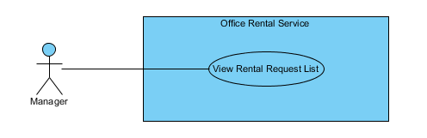

Figure : <Manager> View Rental Request List

**Use Case Specification**

|  |  |  |  |
| --- | --- | --- | --- |
| **USE CASE VIEW RENTAL REQUEST LIST** | | | |
| **Use Case No.** | UC141 | **Use Case Version** | 1.0 |
| **Use Case Name** | View Rental Request List | | |
| **Author** | Nguyễn Vũ Hoàng Quốc | | |
| **Date** | 31/05/2015 | **Priority** | Normal |
| **Actor:**   * Manager   **Summary:**   * This use case allows manager see all rental requests   **Goal:**   * Show suggest staff and suggest time * Show all rental request   **Triggers:**   * From the menu bar on admin page:   + Select “Thuê thiết bị” on the menu.   **Preconditions:**   * At lease exist one rental request in database   **Post Conditions:**   * **Success:** All request rental are shown * **Fail:** Cannot get rental request list from database.   **Main Success Scenario:**   |  |  |  | | --- | --- | --- | | Step | Actor Action | System Response | | 1 | Click “Thuê thiết bị” button on menu of manager role | * Show all rental requests list in which includes:   + Tên văn phòng [text]   + Khách hàng [text]   + Ngày tạo yêu cầu [Date]   + Mô tả [text]   + Đề xuất nhân viên [dropdown list]   + Đề xuât thời gian [Date]   [Exception 1]   * Button group   + Giao việc   + Chi tiết | |  |  |  |   **Alternative Scenario:**   |  |  |  | | --- | --- | --- | | No | Actor Action | System Response | |  | . |  |   **Exceptions:**   |  |  |  | | --- | --- | --- | | No | Actor Action | System Response | | 1 | Cannot load rental request list from database | Display error message: “Không lấy được dữ liệu toàn bộ yêu cầu thuê thiết bị. Xin vui lòng thử lại” |   **Relationships:** Rental, Rental Detail, Rental Item, Rental Status  **Business Rules:**   * Manager can view all request rental for assigning to staff | | | |

##### <Manager> Assign Rental

**Use Case Diagram**

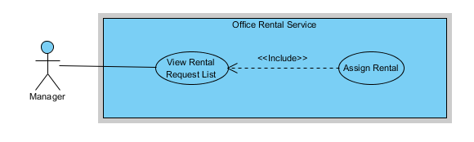

Figure : <Manager> Assign Rental

**Use Case Specification**

|  |  |  |  |
| --- | --- | --- | --- |
| **USE CASE ASSIGN RENTAL** | | | |
| **Use Case No.** | UC141 | **Use Case Version** | 1.0 |
| **Use Case Name** | Assign Rental | | |
| **Author** | Nguyễn Vũ Hoàng Quốc | | |
| **Date** | 31/05/2015 | **Priority** | Normal |
| **Actor:**   * Manager   **Summary:**   * This use case allows manager assign rental request to staff   **Goal:**   * Show suggest staff and suggest time * Request is assigned to staff successful   **Triggers:**   * From the menu bar on admin page:   + Select “Thuê thiết bị ” on the menu.   + Click “Giao việc” button   **Preconditions:**   * At lease exist one rental request in database * At lease exist one staff in database   **Post Conditions:**   * **Success:** Request is assigned to staff successful * **Fail:** Assign failed   **Main Success Scenario:**   |  |  |  | | --- | --- | --- | | Step | Actor Action | System Response | | 1 | Click “Thuê Thiết bị” button on menu bar of manager role | * Show all rental requests list in which includes:   + Tên văn phòng [text]   + Khách hàng [text]   + Ngày tạo yêu cầu [Date]   + Mô tả [text]   + Đề xuất nhân viên [dropdown list]   + Đề xuât thời gian [Date]   [Exception 1]   * Button group   + Giao việc   + Chi tiết | | 2 | Click “Giao việc” button | * Change status of request rental * Change detail of request rental   [Exception 2] |   **Alternative Scenario:**   |  |  |  | | --- | --- | --- | | No | Actor Action | System Response | |  | . |  |   **Exceptions:**   |  |  |  | | --- | --- | --- | | No | Actor Action | System Response | | 1 | Cannot load repair request list from database | Display error message: “Không lấy được dữ liệu toàn bộ yêu cầu thuê thiết bị. Xin vui lòng thử lại” | | 2 | Cannot assign to staff |  |   **Relationships:** Rental, Rental Detail, Rental Item, Rental Status  **Business Rules:**   * Manager can view staff is suggested for the rental request and assign staff for the rental request | | | |

##### <Manager> Cancel Rental Request

**Use Case Diagram**

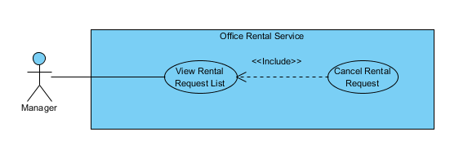

Figure : <Manager> Cancel Rental Request

**Use Case Specification**

|  |  |  |  |
| --- | --- | --- | --- |
| **USE CASE CANCEL RENTAL REQUEST** | | | |
| **Use Case No.** | UC141 | **Use Case Version** | 1.0 |
| **Use Case Name** | Cancel Rental Request | | |
| **Author** | Nguyễn Vũ Hoàng Quốc | | |
| **Date** | 31/05/2015 | **Priority** | Normal |
| **Actor:**   * Manager   **Summary:**   * This use case allows manager cancel rental request   **Goal:**   * The rental request has been canceled.   **Triggers:**   * From the menu bar on admin page:   + Select “Thuê thiết bị” on the menu.   + Choose one request   + Click “Từ chối” button on rental detail page   **Preconditions:**   * At lease exist one rental request in database * The request status is “Cần giao việc”   **Post Conditions:**   * **Success:** Request is assigned to staff successful * **Fail:** Assign failed   **Main Success Scenario:**   |  |  |  | | --- | --- | --- | | Step | Actor Action | System Response | | 1 | Click “Thuê thiết bị” button on menu of manager role | * Show all rental requests list in which includes:   + Tên văn phòng [text]   + Khách hàng [text]   + Ngày tạo yêu cầu [Date]   + Mô tả [text]   + Đề xuất nhân viên [dropdown list]   + Đề xuât thời gian [Date]   [Exception 1]   * Button group   + Giao việc   + Chi tiết | | 2 | Click “Chi tiết” button | * Show detail of rental request:   + Tên văn phòng [text]   + Khách hàng [text]   + Ngày tạo yêu cầu [Date]   + Mô tả [text]   + Đề xuất nhân viên [dropdown list]   + Đề xuât thời gian [Date] * Button group:   + Giao việc   + Từ chối   + Quay về [Alternative 1] | | 3 | Click “Từ chối” button | * Change status of rental repair * Return to rental repair list page |   **Alternative Scenario:**   |  |  |  | | --- | --- | --- | | No | Actor Action | System Response | | 1 | Click “Quay về” button | * Return to rental request list page |   **Exceptions:**   |  |  |  | | --- | --- | --- | | No | Actor Action | System Response | | 1 | Cannot load repair request list from database | Display error message: “Không lấy được dữ liệu toàn bộ yêu cầu thuê thiết bị. Xin vui lòng thử lại” | | 2 | Cannot cancel request |  |   **Relationships:** Rental, Rental Detail, Rental Item, Rental Status  **Business Rules:**   * Manager can cancel rental request if that request has invalid info. | | | |