##### <System> Suggest Requested Office

**Use Case Diagram**

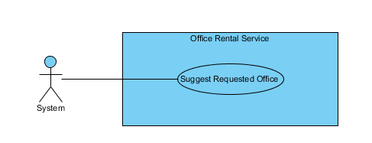

Figure 27: <System> Suggest Requested Office

**Use Case Specification**

|  |  |  |  |
| --- | --- | --- | --- |
| **USE CASE SUGGEST REQUESTED OFFICE** | | | |
| **Use Case No.** | UC041 | **Use Case Version** | 1.0 |
| **Use Case Name** | Suggest Requested Office | | |
| **Author** | Nguyễn Vũ Hoàng Quốc | | |
| **Date** | 31/05/2015 | **Priority** | Normal |
| **Actor:**   * System   **Summary:**   * This use case show system find offices that suitable with customer’s requests.   **Goal:**   * Find offices that suitable with customer’s requests.   **Triggers:**   * Schedule start   **Preconditions:**   * There are at least one request office from customer * There are at least one office in database   **Post Conditions:**   * **Success:** Office that suitable with customer’s requests is saved to database. * **Fail:** Cannot find office although there is the office suitable.   **Main Success Scenario:**   |  |  |  | | --- | --- | --- | | Step | Actor Action | System Response | | 1 | Start schedule | * Find all office in database * Find all request office in database * Check office with request * Find office that suitable * Save id of office to request office |   **Alternative Scenario:**   |  |  |  | | --- | --- | --- | | No | Actor Action | System Response | |  |  |  |   **Exceptions:**   |  |  |  | | --- | --- | --- | | No | Actor Action | System Response | |  |  |  |   **Relationships:** RequestOffice, Office  **Business Rules:**   * System will automatic check all requests office of customer and find which office in database suitable. * System will check 5 criteria:   + Amenity:     - If there is one request amenity in request, system will find if office which has that amenity will be suitable.     - If there are two or more request amenities, system will find if office which has two or more amenities in request will be suitable.   + Category:     - System will find which office suitable with request’s category.   + Price:     - System will find which office’s price is in range of request’s price: from (request’s price * 80%) to (request’s price * 120%)   + Area:     - If request category is “Văn phòng nguyên căn”: office’s area in range is suitable: from (request’s area * 80%) to (request’s area * 120%)     - If request category is “Tòa nhà văn phòng”: office’s area is larger than request’s area is suitable   + District:     - System will check which office in district of customer’s request | | | |

##### <System> Check Contract Due Date

**Use Case Diagram**

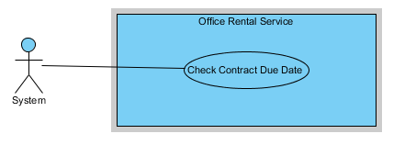

Figure 27: <System> Check Contract Due Date

**Use Case Specification**

|  |  |  |  |
| --- | --- | --- | --- |
| **USE CASE CHECK CONTRACT DUE DATE** | | | |
| **Use Case No.** | UC041 | **Use Case Version** | 1.0 |
| **Use Case Name** | Check Contract Due Date | | |
| **Author** | Nguyễn Vũ Hoàng Quốc | | |
| **Date** | 31/05/2015 | **Priority** | Normal |
| **Actor:**   * System   **Summary:**   * This use case show system check contract and send notification mail to customer.   **Goal:**   * Find contract which nearly expired and contract is expired in day and send mail to customer.   **Triggers:**   * Schedule start   **Preconditions:**   * There are at least one contract in database   **Post Conditions:**   * **Success:** Customer receive mail that notify about their contract will be expired of expired. * **Fail:** Send mail failed.   **Main Success Scenario:**   |  |  |  | | --- | --- | --- | | Step | Actor Action | System Response | | 1 | Start schedule | * Find all contract in database * Check contract with is nearly or expired in day * Send notification mail to customer |   **Alternative Scenario:**   |  |  |  | | --- | --- | --- | | No | Actor Action | System Response | |  |  |  |   **Exceptions:**   |  |  |  | | --- | --- | --- | | No | Actor Action | System Response | |  |  |  |   **Relationships:** Contract, account  **Business Rules:**   * System check if contract has 7 days before expired will send mail to customer base on customer info. * If contract is due date it will auto change status to expired and send mail to customer. | | | |