##### <Customer> View Result Request Office

**Summary:** This diagram used to describe the process of customer view result request office.

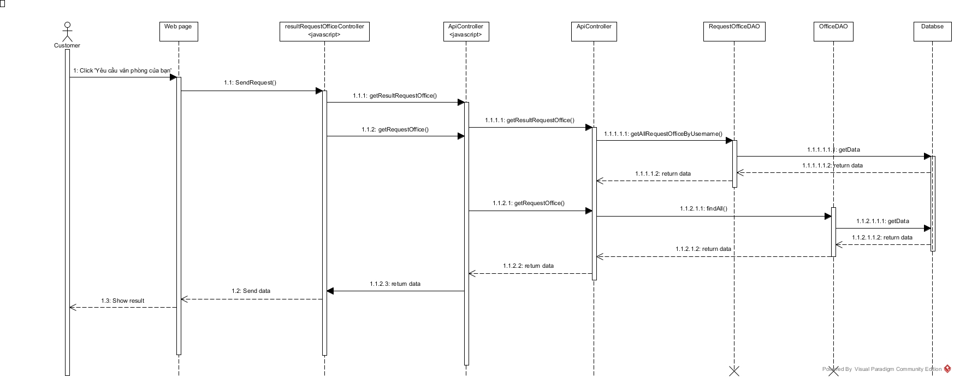

Figure : View Result Request Office Sequence Diagram

##### <Manager> Assign Appointment

**Summary:** This diagram used to describe the process of manager assign appointment requests to staff.

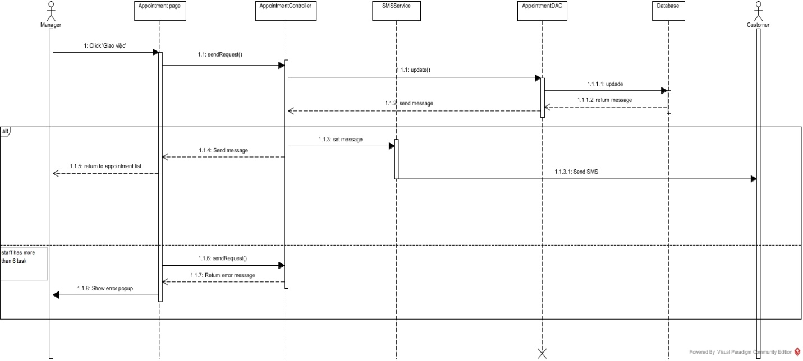

Figure : Assign Appointment Sequence Diagram

##### <Manager> Create Contract

**Summary:** This diagram used to describe the process of manager create contract

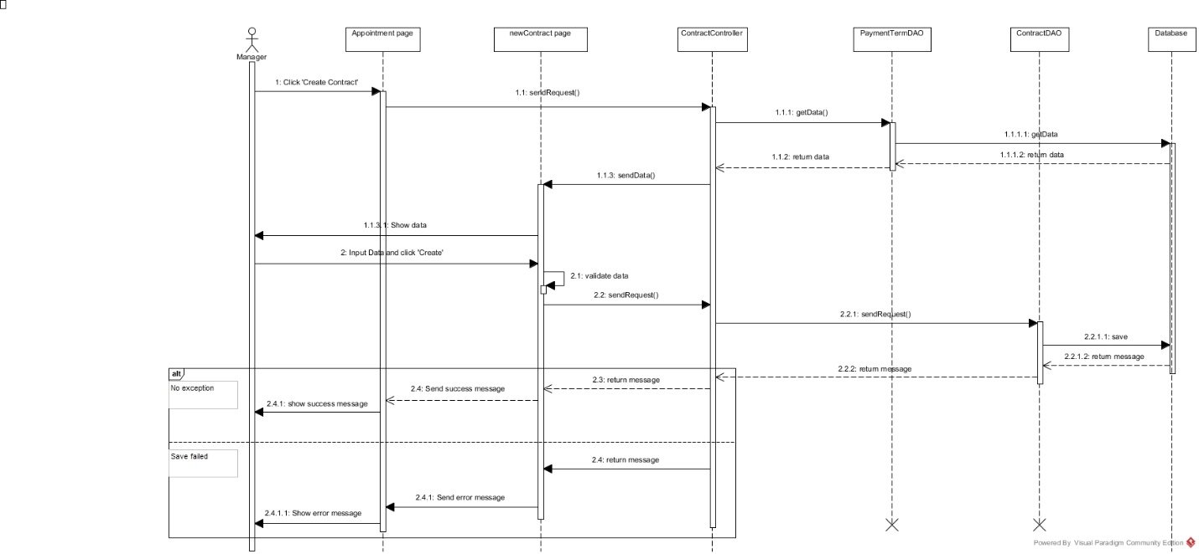

Figure : Create Contract Sequence Diagram

##### <Manager> Approve Created Office

**Summary:** This diagram used to describe the process of manager approve created office

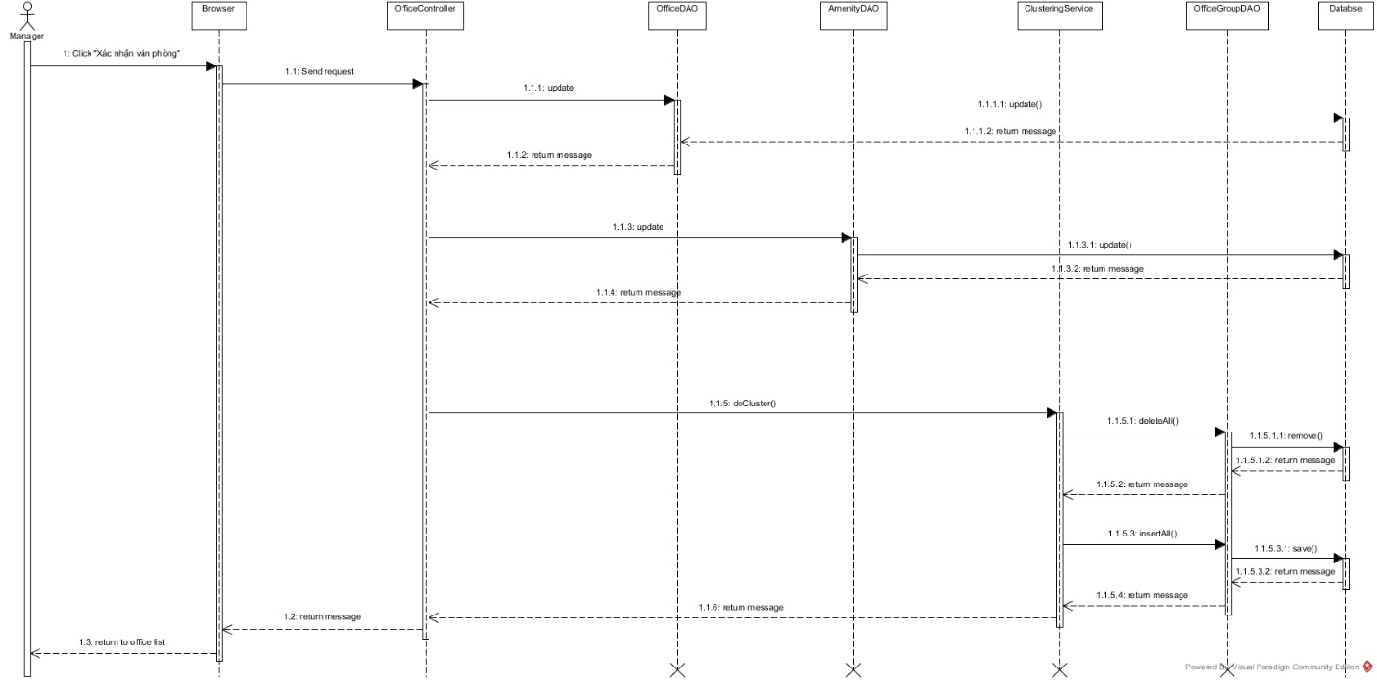

Figure : Approve Created Office Sequence Diagram

##### <System> Check Contract Due Date

**Summary:** This diagram used to describe the process of system check contract due date.

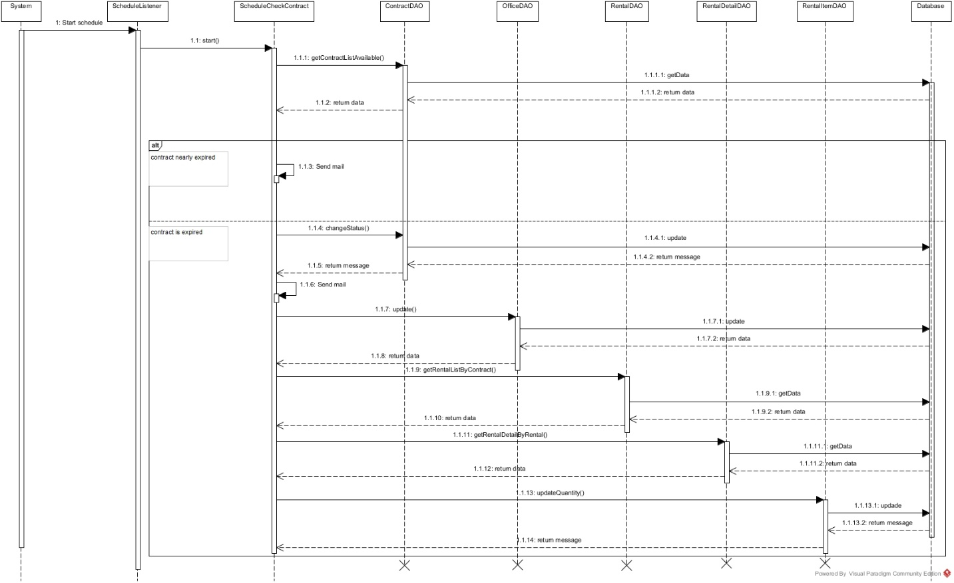

Figure : Check Contract Due Date Sequence Diagram

##### <System> Suggest Request Office

**Summary:** This diagram used to describe the process of system suggest request office to customer.

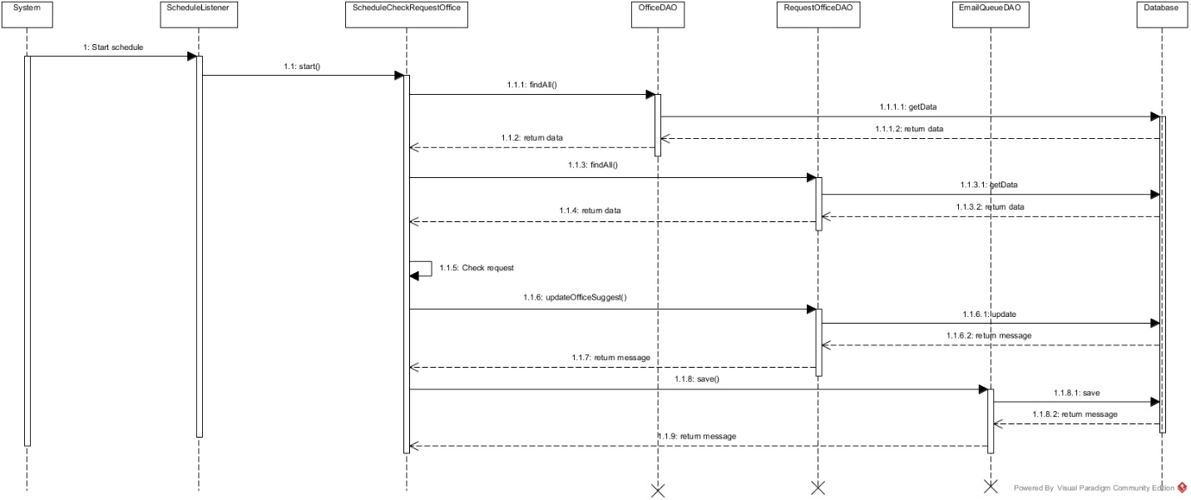

Figure : Suggest Request Office Sequence Diagram

##### <System> Check Appointment Due Date

**Summary:** This diagram used to describe the process of system check appointment due date

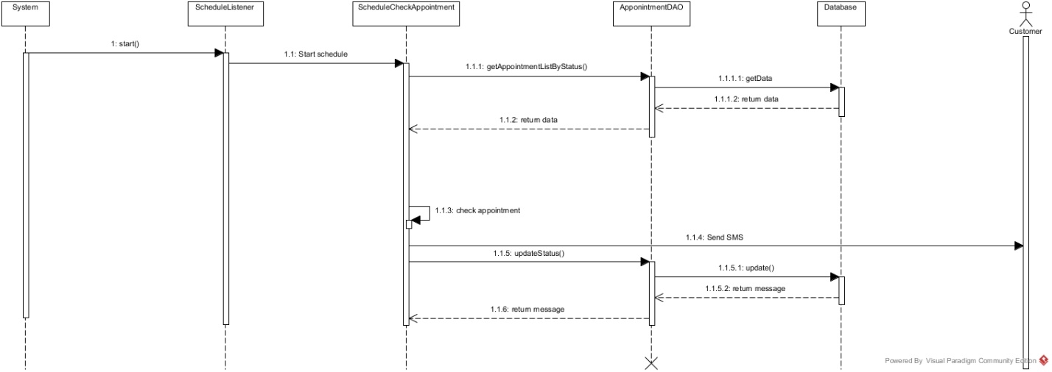

Figure : Check Appointment Due Date Sequence Diagram