##### <Manager> View Appointment Request List

**Use Case Diagram**

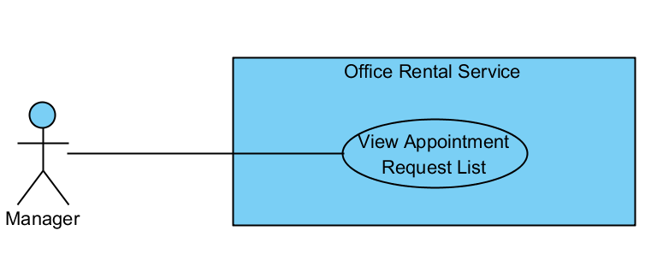

Figure : <Manager> View Appointment Request List

**Use Case Specification**

|  |  |  |  |
| --- | --- | --- | --- |
| **USE CASE VIEW APPOINTMENT REQUEST LIST** | | | |
| **Use Case No.** | UC043 | **Use Case Version** | 1.0 |
| **Use Case Name** | View Appointment Request List | | |
| **Author** | Nguyễn Vũ Hoàng Quốc | | |
| **Date** | 31/05/2015 | **Priority** | Normal |
| **Actor:**   * Manager   **Summary:**   * This use case allows manager see all appointment request   **Goal:**   * Show all appointment request   **Triggers:**   * From the menu bar on admin page:   + Select “Lịch hẹn” menu.   **Preconditions:**   * There are at least request appointment from customer * Requests from customers are valid and send successful   **Post Conditions:**   * **Success:** All appointment request are shown * **Fail:** Cannot get appointment list from database.   **Main Success Scenario:**   |  |  |  | | --- | --- | --- | | Step | Actor Action | System Response | | 1 | Click “Appointment” button from menu bar on admin page | * Show all request appointment list in which includes:   + Khách hàng   + Văn phòng   + Thời gian gặp   + Đề xuất nhân viên   [Exception 1] |   **Alternative Scenario:** N/A  **Exceptions:**   |  |  |  | | --- | --- | --- | | No | Actor Action | System Response | | 1 | Cannot load appointment list from database | Display error message: “Không lấy được lịch hẹn.” |   **Relationships:** Account, Office  **Business Rules:**   * Manager can view all list appointment from customer’s request. * On list appointment system will suggest staff suitable. | | | |

Table : <Manager> View Appointment request

##### <Manager> Assign Appointment

**Use Case Diagram**

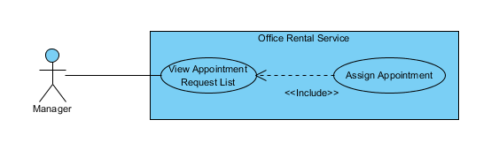

Figure : <Manager> Assign Appointment

**Use Case Specification**

|  |  |  |  |
| --- | --- | --- | --- |
| **USE CASE ASSIGN APPOINTMENT** | | | |
| **Use Case No.** | UC045 | **Use Case Version** | 1.0 |
| **Use Case Name** | Assign Appointment | | |
| **Author** | Nguyễn Vũ Hoàng Quốc | | |
| **Date** | 31/05/2015 | **Priority** | Normal |
| **Actor:**   * Manager   **Summary:**   * This use case allows manager assign appointment request to staff   **Goal:**   * Assign appointment to staff successful   **Triggers:**   * From the menu bar:   + Select “Lịch hẹn” menu.   + Click “Giao việc”   **Preconditions:**   * There are request appointment from customer * Requests from customers are valid and send successful * Manager checked the appointment is suitable   **Post Conditions:**   * **Success:** Appointment request is assign successful * **Fail:** Assign error.   **Main Success Scenario:**   |  |  |  | | --- | --- | --- | | Step | Actor Action | System Response | | 1 | Click “Lịch hẹn” button from menu bar on admin page | * Schedule staff who suitable * Show all request appointment list   + Khách hàng   + Văn phòng   + Thời gian gặp   + Đề xuất nhân viên   [Exception 1] | | 2 | Click “Giao việc” button on each row of appointment | [Exception 2] |   **Alternative Scenario:**   |  |  |  | | --- | --- | --- | | No | Actor Action | System Response | | 1 | Click “close” button on list staff | * Show appointment detail page |   **Exceptions:**   |  |  |  | | --- | --- | --- | | No | Actor Action | System Response | | 1 | Cannot load appointment list from database | Display error message: “Không lấy được lịch hẹn.” | | 2 | Cannot get detail of chosen appointment from database | Display error message: “Không thể lấy được thông tin lịch hẹn.” | | 3 | Assign error | Display error message: “Giao việc không thành công.” |   **Relationships:** Account, Office  **Business Rules:**   * Manager can assign appointment from customer’s request to staff if the request is suitable. * When assign, system will send email to staff’ and add the request to staff’s task list. | | | |

Table : <Manager> Assign Appointment

##### <Manager> Create Contract

**Use Case Diagram**

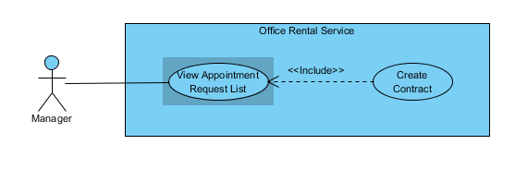

Figure : <Manager> Create Contract

**Use Case Specification**

|  |  |  |  |
| --- | --- | --- | --- |
| **USE CASE CREATE CONTRACT** | | | |
| **Use Case No.** | UC049 | **Use Case Version** | 1.0 |
| **Use Case Name** | Create Contract | | |
| **Author** | Nguyễn Vũ Hoàng Quốc | | |
| **Date** | 31/05/2015 | **Priority** | Normal |
| **Actor:**   * Manager   **Summary:**   * This use case allows manager create contract   **Goal:**   * Contract is create and add to database   **Triggers:**   * From the menu bar:   + Click “Lịch hẹn” on menu.   + On “Chấp nhận” tab click “Đến kí/ hủy hợp đồng”   + Click “Tạo hợp đồng” button   + Click “Tạo mới” button after input information   **Preconditions:**   * Appointment has been accepted by customer and status is accepted   **Post Conditions:**   * **Success:** Contract is saved to database * **Fail:** Create fail   **Main Success Scenario:**   |  |  |  | | --- | --- | --- | | Step | Actor Action | System Response | | 1 | Click “Lịch hẹn” on menu | * Show all appointment list   [Exception 1] | | 2 | On “Chấp nhận” tab click “Đến kí/ hủy hợp đồng” | * Show detail of the appointment   + Khách hàng [text]   + Văn phòng [text]   + Nhân viên được giao [text]   + Thời gian gặp [Date]   + Tình trạng [Text] * Group button:   + Tạo hợp đồng   + Hủy lịch hẹn [Alternative 1]   + Quay về [Alternative 2] | | 3 | Click “Tạo hợp đồng” | * Show detail of office, customer and owner. * Show input field and detail of contract:   + Khách hàng [text]   + Văn phòng [text]   + Thời gian thuê [number]   + Ngày bắt đầu [Date]   + Ngày kết thúc [Date]   + Giá [Number]   + Tiền đặt cọc [Number]   + Thời hạn thanh toán [text]   + Thời gian thanh toán kỳ đầu[Number]   + Thời gian thanh toán các kỳ tiếp theo[Number]   + Thời gian thanh toán tiền đặt cọc[Number]   + Phí phụ trội[Number] * Button “Tạo mới” | | 4 | Input information and click “Tạo mới” button | * Validate input data [Exception 2] * Show successful message [Exception 3] |   **Alternative Scenario:**   |  |  |  | | --- | --- | --- | | No | Actor Action | System Response | | 1 | Click “Hủy lịch hẹn” button | * Show popup input comment and return to appointment list page after manager input comment | | 2 | Click “Quay về” button | * Return to appointment list page |     **Exceptions:**   |  |  |  | | --- | --- | --- | | No | Actor Action | System Response | | 1 | Cannot load contract list from database | Display error message: “Không lấy được danh sách hợp đồng.” | | 2 | Payment Term > time | Display error message: “Thời hạn thanh toán không thể lớn hơn thời gian thuê” | | 3 | Cannot save new contract to database | Display error message: “Không thể tạo hợp đồng” |   **Relationships:** Office, Account  **Business Rules:**   * Manager will meet customer after customer decide to rent office * Manager will create contract after the meeting | | | |

Table : <Manager> Create Contract

##### <System> Suggest Requested Office

**Use Case Diagram**

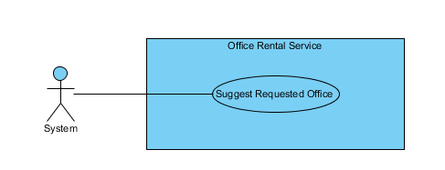

Figure : <System> Suggest Requested Office

**Use Case Specification**

|  |  |  |  |
| --- | --- | --- | --- |
| **USE CASE SUGGEST REQUESTED OFFICE** | | | |
| **Use Case No.** | UC077 | **Use Case Version** | 1.0 |
| **Use Case Name** | Suggest Requested Office | | |
| **Author** | Nguyễn Vũ Hoàng Quốc | | |
| **Date** | 31/05/2015 | **Priority** | Normal |
| **Actor:**   * System   **Summary:**   * This use case show system find offices that suitable with customer’s requests.   **Goal:**   * Find offices that suitable with customer’s requests.   **Triggers:**   * Schedule start   **Preconditions:**   * There are at least one request office from customer * There are at least one office in database   **Post Conditions:**   * **Success:** Office that suitable with customer’s requests is saved to database. * **Fail:** Cannot find office although there is the office suitable.   **Main Success Scenario:**   |  |  |  | | --- | --- | --- | | Step | Actor Action | System Response | | 1 | Start schedule | * Find all office in database * Find all request office in database * Check office with request * Find office that suitable * Save id of office to request office |   **Alternative Scenario: N/A**  **Exceptions:** N/A  **Relationships:** RequestOffice, Office, EmailQueue, Account  **Business Rules:**   * System will automatic check all requests office of customer and find which office in database suitable. * System will check 5 criteria:   + Amenity:     - If there is one request amenity in request, system will find if office which has that amenity will be suitable.     - If there are two or more request amenities, system will find if office which has two or more amenities in request will be suitable.   + Category:     - System will find which office suitable with request’s category.   + Price:     - System will find which office’s price is in range of request’s price: from (request’s price * 80%) to (request’s price * 120%)   + Area:     - If request category is “Văn phòng nguyên căn”: office’s area in range is suitable: from (request’s area * 80%) to (request’s area * 120%)     - If request category is “Tòa nhà văn phòng”: office’s area is larger than request’s area is suitable   + District:     - System will check which office in district of customer’s request | | | |

Table : <System> Suggest requested office

##### <System> Check Contract Due Date

**Use Case Diagram**

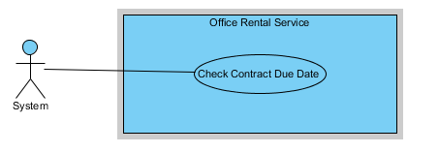

Figure : <System> Check Contract Due Date

**Use Case Specification**

|  |  |  |  |
| --- | --- | --- | --- |
| **USE CASE CHECK CONTRACT DUE DATE** | | | |
| **Use Case No.** | UC078 | **Use Case Version** | 1.0 |
| **Use Case Name** | Check Contract Due Date | | |
| **Author** | Nguyễn Vũ Hoàng Quốc | | |
| **Date** | 31/05/2015 | **Priority** | Normal |
| **Actor:**   * System   **Summary:**   * This use case show system check contract and send notification mail to customer.   **Goal:**   * Find contract which nearly expired and contract is expired in day and send mail to customer.   **Triggers:**   * Schedule start   **Preconditions:**   * There are at least one contract in database   **Post Conditions:**   * **Success:** Customer receive mail that notify about their contract will be expired of expired. * **Fail:** Send mail failed.   **Main Success Scenario:**   |  |  |  | | --- | --- | --- | | Step | Actor Action | System Response | | 1 | Start schedule | * Find all contract in database * Check contract with is nearly or expired in day * Send notification mail to customer |   **Alternative Scenario: N/A**  **Exceptions:** N/A  **Relationships:** Contract, account, Office, RentalItem  **Business Rules:**   * System check if contract has 7 days before expired will send mail to customer base on customer info. * If contract is due date it will auto change status to expired and send mail to customer. | | | |

Table : <System> Check contract due date

##### <System> Check Appointment Due Date

**Use Case Diagram**

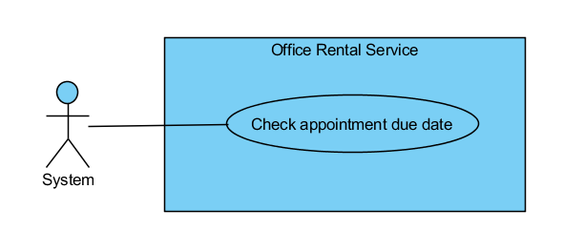

Figure : <System> Check Appointment Due Date

**Use Case Specification**

|  |  |  |  |
| --- | --- | --- | --- |
| **USE CASE CHECK CONTRACT DUE DATE** | | | |
| **Use Case No.** | UC078 | **Use Case Version** | 1.0 |
| **Use Case Name** | Check Apponitment Due Date | | |
| **Author** | Nguyễn Vũ Hoàng Quốc | | |
| **Date** | 13/09/2015 | **Priority** | Normal |
| **Actor:**   * System   **Summary:**   * This use case show system check appointment and send sms to customer.   **Goal:**   * Find appointment which is due date and send sms to customer   **Triggers:**   * Schedule start   **Preconditions:**   * There are at least one appointment in database   **Post Conditions:**   * **Success:** Customer sms that notify about their appointment. * **Fail:** Send mail failed.   **Main Success Scenario:**   |  |  |  | | --- | --- | --- | | Step | Actor Action | System Response | | 1 | Start schedule | * Find all contract in database * Check contract with is nearly or expired in day * Send notification mail to customer |   **Alternative Scenario: N/A**  **Exceptions:** N/A  **Relationships:** Account, Office  **Business Rules:**   * System check if appointment is due date will automatically change the appointment’s status and notify to customer by sms | | | |

Table : <System> Check Appointment due date