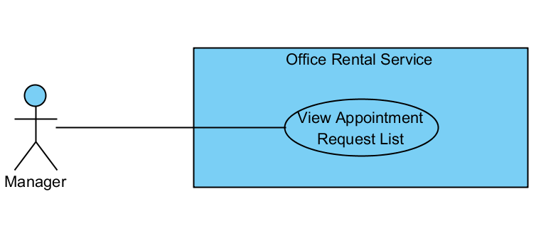

|  |  |  |  |
| --- | --- | --- | --- |
| **USE CASE VIEW APPOINTMENT REQUEST LIST** | | | |
| **Use Case No.** |  | **Use Case Version** | 1.0 |
| **Use Case Name** | View Appointment Request List | | |
| **Author** | Nguyễn Vũ Hoàng Quốc | | |
| **Date** | 31/05/2015 | **Priority** | Normal |
| **Actor:**   * Manager   **Summary:**   * This use case allows manager see all appointment request   **Goal:**   * Show all appointment request   **Triggers:**   * From the menu bar:   + Select “ Appointment ” menu.   **Preconditions:**   * There are request appointment from customer * Requests from customers are valid and send successful   **Post Conditions:**   * **Success:** All appointment request are shown * **Fail:** Cannot get appointment list from database.   **Main Success Scenario:**   |  |  |  | | --- | --- | --- | | Step | Actor Action | System Response | | 1 | Click “Appointment” button on menu bar of manager role | * Show all request appointment list in which includes:   + Customer name   + Assigned staff   + Office   + Time   [Exception 1] |   **Alternative Scenario:**   |  |  |  | | --- | --- | --- | | No | Actor Action | System Response | |  | . |  |   **Exceptions:**   |  |  |  | | --- | --- | --- | | No | Actor Action | System Response | | 1 | Cannot load appointment list from database | Display error message: “Cannot get request appointment list. Please try again” |   **Relationships:** Delete Appointment request, Assign Appointment, View Customer Info  **Business Rules:**   * Manager can view all list appointment from customer’s request | | | |

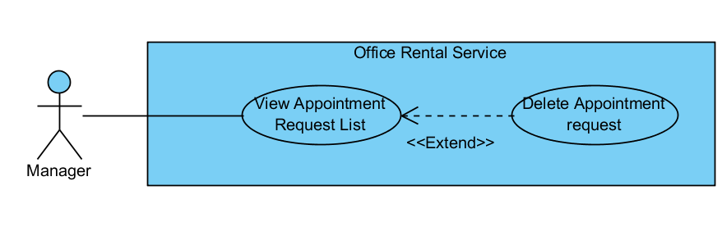

|  |  |  |  |
| --- | --- | --- | --- |
| **USE CASE DELETE APPOINTMENT REQUEST** | | | |
| **Use Case No.** |  | **Use Case Version** | 1.0 |
| **Use Case Name** | Delete Appointment request | | |
| **Author** | Nguyễn Vũ Hoàng Quốc | | |
| **Date** | 31/05/2015 | **Priority** | Normal |
| **Actor:**   * Manager   **Summary:**   * This use case allows manager delete appointment request which is not suitable   **Goal:**   * Delete appointment request successful   **Triggers:**   * From the menu bar:   + Select “Appointment” menu.   + Choose appointment   + Click “Delete” button on appointment detail page   **Preconditions:**   * There are request appointment from customer * Requests from customers are valid and send successful   **Post Conditions:**   * **Success:** Appointment request is deleted successful * **Fail:** Delete error.   **Main Success Scenario:**   |  |  |  | | --- | --- | --- | | Step | Actor Action | System Response | | 1 | Click “Appointment” button on menu bar of manager role | * Show all request appointment list   [Exception 1] | | 2 | Choose the appointment in appointment list. | * Show detail of this appointment   [Exception 2] | | 3 | Click “Delete” button on appointment detail page | * Show warning popup: “Are you sure to delete this appointment?” with “Yes” and “No button” | | 4 | Click “Yes” button on warning popup  [Alternative 1] | * Show successful message: “The appointment has been deleted”   [Exception 3] |   **Alternative Scenario:**   |  |  |  | | --- | --- | --- | | No | Actor Action | System Response | | 1 | Click “No” button on warning popup | * Close warning popup |   **Exceptions:**   |  |  |  | | --- | --- | --- | | No | Actor Action | System Response | | 1 | Cannot load appointment list from database | Display error message: “Cannot get request appointment list. Please try again” | | 2 | Cannot get detail of chosen appointment from database | Display error message: “Cannot get data this appointment. Please try again” | | 3 | Delete error | Display error message: “Cannot delete this appointment. Please try again” |   **Relationships:** Appointment Request List  **Business Rules:**   * Manager can delete appointment from customer’s request if there are some error with customer’s error. * When delete, system will send email to customer’s mail. | | | |

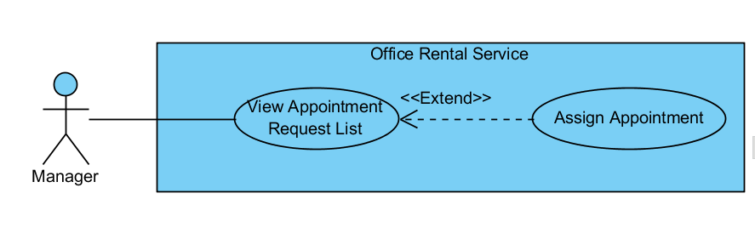

|  |  |  |  |
| --- | --- | --- | --- |
| **USE CASE ASSIGN APPOINTMENT** | | | |
| **Use Case No.** |  | **Use Case Version** | 1.0 |
| **Use Case Name** | Assign Appointment | | |
| **Author** | Nguyễn Vũ Hoàng Quốc | | |
| **Date** | 31/05/2015 | **Priority** | Normal |
| **Actor:**   * Manager   **Summary:**   * This use case allows manager assign appointment request to staff   **Goal:**   * Assign appointment to staff successful   **Triggers:**   * From the menu bar:   + Select “Appointment” menu.   + Choose appointment   + Click “Assign” button on appointment detail page   + Choose staff in staff list   + Click “Assign” button on staff list   **Preconditions:**   * There are request appointment from customer * Requests from customers are valid and send successful * Manager checked the appointment is suitable   **Post Conditions:**   * **Success:** Appointment request is assign successful * **Fail:** Assign error.   **Main Success Scenario:**   |  |  |  | | --- | --- | --- | | Step | Actor Action | System Response | | 1 | Click “Appointment” button on menu bar of manager role | * Show all request appointment list   [Exception 1] | | 2 | Choose the appointment in appointment list. | * Show detail of this appointment   [Exception 2] | | 3 | Click “Assign” button on appointment detail page | * Show list of staffs | | 4 | Choose staff in staff list  [Alternative 1] | * Show “checked” at staff was chosen | | 5 | Click “Assign” button on list staff | * Show success message: “Assign successful”   [Exception 3] |   **Alternative Scenario:**   |  |  |  | | --- | --- | --- | | No | Actor Action | System Response | | 1 | Click “close” button on list staff | * Show appointment detail page |     **Exceptions:**   |  |  |  | | --- | --- | --- | | No | Actor Action | System Response | | 1 | Cannot load appointment list from database | Display error message: “Cannot get request appointment list. Please try again” | | 2 | Cannot get detail of chosen appointment from database | Display error message: “Cannot get data this appointment. Please try again” | | 3 | Assign error | Display error message: “Cannot assign this appointment to staff. Please try again” |   **Relationships:** Appointment Request List  **Business Rules:**   * Manager can assign appointment from customer’s request to staff if the request is suitable. * When assign, system will send email to staff’ and add the request to staff’s task list. | | | |

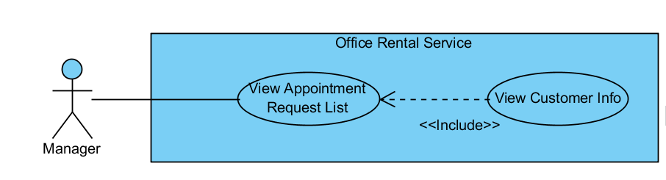

|  |  |  |  |
| --- | --- | --- | --- |
| **USE CASE VIEW CUSTOMER INFO** | | | |
| **Use Case No.** |  | **Use Case Version** | 1.0 |
| **Use Case Name** | View Customer Info | | |
| **Author** | Nguyễn Vũ Hoàng Quốc | | |
| **Date** | 31/05/2015 | **Priority** | Normal |
| **Actor:**   * Manager   **Summary:**   * This use case allows manager view customer info from appointment list   **Goal:**   * View customer profile   **Triggers:**   * From the menu bar:   + Select “Appointment” menu.   + Choose appointment   + Click to customer’s name in appointment detail page   **Preconditions:**   * There are request appointment from customer * Requests from customers are valid and send successful   **Post Conditions:**   * **Success:** Show customer profile * **Fail:** Cannot get data of the customer in database.   **Main Success Scenario:**   |  |  |  | | --- | --- | --- | | Step | Actor Action | System Response | | 1 | Click “Appointment” button on menu bar of manager role | * Show all request appointment list   [Exception 1] | | 2 | Choose the appointment in appointment list. | * Show detail of this appointment   [Exception 2] | | 3 | Click to name of customer in appointment detail page | * Show customer profile includes:   + Username   + Email   + Phone   + Address   [Exception 3] |   **Alternative Scenario:**   |  |  |  | | --- | --- | --- | | No | Actor Action | System Response | |  |  |  |     **Exceptions:**   |  |  |  | | --- | --- | --- | | No | Actor Action | System Response | | 1 | Cannot load appointment list from database | Display error message: “Cannot get request appointment list. Please try again” | | 2 | Cannot get detail of chosen appointment from database | Display error message: “Cannot get data this appointment. Please try again” | | 3 | Cannot get detail of chosen customer from database | Display error message: “Cannot get data this customer. Please try again” |   **Relationships:** Appointment Request List  **Business Rules:**   * Manager can find customer profile base on appointment request list | | | |

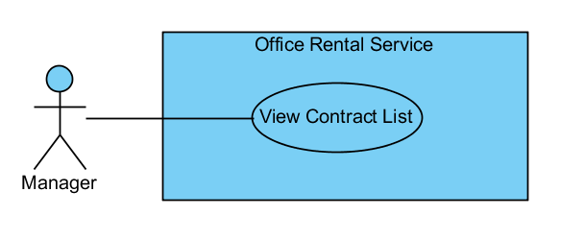

|  |  |  |  |
| --- | --- | --- | --- |
| **USE CASE VIEW CONTRACT LIST** | | | |
| **Use Case No.** |  | **Use Case Version** | 1.0 |
| **Use Case Name** | View Contract List | | |
| **Author** | Nguyễn Vũ Hoàng Quốc | | |
| **Date** | 31/05/2015 | **Priority** | Normal |
| **Actor:**   * Manager   **Summary:**   * This use case allows manager view contract list   **Goal:**   * Show all contract list   **Triggers:**   * From the menu bar:   + Select “Contract” menu.   **Preconditions:**   * Login as manager role   **Post Conditions:**   * **Success:** Show all contracts in database * **Fail:** Cannot get data of the contract in database.   **Main Success Scenario:**   |  |  |  | | --- | --- | --- | | Step | Actor Action | System Response | | 1 | Click “Contract” button on menu bar of manager role | * Show all contract in list   [Exception 1] |   **Alternative Scenario:**   |  |  |  | | --- | --- | --- | | No | Actor Action | System Response | |  |  |  |     **Exceptions:**   |  |  |  | | --- | --- | --- | | No | Actor Action | System Response | | 1 | Cannot load contract list from database | Display error message: “Cannot get contract list. Please try again” |   **Relationships:** Contract  **Business Rules:**   * Only manager can see all contracts in database | | | |

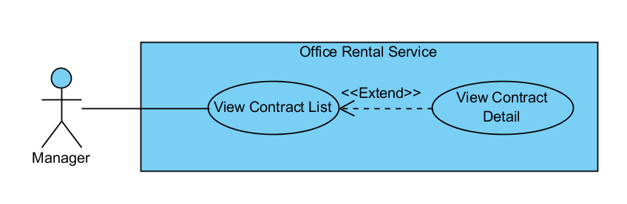

|  |  |  |  |
| --- | --- | --- | --- |
| **USE CASE VIEW CONTRACT DETAIL** | | | |
| **Use Case No.** |  | **Use Case Version** | 1.0 |
| **Use Case Name** | View Contract Detail | | |
| **Author** | Nguyễn Vũ Hoàng Quốc | | |
| **Date** | 31/05/2015 | **Priority** | Normal |
| **Actor:**   * Manager   **Summary:**   * This use case allows manager view contract detail   **Goal:**   * Show contract detail   **Triggers:**   * From the menu bar:   + Select “Contract” menu.   + Choose contract in the contract list   **Preconditions:**   * Contract is not out of date   **Post Conditions:**   * **Success:** Show detail of chosen contract * **Fail:** Cannot get data of the contract in database.   **Main Success Scenario:**   |  |  |  | | --- | --- | --- | | Step | Actor Action | System Response | | 1 | Click “Contract” button on menu bar of manager role | * Show all contract in list   [Exception 1] | | 2 | Choose contract in contract list | * Show all detail of the contract includes:   + Customer name   + Office name   + Start date   + End date   + Payment fee   + Payment term   [Exception 2] |   **Alternative Scenario:**   |  |  |  | | --- | --- | --- | | No | Actor Action | System Response | |  |  |  |     **Exceptions:**   |  |  |  | | --- | --- | --- | | No | Actor Action | System Response | | 1 | Cannot load contract list from database | Display error message: “Cannot get contract list. Please try again” | | 2 | Cannot load data of the chosen contract | Display error message: “Cannot get data of this contract. Please try again” |   **Relationships:** Contract  **Business Rules:**   * Manager can see detail of the contract * The contract is still have time if not system will delete contract in database and send notification to customer | | | |

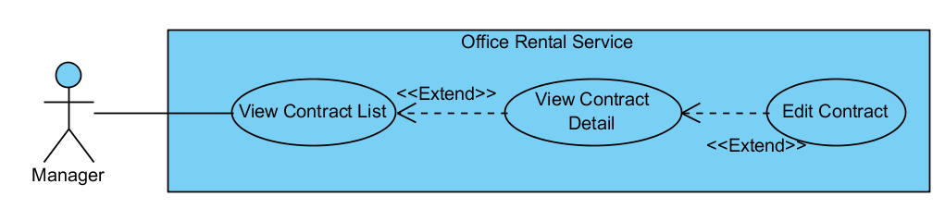

|  |  |  |  |
| --- | --- | --- | --- |
| **USE CASE EDIT CONTRACT** | | | |
| **Use Case No.** |  | **Use Case Version** | 1.0 |
| **Use Case Name** | Edit Contract | | |
| **Author** | Nguyễn Vũ Hoàng Quốc | | |
| **Date** | 31/05/2015 | **Priority** | Normal |
| **Actor:**   * Manager   **Summary:**   * This use case allows manager edit contract   **Goal:**   * Contract is edited   **Triggers:**   * From the menu bar:   + Select “Contract” menu.   + Choose contract in the contract list   + Click “Edit” button in contract detail page   **Preconditions:**   * Contract is not out of date * There is request to change detail in contract from customer   **Post Conditions:**   * **Success:** Edit contract successful * **Fail:** Edit error   **Main Success Scenario:**   |  |  |  | | --- | --- | --- | | Step | Actor Action | System Response | | 1 | Click “Contract” button on menu bar of manager role | * Show all contract in list   [Exception 1] | | 2 | Choose contract in contract list | * Show all detail of the contract   + Customer name   + Office name   + Start date   + End date   + Payment fee   + Payment term   [Exception 2] | | 3 | Click “Edit” button on contract detail page | * Show input text for edit * Show “save” and “cancel” button | | 4 | Input or edit field on contract detail page | * Validate input show error if data invalid   [Exception 3] | | 5 | Click “Save” button on contract  [Alternative 1] | * Show successful message |   **Alternative Scenario:**   |  |  |  | | --- | --- | --- | | No | Actor Action | System Response | | 1 | Click “cancel” button | * Show “Edit” button, hide “save” and “cancel” button |     **Exceptions:**   |  |  |  | | --- | --- | --- | | No | Actor Action | System Response | | 1 | Cannot load contract list from database | Display error message: “Cannot get contract list. Please try again” | | 2 | Cannot load data of the chosen contract | Display error message: “Cannot get data of this contract. Please try again” | | 3 | From date > End Date | Display error message: “From date or end date is invalid. Please check again” |   **Relationships:** Contract  **Business Rules:**   * Manager edit contract when customer need to renewal contract before contract is out of date * System will send message to customer before contract is out date 1 month * If customer want to renewal contract, manager will edit | | | |

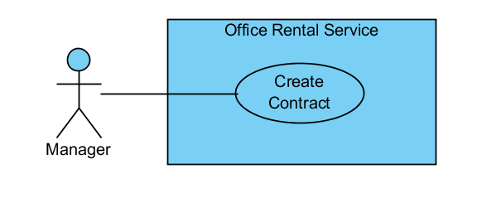

|  |  |  |  |
| --- | --- | --- | --- |
| **USE CASE CREATE CONTRACT** | | | |
| **Use Case No.** |  | **Use Case Version** | 1.0 |
| **Use Case Name** | Create Contract | | |
| **Author** | Nguyễn Vũ Hoàng Quốc | | |
| **Date** | 31/05/2015 | **Priority** | Normal |
| **Actor:**   * Manager   **Summary:**   * This use case allows manager create contract   **Goal:**   * Contract is create and add to database   **Triggers:**   * From the menu bar:   + Select “Contract” menu.   + Click “New” button on menu bar   + Click “Create” button after input info   **Preconditions:**  **Post Conditions:**   * **Success:** Contract is saved to database * **Fail:** Create fail   **Main Success Scenario:**   |  |  |  | | --- | --- | --- | | Step | Actor Action | System Response | | 1 | Click “Contract” button on menu bar of manager role | * Show all contract in list   [Exception 1] | | 2 | Click “New” button on menu bar | * Show input field for detail of the contract   + Customer name: textbox   + Office name: textbox   + Start date: calendar   + End date: calendar   + Payment fee: dropdown list   + Payment term: dropdown list | | 3 | Input info for all field | * Validate input show error if data invalid   [Exception 2] | | 4 | Click “Create” button on contract | * Show successful message |   **Alternative Scenario:**   |  |  |  | | --- | --- | --- | | No | Actor Action | System Response | |  |  |  |     **Exceptions:**   |  |  |  | | --- | --- | --- | | No | Actor Action | System Response | | 1 | Cannot load contract list from database | Display error message: “Cannot get contract list. Please try again” | | 2 | From date > End Date | Display error message: “From date or end date is invalid. Please check again” |   **Relationships:** Contract  **Business Rules:**   * Manager will meet customer after customer decide to rent office * Manager will create contract after the meeting | | | |

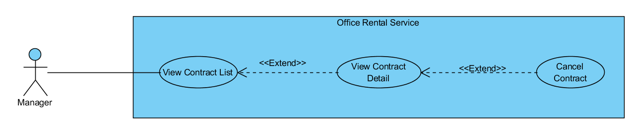

|  |  |  |  |
| --- | --- | --- | --- |
| **USE CASE CANCEL CONTRACT** | | | |
| **Use Case No.** |  | **Use Case Version** | 1.0 |
| **Use Case Name** | Cancel Contract | | |
| **Author** | Nguyễn Vũ Hoàng Quốc | | |
| **Date** | 31/05/2015 | **Priority** | Normal |
| **Actor:**   * Manager   **Summary:**   * This use case allows manager cancel contract   **Goal:**   * Contract is canceled and removed from database   **Triggers:**   * From the menu bar:   + Select “Hợp đồng” on menu.   + Choose a contract from contract list   + Click “Hủy hợp đồng” button on contract page detail   **Preconditions:**   * At least exist one contract in database and not expired * Have request cancel from customer   **Post Conditions:**   * **Success:** Contract is canceled and removed from database * **Fail:** Remove contract fail   **Main Success Scenario:**   |  |  |  | | --- | --- | --- | | Step | Actor Action | System Response | | 1 | Click “Hợp đồng” button on menu bar of manager role | * Show all contract in list   [Exception 1] | | 2 | Choose a contract from contract list | * Show detail of chosen contract   [Exception 2] | | 3 | Click “Hủy hợp đồng” button on contract page detail | * Show warning popup: “Bạn chắc chắn muốn huy hợp đồng này chứ?” with “Đồng ý” and “Không đồng ý” button | | 4 | Click “Đồng ý” button on warning popup  [Alternative 1] | * Show successful message: “Đã hủy hợp đồng thành công”   [Exception 3] |   **Alternative Scenario:**   |  |  |  | | --- | --- | --- | | No | Actor Action | System Response | | 1 | Click “Không đồng ý” button on warning popup | * Return to detail page of the chosen contract |     **Exceptions:**   |  |  |  | | --- | --- | --- | | No | Actor Action | System Response | | 1 | Cannot load contract list from database | Display error message: “Không lấy được dữ liệu hợp đồng. Xin vui lòng thử lại” | | 2 | Cannot get data of the chosen contract | Display error message: “Không lấy được dữ liệu của hợp đồng này. Xin vui lòng thử lại” | | 3 | Cannot delete contract from database | Display error message: “Không thể hủy hợp đồng này. Xin vui lòng thử lại” |   **Relationships:** Contract  **Business Rules:**   * Manager will meet customer after customer decide to rent office * Manager will create contract after the meeting with customer | | | |

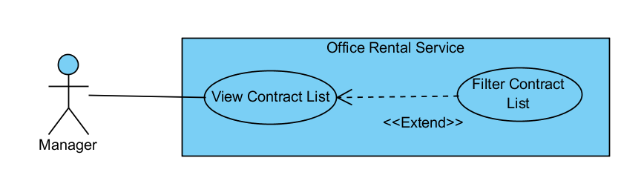

|  |  |  |  |
| --- | --- | --- | --- |
| **USE CASE FILTER CONTRACT LIST** | | | |
| **Use Case No.** |  | **Use Case Version** | 1.0 |
| **Use Case Name** | Filter Contract List | | |
| **Author** | Nguyễn Vũ Hoàng Quốc | | |
| **Date** | 31/05/2015 | **Priority** | Normal |
| **Actor:**   * Manager   **Summary:**   * This use case allows manager filter contract in list   **Goal:**   * Show all contract is suitable with filter   **Triggers:**   * From the menu bar:   + Select “Hợp đồng” on menu.   + Click “Tìm kiếm nâng cao” on menu bar   + Input info for filter   + Click “Tìm” button   **Preconditions:**   * At least exist one contract in database and not expired   **Post Conditions:**   * **Success:** show one or many contracts * **Fail:** Cannot find any contract   **Main Success Scenario:**   |  |  |  | | --- | --- | --- | | Step | Actor Action | System Response | | 1 | Click “Hợp đồng” button on menu bar of manager role | * Show all contract in list   [Exception 1] | | 2 | Click “Tìm kiếm nâng cao” on menu bar | * Show input field for filter:   + City: dropdown list   + District: dropdown list   + Office: textbox   [Exception 2] | | 3 | Input info for filter | * Validate info | | 4 | Click “Tìm” button | * Show list of contract which is suitable which filter info   [Exception 3] |   **Alternative Scenario:**   |  |  |  | | --- | --- | --- | | No | Actor Action | System Response | |  |  |  |     **Exceptions:**   |  |  |  | | --- | --- | --- | | No | Actor Action | System Response | | 1 | Cannot load contract list from database | Display error message: “Không lấy được dữ liệu hợp đồng. Xin vui lòng thử lại” | | 2 | Office name not exist in database | Display error message: “Văn phòng này không tồn tại” | | 3 | Cannot filter contract | Display error message: “Không tìm được bất kỳ hợp đồng nào. Xin vui lòng thử lại” |   **Relationships:** Contract  **Business Rules:**   * Manager manages many contracts. So they can filter which contract base on city, district or office to make them easy to manage. | | | |

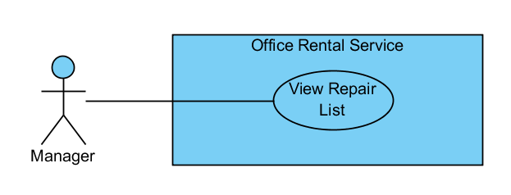

|  |  |  |  |
| --- | --- | --- | --- |
| **USE CASE VIEW REPAIR LIST** | | | |
| **Use Case No.** |  | **Use Case Version** | 1.0 |
| **Use Case Name** | View Repair List | | |
| **Author** | Nguyễn Vũ Hoàng Quốc | | |
| **Date** | 31/05/2015 | **Priority** | Normal |
| **Actor:**   * Manager   **Summary:**   * This use case allows manager see all repair requests   **Goal:**   * Show all repair request   **Triggers:**   * From the menu bar:   + Select “ Sửa chữa ” on the menu.   **Preconditions:**   * At lease exist one repair request in database   **Post Conditions:**   * **Success:** All request repair are shown * **Fail:** Cannot get repair list from database.   **Main Success Scenario:**   |  |  |  | | --- | --- | --- | | Step | Actor Action | System Response | | 1 | Click “Sửa chữa” button on menu bar of manager role | * Show all repair requests list in which includes:   + ContractID: text   + Assigned staff: text   + Type: dropdown list   + Description: text   [Exception 1] | |  |  |  |   **Alternative Scenario:**   |  |  |  | | --- | --- | --- | | No | Actor Action | System Response | |  | . |  |   **Exceptions:**   |  |  |  | | --- | --- | --- | | No | Actor Action | System Response | | 1 | Cannot load repair request list from database | Display error message: “Không lấy được dữ liệu toàn bộ yêu cầu sửa chữa. Xin vui lòng thử lại” |   **Relationships:** Request repair  **Business Rules:**   * Manager can view all request repair for assigning to staff | | | |

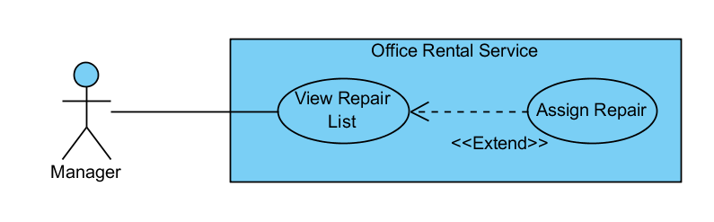

|  |  |  |  |
| --- | --- | --- | --- |
| **USE CASE ASSIGN REPAIR** | | | |
| **Use Case No.** |  | **Use Case Version** | 1.0 |
| **Use Case Name** | Assign Repair | | |
| **Author** | Nguyễn Vũ Hoàng Quốc | | |
| **Date** | 31/05/2015 | **Priority** | Normal |
| **Actor:**   * Manager   **Summary:**   * This use case allows manager assign repair request to staff   **Goal:**   * The repair request is assigned to staff.   **Triggers:**   * From the menu bar:   + Select “Sửa chữa” on the menu.   + Select repair request on repair list   + Click  “Giao việc” button on repair request detail page   + Choose staff in staff list   + Click “Giao” button   **Preconditions:**   * At lease exist one repair request in database   **Post Conditions:**   * **Success:** The request has been assigned to staff and added to staff task list * **Fail:** Cannot assign to staff.   **Main Success Scenario:**   |  |  |  | | --- | --- | --- | | Step | Actor Action | System Response | | 1 | Click “Sửa chữa” button on menu bar of manager role | * Show all repair requests list in which includes:   + ContractID: text   + Assigned staff: text   + Type: dropdown list   + Description: text   [Exception 1] | | 2 | Select repair request on repair list | * Show detail of the chosen repair request includes:   + ContractID: text   + Assigned staff: text   + Type: dropdown list   + Description: text   + Time: text   [Exception 2] | | 3 | Click  “Giao việc” button on repair request detail page | * Show list of staff includes:   + Staff name: text   + Email: text   + Phone: text   + Address: text   + “Giao” and “Hủy” button   [Exception 3] | | 4 | Choose staff in staff list | * Show staff whom was chosen in textarea | | 5 | Click  “Giao” button  [Alternative 1] | * Show success message: “Yêu cầu sửa chữa đã được giao cho nhân viên”   [Exception 4]   * Add repair request to staff’s task   [Exception 5] |   **Alternative Scenario:**   |  |  |  | | --- | --- | --- | | No | Actor Action | System Response | | 1 | Click “Hủy” button | -Close staff list and show the chosen repair request detail page |   **Exceptions:**   |  |  |  | | --- | --- | --- | | No | Actor Action | System Response | | 1 | Cannot load repair request list from database | Display error message: “Không lấy được dữ liệu toàn bộ yêu cầu sửa chữa. Xin vui lòng thử lại” | | 2 | Cannot load repair request detail | Display error message: “Không lấy được dữ liệu yêu cầu này. Xin vui lòng thử lại” | | 3 | Cannot load list of staffs | Display error message: “Không lấy được dữ liệu toàn bộ nhân viên. Xin vui lòng thử lại” | | 4 | Cannot assign to staff | Display error message: “Không lấy được giao yêu cầu cho nhân viên. Xin vui lòng thử lại” | | 5 | Cannot add repair request to staff’s task | Display error message: “Lưu yêu cầu sửa chữa không thành công. Xin vui lòng thử lại” |   **Relationships:** Request repair  **Business Rules:**   * Manager can assign repair request to staff and this request save to task list of staff | | | |