### **Customer**

#### **Request repair**

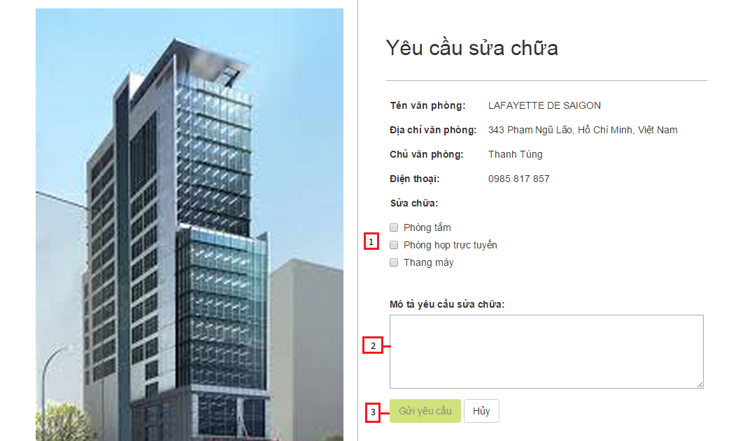

**Figure 166: Request Repair UI**

|  |  |
| --- | --- |
| **Step** | **Description** |
| 1 | Click the amenity tile that you want to repair  (E.g: Click “Phòng tắm”) |
| 2 | Fill in “Mô tả yêu cầu sửa chữa”  (E.g: Vòi nước hỏng) |
| 2 | Click “Gửi yêu cầu” |

**Table 97: Request Repair Step**