### **Setting up environment at server side**

The following software must be installed into the server machine:

#### **Hardware requirements**

Server computer for deploying with the minimum configuration:

* CPU Intel® Core 2 Duo
* 2GB RAM.
* 30GB of hard disk.
* Internet

#### **Software requirements**

* Web Server: Internet Information System – IIS 7.
* Operating system: Windows Server 2008, or above
* SQL Server 2008 Express, or above: used to create and manage database of web application.

### **Deployment at server side**

#### **Prepare deployment package**

* Extract the deployment package to a folder on the server.
* For example: E:\Capstone\capstone-ors\trunk\ORS\out\artifacts\ ORS_war_exploded

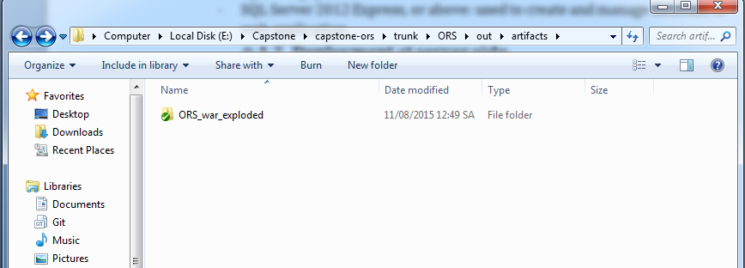

**Figure 158: Extract Deployment Package**

#### **Database Deployment**

* Open Microsoft SQL Server Management Studio 2012 and login with administration account.

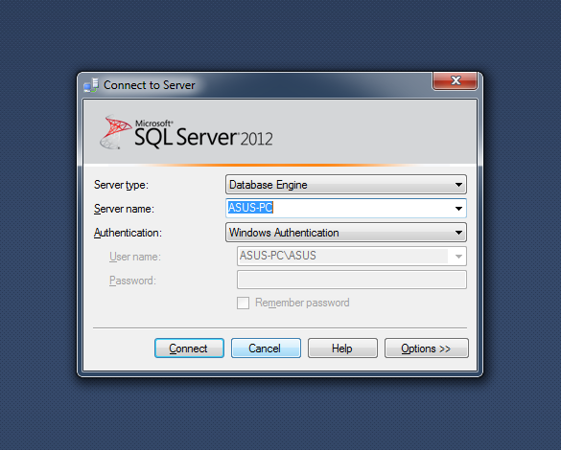

* Open “ORS_script.sql” in Microsoft SQL Server Management
* Change FILENAME to the directory of SQL Server Instance in your server.

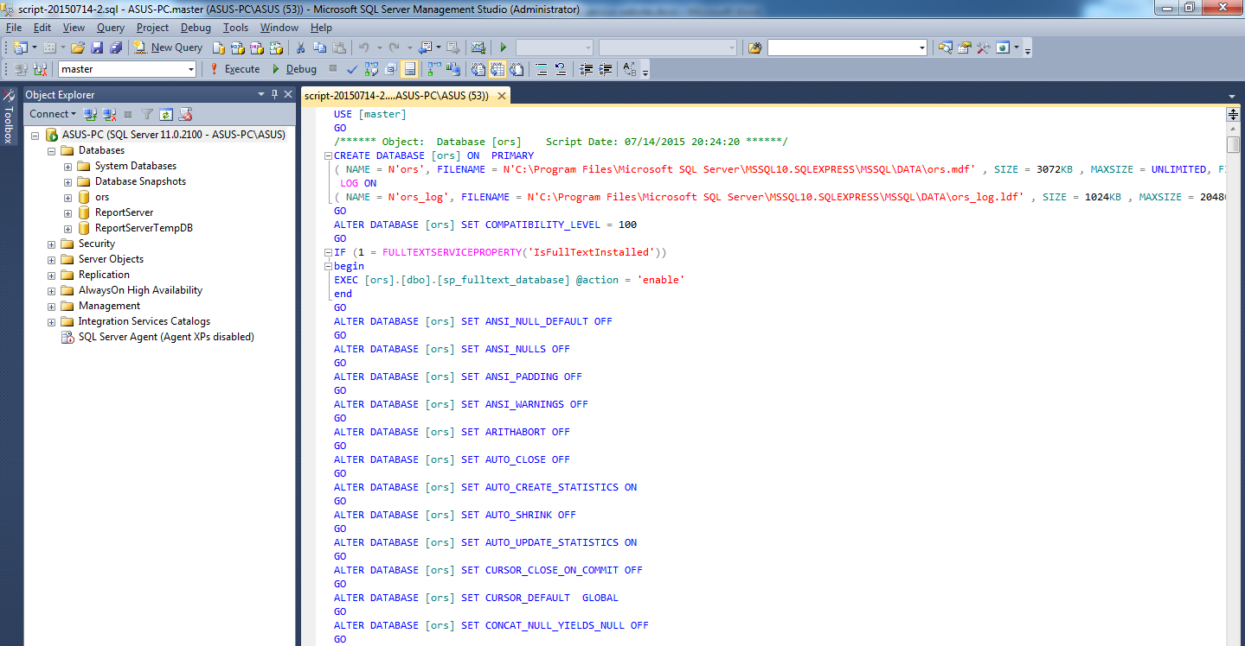

**Figure 160: Open database script**

* Execute the script

#### **Server configuration**

* Open the Internet Information System Manager
* Change the .NET Framework version to 4.0

**Figure 161: Configure Server**

#### **Deploy**

* Change the user ID, password and data source parts of connection string in hibernate.cfg.xml with your data

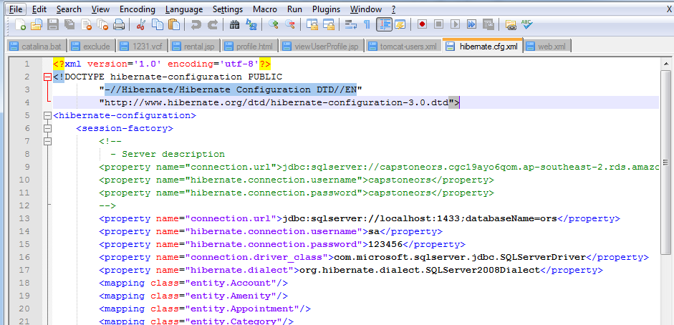

**Figure 160: Config hibernate.cfg.xml**

* Copy unpacked folder

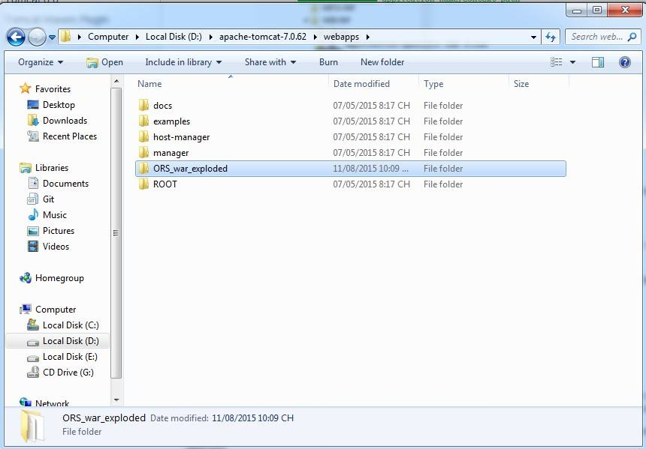

**Figure 160: Copy Unpacked Folder**

* Run server

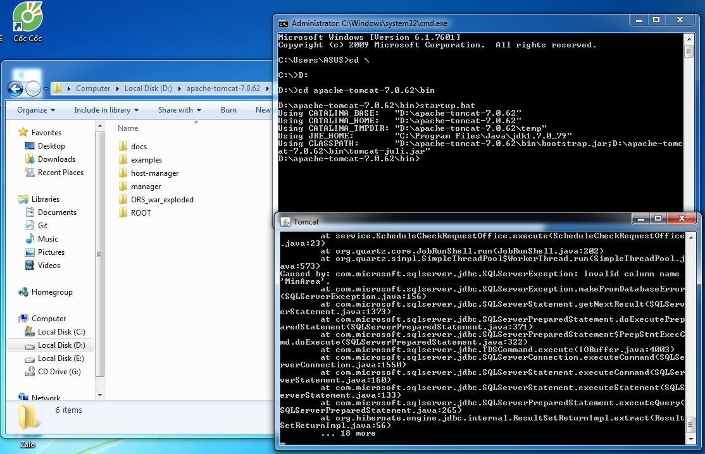

**Figure 160: Run Server**

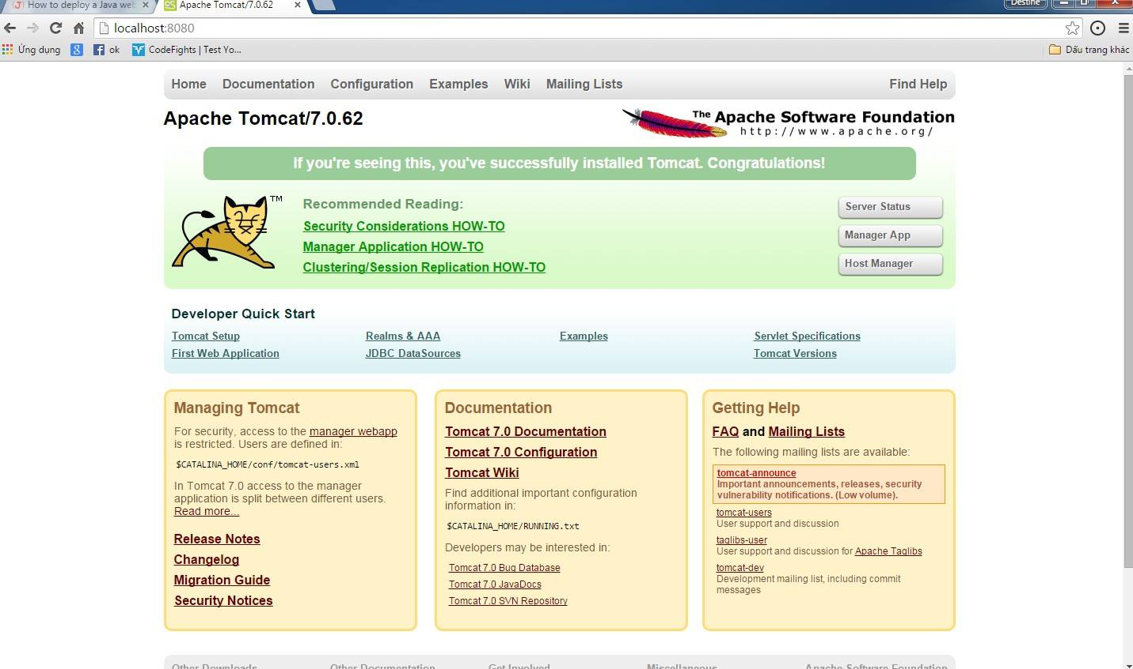

* Open <http://localhost:8080/manager/html> to check status

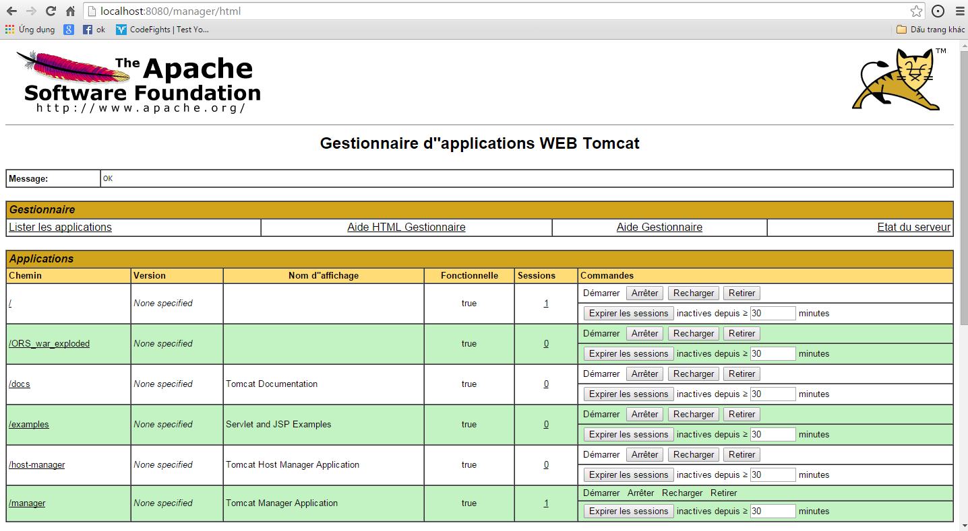

**Figure 160: Check Status Application**

* Open in <http://localhost:8080/>



**Figure 165: Deploy Web Application On Server**

### **Client side environment setting**

Client side should have one of these following browser:

* Google Chrome
* Firefox
* Internet Explorer