#### View amenity list

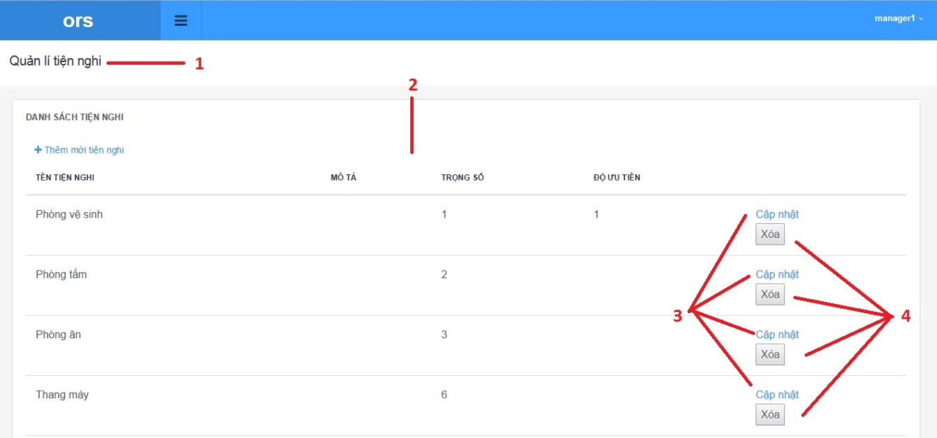

Figure 106: View amenity list

**Fields**

|  |  |  |  |  |  |  |  |
| --- | --- | --- | --- | --- | --- | --- | --- |
| **No** | **Field Name** | **Description** | **Read only** | **Mandatory** | **Control Type** | **Data Type** | **Length** |
| 1 | Page title | Title of amenity list | Yes | Yes | Label | N/A | N/A |
| 2 | Amenity list | List of amenity list has been sent | Yes | Yes | Listview | N/A | N/A |

**Buttons/Hyperlinks**

|  |  |  |  |  |
| --- | --- | --- | --- | --- |
| **No** | **Function** | **Description** | **Validation** | **Outcome** |
| 3 | Add amenity | Add amenity to amenity list | No | N/A |
| 4 | Remove amenity | Remove amenity from amenity list | No | Transfer to home page |

**Ameni list includes**

|  |  |  |  |  |  |
| --- | --- | --- | --- | --- | --- |
| **Field Name** | **Description** | **Read only** | **Control Type** | **Data Type** | **Length** |
| Amenity name | Name of amenity | Yes | Textview | String | N/A |
| Amenity description | Description of amenity | Yes | Textview | String | N/A |
| Amenity weight | Weight of amenity | Yes | Textview | Integer | N/A |
| Amenity priority | Priority of amenity | Yes | Textview | Integer | N/A |

#### Update amenity

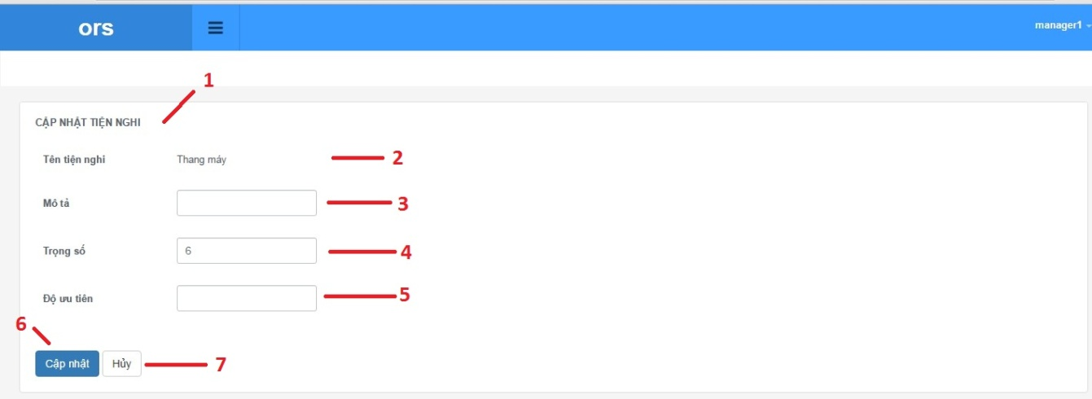

Figure 106: Update amenity

**Fields**

|  |  |  |  |  |  |  |  |
| --- | --- | --- | --- | --- | --- | --- | --- |
| **No** | **Field Name** | **Description** | **Read only** | **Mandatory** | **Control Type** | **Data Type** | **Length** |
| 1 | Page title | Title of amenity list | Yes | Yes | Label | N/A | N/A |
| 2 | Amenity name | Name of amenity | Yes | Yes | Label | N/A | N/A |
| 3 | Amenity description | Description of amenity | No | Yes | Textbox | N/A | N/A |
| 4 | Amenity weight | Weight of amenity | No | Yes | Textbox | N/A | N/A |
| 5 | Amenity priority | Priority of amenity | No | Yes | Textbox | N/A | N/A |

**Buttons/Hyperlinks**

|  |  |  |  |  |
| --- | --- | --- | --- | --- |
| **No** | **Function** | **Description** | **Validation** | **Outcome** |
| 6 | Update amenity | Add amenity to amenity list | Yes | N/A |
| 7 | Cancel | Return to amenity list | No | N/A |

**Amenity detail includes**

|  |  |  |  |  |  |
| --- | --- | --- | --- | --- | --- |
| **Field Name** | **Description** | **Read only** | **Control Type** | **Data Type** | **Length** |
| Amenity name | Name of amenity | Yes | Textview | String | N/A |
| Amenity description | Description of amenity | Yes | Textbox | String | N/A |
| Amenity weight | Weight of amenity | Yes | Textbox | Integer | N/A |
| Amenity priority | Priority of amenity | Yes | Textbox | Integer | N/A |

#### Delete amenity



Figure 106: Delete amenity

**Fields**

|  |  |  |  |  |  |  |  |
| --- | --- | --- | --- | --- | --- | --- | --- |
| **No** | **Field Name** | **Description** | **Read only** | **Mandatory** | **Control Type** | **Data Type** | **Length** |
| 1 | Page title | Title of amenity list | Yes | Yes | Label | N/A | N/A |
| 2 | Amenity list | List of amenity list has been sent | Yes | Yes | Listview | N/A | N/A |

**Buttons/Hyperlinks**

|  |  |  |  |  |
| --- | --- | --- | --- | --- |
| **No** | **Function** | **Description** | **Validation** | **Outcome** |
| 3 | Add amenity | Add amenity to amenity list | No | N/A |
| 4 | Remove amenity | Remove amenity from amenity list | No | Transfer to amenity page |

**Amenity list includes**

|  |  |  |  |  |  |
| --- | --- | --- | --- | --- | --- |
| **Field Name** | **Description** | **Read only** | **Control Type** | **Data Type** | **Length** |
| Amenity name | Name of amenity | Yes | Textview | String | N/A |
| Amenity description | Description of amenity | Yes | Textview | String | N/A |
| Amenity weight | Weight of amenity | Yes | Textview | Integer | N/A |
| Amenity priority | Priority of amenity | Yes | Textview | Integer | N/A |

#### Create amenity

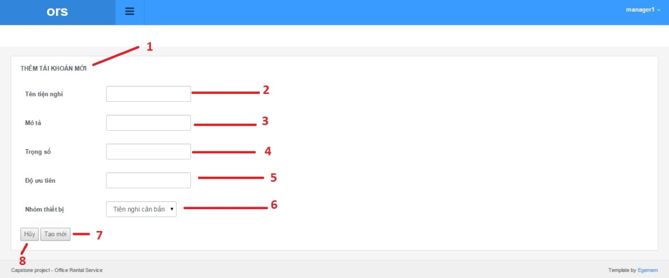

Figure 106: Create amenity

**Fields**

|  |  |  |  |  |  |  |  |
| --- | --- | --- | --- | --- | --- | --- | --- |
| **No** | **Field Name** | **Description** | **Read only** | **Mandatory** | **Control Type** | **Data Type** | **Length** |
| 1 | Page title | Title of amenity list | Yes | Yes | Label | N/A | N/A |
| 2 | Amenity name | Fill amenity name | No | Yes | Textbox | N/A | N/A |
| 3 | Amenity description | Fill amenity description | No | Yes | Textbox | N/A | N/A |
| 4 | Amenity weight | Fill amenity weight | No | Yes | Textbox | N/A | N/A |
| 5 | Amenity priority | Fill amenity priority | No | Yes | Textbox | N/A | N/A |
| 6 | Amenity group | Fill amenity group | No | Yes | Dropbox | N/A | N/A |

**Buttons/Hyperlinks**

|  |  |  |  |  |
| --- | --- | --- | --- | --- |
| **No** | **Function** | **Description** | **Validation** | **Outcome** |
| 7 | Add amenity | Add amenity to amenity list | No | N/A |
| 8 | Cancel | Return to amenity list page | No | Transfer to amenity page |

#### View appointment request list

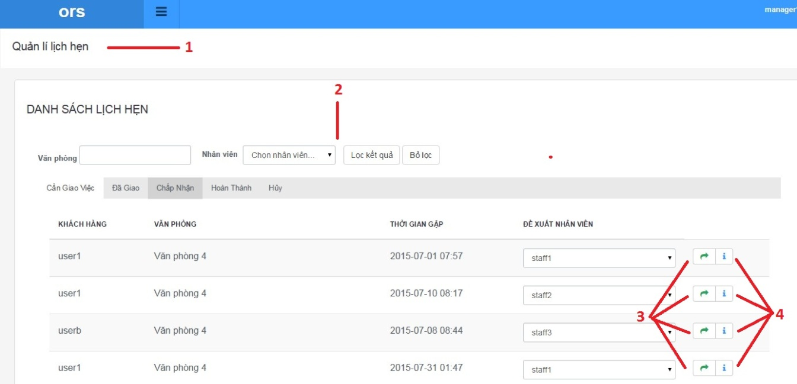

Figure 106: View appointment request list

**Fields**

|  |  |  |  |  |  |  |  |
| --- | --- | --- | --- | --- | --- | --- | --- |
| **No** | **Field Name** | **Description** | **Read only** | **Mandatory** | **Control Type** | **Data Type** | **Length** |
| 1 | Page title | Title of appointment request list | Yes | Yes | Label | N/A | N/A |
| 2 | Appointment list | List of request appointment list has been sent | Yes | Yes | Listview | N/A | N/A |

**Buttons/Hyperlinks**

|  |  |  |  |  |
| --- | --- | --- | --- | --- |
| **No** | **Function** | **Description** | **Validation** | **Outcome** |
| 3 | Assign staff | Auto assign staff | No | N/A |
| 4 | Information appointment request | Show information about appointment request and assign staff | No | Transfer to amenity page |

**Appointment request list includes**

|  |  |  |  |  |  |
| --- | --- | --- | --- | --- | --- |
| **Field Name** | **Description** | **Read only** | **Control Type** | **Data Type** | **Length** |
| Customer name | Name of customer | Yes | Textview | String | N/A |
| Office name | Description of office | Yes | Textview | String | N/A |
| Time meeting | Time to meet | Yes | Textview | Integer | N/A |
| Suggest staff | Suggest staff to assign | Yes | Dropbox | Integer | N/A |

#### View appointment request detail

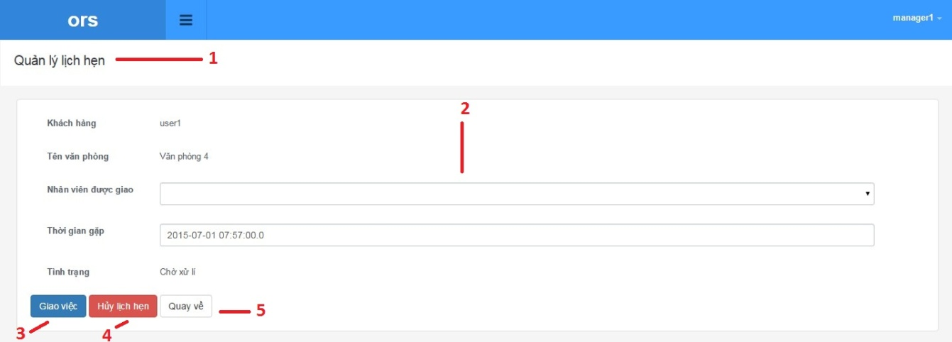

Figure 106: View appointment request detail

**Fields**

|  |  |  |  |  |  |  |  |
| --- | --- | --- | --- | --- | --- | --- | --- |
| **No** | **Field Name** | **Description** | **Read only** | **Mandatory** | **Control Type** | **Data Type** | **Length** |
| 1 | Page title | Title of appointment | Yes | Yes | Label | N/A | N/A |
| 2 | appointment information | Information of appointment | No | Yes | Textbox | N/A | N/A |

**Buttons/Hyperlinks**

|  |  |  |  |  |
| --- | --- | --- | --- | --- |
| **No** | **Function** | **Description** | **Validation** | **Outcome** |
| 3 | Assign staff | Add amenity to amenity list | Yes | N/A |
| 4 | Cancel appointment | Cancel appointment | Yes | N/A |
| 5 | Come back | Return to appointment list | No | N/A |

**Appointment detail includes**

|  |  |  |  |  |  |
| --- | --- | --- | --- | --- | --- |
| **Field Name** | **Description** | **Read only** | **Control Type** | **Data Type** | **Length** |
| Customer username | Username of customer | Yes | Textview | String | N/A |
| Office name | Description of amenity | Yes | Textview | String | N/A |
| Assigned staff | Weight of amenity | No | Dropbox | String | N/A |
| Time meeting | Priority of amenity | No | Textbox | Date time | N/A |
| Status | Status of appointment | Yes | Textview | String | N/A |

#### View amenity group list

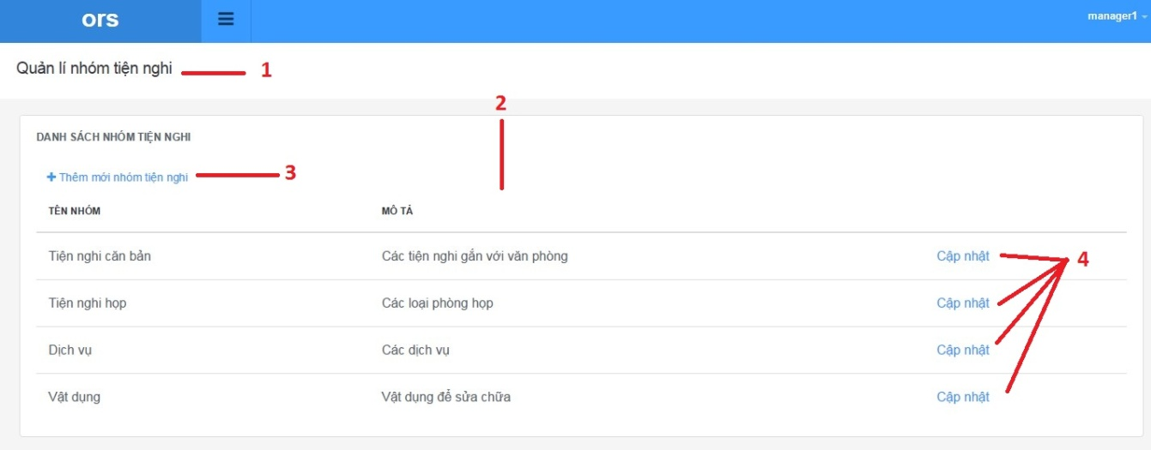

Figure 106: View amenity group list

**Fields**

|  |  |  |  |  |  |  |  |
| --- | --- | --- | --- | --- | --- | --- | --- |
| **No** | **Field Name** | **Description** | **Read only** | **Mandatory** | **Control Type** | **Data Type** | **Length** |
| 1 | Page title | Title of amenity group list | Yes | Yes | Label | N/A | N/A |
| 2 | Amenity group list infomation | Information of amenity group list | Yes | Yes | Label | N/A | N/A |

**Buttons/Hyperlinks**

|  |  |  |  |  |
| --- | --- | --- | --- | --- |
| **No** | **Function** | **Description** | **Validation** | **Outcome** |
| 3 | Add new amenity group | Add amenity group to amenity group list | No | N/A |
| 4 | Update amenity group | Update amenity group | No | N/A |

**Amenity group list includes**

|  |  |  |  |  |  |
| --- | --- | --- | --- | --- | --- |
| **Field Name** | **Description** | **Read only** | **Control Type** | **Data Type** | **Length** |
| Amenity group name | Name of amenity group | Yes | Textview | String | N/A |
| Amenity group description | Description of amenity | Yes | Textview | String | N/A |

#### Add new amenity group

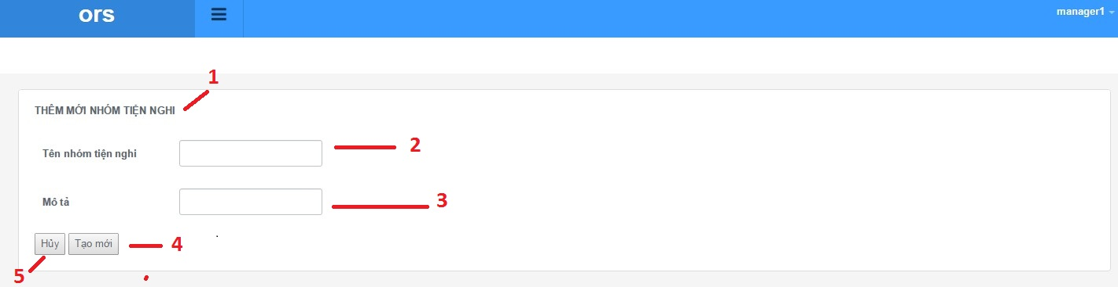

Figure 106: Add new amenity group

**Fields**

|  |  |  |  |  |  |  |  |
| --- | --- | --- | --- | --- | --- | --- | --- |
| **No** | **Field Name** | **Description** | **Read only** | **Mandatory** | **Control Type** | **Data Type** | **Length** |
| 1 | Page title | Title of amenity group | Yes | Yes | Label | N/A | N/A |
| 2 | Amenity group name | Fill amenity group name | No | Yes | Textbox | N/A | N/A |
| 3 | Amenity group description | Fill amenity group description | No | No | Textbox | N/A | N/A |

**Buttons/Hyperlinks**

|  |  |  |  |  |
| --- | --- | --- | --- | --- |
| **No** | **Function** | **Description** | **Validation** | **Outcome** |
| 4 | Add new amenity group | Add amenity group to amenity group list | Yes | N/A |
| 5 | Cancel | Go to amenity group list page | No | N/A |

#### Update amenity group

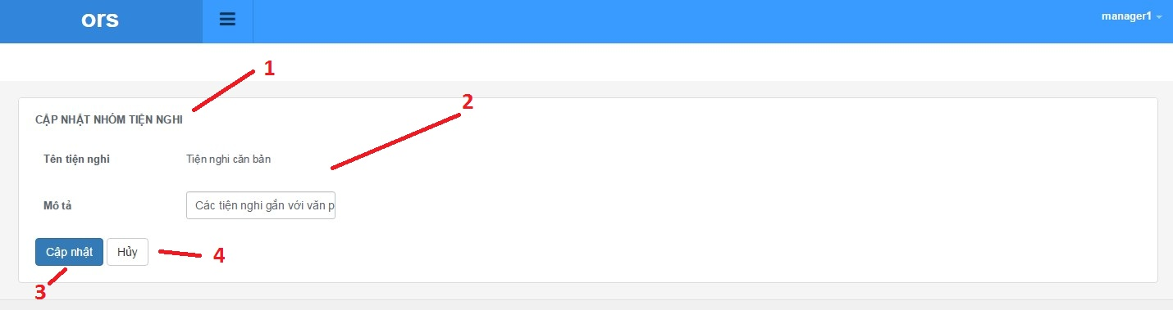

Figure 106: Update amenity group

**Fields**

|  |  |  |  |  |  |  |  |
| --- | --- | --- | --- | --- | --- | --- | --- |
| **No** | **Field Name** | **Description** | **Read only** | **Mandatory** | **Control Type** | **Data Type** | **Length** |
| 1 | Page title | Title of amenity list | Yes | Yes | Label | N/A | N/A |
| 2 | Amenity group information | Information of amenity | No | Yes | Label | N/A | N/A |

**Buttons/Hyperlinks**

|  |  |  |  |  |
| --- | --- | --- | --- | --- |
| **No** | **Function** | **Description** | **Validation** | **Outcome** |
| 3 | Update amenity | Add amenity group to amenity group list | Yes | N/A |
| 4 | Cancel | Return to amenity group list | No | N/A |

**Amenity detail includes**

|  |  |  |  |  |  |
| --- | --- | --- | --- | --- | --- |
| **Field Name** | **Description** | **Read only** | **Control Type** | **Data Type** | **Length** |
| Amenity group name | Name of amenity group | Yes | Label | String | N/A |
| Amenity group description | Description of amenity | Yes | Textbox | String | N/A |

#### View user list

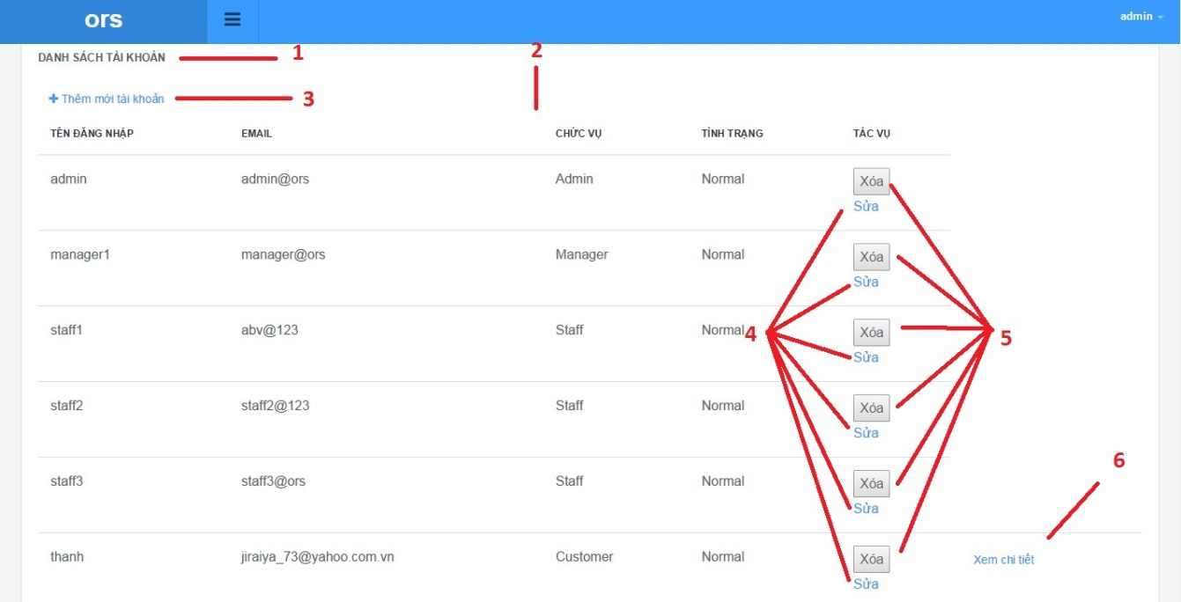

Figure 106: View user list

**Fields**

|  |  |  |  |  |  |  |  |
| --- | --- | --- | --- | --- | --- | --- | --- |
| **No** | **Field Name** | **Description** | **Read only** | **Mandatory** | **Control Type** | **Data Type** | **Length** |
| 1 | Page title | Title of user list | Yes | Yes | Label | N/A | N/A |
| 2 | User list infomation | Information of amenity group list | Yes | Yes | Label | N/A | N/A |

**Buttons/Hyperlinks**

|  |  |  |  |  |
| --- | --- | --- | --- | --- |
| **No** | **Function** | **Description** | **Validation** | **Outcome** |
| 3 | Add new user | Add amenity group to amenity group list | No | N/A |
| 4 | Update user information | Update amenity group | No | N/A |
| 5 | Delete user | Delete account user | No | N/A |
| 6 | Detail user | Show information about user | No | N/A |

**User list includes**

|  |  |  |  |  |  |
| --- | --- | --- | --- | --- | --- |
| **Field Name** | **Description** | **Read only** | **Control Type** | **Data Type** | **Length** |
| Username | Username of user | Yes | Textview | String | N/A |
| Email | Email of user | Yes | Textview | String | N/A |
| Role | Role of user | Yes | Textview | String | N/A |
| Status | Status of user | Yes | Textview | String | N/A |
| Action | Action of website | Yes | Textview | String | N/A |

#### Add new user

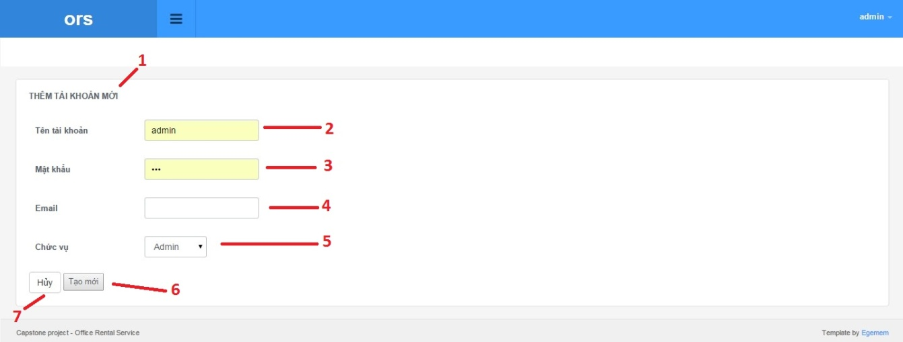

Figure 106: Add new user

**Fields**

|  |  |  |  |  |  |  |  |
| --- | --- | --- | --- | --- | --- | --- | --- |
| **No** | **Field Name** | **Description** | **Read only** | **Mandatory** | **Control Type** | **Data Type** | **Length** |
| 1 | Page title | Title of add user page | Yes | Yes | Label | N/A | N/A |
| 2 | Username | Fill username of user | No | Yes | Textbox | N/A | N/A |
| 3 | Password | Fill password of user | No | Yes | Textbox | N/A | N/A |
| 4 | Email | Fill email of user | No | No | Textbox | N/A | N/A |
| 5 | Role | Choose role of user | No | Yes | Dropbox | N/A | N/A |

**Buttons/Hyperlinks**

|  |  |  |  |  |
| --- | --- | --- | --- | --- |
| **No** | **Function** | **Description** | **Validation** | **Outcome** |
| 6 | Add new user | Add account to account list | Yes | N/A |
| 7 | Cancel | Go to user list page | No | N/A |

#### Update user

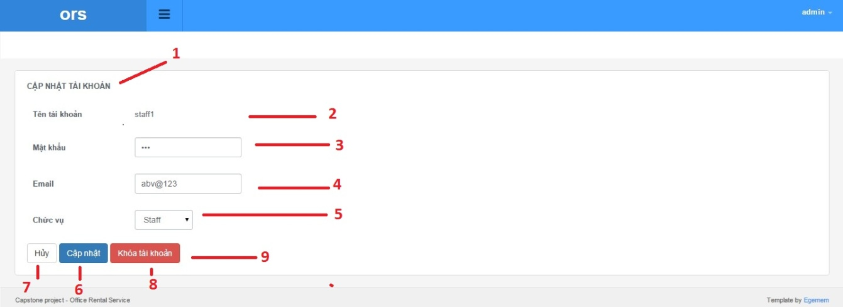

Figure 106: Update user

**Fields**

|  |  |  |  |  |  |  |  |
| --- | --- | --- | --- | --- | --- | --- | --- |
| **No** | **Field Name** | **Description** | **Read only** | **Mandatory** | **Control Type** | **Data Type** | **Length** |
| 1 | Page title | Title of add user page | Yes | Yes | Label | N/A | N/A |
| 2 | Username | Fill username of user | No | Yes | Label | N/A | N/A |
| 3 | Password | Fill password of user | No | Yes | Textbox | N/A | N/A |
| 4 | Email | Fill email of user | No | No | Textbox | N/A | N/A |
| 5 | Role | Choose role of user | No | Yes | Dropbox | N/A | N/A |

**Buttons/Hyperlinks**

|  |  |  |  |  |
| --- | --- | --- | --- | --- |
| **No** | **Function** | **Description** | **Validation** | **Outcome** |
| 6 | Update | update account infomation | Yes | N/A |
| 7 | Cancel | Go to user list page | No | N/A |
| 8 | Ban | Ban account user | Yes | N/A |
| 9 | Unban | Unban account user | Yes | N/A |

#### View user profile

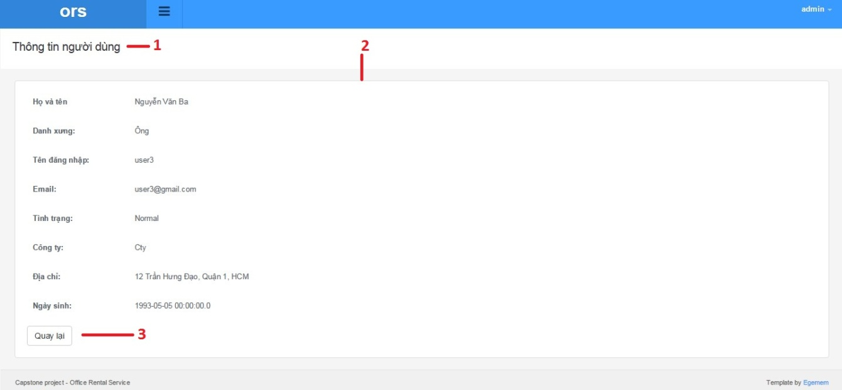

Figure 106: View user profile

**Fields**

|  |  |  |  |  |  |  |  |
| --- | --- | --- | --- | --- | --- | --- | --- |
| **No** | **Field Name** | **Description** | **Read only** | **Mandatory** | **Control Type** | **Data Type** | **Length** |
| 1 | Page title | Title of user profile | Yes | Yes | Label | N/A | N/A |
| 2 | User information | Information of amenity group list | Yes | Yes | Label | N/A | N/A |

**Buttons/Hyperlinks**

|  |  |  |  |  |
| --- | --- | --- | --- | --- |
| **No** | **Function** | **Description** | **Validation** | **Outcome** |
| 3 | Back | Go to user list page | No | N/A |

**User profile includes**

|  |  |  |  |  |  |
| --- | --- | --- | --- | --- | --- |
| **Field Name** | **Description** | **Read only** | **Control Type** | **Data Type** | **Length** |
| Full name | Full name of user | Yes | Textview | String | N/A |
| Title | Title of user | Yes | Textview | String | N/A |
| Username | Username of user | Yes | Textview | String | N/A |
| Email | Email of user | Yes | Textview | String | N/A |
| Status | Status of user | Yes | Textview | String | N/A |
| Company | Company of user | Yes | Textview | String | N/A |
| Address | Address of user | Yes | Textview | String | N/A |
| Birthday | Birthday of user | Yes | Textview | String | N/A |

#### View retal detail

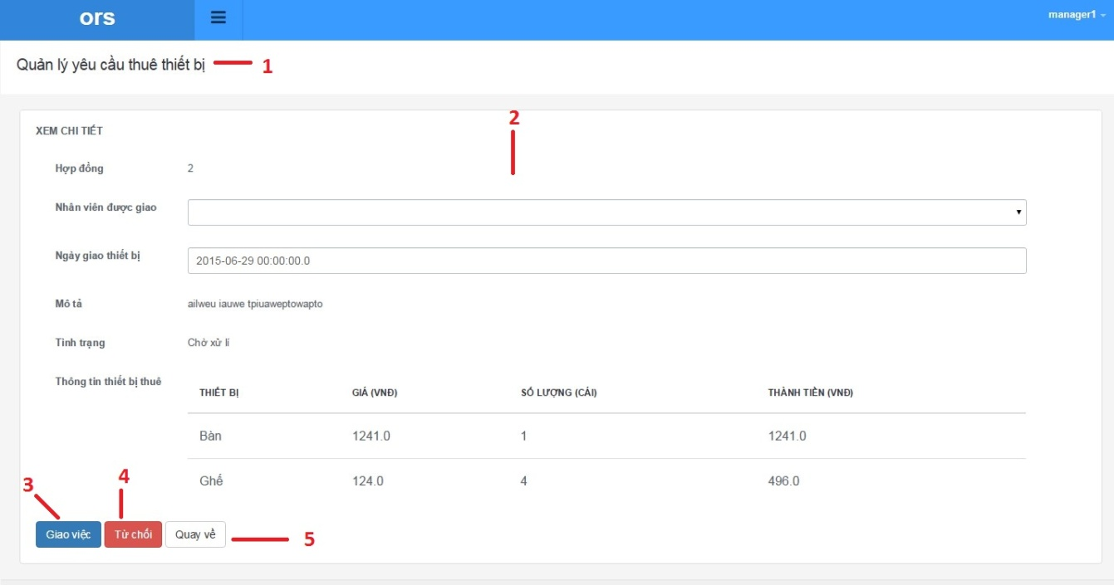

Figure 106: View rental detail

**Fields**

|  |  |  |  |  |  |  |  |
| --- | --- | --- | --- | --- | --- | --- | --- |
| **No** | **Field Name** | **Description** | **Read only** | **Mandatory** | **Control Type** | **Data Type** | **Length** |
| 1 | Page title | Title of rental detail | Yes | Yes | Label | N/A | N/A |
| 2 | Rental information | Information of rental detail | Yes | Yes | Label | N/A | N/A |

**Buttons/Hyperlinks**

|  |  |  |  |  |
| --- | --- | --- | --- | --- |
| **No** | **Function** | **Description** | **Validation** | **Outcome** |
| 3 | Assign staff | Assign rental for suggest staff | Yes | N/A |
| 4 | Cancel rental | Go to rental detail page | No | N/A |
| 5 | Back | Go to rental list page | No | N/A |

**Retal detail includes**

|  |  |  |  |  |  |
| --- | --- | --- | --- | --- | --- |
| **Field Name** | **Description** | **Read only** | **Control Type** | **Data Type** | **Length** |
| Id | Id of rental | Yes | Textview | String | N/A |
| Staff | Name of assigned staff | No | Dropbox | String | N/A |
| Assigned day | Create date of rental | No | Dropbox | String | N/A |
| Description | Description of rental | Yes | Textview | String | N/A |
| Status | Tool for auto assign staff | Yes | Textview | String | N/A |
| Rental item list | Table of rental item | Yes | Textview | String | N/A |
| Retal item name | Name of rental item | Yes | Textview | String | N/A |
| Price | Price of rental item | Yes | Textview | String | N/A |
| Number | Number of rental item | Yes | Textview | String | N/A |
| Total | Total price | Yes | Textview | String | N/A |

#### View retal list

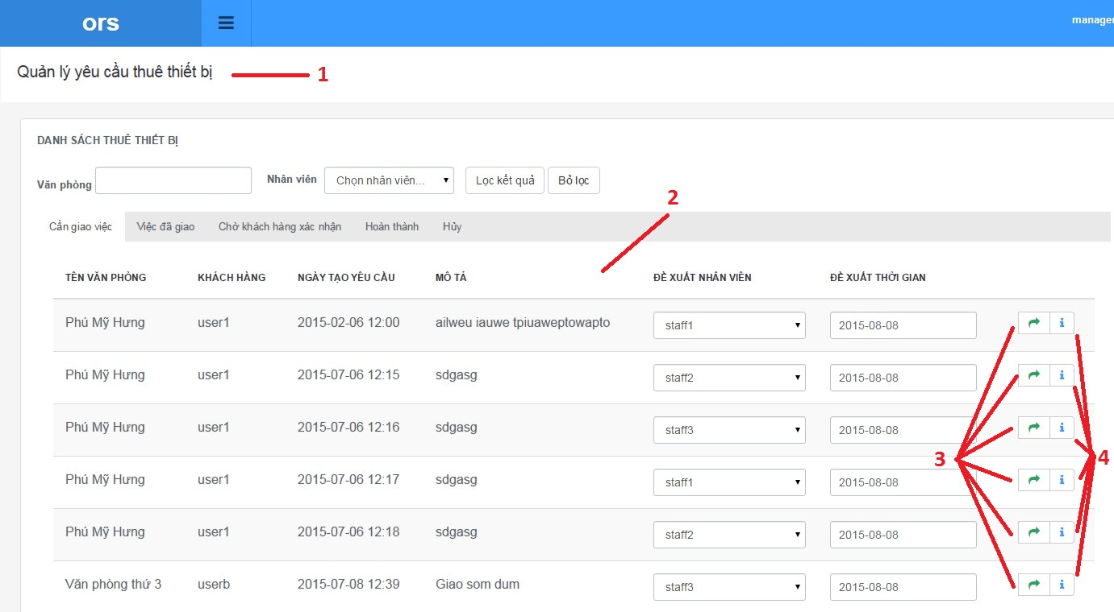

Figure 106: View rental list

**Fields**

|  |  |  |  |  |  |  |  |
| --- | --- | --- | --- | --- | --- | --- | --- |
| **No** | **Field Name** | **Description** | **Read only** | **Mandatory** | **Control Type** | **Data Type** | **Length** |
| 1 | Page title | Title of rental list | Yes | Yes | Label | N/A | N/A |
| 2 | Rental information | Information rental list | Yes | Yes | Label | N/A | N/A |

**Buttons/Hyperlinks**

|  |  |  |  |  |
| --- | --- | --- | --- | --- |
| **No** | **Function** | **Description** | **Validation** | **Outcome** |
| 3 | Assign staff | Assign rental for suggest staff | No | N/A |
| 4 | Rental detail | Go to rental detail page | No | N/A |

**Retal list includes**

|  |  |  |  |  |  |
| --- | --- | --- | --- | --- | --- |
| **Field Name** | **Description** | **Read only** | **Control Type** | **Data Type** | **Length** |
| Office name | Name of office | Yes | Textview | String | N/A |
| Customer name | Name of customer | Yes | Textview | String | N/A |
| Create date | Create date of rental | Yes | Textview | String | N/A |
| Description | Description of rental | Yes | Textview | String | N/A |
| Suggest staff | Tool for auto assign staff | Yes | Textview | String | N/A |
| Suggest time | Tool for auto assign time | Yes | Textview | String | N/A |

#### View retal item list

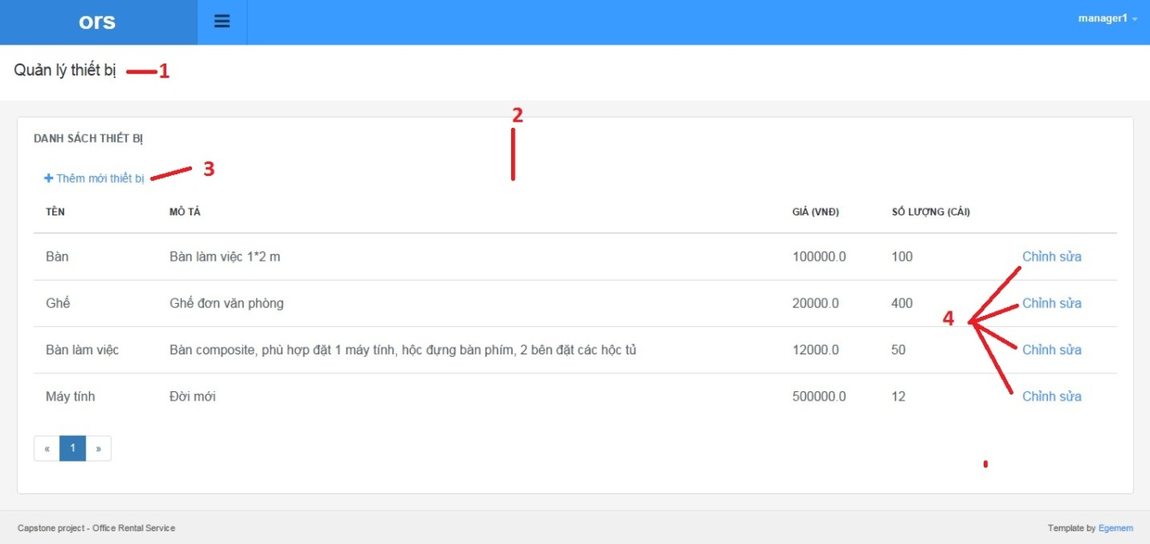

Figure 106: View rental item list

**Fields**

|  |  |  |  |  |  |  |  |
| --- | --- | --- | --- | --- | --- | --- | --- |
| **No** | **Field Name** | **Description** | **Read only** | **Mandatory** | **Control Type** | **Data Type** | **Length** |
| 1 | Page title | Title of rental item list | Yes | Yes | Label | N/A | N/A |
| 2 | Rental information | Information rental item list | Yes | Yes | Label | N/A | N/A |

**Buttons/Hyperlinks**

|  |  |  |  |  |
| --- | --- | --- | --- | --- |
| **No** | **Function** | **Description** | **Validation** | **Outcome** |
| 3 | Add new | Add new rental item | No | N/A |
| 4 | Update | Update rental item | No | N/A |

**Retal list includes**

|  |  |  |  |  |  |
| --- | --- | --- | --- | --- | --- |
| **Field Name** | **Description** | **Read only** | **Control Type** | **Data Type** | **Length** |
| Name | Name of item rental | Yes | Textview | String | N/A |
| Description | Description of item rental | Yes | Textview | String | N/A |
| Price | Price of item rental | Yes | Textview | String | N/A |
| Number | Number of item rental | Yes | Textview | String | N/A |

#### Add new rental item

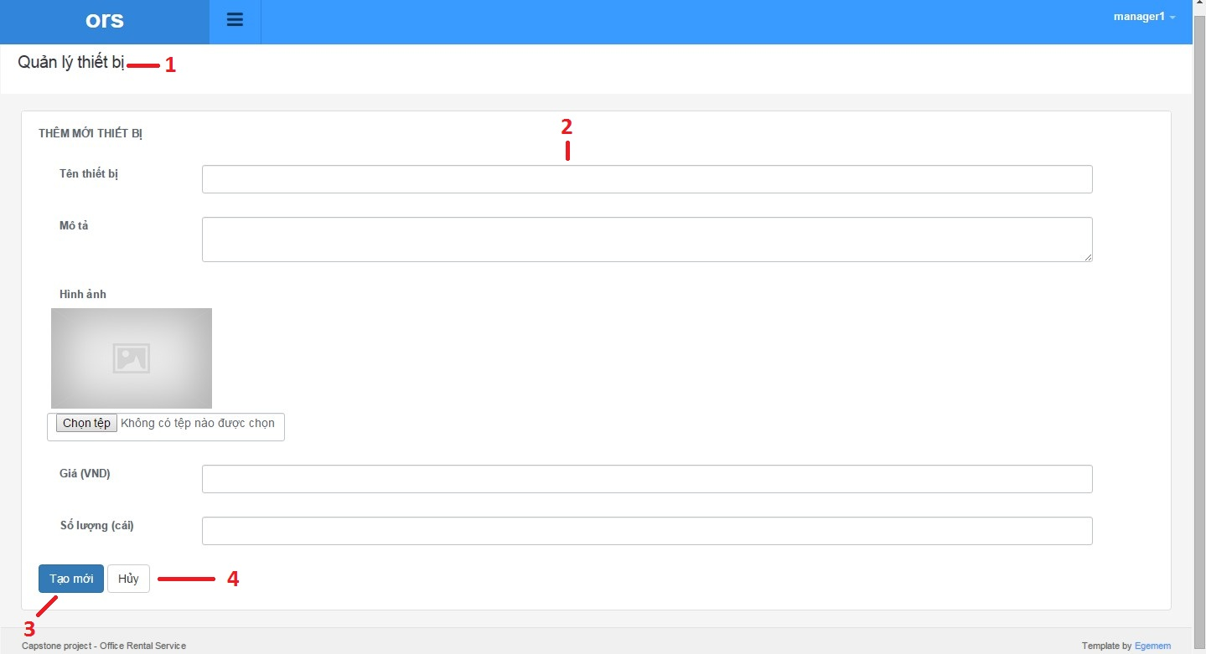

Figure 106 Add new rental item

**Fields**

|  |  |  |  |  |  |  |  |
| --- | --- | --- | --- | --- | --- | --- | --- |
| **No** | **Field Name** | **Description** | **Read only** | **Mandatory** | **Control Type** | **Data Type** | **Length** |
| 1 | Page title | Title of add rental item | Yes | Yes | Label | N/A | N/A |
| 2 | Rental information | Information rental item list | Yes | Yes | Label | N/A | N/A |

**Buttons/Hyperlinks**

|  |  |  |  |  |
| --- | --- | --- | --- | --- |
| **No** | **Function** | **Description** | **Validation** | **Outcome** |
| 3 | Add new | Add new rental item | No | N/A |
| 4 | Cancel | Cancel add new rental item | No | N/A |

**Retal list includes**

|  |  |  |  |  |  |
| --- | --- | --- | --- | --- | --- |
| **Field Name** | **Description** | **Read only** | **Control Type** | **Data Type** | **Length** |
| Name | Name of item rental | Yes | Textbox | String | N/A |
| Description | Description of item rental | Yes | Textbox | String | N/A |
| Picture | Picture of item rental | Yes | Textbox | String | N/A |
| Price | Price of item rental | Yes | Textbox | String | N/A |
| Number | Number of item rental | Yes | Textbox | String | N/A |

#### Update retal item

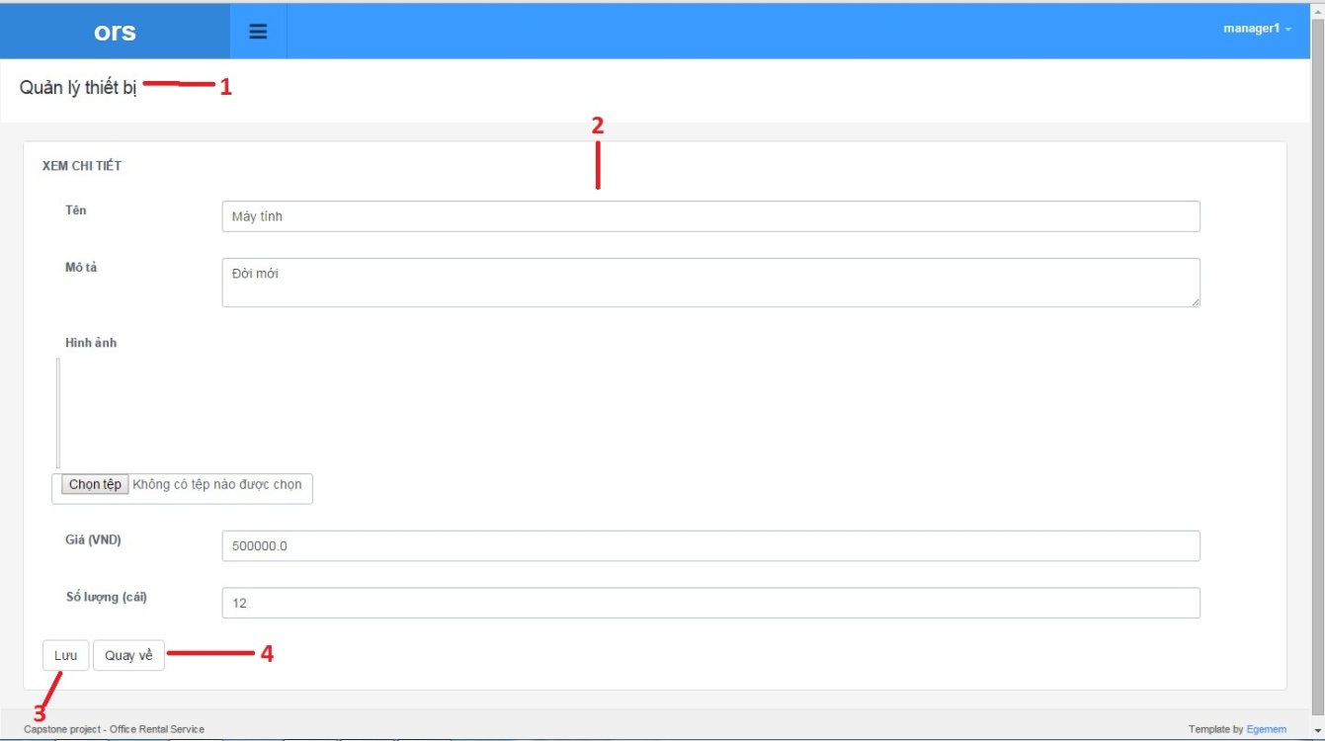

Figure 106 Update rental item

**Fields**

|  |  |  |  |  |  |  |  |
| --- | --- | --- | --- | --- | --- | --- | --- |
| **No** | **Field Name** | **Description** | **Read only** | **Mandatory** | **Control Type** | **Data Type** | **Length** |
| 1 | Page title | Title of update rental item | Yes | Yes | Label | N/A | N/A |
| 2 | Rental information | Information rental item list | Yes | Yes | Label | N/A | N/A |

**Buttons/Hyperlinks**

|  |  |  |  |  |
| --- | --- | --- | --- | --- |
| **No** | **Function** | **Description** | **Validation** | **Outcome** |
| 3 | Save | Save rental item detail | No | N/A |
| 4 | Cancel | Cancel update rental item | No | N/A |

**Retal list includes**

|  |  |  |  |  |  |
| --- | --- | --- | --- | --- | --- |
| **Field Name** | **Description** | **Read only** | **Control Type** | **Data Type** | **Length** |
| Name | Name of item rental | Yes | Textbox | String | N/A |
| Description | Description of item rental | Yes | Textbox | String | N/A |
| Picture | Picture of item rental | Yes | Textbox | String | N/A |
| Price | Price of item rental | Yes | Textbox | String | N/A |
| Number | Number of item rental | Yes | Textbox | String | N/A |