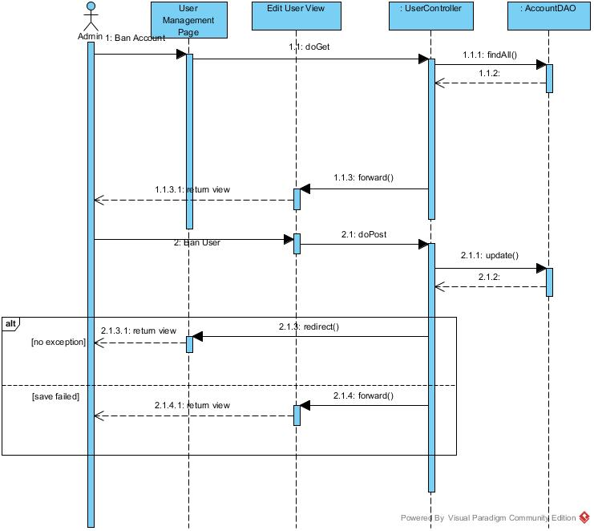

Figure ?? :<Admin> Ban account Sequence Diagram

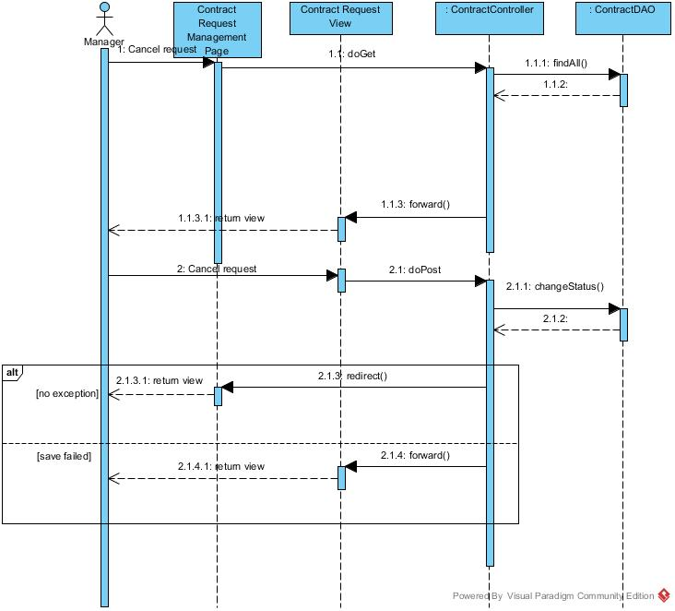

Figure ?? :<Manager> Cancel request Sequence Diagram

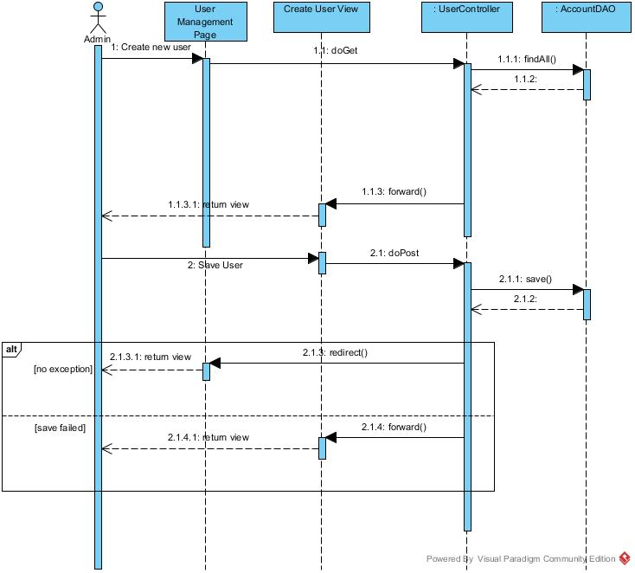

Figure ?? :<Admin> Create Account Sequence Diagram

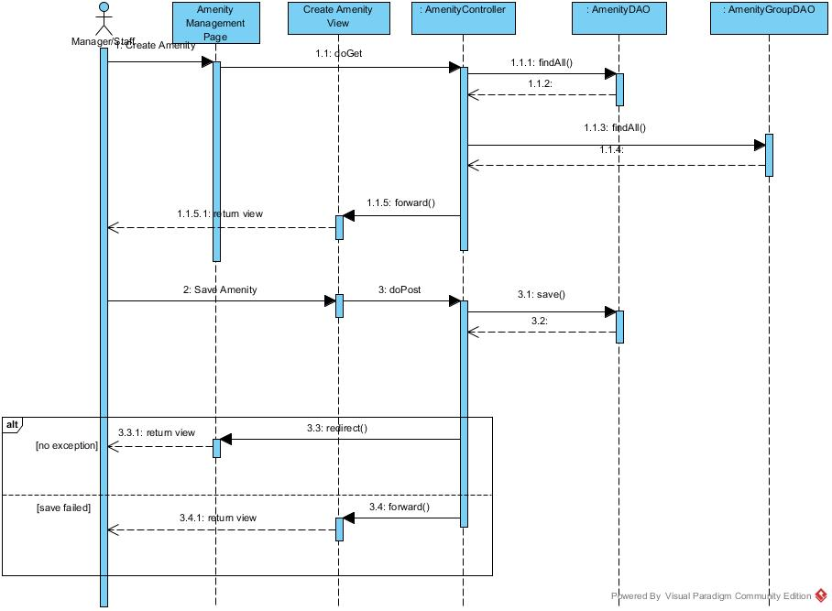

Figure ?? :<Manager, Staff> Create Amenity Sequence Diagram

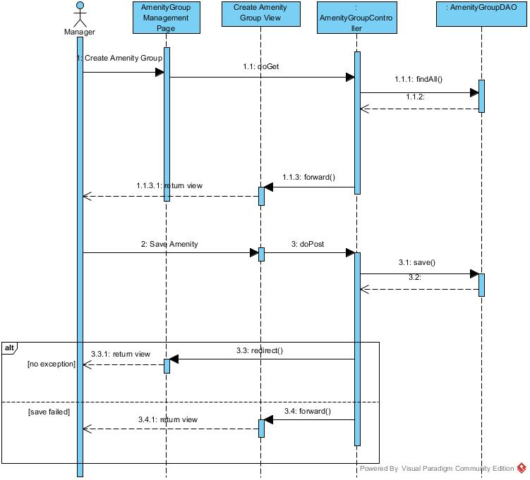

Figure ?? :<Manager> Create Amenity Group Sequence Diagram

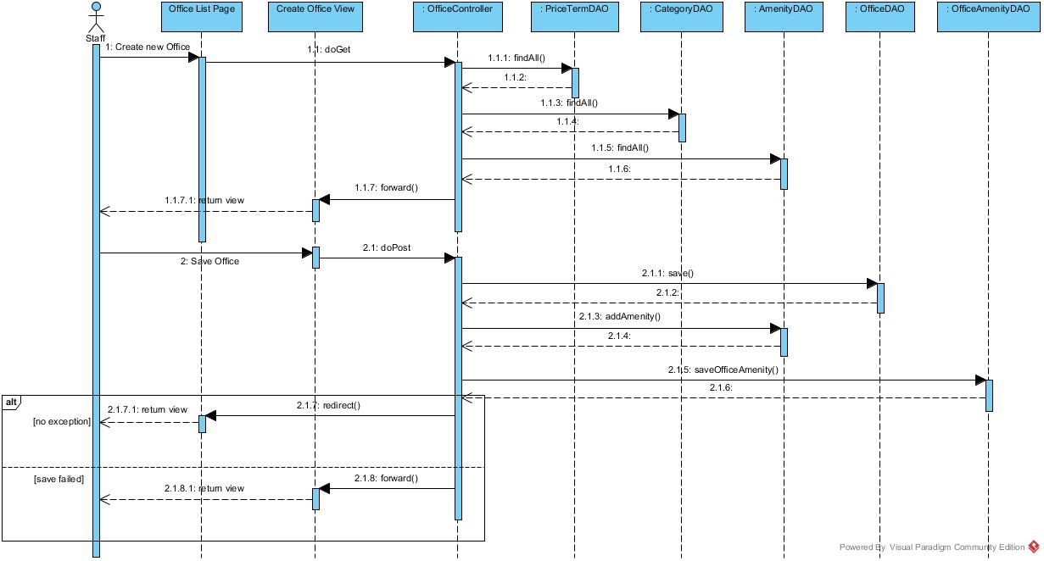

Figure ?? :<Staff> Create New Office Sequence Diagram

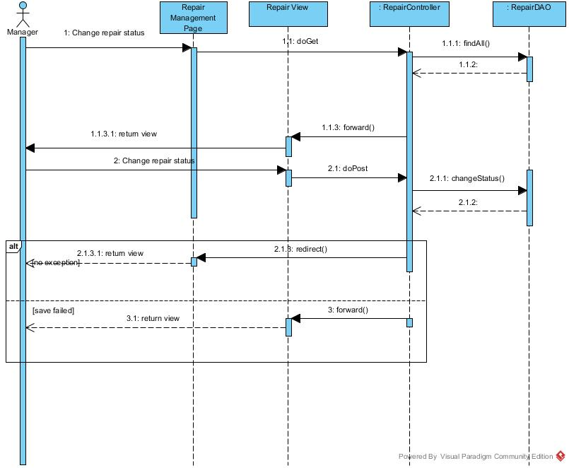

Figure ?? :Change Repair Status Sequence Diagram

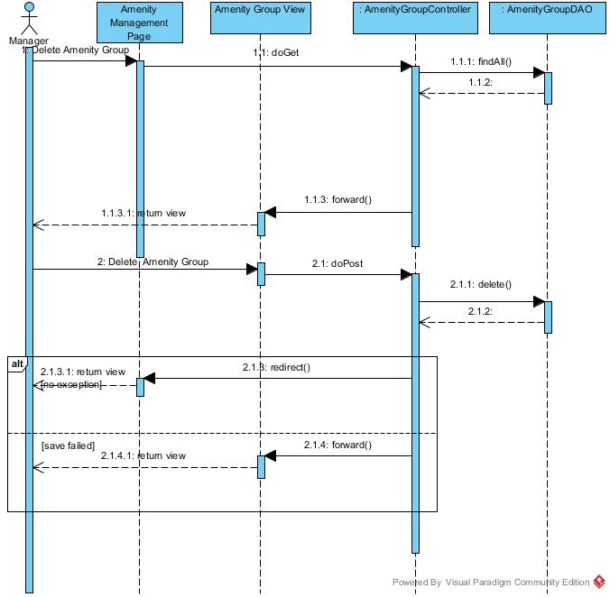

Figure ?? :<Manager> Create Amenity Group Sequence Diagram

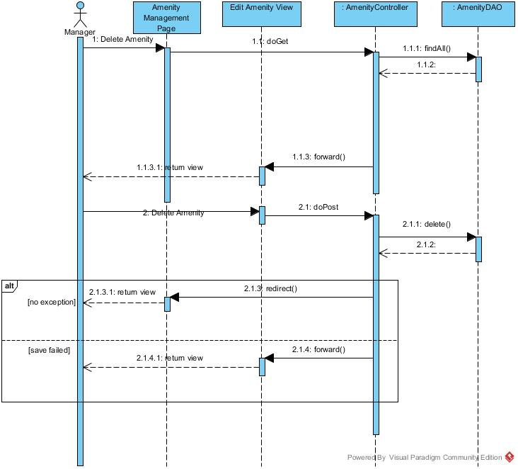

Figure ?? :<Manager> Delete Amenity Sequence Diagram

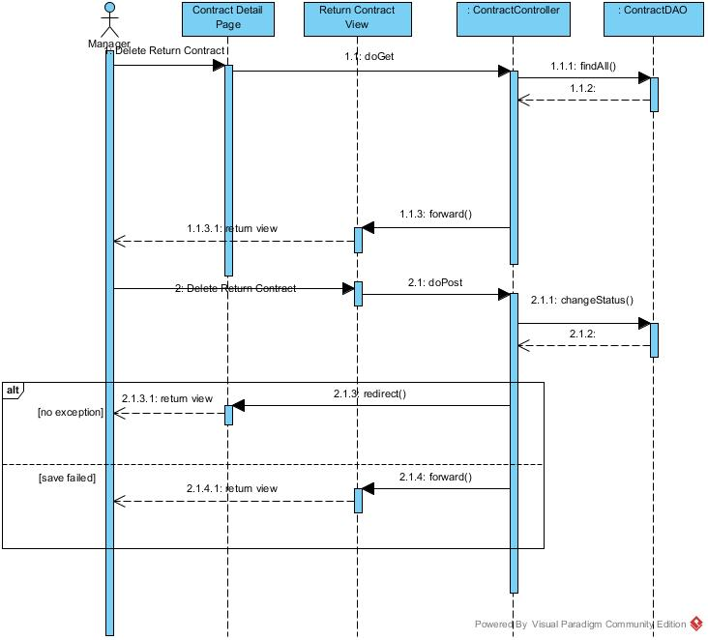

Figure ?? : <Manager> Delete Return Contract Sequence Diagram

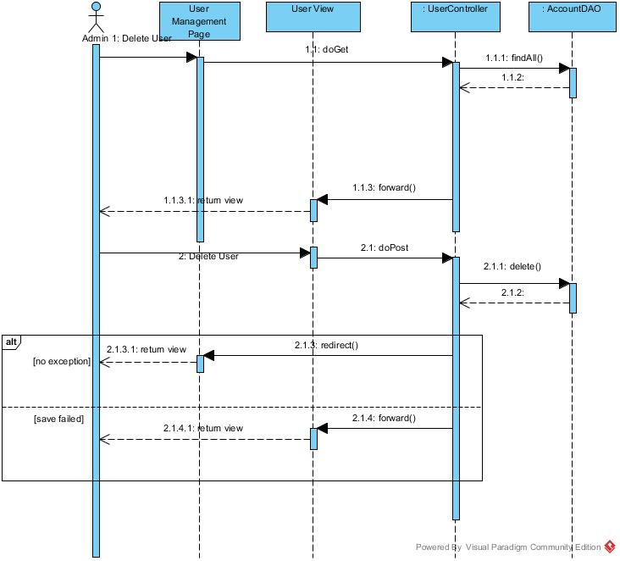

Figure ?? :<Admin> Delete User Sequence Diagram

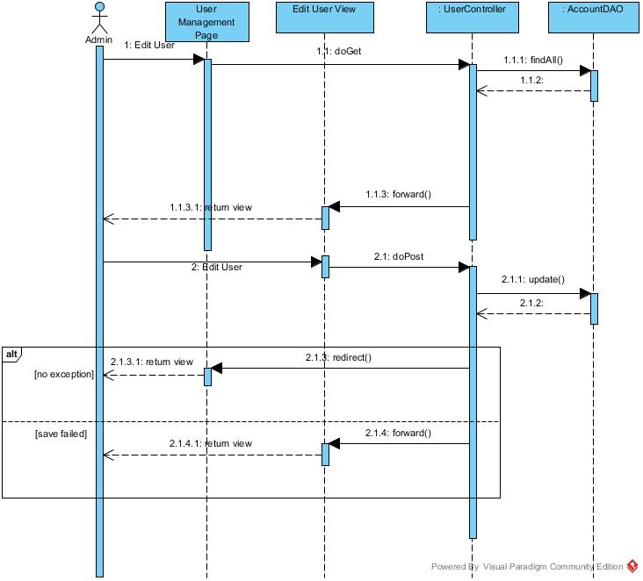

Figure ?? :<Admin> Edit User Sequence Diagram

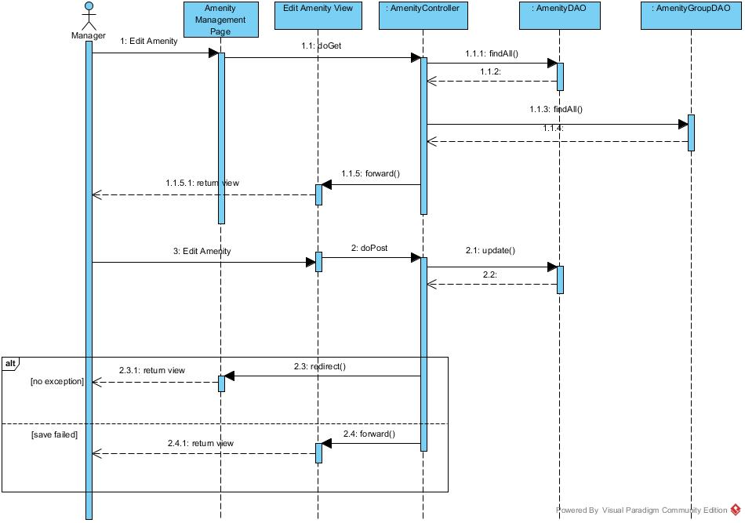

Figure ?? :<Manager> Edit Amenity Sequence Diagram

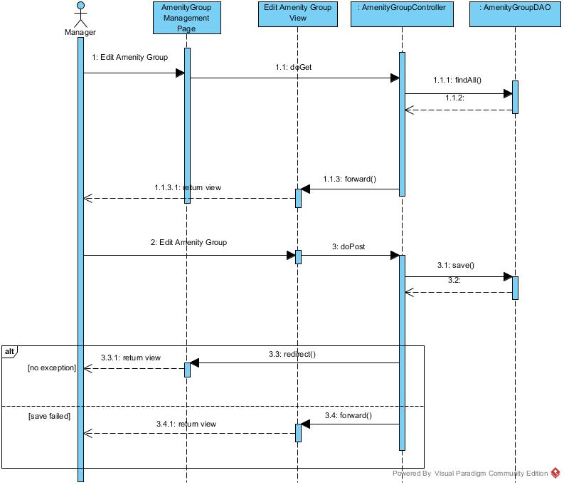

Figure ?? :<Manager>Edit Amenity Group Sequence Diagram

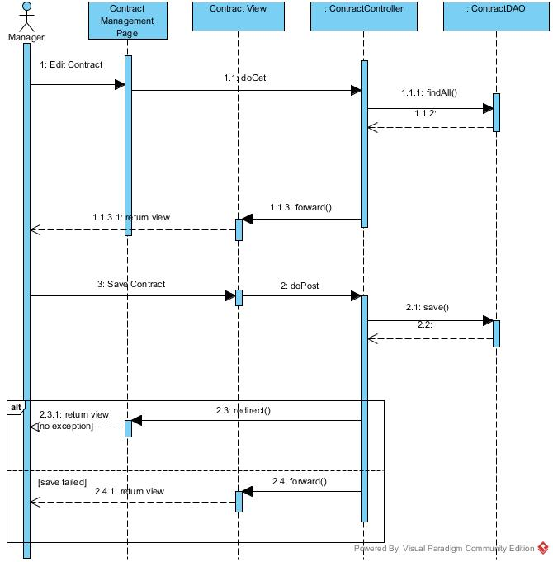

Figure ?? :<Manager> Edit ContractSequence Diagram

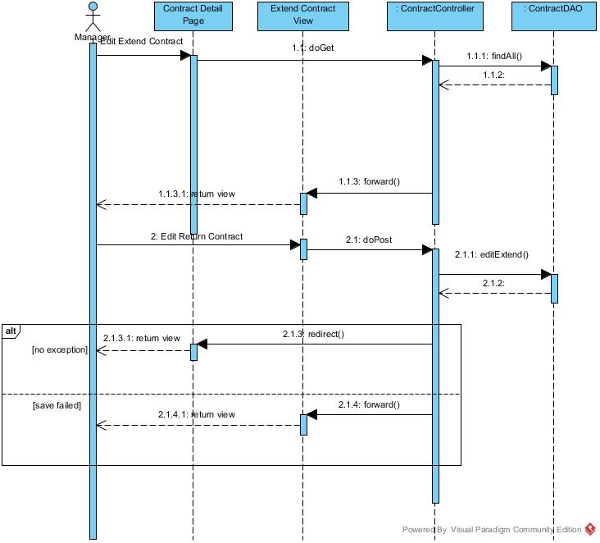

Figure ?? :<Manager>Edit Extend Contract Sequence Diagram

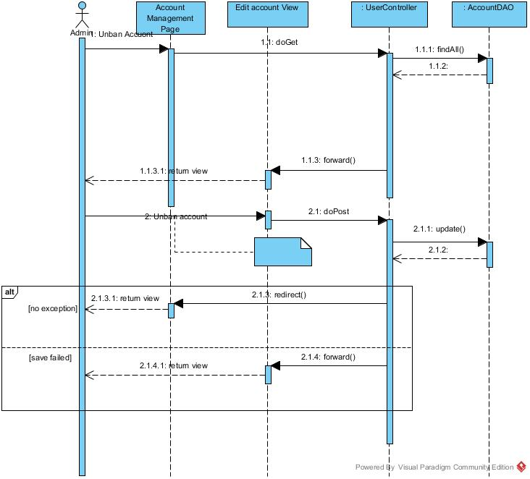

Figure ?? :<Admin> Unban Account Sequence Diagram

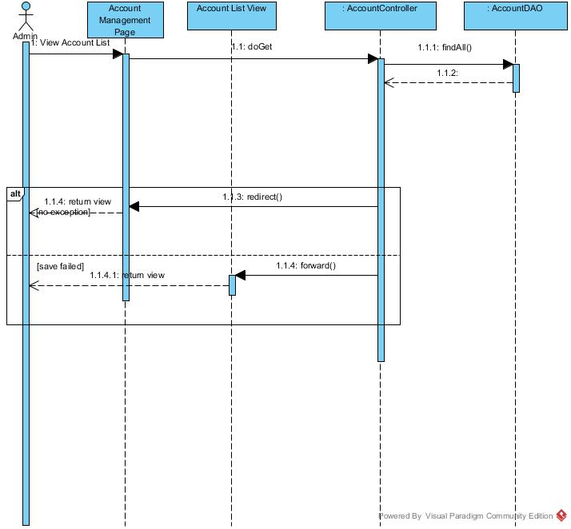

Figure ?? :<Admin> View Account List Sequence Diagram

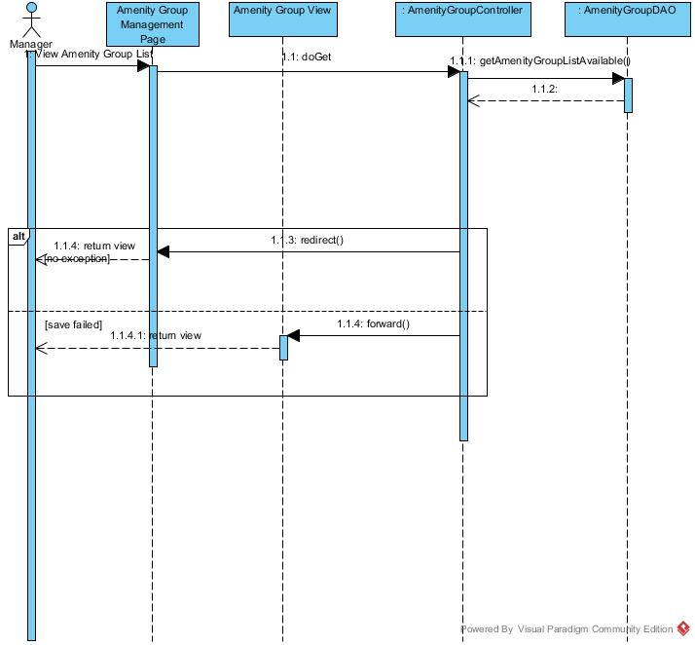

Figure ?? :<Manager> View Amenity Group List Sequence Diagram

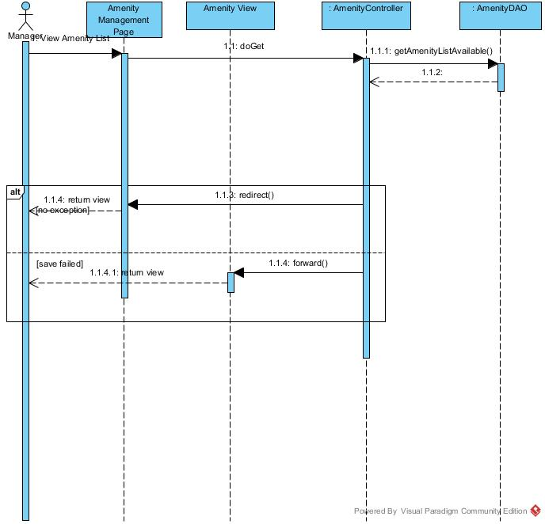

Figure ?? :<Manager> View Amenity List Sequence Diagram

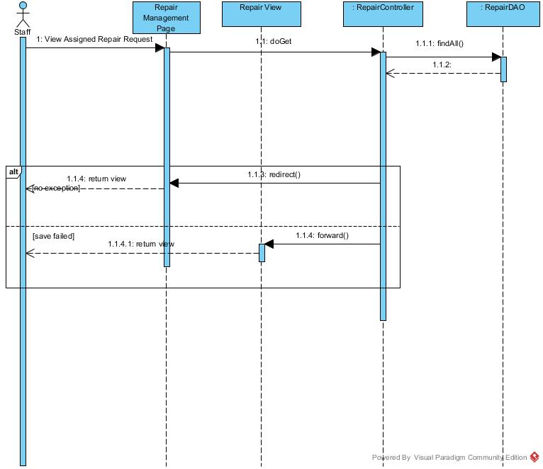

Figure ?? :<Staff> View Assigned Repair Request Sequence Diagram

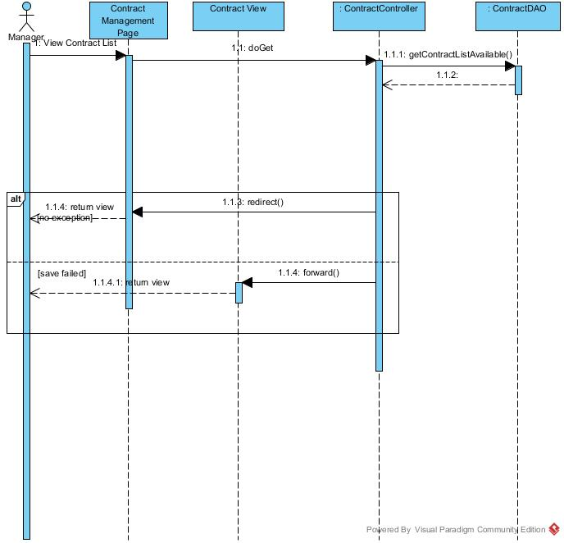

Figure ?? :<Manager> View Contract List Sequence Diagram

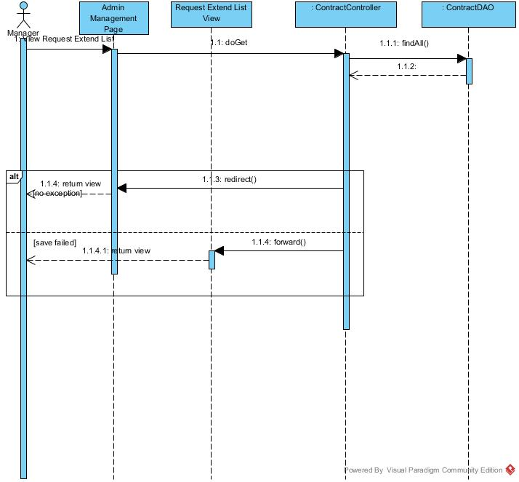

Figure ?? :<Manager> View Request Extend List Sequence Diagram

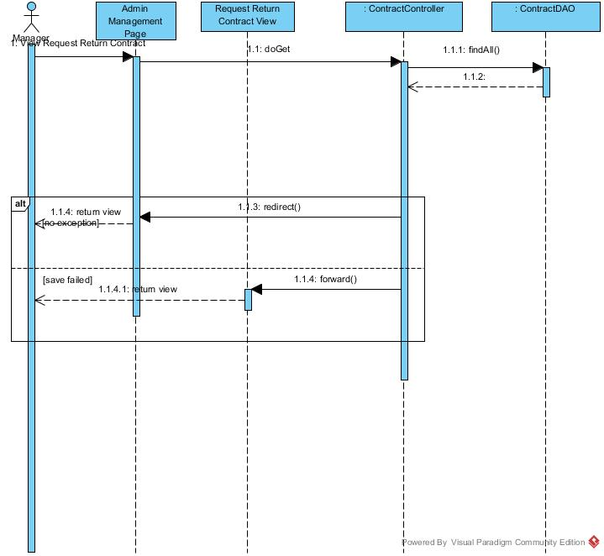

Figure ?? :<Manager> View Request Return Contract Sequence Diagram