npm install express

npm install

Cày thư viện:

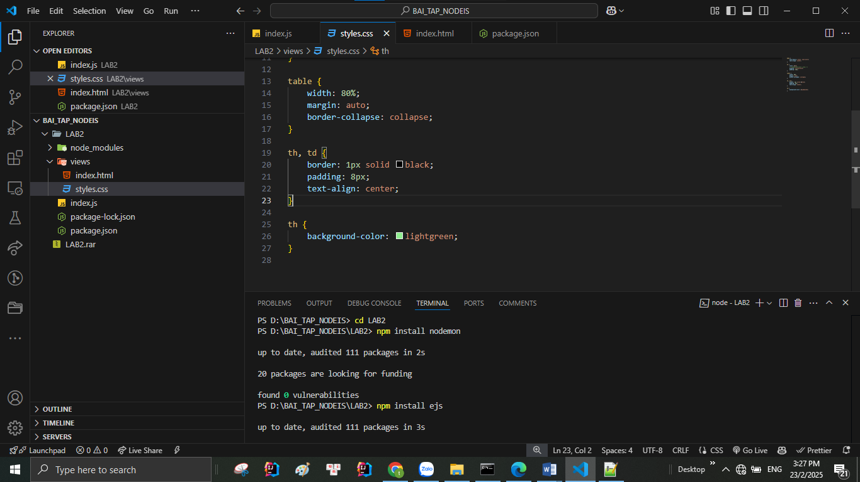

1/ Chạy local:

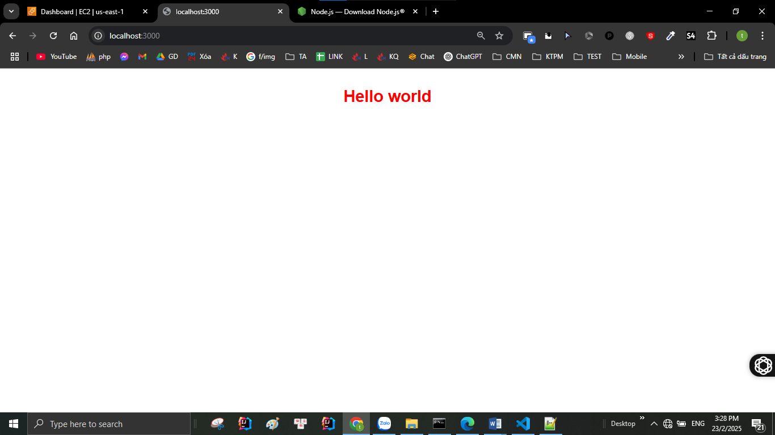

**Khởi chạy EC2**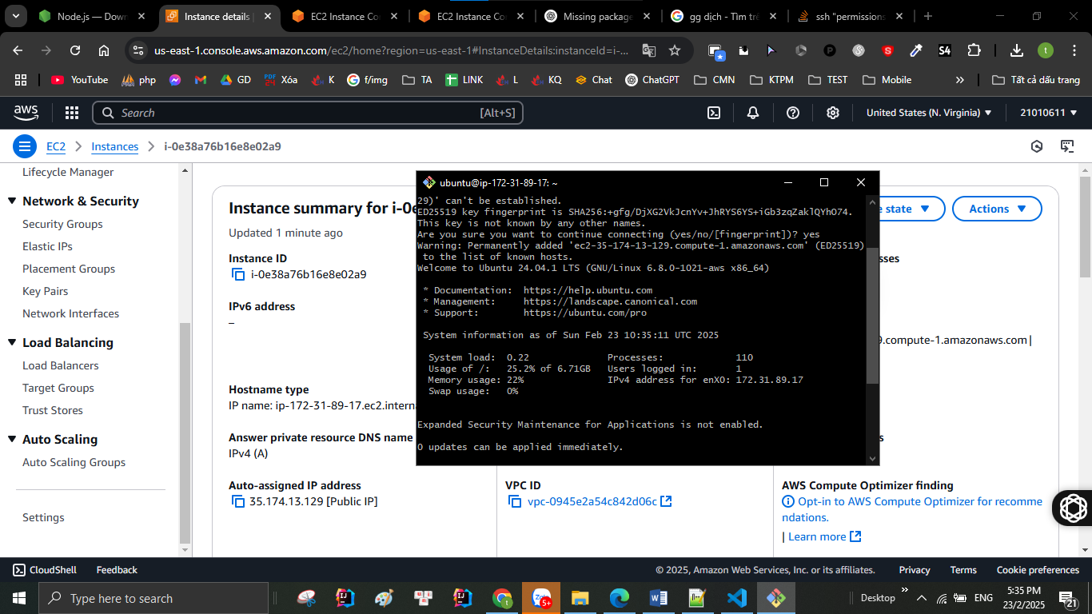

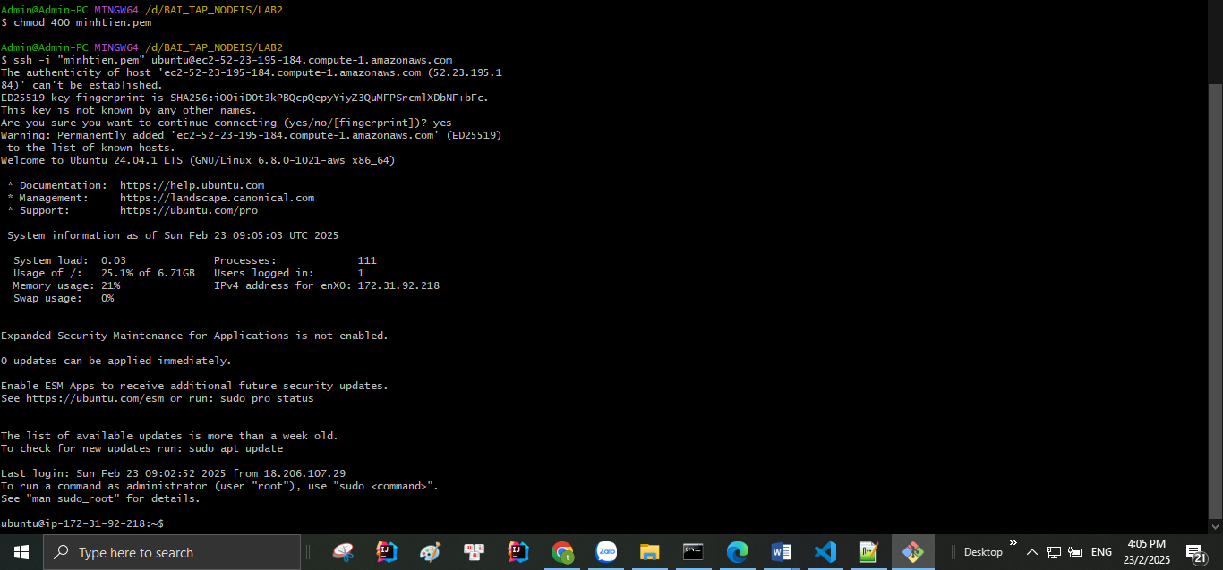

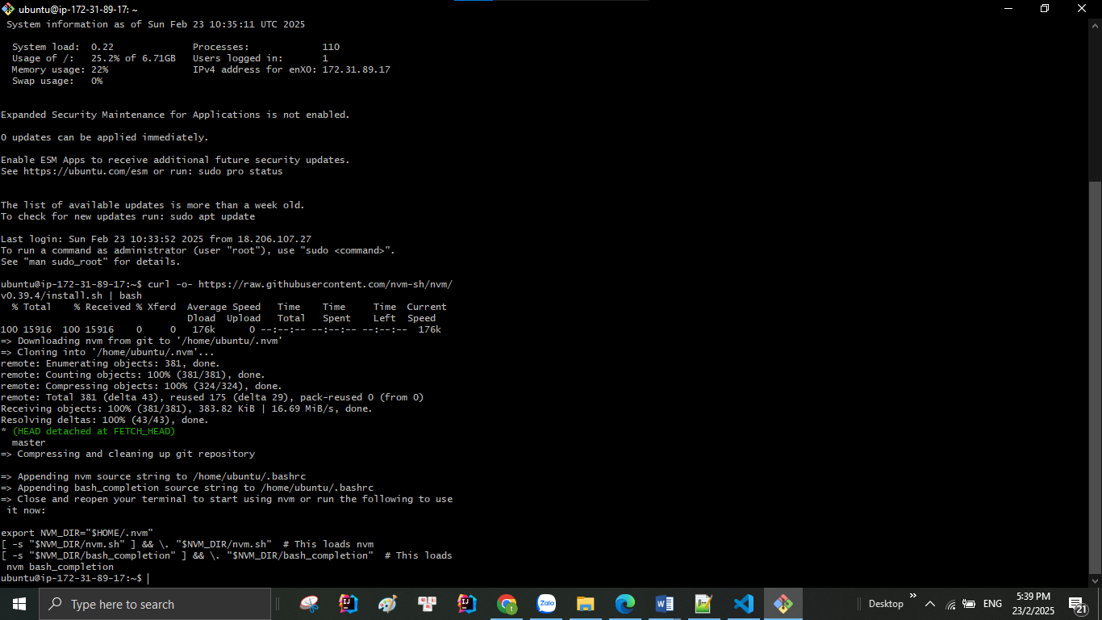 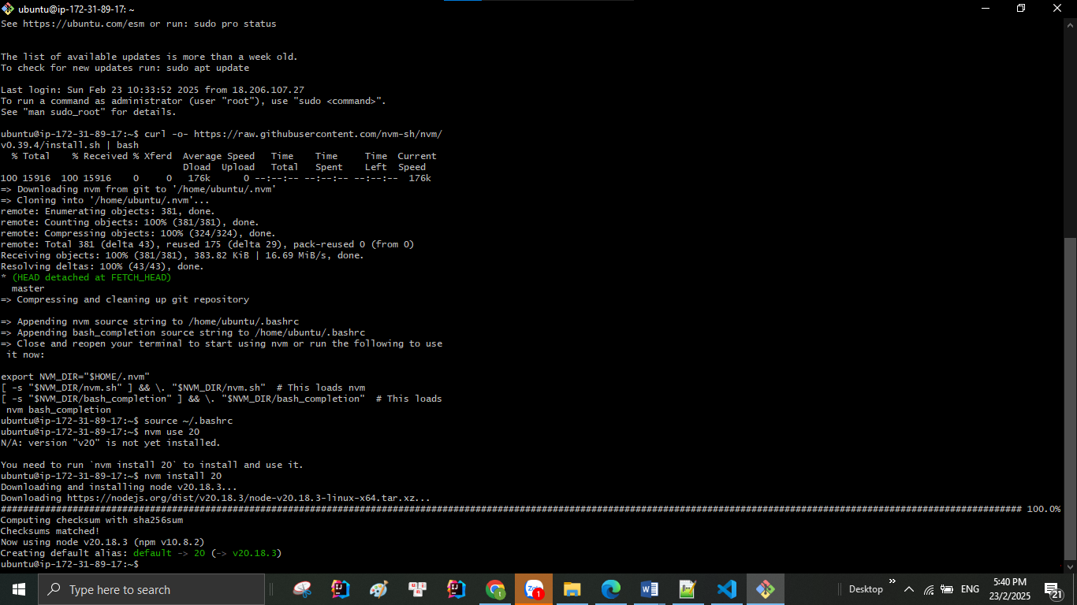

**scp -i "D:\BAI_TAP_NODEIS\tien03.pem" -r "D:\BAI_TAP_NODEIS\week2"** [**ubuntu@35.174.13.129:/home/ubuntu**](mailto:ubuntu@35.174.13.129:/home/ubuntu)

**thay quyền Admi**



