***ADJECTIVE: TO LEARN TO DRAW A LINE USING DDA ALGO***

***Answer:***

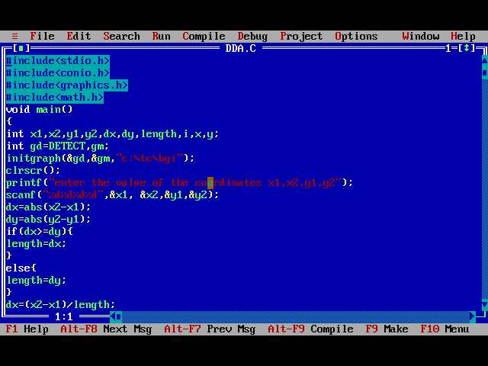

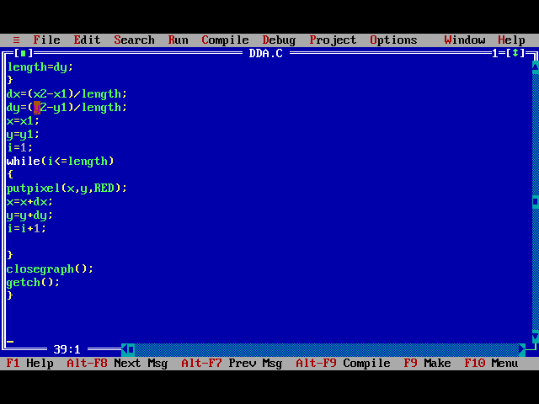 ***output:***

