|  |  |
| --- | --- |
|  | **FPT ACADEMY INTERNATIONAL**  **FPT – APTECH COMPUTER EDUCATION** |

**Centre Name: ACE-HCMC-2-FPT.**

**Address: 590 Cach Mang Thang 8, District 3, Ho Chi Minh City, Viet Nam.**

**FANoFAN COMPANY**

|  |  |  |
| --- | --- | --- |
| **Supervisor:** | PHAN THI LANH | |
| **Term:** | TEN DAYS | |
| **Batch No:** | T1.2008.M0 | |
| **Group No:** | 04 | |
| **Order:** | **Full name** | **Roll No.** |
| 1. | NGUYEN TRONG TIEN | Student1270650 |
| 2. | NGUYEN TRUNG HIEU | Student1273504 |
| 3. | NGO TRIEU TIEN | Student1262869 |

Month 10 Year 2020



**This is to certify that**

**Mr:** Nguyen Trong Tien

**Mr:** Nguyen Trung Hieu

**Mr:** Ngo Trieu Tien

Has successfully Designed & Developed

**FANoFAN COMPANY**

Submitted by:

Pham Thi Lanh

Date of issue:

October, 23th 2020

Authorized Signature:

Contents

1 ACKNOWLEDGEMENT iv

2 SYNOPSIS v

3 REVIEW 1 vi

3.1 Requirement Specification vii

3.2 PROBLEM DEFINITION viii

3.3 Hardware/ Software Requirements ix

3.4 ARCHITECTURE & DESIGN OFTHE SYSTEM x

3.5 SITE MAP xi

3.6 WEBSITE LAYOUTS xii

3.6.1 Homepage: xii

3.6.2 Product xiv

3.6.3 Service xv

3.6.4 Offer xvi

3.6.5 Informative pages: xvii

4 TASK SHEET 1 xix

# ACKNOWLEDGEMENT

I would like to acknowledge all those who have given moral support and helped in making the project a success.

I wish to express my gratitude to the e-Projects Team at the Head Office, who guided and helped me. I would also like to express my gratitude to all the staff members of my center for not only providing me with the opportunity to work with them on this project, but also for their support and encouragement throughout the process.

I also express my sincere gratitude to the e-Projects Team at the Aptech Head Office and my project guide at the organization, for her valuable guidance and support for the completion of this project.

And finally, I would like to offer many thanks to all my colleagues for their valuable suggestions and constructive feedback.

# SYNOPSIS

FANoFAN Company is into manufacturing and selling on Fans. They manufacture fans for various needs of customers. From Ceiling Fans to Table Fans to Exhaust Fans, they are into all types of Fan Manufacturing.

They are looking to come up with their own website and display all the products available with them. They want to provide a detailed information about all their products.

The website is to be developed for the Windows Platform using HTML5, JavaScript and Geolocation. The site should work well in all leading browsers including Chrome, IE, Firefox etc.

# REVIEW 1

## Requirement Specification

**The Web site is to be created based on the following requirements.**

1. The Home Page should be created making use of Sections with a suitable logo, the header section can be added which will show images Fans.
2. The site must contain the links to navigate through any category for the information.
3. Links of bottles can be categorized like (Ceiling Fans, Table Fans, Exhaust etc.)
4. Specification and Pricing of Fans can be added along with the images.
5. Gallery section can be added for viewing different images.
6. Feedback must be allowed to enter by the viewer
7. Site map, Gallery, about us, Queries link, Contact us link must be added. Address of the Company should be displayed using GeoLocation API (eg. GoogleMaps).
8. The complete description must be allowed to get download as pdf or doc file.
9. The advertise section with various facilities provided should be mentioned.

## PROBLEM DEFINITION

After reading the project specifications, the developer states the scope of the project very briefly. This is referred to as the problem definition. Queries of various staff members can be one or all of the following:

1. How many products can be displayed on Homepage at a time?

2. What information should be displayed about each product in Homepage?

3. Users can contact the company if they have any questions?

4. Will the users be able to feedback their opinions?

5. Can users ask questions about the company's products and services?

After consulting several IT companies and considering the budget constraints, the management of FANoFAN Company to launch the Web application as a single page responsive Web application using HTML5, CSS3, JavaScript, Geolocation API, Web Storage, AngularJS, and Bootstrap 3.3 from getbootstrap.com, jQuery plugins, and Coffee Cup, Notepad++, or other HTML editor. Also, the site will be tested on popular browsers and mobile emulator software.

## Hardware/ Software Requirements

**Hardware**

* A minimum computer system that will help you access all the tools in the courses is a Pentium 166 or better
* 64 Megabytes of RAM or better

**Software**

* Notepad/HTML editor
* Dreamweaver
* IE 5.0/ Netscape 6.0

## ARCHITECTURE & DESIGN OFTHE SYSTEM

**CLIENT**

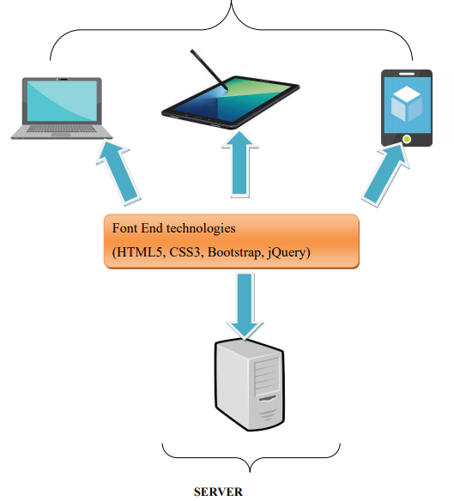

## SITE MAP

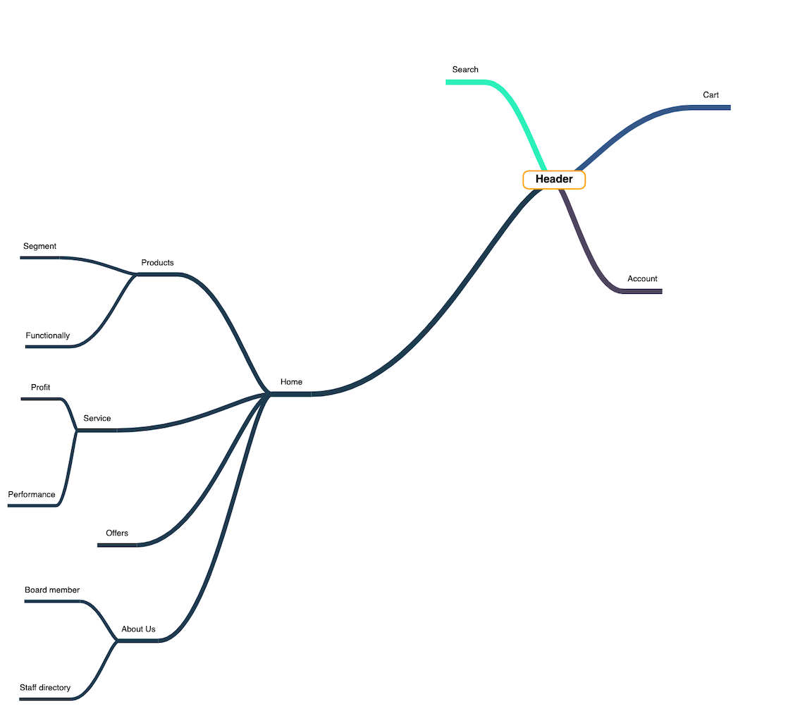

## WEBSITE LAYOUTS

**Below is our layout that will show you how we analyze ideas for corporate websites. Since it's an academic website, we tried to build them SIMPLE but USEFUL and INFORMATION like as much as possible. Site will have a number of pages included information in the same main layout.**

### Homepage:

The layout below describes how we create Home Containers

Three important parts:

Page Title and Navigation Bar:

The page title should contain the company logo and other links such as a shopping cart,

account. Search bar /

The navigation bar is one of the most important parts of the entire website

This will let people know how they interact with us. It offers a number

Information such as Home, About Us, Services, and Parts

Academic. Each section must contain brief information.

- Content:

This section is customized depending on the title of each website,

especially the Home page with some description of FANoFAN,

Company history and its brief developments throughout the years.

- Footer:

The final piece of all of our websites is definitely the Footer that will reveal

Some convenient ways to contact your company in different social channels

like Email, Facebook, Twitter, Skype ...

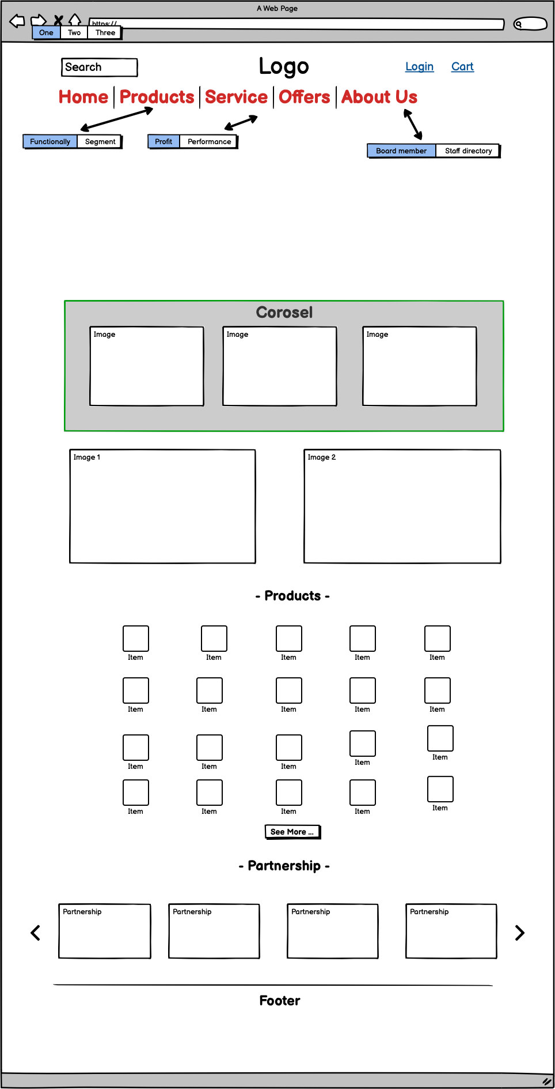

### Product

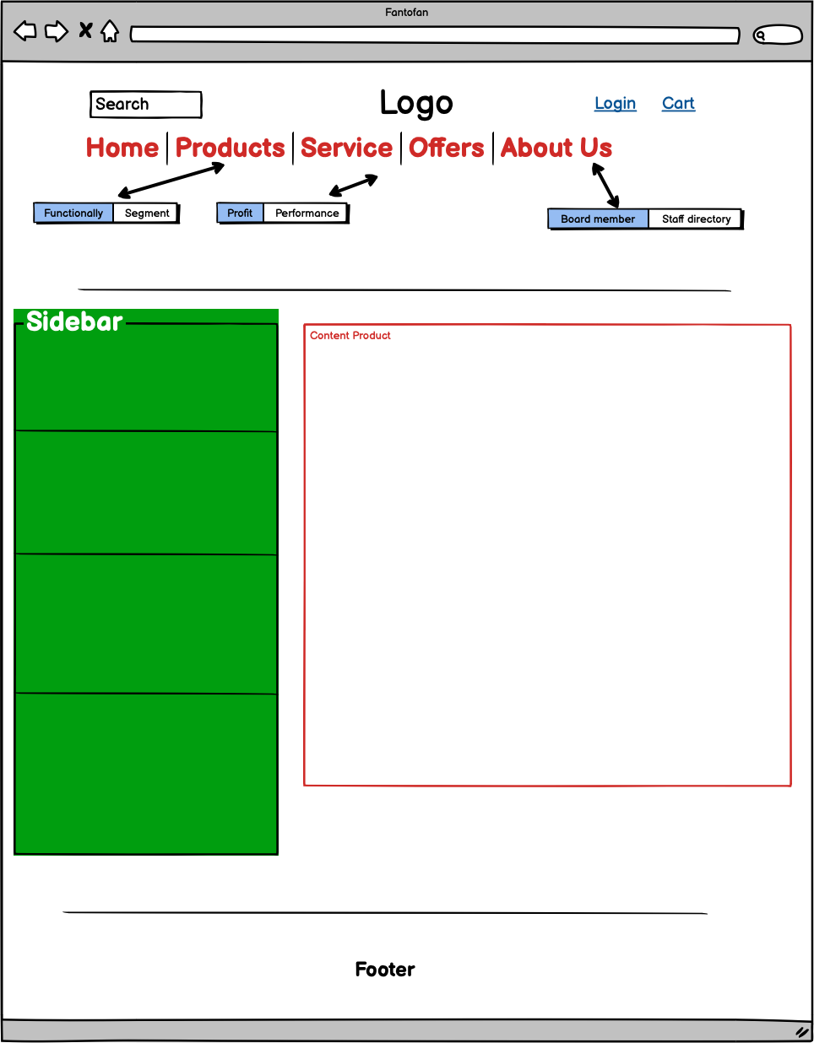

### Service

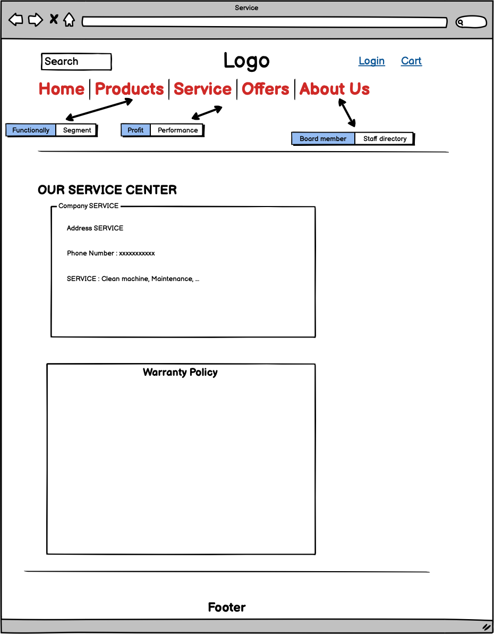

### Offer

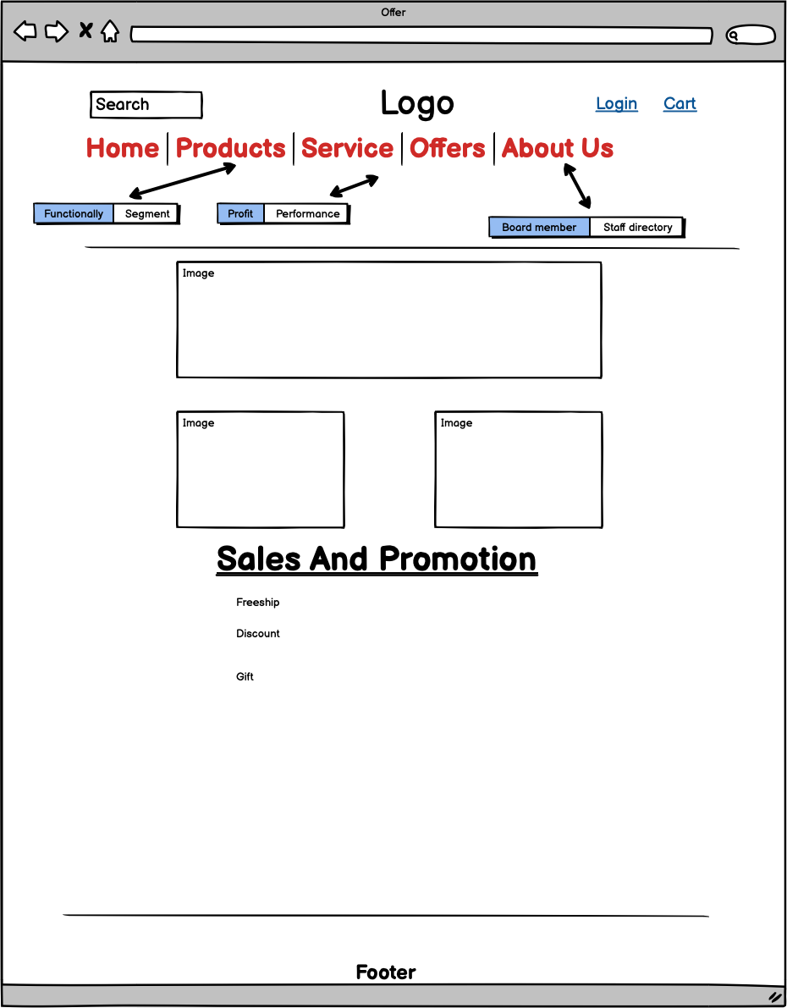

### Informative pages:

This layout we will apply for most of other pages (Contact us, Feedback, Query...) which provide people different information about the FANoFAN company.

It also has the same Page-header, Navigation bar and Footer as Homepage, but the main content is changed. Interestingly, we will design additional sidebar with class “active” to help people enter another related website easier.

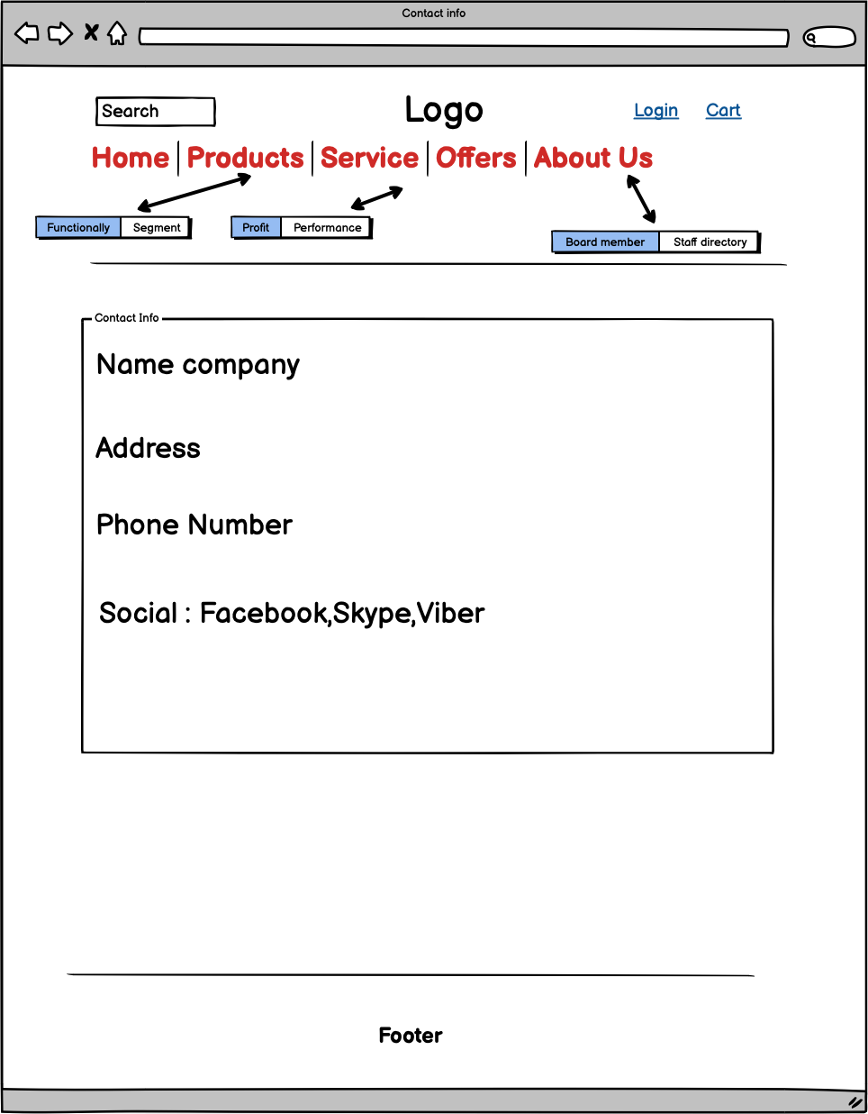

# TASK SHEET 1

|  |  |  |  |  |  |  |
| --- | --- | --- | --- | --- | --- | --- |
| Task | Project title | Activity plan prepared by | Actual start date | Actual days | Teammate names | Status |
| Create layouts for website base on group discussion ideas | FANoFAN  COMPANY | Tien | 15/10/2020 | 3 | Tien  Tien | Completed |
| Draw layouts using Balsamiq Wireframes | FANoFAN  COMPANY | Hieu | 18/10/2020 | 2 | Hieu | Completed |
| Write project report 1 | FANoFAN  COMPANY | Tien | 20/10/2020 | 2 | Tien | Completed |
| Homepage design and coding ( include navigation bar and footer ) | FANoFAN  COMPANY | Tien | 21/10/2020 | 3 | Hieu  Tien | Completed |

|  |  |
| --- | --- |
| **Signature of Faculty** | **Signature of Leader Team** |
|  |  |