Họ tên: Nguyễn Văn Khải Tiến
MSSV: 22731841
Lớp: DHKTPM18A
Các lệnh cơ bản thao tác với Docker
docker –version
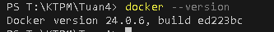
docker run hello-world
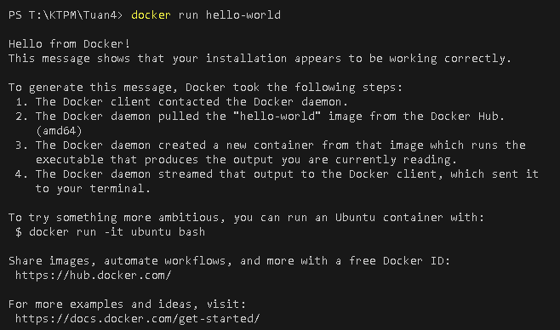
docker pull nginx
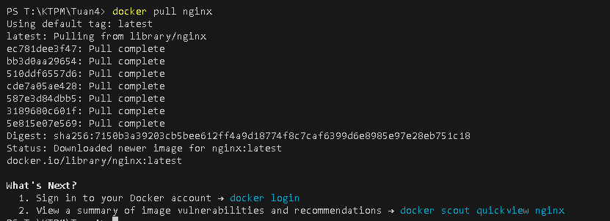
docker images
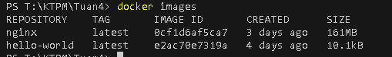
docker run -d nginx
docker ps
docker ps –a
docker logs <container_id>
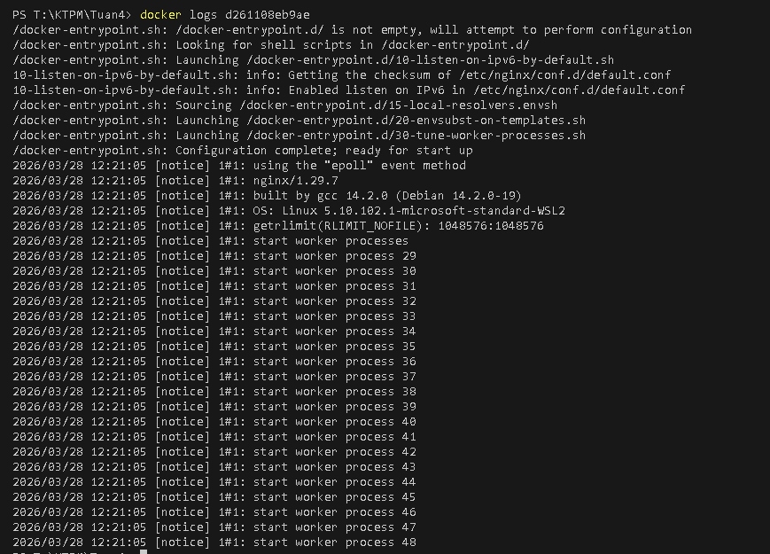
docker exec -it <container_id> /bin/sh
docker stop <container_id>
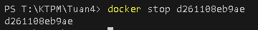
docker restart <container_id>
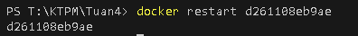
docker rm <container_id>
docker container prune
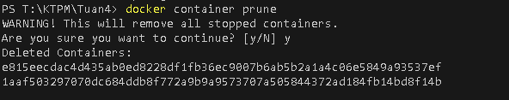
docker rmi <image_id>
docker image prune –a
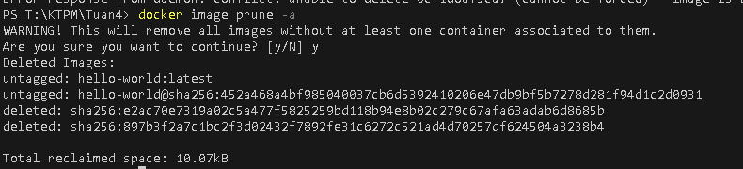
docker run -d -p 8080:80 nginx
docker inspect <container_id>
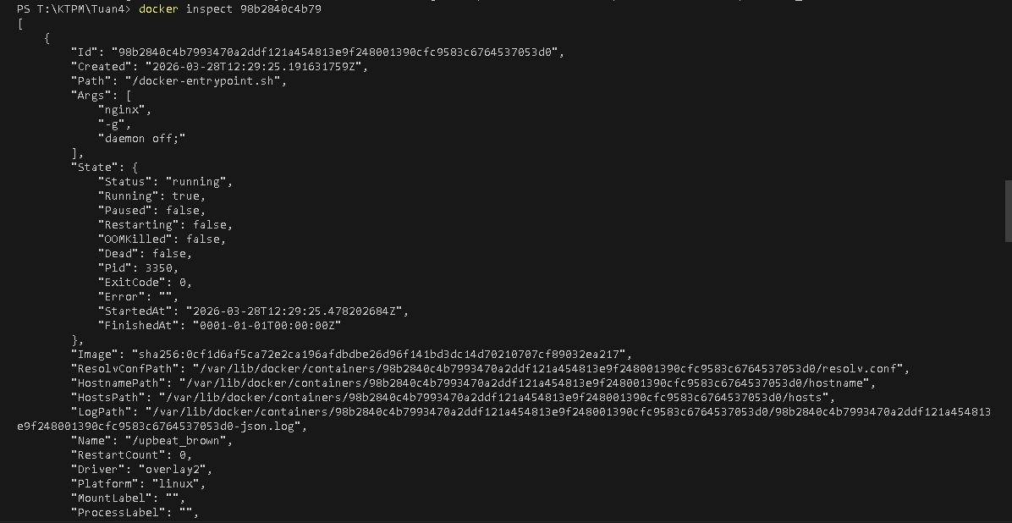
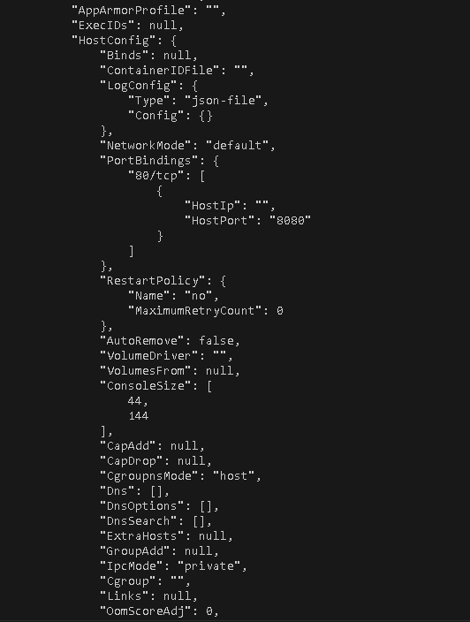
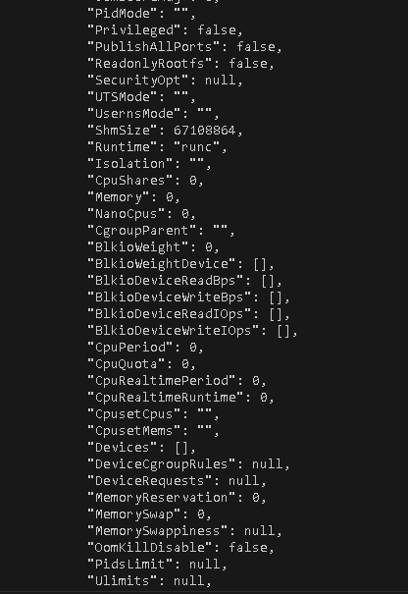
docker run -d -v mydata:/data nginx
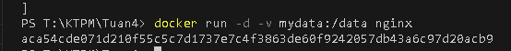
docker volume ls
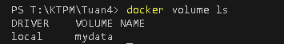
docker volume prune
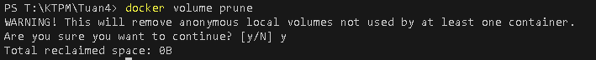
docker run -d --name my_nginx nginx
docker stats
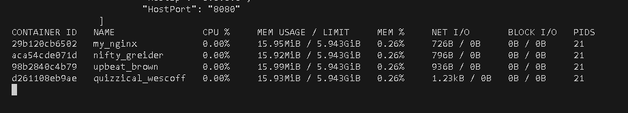
docker network ls
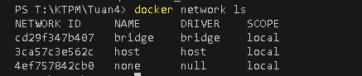
docker network create my_network
docker run -d --network my_network --name my_container nginx
docker network connect my_network my_nginx
docker run -d -e MY_ENV=hello_world nginx
docker logs -f my_nginx
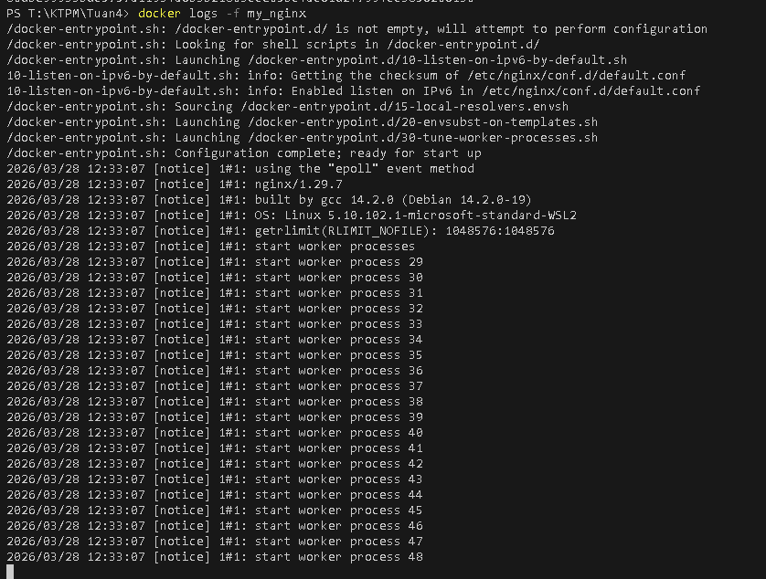
FROM nginx
COPY index.html /usr/share/nginx/html/index.html
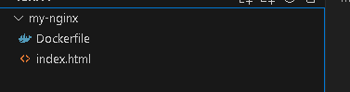

docker build -t my_nginx_image .
docker run -d -p 8080:80 my_nginx_image
