**GENERAL SETUP**

How to install aws cli

[Set up the AWS CLI - AWS Command Line Interface (amazon.com)](https://docs.aws.amazon.com/cli/latest/userguide/getting-started-quickstart.html)

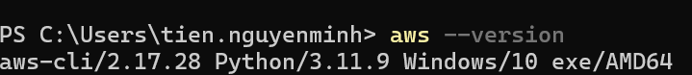

How to configure access token for awscli

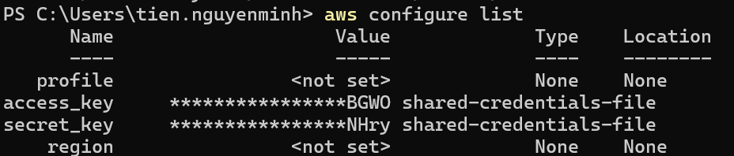

How to install terraform

[Install | Terraform | HashiCorp Developer](https://developer.hashicorp.com/terraform/install)

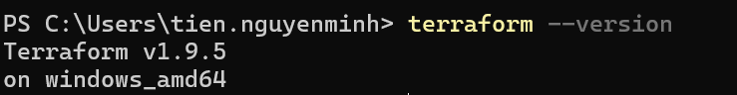

How to create a github repository

[Creating a new repository - GitHub Docs](https://docs.github.com/en/repositories/creating-and-managing-repositories/creating-a-new-repository)

Create S3 bucket for Terraform backend

[Step 1: Create your first S3 bucket - Amazon Simple Storage Service](https://docs.aws.amazon.com/AmazonS3/latest/userguide/creating-bucket.html)

How to create backend for terraform



Show list of bucket



**CI-SETUP INFRA**

In subfolder CI of Infrastructure run terraform init to install required module and setup backend for CI infra

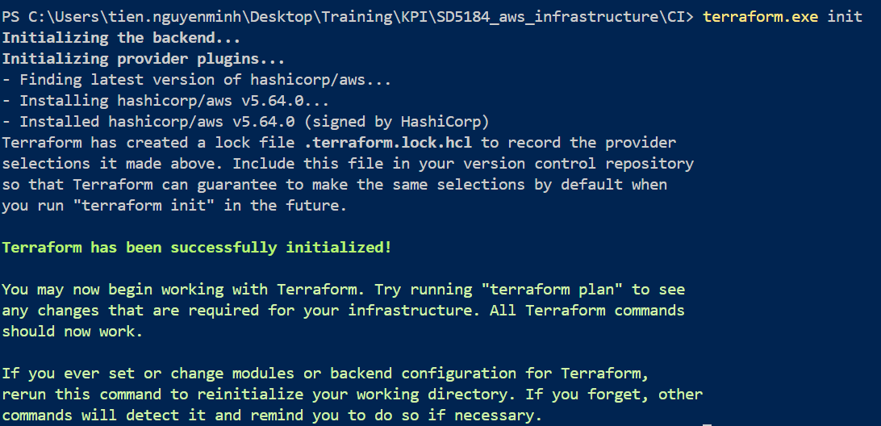

How to deploy ec2

In subfolder CI of Infrastructure run terraform apply –auto-approve to deploy ec2 and related infra. Wait for the deployment finish and double check on the chosen region

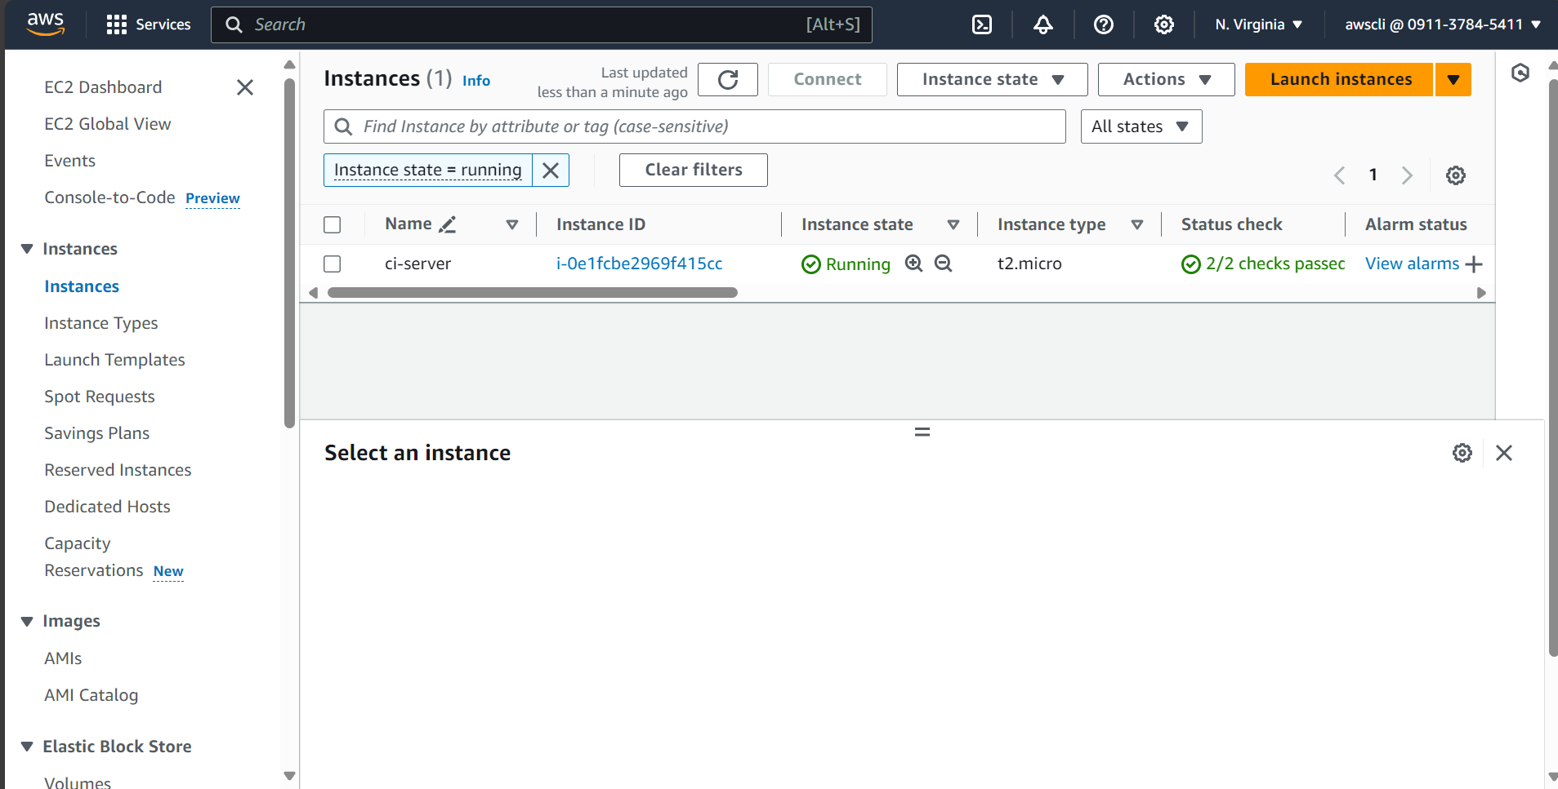

**CI-INSTALL SOFTWARE**

How to install docker on Ubuntu

[Install Docker Engine on Ubuntu | Docker Docs](https://docs.docker.com/engine/install/ubuntu/)



Run post deployment steps to access docker from default user

[Linux post-installation steps for Docker Engine | Docker Docs](https://docs.docker.com/engine/install/linux-postinstall/)



Intall OpenJDK17

[Installing OpenJDK on Ubuntu 22.04 | Linode Docs](https://www.linode.com/docs/guides/how-to-install-openjdk-ubuntu-22-04/)



Install jenkins server​

[Linux (jenkins.io)](https://www.jenkins.io/doc/book/installing/linux/" \l "prerequisites)

Access port 8080 of ci-server ip public from browser to double check the installation

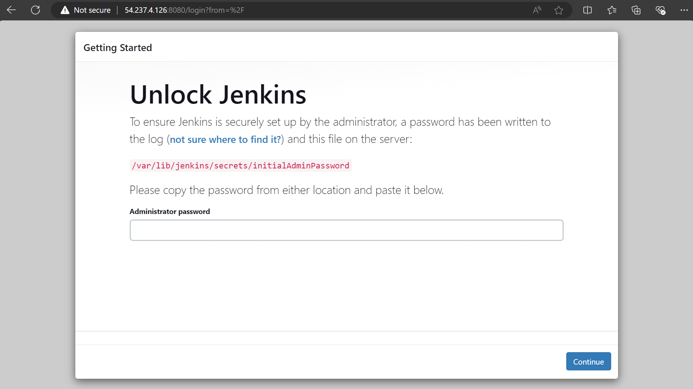

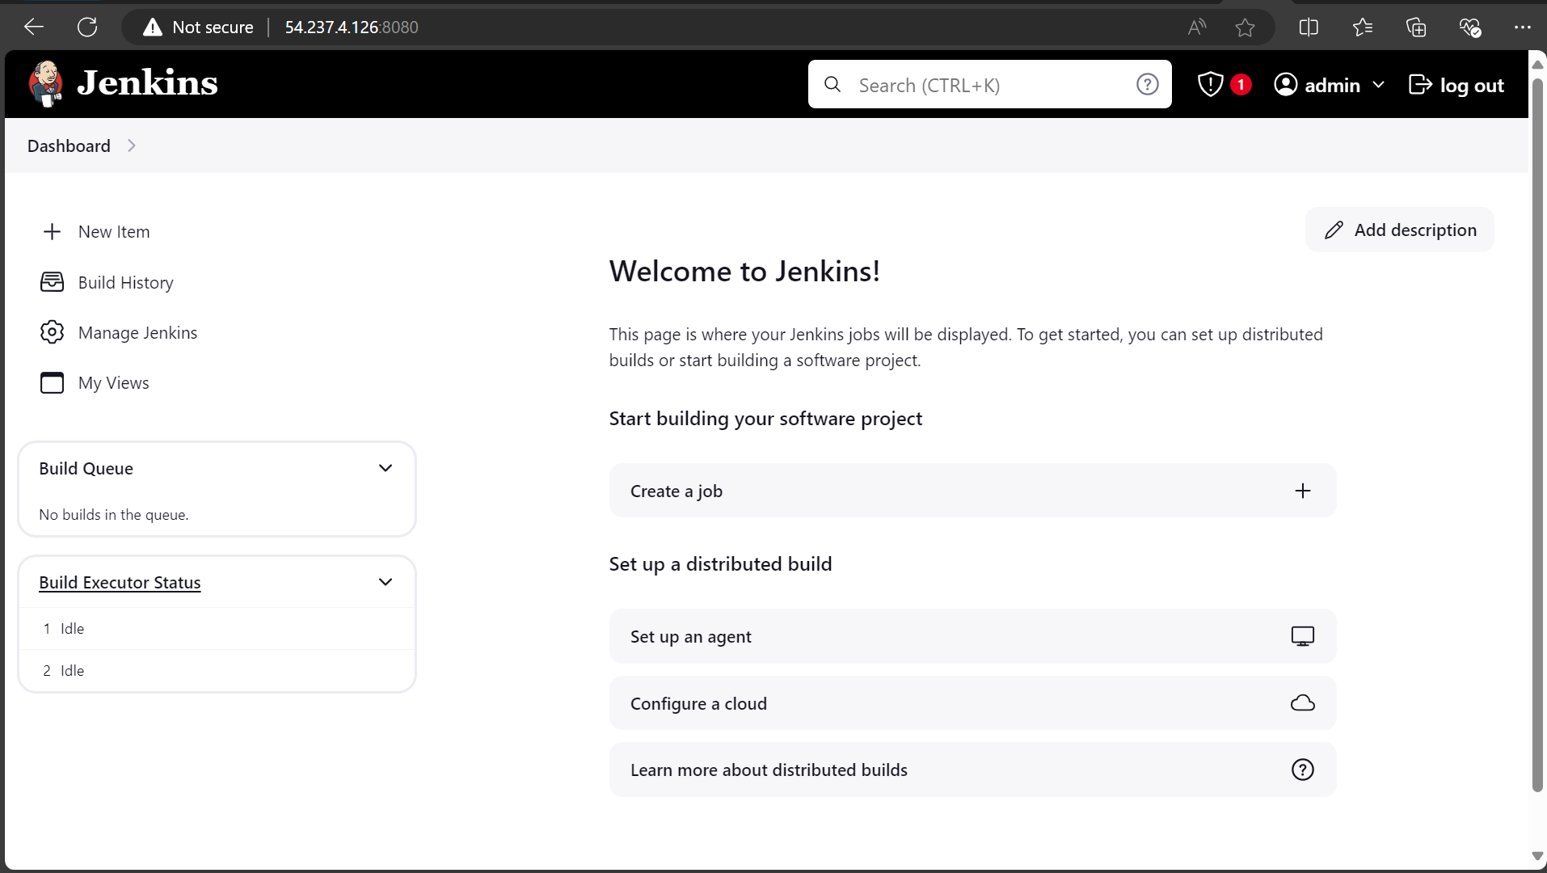

Configure Jenkins

1. Create a build trigger for pipeline

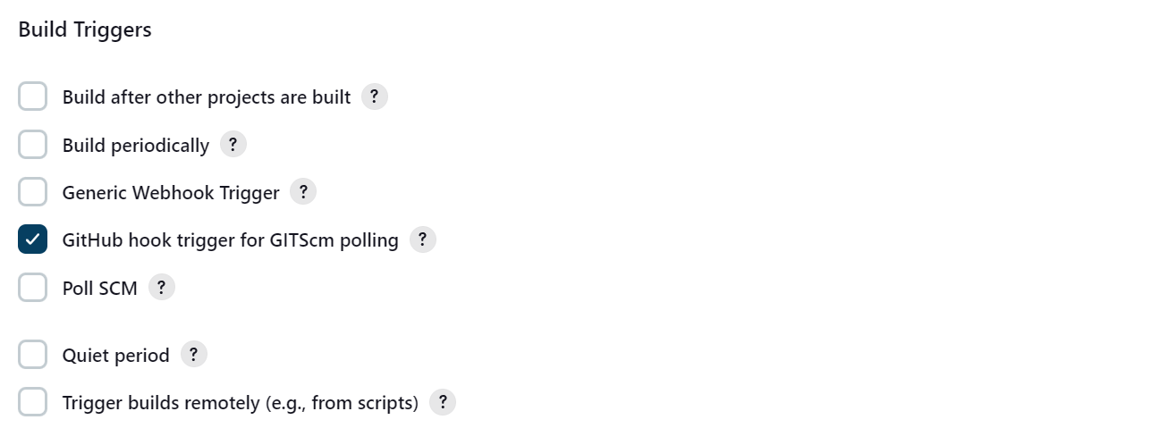

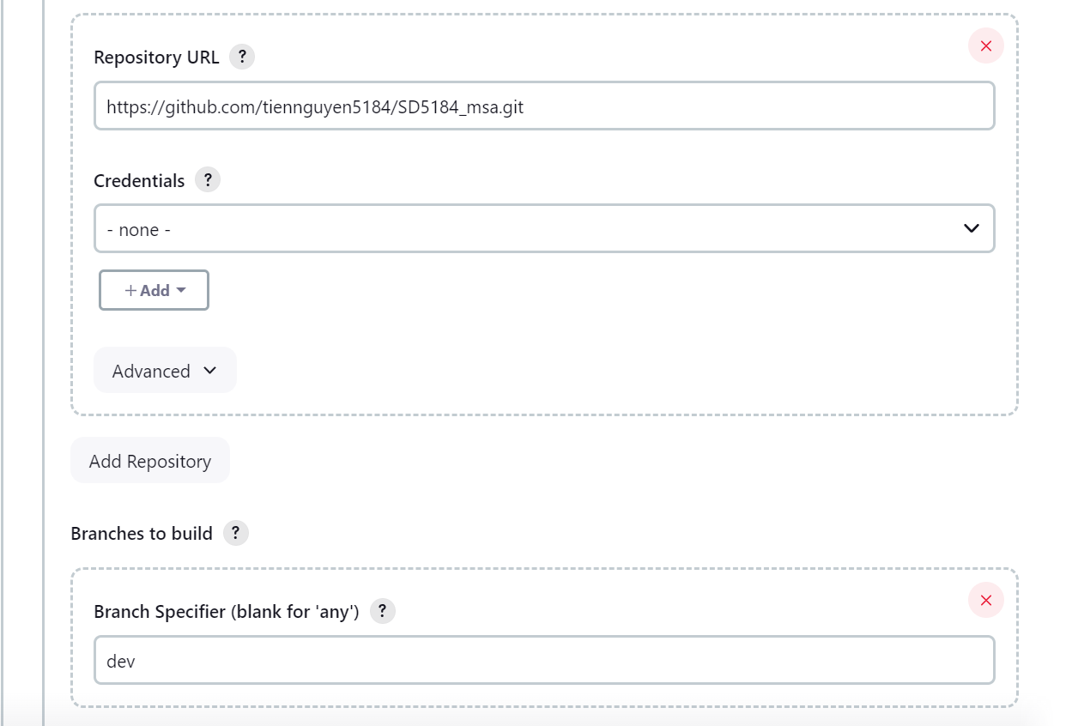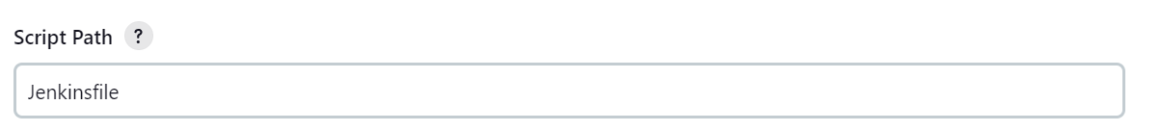

Create webhook in github:

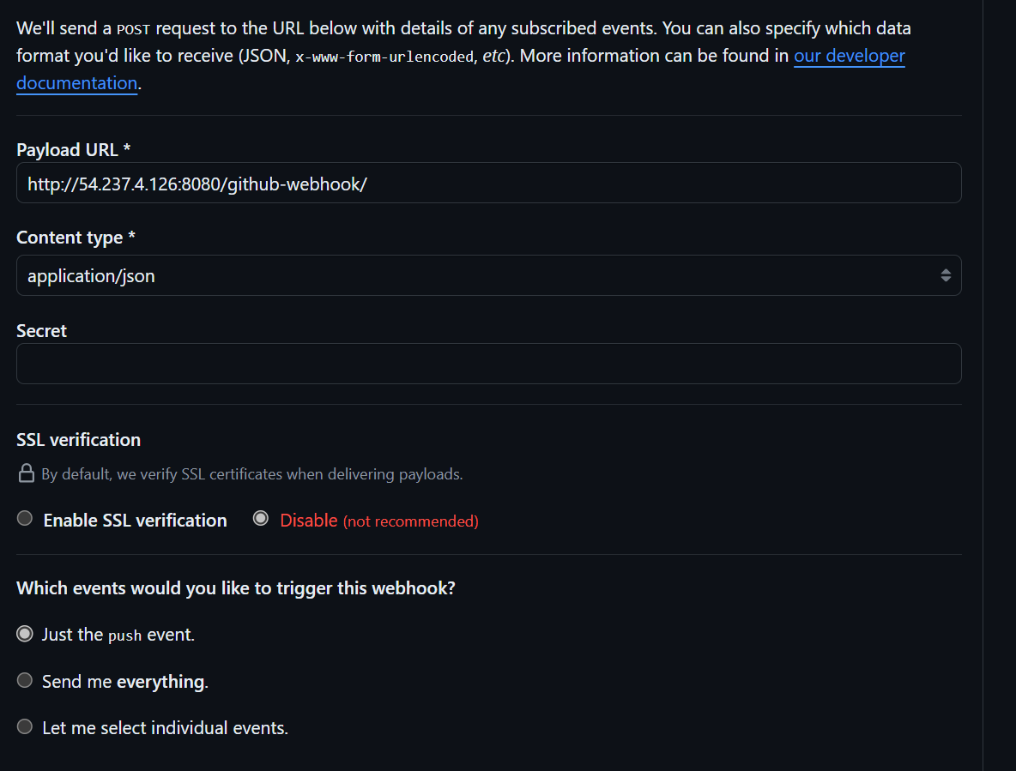

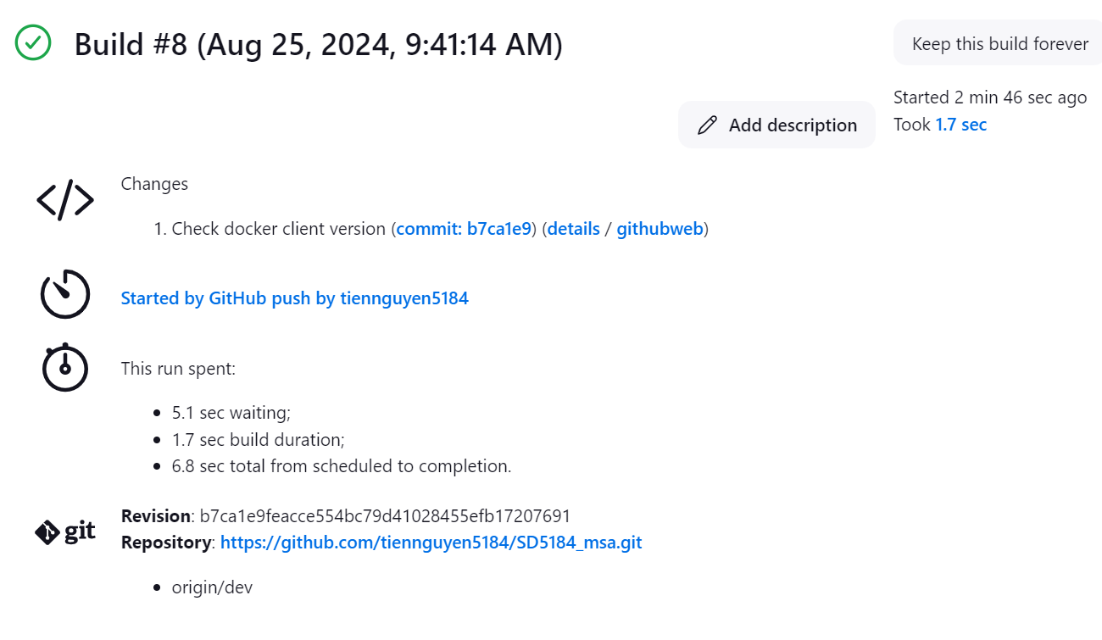Result after successfully configure webhook

How to deploy EKS cluster

[aws_eks_cluster | Resources | hashicorp/aws | Terraform | Terraform](https://registry.terraform.io/providers/hashicorp/aws/latest/docs/resources/eks_cluster)

The detail terraform code is in subfolder CD. Remember to create S3 backend and run terraform init before running terraform apply

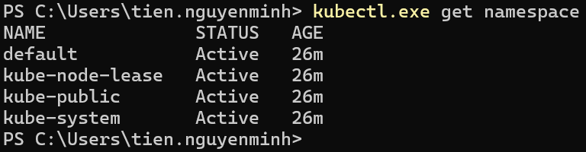

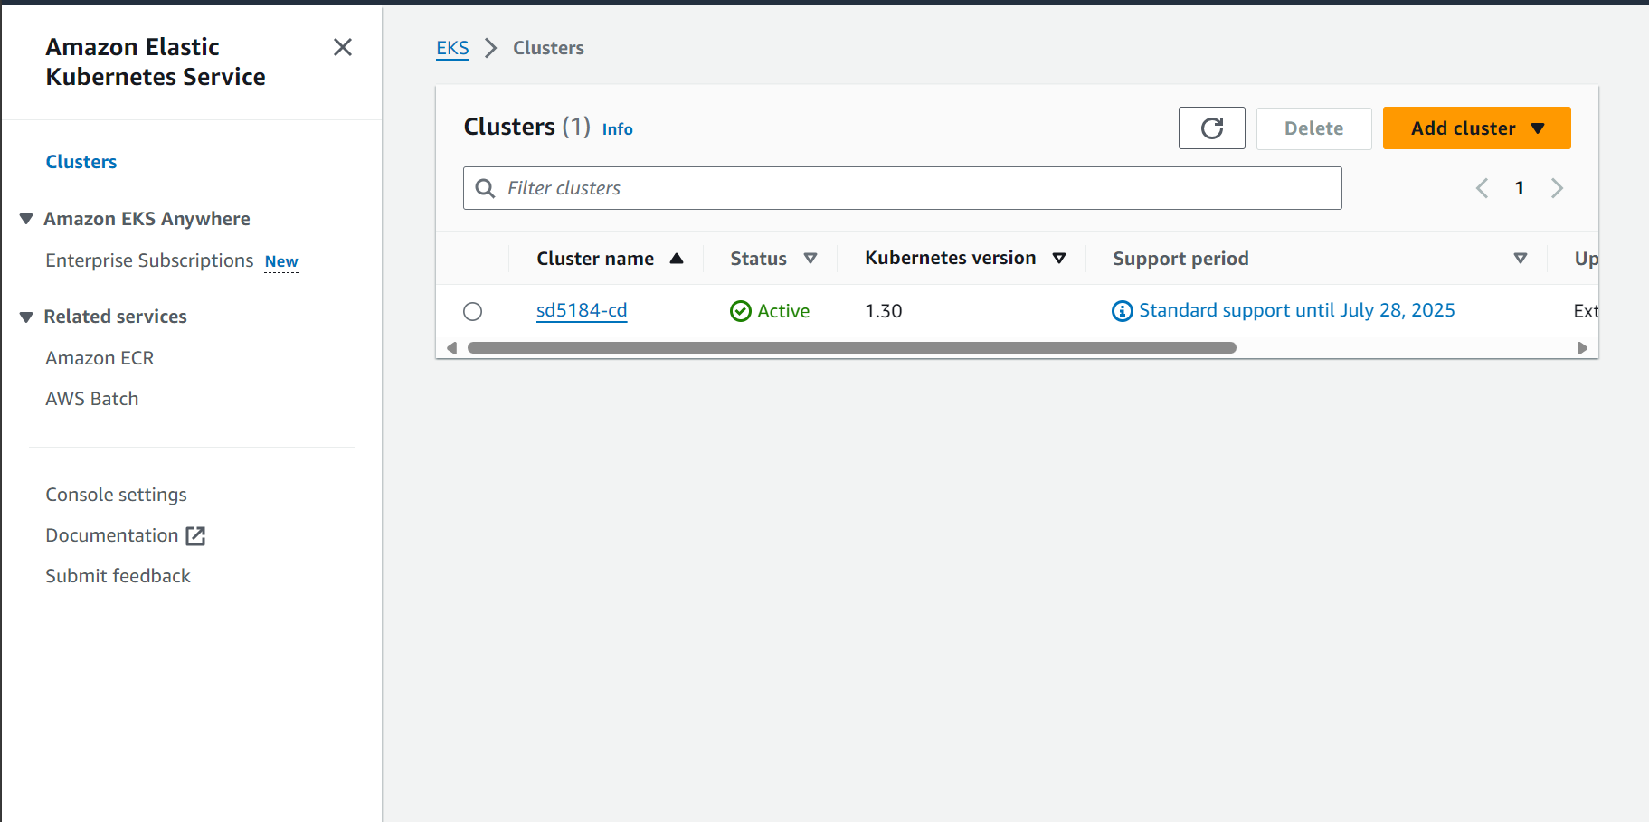

How to deploy argocd on k8s

[Getting Started - Argo CD - Declarative GitOps CD for Kubernetes (argo-cd.readthedocs.io)](https://argo-cd.readthedocs.io/en/stable/getting_started/)

How to deploy prometheus ad grafana

[Monitor Kubernetes cluster performance with the Prometheus operator (grafana.com)](https://grafana.com/blog/2023/01/19/how-to-monitor-kubernetes-clusters-with-the-prometheus-operator/)

How to configure jenkins server webhook and github