**Deep Learning: Alphabet Soup**

OVERVIEW:

The Alphabet Soup wants to create an algorithm to predict if the applicants for the applicants for the funding will be successful. With the knowledge of machine learning and neural networks, I must use the features in the provided dataset to create a binary classifier to predict whether the application will be successful if funded by the Alphabet Soup.

RESULTS:

As we began the data processing, we removed some of the irrelevant information like removing EIN and NAME columns. After dropping these columns, the remaining columns were considered features for the model. The target variable for the model “IS_SUCCESSFUL” has the value of 1 for yes and 0 for no. “APPLICATION” data was analyzed and “CLASSIFICATION” value was used for binning. We used some of the data to see if we can bin “rare variables together with the new value of “Other” for each unique value as a cutoff. The categorical variables were encoded by get_dummies() to see if the binning is successful in the model.

COMPILING, TRAINING AND EVALUATION:

When it comes to compiling the model, there are three layers for each model after applying Neural Networks. There are hidden nodes were dictated by the number of features.

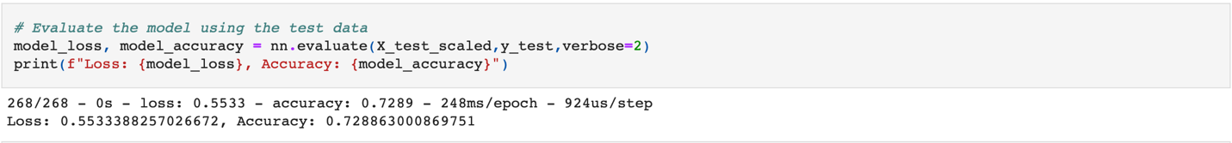

477 parameters were created by a three layer model. The first attempt was just over 72% accuracy which is under 75% but not too far off the value.

OPTIMIZATION:

The second attempt with the “NAME” column in the dataset, achieved an accuracy of almost 79% of the model. This has gained over 75% with 3,298 parameters.

The multiple-layer model should be used for deep learning since it predicts and classifying the information based on computer inputs through layers.

