Click here to open “SearchPopup”

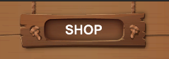

Search for more items

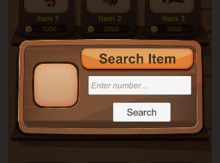

Link Github : <https://github.com/tiennv4869/shop.git>

Thanks !!!