Student name:

Student ID:

SIT225: Data Capture Technologies

# Activity 2.1: Working with sensor - DHT22

DHT22 is a temperature and humidity sensor.

## Hardware Required

* Arduino Board
* DHT22 sensor
* USB cable

## Software Required

Arduino programming environment

## Known issue, action required

Arduino Nano 33 IoT board operates on 3.3 V, it needs to be arranged to make it 5 V. The Arduino board has a pin called VUSB or VBUS and there are 2 pads next to the pin. **These two pads must be shorted to enable the pin** (see detail here <https://support.arduino.cc/hc/en-us/articles/360014779679-Enable-5-V-power-on-the-VUSB-or-VBUS-pin-on-Nano-boards> ).

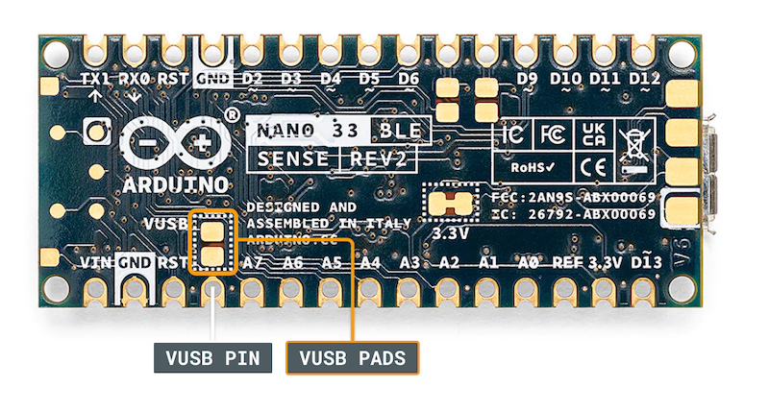

To test, you can use a wire and connect these 2 pads manually by hand to see if data is coming through DHT22 sensor. For long data collection, you will need to solder the wire permanently to connect the pads. Seeking help from tutors there is an on-campus facility called Maker Space where you can do it.

## Steps:

|  |  |
| --- | --- |
| **Step** | **Action** |
| 1 | Connect your DHT22 Temperature and Humidity Sensor to the Arduino board. Note that the pin layout in the image below may look different than the board you may have.       1. Pick a red male-female jumper wire and attach the female end to pin 1 (VCC pin) on the sensor. Plug the male end into the Arduino board’s 5V power pin. 2. Pick a blue male-female jumper wire and attach the female end to pin 2 (DATA pin) on the sensor. Plug the male end into the Arduino board’s digital data pin 2. 3. Pick a black male-female jumper wire and attach the female end to pin 4 (GND) on the sensor. Plug the male end into the Arduino board’s GND pin. 4. Sensor’s pin 3 is not used. |
| 2 | Connect your Arduino board to your computer using the USB cable. |
| 3 | Write an Arduino sketch (or download it from <https://github.com/deakin-deep-dreamer/sit225/blob/main/week_2/sketch_dht22.ino> ) which looks like below. Compile the code in Arduino IDE, deploy to the board and observe output in the Arduino IDE serial monitor. |
| 4 | Question: A spec of the DHT22 sensor is given in the link below. It mentions that the sampling rate is 0.5 Hz.  <https://lastminuteengineers.com/dht11-dht22-arduino-tutorial>  i) What does the sampling rate mean?  ii) Where is this used in the Arduino code?  Answer: <Your answer> |
| 5 | Question: Take a screenshot of your Serial Monitor displaying temperature & humidity sensor data logs. Add the image here.  Answer: <Your answer> |

# Activity 2.2: Working with sensor - HC-SR04

HC-SR04 is an Ultrasonic sensor.

## Hardware Required

* Arduino Board
* HC-SR04 Ultrasonic sensor
* USB cable

## Software Required

Arduino programming environment

## Known issue, action required

The same known issue applies to SR04 which operates at 5 V source while the Arduino Nano 33 IoT supplies 3.3 V. It requires 2 VUSB (or VBUS) pads to be shorted to enable the pin.

## Steps:

|  |  |
| --- | --- |
| **Step** | **Action** |
| 1 | Connect your HC-SR04 sensor to the Arduino board. Note that the pin layout in the image below may look different than the board you may have. |
| 2 | Connect your Arduino board to your computer using the USB cable. |
| 3 | Write an Arduino sketch (or download it from <https://github.com/deakin-deep-dreamer/sit225/blob/main/week_2/sketch_hcsr04_distance.ino> ) which looks like below. Compile the code in Arduino IDE, deploy to the board and observe output in the Arduino IDE serial monitor. |
| 4 | Question: Spec of SR04 is available here (<https://cdn.sparkfun.com/datasheets/Sensors/Proximity/HCSR04.pdf> ). Identify 2 critical aspects you should be careful about this sensor operation.  Answer: <Your answer> |
| 5 | Question: Take a screenshot of your Serial Monitor displaying distance values while you try to generate a periodic motion by moving your hand gradually back and forth towards the sensor. Add the image here.  Answer: <Your answer> |

# Activity 2.3: Working with sensor - Accelerometer

LSM6DS3 module on the Arduino Nano 33 IoT is an accelerometer and gyroscope sensor.

## Hardware Required

* Arduino Nano 33 IoT Board (has inbuilt LSM6DS3 module)
* USB cable

## Software Required

Arduino programming environment

## Steps:

|  |  |
| --- | --- |
| **Step** | **Action** |
| 1 | Write Arduino sketch (or download code from <https://github.com/deakin-deep-dreamer/sit225/blob/main/week_2/sketch_accelero.ino> ) which looks like below. Compile the code in Arduino IDE, deploy to the board and observe output in the Arduino IDE serial monitor. |
| 2 | Question: Spec of LSM6DS3 is available here (<https://content.arduino.cc/assets/st_imu_lsm6ds3_datasheet.pdf> ). Identify at least 3 attributes of this sensor you think important to work with.  Answer: <Your answer> |
| 3 | Question: Take a screenshot of your Serial Monitor displaying sensor readings. Add the image here.  Answer: <Your answer> |
| 4 | Question: Identify the max sampling rate and consider reducing the delay (line 37 in the sketch) to increase the number of samples. Summarise your findings here.  Answer: <Your answer> |

# Activity 2.4: Plot data using Python Notebook

Matplotlib is a comprehensive library for creating static, animated, and interactive visualizations in Python. You can find detail in official website (https://matplotlib.org).

## Hardware Required

* No hardware required

## Software Required

Python Jupyter notebook

## Steps:

|  |  |
| --- | --- |
| **Step** | **Action** |
| 1 | Download the Jupyter notebook **week2_notebook.ipynb** from here (<https://github.com/deakin-deep-dreamer/sit225/blob/main/week_2/week2_notebook.ipynb> ). Follow the instructions in the notebook to carry out instructions and finally convert the notebook to PDF so you can combine it with this activity sheet PDF. |