[phucnt38@fpt.com](mailto:phucnt38@fpt.com), [tienphuckx@gmail.com](mailto:tienphuckx@gmail.com)

**CAR DASHBOARD SUBSCRIPTION**

Github: <https://github.com/tienphuckx/car-dashboard-subscription>

**Overview**

This project focuses on developing a sophisticated real-time car dashboard using the Qt Framework, designed to display essential vehicle metrics such as speed, fuel level, gear position, temperature, humidity, and time.

Data is captured from the vehicle's sensors, including a DHT11 sensor, using an ESP32 microcontroller, and then transmitted to a Linux-based server powered by PHP 7 and MariaDB for storage and processing.

The Qt dashboard retrieves this data from the server and updates dynamically using long polling for real-time performance.

**Design**

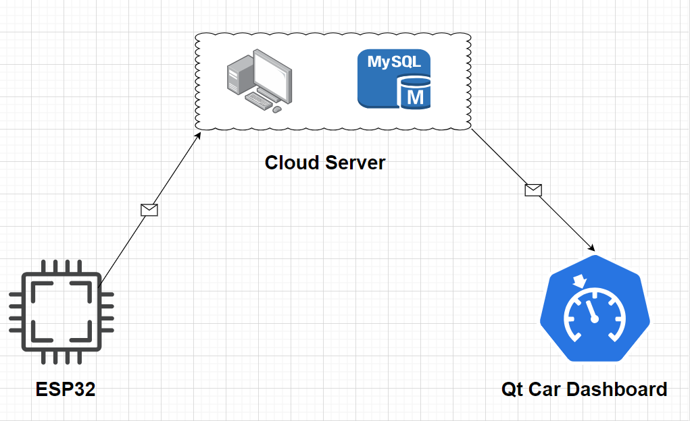

**Technologies**

**MICROCONTROLLER**

Microcontroller: ESP32 DevKit V1 - module ESP-WROOM-32 - S1H15

Sensor: DHT11

IDE: Arduino

LCD OLED

**CLOUD SERVER**

Programming language: PHP 7

Database: MariaDB

OS: Linux

**QT FRAMEWORK**

Qt 6

QML

CMake

Qt Test

**DEMO**

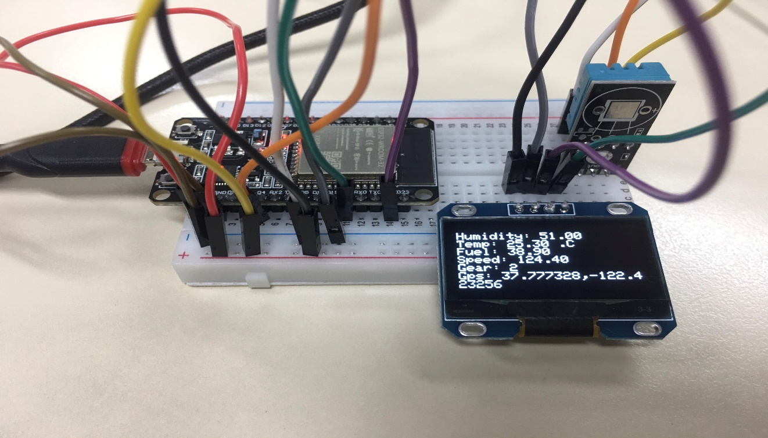

ESP32 reads data from a sensor, displays it on an OLED LCD, and pushes the data to a server.

**SERVER**

POST API for ESP32: <https://tienphuckx.ueuo.com/automotive/api-car-dashboard.php>

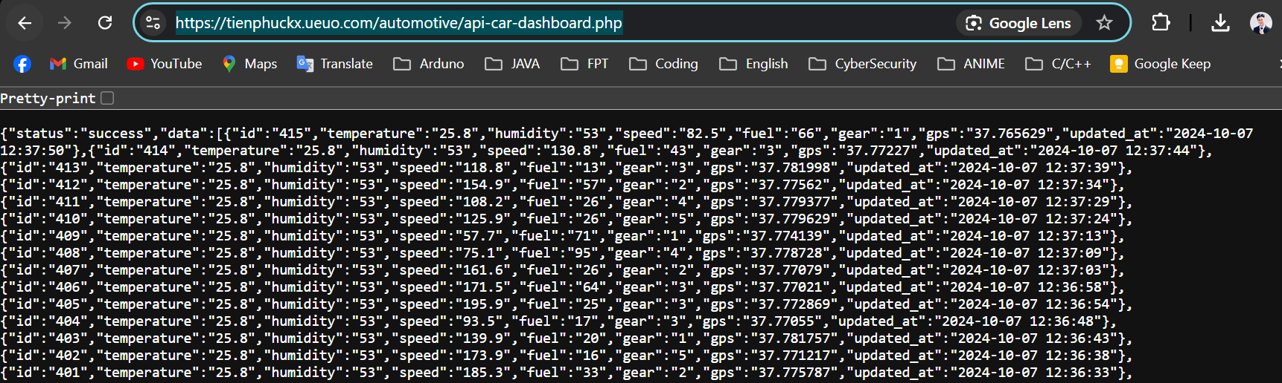

GET API for QT Dashboard App: <https://tienphuckx.ueuo.com/automotive/api-car-dashboard-qt.php> to select the newest record on DB.

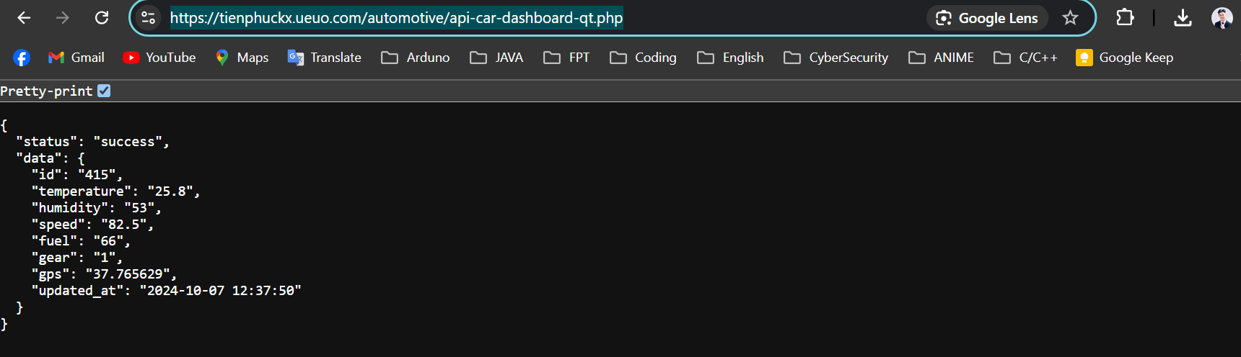

**Qt Car Dashboard app** displays real-time data using **long polling**.

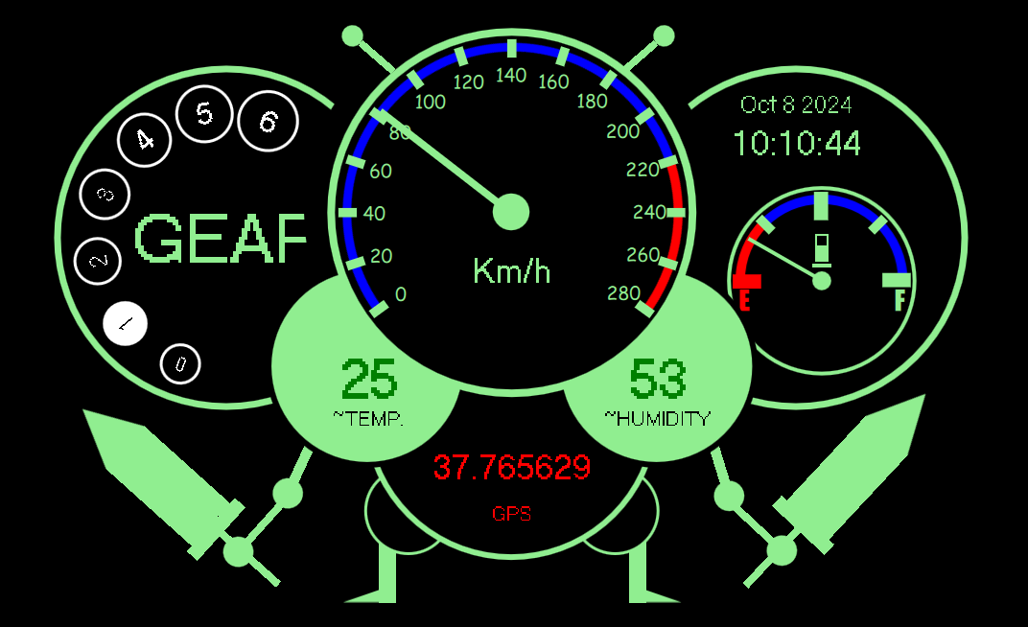

All source code and documentation are available on GitHub. Please check for more details.

<https://github.com/tienphuckx/car-dashboard-subscription>

The video intro link is available on Youtube: