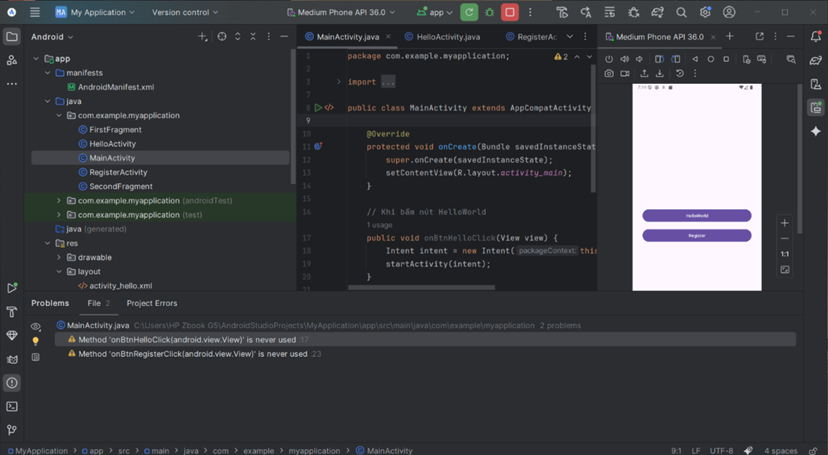

1. **MainActivity.java**

package com.example.teoapp;

import android.content.Intent;

import android.os.Bundle;

import android.view.View;

import androidx.appcompat.app.AppCompatActivity;

public class MainActivity extends AppCompatActivity {

@Override

protected void onCreate(Bundle savedInstanceState) {

super.onCreate(savedInstanceState);

setContentView(R.layout.activity_main);

}

// Gắn với android:onClick trong layout

public void onBtnHelloClick(View v) {

startActivity(new Intent(this, HelloActivity.class));

}

public void onBtnRegisterClick(View v) {

startActivity(new Intent(this, RegisterActivity.class));

}

}

2. **HelloActivity.java**

package com.example.teoapp;

import android.os.Bundle;

import androidx.appcompat.app.AppCompatActivity;

public class HelloActivity extends AppCompatActivity {

@Override

protected void onCreate(Bundle savedInstanceState) {

super.onCreate(savedInstanceState);

setContentView(R.layout.activity_hello);

}

}

3. **activity_main.xml**

Giữ đúng theo bạn đưa, chỉ thêm tools:context và namespace chuẩn.

<?xml version="1.0" encoding="utf-8"?>

<androidx.constraintlayout.widget.ConstraintLayout

xmlns:android="http://schemas.android.com/apk/res/android"

xmlns:app="http://schemas.android.com/apk/res-auto"

xmlns:tools="http://schemas.android.com/tools"

android:id="@+id/main"

android:layout_width="match_parent"

android:layout_height="match_parent"

tools:context=".MainActivity">

<Button

android:id="@+id/btnHelloWorld"

android:layout_width="wrap_content"

android:layout_height="wrap_content"

android:layout_marginTop="228dp"

android:onClick="onBtnHelloClick"

android:text="HelloWorld"

app:layout_constraintEnd_toEndOf="parent"

app:layout_constraintStart_toStartOf="parent"

app:layout_constraintTop_toTopOf="parent" />

<Button

android:id="@+id/btnRegister"

android:layout_width="wrap_content"

android:layout_height="wrap_content"

android:layout_marginTop="80dp"

android:onClick="onBtnRegisterClick"

android:text="Register"

app:layout_constraintEnd_toEndOf="parent"

app:layout_constraintStart_toStartOf="parent"

app:layout_constraintTop_toBottomOf="@+id/btnHelloWorld" />

</androidx.constraintlayout.widget.ConstraintLayout>

**4. activity_hello.xml**

Màn hình “Hello World!” đơn giản.

<?xml version="1.0" encoding="utf-8"?>

<androidx.constraintlayout.widget.ConstraintLayout

xmlns:android="http://schemas.android.com/apk/res/android"

xmlns:app="http://schemas.android.com/apk/res-auto"

android:layout_width="match_parent"

android:layout_height="match_parent">

<TextView

android:id="@+id/tvHello"

android:layout_width="wrap_content"

android:layout_height="wrap_content"

android:text="Hello World!"

android:textSize="24sp"

app:layout_constraintTop_toTopOf="parent"

app:layout_constraintBottom_toBottomOf="parent"

app:layout_constraintStart_toStartOf="parent"

app:layout_constraintEnd_toEndOf="parent"/>

</androidx.constraintlayout.widget.ConstraintLayout>