Subject : ViBE Data Model V12.3.17
This document describes the data model defined for internal Control & Command in ViBE and EM1000/2000/3000/4000 products.

Distribution :
…
Note: only the above addresses will be systematically informed of changes in this document.
Intranet :

Archives :
Archived by (cf Quality Assurance Plan)

Appraisal Authority:
Document revised and approved by (cf Quality Assurance Plan)

Date of Implementation:

Status of Main Changes
Ind | Date | Change Description | Made by
V 0.2 | Nov 26th 2002 | - Updates in CFG_TSxxx and CFG_IRDxxx descriptors  - Adding of a “Topology” sub-package in Configuration | O. Sernin
V 0.3 | Dec 11th 2002 | - Updates in CFG_IRDService, CFG_IRDVideo and CFG_TSAudio descriptors  - Creation of descriptors CFG_LSID and CFG_LSTopology to manage logical streams  - Other minor updates (possible values, links between descriptors, …) | O. Sernin
V 0.4 | Feb 12th 2003 | - Update of control_unit_id field (2 bytes)  - Updates of possible values for some fields in CFG_TSAudio and CFG_TSVideo descriptors | O. Sernin
V 0.5 | Mar 17th 2003 | - Update of CFG_TSPMTdescriptors and CFG_TSSDTdescriptors  - Minor updates in possible and default values  - Adding of default values, if defined | O. Sernin
V 0.6 | Apr 11th 2003 | - Adding of Supervision sub-package for alarm and monitoring descriptors  - Adding of Data sub-package for download and signaling descriptors  - Adding of CFG_VBRSlave descriptor for statmux management  - Adding of CFG_CUStatus descriptor for redundancy and status management  - Minor updates in CFG_TSSigIn, CFG_TSAnalogAudioInfo and IDT_ControlUnit descriptors | O. Sernin
V 0.7 | June 17th 2003 | - Adding of Identification example diagrams for encoder and decoder  - Adding of interface_id field in IDT_Interface descriptor  - New CFG sub-package with descriptors for Front-End boards configuration  - New descriptors for Statmux management : CFG_Alloc, CFG_Pool, CFG_VBRSlaveForMaster  - Adding of Test descriptors package | O. Sernin
V0.8 | July 28th 2003 | - Adding of Identification example diagrams for PDH and IP Front Ends  - Creation of IDT_InterfaceFE descriptor with interface_id field  - Updates in FE models : creation of CFG_ELII, CFG_ELOI, CFG_ILII, CFG_ILOI descriptors to configure external/internal logical input/output interfaces  - Adding of CFG_TSExpertConfig and CFG_TSVideoADVProc descriptors for Encoder V1.5  - Adding of HDLC_add field in CFG_CUTopology  - Update of pool_id field in CFG_Pool and CFG_VBRSlave (only 1 byte)  - Version field managed for every descriptor (value = 1)  - Some possible values changed in CFG_TSAudio (additional_delay), CFG_TSAnalogVideoInfo (analog_in_filtering), CFG_Pool and CFG_VBRSlave (flextream_mode) | O. Sernin
V 0.9 | Sept 9th 2003 | - Adding of CFG_Supplier and CFG_Consumer descriptors to manage logical streams  - CFG_TSVideo descriptor : adding of quantification_MB_adjust and default_pattern fields  - FE diagrams : links between configuration and identification descriptors updated | O. Sernin
V 0.10 | Sept 29th 2003 | - New descriptors for ASI FE board : CFG_ASIInInterface, CFG_ASIOutInterface, CFG_ASIInterfaceTransferMode  - Adding of stream_format field in CFG_IRDAudio  - Adding of CFG_TSAudioDolbyAC3 descriptor  - Adding of CFG_OptionTopology and IDT_Option descriptors for options declaration and identification  - Adding of SUP_Statistics descriptor | O. Sernin
V 0.11 | Oct 21st 2003 | - New descriptor IDT_SmartBoard  - Hardware infos added in IDT_Shelf and IDT_Board  - Adding of “active” field in IDT_BoardPackage  - Adding of Service package and SRV_Option and SRV_HistreamClockBackup descriptors | O. Sernin
V 0.11a | Nov 26th 2003 | - Adding of “key” and “hide” fields in IDT_Option  - Update of “key” field in SRV_Option descriptor | O. Sernin
V 1.6 | Jan 26th 2004 | - Update for Encoder V1.6 : in CFG_TSVideo descriptor, adding of ENU_LONG_DELAY value for low_delay_mode | O. Sernin
V 2.0 | Feb 3rd 2004 | - Identification : Adding of AS-ENC and DS-ENC boards  - New descriptor CFG_DataBroadcasting  - Adding of “mute_bad_language” field in CFG_IRDAudio  - Adding of “ASI distributor” configuration for Decoder  - All histream_id fields removed in CFG_ELII/ELOI/ILII/ILOI descriptors, and descriptors linked to CFG_HistreamID  - Adding of CU_Type field in SUP_Alarm  - Update of SUP_TS, SUP_TSService, SUP_TSComponent descriptors used for monitoring management | O. Sernin
V 2.0a | Feb 19th 2004 | - For Conditional Access : new descriptors CFG_CAFixedKey and SRV_InjectedKey  - For Manager configuration : new descriptor CFG_GPI  - For Service messages, new descriptors SRV_StandBy and SRV_Reboot | O. Sernin
V 2.0b | Mar 11th 2004 | - Adding of “RDB_clamp” field in CFG_TSVideoADVProc  - Update of all IP FE board configuration descriptors  - Removal of (unused) CFG_LSID descriptor  - Creation of SRV_Autotest descriptor  - Adding of “reply_waited” field in TST_NCCPTest | O. Sernin
V 2.0c | Mar 23rd 2004 | - Adding of “enable_decoding” field in CFG_IRDVideo and CFG_IRDAudio descriptors  - Removal of “supplier_IP_address” field in CFG_ILII  - “state” field replaced with “broadcast_status” and “building_mode” in CFG_TSSigOut descriptor  - Removal of (unused) DAT_BoardPackage and DAT_Download descriptors | O. Sernin
V 2.0d | Apr 5th 2004 | - Update of “burst_overhead” and “line_overhead” fields in CFG_FECOut descriptor | O. Sernin
V 2.5 | July 05th 2004 | - Management of AUD_ENC and H264_CP extension boards (identification : board, interface, resource, option ; topology : board, option)  - IDT_BoardPackage now linked with IDT_SmartBoard  - FE configuration : CFG_ServiceFilter, CFG_EMMFilter, CFG_ServiceCrossing and CFG_ComponentCrossing descriptors added, CFG_ELII updated(“service_filtering” and “EMM_filtering” fields added)  - SRV_Option : “option_code”, “status” and “option_commen” fields added  - MPEG4 Encoder configuration : new CFG_TSVideoMPEG4 descriptor | O. Sernin
V 2.5a | Sept 1st 2004 | - CFG_ServiceCrossing : “component_filtering” field added  - Adding of SRV_VideoTimeControl descriptor  - SRV_Option updated : “hide” field added | O. Sernin
V 2.5b | Sept 30th 2004 | - CFG_TSVideoMPEG4 : “deblocking_filter” field added  - Signalling management : creation of CFG_SigNIT and CFG_SigTOT descriptors  - CFG_ELII : “service_filtering” and “EMM_filtering” fields removed  - Creation of CFG_ServiceAndEMMFilter descriptor  - CFG_ServiceFilter and CFG_EMMFilter descriptors removed  - Predefined configurations management : creation of SRV_ConfRequest and SRV_ConfDescription descriptors | O. Sernin
V 2.5c | Oct 26th 2004 | - Update of all FE 100BT configuration descriptors  - Update of “date” field in SRV_ConfDescription descriptor  - Creation of CFG_RelatedDevice descriptor, used in external FE configuration only | O. Sernin
V 2.5d | Jan 6th 2005 | - Update of all FE configuration diagrams to indicate whether descriptors are mandatory or not  - Update of “IP_frame” field in CFG_TSVideo descriptor : max value is now ENU_DMH_MAX_IP_FRAME | O. Sernin
V 2.6 | Feb 25th 2005 | - Update of “external_channel_id” field in CFG_ELII and CFG_ELOI descriptor : values from 1 to 4 (default = 1)  - CFG_TSVideoADVProc : “FBD_temporal_status” and “FBD_temporal_level” fields added  - Management of AD_ENC board  - Update of “dest_UDP_port” minimal values in CFG_100BTFEDecaps/Encaps and CFG_FECIn/Out  - More information for “default_supplier_channel_id” field in CFG_ELII | O. Sernin
V 2.6a | Mar 14th 2005 | - Update of CFG_CUTopology : “network_id” field added | O. Sernin
V 3.0 | Mar 31st 2005 | - CFG_GPI descriptor : “GPIO_output_level” field added  - CFG_TSAudio descriptor : “AAC_profile” field added  - Creation of CFG_TSDataEthernet and CFG_TSDataDownstream descriptors  - Creation of CFG_TSDPI descriptor  - SRV_ConfDescription : “data_model_version” field added  - Creation of SRV_FileRequest descriptor  - Creation of SRV_DPIMessage descriptor | O. Sernin
V 3.0a | Apr 14th 2005 | - CFG_GPI descriptor : “GPIO_output_name”, “GPIO_input1_name”, “GPIO_input2_name” fields added  - Creation of SRV_ConfMemory descriptor  - Update of “action” field in SRV_ConfRequest : adding of ENU_ACTION_GET_MEMORY as a possible value | O. Sernin
V 3.0b | May 9th 2005 | - CFG_VBRSlaveForMaster descriptor : default values updated for “min_bit_rate”, “max_bit_rate”, “default_bit_rate” and “VBR_quality” fields  - SRV_DPIMessage descriptor : “protocol_version” and “DPI_command_message_type” fields added | O. Sernin
V 3.1 | Sept 15th 2005 | - Integration of MPEG-4 HD Encoder V1.0 DataModel  - Adding of a default configuration diagram for each type of control unit | O. Sernin
V 3.5 | Oct 13th 2005 | - CFG_TSAudio descriptor : “AAC_packet” field added  - Access Control management :  - CFG_TSDataEthernet descriptor : “SCPDG_client_id” and “SCPDG_id” fields added  - Creation of CFG_TSServiceEMM, CFG_CAGroup and CFG_CACAddress descriptors  - Creation of SRV_CAMessage descriptor  - Remote Flextream management :  - CFG_VBRSlave descriptor : “flex_type” and “flex_air_status” fields added  - Creation of CFG_FlexAlloc and CFG_FlexProxy | O. Sernin
V 3.5a | Nov 17th 2005 | - Remote Flextream management :  - CFG_FlexAlloc : “flex_frequency_area”, “flex_nominal_air_status”, “flex_redundant_IP_addr” and “flex_redundant_air_status” fields removed, “control_unit_id”, “remote_flextream_port”, “nominal_redundant” and “broadcast_status” fields added  - CFG_FlexProxy : “remote_flextream_port” and “frequency_area” fields added  - CFG_VBRSlaveForMaster : “nominal_redundant”, “broadcast_status” and “IP_ref_add” fields added  - CFG_VBRSlave : “flex_type” and “flex_air_status” fields removed  - Data injection management : creation of CFG_TSDataSimulcrypt and CFG_TSDataSerial | O. Sernin
V 3.5b | Jan 09th 2006 | - MPEG-4 HD Encoder : 4 audio options added  - Update of SD Encoder configuration diagram : links added for data components descriptors | O. Sernin
V 3.51 | Mar 02nd 2006 | - Extended types created for DP_ENC and H264_CP boards (for boards with new DSP)  - Encoder configuration diagram updated for DVB-Simulcrypt data components  - New possible values for “line” attribute of CFG_TSVBI descriptor  - New possible values for “audio_standard” attribute of CFG_TSAudio descriptor  - FrontEnd “expert parameters” : update of CFG_100BTFEDecaps (“RX_input_bit_rate” attribute), CFG_100BTFEEncaps (“TX_RTP_encapsulation”), CFG_ASIInInterface (“input_max_rate”), CFG_PdhInterfaceTransferMode (“rate”) | O. Sernin
V 3.51a | Mar 27th 2006 | - Removal (in CFG_BoardTopology only) of extended types created for DP_ENC and H264_CP boards  - Creation of SRV_EncoderInfo descriptor for exchanges between xP_Enc and H264_CP boards | O. Sernin
V 3.6 | Apr 13th 2006 | - New “board_type” value in identification and topology for IP_ENC board  - New “control_unit_type” for FE MultiEncaps  - Creation of CFG_EthernetInterface and CFG_IPEncaps descriptors for the configuration of IP interfaces  - MPEG-4 HD Encoder V1.5 :  - update of configuration diagrams to include Flextream management  - creation of CFG_TSData descriptor  - update of CFG_TSVideoHD descriptor for VBI parameters | O. Sernin
V 3.6a | May 11th 2006 | - CFG_EthernetInterface : ENU_1GBS value added for “speed” field, “RPIv2_authentication” renamed  - CFG_IPEncaps : removal of “TX_output_bit_rate” field, possible values changed for “TX_RTP_encapsulation”  - ENU_CUNIT_FE_ME value added in SUP_Alarm and SRV_ConfDescription descriptors | O. Sernin
V 4.0 | June 13th 2006 | - New “board_type” for FE MultiEncaps  - Creation of 2 new audio resources on enhanced H264_CP | O. Sernin
V 4.0a | June 29th 2006 | - Update of values for CFG_EthernetInterface : …  - CFG_VBRSlave : new fields “remote_status”, “remote_coding_type”, “remote_constant_bit_rate”, “RTD”  - CFG_FlexAlloc and CFG_FlexProxy completely redefined | O. Sernin
V 4.1 | Aug 25th 2006 | - New AUD-SUR board :  - Updates in IDT_Board, IDT_Interface and IDT_Resource descriptors  - Update of MPEG-4 HD Encoder identification diagram  - Update of CFG_BoardTopology descriptor  - Updates in CFG_TSAudio and CFG_TSAudioDolbyAC3 descriptors  - Creation of CFG_TSAudioDolbyExt and CFG_AudioDolbyEDecoder descriptors  - Creation of SUP_AudioDolbyEDecoder descriptor  - Update of MPEG-4 HD Encoder configuration diagram  - MPEG-4 HD Encoder V2.0 :  - CFG_TSAudio : update of “audio_standard” for Audio External AAC  - Update of MPEG-4 HD Encoder configuration diagram for IP interfaces  - Creation of CFG_TSVBIHD descriptor | O. Sernin
V 4.1a | Sept 15th 2006 | - AUD_SUR configuration :  - CFG_TSAudio : “dolby_E_program_number” added  - CFG_TSAudioDolbyExt : “extended_bitstream_info” field added  - Adding of extended types for IDT_Interface  - MPEG-4 HD Encoder V2.0 :  - IDT_Board : “nextboot_version”, “EPLD_version” and “coding_wheel” added  - CFG_TSAudio : ENU_AUD_ARIB_B24 added for “audio”standard” | O. Sernin
V 4.1b | Oct 13th 2006 | - AUD_SUR identification  - Update of MPEG-4 HD encoder diagram to manage 6 digital input interfaces  - AUD_SUR configuration :  - CFG_TSAudio : ENU_AUD_DOLBY_AC3_PLUS added for “audio”standard”  - CFG_TSAudio : new possible values added for “encoder_bit_rate” when Dolby AC3+ | O. Sernin
V 4.1c | Nov 29th 2006 | - AUD_SUR identification and topology  - Management of 6 audio resources instead of 2  - Management of 3 different board types | O. Sernin

V 5.0 | Dec 18th 2006 | - Update to take into account Mustang HD and SD (EM1000) encoders in identification and topology | O. Sernin
V 5.0a | Jan 18th 2007 | - EM1000 configuration added  - EM2000 added in identification and topology | O. Sernin
V 5.0b | Feb 14th 2007 | - Remote flextream :  - “remote_mode” field added in CFG_VBRSlave descriptor  - EM_CONTROLLER configuration :  - CFG_ExpertParam descriptor created  - “interface_desactivation” field added in CFG_EthernetInterface descriptor  - “GPIO_input3_name” and “GPIO_input4_name” fields added in CFG_GPI descriptor  - Update of all diagrams  - EM_ENCODER configuration :  - “alarm_saturation” and “detected_silence” fields added in CFG_TSAudio descriptor  - CFG_TSVideoPIP and CFG_TSVideoEM descriptors created  - Update of all diagrams | O. Sernin
V 5.0c | Mar 06th 2007 | - AUD_SUR configuration :  - CFG_AudioDolbyEDecoder : ENU_AUTO_SENSING value added for “decoder_enable” field  - HD DSP encoder V2.57 configuration :  - CFG_FEC2DOut descriptor created  - EM_CONTROLLER configuration :  - CFG_EncoderConfig : value 0 added for EM_CONTROLLER in “encoder_nb” field  - EM_ENCODER configuration :  - CFG_TSVideoEM : “PVR_descriptor” field added  - Update of EM1000 encoder configuration diagrams | O. Sernin
V 5.0d | Apr 26th 2007 | EM1000 configuration :  - CFG_IPEncaps : “virtual_src_IP_address” field added  - CFG_TSAudio : possible values defined for “detected_silence” field | O. Sernin
V 5.0e | May 24th 2007 | - EM1000  - Default configurations updated for EM_ENCODER and EM_CONTROLLER control units  - EM_ENCODER configuration diagram : CFG_TSData and CFG_VBRSlave descriptors added, CFG_TSAudioDolbyExt removed  - CFG_CUStatus : moved from EM_ENCODER to EM_CONTROLLER configuration and “device_name” and “nominal_device_name” fields added  - EM3000  - Same identification as MPEG-4 HD DSP Encoder : removal of ENU_BOARD_HDM_VIDEO_ENC  - CFG_TSVideoHD : “hierarchical_GOP”, “direct_mode”, “PAFF”, “MBAFF”, “PVR_descriptor” and “film_mode” fields added  - CFG_TSVideoPIP : “video_profile” field added | O. Sernin
V 5.0f | June 13th 2007 | - EM3000  - CFG_TSVideoHD : “station_id” field added  - CFG_TSVideoPIP : new value added for “picture_resolution”  - Mustang HD encoder configuration diagram added | O. Sernin
V 5.0g | July 06th 2007 | - EM1000  - CFG_TSVideoEM : “EIA708B” field added  - EM_ENCODER configuration diagram : link added between CFG_TSData and IDT_Interface  - EM3000  - CFG_TSVideoHD : “quantification_MB_adjust” field added  - CFG_TSVBIHD : new value ENU_VBI_HD_TELETEXT for “VBI_type” field | O. Sernin
V 5.0h | Aug 24th 2007 | 1) EM1000 / EM2000 / EM3000 options :  - IDT_Option and SRV_Option : new possible values for “option_id” field added  2) EM1000 configuration :  - CFG_TSAudio : possible values for “detected_silence” field updated  - CFG_TSOut : possible values for “synthetizer_clock_frequency” field updated  3) ViBE SD Encoder configuration :  - CFG_TSVBI : new “VBI_missing” field added | O. Sernin
V 5.0i | Sep 07th 2007 | 1) EM1000 / EM2000 / EM3000 configuration :  a. CFG_TSVideoPIP : “aspect_ratio” field added, “GOP_size” field updated  2) EM1000 configuration :  a. CFG_TSVideoEM : possible values for “picture_resolution” field added  3) EM3000 supervision / monitoring :  a. SUP_AudioDolbyEDecoder descriptor updated | O. Sernin
V 5.0j | Sep 26th 2007 | 1) ViBE encoder configuration :  a. CFG_TSVBI : “VBI_type” field updated  2) ViBE decoder configuration :  a. CFG_IRDVBI : “line_VPS”, “VITC_1761”, “PID_1761_VITC”, “VITS_1761”, “PID_1761_VITS”, “field1_VITC” and “field2_VITC” fields added | O. Sernin
V 5.0k | Oct 11th 2007 | 1) EM1000 configuration :  a. CFG_TSVideoEM and CFG_TSVideoPIP : new ENU_DMH_VID_BAR_PATTERN value for “default_pattern” field  2) ViBE encoder configuration :  a. CFG_TSVBI : values for “VBI_type” field updated  3) ViBE decoder configuration :  a. CFG_IRDVBI : values for “field1_VITC” updated | O. Sernin
V 5.1 | Nov 14th 2007 | 1) EM1000 Flextream configuration :  a. CFG_FlexProxy : “IP_multicast_TTL” field added  b. CFG_VBRSlave : new values for “RTD” field  2) ViBE decoder configuration :  a. CFG_IRDVBI : “line2_field1_VITC”, “line2_field2_VITC”, “line1_field1_VITS”, “line1_field2_VITS”, “line2_field1_VITS” and “line2_field2_VITS” fields added  3) EM3000 :  a. SRV_StandardDetected descriptor created | O. Sernin
V 5.1a | Jan 11th 2008 | 1) EM1000 Flextream configuration :  a. CFG_VBRSlave : new ENU_VBR_CAPPED value for “flextream_mode” field  b. EM_CONTROLLER configuration diagram updated  2) EM2000 :  a. IDT_Resource : 4 values added for “extended_type” field for audio encoders  c. Identification diagrams updated  b. Configuration diagram added | O. Sernin
V 5.1b | Feb 11th 2008 | 1) EM2000 configuration :  a. Encoder default configuration diagram added  b. Configuration diagrams updated | O. Sernin
V 5.1c | Mar 06th 2008 | 1) EM1000/3000 configuration :  a. CFG_TSVideoHD and CFG_TSVideoEM : possible values updated for PAFF attribute | O. Sernin
V 5.1d | Apr 15th 2008 | 1) EM3000 configuration :  a. CFG_AudioDolbyEDecoder : value ENU_DESEMBED5 added for main_input and PCM_input attributes  b. CFG_AudioChannel : PCM_reversion_audio_group and PCM_reversion_audio_channel fields added  c. CFG_TSVideoHD : AFD_insertion and AFD_reversion_data fields added | O. Sernin
V 5.1e | Jun 24th 2008 | 1) EM1000/2000 configuration :  a. CFG_TSVideoEM : ENU_HPL3 value added for video_profile attribute  b. CFG_TSAudio : ENU_AAC_HE_V2 added for AAC_profile attribute  2) EM2000 identification :  a. removal of “Clarity pre-processing” software option | O. Sernin
V 5.1f | Aug 07th 2008 | 1) EM3000 configuration :  a. CFG_FEC2DOut : FEC_mode attribute added  2) EM3000 service :  a. SRV_VideoTimeControl : TC_source attribute added | O. Sernin
V 5.2 | Oct 14th 2008 | 1) EM1000/2000 identification/service :  a. IDT_Option/SRV_Option : Clarity and DPI options added  2) EM1000/2000 configuration :  a. CFG_TSService : service_name attribute type changed to hbyte[1+n]  b. CFG_TSDVBInfo : service_provider_name attribute type changed to hbyte[1+n]  c. CFG_TSAudio : ENU_AUD_EXTERNAL_AC3_PLUS value added for audio_standard attribute  d. CFG_TSVideoEM : new values for deblocking_filter attribute, new delay_mode and auto_conf attributes  e. CFG_TSData : encoder_bitrate attribute added | O. Sernin
V 5.3 | Dec 22nd 2008 | 1) EM1000/2000 identification/service :  a. IDT_Option/SRV_Option : Clarity and DPI options removed  2) EM1000/2000 v1.6 configuration :  a. CFG_TSDPI added in configuration diagrams  3) EM3000 v1.6 configuration :  a. CFG_TSVideoHD : new values for deblocking_filter attribute, new delay_mode attribute  4) MPEG-2 SD Encoder (Phyllium) configuration :  a. CFG_TSVideoEM : new value ENU_420_MP_ML for video_profile attribute, new closed_GOP_mode attribute  b. CFG_EncoderConfig : new coding_mode attribute | O. Sernin
V 5.3a | Jan 09th 2009 | 1) EM2000 v1.6 configuration :  a. CFG_TSVideoHDADVP : new values for RDB_level and ADD_level attributes, new auto_conf and objective_measure attributes | O. Sernin
V 5.3b | Apr 22nd 2009 | 1) EM1000/2000 v2.0 configuration :  a. CFG_TSVideoEM : new values for default_pattern and adaptive_GOP attributes  2) EM1000/2000 identification/service :  a. IDT_Option/SRV_Option : Scrambling, MPEG-2 and MPEG-4 encoding options added  3) EM3000 configuration :  a. CFG_TSAudio : new value ENU_AUD_DOLBY_PULSE for audio_standard attribute | O. Sernin
V 5.3c | Jun 06th 2009 | 1) EM3000 configuration :  a. CFG_TSAudio : new values ENU_AUD_MPEG4_DOLBY_PULSE and ENU_AUD_MPEG2_DOLBY_PULSE for audio_standard attribute  b. CFG_TSVideoHD : new values ENU_ON_WITH_REVERSION_DATA and ENU_ON_WITH_STATIC_DATA for AFD_insertion attributes | O. Sernin
V 5.3d | Jun 12th 2009 | 1) EM3000 identification  a. IDT_Board and CFG_BoardTopology : new value ENU_BOARD_AUD_SUR_DOLBY_PULSE for board_type attribute  2) EM1000/2000 configuration :  a. CFG_TSVideoEM : new values for default_pattern attribute  b. CFG_IPEncaps : new transport_resource_name attribute | O. Sernin
V 5.4 | Jul 8th 2009 | 1) EM3000 identification  a. IDT_Shelf : new value ENU_MP2_SHELF_HD for shelf_type attribute  2) EM3000 configuration :  a. CFG_TSVideoHD : new value ENU_420_MP_HL for video_profile attribute and new closed_GOP_mode attribute | O. Sernin
V 5.4a | Sep 22nd 2009 | 1) EM1000/2000 configuration :  a. CFG_TSVideoEM : new nb_lines_CC and CC_lines attributes  b. CFG_EthernetInterface : new interface_backup_status attribute | O. Sernin
V 5.5 | Dec 2nd 2009 | 1) EM2002 identification  a. IDT_Shelf : new value ENU_EM_SHELF_EM2002 for shelf_type attribute  b. IDT_Board/IDT_SmartBoard : new value ENU_BOARD_EM2002 for board_type attribute  2) EM1000/2000 configuration :  a. CFG_TSVideoEM : new value ENU_SHORT_DELAY for delay_mode attribute  b. CFG_GPI : new GPIO_input_level attribute  c. CFG_TSDPI : new preroll_time, break_duration and SCTE104_origin attributes  d. CFG_FlexAlloc : new multicast_mode and source_IP_address attributes | O. Sernin
V 5.5a | Jan 26th 2010 | 1) EM1000/2000 configuration :  a. New CFG_TSVideoLogo descriptor for logo insertion  b. CFG_TSAudio : new static_gain attribute  2) EM1000/2000/3000 configuration :  a. CFG_TSData : new input_synchro, PCR_PID and additional_delay attributes | O. Sernin
V 5.5b | Mar 16th 2010 | 1) EM1000/2000 configuration :  a. CFG_TSAudio : update of static_gain attribute  b. CFG_TSData : update of additional_delay attribute | O. Sernin
V 5.5c | Mar 25th 2010 | 1) EM1000/2000 configuration :  a. CFG_TSVideoEM : update of default_pattern attribute  b. New CFG_FTP, CFG_Logos and CFG_Patterns descriptors for logo insertion and custom patterns management  c. CFG_TSDPI : new GPI_inputs attributes | O. Sernin
V 5.6 | May 20th 2010 | 1) EM2004 identification :  a. new EM2004 type in IDT_Shelf and IDT_Board/SmartBoard  b. new EM2004 type in CFG_BoardTopology  2) EM3000 configuration :  a. CFG_TSAudio : new auto_sensing_mode attribute  b. CFG_TSAudio : new value ENU_AUD_EXTERNAL_AC3_TO_AC3_PLUS for audio_standard attribute | O. Sernin
V 5.6a | Jul 13th 2010 | 1) EM3000 identification/service :  a. IDT_Option/SRV_Option : NEMS3D2D option added  2) EM1000/2000 configuration :  a. CFG_TSAudio : new frequency_area attribute  b. CFG_TSVideoHDADVP : new mosquito_noise_reducer attribute | O. Sernin
V 5.6b | Sep 16th 2010 | 1) EM1000/2000 configuration :  a. CFG_TSAudio : new static_gain_right attribute | O. Sernin
V 5.6c | Dec 7th 2010 | 1) EM1000/2000 configuration :  a. CFG_TSVideoHDADVP : new additional_filters attribute | O. Sernin
V 6.0 | Aug 8th 2010 | 1) EM1000/2000 V3.2 identification :  a. new AVDEC type in IDT_Board/SmartBoard/ControlUnit  b. new AVDEC type in CFG_BoardTopology  2) EM1000/2000 V3.2 configuration :  a. new descriptors for AVDEC configuration  3) EM1000/2000 V3.2 supervision :  a. new descriptors for AVDEC status/monitoring | O. Sernin
V 6.0a | Oct 18th 2010 | 1) EM1000/2000 V3.2 configuration :  a. new CFG_DVBSubtitle and CFG_Fonts descriptors for DVB subtitling | O. Sernin
V 6.0b | Dec 9th 2010 | 1) EM1000/2000 V3.2 configuration :  a. CFG_TSVideoHDADVP : new additional_filters attribute  b. CFG_VBRSlave : new trigger_fallback_enable attribute | O. Sernin
V 6.0c | Mar 28th 2011 | 1) EM1000/2000 V3.2 configuration :  a. CFG_TSExpertConfig : new DVBSub_param attribute | O. Sernin
V 6.1 | Feb 17th 2011 | 1) EM1000/2000 V3.2.2 encoder configuration :  a. CFG_TSExpertConfig : new DVBSub_param attribute  b.CFG_TSVBI : new SMPTE2031 and SMPTE2031_filtering attributes  c. CFG_TSData : new input_index and alarm_no_stream attributes  d. new CFG_TSDataPassThru descriptor  2) EM1000/2000 V3.2.2 AVDEC configuration :  a. CFG_AVP : new PLL_mode and PLL_forced_mode attributes  b. CFG_Dejittering : new values for correction_level attribute | O. Sernin
V 6.1a | Apr 5th 2011 | 1) EM1000/2000 V3.2.2 AVDEC configuration :  a. CFG_EthernetInput : new input_enable attribute  b. CFG_ASIInput : new input_enable attribute  c. CFG_AVP : new default value for TS_output_clock attribute  2) EM1000/2000 V3.2.2 encoder configuration :  a. CFG_FEC2DOut : new packet_linearization attribute | O. Sernin
V 6.1b | Sep 12th 2011 | 1) EM1000/2000 V3.2.3 encoder configuration :  a. CFG_DVBSubtitle : new vertical_offset, text_height and border_width attributes  b. CFG_DVBSubtitle : new min, max and default values for presend attribute  2) EM3000 V2.4 encoder configuration :  a. CFG_TSVideoHD : new ENU_AUTO_MEDIUM2 value for deblocking_filter attribute  b. CFG_TSDPI : new ENU_OFF and ENU_INPUT_INBAND values for SCTE104_origin attribute  3) EM1000/2000 V3.2.3 AVDEC monitoring :  a. SUP_VideoStatus : new ANC_presence attribute | O. Sernin
V 7.0 | Sep 13th 2011 | - EM4000 V1.0 identification :  - new values for type attributes in IDT_Shelf, IDT_Board, IDT_Interface and IDT_Resource descriptors  - IDT_Option / SRV_Option : new values for option_id attribute  - EM1000/2000/3000 identification :  - IDT_Option / SRV_Option : new values for option_id attribute  - EM4000 V1.0 configuration :  - CFG_BoardTopology : new values for board_type attribute  - new CFG_SDIConfig descriptor  - CFG_TSAudio : new dolbyE_autoswitch_mode attribute | O. Sernin
V 7.0a | Sep 27th 2011 | - EM4000 V1.0 configuration :  - CFG_TSAudio : new audio_description and AD_null_packets attributes | O. Sernin
V 7.0b | Dec 9th 2011 | - EM2000 V4.0 identification :  - IDT_Option / SRV_Option : new NEMS2DDE value for option_id attribute  - EM1000/2000 V4.0 AVDEC configuration :  - CFG_EthernetInput : new interface_desactivation attribute  - CFG_IPTS : new transport_resource_name attribute  - EM1000/2000 V4.0 AVDEC monitoring :  - New SUP_RTPStatus descriptor | O. Sernin
V 7.0c | Mar 1st 2012 | - EM4000 identification :  - IDT_Option / SRV_Option : new NEMS4FLE value for option_id attribute  - EM1000/2000 V4.0 AVDEC configuration :  - CFG_Dejittering : new values for correction_level attribute  - EM1000/2000 V4.0 Encoder configuration :  - CFG_TSExpertConfig : new video_ext_param attribute  - CFG_TSVideoEM : new values for deblocking_filter (ENU_PICTURE_DEF_AUTO) and quantification_MB_adjust (ENU_PVE_STANDARD, ENU_PVE_NEUTRAL) attributes | O. Sernin
V 7.0d | Apr 10th 2012 | - EM1000/2000 V4.0 Encoder configuration :  - CFG_TSVideoEM : new still_pictures attribute | O. Sernin
V 7.1 | Mar 23rd 2012 | - EM1000/2000 V4.10 Encoder configuration :  - CFG_TSVBI : new max_bitrate attribute  - CFG_VBRSlave : new stream_content and component_type attributes  - AVDEC monitoring :  a. SUP_IPTSStatus : new TS_packets_number attribute | O. Sernin
V 7.1a | Apr 13th 2012 | - EM1000/2000 V4.10 Encoder identification :  - IDT_Option / SRV_Option : NEMS1FLS and NEMS2FLS options added  - EM1000/2000 V4.0 Encoder configuration :  - CFG_TSVideoEM : new still_pictures attribute  - EM1000/2000 V4.10 Encoder configuration :  - CFG_DVBSubtitle : new no_teletext attribute  - CFG_TSVBI : new additional_delay attribute | O. Sernin
V 7.1b | Jun 8th 2012 | - EM1000/2000 V4.10 / EM4000 V1.10 Encoder identification :  - IDT_Resource : new values (ENU_RESOURCE_AUDIO_ENCODER_[9..48]) for extended_type attribute  - EM3000 V3.0 configuration :  - CFG_TSAudioDolbyExt : new ENU_CAC3_MD_SRC_SMPTE2020 value for metadata_source attribute  - EM1000/2000 V4.10 Encoder configuration :  - CFG_TSVBI : new max_lines_transmitted attribute  - EM1000/2000 V4.10 AVDEC supervision :  - SUP_DejitterStatus : new dejitter_mode attribute and new values for correction_level attribute | O. Sernin
V 7.2 | Aug 9th 2012 | - EM1000/2000 V4.10 Encoder configuration :  - CFG_DVBSubtitle : new left_margin, right_margin and box_height attributes  - EM1000/2000 V4.10 AVDEC supervision :  - SUP_VideoStatus : new ENU_HEIGHT_720 value for encoded_height attribute and ENU_WIDTH_1280 for encoded_width attribute | O. Sernin
V 8.0.0 | Sep 21st 2012 | - EM4000 V2.0 identification :  - IDT_Option / SRV_Option : some EM4000 options added  - EM1000/2000 V4.20 Encoder configuration :  - CFG_TSVBI : new no_teletext attribute  - EM1000/2000 V4.20 / EM4000 V2.0 Controller configuration :  - CFG_FlexAlloc : new deployment_mode and source_IP_address_2 attributes  - EM4000 V2.0 Encoder configuration :  - CFG_TSVBIHD : new values for VBI_type attribute  - CFG_Fonts : new max values for nb_fonts and font_number attributes for EM4000  - CFG_DVBSubtitle : new values [1,32] for font_default attribute for EM4000  - CFG_TSAudioDolbyExt : new metadata_transmission_mode attribute, new values for metadata_source, center_mixing_level and surround_mixing_level attributes  - New CFG_TSAudioLoudness descriptor  - EM1000/2000 V4.20 Supervision :  - New SUP_AlarmWording descriptor | O. Sernin
V 8.0.1 | Nov 19th 2012 | - EM4000 V2.0 identification :  - IDT_Resource : new ENU_RESOURCE_DVB_SUBTITLE value for resource_type attribute  - EM1000/2000 V4.20 Encoder configuration :  - CFG_DVBSubtitle : new auto_wipe_out attribute  - New CFG_PreservedAreas descriptor  - EM4000 V2.0 Encoder configuration :  - CFG_TSAudioDolbyExt : new ENU_9_DB_ATT for center_mixing_level and surround_mixing_level attributes | O. Sernin
V 8.1.0 | Feb 22nd 2013 | - EM1000/2000 V4.30 identification :  - IDT_Option / SRV_Option : NEMS1J20 / NEMS2J20 options added  - EM4000 V2.10 Encoder configuration :  - CFG_Patterns : new pattern_geometry_wxh attribute  - CFG_TSVideoHD : new still_pictures attribute and new possible values for standard, default_pattern and delay_mode attributes  - CFG_DVBSubtitle : new extended_vertical_offset attribute  - CFG_TSVideoEM : new station_id attribute  - CFG_TSVBIHD : new VBI_missing attribute  - EM1000/2000/4000 supervision :  - SUP_Alarm : list of Probable_Cause values updated | O. Sernin
V 8.1.1 | Mar 11th 2013 | - EM4000 V2.10 Encoder configuration :  - CFG_DVBSubtitle : new extended_left_margin and extended_right_margin attributes  - EM1000/2000 V4.30 Encoder configuration :  - CFG_VBRSlave : new ENU_VBR_SINGLE_SERVICE value for flextream_mode attribute | O. Sernin
V 8.2.0 | Apr 17th 2013 | - EM4000 V2.50 identification :  - IDT_Option / SRV_Option : NEMS4PIP and NEMS4FEC options added  - EM4000 V2.50 Encoder configuration :  - CFG_TSVideoPIP : new IP_frame, adaptive_GOP and closed_GOP_mode attributes  - CFG_TSData : new input_PID attribute  - EM1000/2000 V4.30 Encoder configuration :  - CFG_DVBSubtitle : new values for auto_wipe_out attribute (ENU_OFF(0) or from 5 to 60) | O. Sernin
V 8.2.1 | Jun 4th 2013 | - EM4000 V2.50 Encoder configuration :  - New CFG_TSPCR descriptor  - CFG_TSAudioDolbyExt : new SDID attribute  - CFG_Patterns : new max value for nb_patterns (8) | O. Sernin
V 9.0.0 | July 2013 | - EM4000 V3.0 Controller / Encoder configuration :  - CFG_EncoderConfig : new input_mode attribute | O. Sernin
V 9.0.1 | Sep 24th 2013 | - EM4000 V3.0 Controller configuration :  - CFG_FlexAlloc : new source_IP_address_3 attribute  - CFG_EthernetInterface : new input_enable attribute  - EM4000 V3.0 Controller configuration :  - CFG_IPTS : new enable attribute  - New CFG_DECData descriptor | O. Sernin
V 9.0.2 | Nov 14th 2013 | - EM4000 V2.60 identification :  - IDT_Option / SRV_Option : NEMS4D2D option added  - EM4000 V2.60 configuration :  - CFG_TSVideoHDADVP : new entropy_shaping attribute  - CFG_DVBSubtitle : new default_alignment attribute  - CFG_SDIConfig : new input_number attribute  - New CFG_PreservedAreasAuto descriptor  - CFG_FEC2DOut : new default value for packet_linearization attribute  - EM4000 3.0 configuration :  - CFG_DECAudio : new TS_passthru_test attribute | O. Sernin
V 9.0.3 | Nov 29th 2013 | - EM4000 V2.60 configuration :  - CFG_SDIConfig : new default value (0) for input_number attribute  - EM4000 V3.0 configuration :  - New CFG_GenericData descriptor  - CFG_TSAudio : new value for audio_type attribute (ENU_FOLLOW_INPUT)  - EM4000 V3.0 supervision  - New SUP_TSComponentMonitoring descriptor  - New SUP_TSMonitoring descriptor  - New SUP_TSServiceMonitoring descriptor  - New SUP_ParamsMonitoring descriptor  - New SUP_TSEMMMonitoring descriptor  - New SUP_TableMonitoring descriptor  - New SUP_TableHeaderMonitoring descriptor  - New SUP_TSECMMonitoring descriptor | O. Sernin
V 9.0.4 | Dec 11th 2013 | - EM4000 V2.51 configuration  - CFG_TSVideoHD / CFG_TSVideoEM : new values for default_pattern attribute (ENU_VID_CUSTOM_PATTERN_5…8)  - EM4000 V3.0 configuration :  - CFG_TSAudioDolbyAC3 : new value for coding_mode attribute (ENU_FOLLOW_INPUT)  - CFG_DECData : new mode attribute  - EM4000 V3.0 supervision  - SUP_TSMonitoring : new TS_sync_loss, sync_byte_error, PAT_error and PMT_error attributes  - SUP_TSComponentMonitoring : new continuity_counter_error and PID_error attributes | O. Sernin
V 9.1.0 | July 7th 2014 | - EM4000 V3.10 configuration :  - CFG_EncoderConfig : new IP_mode and TS_number attributes  - New CFG_IPTSGroup descriptor  - CFG_DECData : new values for mode attribute  - EM4000 identification (previous versions) :  - IDT_Option / SRV_Option : NEMS4HDE, NEMS4SDE and NEMS4DDD options added  - EM4000 configuration (previous versions) :  - CFG_TSVBI / CFG_TSVBIHD : new value for VBI_missing attribute (ENU_EM_VBI_DISABLE_ALARM)  - CFG_TSAudio : new autoswitch_mode, video_frame_sync and radio_latency attributes, and new value for AD_null_packets attribute (ENU_AUTOMATIC_MODE)  - CFG_TSVideoEM : new values for EIA708B attribute (ENU_OFF / ENU_ON replaced with ENU_OFF / ENU_FORCED_EIA708B / ENU_LATAM)  - CFG_TSVideoHD : new values for default_pattern attribute (ENU_VID_DISABLE_OUTPUT / ENU_VID_DISABLE_TS / ENU_VID_NULL_BITRATE) | O. Sernin
V 10.0.0 | Oct 7th 2014 | - EM4000 V4.0 identification :  - IDT_Option / SRV_Option : NEMS4UPS, NEMS4DWS, NEMS4LOG and NEMS4FLS options added  - EM4000 V4.0 configuration :  - CFG_IPTSGroup : new values for switching_strategy and trigger_mode attributes, and new transport_resource_name attribute  - CFG_TSVideoHD / CFG_TSVideoEM : new conversion_mode and reversion_mode attributes  - EM4000 V4.0 supervision :  - New SUP_IPTSGroupStatus descriptor | O. Sernin
V 10.0.1 | Nov 4th 2014 | - EM4000 V4.0 identification :  - IDT_Option / SRV_Option : NEMS4UCV and NEMS4DWO renamed  - EM4000 V4.0 configuration :  - CFG_TSAudio : new value ENU_MONO for audio_type attribute  - CFG_AVP : new rescale_mode attribute  - CFG_TSAudioDolbyAC3 : new value ENU_CAC3_MONO for coding_mode attribute | O. Sernin
V 10.0.2 | Jan 19th 2015 | - EM4000 V4.10 identification :  - IDT_Option / SRV_Option : NEMS4DWO removed  - IDT_Option : new commercial_ref attribute  - EM4000 V4.10 configuration :  - CFG_EthernetInterface : new value ENU_LINK_UP_NO_TRAFFIC_ARP for interface_desactivation attribute  - CFG_SDIConfig : new value ENU_SDI_HD_720P for input_standard attribute  - CFG_IPEncaps : new source_UDP_port attribute | O. Sernin
V 10.0.3 | Feb 3rd 2015 | - EM4000 V2.75 configuration :  - CFG_TSAudio : new AAC_SBRsignaling attribute  - CFG_TSVideoHD / CFG_TSVideoEM : new value for deblocking_filter attribute (ENU_PICTURE_DEF_SUPER_SHARP)  - EM4000 V4.10 configuration :  - CFG_TSVideoEM : new values for conversion_mode attribute (ENU_SD_CONV_AUTO_4_3_AFD and ENU_SD_CONV_AUTO_16_9_AFD) and for aspect_ratio attribute (ENU_FULL_AUTOMATIC_AFD)  - CFG_Logos : new max value for nb_logos (8) | O. Sernin
V 10.0.4 | Mar 27th 2015 | - EM4000 V4.10 configuration :  - CFG_TSVideoHD : new VITC_line attribute  - CFG_TSVBI : new VBI_type_downscale attribute | O. Sernin
V 10.0.5 | Apr 16th 2015 | - EM4000 V4.10 configuration :  - CFG_TSVBIHD : new nb_lines attribute and loop of VBI lines | O. Sernin
V 10.2.0 | Apr 17th 2015 | - EM4000 V4.20 configuration :  - CFG_Pool : new min_bitrate and flexservice_mode attributes  - CFG_VBRSlave : new VBR_capped_quality, flexable_max_bitrate, flexable_default_bitrate, flexable_cbr_bitrate and nb_flexable_categories attributes, and loop of flexable categories | O. Sernin
V 10.2.1 | Jul 7th 2015 | - EM4000 V2.80 configuration :  - CFG_TSData : new PCR_synchro_mode attribute  - CFG_EncoderConfig : new PCR_synchro_mode attribute  - EM4000 V4.0 identification :  - IDT_Option / SRV_Option : NEMS4SU2 option added  - EM4000 V4.20 configuration :  - CFG_TSVideoHD : new EIA708B attribute  - CFG_TSAudio : new one_frame_per_PES attribute  - CFG_TSDPI : new audio_stream_conditioning, redundancy_with_AS and alarm_no_alive attributes | O. Sernin
V 10.2.2 | Aug 11th 2015 | - EM4000 V4.20 identification :  - IDT_Option / SRV_Option : NEMS4TGA option added  - EM4000 V4.20 configuration :  - CFG_TSDPI : new targeted_video_insert, SCTE104_min_preroll_time_conformity, unique_pgm_id_forced_mode and unique_pgm_id_user_value attributes | O. Sernin
V 10.2.3 | Sep 15th 2015 | - EM4000 V4.20 configuration :  - CFG_TSVBIHD : new value ENU_VBI_HD for VBI_lines.VBI_type attribute  - CFG_FlexAlloc : new t_act attribute  - CFG_TSDPI : new keep_alive_splice_null and keep_alive_repetition attributes | O. Sernin
V 10.2.4 | Sep 24th 2015 | - EM4000 V2.80 configuration :  - CFG_EncoderConfig : new PLL_timeout_value attribute  - EM4000 V4.20 configuration :  - CFG_TSVBIHD : new max_bitrate attribute | O. Sernin
V 11.0.0 | Nov 9th 2015 | - ViBE4K V1.10 identification :  - IDT_Shelf : new value ENU_EM_SHELF_VIBE4K for shelf_type attribute  - IDT_SmartBoard : new value ENU_BOARD_ADVANTECH for board_type attribute  - IDT_Resource : new value ENU_RESOURCE_VIDEO_UHD for extended_type attribute  - ViBE4K V1.10 configuration :  - CFG_BoardTopology : new value ENU_BOARD_ADVANTECH for board_type attribute  - New CFG_TSVideoUHD descriptor  - CFG_TSAudio : new values ENU_AUD_DOLBY_AC4 and ENU_AUD_EXTERNAL_AC4 for audio_standard attribute | O. Sernin
V 12.0.0 | Feb 1st 2016 | - ViBE4K V1.10 identification :  - IDT_Option / SRV_Option : ViBE4K options added  - ViBE4K V1.10 configuration :  - CFG_TSVideoUHD : new values ENU_VID_DISABLE_TS and ENU_VID_DISABLE_OUTPUT for default_pattern attribute  - CFG_TSVideoUHD : new default value for encoder_bit_rate and GOP_size attributes  - EM4000 V4.30 configuration :  - CFG_FlexAlloc : new monitoring_enable, monitoring_mcast_addr, monitoring_mcast_port and monitoring_mcast_mode attributes  - CFG_TSVideoHD : new VBI_missing attribute  - CFG_TSVideoEM : new VBI_missing and ultra_low_bitrate_encoding attributes  - CFG_TSAudio : new legacy_AAC_packetization attribute | O. Sernin
V 12.0.1 | Feb 19th 2016 | - ViBE4K V2.0 identification :  - IDT_Option / SRV_Option : N4KS4HHA option added  - ViBE4K V2.0 configuration :  - CFG_SDIConfig : new values ENU_SDI_HD_3G_LEVEL_A / LEVEL_B for input_standard attribute  - CFG_TSVideoUHD : new values for default_pattern, standard, video_profile, delay_mode, IP_frame, GOP_size, encoder_bit_rate and adaptive_GOP attributes  - CFG_TSVideoUHD : new HDR_mode and HDR_type attributes  - CFG_EncoderConfig : new video_encoding_mode attribute  - CFG_TSVideoHD : new values for default_pattern, standard, video_profile and picture_resolution attributes  - CFG_TSVideoHD : new HDR_mode and HDR_type attributes | O. Sernin
V 12.1.0 | Apr 29th 2016 | - EM4000 V4.40 identification :  - IDT_Option / SRV_Option : NEMS4HCV and NEMS4PSP options added  - EM4000 V4.40 configuration :  - CFG_SDIConfig : new value ENU_SDI_HD_AUTO for input_standard attribute and new cross_conversion attribute  - CFG_ASIOutInterface : new output_enable attribute  - CFG_TSVideoHDADVP : new sharpness and color_saturation attributes  - CFG_TSVideoEM : new fake_bitrate attribute | O. Sernin
V 12.1.1 | May 17th 2016 | - EM4000 V4.40 configuration :  - CFG_Alloc : new t_act attribute  - CFG_VBRSlave : new value ENU_1_1_SECOND for RTD attribute  - ViBE4K V2.00 configuration :  - CFG_TSVideoHD : new temporal_scalability attribute  - New CFG_TSVideoMetadataHDR descriptor | O. Sernin
V 12.1.2 | Jun 13th 2016 | - EM4000 V4.40 configuration :  - CFG_TSSIGOut : new values ENU_ATSC_CONFORMITY and ENU_STATIC_PSIP for signalling_generation attribute, and new VCT_type and EIT0_PID attributes  - CFG_TSService : new PSIP_major_number and PSIP_minor_number attributes  - New CFG_PSIPGenerator descriptor  - New CFG_DaylightSavings descriptor  - CFG_Pool : new t_act attribute  - ViBE4K V2.00 configuration :  - CFG_TSVideoHD : new values for standard attribute | O. Sernin
V 12.1.3 | Jun 16th 2016 | - EM4000 V4.40 configuration :  - CFG_Pool : new def_bitrate_mode attribute  - CFG_TSSIGOut : new value ENU_EXTERNAL_PSIP for signalling_generation attribute  - CFG_PSIPGenerator : new values for server_port_number attribute  - EM4000 V4.40 service :  - SRV_FileRequest : new value ENU_ACTION_PUSH_TBL for action attribute | O. Sernin
V 12.2.0 | Jul 8th 2016 | - EM4000 V4.50 configuration :  - CFG_TSVideoEM and CFG_TSVideoHD : new values ENU_SUPER_SHORT_DELAY and ENU_ULTRA_SHORT_DELAY for delay_mode attribute  - CFG_TSAudioLoudness : new level_control, weighting_mode and noise_level attributes  - CFG_Logos : new multiple_logos attribute  - CFG_TSVideoLogo : new insertion_layer attribute  - New CFG_TextFiles descriptor  - New CFG_TSVideoCrawlText descriptor | O. Sernin
V 12.2.1 | Aug 10th 2016 | 1) ViBE4K V2.00 identification :  - IDT_Option / SRV_Option : N4KS4HPQ and N4KS4HLG options added  - EM4000 V4.50 identification :  - IDT_Option / SRV_Option : NEMS4CTX, NEMS4L20 and NEMS4L51 options added  - EM4000 V4.50 configuration :  - CFG_TSVideoCrawlText : new possible and default values for several attributes, and new stroke_status, stroke_color_R/G/B, stroke_width, vertical_text, custom_overlay_length, custom_distance_border and text2 attributes | O. Sernin
V 12.2.2 | Aug 31st 2016 | - EM4000 V4.50 configuration :  - CFG_TSAudio : new audio_decoding_format attribute  - CFG_TSVideoCrawlText : new file_number attribute  - CFG_Logos : new geometry attribute  - CFG_DECData : new values ENU_MODE_TRANSPORT_ARIBCC and ENU_MODE_DECODING_ARIBCC for mode attribute | O. Sernin
V 12.2.3 | Sep 22nd 2016 | - EM4000 V4.50 configuration :  - CFG_TextFiles : new file_encoding_type attribute  - CFG_TSVideoCrawlText : new values for font attribute | O. Sernin
V 12.3.0 | Nov 15th 2016 | - EM4000 V4.60 configuration :  - New CFG_TSTEMIComponent and CFG_TSTEMIParameters descriptors  - CFG_TSService : new TEMI_PID attribute  - CFG_TSVideoHD : new TEMI_insertion attribute  - CFG_TSVideoEM : new TEMI_insertion attribute  - CFG_TSAudio : new decoding_compression_mode attribute | O. Sernin
V 12.3.1 | Dec 1th 2016 | - EM4000 V4.60 configuration :  - New CFG_TSTEMIComponent : add maximum_birate parameter | LEBLANC
V 12.3.3 | 06/07/2017 | New parameter CFG_TSVideoHDR  Update CFG_TSVideoUHD and CFG_TSVideo | LINCY
V 12.3.4 | 17/09/2017 | CP9000 v1.0  Configuration : update CFG_TSDVBInfo() attribute values  Identification : update IDT_Option / SRV_Option | LEBLANC
V 12.3.5 | 07/11/2017 | CP9000 v1.10  Configuration : add new enum for  TSVideoHD (attribute video_profile)  TSVideoUHD (attribute video_profile)  EncoderConfig (attribute coding_mode)  TSVBIHD (atttribute VBI_type)  SDIConfig (attribute input standard)  SDIConfig (attribute sdi_standard)  TSVideoHDR (attributes HDR_color_space and HDR_type)  Add new attribute sdi_standard for SDIConfig  Add new attribute:GOP_structure for TSVideoHD and TSVideoUHD  Add new attributes HDR_color_space, insert_SEI_137, insert_SEI_144, insert_SEI_147 for CFG_TSVideoHDR _descriptor  Remove attribute HDR_mode for CFG_TSVideoHDR _descriptor  Add new attribute: SEI_147_alt_transfer_charact for CFG_TSVideoMetadataHDR _descriptor  Identification : add new AVC options  EM4K 4.70  Add new attributes livesub_mode, livesub_status,  livesub_delay and livesub_alarm for CFG_TSVBI_descriptor  CFG_TSVBIHD_descriptor and CFG_DVBSubtitle_descriptor.  Add new attribute video_encoding_latency for EncoderConfig  Add new attributes GOP_Struture for TSVideoHD and TSVideoUHD  Add new attributes Tier for TSVideoHD and TSVideoUHD  Add new attributes Level for TSVideoHD and TSVideoUHD | LINCY/CANCOUET
V 12.3.6 | 15/03//2018 | CP9000 v1.20  Configuration :  - update CFG_TSVideoUHD_descriptor  add attribute values : VITC,closed_caption, EIA708B, AFD_insertion | LEBLANC
V 12.3.7 | 11/04/2018 | New parameter CFG_ZIXIOutputs | CANCOUET
V 12.3.8 | 23/04/2018 | CP9000 SDI monitoring | LINCY
V 12.3.9 | 24/07/2018 | New parameter CFG_REDUND | CANCOUET
V 12.3.10 | 24/08/2018 | The descriptor CFG_REDUND is renamed CFG_StanaloneRedundancy | LEBLANC
V 12.3.11 | 04/09/2018 | Add descriptor CFG_AutoConf | LINCY
V 12.3.12 | 23/01/2019  17/04/2014 | CP9000  SDI over IP interfaces  Rescaling :  CFG_EncoderConfig_descriptor()  -- add parameter UHD_downscale  CFG_TSVideoUHD_descriptor()  -- update standard parameter  -- update picture_resolution parameter  BISS1 :  - CFG_EncoderConfig_descriptor()  -- update scrambling_mode parameter  - IDT_Board_descriptor() + IDT_smartBoard_descriptor()  -- add fields buried_biss1 and buried_biss2  BISS2 :  - CFG_CAFixedKey_descriptor()  -- add parameter BISS_protocol  -- add parameter BISS2_CW_key  DPI :  CFG_TSDPI_descriptor()  -- add VITC_alarm_filtering parameter | CANCOUET
V 12.3.13 | 04/09/2019 | Add descriptor CFG_SRTOutputs | CANCOUET
V 12.3.14 | 10/4/2019  11/07/2019 | Update CFG_EncoderConfig descriptor to add Robust Mode parameters  update SRV_FileRequest_descriptor | B.Derrien  LEBLANC
V12.3.15 | 11/18/2019  10/01/2020 | Add descriptors for 4xHD Encoding Services over ST-2110  > see SMPTE2110 Media stream descriptors  CFG_PTP descriptor  CFG_IPEssVideo descriptor,  CFG_IPEssAudioPCM descriptor  CFG_IPEssAudioAES descriptor  CFG_IPEssAncData descriptor  For Moving Pattern modify  - CFG_TSvideoHD descriptor  - CFG_TSvideoUHD descriptor | LEBLANC
V12.3.16 | 27/08/2020 | Change for SMPTE2110 descriptors  1. SMPTE2110 configuration  - update CFG_IPEss_Video descriptor  -- add standard and picture_resolution for UHD video  -- update standard for HD video  2. SMPTE2110 monitoring  - update SUP_SDIMonitoring descriptor  -- modify SUP_SDI_Audio_status structure  --- add group12_error, group34_error parameters  -- add SUP_IP_PTP_status structure  -- add SUP_SDI_AES_status structure  -- add SUP_MediaSDI_ANC_status structure  3. HD/UHD video configuration  - update CFG_TSVideoHD, CFG_TSVideoUHD descriptors  -- add parameter IDR_interval  4. DPI configuration  - update CFG_TSDPI descriptor  -- add parameter SMPTE2110_encaps_delay  5. Ehernet configuration  - update CFG_EthernetInterface descriptor  -- add parameter dhcp_enable  -- add parameter dhcp_query_resolved  - update CFG_IPEncaps descriptor  -- add parameter dns_enable  -- add parameter dns_query_resolved  -- add parameter TX_dest_url  6. DNS server configuration  - add CFG_DNSServer descriptor  7. PTP configuration  -update CFG_PTP descriptor  -add parameter priority1  -add parameter priority2  -add parameter announce_interval
V12.3.17 | 26/10/2020  21/01/2021  15/03/2021 | 1. BISS-CA configuration  1.1 add CFG_BissCAGroup descriptor  ================================================  2. SD MPEG4-AVC encoding  2.1 update CFG_EncoderConfig descriptor  - video_encoding_mode parameter  -- add value = ENU_QUAD_SD_HD  2.2 CFG_TSVideoEM descriptor  1) Modify parameters:  - default_pattern  -- add value = ENU_VID_BLUE_PATTERN  - video_profile  -- add value =  ENU_AVC_MAIN_420  ENU_AVC_HIGH_420  ENU_AVC_HIGH10_420  ENU_AVC_HIGH_422  ENU_AVC_HIGH10_422  2) Add parameters :  - GOP_structure  - pattern_noSource  - pattern_onLive  - IDR_interval  ================================================  3. Audio Transcoding DD or DD+ to DD/DD+ or MP1L2  3.1 update CFG_TSAudio_descriptor() descriptor  - audio_standard parameter  -- add value =  ENU_AUD_EXTERNAL_AC3_TO_AC3  ENU_AUD_EXTERNAL_AC3_PLUS_TO_AC3  ENU_AUD_EXTERNAL_AC3_TO_MPEG  ENU_AUD_EXTERNAL_AC3_PLUS_TO_MPEG

Table of Contents

1 Introduction 39
1.1 Overview 39
1.2 Document overview 39
1.3 Referenced documents 39
2 Logical view 40
2.1 Overview 40
2.2 Rules 40
3 Identification 42
3.1 Hardware Identification 42
3.1.1 Hardware Identification Diagrams 42
3.1.1.1 Hardware declared identity 42
3.1.1.2 Decoder Identification 43
3.1.1.3 Encoder Identification 44
3.1.1.4 FE PDH Identification 48
3.1.1.5 FE 100BT Identification 48
3.1.1.6 FE ASI Identification 49
3.1.1.7 FE MultiEncaps Identification 49
3.1.1.8 MPEG-4 HD Encoder Identification 50
3.1.1.9 Mustang SD Encoder identification 51
3.1.1.10 CP9000 Encoder identification 53
3.1.2 Hardware Identification Descriptors 54
3.1.2.1 Descriptor IDT_Shelf 54
3.1.2.2 Descriptor IDT_ControlUnit 55
3.1.2.3 Descriptor IDT_Board 56
3.1.2.4 Descriptor IDT_SmartBoard 59
3.1.2.5 Descriptor IDT_Interface 62
3.1.2.6 Descriptor IDT_Resource 64
3.1.2.7 Descriptor IDT_InterfaceEthernet 66
3.1.2.8 Descriptor IDT_InterfaceFE 67
3.1.2.9 Descriptor IDT_InterfaceEthernet100BTFE 69
3.1.2.10 Descriptor IDT_Option 70
3.2 Software Identification 76
3.2.1 Software Identification Diagrams 76
3.2.1.1 Software identity 76
3.2.2 Software Identification Descriptors 76
3.2.2.1 Descriptor IDT_SystemPackage 76
3.2.2.2 Descriptor IDT_BoardPackage 77
3.2.2.3 Descriptor IDT_Firmware 78
4 Configuration 80
4.1 Topology 80
4.1.1 Topology Diagrams 80
4.1.1.1 ViBE Topology 80
4.1.1.2 MPEG-4 HD Encoder Topology 81
4.1.1.3 EM1000 Topology 81
4.1.1.4 EM2000 Topology 81
4.1.2 Topology Descriptors 82
4.1.2.1 Descriptor CFG_CUTopology 82
4.1.2.2 Descriptor CFG_BoardTopology 83
4.1.2.3 Descriptor CFG_Supplier 84
4.1.2.4 Descriptor CFG_Consumer 85
4.1.2.5 Descriptor CFG_OptionTopology 85
4.2 Common 87
4.2.1 Common Diagrams 87
4.2.2 Common Descriptors 87
4.2.2.1 Descriptor CFG_TSSIGIn 87
4.2.2.2 Descriptor CFG_TSSIGOut 88
4.2.2.3 Descriptor CFG_CUStatus 90
4.2.2.4 Descriptor CFG_HistreamID 91
4.2.2.5 Descriptor CFG_DataBroadcasting 92
4.2.2.6 Descriptor CFG_TSOut 92
4.2.2.7 Descriptor CFG_CAFixedKey 93
4.2.2.8 Descriptor CFG_GPI 94
4.2.2.9 Descriptor CFG_SigNIT 95
4.2.2.10 Descriptor CFG_SigTOT 95
4.2.2.11 Descriptor CFG_EthernetInterface 96
4.2.2.12 Descriptor CFG_IPEncaps 100
4.2.2.13 Descriptor CFG_TSVideoPIP 103
4.3 Decoder 107
4.3.1 Decoder Diagrams 107
4.3.1.1 Service decoding 107
4.3.1.2 Ident/Config relations 107
4.3.1.3 Decoder example 108
4.3.1.4 ASI distributor example 109
4.3.1.5 Decoder function default configuration 110
4.3.2 Decoder Descriptors 110
4.3.2.1 Descriptor CFG_IRDService 110
4.3.2.2 Descriptor CFG_IRDVideo 111
4.3.2.3 Descriptor CFG_IRDAudio 113
4.3.2.4 Descriptor CFG_IRDVBI 116
4.4 Encoder 122
4.4.1 Encoder Diagrams 122
4.4.1.1 Ident/Config relations 122
4.4.1.2 ViBE Encoder configuration 123
4.4.1.3 MuxStat 124
4.4.1.4 RemoteFlextream 124
4.4.1.5 Access Control 125
4.4.1.6 IP config 126
4.4.1.7 Encoder example 126
4.4.1.8 Encoder function default configuration 127
4.4.2 Encoder Descriptors 128
4.4.2.1 Descriptor CFG_TSService 128
4.4.2.2 Descriptor CFG_TSDVBInfo 129
4.4.2.3 Descriptor CFG_TSVideo 130
4.4.2.4 Descriptor CFG_TSAudio 136
4.4.2.5 Descriptor CFG_TSVBI 144
4.4.2.6 Descriptor CFG_TSAnalogVideoInfo 146
4.4.2.7 Descriptor CFG_TSAnalogAudioInfo 148
4.4.2.8 Descriptor CFG_TSAudioDolbyAC3 148
4.4.2.9 Descriptor CFG_TSPMTdescriptors 151
4.4.2.10 Descriptor CFG_TSSDTdescriptors 151
4.4.2.11 Descriptor CFG_TSExpertConfig 152
4.4.2.12 Descriptor CFG_TSVideoADVProc 153
4.4.2.13 Descriptor CFG_TSVideoMPEG4 155
4.4.2.14 Descriptor CFG_TSDataDownstream 155
4.4.2.15 Descriptor CFG_TSDataEthernet 156
4.4.2.16 Descriptor CFG_TSDPI 157
4.4.2.17 Descriptor CFG_TSDataSimulcrypt 162
4.4.2.18 Descriptor CFG_TSDataSerial 163
4.4.3 MuxStat Descriptors 165
4.4.3.1 Descriptor CFG_Alloc 165
4.4.3.2 Descriptor CFG_Pool 165
4.4.3.3 Descriptor CFG_VBRSlaveForMaster 166
4.4.3.4 Descriptor CFG_VBRSlave 168
4.4.4 Remote Flextream Descriptors 171
4.4.4.1 Descriptor CFG_FlexAlloc 171
4.4.4.2 Descriptor CFG_FlexProxy 173
4.4.5 Access Control Descriptors 174
4.4.5.1 Descriptor CFG_CAGroup 174
4.4.5.2 Descriptor CFG_TSServiceEMM 174
4.4.5.3 Descriptor CFG_CACAddress 175
4.4.6 SMPTE2110 Media stream Descriptors 176
4.4.6.1 Controller Configuration Model 176
4.4.6.2 Descriptor CFG_PTP 176
4.4.6.3 Encoder Configuration Model 179
4.4.6.4 Descriptor CFG_IPEss_Video 179
4.4.6.5 Descriptor CFG_IPEss_AudioPCM 182
4.4.6.6 Descriptor CFG_IPEssAudioAES 184
4.4.6.7 Descriptor CFG_IPEssAncillaryData 186
4.5 Front End 188
4.5.1 Front End Diagrams 188
4.5.1.1 GeneralModelFE 188
4.5.1.2 DetailedModelFE 189
4.5.1.3 MultiEncaps FE 190
4.5.1.4 100BTFEIn 191
4.5.1.5 100BTFEOut 192
4.5.1.6 PDHFEIn 193
4.5.1.7 PDHFEOut 194
4.5.1.8 ASIFEIn 195
4.5.1.9 ASIFEOut 196
4.5.1.10 100BT FE default configuration 197
4.5.1.11 ASI FE default configuration 197
4.5.1.12 PDH FE default configuration 197
4.5.1.13 MultiEncaps FE default configuration 197
4.5.2 Generic Front End Descriptors 198
4.5.2.1 Descriptor CFG_OutputInterface 198
4.5.2.2 Descriptor CFG_InputInterface 198
4.5.2.3 Descriptor CFG_ELII 198
4.5.2.4 Descriptor CFG_ELOI 199
4.5.2.5 Descriptor CFG_ILII 199
4.5.2.6 Descriptor CFG_ILOI 200
4.5.2.7 Descriptor CFG_ServiceCrossing 200
4.5.2.8 Descriptor CFG_ComponentCrossing 201
4.5.2.9 Descriptor CFG_ServiceAndEMMFilter 201
4.5.2.10 Descriptor CFG_RelatedDevice 202
4.5.3 100BT Front End Descriptors 204
4.5.3.1 Descriptor CFG_100BTFEDecaps 204
4.5.3.2 Descriptor CFG_100BTFEEncaps 205
4.5.3.3 Descriptor CFG_Ethernet100BTFEInterface 206
4.5.3.4 Descriptor CFG_FECIn 209
4.5.3.5 Descriptor CFG_FECOut 210
4.5.4 PDH Front End Descriptors 212
4.5.4.1 Descriptor CFG_PdhInterfaceAtmIdentifier 212
4.5.4.2 Descriptor CFG_PdhInterfaceAtmMode 212
4.5.4.3 Descriptor CFG_PdhInterfaceTransferMode 213
4.5.5 ASI Front End Descriptors 215
4.5.5.1 Descriptor CFG_ASIInInterface 215
4.5.5.2 Descriptor CFG_ASIOutInterface 215
4.5.5.3 Descriptor CFG_ASIInterfaceTransferMode 216
4.6 MPEG-4 HD Encoder 217
4.6.1 MPEG-4 HD Encoder Diagrams 217
4.6.1.1 MPEG-4 HD Encoder configuration 217
4.6.1.2 AUD_SUR configuration 218
4.6.1.3 MPEG-4 HD Encoder default configuration 218
4.6.1.4 AUD_SUR example 220
4.6.1.5 Mustang HD Encoder configuration 221
4.6.2 MPEG-4 HD Encoder Descriptors 222
4.6.2.1 Descriptor CFG_TSOutHD 222
4.6.2.2 Descriptor CFG_TSVideoHD 222
4.6.2.3 Descriptor CFG_TSVideoHDADVP 230
4.6.2.4 Descriptor CFG_TSData 233
4.6.2.5 Descriptor CFG_TSVBIHD 235
4.6.2.6 Descriptor CFG_TSAudioDolbyExt 237
4.6.2.7 Descriptor CFG_AudioDolbyEDecoder 240
4.6.2.8 Descriptor CFG_TSAudioChannel 242
4.6.2.9 Descriptor CFG_FEC2DOut 243
4.6.2.10 Descriptor CFG_SDIConfig 244
4.6.2.11 Descriptor CFG_TSAudioLoudness 245
4.6.2.12 Descriptor CFG_TSPCR 248
4.6.2.13 Descriptor CFG_PreservedAreasAuto 249
4.6.2.14 Descriptor CFG_GenericData 249
4.6.2.15 Descriptor CFG_PSIPGenerator 249
4.6.2.16 Descriptor CFG_DateTimeSettings 250
4.6.2.17 Descriptor CFG_TextFiles 253
4.6.2.18 Descriptor CFG_TSVideoCrawlText 254
4.6.2.19 Descriptor CFG_TSTEMIComponent 258
4.6.2.20 Descriptor CFG_TSTEMIParameters 259
4.7 Mustang SD Encoder 261
4.7.1 Mustang SD Encoder Diagrams 261
4.7.1.1 EM1000/2000 controller configuration 261
4.7.1.2 EM1000 encoder configuration 262
4.7.1.3 EM2000 encoder configuration 263
4.7.1.4 EM1000 controller - n SPTS example 264
4.7.1.5 EM1000 controller - 1 MPTS - IP example 264
4.7.1.6 EM1000 controller - 1 MPTS - ASI example 264
4.7.1.7 EM1000 encoder - 1 SPTS example 265
4.7.1.8 EM1000 encoder - 2 SPTS example 266
4.7.1.9 EM1000 encoder - 1 MPTS example 267
4.7.1.10 EM1000/2000 controller default configuration 268
4.7.1.11 EM1000 encoder default configuration 268
4.7.1.12 EM2000 encoder default configuration 268
4.7.1.13 EM2000 controller - 1 SPTS example 269
4.7.1.14 EM2000 controller – 2 SPTS example 269
4.7.1.15 EM2000 encoder - 1 SPTS example 270
4.7.1.16 EM2000 encoder – 2 SPTS example 270
4.7.2 Mustang SD Encoder Descriptors 271
4.7.2.1 Descriptor CFG_EncoderConfig 271
4.7.2.2 Descriptor CFG_ExpertParam 273
4.7.2.3 Descriptor CFG_TSVideoEM 273
4.7.2.4 Descriptor CFG_TSVideoLogo 281
4.7.2.5 Descriptor CFG_FTP 282
4.7.2.6 Descriptor CFG_Logos 283
4.7.2.7 Descriptor CFG_Patterns 284
4.7.2.8 Descriptor CFG_Fonts 285
4.7.2.9 Descriptor CFG_DVBSubtitle 286
4.7.2.10 Descriptor CFG_TSDataPassThru 292
4.7.2.11 Descriptor CFG_PreservedAreas 292
4.8 AVDEC 295
4.8.1 AVDEC Diagrams 295
4.8.1.1 AVDEC Configuration 295
4.8.1.2 AVDEC config example 296
4.8.2 AVDEC Descriptors 296
4.8.2.1 Descriptor CFG_SDIOutput 296
4.8.2.2 Descriptor CFG_AVP 297
4.8.2.3 Descriptor CFG_DECVideo 300
4.8.2.4 Descriptor CFG_DECAudio 300
4.8.2.5 Descriptor CFG_DECAncillary 301
4.8.2.6 Descriptor CFG_ASIInput 302
4.8.2.7 Descriptor CFG_EthernetInput 302
4.8.2.8 Descriptor CFG_EthernetRedundancy 303
4.8.2.9 Descriptor CFG_IPTS 304
4.8.2.10 Descriptor CFG_Dejittering 305
4.8.2.11 Descriptor CFG_DecoderConfig 306
4.8.2.12 Descriptor CFG_PatternGenerator 306
4.8.2.13 Descriptor CFG_DECData 307
4.8.2.14 Descriptor CFG_IPTSGroup 308
4.9 ViBE 4K Encoder / CP9000 Encoder 310
4.9.1 Encoder Diagrams 310
4.9.1.1 ViBE 4K Controller config 310
4.9.1.2 ViBE CP9000 Controller config 310
4.9.1.3 ViBE 4K Encoder config 313
4.9.1.4 ViBE CP9000 Encoder config 314
4.9.2 ViBE 4K Encoder Descriptors 316
4.9.2.1 Descriptor CFG_TSVideoUHD 316
4.9.2.2 Descriptor CFG_TSVideoMetadataHDR 321
4.9.2.3 Descriptor CFG_TSVideoHDR 322
4.9.2.4 Descriptor CFG_ZIXIOutputs 324
4.9.2.5 Descriptor CFG_StandaloneRedundancy 325
4.9.2.6 Descriptor CFG_AutoConf 326
4.9.2.7 Descriptor CFG_SRTOutputs 327
4.9.2.8 Descriptor CFG_DNSServer 328
4.9.2.9 Descriptor CFG_BissCAGroup 328
5 Supervision 331
5.1 Alarms 331
5.1.1 Alarms Diagrams 331
5.1.2 Alarms Descriptors 331
5.1.2.1 Descriptor SUP_Alarm 331
5.1.2.2 Descriptor SUP_AlarmWording 333
5.2 Monitoring 335
5.2.1 Monitoring Diagrams 335
5.2.1.1 TS Monitoring 335
5.2.1.2 AVDEC Monitoring 336
5.2.2 Monitoring Descriptors 337
5.2.2.1 Descriptor SUP_TS 337
5.2.2.2 Descriptor SUP_TSService 339
5.2.2.3 Descriptor SUP_TSComponent 340
5.2.2.4 Descriptor SUP_ParamMonitoring 341
5.2.2.5 Descriptor SUP_AudioDolbyEDecoder 342
5.2.2.6 Descriptor SUP_GeneralStatus 342
5.2.2.7 Descriptor SUP_SDIOutputStatus 343
5.2.2.8 Descriptor SUP_AVPStatus 343
5.2.2.9 Descriptor SUP_VideoStatus 345
5.2.2.10 Descriptor SUP_AudioStatus 347
5.2.2.11 Descriptor SUP_AncillaryStatus 348
5.2.2.12 Descriptor SUP_IPTSStatus 349
5.2.2.13 Descriptor SUP_EthernetInputStatus 350
5.2.2.14 Descriptor SUP_TimeStamp 352
5.2.2.15 Descriptor SUP_ASIInputStatus 352
5.2.2.16 Descriptor SUP_DejitterStatus 352
5.2.2.17 Descriptor SUP_DescramblerStatus 353
5.2.2.18 Descriptor SUP_PatternGenerator 353
5.2.2.19 Descriptor SUP_EthernetRedundancy 354
5.2.2.20 Descriptor SUP_TSPMTdescriptors 354
5.2.2.21 Descriptor SUP_TSSDTdescriptors 355
5.2.2.22 Descriptor SUP_TSCATdescriptors 356
5.2.2.23 Descriptor SUP_RTPStatus 356
5.3 Status 358
5.3.1 Status Diagrams 358
5.3.2 Status Descriptors 358
5.3.2.1 Descriptor SUP_Statistics 358
5.4 EM4000 monitoring 359
5.4.1 EM4000 monitoring Diagrams 359
5.4.2 EM4000 monitoring Descriptors 359
5.4.2.1 Descriptor SUP_TSComponentMonitoring 359
5.4.2.2 Descriptor SUP_TSMonitoring 361
5.4.2.3 Descriptor SUP_TSServiceMonitoring 364
5.4.2.4 Descriptor SUP_ParamsMonitoring 367
5.4.2.5 Descriptor SUP_TSEMMMonitoring 368
5.4.2.6 Descriptor SUP_TableMonitoring 368
5.4.2.7 Descriptor SUP_TableHeaderMonitoring 369
5.4.2.8 Descriptor SUP_TSECMMonitoring 370
5.4.2.9 Descriptor SUP_IPTSGroupStatus 371
5.5 CP9000 monitoring 372
5.5.1 CP9000 monitoring Diagrams 372
5.5.2 CP9000 monitoring Descriptors 372
5.5.2.1 structure SUP_SDI_Audio_status 372
5.5.2.2 structure SUP_SDIoIP_status 373
5.5.2.3 structure SUP_IP_PTP_status 373
5.5.2.4 structure SUP_SDI_AES_status 374
5.5.2.5 structure SUP_MediaSDI_ANC_status 375
5.5.2.6 Descriptor SUP_SDIMonitoring 376
6 Data 379
6.1 SI 379
6.1.1 SI Diagrams 379
6.1.2 SI Descriptors 379
6.1.2.1 Descriptor DAT_SIG 379
7 Service 380
7.1 Histream Clock Backup 380
7.1.1 Histream Clock Backup Diagrams 380
7.1.2 Histream Clock Backup Descriptors 380
7.1.2.1 Descriptor SRV_HistreamClockBackup 380
7.2 Option 381
7.2.1 Option Diagrams 381
7.2.2 Option Descriptors 381
7.2.2.1 Descriptor SRV_Option 381
7.3 Conditional Access 386
7.3.1 Conditional Access Diagrams 386
7.3.2 Conditional Access Descriptors 386
7.3.2.1 Descriptor SRV_InjectedKey 386
7.3.2.2 Descriptor SRV_CAMessage 386
7.4 Autotest 387
7.4.1 Autotest Diagrams 387
7.4.2 Autotest Descriptors 387
7.4.2.1 Descriptor SRV_Autotest 387
7.5 Common 388
7.5.1 Common Diagrams 388
7.5.2 Common Descriptors 388
7.5.2.1 Descriptor SRV_Reboot 388
7.5.2.2 Descriptor SRV_StandBy 388
7.6 Encoder 389
7.6.1 Encoder Diagrams 389
7.6.2 Encoder Descriptors 389
7.6.2.1 Descriptor SRV_VideoTimeControl 389
7.6.2.2 Descriptor SRV_EncoderInfo 390
7.6.2.3 Descriptor SRV_StandardDetected 390
7.7 Predefined Configurations 391
7.7.1 Predefined Configurations Diagrams 391
7.7.2 Predefined Configurations Descriptors 391
7.7.2.1 Descriptor SRV_ConfRequest 391
7.7.2.2 Descriptor SRV_ConfDescription 391
7.7.2.3 Descriptor SRV_ConfMemory 392
7.8 File 394
7.8.1 File Diagrams 394
7.8.2 File Descriptors 394
7.8.2.1 Descriptor SRV_FileRequest 394
7.9 DPI 395
7.9.1 DPI Diagrams 395
7.9.2 DPI Descriptors 395
7.9.2.1 Descriptor SRV_DPIMessage 395
8 Test 396
8.1 Test Board 396
8.1.1 Test Board Diagrams 396
8.1.2 Test Board Descriptors 396
8.1.2.1 Descriptor TST_BoardMode 396
8.2 NCCPTest 397
8.2.1 NCCPTest Diagrams 397
8.2.2 NCCPTest Descriptors 397
8.2.2.1 Descriptor TST_NCCPTest 397

Introduction

Overview
This document aims at presenting an object model, defining the data elements that may be handled in ViBE and MPEG-4 HD equipments for control and command.
All control and command parameters are organized into descriptors, with links between them.
A Control and Command Protocol is also defined in order to exchange these elements between equipments or inside an equipment (refer to the document specifying this protocol for more details [1]).

Document overview
The present document gives the definition of all the descriptors, with all their attributes and for each of them the possible values.
It also contains some UML class diagrams that show the descriptors and their associations.
In these diagrams, the following UML notations are used :
A > B means there is a link between A and B (A is the parent / B is the child)
A B means A is derived from B, A specializes B (with specific features).

Referenced documents

Ref. | Title | Author | Date
[1] | DMH_SYST_NCCP_Spec. – V3.5 | O. Sernin | Nov 16th 2005

Logical view

Overview
The data descriptors are split into 6 packages for ViBE and MPEG-4 HD equipments :
- Identification : all the descriptors containing the data identifying a ViBE and all its elements (identity and capabilities of all its boards, interfaces, resources) ;
- Configuration : data to define the content of the required output streams ;
- Supervision : package grouping together all the descriptors for alarms, events and status management, and for inputs and outputs monitoring ;
- Data : all other data descriptors, for example descriptors for firmware downloading, for Conditional Access management, …
- Service : package grouping together descriptors used to send service commands ;
- Test : test descriptors, used to send a command to a specific process or to a test board
Every descriptor contains 5 common header fields (refer to document [1]), set by the module that creates the descriptor, and a body with specific fields.
descriptor_header ()
{
ref byte[2] (reference of the descriptor, unique inside the Control Unit)
type byte[2] (value = DESC_<descriptor name>)
version byte[1] (descriptor version)
reserved byte[1] (reserved for future use)
length byte[2] (length of the body)
}
The descriptor header will not be detailed for every descriptor in this document, except for the fields that have a specific value.

Rules
The name of every descriptor is prefixed with IDT_, CFG_, … according to the package it belongs to.
The name of an attribute is written in small letters, except for acronyms, and words are separated with a ‘_’ (for example “slot_number”, “GOP_size”).
No descriptor field can be named “ref”, “type”, “version”, “reserved”, length”, as these names are already used in the descriptor header.
The type of an attribute can be one of the following :
- byte[1], byte[2], … when the field is an unsigned value, containing a well-defined number of bytes ;
- sbyte[1], sbyte[2], … for a signed value ;
- byte[1+n] for a string, where the first byte is the number of characters, followed by the n string characters ;
- byte[n] for a buffer of variable size (n is given in the previous field).
Loops can be expressed by “for (i = 1 ; i <= nb_xxx) {…}”, with the attributes to be repeated contained in the “{…}”. “nb_xxx” is given in the previous field.
No conditional expression is allowed in the definition of a descriptor (“if (field == x) {…}”) ; the format of a descriptor is always the same (a field can be insignificant, but a value must be transmitted).

Identification
This package describes the identification data of an equipment or a system (identity and capabilities of the device and of its components). Sub-packages contain the descriptors relating to hardware or software identification data. All these descriptors are read-only (can only be sent as a reply to a GET command).

Hardware Identification

Hardware Identification Diagrams

Hardware declared identity
As described in this diagram, a ViBE can be composed of a set of Control Units.
A Control Unit is composed of one or more boards : one Smart Board and possibly some extension boards. The Control Unit provides resources (video and/or audio encoder, decoder, scrambler, descrambler ...) and interfaces (sdi, tsin, tsout ...)
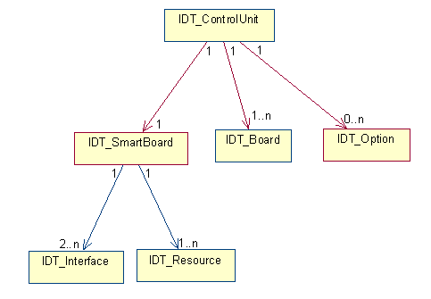
Figure 1 : Hardware declared identity

Decoder Identification
Example of identification model for a decoder.
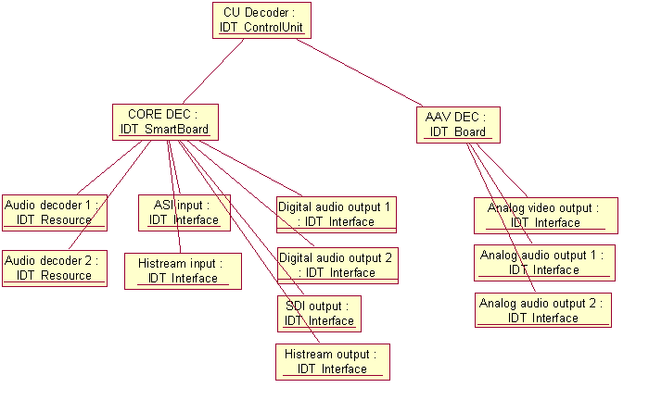
Figure 2 : Decoder Identification

Encoder Identification
Examples of identification models for an encoder.
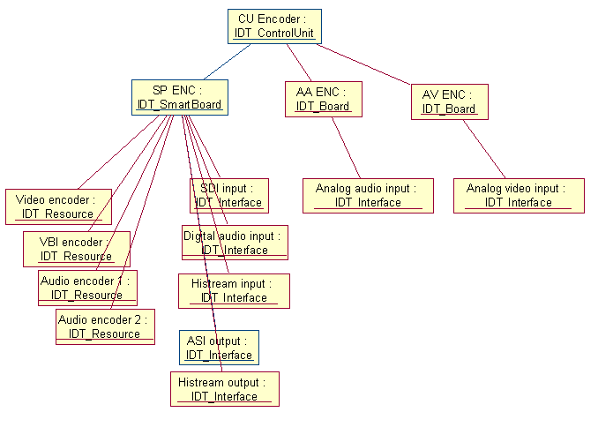
Figure 3 : Encoder Identification (SP-ENC + AA-ENC + AV-ENC)

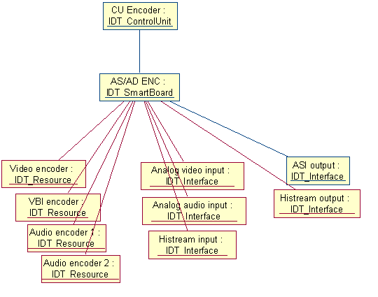
Figure 4 : Encoder Identification (AS-ENC or AD-ENC)

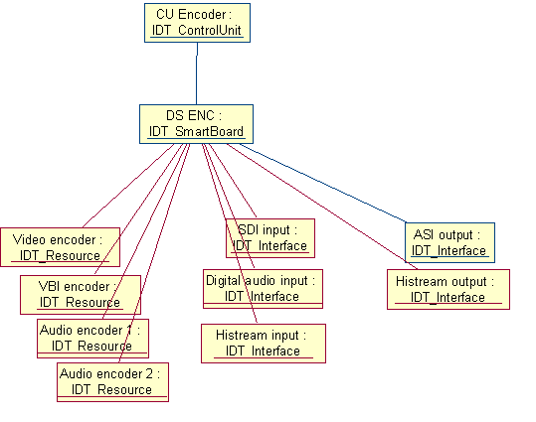
Figure 5 : Encoder Identification (DS-ENC)

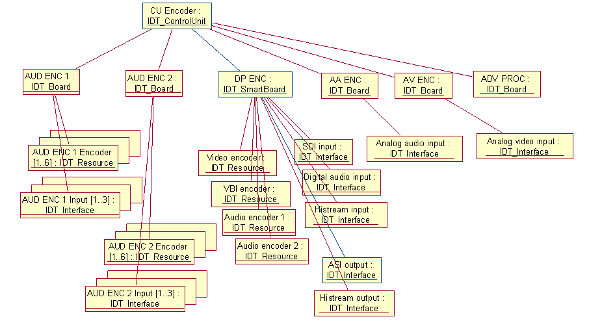
Figure 6 : Encoder identification (DP-ENC + AUD_ENC)

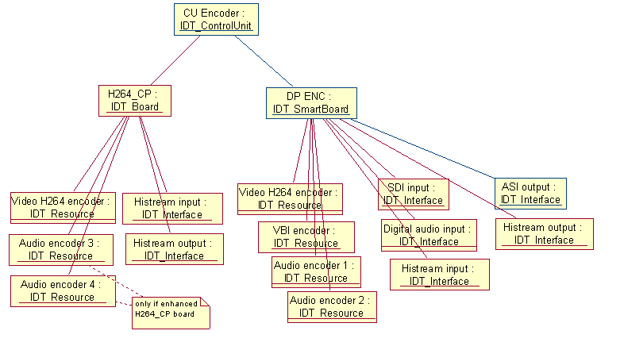
Figure 7 : Encoder Identification (DP-ENC + H264_CP)

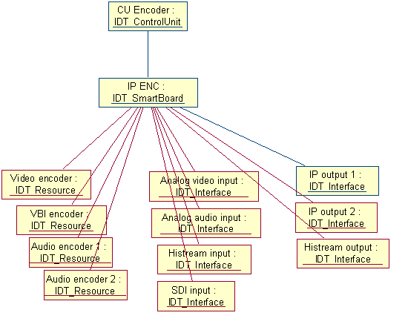
Figure 8 : Encoder Identification (IP-ENC)

FE PDH Identification
Example of identification model for PDH Front End.
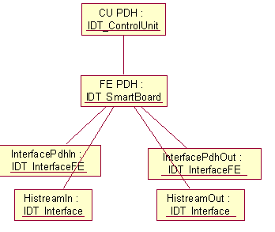
Figure 9 : FE PDH Identification

FE 100BT Identification
Example of identification model for IP Front End.
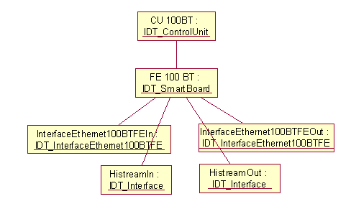
Figure 10 : FE 100BT Identification

FE ASI Identification
Example of identification model for ASI Front End.
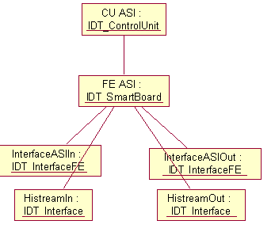
Figure 11 : FE ASI Identification

FE MultiEncaps Identification

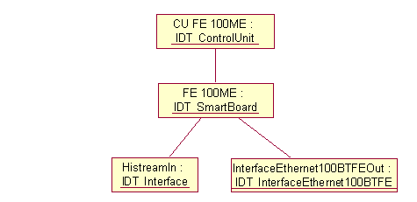
Figure 12 : FE MultiEncaps Identification

MPEG-4 HD Encoder Identification
Identification model is strictly the same for MPEG-4 HD DSP Encoder and EM3000.
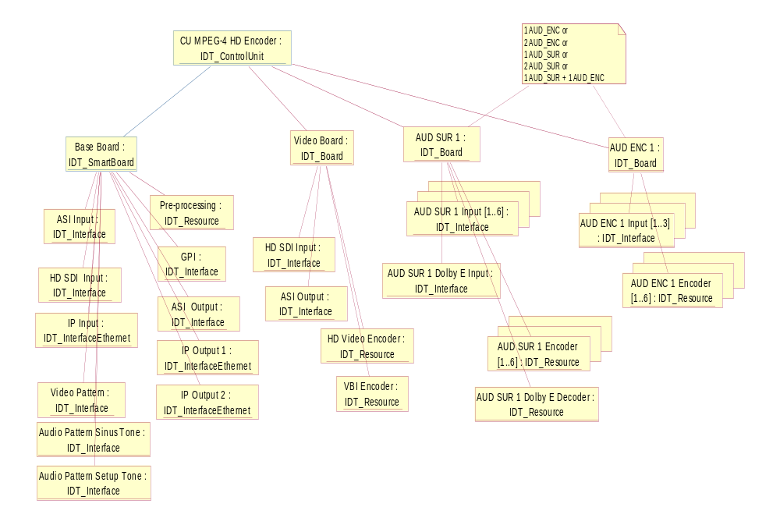
Figure 13 : MPEG-4 HD Encoder Identification

Mustang SD Encoder identification
EM1000 identification is divided in 5 control units : 1 controller grouping together all the common elements, and 4 encoders.
EM2000 identification only contains 1 controller and 1 encoder control units.

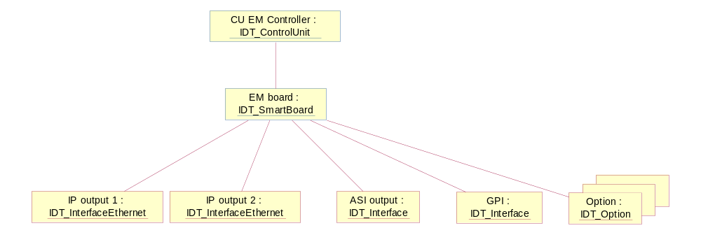
Figure 14 : Mustang SD Controller identification

Generic identification model for 1of the 4 encoders of the EM1000 product :
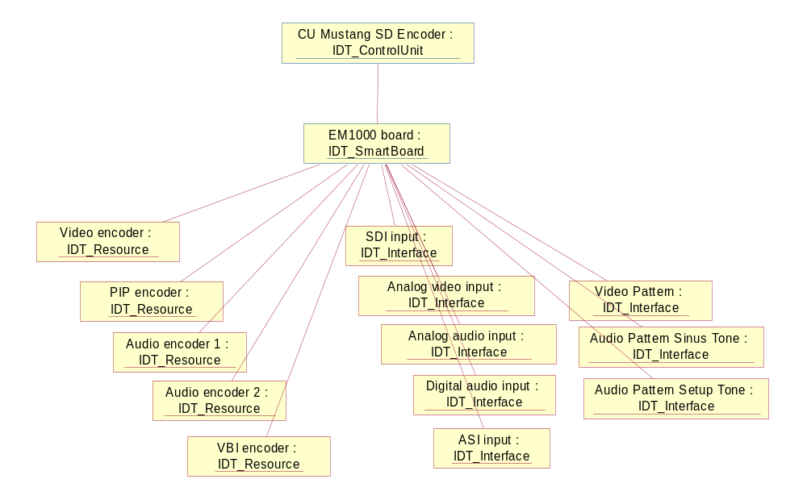
Figure 15 : EM1000 Encoder identification

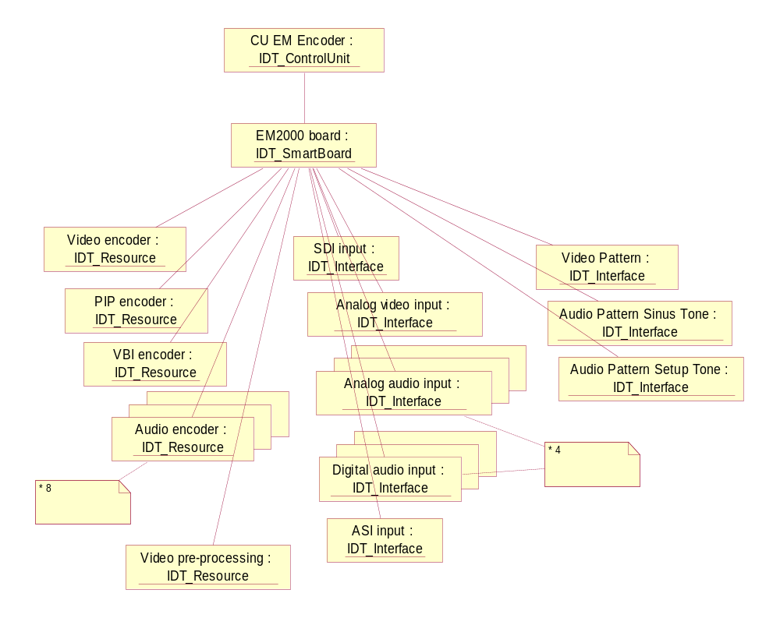
Figure 16 : EM2000 Encoder identification

CP9000 Encoder identification
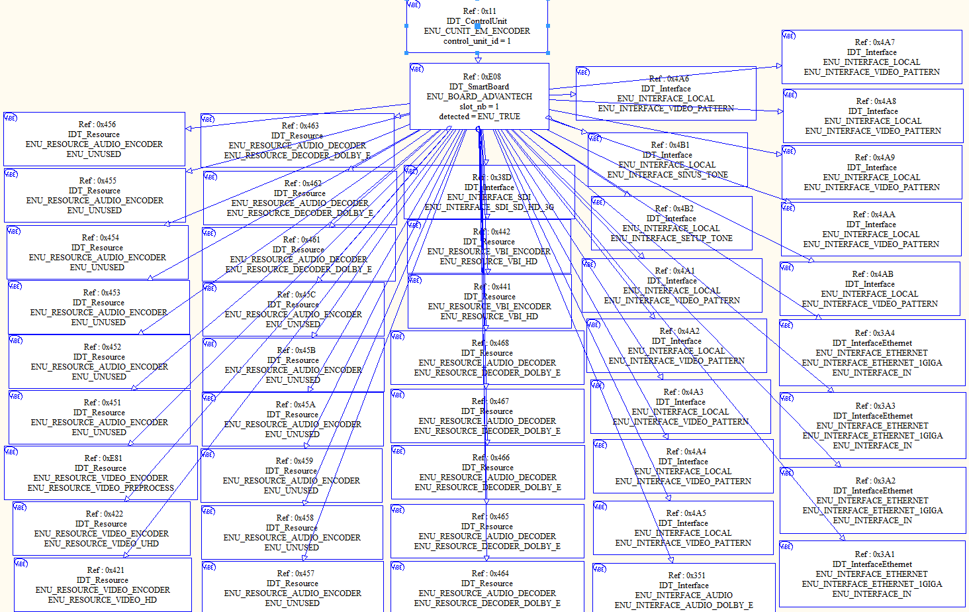

Hardware Identification Descriptors

Descriptor IDT_Shelf
This descriptor contains all the information relating to shelf identity.
IDT_Shelf_descriptor()
{
descriptor_header (type = NCCPD_DESC_IDT_SHELF, version = 2) byte[8]

hin byte[1+n]
prod_serial_nb byte[1+n]
prod_unit_part_nb byte[1+n]
prod_unit_variant byte[1+n]
main_serial_nb byte[1+n]
main_unit_part_nb byte[1+n]
hdw_level byte[1]
manufacturing_date byte[1+n]
manufacturing_test byte[1]

shelf_type byte[1]
extended_type byte[1]
code byte[1+n]
shelf_number byte[1]
sbs_version byte[1+n]
MMI_version byte[1+n]
coding_wheel byte[1]
}
hin This attribute contains a unique hardware identifier number.
This value is set from SIN.

prod_serial_nb This attribute contains the device serial number (set from product serial number from RID).

prod_unit_part_nb This attributes gives the unit part number of the hardware item and is set from RID (from product unit part number).

prod_unit_variant This attributes gives the unit variant of the hardware item and is set from RID (from product unit variant).

main_serial_nb Main board serial number, set from RID.

main_unit_part_nb Main board unit part number, set from RID.

hdw_level Hardware level.

manufacturing_date Manufacturing date.

manufacturing_test Manufacturing test level.

shelf_type This attribute contains the shelf type.
Possible values :
- ENU_DMH_SHELF_1U
- ENU_DMH_SHELF_5U
- ENU_MP4_SHELF_HD
- ENU_MP2_SHELF_HD
- ENU_EM_SHELF_EM1000
- ENU_EM_SHELF_EM2000
- ENU_EM_SHELF_EM2002
- ENU_EM_SHELF_EM2004
- ENU_EM_SHELF_EM4002
- ENU_EM_SHELF_EM4004
- ENU_EM_SHELF_EM4006
- ENU_EM_SHELF_EM4008
- ENU_EM_SHELF_VIBE4K

extended_type This attribute contains the shelf extended type identifier.
Possible values :
- ENU_UNUSED (for the first version)

code This attribute gives a unique equipment code and is used for node-locked option checking.

shelf_number Number of the shelf.

sbs_version Service Bus software version number.

MMI_version MMI version number.

coding_wheel Position of the coding wheel.

Descriptor IDT_ControlUnit
This descriptor contains all the information relating to Control Unit Identity
A Control Unit groups together a set of boards (one SmartBoard and its extension boards), with their resources and interfaces.
IDT_ControlUnit_descriptor()
{
descriptor_header (type = NCCPD_DESC_IDT_CONTROLUNIT, version = 1) byte[8]

control_unit_type byte[1]
extended_type byte[1]
control_unit_id byte[2]
name byte[1+n]

}
control_unit_type This attribute contains the control unit type.
Possible values :
- ENU_CUNIT_CONTROLLER
- ENU_CUNIT_ENCODER
- ENU_CUNIT_DECODER
- ENU_CUNIT_FE_PDH
- ENU_CUNIT_FE_100BT
- ENU_CUNIT_FE_ASI
- ENU_CUNIT_FE_100ME
- ENU_CUNIT_UNKNOWN

- ENU_CUNIT_HD_ENCODER

- ENU_CUNIT_EM_CONTROLLER
- ENU_CUNIT_EM_ENCODER
- ENU_CUNIT_AVDEC

extended_type This attribute contains the control unit extended type.
Possible values :
- ENU_UNUSED (for the first versions)

control_unit_id Control unit identifier.
Possible values :
- from ENU_MIN_CUID (1) to ENU_MAX_CUID (1023)

name Control unit name.

Descriptor IDT_Board
This descriptor contains all the information relating to Board identity.
IDT_Board_descriptor()
{
descriptor_header (type = NCCPD_DESC_IDT_BOARD, version = 5) byte[8]

hin byte[1+n]
prod_serial_nb byte[1+n]
prod_unit_part_nb byte[1+n]
prod_unit_variant byte[1+n]
main_serial_nb byte[1+n]
main_unit_part_nb byte[1+n]
hdw_level byte[1]
manufacturing_date byte[1+n]
manufacturing_test byte[1]
board_type byte[1]
extended_type byte[1]
code byte[1+n]
slot_nb byte[1]
detected byte[1]
sbs_version byte[1+n]
PCB_version byte[1+n]
ext1_serial_nb byte[1+n]
ext1_unit_part_nb byte[1+n]
ext2_serial_nb byte[1+n]
ext2_unit_part_nb byte[1+n]
nb_ext_boards byte[1]
for (i = 1 ; i <= nb_ext_boards)
{
ext_serial_nb byte[1+n]
ext_unit_part_nb byte[1+n]
}
nextboot_version byte[1+n]
EPLD_version byte[1+n]
coding_wheel byte[1]
buried_biss1 byte[1+n]
buried_biss2 byte[1+n]
}
hin This attribute contains a unique hardware identifier number.
This value is set from BIN.
prod_serial_nb This attribute contains the device serial number (set from product serial number from RID).
prod_unit_part_nb This attributes gives the unit part number of the hardware item and is set from RID (from product unit part number).
prod_unit_variant This attributes gives the unit variant of the hardware item and is set from RID (from product unit variant).
main_serial_nb Main board serial number, set from RID.
main_unit_part_nb Main board unit part number, set from RID.
hdw_level Hardware level.
manufacturing_date Manufacturing date.
manufacturing_test Manufacturing test level.
board_type This attribute contains the board type identifier.
Possible values :
- ENU_BOARD_MANAGER

- ENU_BOARD_SP_ENC
- ENU_BOARD_DP_ENC
- ENU_BOARD_AS_ENC
- ENU_BOARD_AD_ENC
- ENU_BOARD_DS_ENC
- ENU_BOARD_IP_ENC
- ENU_BOARD_AA_ENC
- ENU_BOARD_AV_ENC
- ENU_BOARD_ADV_PROC
- ENU_BOARD_AUD_ENC
- ENU_BOARD_H264_CP
- ENU_BOARD_AUD_SUR_DOLBY_FULL
- ENU_BOARD_AUD_SUR_DOLBY_LITE
- ENU_BOARD_AUD_SUR_BASE
- ENU_BOARD_AUD_SUR_DOLBY_PULSE

- ENU_BOARD_CORE_DEC
- ENU_BOARD_AAV_DEC

- ENU_BOARD_FE_PDH
- ENU_BOARD_FE_100BT
- ENU_BOARD_FE_ASI
- ENU_BOARD_FE_100ME

- ENU_BOARD_UNKNOWN

- ENU_BOARD_BASE
- ENU_BOARD_VIDEO_ENC

- ENU_BOARD_EM1000
- ENU_BOARD_EM2000
- ENU_BOARD_EM2002
- ENU_BOARD_EM2004
- ENU_BOARD_AVDEC

- ENU_BOARD_EM4000 (main board of EM4000 product)
- ENU_BOARD_PEGASUS
- ENU_BOARD_ADVANTECH

extended_type This attribute contains the board extended type identifier.
Possible values :
- ENU_UNUSED
- ENU_BOARD_EXT_TYPE_DP_ENC_BA (used for DP_ENC board with new DSP (321))
- ENU_BOARD_EXT_TYPE_H264_CP_BA (used for H264_CP board with new DSP (321))

code This attribute gives a unique code attached to the board and is used for node-locked option checking.
slot_nb Possible values :
- from 1 to 15 (and more when shelves chaining is possible)
detected Indicates if the board is present in the shelf.
Possible values :
- ENU_TRUE
- ENU_FALSE
sbs_version Service Bus software version number.
PCB_version PCB version number.
ext1_serial_nb First daughter board serial number.
ext1_unit_part_nb First daughter unit part number.
ext2_serial_nb Second daughter board serial number.
ext2_unit_part_nb Second daughter unit part number.
nb_ext_boards Number of extension boards in following loop.
ext_serial_nb Extension board serial number.
ext_unit_part_nb Extension board unit part number.
nextboot_version NextBoot version number.
EPLD_version EPLD version number.
coding_wheel Position of the coding wheel.
buried_biss1 buried_id code in BISS-1 protocol
buried_biss2 buried_id code in BISS-2 protocol

Descriptor IDT_SmartBoard
IDT_SmartBoard_descriptor()
{
descriptor_header (type = NCCPD_DESC_IDT_SMARTBOARD, version = 2) byte[8]

hin byte[1+n]
prod_serial_nb byte[1+n]
prod_unit_part_nb byte[1+n]
prod_unit_variant byte[1+n]
main_serial_nb byte[1+n]
main_unit_part_nb byte[1+n]
hdw_level byte[1]
manufacturing_date byte[1+n]
manufacturing_test byte[1]
board_type byte[1]
extended_type byte[1]
code byte[1+n]
slot_nb byte[1]
detected byte[1]
sbs_version byte[1+n]
PCB_version byte[1+n]
ext1_serial_nb byte[1+n]
ext1_unit_part_nb byte[1+n]
ext2_serial_nb byte[1+n]
ext2_unit_part_nb byte[1+n]
nextboot_version byte[1+n]
EPLD_version byte[1+n]
coding_wheel byte[1]
buried_biss1 byte[1+n]
buried_biss2 byte[1+n]
}
hin This attribute contains a unique hardware identifier number.
This value is set from BIN.
prod_serial_nb This attribute contains the device serial number (set from product serial number from RID).
prod_unit_part_nb This attributes gives the unit part number of the hardware item and is set from RID (from product unit part number).
prod_unit_variant This attributes gives the unit variant of the hardware item and is set from RID (from product unit variant).
main_serial_nb Main board serial number, set from RID.
main_unit_part_nb Main board unit part number, set from RID.
hdw_level Hardware level.
manufacturing_date Manufacturing date.
manufacturing_test Manufacturing test level.
board_type This attribute contains the board type identifier.
Possible values :
- ENU_BOARD_MANAGER

- ENU_BOARD_SP_ENC
- ENU_BOARD_DP_ENC
- ENU_BOARD_AS_ENC
- ENU_BOARD_AD_ENC
- ENU_BOARD_DS_ENC
- ENU_BOARD_IP_ENC

- ENU_BOARD_CORE_DEC

- ENU_BOARD_FE_PDH
- ENU_BOARD_FE_100BT
- ENU_BOARD_FE_ASI
- ENU_BOARD_FE_100ME

- ENU_BOARD_UNKNOWN

- ENU_BOARD_BASE

- ENU_BOARD_EM1000
- ENU_BOARD_EM2000
- ENU_BOARD_EM2002
- ENU_BOARD_EM2004
- ENU_BOARD_AVDEC

- ENU_BOARD_EM4000 (main board of EM4000 product)
- ENU_BOARD_PEGASUS
- ENU_BOARD_ADVANTECH
extended_type This attribute contains the board extended type identifier.
Possible values :
- ENU_UNUSED
- ENU_BOARD_EXT_TYPE_DP_ENC_BA (used for DP_ENC board
code This attribute gives a unique code attached to the board and is used for node-locked option checking.
slot_nb Possible values :
- from 1 to 15 (and more when shelves chaining is possible)
detected Indicates if the board is present in the shelf.
Possible values :
- ENU_TRUE
- ENU_FALSE
sbs_version Service Bus software version number.
PCB_version PCB version number.
ext1_serial_nb First daughter board serial number.
ext1_unit_part_nb First daughter unit part number.
ext2_serial_nb Second daughter board serial number.
ext2_unit_part_nb Second daughter unit part number.
nextboot_version NextBoot version number.
EPLD_version EPLD version number.
coding_wheel Position of the coding wheel.
buried_biss1 buried_id code in BISS-1 protocol
buried_biss2 buried_id code in BISS-2 protocol

Descriptor IDT_Interface
This descriptor contains all the information relating to interface identity.
It is a generic descriptor, other descriptors are defined in order to identify some interfaces with specific attributes.
IDT_Interface_descriptor()
{
descriptor_header (type = NCCPD_DESC_IDT_INTERFACE, version = 1) byte[8]

interface_type byte[1]
extended_type byte[1]
direction byte[1]
rate byte[4]
rate_unit byte[1]
}

interface_type This attribute contains the interface type.
Possible values :
- ENU_INTERFACE_ETHERNET
- ENU_INTERFACE_SERIAL
- ENU_INTERFACE_TS
- ENU_INTERFACE_SDI
- ENU_INTERFACE_AUDIO
- ENU_INTERFACE_VIDEO
- ENU_INTERFACE_PDH
- ENU_INTERFACE_HISTREAM
- ENU_INTERFACE_LOCAL
- ENU_INTERFACE_GPI
- ENU_INTERFACE_ANY
- ENU_UNUSED

extended_type This attribute contains the interface extended type.
Possible values for Ethernet :
- ENU_INTERFACE_ETHERNET_10BASET (Ethernet on twisted pairs - RJ45)
- ENU_INTERFACE_ETHERNET_100BASET (Ethernet on twisted pairs - RJ45)
- ENU_INTERFACE_ETHERNET_10BASE2 (Coaxial Ethernet)
- ENU_INTERFACE_ETHERNET_10BASEF (Optical Ethernet)
- ENU_INTERFACE_ETHERNET_1GIGA
- ENU_INTERFACE_ETHERNET_10GIGA
- ENU_INTERFACE_ETHERNET_25GIGA
Possible values for Serial :
- ENU_INTERFACE_SERIAL_RS232
- ENU_INTERFACE_SERIAL_RS485
Possible values for Transport Stream :
- ENU_INTERFACE_TS
Possible values for SDI :
- ENU_INTERFACE_SDI
- ENU_INTERFACE_SDI_BI
- ENU_INTERFACE_SDI_HD
- ENU_INTERFACE_SDI_SD_HD_3G
Possible values for Audio :
- ENU_INTERFACE_ANALOG_AUDIO
- ENU_INTERFACE_DIGITAL_AUDIO
- ENU_INT_AUD_ENC_1_DIGITAL_1
- ENU_INT_AUD_ENC_1_DIGITAL_2
- ENU_INT_AUD_ENC_1_DIGITAL_3
- ENU_INT_AUD_ENC_2_DIGITAL_1
- ENU_INT_AUD_ENC_2_DIGITAL_2
- ENU_INT_AUD_ENC_2_DIGITAL_3
- ENU_INT_AUD_SUR_1_DIGITAL_1
- ENU_INT_AUD_SUR_1_DIGITAL_2
- ENU_INT_AUD_SUR_1_DIGITAL_3
- ENU_INT_AUD_SUR_1_DIGITAL_4
- ENU_INT_AUD_SUR_1_DIGITAL_5
- ENU_INT_AUD_SUR_1_DIGITAL_6
- ENU_INT_AUD_SUR_2_DIGITAL_1
- ENU_INT_AUD_SUR_2_DIGITAL_2
- ENU_INT_AUD_SUR_2_DIGITAL_3
- ENU_INT_AUD_SUR_2_DIGITAL_4
- ENU_INT_AUD_SUR_2_DIGITAL_5
- ENU_INT_AUD_SUR_2_DIGITAL_6
- ENU_INT_AUD_SUR_1_DOLBY_E
- ENU_INT_AUD_SUR_2_DOLBY_E
- ENU_INTERFACE_AUDIO_DOLBY_E
Possible values for Video :
- ENU_INTERFACE_ANALOG_VIDEO
- ENU_INTERFACE_ANALOG_VIDEO_BI
Possible values for PDH :
- ENU_INTERFACE_PDH
Possible values for Local :
- ENU_INTERFACE_BLACK_PATTERN (video)
- ENU_INTERFACE_BAR_PATTERN (video)
- ENU_INTERFACE_CUSTOM_PATTERN (video)
- ENU_INTERFACE_SINUS_TONE (audio)
- ENU_INTERFACE_SETUP_TONE (audio)
- ENU_INTERFACE_VIDEO_PATTERN (generic video)
Possible values for Any :
- ENU_ANY_SIGNALS
- ENU_UNUSED

direction This attribute gives the direction of the interface.
Possible values :
- ENU_INTERFACE_IN
- ENU_INTERFACE_OUT

rate This attribute contains the rate of this interface (the unit is defined by rate_unit attribute).

rate_unit This attribute defines the rate unit.
Possible values :
- ENU_UNIT_BIT_SECOND
- ENU_UNIT_KBIT_SECOND
- ENU_UNIT_MBIT_SECOND
- ENU_UNIT_GBIT_SECOND
- ENU_UNIT_TBIT_SECOND
- ENU_UNIT_BYTE_SECOND
- ENU_UNIT_KBYTE_SECOND
- ENU_UNIT_MBYTE_SECOND
- ENU_UNIT_GBYTE_SECOND
- ENU_UNIT_TBYTE_SECOND

Descriptor IDT_Resource
This descriptor contains all the information relating to resource identity. A resource can be a hardware device, but also a pure software device.
It is a generic descriptor, other descriptors may be defined later in order to identify some resources with specific attributes (for example to give the capabilities of an audio encoder).
IDT_Resource_descriptor()
{
descriptor_header (type = NCCPD_DESC_IDT_RESOURCE, version = 1) byte[8]

resource_type byte[1]
extended_type byte[1]
stream_rate byte[4]
stream_rate_unit byte[1]
}

resource_type This attribute contains the resource type.
Possible values :
- ENU_RESOURCE_VIDEO_ENCODER
- ENU_RESOURCE_AUDIO_ENCODER
- ENU_RESOURCE_VBI_ENCODER
- ENU_RESOURCE_VIDEO_DECODER
- ENU_RESOURCE_AUDIO_DECODER
- ENU_RESOURCE_VBI_DECODER
- ENU_RESOURCE_SCRAMBLER
- ENU_RESOURCE_DESCRAMBLER
- ENU_RESOURCE_DATA_INJECTOR
- ENU_RESOURCE_DATA_EXTRACTOR
- ENU_RESOURCE_DVB_SUBTITLE
- ENU_UNUSED

extended_type This attribute contains the resource extended type.
Possible values for Video Encoder :
- ENU_RESOURCE_VIDEO_SD
- ENU_RESOURCE_VIDEO_HD
- ENU_RESOURCE_VIDEO_H264
- ENU_RESOURCE_VIDEO_PREPROCESS
- ENU_RESOURCE_VIDEO_PIP
- ENU_RESOURCE_VIDEO_UHD
Possible values for Audio Encoder :
- ENU_RESOURCE_AUDIO_ENCODER_1
- ENU_RESOURCE_AUDIO_ENCODER_2
- ENU_RSC_AUD_ENC_1_ENCODER_1
- ENU_RSC_AUD_ENC_1_ENCODER_2
- ENU_RSC_AUD_ENC_1_ENCODER_3
- ENU_RSC_AUD_ENC_1_ENCODER_4
- ENU_RSC_AUD_ENC_1_ENCODER_5
- ENU_RSC_AUD_ENC_1_ENCODER_6
- ENU_RSC_AUD_ENC_2_ENCODER_1
- ENU_RSC_AUD_ENC_2_ENCODER_2
- ENU_RSC_AUD_ENC_2_ENCODER_3
- ENU_RSC_AUD_ENC_2_ENCODER_4
- ENU_RSC_AUD_ENC_2_ENCODER_5
- ENU_RSC_AUD_ENC_2_ENCODER_6
- ENU_RESOURCE_AUDIO_ENCODER_3 (on enhanced H264_CP board)
- ENU_RESOURCE_AUDIO_ENCODER_4 (on enhanced H264_CP board)
- ENU_RSC_AUD_SUR_1_ENCODER_1
- ENU_RSC_AUD_SUR_1_ENCODER_2
- ENU_RSC_AUD_SUR_1_ENCODER_3
- ENU_RSC_AUD_SUR_1_ENCODER_4
- ENU_RSC_AUD_SUR_1_ENCODER_5
- ENU_RSC_AUD_SUR_1_ENCODER_6
- ENU_RSC_AUD_SUR_2_ENCODER_1
- ENU_RSC_AUD_SUR_2_ENCODER_2
- ENU_RSC_AUD_SUR_2_ENCODER_3
- ENU_RSC_AUD_SUR_2_ENCODER_4
- ENU_RSC_AUD_SUR_2_ENCODER_5
- ENU_RSC_AUD_SUR_2_ENCODER_6
- ENU_RESOURCE_AUDIO_ENCODER_5
- ENU_RESOURCE_AUDIO_ENCODER_6
- ENU_RESOURCE_AUDIO_ENCODER_7
- ENU_RESOURCE_AUDIO_ENCODER_8
- ENU_RESOURCE_AUDIO_ENCODER_9
- …
- ENU_RESOURCE_AUDIO_ENCODER_48
Possible values for Audio Decoder :
- ENU_RSC_AUD_SUR_1_DECODER_DOLBY_E
- ENU_RSC_AUD_SUR_2_DECODER_DOLBY_E
- ENU_RESOURCE_DECODER_DOLBY_E
Possible values for Scrambler :
- ENU_RESOURCE_SCRAMBLER_DVB_CS
- ENU_RESOURCE_SCRAMBLER_DES_ECB
- ENU_RESOURCE_SCRAMBLER_3DES_CBC
Possible values for Descrambler :
- ENU_RESOURCE_DESCRAMBLER_DVB_CS
- ENU_RESOURCE_DESCRAMBLER_DES_ECB
- ENU_RESOURCE_DESCRAMBLER_3DES_CBC
Possible values for Data Injector :
- ENU_RESOURCE_DATINJ_NORMAL
- ENU_RESOURCE_DATINJ_OPPORTUNISTIC
Possible values for Data Extractor :
- ENU_RESOURCE_DATEXT_NORMAL
Possible values for VBI Encoder :
- ENU_RESOURCE_VBI_SD
- ENU_RESOURCE_VBI_HD
- ENU_UNUSED

stream_rate This attribute gives the maximum stream rate of data that this resource can manage.

stream_rate_unit This rate defines the stream rate unit.
Possible values :
- ENU_UNIT_BIT_SECOND
- ENU_UNIT_KBIT_SECOND
- ENU_UNIT_MBIT_SECOND
- ENU_UNIT_GBIT_SECOND
- ENU_UNIT_TBIT_SECOND
- ENU_UNIT_BYTE_SECOND
- ENU_UNIT_KBYTE_SECOND
- ENU_UNIT_MBYTE_SECOND
- ENU_UNIT_GBYTE_SECOND
- ENU_UNIT_TBYTE_SECOND

Descriptor IDT_InterfaceEthernet
Descriptor specializing IDT_Interface for an Ethernet interface.
IDT_InterfaceEthernet_descriptor()
{
descriptor_header (type = NCCPD_DESC_IDT_INTERFACEETHERNET, version = 1) byte[8]

interface_type byte[1]
extended_type byte[1]
direction byte[1]
rate byte[4]
rate_unit byte[1]

gateway byte[4]
MAC_address byte[6]
IP_address byte[4]
netmask byte[4]
}
interface_type This attribute contains the interface type.
Possible values :
- ENU_INTERFACE_ETHERNET

extended_type This attribute contains the interface extended type.
Possible values :
- ENU_INTERFACE_ETHERNET_10BASET (Ethernet on twisted pairs - RJ45)
- ENU_INTERFACE_ETHERNET_100BASET (Ethernet on twisted pairs - RJ45)
- ENU_INTERFACE_ETHERNET_10BASE2 (Coaxial Ethernet)
- ENU_INTERFACE_ETHERNET_10BASEF (Optical Ethernet)
- ENU_INTERFACE_ETHERNET_1GIGA

direction This attribute gives the direction of the interface.
Possible values :
- ENU_INTERFACE_IN
- ENU_INTERFACE_OUT

rate This attribute contains the rate of this interface (the unit is defined by rate_unit attribute).

rate_unit This attribute defines the rate unit.
Possible values :
- ENU_UNIT_BIT_SECOND
- ENU_UNIT_KBIT_SECOND
- ENU_UNIT_MBIT_SECOND
- ENU_UNIT_GBIT_SECOND
- ENU_UNIT_TBIT_SECOND
- ENU_UNIT_BYTE_SECOND
- ENU_UNIT_KBYTE_SECOND
- ENU_UNIT_MBYTE_SECOND
- ENU_UNIT_GBYTE_SECOND
- ENU_UNIT_TBYTE_SECOND

gateway Default gateway.

MAC_address Physical Ethernet address.

IP_address IP Ethernet address.

netmask IP subnet mask.

Descriptor IDT_InterfaceFE
IDT_InterfaceFE_descriptor()
{
descriptor_header (type = NCCPD_DESC_IDT_INTERFACEFE, version = 1) byte[8]

interface_type byte[1]
extended_type byte[1]
direction byte[1]
rate byte[4]
rate_unit byte[1]

interface_id byte[1]
}
interface_type This attribute contains the interface type.
Possible values :
- ENU_INTERFACE_ETHERNET
- ENU_INTERFACE_TS
- ENU_INTERFACE_PDH
- ENU_INTERFACE_ANY
- ENU_UNUSED

extended_type This attribute contains the interface extended type.
Possible values for Ethernet :
- ENU_INTERFACE_ETHERNET_100BASET (Ethernet on twisted pairs - RJ45)
Possible values for Transport Stream :
- ENU_INTERFACE_TS
Possible values for PDH :
- ENU_INTERFACE_PDH
Possible values for Any :
- ENU_ANY_SIGNALS
- ENU_UNUSED

direction This attribute gives the direction of the interface.
Possible values :
- ENU_INTERFACE_IN
- ENU_INTERFACE_OUT

rate This attribute contains the rate of this interface (the unit is defined by rate_unit attribute).

rate_unit This attribute defines the rate unit.
Possible values :
- ENU_UNIT_BIT_SECOND
- ENU_UNIT_KBIT_SECOND
- ENU_UNIT_MBIT_SECOND
- ENU_UNIT_GBIT_SECOND
- ENU_UNIT_TBIT_SECOND
- ENU_UNIT_BYTE_SECOND
- ENU_UNIT_KBYTE_SECOND
- ENU_UNIT_MBYTE_SECOND
- ENU_UNIT_GBYTE_SECOND
- ENU_UNIT_TBYTE_SECOND

interface_id Physical interface identifier (input or output number).

Descriptor IDT_InterfaceEthernet100BTFE
IDT_InterfaceEthernet100BTFE_descriptor()
{
descriptor_header (type = NCCPD_DESC_IDT_INTERFACEETHERNET100BTFE, version = 1) byte[8]

interface_type byte[1]
extended_type byte[1]
direction byte[1]
rate byte[4]
rate_unit byte[1]

interface_id byte[1]

MAC_address byte[6]
}

interface_type This attribute contains the interface type.
Possible values :
- ENU_INTERFACE_ETHERNET

extended_type This attribute contains the interface extended type.
Possible values :
- ENU_INTERFACE_ETHERNET_100BASET (Ethernet on twisted pairs - RJ45)

direction This attribute gives the direction of the interface.
Possible values :
- ENU_INTERFACE_IN
- ENU_INTERFACE_OUT

rate This attribute contains the rate of this interface (the unit is defined by rate_unit attribute).

rate_unit This attribute defines the rate unit.
Possible values :
- ENU_UNIT_BIT_SECOND
- ENU_UNIT_KBIT_SECOND
- ENU_UNIT_MBIT_SECOND
- ENU_UNIT_GBIT_SECOND
- ENU_UNIT_TBIT_SECOND
- ENU_UNIT_BYTE_SECOND
- ENU_UNIT_KBYTE_SECOND
- ENU_UNIT_MBYTE_SECOND
- ENU_UNIT_GBYTE_SECOND
- ENU_UNIT_TBYTE_SECOND

interface_id Physical interface identifier (input or output number).
MAC_address Defines the board MAC address.

Descriptor IDT_Option
IDT_Option_descriptor()
{
descriptor_header (type = NCCPD_DESC_IDT_OPTION, version = 5) byte[8]

option_id byte[1]
option_code byte[1+n]
key byte[1+n]
status byte[1]
option_comment byte[1+n]
hide byte[1]

option_type byte[1]
option_amount byte[1]
breaking_date byte[2]
commercial_ref byte[1+n]
}
option_id Option identifier.
Possible values for Encoder :
- ENU_CUNIT_ENC_N601SATR (Uncompressed and AC3 transport and transparent audio)
- ENU_CUNIT_ENC_N601SADL (Dolby AC3 stereo encoding)
- ENU_CUNIT_ENC_N601SFKS (Fixed key scrambling (BISS 1 and BISS mode E))
- ENU_CUNIT_ENC_N601SFLX (Flextream)
- ENU_CUNIT_ENC_N601S2ST (2nd MPEG1 LII stereo channel (or mono # 3&4))
- ENU_CUNIT_ENC_N601S1DL (Dolby Digital Encoding on the first stereo channel (or 1 mono channel))
- ENU_CUNIT_ENC_N601S2DL (Dolby Digital Encoding on the second stereo channel (or 2 mono channel))
- ENU_CUNIT_ENC_N601S1X4 (4 audio channels on 1st AUD_ENC board)
- ENU_CUNIT_ENC_N601S1X6 (6 audio channels on 1st AUD_ENC board)
- ENU_CUNIT_ENC_N601S2X4 (4 audio channels on 2nd AUD_ENC board)
- ENU_CUNIT_ENC_N601S2X6 (6 audio channels on 2nd AUD_ENC board)
- ENU_CUNIT_ENC_N601S1XT (Linear and AC3 pass through - 6 channels on 1st AUD_ENC)
- ENU_CUNIT_ENC_N601S2XT (Linear and AC3 pass through - 6 channels on 2nd AUD_ENC)
- ENU_CUNIT_ENC_N601S1XD (Dolby Digital (AC3 stereo) encoding - 6 channels on 1st AUD_ENC)
- ENU_CUNIT_ENC_N601S2XD (Dolby Digital (AC3 stereo) encoding - 6 channels on 2nd AUD_ENC)
- ENU_CUNIT_ENC_N601SSHA (Entropy Shaping)
- ENU_CUNIT_ENC_N601SAAC (AAC Encoding (one stereo channel))
- ENU_CUNIT_ENC_N601S1XA (Audio AAC encoding extension (aud-enc1))
- ENU_CUNIT_ENC_N601S2XA (Audio AAC encoding extension (aud-enc2))
- ENU_CUNIT_ENC_N601SDP1 (Digital Program Insertion)
Possible values for Decoder :
- ENU_CUNIT_DEC_N602SAUN (Audio-Transparent)
Possible values for Front End :
- ENU_CUNIT_FE_100BT_N605S100 (100BT Front End Smart Mux)
- ENU_CUNIT_FE_100BT_N605S1FC (100BT Front End Forward Error Correction)
- ENU_CUNIT_FE_PDH_N605S200 (PDH Front End Smart Mux)
- ENU_CUNIT_FE_PDH_N605S2FC (PDH Front End Forward Error Correction)
- ENU_CUNIT_FE_ASI_N605SA00 (ASI Front End Smart Mux)
Possible values for HD Encoder :
- ENU_CUNIT_HD_ENC_NHDESAAC (3 audio channels AAC stereo on 1st AUD-ENC)
- ENU_CUNIT_HD_ENC_NHDESAC3 (6 audio channels AC3 stereo on 1st AUD-ENC)
- ENU_CUNIT_HD_ENC_NHDESBAC (3 audio channels AAC stereo on 2nd AUD-ENC)
- ENU_CUNIT_HD_ENC_NHDESBC3 (6 audio channels AC3 stereo on 2nd AUD-ENC)
- ENU_CUNIT_HD_ENC_NHDEFLEX (Statistical multiplexing (Flextream))
- ENU_CUNIT_HD_ENC_NHDESFEC (FEC-2D Pro-MPEG COP #3)
- ENU_CUNIT_HD_ENC_NEMS3P1P (Picture In Picture on HD Mustang)
- ENU_CUNIT_HD_ENC_NEMS3D2D (AC3 to E-AC3 Transcoding on AUD_SUR)
- ENU_CUNIT_HD_ENC_NEMS3FLA (Statistical multiplexing (Flextream) WAN/LAN)
Possible values for EM1000 :
- ENU_CUNIT_EM_NEMS1P1P (Picture In Picture on EM1000)
- ENU_CUNIT_EM_NEMS1FLE (Flextream btw equipment located on the same site on EM1000 )
- ENU_CUNIT_EM_NEMS1AAC (AAC audio encoding on EM1000)
- ENU_CUNIT_EM_NEMS1D0L (Dolby audio encoding on EM1000)
- ENU_CUNIT_EM_NEMS1MP1 (MPEG1 L2 stereo audio encoding on EM1000)
- ENU_CUNIT_EM_NEMS1FSK (Fixed Key Scrambling BISS1, BISS E on EM1000)
- ENU_CUNIT_EM_NEMS1MP4 (MPEG-4 software license on EM1000)
- ENU_CUNIT_EM_NEMS1MP2 (MPEG-2 software license on EM1000)
- ENU_CUNIT_EM_NEMS1FLA (Flextream btw equipment located on the same site and/or on distant sites on EM1000)
- ENU_CUNIT_EM_NEMS1LOG (Logo insertion on EM1000)
- ENU_CUNIT_EM_NEMS1SUB (First DVB subtitle on EM1000)
- ENU_CUNIT_EM_NEMS1ASB (Additional DVB subtitle on EM1000)
- ENU_CUNIT_EM_NEMS1FEC (FEC generation on EM1000)
- ENU_CUNIT_EM_NEMS1D20 (Dolby audio decoding for MPEG IN on EM1000)
- ENU_CUNIT_EM_NEMS1FLS (FlexService on EM1000)
- ENU_CUNIT_EM_NEMS1J20 (Automatic Loudness Control on EM1000)
Possible values for EM2000 :
- ENU_CUNIT_EM_NEMS2P1P (Picture In Picture on EM2000)
- ENU_CUNIT_EM_NEMS2FLE (Flextream btw equipment located on the same site on EM2000)
- ENU_CUNIT_EM_NEMS2AAC (AAC audio encoding on EM2000)
- ENU_CUNIT_EM_NEMS2D0L (Dolby audio encoding on EM2000)
- ENU_CUNIT_EM_NEMS2MP1 (MPEG1 L2 stereo audio encoding on EM2000)
- ENU_CUNIT_EM_NEMS2FSK (Fixed Key Scrambling BISS1, BISS E on EM2000)
- ENU_CUNIT_EM_NEMS2L0W (MPEG-4 low latency software license on EM2000)
- ENU_CUNIT_EM_NEMS2MP4 (MPEG-4 software license on EM2000)
- ENU_CUNIT_EM_NEMS2MP2 (MPEG-2 software license on EM2000)
- ENU_CUNIT_EM_NEMS2FLA (Flextream btw equipment located on the same site and/or on distant sites on EM2000)
- ENU_CUNIT_EM_NEMS2LOG (Logo insertion on EM2000)
- ENU_CUNIT_EM_NEMS2SUB (First DVB subtitle on EM2000)
- ENU_CUNIT_EM_NEMS2ASB (Additional DVB subtitle on EM2000)
- ENU_CUNIT_EM_NEMS2FEC (FEC generation on EM2000)
- ENU_CUNIT_EM_NEMS2D20 (Dolby audio decoding for MPEG IN on EM2000)
- ENU_CUNIT_EM_NEMS2DDE (Dolby E decoding on EM2000)
- ENU_CUNIT_EM_NEMS2FLS (FlexService on EM2000)
- ENU_CUNIT_EM_NEMS2J20 (Automatic Loudness Control on EM2000)
Possible values for EM4000 :
- ENU_CUNIT_NEMS4H4A (One channel HD/SD AVC encoding)
- ENU_CUNIT_NEMS4FLA (WAN+LAN Flextream)
- ENU_CUNIT_NEMS4FLE (LAN Flextream)
- ENU_CUNIT_NEMS4H2A (One channel HD/SD MP2 encoding)
- ENU_CUNIT_NEMS4S4A (One channel SD/AVC encoding)
- ENU_CUNIT_NEMS4S2A (One channel SD/MP2 encoding)
- ENU_CUNIT_NEMS4PIP (One channel PIP encoding)
- ENU_CUNIT_NEMS4HDE (One channel HD AVC/MPEG2 and 6 MPEG1 L2/AAC decoding)
- ENU_CUNIT_NEMS4SDE (One channel SD AVC/MPEG2 and 6 MPEG1 L2/AAC decoding)
- ENU_CUNIT_NEMS4SU2 (One channel ultra low SD MP2 enhancement)
- ENU_CUNIT_NEMS4D51 (DD-DD+ surround encoding (1x5.1/3x2.0))
- ENU_CUNIT_NEMS4DDE (Dolby E decoding)
- ENU_CUNIT_NEMS4D0L (DD-DD+ stereo encoding)
- ENU_CUNIT_NEMS4AAC (AAC stereo encoding)
- ENU_CUNIT_NEMS4A51 (AAC-HE surround encoding (1x5.1/3x2.0))
- ENU_CUNIT_NEMS4MP1 (MPEG1 L2 stereo encoding)
- ENU_CUNIT_NEMS4J20 (Jünger Loudness control (1 mono/stereo))
- ENU_CUNIT_NEMS4J51 (Jünger Loudness control (1 surround))
- ENU_CUNIT_NEMS4DDD (DD-DD+ surround decoding (1x5.1/1x2.0))
- ENU_CUNIT_NEMS4SUB (First DVB subtitle)
- ENU_CUNIT_NEMS4ASB (Additional DVB subtitle)
- ENU_CUNIT_NEMS4FEC (FEC generation)
- ENU_CUNIT_NEMS4UCV (SD to HD upconversion (1 per output channel))
- ENU_CUNIT_NEMS4LOG (One video channel Logo Insertion)
- ENU_CUNIT_NEMS4FLS (FlexService)
- ENU_CUNIT_NEMS4TGA (Bitstream customization for targeted video insertion)
- ENU_CUNIT_NEMS4HCV (One channel 1080i to 720P conversion)
- ENU_CUNIT_NEMS4PSP (One TS PSIP Spooling)
- ENU_CUNIT_NEMS4D2D (DD to DD+ transcoding)
- ENU_CUNIT_NEMS4CTX (One video channel Crawl text insertion)
- ENU_CUNIT_NEMS4L20 (One stereo Harmonic Auto Loudness Control)
- ENU_CUNIT_NEMS4L51 (One surround Harmonic Auto Loudness Control)
Possible values for ViBE4K :
- ENU_CUNIT_N4KS4H4A (One channel UHD HEVC 4:2:0 Main10 encoding)
- ENU_CUNIT_N4KS4422 (4:2:2 profile encoding)
- ENU_CUNIT_N4KS4HHA (One channel HD HEVC 4:2:0 Main10 encoding)
- ENU_CUNIT_N4KS4HPQ (HDR encoding compliant with SMPTE 2084 (PQ) gamma law)
- ENU_CUNIT_N4KS4HLG (HDR encoding compliant with HLG gamma law)
- ENU_CUNIT_N4KS4MP1 (One MPEG1 L2 stereo encoding)
- ENU_CUNIT_N4KS4D0L (One DD-DD+ stereo encoding)
- ENU_CUNIT_N4KS4AAC (One AAC/HE-AAC stereo encoding)
- ENU_CUNIT_N4KS4D51 (DD-DD+ surround encoding (1x5.1/3x2.0))
- ENU_CUNIT_N4KS4A51 (AAC-LC or HE-AAC surround encoding (1x5.1/3x2.0))
- ENU_CUNIT_N4KS4J20 (Junger Loudness control (1 stereo))
- ENU_CUNIT_N4KS4J51 (Junger Loudness control (1 surround))
- ENU_CUNIT_N4KS4DDE (One Dolby E decoding)
- ENU_CUNIT_N4KS4D2D (One DD to DD+ transcoding)
- ENU_CUNIT_N4KS4451 (AC4 surround encoding (1x5.1/3x2.0))
- ENU_CUNIT_N4KS4420 (One AC4 stereo encoding)
- ENU_CUNIT_N4KS4FEC (FEC generation)
Possible values for CP9000 :
- ENU_CUNIT_CP9X00_ENC_HEVC_1HD420 (First HD HEVC 4:2:0)
- ENU_CUNIT_CP9X00_ENC_HEVC_1HD422 (First HD HEVC 4:2:0/4:2:2)
- ENU_CUNIT_CP9X00_ENC_HEVC_HD420 (Add HD HEVC 4:2:0)
- ENU_CUNIT_CP9X00_ENC_HEVC_HD422 (Add HD HEVC 4:2:0/4:2:2)
- ENU_CUNIT_CP9X00_ENC_HEVC_UHD420 (one UHD HEVC or 4xHD HEVC 4:2:0)
- ENU_CUNIT_CP9X00_ENC_HEVC_UHD422 (one UHD HEVC or 4xHD HEVC 4:2:0/4:2:2)
- ENU_CUNIT_CP9X00_ENC_HDR_PQ (HDR with SMPTE 2084 (PQ) gamma law)
- ENU_CUNIT_CP9X00_ENC_HDR_HLG (HDR with HLG gamma law)
- ENU_CUNIT_CP9X00_ENC_HEVC_ULL (one HD HEVC Ultra Low Latency)
- ENU_CUNIT_CP9X00_ENC_MP1L2_AAC (one stereo MPEG1 or AAC-LC/HE)
- ENU_CUNIT_CP9X00_ENC_DD (one stereo DD-DD+)
- ENU_CUNIT_CP9X00_TRX_DD2DDPLUS (one DD to DD+ transcoding)
- ENU_CUNIT_CP9X00_DEC_DE (one Dolby E decoding)
- ENU_CUNIT_CP9X00_ENC_AC4 (one stereo AC4)
- ENU_CUNIT_CP9X00_JUNG (one stereo Junger Loudness control)
- ENU_CUNIT_CP9X00_FEC (FEC generation)
- ENU_CUNIT_CP9X00_SCTE (one channel SCTE104 to SCTE35)

option_code Unique code for the option.

key Option key.

status Option status : installed or not.
Possible values :
- ENU_OPTION_INSTALLED (only installed)
- ENU_OPTION_NOT_INSTALLED (declared but not installed)
- ENU_OPTION_USED (declared and installed)
- ENU_OPTION_DECLARED (declared off-line)

option_comment Option description.

hide Indicates if the option is hidden or not.
Possible values :
- ENU_OPTION_NOT_HIDDEN
- ENU_OPTION_HIDDEN

option_type When the option could be node-locked or floating.
Possible values :
- ENU_OPTION_NODE_LOCKED

option_amount Amount of allowed options, when the option could be present more than once.
Possible values : 1.

breaking_date Maximum date for the option validity (0 for forever).
commercial_ref Commercial name of the option.

Software Identification

Software Identification Diagrams

Software identity
As depicted in this diagram, a board package is linked to a [Smart]Board and contains firmwares.
When it is used, a system package, containing board packages, can be linked to a shelf (not used in the current version).
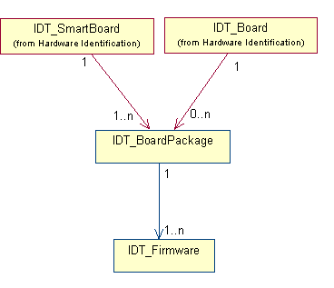
Figure 17 : Software identity

Software Identification Descriptors

Descriptor IDT_SystemPackage
This descriptor contains all the information relating to System Software Package identity.
IDT_SystemPackage_descriptor()
{
descriptor_header (type = NCCPD_DESC_IDT_SYSTEMPACKAGE, version = 1) byte[8]

scode byte[1+n]
soft_version byte[1+n]
author byte[1+n]

}
scode A string which identifies non-ambiguously the software type and board/resource association.
(refer to the document specifying firmware versioning).
Possible values : TBD

soft_version The software version with the format XX.YY.ZZZ LC, with :
- XX : major version
- YY : minor version
- ZZZ : Change
- L : Level
- C : Category

author Author of the package.

Descriptor IDT_BoardPackage
This descriptor contains all the information relating to Board Software Package identity.
IDT_BoardPackage_descriptor()
{
descriptor_header (type = NCCPD_DESC_IDT_BOARDPACKAGE, version = 2) byte[8]

scode byte[1+n]
soft_version byte[1+n]
author byte[1+n]

active byte[1]
}
scode A string which identifies non-ambiguously the software type and board/resource association.
(refer to the document specifying firmware versioning).
Possible values :
- "MANAGER" for DMC board
- "ENCODER" for SP-ENC or DP-ENC board
- "DECODER" for CORE-DEC board
- "PDHFE" for PDH FE board
- "100BTFE" for IP FE board
- "ASIFE" for ASI FE board
- "MP4HDEB" for MPEG-4 HD Encoder Base board
- "MP4HDEV" for MPEG-4 HD Encoder Video board

soft_version The software version with the format XX.YY.ZZZ LC, with :
- XX : major version
- YY : minor version
- ZZZ : Change
- L : Level
- C : Category

author Author of the package.

active Indicates if the BoardPackage is the active one or not.
Possible values :
- ENU_TRUE
- ENU_FALSE

Descriptor IDT_Firmware
This descriptor contains all the information relating to Firmware identity.
IDT_Firmware_descriptor()
{
descriptor_header (type = NCCPD_DESC_IDT_FIRMWARE, version = 1) byte[8]

scode byte[1+n]
soft_version byte[1+n]
author byte[1+n]

}
scode A string which identifies non-ambiguously the software type and board/resource association.
(refer to the document specifying firmware versioning).
Possible values for all ViBE board packages (common firmwares) :
- "BASE"
- "KERNEL"
Possible values for MANAGER board package :
- "CHIEF"
- "HIDMC"
- "HIMAN"
- "MXSES"
Possible values for ENCODER board package :
- "APPDSP"
- "APPFILT"
- "APPMOEST"
- "ENCAS"
- "ENCAUD"
- "ENCPGI"
- "ENCPGO"
- "ENCRES"
- "ENCVLE"
Possible values for DECODER board package :
- "AAVPG"
- "DECCS24"
- "DECAS"
- "DECPG"
- "DECRES"
- "DECVBI"
Possible values for PDH FE board package :
- "HIMEF"
- "PADAPJ"
- "PDHFEAST"
Possible values for IP FE board package :
- "HIMEF"
- "PADIPC"
- "100BTFEAST"
Possible values for ASI FE board package :
- "HIMEF"
- "PADAS"
- "ASIFEAST"

Possible values for MPEG-4 HD Encoder Base board package :
- "HDVIDINT" (hdvidint fpga)
- "HDNOISE" (hdnoise fpga)
- "HDFILTER" (hdfilter fpga)
- "HDTSINT" (hdtsint fpga)
- "HDBBNIOS" (hdvidint fpga)
- "BOSS" (C&C software)
- "BREST" (drivers & kernel modules)
- "ENCAUD" (audio software)
- "HDBASE" (system tools)
- "HDKERNEL" (linux)
Possible values for MPEG-4 HD Encoder Video board package :
- "HDVIDENC" (hdvidenc board FPGA)
- "FPGAMBIO" (Ateme mother board FPGA)
- "FPGAENC" (Ateme PMC board FPGA)
- "FPGADEC" (Ateme PMC board FPGA)
- "NELPRG" (NEL program file)
- "NEMPARAM" (NEL parameter file)
- "M2DEC" (Ateme PMC board DSP)
- "M4DECIS" (Ateme PMC board DSP)
- "M4ENC" (Ateme PMC board DSP)
- "HIVENS" (C&C software)
- "HIVRES" (drivers & kernel modules)
- "HDBASE" (system tools)
- "HDKERNEL" (linux)

soft_version The software version with the format XX.YY.ZZZ LC, with :
- XX : major version
- YY : minor version
- ZZZ : Change
- L : Level
- C : Category

author Author of the package.

Configuration
This package describes the configuration data of an equipment or a system. Its architecture is based upon the definition of the output, that is to say the definition of the elements composing the required output stream(s), linked with the inputs and the resources to use. In the current version, some sub-packages contain the descriptors relating to Decoder, Encoder or Front End configuration data.

Topology
This sub-package defines descriptors used for a topology declaration, sent by an external management system.

Topology Diagrams

ViBE Topology
Model for a topology declaration :
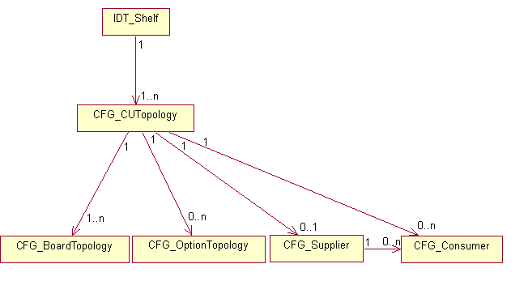
Figure 18 : ViBE Topology

MPEG-4 HD Encoder Topology
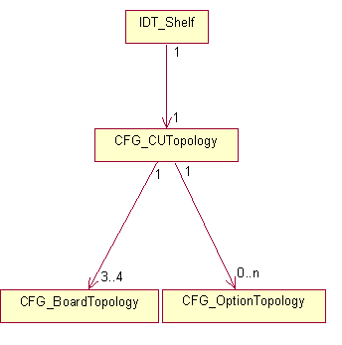
Figure 19 : MPEG-4 HD Encoder Topology

EM1000 Topology
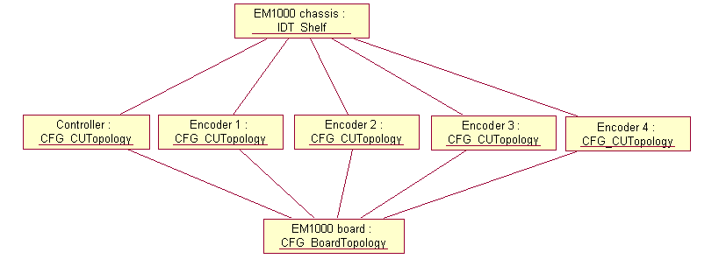
Figure 20 : EM1000 Topology

EM2000 Topology
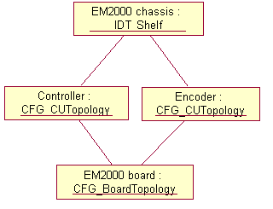
Figure 21 : EM2000 Topology

Topology Descriptors

Descriptor CFG_CUTopology
Descriptor used to declare the topology of a Control Unit.
CFG_CUTopology_descriptor()
{
descriptor_header (type = NCCPD_DESC_CFG_CUTOPOLOGY, version = 3) byte[8]

control_unit_type byte[1]
extended_type byte[1]
control_unit_id byte[2]
name byte[1+n]

HDLC_add byte[1]
network_id byte[1]
remote_flextream_status byte[1]
}
control_unit_type This attribute contains the control unit type.
Possible values :
- ENU_CUNIT_CONTROLLER
- ENU_CUNIT_ENCODER
- ENU_CUNIT_DECODER
- ENU_CUNIT_FE_PDH
- ENU_CUNIT_FE_100BT
- ENU_CUNIT_FE_ASI
- ENU_CUNIT_FE_100ME
- ENU_CUNIT_UNKNOWN

- ENU_CUNIT_HD_ENCODER

- ENU_CUNIT_EM_CONTROLLER
- ENU_CUNIT_EM_ENCODER
- ENU_CUNIT_AVDEC
(default value = ENU_CUNIT_UNKNOWN)

extended_type This attribute contains the control unit extended type.
Possible values :
- ENU_UNUSED (for the first versions)
(default value = ENU_UNUSED)

control_unit_id Control unit identifier.
Possible values :
- from ENU_MIN_CUID (1) to ENU_MAX_CUID (1023)
(default value = ENU_MIN_CUID)

name Control unit name.
(default value = "")

HDLC_add Address on HDLC bus (significant only if control_unit_type = ENU_CUNIT_ENCODER).
(default value = 0)

network_id Identification of HDLC bus (significant only if control_unit_type = ENU_CUNIT_ENCODER).
(default value = 0)

remote_flextream_status Significant only if control_unit_type = ENU_CUNIT_ENCODER.
Possible values :
- ENU_ON (remote flextream)
- ENU_OFF (local flextream)
(default value = ENU_OFF)

Descriptor CFG_BoardTopology
Descriptor used for the declaration of a board in the topology.
CFG_BoardTopology_descriptor()
{
descriptor_header (type = NCCPD_DESC_CFG_BOARDTOPOLOGY, version = 1) byte[8]

board_type byte[1]
extended_type byte[1]

slot_number byte[1]
}
board_type This attribute contains the board type identifier.
Possible values :
- ENU_BOARD_MANAGER

- ENU_BOARD_SP_ENC
- ENU_BOARD_DP_ENC
- ENU_BOARD_AS_ENC
- ENU_BOARD_AD_ENC
- ENU_BOARD_DS_ENC
- ENU_BOARD_IP_ENC
- ENU_BOARD_AA_ENC
- ENU_BOARD_AV_ENC
- ENU_BOARD_ADV_PROC
- ENU_BOARD_AUD_ENC
- ENU_BOARD_H264_CP
- ENU_BOARD_AUD_SUR_DOLBY_FULL
- ENU_BOARD_AUD_SUR_DOLBY_LITE
- ENU_BOARD_AUD_SUR_BASE
- ENU_BOARD_AUD_SUR_DOLBY_PULSE

- ENU_BOARD_CORE_DEC
- ENU_BOARD_AAV_DEC

- ENU_BOARD_FE_PDH
- ENU_BOARD_FE_100BT
- ENU_BOARD_FE_ASI
- ENU_BOARD_FE_100ME

- ENU_BOARD_UNKNOWN

- ENU_BOARD_BASE
- ENU_BOARD_VIDEO_ENC

- ENU_BOARD_EM1000
- ENU_BOARD_EM2000
- ENU_BOARD_EM2002
- ENU_BOARD_EM2004
- ENU_BOARD_AVDEC

- ENU_BOARD_EM4000 (main board of EM4000 product)
- ENU_BOARD_PEGASUS
- ENU_BOARD_ADVANTECH
(default value = ENU_BOARD_UNKNOWN)

extended_type This attribute contains the board extended type identifier.
Possible values :
- ENU_UNUSED
(default value = ENU_UNUSED)

slot_number Board slot number.
Possible values :
- from 1 to 15
(default value = 1)

Descriptor CFG_Supplier
Description of a stream supplier in the topology.
CFG_Supplier_descriptor()
{
descriptor_header (type = NCCPD_DESC_CFG_SUPPLIER, version = 1) byte[8]

supplier_channel_id byte[1]
ls_id byte[1]
ls_name byte[1+n]
ls_state byte[1]
}

supplier_channel_id Supplier channel identifier.
Possible values :
- from 1 to 255
(default value = 1)

ls_id Logical stream identifier.
Possible values :
- from 1 to 255
(default value = 1)

ls_name Logical stream name.
(default value = "")

ls_state Logical stream state.
Possible values :
- ENU_ENABLE
- ENU_DISABLE
(default value = ENU_ENABLE)

Descriptor CFG_Consumer
CFG_Consumer_descriptor()
{
descriptor_header (type = NCCPD_DESC_CFG_CONSUMER, version = 1) byte[8]

consumer_channel_id byte[1]
consumption_type byte[1]
}

consumer_channel_id Consumer channel identifier.
Possible values :
- from 1 to 255
(default value = 1)

consumption_type Possible values :
- ENU_DMH_FIXED
- ENU_DMH_SECURED
(default value = ENU_DMH_FIXED)

Descriptor CFG_OptionTopology
CFG_OptionTopology_descriptor()
{
descriptor_header (type = NCCPD_DESC_CFG_OPTIONTOPOLOGY, version = 1) byte[8]

option_code byte[1+n]
option_type byte[1]
option_amount byte[1]
}

option_code Unique code for the option.
(default value = "")

option_type When the option could be node-locked or floating.
Possible values :
- ENU_OPTION_NODE_LOCKED
(default value = ENU_OPTION_NODE_LOCKED)

option_amount Amount of allowed options, when the option could be present more than once.
Possible values : 1.
(default value = 1)

Common

Common Diagrams

Common Descriptors

Descriptor CFG_TSSIGIn
Describes management on input signalling.
CFG_TSSIGIn_descriptor()
{
descriptor_header (type = NCCPD_DESC_CFG_TSSIGIN, version = 1) byte[8]

signalling_mode byte[1]
nb_subtables byte[1]
for (i = 1 ; i <= nb_subtables)
{
PID byte[2]

table_id byte[1]

table_id_extension byte[2]

state byte[2]

}

}

signalling_mode Possible values :
- ENU_ISO_CONFORMITY
- ENU_DVB_CONFORMITY
- ENU_DVB_RESTRICTED_CONFORMITY
- ENU_WITHOUT_SIGNALLING
- ENU_CUSTOMIZED
(default value = ENU_ISO_CONFORMITY)

nb_subtables Number of subtables in input.
Equals 0 if signalling_mode is different from ENU_CUSTOMIZED.
(default value = 0)

PID PID of signalling table.
(default value = 0)

table_id table_id of signalling table.
(default value = 0)

table_id_extension table_id_extension of signalling table.
(default value = 0)

state The state is an "OR" of following states:
- ENU_SIG_TABLE_OFF
- ENU_SIG_TABLE_EXTRACTED
- ENU_SIG_TABLE_FILTERED
- ENU_SIG_TABLE_TRANSMITTED
(default value = ENU_SIG_TABLE_OFF)

Descriptor CFG_TSSIGOut
Describes the list of signalling tables to manage.
CFG_TSSIGOut_descriptor()
{
descriptor_header (type = NCCPD_DESC_CFG_TSSIGOUT, version = 3) byte[8]

original_network_id byte[2]
transport_stream_id byte[2]
SI_maximum_rate byte[2]
NIT_in_PAT byte[1]
station_identification byte[1+n]
signalling_generation byte[1]
nb_subtables byte[1]
for (i = 1 ; i <= nb_subtables)
{
PID byte[2]

table_id byte[1]

table_id_extension byte[2]

broadcast_status byte[1]

building_mode byte[1]

repetition_rate byte[1]

}
VCT_type byte[1]
EIT0_PID byte[2]

}

original_network_id Label identifying the network_id of the originating delivery system.
(default value = 1)

transport_stream_id Label for identification of the TS.
(default value = 0)

SI_maximum_rate Maximum rate allowed to signalling and ECM (in pack/sec). This value is only used for alarm generation.
(default value = 100)

NIT_in_PAT Indicates if the NIT must be referred in the PAT or not in ISO signalling mode.
Possible values :
- ENU_OFF (the NIT mustn't be referred)
- ENU_ON (the NIT must be referred)
(default value = ENU_OFF)

station_identification A string used for TSDT generation.
(default value = "")

signalling_generation Possible values :
- ENU_ISO_CONFORMITY
- ENU_DVB_CONFORMITY
- ENU_WITHOUT_SIGNALLING
- ENU_CUSTOMIZED
- ENU_ATSC_CONFORMITY
- ENU_STATIC_PSIP
- ENU_EXTERNAL_PSIP
(default value = ENU_ISO_CONFORMITY)

nb_subtables Number of subtables in output.
(default value = 0)

PID PID of signalling table.
(default value = 0)

table_id table_id of signalling table.
(default value = 0)

table_id_extension table_id_extension of signalling table.
(default value = 0)

broadcast_status Enables/disables broadcast on output.
Possible values :
- ENU_SIG_TABLE_BROADCAST_OFF
- ENU_SIG_TABLE_BROADCAST_ON
(default value = ENU_SIG_TABLE_BROADCAST_ON)

building_mode Defines where the table is built.
Possible values :
- ENU_SIG_TABLE_OFF (for test purpose only)
- ENU_SIG_TABLE_LOCALLY_BUILT (locally generated)
- ENU_SIG_TABLE_DOWNLOADED (downloaded from output)
(default value = ENU_SIG_TABLE_LOCALLY_BUILT)

repetition_rate Possible values depend on table.
Possible values for PAT, CAT, PMT :
- ENU_500_MILLISECONDS
- ENU_200_MILLISECONDS
- ENU_100_MILLISECONDS
Possible values for SDT_actual, EIT_actual_pf (not used), TSDT :
- ENU_10_SECONDS
- ENU_5_SECONDS
- ENU_2_SECONDS
- ENU_1_SECOND
- ENU_500_MILLISECONDS
- ENU_200_MILLISECONDS
- ENU_100_MILLISECONDS
Possible values for NIT, NIT_other (not used), BAT, SDT_other (not used), EIT_other_pf (not used), EIT_actual_schedule (not used), EIT_other_schedule (not used) :
- ENU_60_SECONDS
- ENU_30_SECONDS
- ENU_20_SECONDS
- ENU_15_SECONDS
- ENU_12_SECONDS
- ENU_10_SECONDS
- ENU_5_SECONDS
- ENU_2_SECONDS
- ENU_1_SECOND
- ENU_500_MILLISECONDS
Possible values for TDT, TOT :
- ENU_10_SECONDS
- ENU_20_SECONDS
- ENU_30_SECONDS
(default value = ENU_100_MILLISECONDS)
VCT_type Possible values :
- ENU_TER_PSIP_CONFORMITY
- ENU_CAB_PSIP_CONFORMITY
(default value = ENU_TER_PSIP_CONFORMITY)

EIT0_PID Possible values :
- from 32 to 8176
(default value = 32)

Descriptor CFG_CUStatus
This descriptor gives redundancy and status information about a Control Unit.
CFG_CUStatus_descriptor()
{
descriptor_header (type = NCCPD_DESC_CFG_CUSTATUS, version = 2) byte[8]

nominal_redundant byte[1]
broadcast_status byte[1]
nominal_cuid byte[2]
maintenance_status byte[1]
device_name byte[1+n]
nominal_device_name byte[1+n]
}

nominal_redundant Control unit redundancy level.
Possible values :
- ENU_NOMINAL
- ENU_REDUNDANT
(default value = ENU_NOMINAL)

broadcast_status Control unit current status.
Possible values :
- ENU_ON_AIR
- ENU_OFF_AIR
(default value = ENU_ON_AIR)

nominal_cuid Gives for a redundant control unit the nominal control unit id. For a nominal control unit, must be equal to cuid.
Possible values :
- from ENU_MIN_CUID (1) to ENU_MAX_CUID (1023)
(default value = ENU_MIN_CUID)

maintenance_status Control unit maintenance status.
Possible values :
- ENU_NOMINAL
- ENU_MAINTENANCE
(default value = ENU_NOMINAL)

device_name Descriptive name associated with the device.
(default value = "")

nominal_device_name Significant for a redundant device : descriptive name of the nominal device.
(default value = "")

Descriptor CFG_HistreamID
Specifies histream_id to use. Can be linked to a TS, a service or a component.
Used in internal modeling only.
CFG_HistreamID_descriptor()
{
descriptor_header (type = NCCPD_DESC_CFG_HISTREAMID, version = 1) byte[8]

histream_id byte[4]
}

histream_id Histream_ID.
(default value = 1025)

Descriptor CFG_DataBroadcasting
This descriptor is used to configure broadcast data receiving.
Used in internal modeling only.
CFG_DataBroadcasting_descriptor()
{
descriptor_header (type = NCCPD_DESC_CFG_DATABROADCASTING, version = 1) byte[8]

port byte[2]
channel_id byte[2]
data_type byte[1]
source_cuid byte[2]
}

port UDP port to listen to.
(default value = 0)

channel_id Virtual channel identifier.
(default value = 0)

data_type Data type to be read.
Possible values :
- ENU_DATA_TYPE_MONITORING
- ENU_DATA_TYPE_SIGNALLING
(default value = 0)

source_cuid Source control unit identifier.
Possible values :
- from ENU_MIN_CUID (1) to ENU_MAX_CUID (1023)
(default value = ENU_MIN_CUID)

Descriptor CFG_TSOut
Describes an output Transport Stream.
CFG_TSOut_descriptor()
{
descriptor_header (type = NCCPD_DESC_CFG_TSOUT, version = 1) byte[8]

output_packet_size byte[1]
synthetizer_clock_frequency byte[4]
}

output_packet_size Possible values :
- ENU_WITH_REED_SOLOMON (packet size is 188 + 16 bytes)
- ENU_WITHOUT_REED_SOLOMON (packet size is 188 bytes)
- ENU_TRANSPARENT (to be used when the stream input is a TS input with packets which are already sized on 188 or 204 bytes)
(default value = ENU_WITHOUT_REED_SOLOMON)

synthetizer_clock_frequency In Hz.
Not significant when output_packet_size = ENU_TRANSPARENT.
Possible values :
- from ENU_EM_MIN_SYNTHETIZER_CLOCK (100000) to ENU_EM_MAX_SYNTHETIZER_CLOCK (54000000) for EM1000/2000
(default value = 45400000)

Descriptor CFG_CAFixedKey
Describes BISS scrambling (used by ViBE encoder and decoder).
CFG_CAFixedKey_descriptor()
{
descriptor_header (type = NCCPD_DESC_CFG_CAFIXEDKEY, version = 2) byte[8]

access_group_type byte[1]
access_mode byte[1]
CW_key byte[8]
BISS_protocol byte[1]
BISS2_CW_key byte[16]
}

access_group_type Kind of services involved in the scrambling group.
Possible values for ViBE encoder :
- ENU_SCRAMBLING_TV_SERVICE (TV service only)
- ENU_SCRAMBLING_OTHER_SERVICES (all services except TV service)
- ENU_SCRAMBLING_ALL_SERVICES (all services)
Possible values for ViBE decoder :
- ENU_DESCRAMBLING_SERVICE
(default value = ENU_SCRAMBLING_TV_SERVICE)

access_mode Access control mode.
Possible values :
- ENU_BISS_MODE1
- ENU_BISS_E_BURIED_ID
- ENU_BISS_E_INJECTED_ID
(default value = ENU_BISS_MODE1)

CW_key Key to be used with BISS-1 protocol
In BISS-1 Mode-1, contains 6 bytes-long SW. The 48 bits SW mapping to 64 bits CW using the DVB conformance mechanism is assumed by the equipment.
In BISS-1 mode-E mode, contains 8 bytes-long ESW.
(default value = 0)
BISS_protocol BISS protocol used
Possible values :
- ENU_PROTOCOL_BISS_1
BISS-1 protocol used DES64 for SW and stream encryption DVB-CSA1
- ENU_ PROTOCOL BISS_2
BISS-2 protocol used AES128 for SW and stream encryption DVB-CISSA (see ETSI TS 103 127)
(default value = ENU_PROTOCOL_BISS_1)
BISS2_CW_key Key to be used with BISS-2 protocol
In BISS-2 Mode-1, contains 16 bytes-long SW in clear
In BISS-2 Mode-E, contains 16 bytes-long ESW encrypted (ESW).
(default value = 0)

Descriptor CFG_GPI
This descriptor describes the configuration of General Purpose Interface, and is to be linked to an IDT_Interface descriptor.
CFG_GPI_descriptor()
{
descriptor_header (type = NCCPD_DESC_CFG_GPI, version = 5) byte[8]

alarm_relay_activation_mode byte[1]
GPIO_output_level byte[1]
GPIO_output_name byte[1+n]
GPIO_input1_name byte[1+n]
GPIO_input2_name byte[1+n]
GPIO_input3_name byte[1+n]
GPIO_input4_name byte[1+n]
GPIO_input_level byte[1]
}

alarm_relay_activation_mode Possible values :
- ENU_ACTIVATE_ON_MAJOR_ALARM (alarm relay will be activated only on major alarm detection)
- ENU_ACTIVATE_ON_MAJOR_OR_MINOR_ALARM (alarm relay will be activated on major or minor alarm detection)
(default value = ENU_ACTIVATE_ON_MAJOR_ALARM)

GPIO_output_level Possible values :
- ENU_LOW_LEVEL
- ENU_HIGH_LEVEL
(default value = ENU_LOW_LEVEL)

GPIO_output_name Name of the output GPI.
(default value = "")

GPIO_input1_name Name of the first GPI input.
(default value = "")

GPIO_input2_name Name of the second GPI input.
(default value = "")

GPIO_input3_name Name of the third GPI input.
(default value = "")

GPIO_input4_name Name of the fourth GPI input.
(default value = "")
GPIO_input_level Possible values :
- ENU_LOW_LEVEL
- ENU_HIGH_LEVEL
- ENU_NO_LEVEL

(default value = ENU_NO_LEVEL)

Descriptor CFG_SigNIT
CFG_SigNIT_descriptor()
{
descriptor_header (type = NCCPD_DESC_CFG_SIGNIT, version = 1) byte[8]

SI_length byte[2]
SI_data byte[n]
}

SI_length Length of following SI_data field.
(default value = 0)

SI_data Contains the section.

Descriptor CFG_SigTOT
CFG_SigTOT_descriptor()
{
descriptor_header (type = NCCPD_DESC_CFG_SIGTOT, version = 1) byte[8]

SI_length byte[2]
SI_data byte[n]
}

SI_length Length of following SI_data field.
(default value = 0)

SI_data Contains the section.

Descriptor CFG_EthernetInterface
Used for the configuration of IP output interfaces.
CFG_EthernetInterface_descriptor()
{
descriptor_header (type = NCCPD_DESC_CFG_ETHERNETINTERFACE, version = 5) byte[8]

output_enable byte[1]
board_IP_address byte[4]
net_mask byte[4]
gateway byte[4]
routing_protocol byte[1]
negotiation byte[1]
speed byte[1]
mode byte[1]
nb_routes byte[1]
for (i = 1 ; i <= nb_routes)
{
static_router_IP_address byte[4]
static_destination_IP_address byte[4]
static_netmask byte[4]
}
RIPv2_update_frequency byte[2]
RIPv2_disable_time_out byte[2]
RIPv2_garbage_time_out byte[2]
RIPv2_authentication byte[1]
RIPv2_password byte[1+n]
RIPv2_auth_key_id byte[1+n]
OSPF_area byte[1+n]
OSPF_stub_area byte[1]
OSPF_hello_interval byte[2]
OSPF_dead_interval byte[2]
OSPF_authentication byte[1]
OSPF_auth_string byte[1+n]
OSPF_auth_key_id byte[1+n]
OSPF_auth_key byte[1+n]
interface_desactivation byte[1]
interface_backup_status byte[1]
input_enable byte[1]
dhcp_enable byte[1]
dhcp_query_resolved byte[1]
}

output_enable Indicates if the IP output is enabled or not.
Possible values :
- ENU_ENABLE
- ENU_DISABLE
(default value = ENU_DISABLE)

board_IP_address Defines Board IP address.
(default value = 0)

net_mask Defines NetMask address.
(default value = 0)

gateway Defines default gateway IP address.
(default value = 0)

routing_protocol Defines dynamic IP routing protocol.
Possible values :
- ENU_NONE
- ENU_RIPv2
- ENU_OSPF
- ENU_RIPv2_OSPF
(default value = ENU_NONE)

negotiation Possible values :
- ENU_AUTO
- ENU_MANUAL
(default value = ENU_AUTO)

speed Possible values :
- ENU_10MBS
- ENU_100MBS
- ENU_1GBS
(default value = ENU_100MBS)

mode Possible values :
- ENU_HALF (half duplex)
- ENU_FULL (full duplex)
(default value = ENU_FULL)

nb_routes Number of static routes.
Possible values :
- from 0 to 12
(default value = 0)

static_router_IP_address Next hop intermediary via where packets with static_destination_IP_address should be routed.
(default value = 0)

static_destination_IP_address Destination IP address (host or network) added statically in the routing table and associated with static_router_IP_address and static_netmask.
(default value = 0)

static_netmask Static netmask in the routing table.
(default value = 0)

RIPv2_update_frequency Defines the frequency of route update, in seconds (significant only if routing_protocol = ENU_RIPv2 or ENU_RIPv2_OSPF).
Possible values :
- from 5 to 65535
(default value = 30)

RIPv2_disable_time_out Defines the time out in seconds after which a route is disabled if no RIP message is received (significant only if routing_protocol = ENU_RIPv2 or ENU_RIPv2_OSPF).
Possible values :
- from 5 to 65535
(default value = 180)

RIPv2_garbage_time_out Defines the time out in seconds after which a disabled route is destroyed (significant only if routing_protocol = ENU_RIPv2 or ENU_RIPv2_OSPF).
Possible values :
- from 5 to 65535
(default value = 120)

RIPv2_authentication Defines the authentication mode (significant only if routing_protocol = ENU_RIPv2 or ENU_RIPv2_OSPF).
Possible values :
- ENU_NONE
- ENU_TEXT
- ENU_MD5
(default value = ENU_NONE)

RIPv2_password Text string which defines the password used for authentication (significant only if routing_protocol = ENU_RIPv2 or ENU_RIPv2_OSPF) (max size = 16).
(default value = "")

RIPv2_auth_key_id Text string which defines the MD5 key id (secret key used to encrypt password through MD5 configured in each router attached to a common network, value from 0 to 2147483647) in MD5 mode (significant only if routing_protocol = ENU_RIPv2 or ENU_RIPv2_OSPF).
(default value = "")

OSPF_area Text string which identifies the OSPF area that the board belongs to (significant only if routing_protocol = ENU_OSPF or ENU_RIPv2_OSPF).
Possible values :
- from "0.0.0.0" to "255.255.255.255"
(default value = "0.0.0.0")

OSPF_stub_area Defines if the OSPF area that the board belongs to is a stub area (significant only if routing_protocol = ENU_OSPF or ENU_RIPv2_OSPF).
Possible values :
- ENU_TRUE
- ENU_FALSE
(default value = ENU_FALSE)

OSPF_hello_interval Defines the time in seconds between 2 hello messages (significant only if routing_protocol = ENU_OSPF or ENU_RIPv2_OSPF).
Possible values :
- from 1 to 65535
(default value = 10)

OSPF_dead_interval Defines the time in seconds after which a router is declared dead if no hello message is received (significant only if routing_protocol = ENU_OSPF or ENU_RIPv2_OSPF).
Possible values :
- from 1 to 65535
(default value = 40)

OSPF_authentication Defines the authentication mode (significant only if routing_protocol = ENU_OSPF or ENU_RIPv2_OSPF).
Possible values :
- ENU_NONE
- ENU_TEXT
- ENU_MD5
(default value = ENU_NONE)

OSPF_auth_string Text string which defines the authentication password in text mode (significant only if routing_protocol = ENU_OSPF or ENU_RIPv2_OSPF) (max size = 8).
(default value = "")

OSPF_auth_key_id Text string which defines the MD5 key id (secret key used to encrypt password through MD5 configured in each router attached to a common network, value from 1 to 255) in MD5 mode (significant only if routing_protocol = ENU_OSPF or ENU_RIPv2_OSPF).
(default value = "")

OSPF_auth_key Text string which defines the MD5 key (password) in MD5 mode (significant only if routing_protocol = ENU_OSPF or ENU_RIPv2_OSPF) (max size = 16).
(default value = "")

interface_desactivation Indicates the link status when the output is disabled.
Possible values :
- ENU_LINK_DOWN
- ENU_LINK_UP_NO_TRAFFIC
- ENU_LINK_UP_NO_MULTICAST
- ENU_LINK_UP_NO_TRAFFIC_ARP
(default value = ENU_LINK_UP_NO_TRAFFIC)
interface_backup_status Indicates if the physical interface is to be disabled when the device is switched to standby mode.
Possible values :
- ENU_UNCHANGED
- ENU_DISABLE
(default value = ENU_ DISABLE)
input_enable When the interface can be in/out, indicates if the input is enabled.
Possible values :
- ENU_ENABLE
- ENU_DISABLE
(default value = ENU_DISABLE)
dhcp_enable DHCP enable.
Possible values :
- ENU_ENABLE Automatic DHCP address configuration
- ENU_DISABLE Manual address configuration
(default value = ENU_DISABLE)
dhcp_query_resolved DHCP query resolution.
Possible values :
- ENU_TRUE
- ENU_FALSE
(default value = ENU_FALSE)

Descriptor CFG_IPEncaps
Used for the configuration of IP output interfaces.

CFG_IPEncaps_descriptor()
{
descriptor_header (type = NCCPD_DESC_CFG_IPENCAPS, version = 7) byte[8]

encaps_enable byte[1]
TX_dest_IP_address byte[4]
IGMP_snooping byte[1]
TX_dest_UDP_port byte[2]
MPEG_TOS byte[1]
MPEG_TTL byte[1]
TX_RTP_encapsulation byte[1]
TX_MPEG_packets_number byte[1]
TX_dest_MAC_address byte[6]
VLAN_field_enable byte[1]
VLAN_identifier byte[2]
VLAN_priority_level byte[1]
virtual_src_IP_address byte[4]
transport_resource_name byte[1+n]
source_UDP_port byte[2]
second_IP_transmission_mode byte[1]
dns_enable byte[1]
dns_query_resolved byte[1]
TX_dest_url byte[1+n]
}

encaps_enable Indicates if the encapsulation is enabled or not.
Possible values :
- ENU_ENABLE
- ENU_DISABLE
(default value = ENU_DISABLE)

TX_dest_IP_address Destination IP address for transmitted frames (unicast or multicast address).
(default value = 0)

IGMP_snooping Defines layer 2 IGMP snooping mode activation.
Used only for MultiEncaps FE configuration.
Possible values :
- ENU_ON
- ENU_OFF
(default value = ENU_OFF)

TX_dest_UDP_port Destination UDP port for transmitted MPEG frames. This value MUST be an even value and is recommended to lie in the range above 5000. Granularity 4.
Possible values :
- from 2 to 65535
(default value = 5000)

MPEG_TOS TOS value for transmitted MPEG frames.
Possible values :
- from 0 to 255
(default value = 0x10)

MPEG_TTL TTL value for transmitted FEC frames.
Possible values :
- from 1 to 255
(default value = 32)

TX_RTP_encapsulation Transmit RTP encapsulation for MPEG traffic.
Possible values :
- ENU_ENABLE
- ENU_DISABLE
(default value = ENU_ENABLE)

TX_MPEG_packets_number Number of MPEG TS packets per transmitted frame.
Possible values :
- from 1 to 7
(default value = 7)

TX_dest_MAC_address Destination MAC address for transmitted frames. If set to 0, destination MAC address is internally computed.
(default value = 0)

VLAN_field_enable If enabled, the VLAN tag is inserted in the Ethernet header, according to the 802.3ac standard.
Possible values :
- ENU_ENABLE
- ENU_DISABLE
(default value = ENU_DISABLE)

VLAN_identifier If VLAN field enabled, number identifying the 802.1q virtual bridged LAN.
Possible values :
- from 0 to 4095
(default value = 0)

VLAN_priority_level If VLAN field enabled, priority level based on the 802.1p prioritization scheme.
Possible values :
- from 0 to 7
(default value = 0)

virtual_src_IP_address Virtual source IP address.
(default value = 0)
transport_resource_name Descriptive label of the transport resource, configured by the management system.
(default value = “”)
source_UDP_port Source UDP port.
Possible values :
- ENU_UNUSED (0)
- from 2 to 65535
(default value = ENU_UNUSED)
second_IP_transmission_mode .
Possible values :
- ENU_TS_INDEPENDANT
- ENU_MIRRORING
- ENU_TS_RTP_SYNCHRO
(default value = ENU_TS_INDEPENDANT)
dns_enable DNS enable.
Possible values :
- ENU_ENABLE
- ENU_DISABLE
(default value = ENU_DISABLE)
dns_query_resolved DNS query resolution.
Possible values :
- ENU_TRUE
- ENU_FALSE
(default value = ENU_FALSE)
TX_dest_url URL identifier resource on internet.
(default value = “”)

Descriptor CFG_TSVideoPIP
Describes a PIP video component.
CFG_TSVideoPIP_descriptor()
{
descriptor_header (type = NCCPD_DESC_CFG_TSVIDEOPIP, version = 4) byte[8]

PID byte[2]
status byte[1]

default_pattern byte[1]
standard byte[1]
PCR_insertion byte[1]
encoder_bit_rate byte[4]
frame_rate byte[1]
GOP_size byte[1]
picture_resolution byte[1]
deblocking_filter byte[1]
PES_priority byte[1]
copyright byte[1]
original_or_copy byte[1]
video_profile byte[1]
aspect_ratio byte[1]
IP_frame byte[1]
adaptive_GOP byte[1]
closed_GOP_mode byte[1]
}
PID TS component PID.
(default value = 256)

status Indicates if the component is actually broadcast or not.
Possible values :
- ENU_ON_AIR (the component is actually broadcast)
- ENU_OFF_AIR (the component is stopped)
(default value = ENU_ON_AIR)

default_pattern This pattern is used either when pattern source is selected or when no signal is detected on the input.
Possible values :
- ENU_DMH_VID_BLACK_PATTERN
- ENU_DMH_VID_BAR_PATTERN
(default value = ENU_DMH_VID_BLACK_PATTERN)

standard Possible values :
- ENU_50HZ_AREA
- ENU_60HZ_AREA
(default value = ENU_50HZ_AREA)

PCR_insertion This field is used to insert the Program Reference Clock in the headers of the TS packets transporting the video component.
Possible values :
- ENU_OFF (the component does not carry the PCR)
- ENU_ON (the component carries the PCR)
(default value = ENU_ON)

encoder_bit_rate In bits/s.
Possible values for SD encoder :
- from ENU_EM_PIP_MIN_VIDEO_ENCODER_BITRATE to ENU_EM_SD_PIP_MAX_VIDEO_ENCODER_BITRATE (100 kbits/s to 700 kbits/s by steps of 1 kbits/s)
Possible values for HD encoder :
- from ENU_EM_PIP_MIN_VIDEO_ENCODER_BITRATE to ENU_EM_HD_PIP_MAX_VIDEO_ENCODER_BITRATE (100 kbits/s to 1000 kbits/s by steps of 1 kbits/s)
(default value = ENU_EM_SD_PIP_MAX_VIDEO_ENCODER_BITRATE)

frame_rate Possible values in 50Hz :
- ENU_25_FRAMES
- ENU_12_5_FRAMES
- ENU_6_25_FRAMES
Possible values in 60Hz :
- ENU_30_FRAMES
- ENU_15_FRAMES
- ENU_7_5_FRAMES
(default value = ENU_25_FRAMES)

GOP_size This parameter defines the recurrence of the Intra pictures.
Possible values :
- from ENU_EM_PIP_MIN_GOP_SIZE (1) to ENU_EM_PIP_MAX_GOP_SIZE (64)
(default value = 24)

picture_resolution This field allows the picture resolution to be reduced in the event of a low video rate. The picture resolution depends on the picture rate.
Possible values :
- ENU_EM_PR_96_96 (96*96)
- ENU_EM_PR_192_192 (192*192)
- ENU_EM_PR_176_144 (QCIF) (176*120/144)
- ENU_EM_PR_320_240 (QVGA) (320*240)
- ENU_EM_PR_128_96 (SQCIF) (128*80/96)
- ENU_EM_PR_352_240 (CIF) (HD only) (352*240/288)
- ENU_EM_PR_192_144 (192*144)
(default value = ENU_EM_PR_176_144)

deblocking_filter Use of deblocking filter.
Possible values :
- ENU_ON
- ENU_OFF
(default value = ENU_ON)

PES_priority Flag in the PES packet header.
Possible values :
- ENU_PES_WITH_PRIORITY
- ENU_PES_WITHOUT_PRIORITY
(default value = ENU_PES_WITH_PRIORITY)

copyright Flag in the PES packet header.
Possible values :
- ENU_COPYRIGHT_NOT_PROTECTED
- ENU_COPYRIGHT_PROTECTED
(default value = ENU_COPYRIGHT_PROTECTED)

original_or_copy Flag in the PES packet header.
Possible values :
- ENU_PES_ORIGINAL
- ENU_PES_COPY
(default value = ENU_PES_ORIGINAL)

video_profile Possible values :
- ENU_MPL3 (only value allowed for SD encoder)
- ENU_MPL2
- ENU_BASELINEL2
(default value = ENU_MPL3)
aspect_ratio Gives the aspect ratio of the image.
Possible values for EM1000/2000 :
- ENU_4_3_FORMAT
- ENU_16_9_FORMAT
- ENU_4_3_AUTOMATIC_WSS (with a default 4/3 mode)
- ENU_16_9_AUTOMATIC_WSS (with a default 16/9 mode)
- ENU_4_3_AUTOMATIC_AFD (with a default 4/3 mode)
- ENU_16_9_AUTOMATIC_AFD (with a default 16/9 mode)
Possible values for EM3000 :
- ENU_4_3_FORMAT
- ENU_16_9_FORMAT
(default value = ENU_4_3_FORMAT)
IP_frame This parameter defines the recurrence of non-bidirectional pictures (P or I pictures).
Possible values :
- from 1 to 4
(default value = 1)
adaptive_GOP Defines the use of fixed, adaptive or full GOP.
Possible values :
- ENU_AGM_DISABLED
- ENU_AGM_RESTRICTED
- ENU_AGM_FULL
(default value = ENU_AGM_DISABLED)
closed_GOP_mode Possible values :
- ENU_ON
- ENU_OFF
(default value = ENU_OFF)

Decoder
This sub-package defines descriptors for the configuration of a ViBE decoder.

Decoder Diagrams

Service decoding
Implementation model for a ViBE decoder configuration :
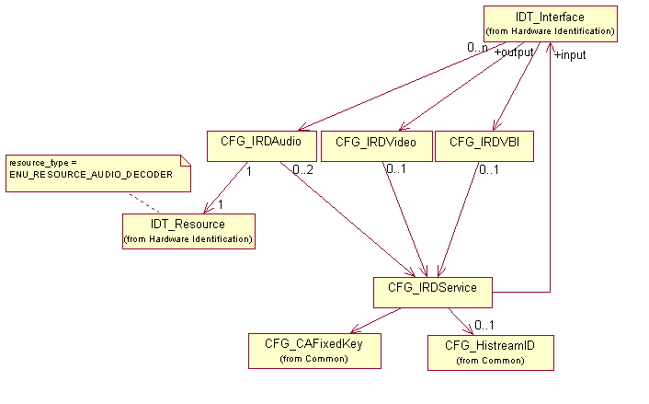
Figure 22 : Service decoding

Ident/Config relations
This diagram gives the relations between Identification and Configuration descriptors, in the case of a ViBE decoder :
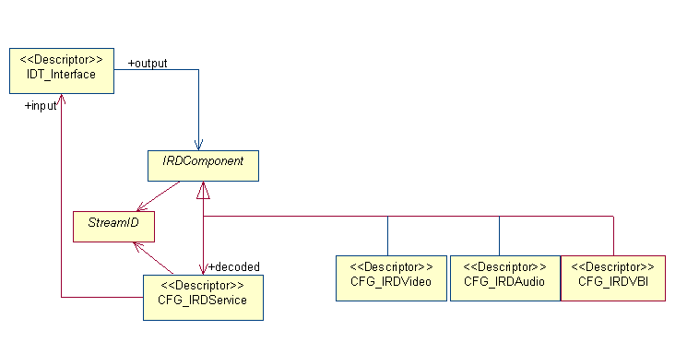
Figure 23 : Ident/Config relations

Decoder example
Example of a decoder configuration :
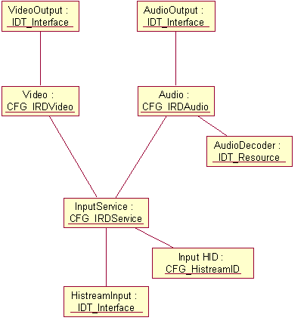
Figure 24 : Decoder example

ASI distributor example
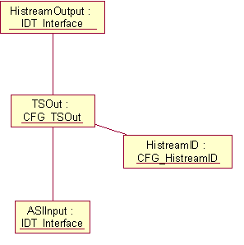
Figure 25 : ASI distributor example

Decoder function default configuration
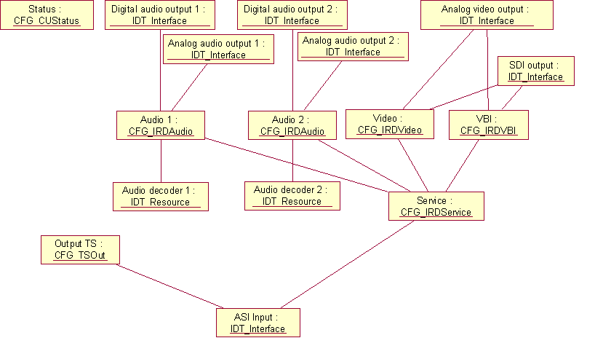
Figure 26 : Decoder function default configuration

Decoder Descriptors

Descriptor CFG_IRDService
This descriptor controls the service to be decoded. The decoder will configure itself to decode the selected service, on the video and audio outputs.
CFG_IRDService_descriptor()
{
descriptor_header (type = NCCPD_DESC_CFG_IRDSERVICE, version = 1) byte[8]

PSI_mode byte[1]
service_id byte[2]
PCR_PID byte[2]
synchro_mode byte[1]
}

PSI_mode This attribute indicates the use of PSI/SI information.
Possible values :
- ENU_PSI_OFF (PSI/SI not used)
- ENU_PSI_ON_DVB (PSI/SI DVB system is used)
- ENU_PSI_ON_ISO (PSI/SI ISO system is used)
(default value = ENU_PSI_OFF)

service_id This attribute defines the service ID to be used.
It is significant when PSI_mode = ENU_PSI_ON_DVB or ENU_PSI_ON_ISO.
Possible values :
- from ENU_IRD_SERVICE_ID_MIN (1) to ENU_IRD_SERVICE_ID_MAX (65535)
(default value = ENU_IRD_SERVICE_ID_MIN)

PCR_PID This attribute defines the PCR component PID of the service.
Possible values :
- from ENU_IRD_PID_MIN to ENU_IRD_PID_MAX
This parameter is significant when PSI_mode = ENU_PSI_OFF.
(default value = ENU_IRD_PID_MIN)

synchro_mode Lip-sync mode.
Possible values :
- ENU_PTS_LOCKED (synchronize service to PTS in TS signal)
- ENU_PTS_GENLOCK (synchronize service to an external genlock signal)
(default value = ENU_PTS_LOCKED)

Descriptor CFG_IRDVideo
This descriptor controls the configuration of the video component to be decoded.
This descriptor contains attributes for both 525 and 625 lines systems.
CFG_IRDVideo_descriptor()
{
descriptor_header (type = NCCPD_DESC_CFG_IRDVIDEO, version = 2) byte[8]

PID byte[2]
preferred_video_format byte[1]
ln625_video_format byte[1]
ln525_video_format byte[1]
aspect_ratio byte[1]
ln625_VITC_lines byte[1]
ln625_VITS_lines byte[1]
ln625_AFD_lines byte[1]
ln525_VITC_lines byte[1]
ln525_VITS_lines byte[1]
ln525_AFD_lines byte[1]
closed_caption byte[1]
GCR_line byte[1]
enable_decoding byte[1]
}

PID This attribute defines the video PID to be used.
It is significant when PSI_mode = ENU_PSI_OFF.
Possible values :
- from ENU_IRD_PID_MIN to ENU_IRD_PID_MAX
(default value = ENU_IRD_PID_MIN)

preferred_video_format Video format to be used if no video format for output information is available in the signal.
Possible values :
- ENU_VIDEO_625LN (625 lines system)
- ENU_VIDEO_525LN (525 lines system)
(default value = ENU_VIDEO_625LN)

ln625_video_format Video output format to use for 625 lines video system.
Possible values :
- ENU_PAL_BGHI
- ENU_PAL_N
- ENU_SECAM
(default value = ENU_PAL_BGHI)

ln525_video_format Output video format to use for 525 lines video system.
Possible values :
- ENU_PAL_M
- ENU_NTSC
- ENU_NTSC_JAPAN
(default value = ENU_NTSC_JAPAN)

aspect_ratio This attribute enables/disables aspect ratio conversion.
Possible values :
- ENU_ARC_OFF
- ENU_ARC_16_9_TO_4_3
(default value = ENU_ARC_OFF)

ln625_VITC_lines Enables/disables VITC (Vertical Interval Time Code) lines to transmit.
Possible values :
- ENU_VITC_LINE_OFF
- ENU_VITC_LINE_14
- ENU_VITC_LINE_12_AND_14
- ENU_VITC_LINE_14_AND_16
- ENU_VITC_LINE_16_AND_18
(default value = ENU_VITC_LINE_14)

ln625_VITS_lines Enables/disables VITS (Vertical Interval Test Signals) lines to insert.
Possible values :
- ENU_VITS_LINE_OFF
- ENU_VITS_LINE_17_AND_18 (CCIR ITS inserted lines : 17, 18, 330, 331)
- ENU_VITS_LINE_19_AND_20 (UK ITS inserted lines : 19, 20, 332, 333)
(default value = ENU_VITS_LINE_OFF)

ln625_AFD_lines Enables/disables AFD (Automatic Format Description).
Possible values :
- ENU_AFD_LINE_OFF
- ENU_AFD_LINE_11_AND_324
(default value = ENU_AFD_LINE_OFF)

ln525_VITC_lines Enables/disables VITC (Vertical Interval Time Code) lines to transmit.
Possible values :
- ENU_VITC_LINE_OFF
- ENU_VITC_LINE_14
- ENU_VITC_LINE_12_AND_14
- ENU_VITC_LINE_14_AND_16
- ENU_VITC_LINE_16_AND_18
(default value = ENU_VITC_LINE_14)

ln525_VITS_lines Enables/disables VITS (Vertical Interval Test Signals) lines to insert.
Possible values :
- ENU_VITS_LINE_OFF
- ENU_VITS_LINE_17 (FCC ITS inserted line : 17, 280)
(default value = ENU_VITS_LINE_OFF)

ln525_AFD_lines Enables/disables AFD (Automatic Format Description) to transmit.
Possible values :
- ENU_AFD_LINE_OFF
- ENU_AFD_LINE_14_AND_277
(default value = ENU_AFD_LINE_OFF)

closed_caption Enables/disables Closed Caption line EIA 708 (line 21) to transmit (for 525 lines system).
Possible values :
- ENU_CLOSEDCAPTION_ON
- ENU_CLOSEDCAPTION_OFF
(default value = ENU_CLOSEDCAPTION_OFF)

GCR_line Enables/disables GCR (Ghost Cancelling Reference) line (19) to insert (for 525 lines system).
Possible values :
- ENU_GCR_OFF
- ENU_GCR_ON
(default value = ENU_GCR_ON)

enable_decoding This attribute enables/disables the decoding.
It is significant when PSI_mode = ENU_PSI_OFF.
Possible values :
- ENU_ON
- ENU_OFF
(default value = ENU_ON)

Descriptor CFG_IRDAudio
This descriptor controls the configuration of the audio component to be decoded.
CFG_IRDAudio_descriptor()
{
descriptor_header (type = NCCPD_DESC_CFG_IRDAUDIO, version = 4) byte[8]

audio_mode byte[1]
PID byte[2]
language byte[1+n]
audio_output_format byte[1]
dual_channel byte[1]
analog_output_level sbyte[4]
output_headroom byte[1]
AC3_PTS_offset byte[2]
stream_format byte[1]
mute_bad_language byte[1]
enable_decoding byte[1]
}

audio_mode This attribute defines the mode for the audio component selecting.
Possible values :
- ENU_PID_SELECTION
- ENU_LANGUAGE_SELECTION (only when PSI_mode = ENU_ON_DVB or ENU_ON_ISO)
(default value = ENU_PID_SELECTION)

PID This attribute defines the audio PID to be decoded.
Possible values :
- from ENU_IRD_PID_MIN to ENU_IRD_PID_MAX
Significant when audio_mode = ENU_PID_SELECTION.
(default value = ENU_IRD_PID_MIN)

language ISO 639 part2 language code for the audio component. If the selected code is not present in the audio streams, an audio stream in the PMT table will be decoded.
Significant when audio_mode = ENU_LANGUAGE_SELECTION.
(default value = "eng")

audio_output_format Audio output format.
Possible values :
- ENU_AUDIO_OUTPUT_MONO
- ENU_AUDIO_OUTPUT_STEREO
- ENU_AUDIO_OUTPUT_TRANSPARENT
(default value = ENU_AUDIO_OUTPUT_TRANSPARENT)

dual_channel Left or right part of a dual mono audio selection. (TBC)
Possible values :
- ENU_AUDIO_LEFT
- ENU_AUDIO_RIGHT
(default value = ENU_AUDIO_LEFT)

analog_output_level Sets analog audio output level. The unit is 0.1 dBu (value 10 = 1 dBu). This attribute is signed. Step is ENU_IRD_AUDIO_STEP_OUTPUT_LEVEL (0.5 dBu).
This parameter must comply with the following relation : ENU_IRD_ANALOG_AUDIO_MIN_LEVEL <= (analog_output_level + output_headroom) <= ENU_IRD_ANALOG_AUDIO_MAX_LEVEL.
Possible values :
- from ENU_IRD_AUDIO_OUTPUT_MIN_LEVEL to ENU_IRD_AUDIO_OUTPUT_MAX_LEVEL
(default value = ENU_IRD_AUDIO_OUTPUT_MIN_LEVEL)

output_headroom Sets analog output headroom. The unit is 1 dBu. Step is ENU_IRD_AUDIO_STEP_HEADROOM (1 dBu).
This parameter must comply with the following relation : ENU_IRD_ANALOG_AUDIO_MIN_LEVEL <= (analog_output_level + output_headroom) <= ENU_IRD_ANALOG_AUDIO_MAX_LEVEL.
Possible values :
- from ENU_IRD_AUDIO_MIN_HEADROOM to ENU_IRD_AUDIO_MAX_HEADROOM
(default value = 18)

AC3_PTS_offset Sets the PTS offset time (in ms) that will be used to compensate the delay introduced by the external AC3 decoder, to achieve LipSync.
Possible values :
- from ENU_IRD_AC3_PTS_OFFSET_MIN (0) to ENU_IRD_AC3_PTS_OFFSET_MAX (64)
(default value = ENU_IRD_AC3_PTS_OFFSET_MIN)

stream_format Sets the format of the audio to be decoded.
Significant only when PSI_mode = ENU_ON_DVB or ENU_ON_ISO.
Possible values :
- ENU_AUDIO_STREAMFORMAT_AUTOMATIC (An Audio MPEG1 layer I/II if present or an Audio linear SMPTE 302M if present or an Audio AC3 precompressed if present is automatically decoded or transmitted on the output)
- ENU_AUDIO_STREAMFORMAT_MUSICAM (Audio MPEG1 layer I/II is decoded and transmitted on the output if present in the input signal)
- ENU_AUDIO_STREAMFORMAT_PRECOMPRESSED_AC3 (Audio AC3 precompressed is transmitted (not decoded) if present in the input signal)
- ENU_AUDIO_STREAMFORMAT_LINEAR_SMPTE302 (Audio linear SMPTE 302M , is transmitted (not decoded) if present in the input signal)
(default value = ENU_AUDIO_STREAMFORMAT_MUSICAM)

mute_bad_language Mute if expected language is not found (significant only when audio_mode = ENU_LANGUAGE_SELECTION).
Possible values :
- ENU_OFF
- ENU_ON
(default value = ENU_OFF)

enable_decoding This attribute enables/disables the decoding.
It is significant when audio_mode = ENU_PID_SELECTION.
Possible values :
- ENU_ON
- ENU_OFF
(default value = ENU_ON)

Descriptor CFG_IRDVBI
This descriptor controls the configuration of the requested VBI to be decoded : Teletext data (magazine and subtitle), VPS, WSS and extended data.
CFG_IRDVBI_descriptor()
{
descriptor_header (type = NCCPD_DESC_CFG_IRDVBI, version = 3) byte[8]

teletext byte[1]
nb_PID_TXT byte[1]
for (i = 1 ; i <= nb_PID_TXT)
{
PID_TXT byte[2]

}

PID_extended_VBI byte[2]
ln625_extended_VBI byte[1]
ln525_extended_VBI byte[1]
VPS byte[1]
PID_VPS byte[2]
WSS byte[1]
PID_WSS byte[2]
line_VPS byte[2]
VITC_1761 byte[1]
PID_1761_VITC byte[2]
VITS_1761 byte[1]
PID_1761_VITS byte[2]
field1_VITC byte[2]
field2_VITC byte[2]
line2_field1_VITC byte[2]
line2_field2_VITC byte[2]
line1_field1_VITS byte[2]
line1_field2_VITS byte[2]
line2_field1_VITS byte[2]
line2_field2_VITS byte[2]
}

teletext Enables/disables decoding of the VBI-teletext data (magazine and subtitle) from the VBI stream.
Lines 7-22 and 320-335 for 625 video.
Possible values :
- ENU_TELETEXT_ON
- ENU_TELETEXT_OFF
(default value = ENU_TELETEXT_OFF)

nb_PID_TXT This attribute defines the number of PIDs to be used (max = MAX_PID_TXT).
When > 0, the PIDs carrying EBU-teletext which are given in the next field are decoded.
When = 0 and PSI_mode = ENU_ON, all the VBI streams which carry EBU_teletext are decoded.
Limitations : when no resource for PID decoding is available on the decoder, an alarm is sent.
(default value = 0)

PID_TXT PID to be used.
Possible values :
- from ENU_IRD_PID_MIN to ENU_IRD_PID_MAX
(default value = ENU_IRD_PID_MIN)

PID_extended_VBI This attribute defines the extended VBI PID to be used.
Possible values :
- from ENU_IRD_PID_MIN to ENU_IRD_PID_MAX
This parameter is significant when PSI_mode = ENU_PSI_OFF.
(default value = ENU_IRD_PID_MIN)

ln625_extended_VBI Enables/disables transmission of extended VBI lines on 625 lines video. The decoder re-inserts the encoded VBI data monochrome 4:2:2 samples on lines 6 to 22 and 318 to 335 for 50Hz.
Possible values :
- ENU_EXTENSION_VBI_ON
- ENU_EXTENSION_VBI_OFF
(default value = ENU_EXTENSION_VBI_OFF)

ln525_extended_VBI Enables/disables transmission of extended VBI lines on 525 lines video. The decoder re-inserts the encoded VBI data monochrome 4:2:2 samples on lines 10 to 21 and 272 to 284 for 60Hz.
Possible values :
- ENU_EXTENSION_VBI_ON
- ENU_EXTENSION_VBI_OFF
(default value = ENU_EXTENSION_VBI_OFF)

VPS Enables/disables decoding of the Video Program System information into the VBI area (line 16).
Possible values :
- ENU_VPS_ON
- ENU_VPS_OFF
(default value = ENU_VPS_OFF)

PID_VPS This attribute defines the VPS PID to be used.
Possible values :
- from ENU_IRD_PID_MIN to ENU_IRD_PID_MAX
This parameter is significant when PSI_mode = ENU_PSI_OFF.
(default value = ENU_IRD_PID_MIN)

WSS Enables/disables decoding of the Wide Screen System information into the VBI area (line 23).
Possible values :
- ENU_WSS_OFF
- ENU_WSS_ON_DVB (WSS will be signalled as sent in the WSS PID)
- ENU_WSS_MPEG_VIDEO (WSS will be signalled as sent in the PES header of the video stream)
(default value = ENU_WSS_OFF)

PID_WSS This attribute defines the WSS PID to be used.
Possible values :
- from ENU_IRD_PID_MIN to ENU_IRD_PID_MAX
This parameter is significant when PSI_mode = ENU_PSI_OFF and WSS_mode = ENU_WSS_ON_DVB.
(default value = ENU_IRD_PID_MIN)
line_VPS Possible values :
- ENU_VPS_LINE_9
- ENU_VPS_LINE_16
(default value = ENU_VPS_LINE_9)
VITC_1761 Enables/disables decoding of the VITC.
Possible values :
- ENU_1761_VITC_ON
- ENU_1761_VITC_OFF
(default value = ENU_1761_VITC_OFF)
PID_1761_VITC This attribute defines the VITC PID to be used.
Possible values :
- from ENU_IRD_PID_MIN to ENU_IRD_PID_MAX
(default value = ENU_IRD_PID_MIN)
VITS_1761 Enables/disables decoding of the VITS.
Possible values :
- ENU_1761_VITS_ON
- ENU_1761_VITS_OFF
(default value = ENU_1761_VITS_OFF)
PID_1761_VITS This attribute defines the VITS PID to be used.
Possible values :
- from ENU_IRD_PID_MIN to ENU_IRD_PID_MAX
(default value = ENU_IRD_PID_MIN)
field1_VITC Possible values :
- ENU_1761_VITC_FIELD1_LINE_6
- ENU_1761_VITC_FIELD1_LINE_7
- ENU_1761_VITC_FIELD1_LINE_8
- ENU_1761_VITC_FIELD1_LINE_9
- ENU_1761_VITC_FIELD1_LINE_10
- ENU_1761_VITC_FIELD1_LINE_11
- ENU_1761_VITC_FIELD1_LINE_12
- ENU_1761_VITC_FIELD1_LINE_13
- ENU_1761_VITC_FIELD1_LINE_14
- ENU_1761_VITC_FIELD1_LINE_15
- ENU_1761_VITC_FIELD1_LINE_16
- ENU_1761_VITC_FIELD1_LINE_17
- ENU_1761_VITC_FIELD1_LINE_18
- ENU_1761_VITC_FIELD1_LINE_19
- ENU_1761_VITC_FIELD1_LINE_20
- ENU_1761_VITC_FIELD1_LINE_21
- ENU_1761_VITC_FIELD1_LINE_22
- ENU_1761_VITC_OFF
(default value = ENU_1761_VITC_OFF)
field2_VITC Possible values :
- ENU_1761_VITC_FIELD2_LINE_320
- ENU_1761_VITC_FIELD2_LINE_321
- ENU_1761_VITC_FIELD2_LINE_322
- ENU_1761_VITC_FIELD2_LINE_323
- ENU_1761_VITC_FIELD2_LINE_324
- ENU_1761_VITC_FIELD2_LINE_325
- ENU_1761_VITC_FIELD2_LINE_326
- ENU_1761_VITC_FIELD2_LINE_327
- ENU_1761_VITC_FIELD2_LINE_328
- ENU_1761_VITC_FIELD2_LINE_329
- ENU_1761_VITC_FIELD2_LINE_330
- ENU_1761_VITC_FIELD2_LINE_331
- ENU_1761_VITC_FIELD2_LINE_332
- ENU_1761_VITC_FIELD2_LINE_333
- ENU_1761_VITC_FIELD2_LINE_334
- ENU_1761_VITC_FIELD2_LINE_335
- ENU_1761_VITC_OFF
(default value = ENU_1761_VITC_OFF)

line2_field1_VITC Possible values :
- ENU_1761_VITC_FIELD1_LINE_6
- ENU_1761_VITC_FIELD1_LINE_7
- ENU_1761_VITC_FIELD1_LINE_8
- ENU_1761_VITC_FIELD1_LINE_9
- ENU_1761_VITC_FIELD1_LINE_10
- ENU_1761_VITC_FIELD1_LINE_11
- ENU_1761_VITC_FIELD1_LINE_12
- ENU_1761_VITC_FIELD1_LINE_13
- ENU_1761_VITC_FIELD1_LINE_14
- ENU_1761_VITC_FIELD1_LINE_15
- ENU_1761_VITC_FIELD1_LINE_16
- ENU_1761_VITC_FIELD1_LINE_17
- ENU_1761_VITC_FIELD1_LINE_18
- ENU_1761_VITC_FIELD1_LINE_19
- ENU_1761_VITC_FIELD1_LINE_20
- ENU_1761_VITC_FIELD1_LINE_21
- ENU_1761_VITC_FIELD1_LINE_22
- ENU_1761_VITC_OFF
(default value = ENU_1761_VITC_OFF)
line2_field2_VITC Possible values :
- ENU_1761_VITC_FIELD2_LINE_320
- ENU_1761_VITC_FIELD2_LINE_321
- ENU_1761_VITC_FIELD2_LINE_322
- ENU_1761_VITC_FIELD2_LINE_323
- ENU_1761_VITC_FIELD2_LINE_324
- ENU_1761_VITC_FIELD2_LINE_325
- ENU_1761_VITC_FIELD2_LINE_326
- ENU_1761_VITC_FIELD2_LINE_327
- ENU_1761_VITC_FIELD2_LINE_328
- ENU_1761_VITC_FIELD2_LINE_329
- ENU_1761_VITC_FIELD2_LINE_330
- ENU_1761_VITC_FIELD2_LINE_331
- ENU_1761_VITC_FIELD2_LINE_332
- ENU_1761_VITC_FIELD2_LINE_333
- ENU_1761_VITC_FIELD2_LINE_334
- ENU_1761_VITC_FIELD2_LINE_335
- ENU_1761_VITC_OFF
(default value = ENU_1761_VITC_OFF)

line1_field1_VITS Possible values :
- ENU_1761_VITS_FIELD1_LINE_6
- ENU_1761_VITS_FIELD1_LINE_7
- ENU_1761_VITS_FIELD1_LINE_8
- ENU_1761_VITS_FIELD1_LINE_9
- ENU_1761_VITS_FIELD1_LINE_10
- ENU_1761_VITS_FIELD1_LINE_11
- ENU_1761_VITS_FIELD1_LINE_12
- ENU_1761_VITS_FIELD1_LINE_13
- ENU_1761_VITS_FIELD1_LINE_14
- ENU_1761_VITS_FIELD1_LINE_15
- ENU_1761_VITS_FIELD1_LINE_16
- ENU_1761_VITS_FIELD1_LINE_17
- ENU_1761_VITS_FIELD1_LINE_18
- ENU_1761_VITS_FIELD1_LINE_19
- ENU_1761_VITS_FIELD1_LINE_20
- ENU_1761_VITS_FIELD1_LINE_21
- ENU_1761_VITS_FIELD1_LINE_22
- ENU_1761_VITS_OFF
(default value = ENU_1761_VITS_OFF)
line1_field2_VITS Possible values :
- ENU_1761_VITS_FIELD2_LINE_320
- ENU_1761_VITS_FIELD2_LINE_321
- ENU_1761_VITS_FIELD2_LINE_322
- ENU_1761_VITS_FIELD2_LINE_323
- ENU_1761_VITS_FIELD2_LINE_324
- ENU_1761_VITS_FIELD2_LINE_325
- ENU_1761_VITS_FIELD2_LINE_326
- ENU_1761_VITS_FIELD2_LINE_327
- ENU_1761_VITS_FIELD2_LINE_328
- ENU_1761_VITS_FIELD2_LINE_329
- ENU_1761_VITS_FIELD2_LINE_330
- ENU_1761_VITS_FIELD2_LINE_331
- ENU_1761_VITS_FIELD2_LINE_332
- ENU_1761_VITS_FIELD2_LINE_333
- ENU_1761_VITS_FIELD2_LINE_334
- ENU_1761_VITS_FIELD2_LINE_335
- ENU_1761_VITS_OFF
(default value = ENU_1761_VITS_OFF)

line2_field1_VITS Possible values :
- ENU_1761_VITS_FIELD1_LINE_6
- ENU_1761_VITS_FIELD1_LINE_7
- ENU_1761_VITS_FIELD1_LINE_8
- ENU_1761_VITS_FIELD1_LINE_9
- ENU_1761_VITS_FIELD1_LINE_10
- ENU_1761_VITS_FIELD1_LINE_11
- ENU_1761_VITS_FIELD1_LINE_12
- ENU_1761_VITS_FIELD1_LINE_13
- ENU_1761_VITS_FIELD1_LINE_14
- ENU_1761_VITS_FIELD1_LINE_15
- ENU_1761_VITS_FIELD1_LINE_16
- ENU_1761_VITS_FIELD1_LINE_17
- ENU_1761_VITS_FIELD1_LINE_18
- ENU_1761_VITS_FIELD1_LINE_19
- ENU_1761_VITS_FIELD1_LINE_20
- ENU_1761_VITS_FIELD1_LINE_21
- ENU_1761_VITS_FIELD1_LINE_22
- ENU_1761_VITS_OFF
(default value = ENU_1761_VITS_OFF)
line2_field2_VITS Possible values :
- ENU_1761_VITS_FIELD2_LINE_320
- ENU_1761_VITS_FIELD2_LINE_321
- ENU_1761_VITS_FIELD2_LINE_322
- ENU_1761_VITS_FIELD2_LINE_323
- ENU_1761_VITS_FIELD2_LINE_324
- ENU_1761_VITS_FIELD2_LINE_325
- ENU_1761_VITS_FIELD2_LINE_326
- ENU_1761_VITS_FIELD2_LINE_327
- ENU_1761_VITS_FIELD2_LINE_328
- ENU_1761_VITS_FIELD2_LINE_329
- ENU_1761_VITS_FIELD2_LINE_330
- ENU_1761_VITS_FIELD2_LINE_331
- ENU_1761_VITS_FIELD2_LINE_332
- ENU_1761_VITS_FIELD2_LINE_333
- ENU_1761_VITS_FIELD2_LINE_334
- ENU_1761_VITS_FIELD2_LINE_335
- ENU_1761_VITS_OFF
(default value = ENU_1761_VITS_OFF)

Encoder
This sub-package defines descriptors for the configuration of a ViBE encoder.

Encoder Diagrams

Ident/Config relations
This diagram gives the relations between Identification and Configuration descriptors, in the case of a ViBE encoder :
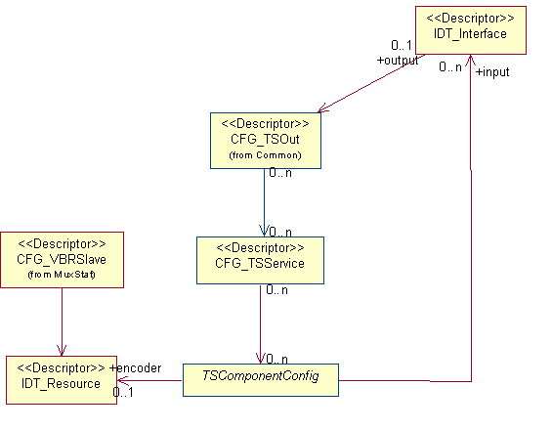
Figure 27 : Ident/Config relations

ViBE Encoder configuration
Implementation model for a ViBE encoder configuration :
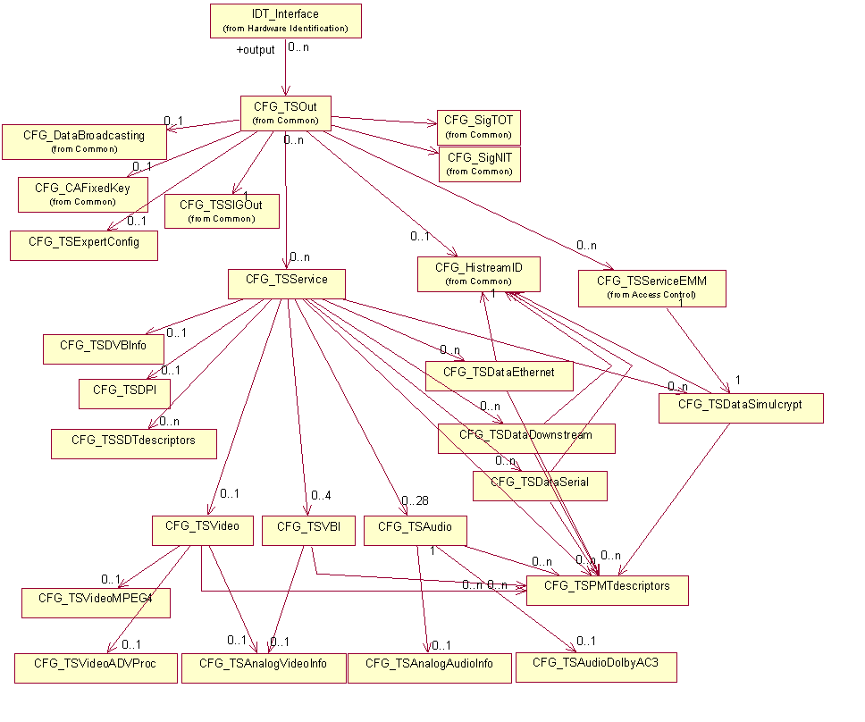
Figure 28 : ViBE Encoder configuration

MuxStat
MuxStat controller view :
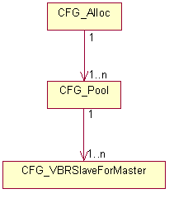
Figure 29 : MuxStat

RemoteFlextream
Remote Flextream controller view :
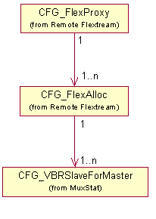
Figure 30 : RemoteFlextream

Access Control
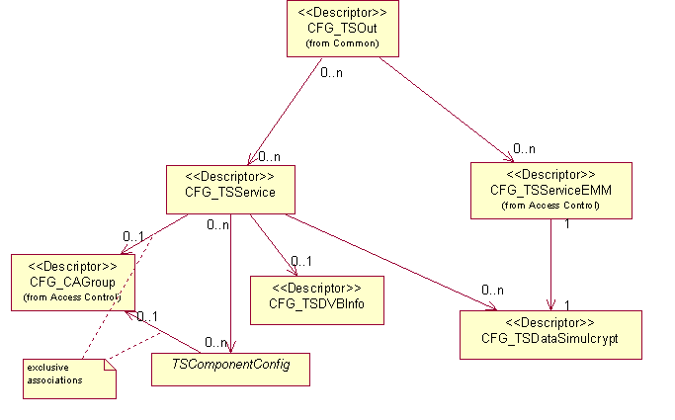
Figure 31 : Access Control

IP config
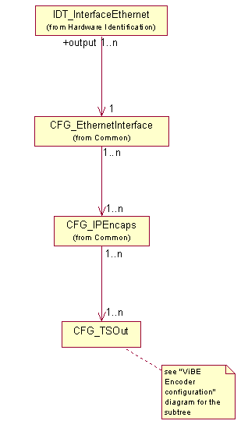
Figure 32 : IP config

Encoder example
Example of an encoder configuration :
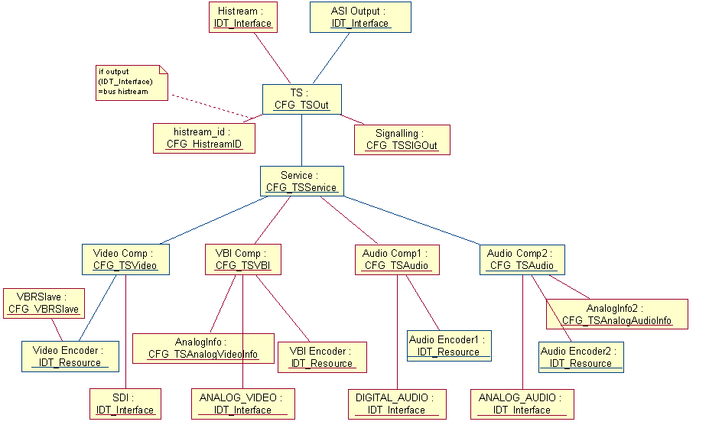
Figure 33 : Encoder example

Encoder function default configuration
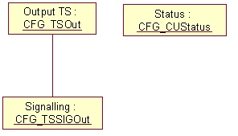
Figure 34 : Encoder function default configuration

Encoder Descriptors

Descriptor CFG_TSService
CFG_TSService_descriptor()
{
descriptor_header (type = NCCPD_DESC_CFG_TSSERVICE, version = 4) byte[8]

service_id byte[2]
service_name hbyte[1+n]
service_status byte[1]
PMT_PID byte[2]
PCR_PID byte[2]
PCR_occurence byte[1]
LTW_occurence byte[1]
encoder_LTW_offset byte[2]
PSIP_major_number byte[1]
PSIP_minor_number byte[2]
TEMI_PID byte[2]
}

service_id Gives the DVB service_id and ISO program_number information.
This id is set to 0 for "ghost service" grouping together all the ghost components.
(default value = 1)

service_name Name of the service.
This name is set to "PHANTOM service" for "ghost service" grouping together all the ghost components.
(default value = "")

service_status Possible values :
- ENU_ON_AIR (the service is generated)
- ENU_OFF_AIR (the service is only described in the SDT, there is no reference for this service in the PAT nor in any PMT)
(default value = ENU_ON_AIR)

PMT_PID PID used for PMT associated with the service.
This PID is set to 0 for "ghost service" grouping together all the ghost components.
(default value = 257)

PCR_PID PID carrying the PCR.
Possible values :
- ENU_NO_PCR (no PCR is associated with the service)
- equal to a PID used by a component of the service : the PCR is associated with the component
- equal to another PID : the PCR is broadcast by a component with this PID
(default value = ENU_NO_PCR)

PCR_occurence Possible values :
- ENU_20_REPETITION_RATE
- ENU_40_REPETITION_RATE
- ENU_50_REPETITION_RATE
- ENU_100_REPETITION_RATE
(default value = ENU_40_REPETITION_RATE)

LTW_occurence Possible values :
- ENU_20_REPETITION_RATE
- ENU_40_REPETITION_RATE
- ENU_50_REPETITION_RATE
- ENU_100_REPETITION_RATE
(default value = ENU_40_REPETITION_RATE)

encoder_LTW_offset Possible values :
- from ENU_MIN_LTW_OFFSET (0) to ENU_MAX_LTW_OFFSET (32767)
(default value = ENU_MIN_LTW_OFFSET)
PSIP_major_number Possible values :
- from ENU_PSIP_MAJOR_NUMBER_MIN (1) to ENU_PSIP_MAJOR_NUMBER_MAX (99)
(default value = ENU_PSIP_MAJOR_NUMBER_MIN)
PSIP_minor_number Possible values :
- from ENU_PSIP_MINOR_NUMBER_MIN (1) to ENU_PSIP_MINOR_NUMBER_MAX (999)
(default value = ENU_PSIP_MINOR_NUMBER_MIN)

TEMI_PID Possible values :
- ENU_PID_NONE (0)
- from 32 to 8190
(default value = ENU_PID_NONE)

Descriptor CFG_TSDVBInfo
CFG_TSDVBInfo_descriptor()
{
descriptor_header (type = NCCPD_DESC_CFG_TSDVBINFO, version = 2) byte[8]

service_type byte[1]
service_provider_name hbyte[1+n]
EIT_schedule_flag byte[1]
EIT_present_following_flag byte[1]
running_status byte[1]
}
service_type Service type : Video, Audio, Data, Ghost.
Possible values :
- ENU_DIGITAL_TELEVISION_SERVICE
- ENU_DIGITAL_RADIO_SOUND_SERVICE
- ENU_TELETEXT_SERVICE
- ENU_NVOD_REFERENCE_SERVICE
- ENU_NVOD_TIME_SHIFTED_SERVICE
- ENU_MOSAIC_SERVICE
- ENU_PAL_CODED_SIGNAL
- ENU_SECAM_CODED_SIGNAL
- ENU_D_D2_MAC
- ENU_FM_RADIO
- ENU_NTSC_CODED_SIGNAL
- ENU_SRV
- ENU_NO_SERVICE_TYPE
- ENU_EMM
- ENU_FIRST_USER_DEFINED_SERVICE
- ENU_LAST_USER_DEFINED_SERVICE
- ENU_ADVANCED_CODEC_HD_SERVICE
- ENU_HEVC_DIGITAL_TELEVISION_SERVICE
(default value = ENU_DIGITAL_TELEVISION_SERVICE)

service_provider_name Provider name.
(default value = "")

EIT_schedule_flag SDT EIT_schedule_flag value.
Possible values :
- ENU_ON
- ENU_OFF
(default value = ENU_OFF)

EIT_present_following_flag SDT EIT_present_following_flag value.
Possible values :
- ENU_ON
- ENU_OFF
(default value = ENU_ON)

running_status SDT 'running_status' value (see ETS 300 468).
Possible values :
- ENU_UNDEFINED
- ENU_NOT_RUNNING
- ENU_STARTS_IN_FEW_SECONDS
- ENU_PAUSING
- ENU_RUNNING
(default value = ENU_RUNNING)

Descriptor CFG_TSVideo
Description of a video component.
CFG_TSVideo_descriptor()
{
descriptor_header (type = NCCPD_DESC_CFG_TSVIDEO, version = 2) byte[8]

PID byte[2]
status byte[1]

video_profile byte[1]
synchronizer_mode byte[1]
frequency_area byte[1]
aspect_ratio byte[1]
resolution byte[1]
film_mode byte[1]
picture_structure byte[1]
DC_precision_code byte[1]
IP_frame byte[1]
GOP_size byte[1]
closed_GOP_mode byte[1]
adaptativ_GOP byte[1]
encoder_bit_rate byte[4]
vbv_leak_mode byte[1]
low_delay_mode byte[1]
PES_priority byte[1]
copyright byte[1]
original_or_copy byte[1]
PCR_insertion byte[1]
LTW_insertion byte[1]
VITC_nb_lines byte[1]
VITC_type byte[1]
VITC_no_line1 byte[2]
VITC_no_line2 byte[2]
caption_nb_even_lines byte[1]
caption_even_no_line1 byte[2]
caption_even_no_line2 byte[2]
caption_nb_odd_lines byte[1]
caption_odd_no_line1 byte[2]
caption_odd_no_line2 byte[2]
quantification_MB_adjust byte[1]
default_pattern byte[1]
}
PID TS component PID.
(default value = 0x100)

status Indicates if the component is actually broadcast or not.
Possible values :
- ENU_ON_AIR (the component is actually broadcast)
- ENU_OFF_AIR (the component is stopped)
(default value = ENU_ON_AIR)

video_profile Possible values :
- ENU_420_MP_ML
- ENU_422_ML
- ENU_MPL3
(default value = ENU_420_MP_ML)

synchronizer_mode (new parameter)
Unused in the current version.
(default value = 0)

frequency_area Possible values :
- ENU_50HZ_AREA
- ENU_60HZ_AREA
- ENU_AUTOMATIC_DETECTION
(default value = ENU_50HZ_AREA)

aspect_ratio Gives the aspect ratio of the image.
Possible values :
- ENU_4_3_FORMAT
- ENU_16_9_FORMAT
- ENU_4_3_AUTOMATIC_WSS (with a default 4/3 mode)
- ENU_16_9_AUTOMATIC_WSS (with a default 16/9 mode)
- ENU_4_3_AUTOMATIC_AFD (with a default 4/3 mode)
- ENU_16_9_AUTOMATIC_AFD (with a default 16/9 mode)
(default value = ENU_4_3_FORMAT)

resolution (enc_format in 2G)
(TBC)
Possible values :
- ENU_ENC_FORMAT_H11P_V11
- ENU_ENC_FORMAT_H11M_V11
- ENU_ENC_FORMAT_H34P_V11
- ENU_ENC_FORMAT_H23P_V11
- ENU_ENC_FORMAT_H12M_V11
- ENU_ENC_FORMAT_H12M_V12
- ENU_ENC_FORMAT_AUTO
- ENU_ENC_FORMAT_H34M_V11
(default value = ENU_ENC_FORMAT_H11P_V11)

film_mode Possible values :
- ENU_VIDEO_MODE
- ENU_AUTOMATIC_MODE
(default value = ENU_VIDEO_MODE)

picture_structure (new parameter)
(TBC)
Possible values :
- ENU_VID_FIELD_CODING
- ENU_VID_FRAME_CODING
- ENU_VID_AUTO_PICT_STRUCT
(default value = ENU_VID_FRAME_CODING)

DC_precision_code Possible values :
- ENU_8_BITS
- ENU_9_BITS
- ENU_10_BITS
(default value = ENU_8_BITS)

IP_frame Gives the image number between two I or P images.
Possible values :
- from ENU_MIN_IP_FRAME to ENU_DMH_MAX_IP_FRAME
(default value = ENU_MAX_IP_FRAME)

GOP_size Gives the image number between two I images.
Possible values :
- from ENU_MIN_GOP_SIZE to ENU_MAX_GOP_SIZE
(default value = 12)

closed_GOP_mode Possible values :
- ENU_ON (GOP is closed)
- ENU_OFF (GOP is open)
(default value = ENU_OFF)

adaptativ_GOP Possible values :
- ENU_AGM_DISABLED (disabled)
- ENU_AGM_RESTRICTED (restrictive adaptative GOP)
- ENU_AGM_FULL (full adaptive GOP)
(default value = ENU_AGM_DISABLED)

encoder_bit_rate In bits/sec.
Possible values :
- from MIN_DMH_VIDEO_ENCODER_BITRATE (0.2 Mbits/s) to MAX_VIDEO_ENCODER_BITRATE (15 Mbits/s) if video_profile = ENU_420_MP_ML
- from MIN_DMH_VIDEO_ENCODER_BITRATE (0.2 Mbits/s) to MAX_422_VIDEO_ENCODER_BITRATE (50 Mbits/s) if video_profile = ENU_422_ML
- from MIN_DMH_VIDEO_H264_ENCODER_BITRATE (0.2 Mbits/s) to MAX_DMH_VIDEO_H264_ENCODER_BITRATE (6 Mbits/s) if video_profile = ENU_MPL3
(default value = 4000000)

vbv_leak_mode (in CBP in 2G)
Possible values :
- ENU_VBV_MODE
- ENU_LEAK_MODE
(default value = ENU_LEAK_MODE)

low_delay_mode Possible values :
- ENU_NORMAL_DELAY
- ENU_LOW_DELAY
- ENU_ULTRA_LOW_DELAY
- ENU_LONG_DELAY
(default value = ENU_NORMAL_DELAY)

PES_priority Possible values :
- ENU_PES_WITH_PRIORITY
- ENU_PES_WITHOUT_PRIORITY
(default value = ENU_PES_WITH_PRIORITY)

copyright Possible values :
- ENU_COPYRIGHT_NOT_PROTECTED
- ENU_COPYRIGHT_PROTECTED
(default value = ENU_COPYRIGHT_PROTECTED)

original_or_copy Possible values :
- ENU_PES_ORIGINAL
- ENU_PES_COPY
(default value = ENU_PES_ORIGINAL)

PCR_insertion Indicates if a PCR must be inserted in the video stream.
Possible values :
- ENU_ON (a PCR must be inserted)
- ENU_OFF (no PCR must be inserted)
(default value = ENU_OFF)

LTW_insertion Possible values :
- ENU_ON (a LTW must be inserted)
- ENU_OFF (no LTW must be inserted)
(default value = ENU_OFF)

VITC_nb_lines Number of VITC lines (max = 2).
(default value = 0)

VITC_type Possible values :
- ENU_VITC
- ENU_DVITC
(default value = ENU_VITC)

VITC_no_line1 VITC line number.
Possible values in 50Hz :
- from 7 to 22
- from 320 to 335
Possible values in 60Hz :
- from 10 to 21
- from 273 to 284
(default value = 0)

VITC_no_line2 VITC line number.
Possible values in 50Hz :
- from 7 to 22
- from 320 to 335
Possible values in 60Hz :
- from 10 to 21
- from 273 to 284
(default value = 0)

caption_nb_even_lines Number of Closed Caption even lines (max = 2).
(default value = 0)

caption_even_no_line1 Closed Caption even line number.
Possible values in 50Hz :
- from 7 to 22
Possible values in 60Hz :
- from 10 to 21
(default value = 0)

caption_even_no_line2 Closed Caption even line number.
Possible values in 50Hz :
- from 7 to 22
Possible values in 60Hz :
- from 10 to 21
(default value = 0)

caption_nb_odd_lines Number of Closed Caption odd lines (max = 2).
(default value = 0)

caption_odd_no_line1 Closed Caption odd line number.
Possible values in 50Hz :
- from 320 to 335
Possible values in 60Hz :
- from 273 to 284
(default value = 0)

caption_odd_no_line2 Closed Caption odd line number.
Possible values in 50Hz :
- from 320 to 335
Possible values in 60Hz :
- from 273 to 284
(default value = 0)

quantification_MB_adjust Indicates if the local adjustment for macro blocks quantification must be used or not.
Possible values :
- ENU_OFF (local quantification MB adjustment is disabled)
- ENU_ON (local quantification MB adjustment is enabled)
(default value = ENU_OFF)

default_pattern Possible values :
- ENU_DMH_VID_BLACK_PATTERN
- ENU_DMH_VID_BAR_PATTERN
- ENU_DMH_VID_CUSTOM_PATTERN
(default value = ENU_DMH_VID_BAR_PATTERN)

Descriptor CFG_TSAudio
Description of an audio component.
CFG_TSAudio_descriptor()
{
descriptor_header (type = NCCPD_DESC_CFG_TSAUDIO, version = 18) byte[8]

PID byte[2]
status byte[1]

audio_group byte[1]
audio_channel byte[1]
audio_standard byte[1]
additional_delay sbyte[2]
PES_priority byte[1]
copyright byte[1]
original_or_copy byte[1]
PCR_insertion byte[1]
LTW_insertion byte[1]
encoder_bit_rate byte[4]
automatic_type_mode byte[1]
packet_CRC_flag byte[1]
emphasis byte[1]
audio_type byte[1]
AAC_profile byte[1]
AAC_packet byte[1]
dolby_E_program_number byte[1]
alarm_saturation byte[1]
detected_silence byte[2]
static_gain sbyte[2]
auto_sensing_mode byte[1]
frequency_area byte[1]
static_gain_right sbyte[2]
dolbyE_autoswitch_mode byte[1]
audio_description byte[1]
AD_null_packets byte[1]
autoswitch_mode byte[1]
video_frame_sync byte[1]
radio_latency byte[1]
AAC_SBRsignaling byte[1]
one_frame_per_PES byte[1]
legacy_AAC_packetization byte[1]
audio_decoding_format byte[1]
decoding_compression_mode byte[1]
}
PID TS component PID.
(default value = 0x102)

status Indicates if the component is actually broadcast or not.
Possible values :
- ENU_ON_AIR (the component is actually broadcast)
- ENU_OFF_AIR (the component is stopped)
(default value = ENU_ON_AIR)

audio_group Possible values :
- ENU_GROUP1
- ENU_GROUP2
- ENU_GROUP3
- ENU_GROUP4
(default value = ENU_GROUP1)

audio_channel (new parameter, linked with audio_group in 2G)
Possible values :
- ENU_CHANNEL1
- ENU_CHANNEL2
(default value = ENU_CHANNEL1)

audio_standard Indicates the audio encoder standard.
Possible values :
- ENU_AUD_MPEG1_LAYERII
- ENU_AUD_EXTERNAL_AC3
- ENU_AUD_TRANSPARENT
- ENU_AUD_UNCOMPRESSED
- ENU_AUD_DOLBY_AC3
- ENU_AUD_MPEG4_AAC (AAC Audio 13818-7)
- ENU_AUD_MPEG2_AAC (AAC Audio 14496-3)
- ENU_AUD_EXTERNAL_AAC
- ENU_AUD_ARIB_B24
- ENU_AUD_DOLBY_AC3_PLUS
- ENU_AUD_EXTERNAL_AC3_PLUS
- ENU_AUD_MPEG4_DOLBY_PULSE
- ENU_AUD_MPEG2_DOLBY_PULSE
- ENU_AUD_EXTERNAL_AC3_TO_AC3_PLUS (AC-3 to E-AC 3 transcoding external source)
- ENU_AUD_DOLBY_AC4
- ENU_AUD_EXTERNAL_AC4
- ENU_AUD_EXTERNAL_AC3_TO_AC3
- ENU_AUD_EXTERNAL_AC3_PLUS_TO_AC3
- ENU_AUD_EXTERNAL_AC3_TO_MPEG
- ENU_AUD_EXTERNAL_AC3_PLUS_TO_MPEG
(default value = ENU_AUD_MPEG1_LAYERII)

additional_delay Gives in ms an additional delay for the audio component. The value must be signed.
The value depends on audio_standard (from CFG_TSAudio) and low_delay_mode (from CFG_TSVideo).
Possible values :
- if audio_standard = ENU_AUD_MPEG1_LAYERII :
- if low_delay_mode = ENU_NORMAL_DELAY or ENU_LOW_DELAY : from -50 to 50
- if low_delay_mode = ENU_ULTRA_LOW_DELAY : from 0 to 50
- if audio_standard = ENU_AUD_TRANSPARENT or ENU_AUD_UNCOMPRESSED :
- if low_delay_mode = ENU_NORMAL_DELAY or ENU_LOW_DELAY : from -250 to 50
- if low_delay_mode = ENU_ULTRA_LOW_DELAY : from -100 to 50
- if audio_standard = ENU_AUD_EXTERNAL_AC3 :
- if low_delay_mode = ENU_NORMAL_DELAY : from -250 to 50
- if low_delay_mode = ENU_LOW_DELAY : from -125 to 50
- if low_delay_mode = ENU_ULTRA_LOW_DELAY : from 0 to 50
(default value = 0)

PES_priority (Not used)
Possible values :
- ENU_PES_WITH_PRIORITY
- ENU_PES_WITHOUT_PRIORITY
(default value = ENU_PES_WITHOUT_PRIORITY)

copyright Possible values :
- ENU_COPYRIGHT_NOT_PROTECTED
- ENU_COPYRIGHT_PROTECTED
- ENU_COPYRIGHT_TRANSPARENT (only for encoders with extended_type (in IDT_Resource descriptor) set to ENU_AUDIO_EXTERNAL_AC3)
(default value = ENU_COPYRIGHT_PROTECTED)

original_or_copy Possible values :
- ENU_PES_ORIGINAL
- ENU_PES_COPY
(default value = ENU_PES_ORIGINAL)

PCR_insertion Indicates if a PCR must be inserted in the audio stream.
Possible values :
- ENU_ON (a PCR must be inserted)
- ENU_OFF (no PCR must be inserted)
(default value = ENU_OFF)

LTW_insertion Possible values :
- ENU_ON (a LTW must be inserted)
- ENU_OFF (no LTW must be inserted)
(default value = ENU_OFF)

encoder_bit_rate Possible values for ENU_AUD_MPEG1_LAYERII :
- ENU_32_KBITS_S
- ENU_48_KBITS
- ENU_56_KBITS
- ENU_64_KBITS_S
- ENU_80_KBITS
- ENU_96_KBITS_S
- ENU_112_KBITS
- ENU_128_KBITS_S
- ENU_160_KBITS
- ENU_192_KBITS_S
- ENU_224_KBITS
- ENU_256_KBITS_S
- ENU_320_KBITS
- ENU_384_KBITS_S
Possible values for ENU_AUD_TRANSPARENT :
- ENU_AUD_TRANSPARENT_16BITS
- ENU_AUD_TRANSPARENT_20BITS
- ENU_AUD_TRANSPARENT_24BITS
Possible values for ENU_AUD_EXTERNAL_AC3 :
- ENU_32_KBITS_S
- ENU_40_KBITS
- ENU_48_KBITS
- ENU_56_KBITS
- ENU_64_KBITS_S
- ENU_80_KBITS
- ENU_96_KBITS_S
- ENU_112_KBITS
- ENU_128_KBITS_S
- ENU_160_KBITS
- ENU_192_KBITS_S
- ENU_224_KBITS
- ENU_256_KBITS_S
- ENU_320_KBITS
- ENU_384_KBITS_S
- ENU_448_KBITS
- ENU_512_KBITS
- ENU_576_KBITS
- ENU_640_KBITS
Possible values for ENU_AUD_AAC :
- ENU_8_KBITS
- ENU_10_KBITS
- ENU_12_KBITS
- ENU_14_KBITS
- ENU_16_KBITS
- ENU_20_KBITS
- ENU_24_KBITS
- ENU_28_KBITS
- ENU_32_KBITS_S
- ENU_40_KBITS
- ENU_48_KBITS
- ENU_56_KBITS
- ENU_64_KBITS_S
- ENU_80_KBITS
- ENU_96_KBITS_S
- ENU_112_KBITS
- ENU_128_KBITS_S
- ENU_144_KBITS
- ENU_160_KBITS
- ENU_192_KBITS_S
- ENU_224_KBITS
- ENU_256_KBITS_S
- ENU_288_KBITS
- ENU_320_KBITS
- ENU_384_KBITS_S
- ENU_448_KBITS
- ENU_480_KBITS
- ENU_512_KBITS
- ENU_576_KBITS
Other values, only possible for ENU_AUD_DOLBY_AC3_PLUS :
- ENU_72_KBITS
- ENU_88_KBITS
- ENU_104_KBITS
- ENU_120_KBITS
- ENU_176_KBITS
- ENU_200_KBITS
- ENU_208_KBITS
- ENU_216_KBITS
- ENU_232_KBITS
- ENU_240_KBITS
- ENU_248_KBITS
- ENU_272_KBITS
- ENU_304_KBITS
- ENU_336_KBITS
- ENU_352_KBITS
- ENU_368_KBITS
- ENU_400_KBITS
- ENU_704_KBITS
- ENU_768_KBITS
- ENU_832_KBITS
- ENU_896_KBITS
- ENU_960_KBITS
- ENU_1024_KBITS
- ENU_1088_KBITS
- ENU_1152_KBITS
- ENU_1216_KBITS
- ENU_1280_KBITS
- ENU_1344_KBITS
- ENU_1408_KBITS
- ENU_1472_KBITS
- ENU_1532_KBITS
(default value = ENU_128_KBITS_S)

automatic_type_mode Indicates if VPS must be taken into account for audio type configuration.
Possible values :
- ENU_OFF
- ENU_ON
(default value = ENU_OFF)

packet_CRC_flag Indicates the PES packet CRC state.
Possible values :
- ENU_PES_WITHOUT_CRC
- ENU_PES_WITH_CRC
(default value = ENU_PES_WITH_CRC)

emphasis Musicam header field.
Possible values :
- ENU_PES_WITHOUT_EMPHASIS
- ENU_PES_EMPHASIS_50_15
- ENU_PES_EMPHASIS_J17
(default value = ENU_PES_WITHOUT_EMPHASIS)

audio_type Audio encoding mode.
Possible values :
- ENU_DUAL_CHANNEL
- ENU_STEREO
- ENU_JOINT_STEREO
- ENU_MONO_LEFT (equivalent to ENU_SINGLE_CHANNEL)
- ENU_MONO_RIGHT
- ENU_5_1
- ENU_7_1
- ENU_FOLLOW_INPUT
- ENU_MONO
(default value = ENU_STEREO)

AAC_profile Indicates the AAC profile.
Possible values :
- ENU_AAC_LC
- ENU_AAC_HE
- ENU_AAC_HE_V2
(default value = ENU_AAC_LC)

AAC_packet Indicates AAC encapsulation.
Possible values :
- ENU_AAC_PACKET_LOAS
- ENU_AAC_PACKET_ADTS
(default value = ENU_AAC_PACKET_LOAS)

dolby_E_program_number Identifies the program selected on Dolby E input.
Possible values :
- from 1 to 8
(default value = 1)

alarm_saturation Indicates if saturation alarm is activated or not.
Possible values :
- ENU_ON
- ENU_OFF
(default value = ENU_OFF)

detected_silence Delay of the detected silence (in seconds).
Possible values :
- from 0 to 60, by step of 2, for EM1000/2000
- from 5 to 90 for ViBE SD Encoder
(default value = 0)
static_gain Indicates the static gain to be applied on the audio. This attribute is signed. The unit is 0.1 dB (value 10 = 1 dB). The step is 0.5 dB.
Possible values :
- from -200 (-20.0 dB * 10) to 200 (20.0 dB * 10)
(default value = 0)
auto_sensing_mode Indicates if the auto sensing mode is enabled on the external input signal.
Only significant when an external AC3 signal is transcoded to an E-AC3 signal.
Possible values :
- ENU_ON
- ENU_OFF
(default value = ENU_OFF)
frequency_area Possible values :
- ENU_50HZ_AREA
- ENU_60HZ_AREA
(default value = ENU_50HZ_AREA)
static_gain_right Indicates the static gain to be applied on the audio/right. This attribute is signed. The unit is 0.1 dB (value 10 = 1 dB). The step is 0.5 dB.
Possible values :
- from -200 (-20.0 dB * 10) to 200 (20.0 dB * 10)
(default value = 0)
dolbyE_autoswitch_mode Indicates if the DolbyE auto switch mode is enabled.
Only significant for DE to AC3/E-AC3 encoding.
Possible values :
- ENU_ON
- ENU_OFF
(default value = ENU_OFF)
audio_description Indicates if the component is used for Audio description feature.
When enabled, a supplementary_audio_descriptor() is inserted with mix_type=0 (audio stream is a supplementary stream).
Possible values :
- ENU_ON
- ENU_OFF
(default value = ENU_OFF)
AD_null_packets For an Audio description component, this parameter controls the TS output if no AD control signal.
Possible values :
- ENU_ON (no output TS packets when no AD control signal (null packets replace the audio packets))
- ENU_OFF (output TS packets when no AD control signal)
(default value = ENU_OFF)
- ENU_AUTOMATIC_MODE
autoswitch_mode Indicates if the auto switch mode is enabled.
Possible values :
- ENU_ON
- ENU_OFF
(default value = ENU_OFF)
video_frame_sync Indicates if PES packetizer is locked on incoming Interlaced Video Frame Start and Rate (ENU_ON) or is in free running mode (ENU_OFF).
Possible values :
- ENU_ON
- ENU_OFF
(default value = ENU_OFF)
radio_latency Indicates if the radio component shall be synchronized with the video component of the A/V service.
Possible values :
- ENU_LATENCY_VIDEO
- ENU_LATENCY_MINIMUM
(default value = ENU_LATENCY_VIDEO)
AAC_SBRsignaling SBR signalling mode.
Possible values :
- ENU_AUD_AAC_SBRSIG_IMPLICIT
- ENU_AUD_AAC_SBRSIG_EXPLICIT_BC
- ENU_AUD_AAC_SBRSIG_EXPLICIT_NBC
(default value = ENU_AUD_AAC_SBRSIG_IMPLICIT)
one_frame_per_PES Possible values :
- ENU_ON
- ENU_OFF
(default value = ENU_OFF)
legacy_AAC_packetization Possible values :
- ENU_ON
- ENU_OFF
(default value = ENU_OFF)
audio_decoding_format Possible values :
- ENU_AUD_DEC_AUTO
- ENU_AUD_DEC_AAC_LC
- ENU_AUD_DEC_AAC_HE
- ENU_AUD_DEC_AAC_HEV2
- ENU_AUD_DEC_MPEG1L2
- ENU_AUD_DEC_AC3
- ENU_AUD_DEC_AC3_PLUS
(default value = ENU_AUD_DEC_AUTO)
decoding_compression_mode Possible values :
- ENU_AUD_DEC_COMPRESSION_NONE
- ENU_AUD_DEC_COMPRESSION_LINE
- ENU_AUD_DEC_COMPRESSION_RF
(default value = ENU_AUD_DEC_COMPRESSION_NONE)

Descriptor CFG_TSVBI
Description of a VBI component.
CFG_TSVBI_descriptor()
{
descriptor_header (type = NCCPD_DESC_CFG_TSVBI, version = 8) byte[8]

PID byte[2]
status byte[1]

frequency_area byte[1]
VBI_encoder_reference byte[1]
data_identifier byte[1]
nb_lines byte[2]
for (i = 1 ; i <= nb_lines)
{
VBI_type byte[1]

line byte[2]

}
VBI_missing byte[1]
SMPTE2031 byte[1]
SMPTE2031_filtering byte[4]
max_bitrate byte[4]
additional_delay sbyte[2]
max_lines_transmitted byte[1]
no_teletext byte[1]
VBI_type_downscale byte[1]
livesub_status byte[1]
livesub_mode byte[1]
livesub_delay byte[2]
livesub_alarm byte[1]

}
PID TS component PID.
(default value = 0x106)

status Indicates if the component is actually broadcast or not.
Possible values :
- ENU_ON_AIR (the component is actually broadcast)
- ENU_OFF_AIR (the component is stopped)
(default value = ENU_ON_AIR)

frequency_area Possible values :
- ENU_50HZ_AREA
- ENU_60HZ_AREA
- ENU_AUTOMATIC_DETECTION
(default value = ENU_50HZ_AREA)

VBI_encoder_reference Possible values :
- ENU_VBI_A_CODER
- ENU_VBI_B_CODER
- ENU_VBI_C_CODER
- ENU_VBI_D_CODER
(default value = ENU_VBI_A_CODER)

data_identifier Possible values :
- from 0x10 to 0x1F
- from 0x90 to 0x9B
(default value = 0x10)

nb_lines The maximum nb_lines is MAX_LINES_NUMBER.
(default value = 0)

VBI_type Possible values :
- ENU_TELETEXT_B_MAGAZINE (magazine)
- ENU_TELETEXT_B_SUBTITLE (subtitling)
- ENU_TELETEXT_B_AUTO (automatic magazine/subtitle selection mode)
- ENU_VPS (VPS data (only with line 16))
- ENU_WSS (WSS data (only with line 23))
- ENU_VBI_VITC
- ENU_VBI_VITS
- ENU_VBI_TRANSPARENT (transparent line)
- ENU_VBI_TEST_LINE (transparent test line)
- ENU_VBI_AMOL_1_2_LINE (Amol 1 & 2)
- ENU_VBI_GEMSTAR_2X_LINE (Gemstar TVGuide 2x)
- ENU_VBI_NABTS_LINE
(default value = ENU_TELETEXT_B_MAGAZINE)

line Possible values in 50Hz :
- from 7 to 22
- from 320 to 335
Possible values in 60Hz :
- from 10 to 22
- from 273 to 285
(default value = 0)
VBI_missing Delay for VBI missing alarm (in seconds).
Possible values :
- from 0 to 90 for ViBE SD Encoder
- ENU_EM_VBI_DISABLE_ALARM (255)
(default value = 0)
SMPTE2031 Possible values :
- ENU_ON
- ENU_OFF
(default value = ENU_OFF)
SMPTE2031_filtering Mask of filtered lines.
(default value = 0)
max_bitrate Max bitrate in bits/s.
(default value = 0)
additional_delay Gives in ms an additional delay for the teletext component. The value must be signed.
Possible values :
- from -500 to 500
(default value = 0)
max_lines_transmitted Max number of VBI lines for TS input.
Possible values :
- from 0 to 32
(default value = 0)
no_teletext Possible values :
- ENU_NO_TXT_PID_MISSING
- ENU_NO_TXT_PID_WITH_STUFFING
(default value = ENU_NO_TXT_PID_MISSING)
VBI_type_downscale Indicates VBI type, in case of HD to SD downscaling.
Possible values :
- ENU_VBI_HD_TELETEXT (incoming VBI data OP47)
- ENU_VBI_HD_TELETEXT_SMPTE_2031 (incoming VBI data SMPTE2031)
(default value = ENU_VBI_HD_TELETEXT)
livesub_status Possible values :
- ENU_ON
- ENU_OFF
livesub_mode Possible values :
- ENU_DVBSUB_LIVESUB_STATIC
- ENU_DVBSUB_LIVESUB_SCTE104_FORCED
- ENU_DVBSUB_LIVESUB_DYNAMIC
livesub _delay Compensation delay in ms.
(default value = 3000)
livesub _alarm Delay for SCTE104 missing alarm (in seconds).
Possible values :
- from 0 to 90
- ENU_EM_VBI_DISABLE_ALARM (255)
(default value = 0)

Descriptor CFG_TSAnalogVideoInfo
CFG_TSAnalogVideoInfo_descriptor()
{
descriptor_header (type = NCCPD_DESC_CFG_TSANALOGVIDEOINFO, version = 1) byte[8]

analog_standard byte[1]
analog_in_VBI_transparency byte[1]
analog_in_composite_mode byte[1]
analog_in_filtering byte[1]
analog_in_NTSC_pedestal byte[1]
analog_in_external_reference_synchro byte[1]
analog_macrovision byte[1]
}

analog_standard Defines the analog standard.
Possible values :
- ENU_DMH_VID_PAL_BDGHI (composite video source PAL_B,G,D,H,I (625 lines only))
- ENU_DMH_VID_SECAM (composite video source SECAM (625 lines only))
- ENU_DMH_VID_NTSC_M (composite video source NTSC_M (525 lines only))
- ENU_DMH_VID_PAL_N (composite video source PAL_N (625 lines only))
- ENU_DMH_VID_PAL_M (composite video source PAL_N (525 lines only))
- ENU_DMH_VID_AUTO_PAL_NTSC (automatic PAL_NTSC)
(default value = ENU_DMH_VID_SECAM)

analog_in_VBI_transparency Transparency mode for the VBI lines (not significant for EM configuration).
Possible values :
- ENU_VBI_TRANSPARENCY (the analog interface lets the VBI go through)
- ENU_VBI_FILTERING (the analog interface stops the VBI)
(default value = ENU_VBI_TRANSPARENCY)

analog_in_composite_mode Indicates the composite mode (not significant for EM configuration).
Possible values :
- ENU_MODE_PROFESSIONAL
- ENU_MODE_CONSUMER
(default value = ENU_MODE_PROFESSIONAL)

analog_in_filtering Filtering type.
Possible values :
- ENU_ADAPTATIV_COMB_FILTERING
- ENU_DMH_LINE_COMB_FILTERING
(default value = ENU_ADAPTATIV_COMB_FILTERING)

analog_in_NTSC_pedestal Possible values :
- ENU_NTSC_WITH_PEDESTAL
- ENU_NTSC_WITHOUT_PEDESTAL
(default value = ENU_NTSC_WITH_PEDESTAL)

analog_in_external_reference_synchro (not significant for EM configuration).
Possible values :
- ENU_OFF
- ENU_ON
(default value = ENU_OFF)

analog_macrovision (not significant for EM configuration).
Possible values :
- ENU_OFF (not supported)
- ENU_ON (supported)
(default value = ENU_OFF)

Descriptor CFG_TSAnalogAudioInfo
CFG_TSAnalogAudioInfo_descriptor()
{
descriptor_header (type = NCCPD_DESC_CFG_TSANALOGAUDIOINFO, version = 1) byte[8]

saturation byte[1]
alignment sbyte[1]
}

saturation Saturation level when analog input.
Possible values :
- from ENU_DMH_AUDIO_MIN_HEADROOM (8) to ENU_DMH_AUDIO_MAX_HEADROOM (24).
(default value = 18)

alignment Alignment when analog input. This attribute is signed. The unit is 0.1 dBu (value 10 = 1 dBu). The step is 0.5 dBu.
Possible values :
- from ENU_DMH_AUDIO_OUTPUT_MIN_LEVEL (-6) * 10 to ENU_DMH_AUDIO_OUTPUT_MAX_LEVEL (6) * 10
(default value = 0)

Descriptor CFG_TSAudioDolbyAC3
CFG_TSAudioDolbyAC3_descriptor()
{
descriptor_header (type = NCCPD_DESC_CFG_TSAUDIODOLBYAC3, version = 1) byte[8]

coding_mode byte[1]
bitstream_mode byte[1]
dialogue_norm sbyte[1]
dolby_surround byte[1]
audio_prod_info byte[1]
mixing_level byte[1]
room_type byte[1]
DRC_line_mode byte[1]
DRC_RF_mode byte[1]
DRC_RF_protection byte[1]
lowpass_filter byte[1]
highpass_filter byte[1]
deemphasis_filter byte[1]
}

coding_mode Indicates Dolby Digital encoding mode.
Possible values :
- ENU_CAC3_MONO_LEFT (single left channel)
- ENU_CAC3_MONO_RIGHT (single right channel)
- ENU_CAC3_STEREO (stereo)
- ENU_CAC3_5_1
- ENU_CAC3_7_1
- ENU_FOLLOW_INPUT
- ENU_CAC3_MONO
(default value = ENU_CAC3_STEREO)

bitstream_mode Indicates the type of service.
Possible values :
- ENU_CAC3_MAS_CM (Main audio service : complete main)
- ENU_CAC3_MAS_ME (Main audio service : music and effects)
- ENU_CAC3_AS_VI (Associated service : visually impaired)
- ENU_CAC3_AS_HI (Associated service : hearing impaired)
- ENU_CAC3_AS_D (Associated service : dialogue)
- ENU_CAC3_AS_C (Associated service : commentary)
- ENU_CAC3_AS_E (Associated service : emergency)
- ENU_CAC3_AS_VO (Associated service : voiceover/karaoke)
(default value = ENU_CAC3_MAS_CM)

dialogue_norm Indicates the average dialogue level. This attribute is signed.
Possible values :
- from ENU_CAC3_MIN_DIALOGUE_NORM (-31) to ENU_CAC3_MAX_DIALOGUE_NORM (-1)
(default value = -27)

dolby_surround Indicates if signal is Dolby surround encoded or not.
Possible values :
- ENU_CAC3_DSR_NOT_INDICATED
- ENU_CAC3_DSR_NOT_ENCODED
- ENU_CAC3_DSR_ENCODED
(default value = ENU_CAC3_DSR_NOT_INDICATED)

audio_prod_info Indicates if audio production informations are provided.
Possible values :
- ENU_OFF
- ENU_ON
(default value = ENU_OFF)

mixing_level Indicates the acoustic sound pressure level during final mix.
Possible values :
- from ENU_CAC3_MIN_MIXING_LEVEL (80) to ENU_CAC3_MAX_MIXING_LEVEL (111)
(default value = 105)

room_type Indicates the type of room used for final mixing.
Possible values :
- ENU_CAC3_RT_NOT_INDICATED
- ENU_CAC3_RT_LARGE_ROOM
- ENU_CAC3_RT_SMALL_ROOM
(default value = ENU_CAC3_RT_NOT_INDICATED)

DRC_line_mode Used by Dolby digital decoders to reduce the decoded audio dynamic range.
Possible values :
- ENU_CAC3_DRC_NONE
- ENU_CAC3_DRC_FILM_STANDARD
- ENU_CAC3_DRC_FILM_LIGHT
- ENU_CAC3_DRC_MUSIC_STANDARD
- ENU_CAC3_DRC_MUSIC_LIGHT
- ENU_CAC3_DRC_SPEECH
(default value = ENU_CAC3_DRC_FILM_STANDARD)

DRC_RF_mode Used by Dolby digital decoders to reduce the decoded audio dynamic range.
Possible values :
- ENU_CAC3_DRC_NONE
- ENU_CAC3_DRC_FILM_STANDARD
- ENU_CAC3_DRC_FILM_LIGHT
- ENU_CAC3_DRC_MUSIC_STANDARD
- ENU_CAC3_DRC_MUSIC_LIGHT
- ENU_CAC3_DRC_SPEECH
(default value = ENU_CAC3_DRC_FILM_STANDARD)

DRC_RF_protection Indicates if the RF overmodulation protection filter is active.
Possible values :
- ENU_OFF
- ENU_ON
(default value = ENU_OFF)

lowpass_filter Indicates if the lowpass filter is active.
Possible values :
- ENU_OFF
- ENU_ON
(default value = ENU_ON)

highpass_filter Indicates if the highpass filter is active.
Possible values :
- ENU_OFF
- ENU_ON
(default value = ENU_OFF)

deemphasis_filter Indicates if the de-emphasis filter is active.
Possible values :
- ENU_OFF
- ENU_ON
(default value = ENU_OFF)

Descriptor CFG_TSPMTdescriptors
Describes additional PMT descriptors.
CFG_TSPMTdescriptors_descriptor()
{
descriptor_header (type = NCCPD_DESC_CFG_TSPMTDESCRIPTORS, version = 1) byte[8]

nb_ISO_descriptors byte[1]
for (i = 1 ; i <= nb_ISO_descriptors)
{
descriptor_tag byte[1]

descriptor_length byte[1]

descriptor_body byte[n]

}

}

nb_ISO_descriptors Can be equal to 0.
(default value = 0)

descriptor_tag Descriptor tag.
(default value = 0)

descriptor_length Descriptor length.
(default value = 0)

descriptor_body Descriptor body.

Descriptor CFG_TSSDTdescriptors
Describes additional SDT descriptors.
CFG_TSSDTdescriptors_descriptor()
{
descriptor_header (type = NCCPD_DESC_CFG_TSSDTDESCRIPTORS, version = 1) byte[8]

nb_DVB_descriptors byte[1]
for (i = 1 ; i <= nb_DVB_descriptors)
{
descriptor_tag byte[1]

descriptor_length byte[1]

descriptor_body byte[n]

}

}

nb_DVB_descriptors Can be equal to 0.
(default value = 0)

descriptor_tag Descriptor tag.
(default value = 0)

descriptor_length Descriptor length.
(default value = 0)

descriptor_body Descriptor body.

Descriptor CFG_TSExpertConfig
This descriptor is used for specific configurations (for interoperability with other devices).
CFG_TSExpertConfig_descriptor()
{
descriptor_header (type = NCCPD_DESC_CFG_TSEXPERTCONFIG, version = 3) byte[8]

video_param byte[4]
audio_param byte[4]
VBI_param byte[4]
DVBSub_param byte[4]
video_ext_param byte[4]
}

video_param Bits field used for specific configuration for video.
(default value = 0)

audio_param Bits field used for specific configuration for audio.
(default value = 0)

VBI_param Bits field used for specific configuration for VBI.
(default value = 0)
DVBSub_param Bits field used for specific configuration for DVBSubtitle.
(default value = 0)
video_ext_param Additional bits field used for specific configuration for video.
(default value = 0)

Descriptor CFG_TSVideoADVProc
CFG_TSVideoADVProc_descriptor()
{
descriptor_header (type = NCCPD_DESC_CFG_TSVIDEOADVPROC, version = 3) byte[8]

RDB_demo_mode byte[1]
RDB_status byte[1]
RDB_level byte[1]
ADD_status byte[1]
ADD_level byte[1]
FBD_status byte[1]
FBD_level byte[1]
ultra_low_delay byte[1]
video_commutation byte[1]
RDB_clamp byte[1]
FBD_temporal_status byte[1]
FBD_temporal_level byte[1]
}

RDB_demo_mode Noise reduction mode.
Possible values :
- ENU_PICTURE_NOISE_REDUCTION (the noise reduction deals with all the picture)
- ENU_VERTICAL_NOISE_REDUCTION (the noise reduction deals with the right part)
- ENU_HORIZONTAL_NOISE_REDUCTION (the noise reduction deals with the upper part)
(default value = ENU_PICTURE_NOISE_REDUCTION)

RDB_status Indicates if the noise reduction function must be used or not.
Possible values :
- ENU_WITHOUT_NOISE_REDUCTION (the noise reduction function is disabled)
- ENU_WITH_NOISE_REDUCTION (the noise reduction function is enabled)
(default value = ENU_WITHOUT_NOISE_REDUCTION)

RDB_level Possible values :
- from ENU_NOISE_REDUCTION_LEVEL_MIN to ENU_DMH_NOISE_REDUCTION_LEVEL_MAX
(default value = ENU_NOISE_REDUCTION_LEVEL_MIN)

ADD_status Indicates if the definition reduction function must be used or not.
Possible values :
- ENU_WITHOUT_RDD (the definition reduction function is disabled)
- ENU_WITH_RDD_WITH_BORDER (the definition reduction function is enabled with level adjustment)
- ENU_WITH_RDD_WITHOUT_BORDER (the definition reduction function is enabled with level adjustment and border are suppressed)
- ENU_DMH_AUTOMATIC_RDD_WITH_BORDER (the definition reduction function is enabled with automatic level)
- ENU_DMH_AUTOMATIC_RDD_WITHOUT_BORDER (the definition reduction function is enabled with automatic level and border are suppressed)
(default value = ENU_WITHOUT_RDD)

ADD_level Definition reduction level.
Possible values :
- from ENU_DEFINITION_REDUCTION_LEVEL_MIN to ENU_DMH_DEFINITION_REDUCTION_LEVEL_MAX
(default value = ENU_DEFINITION_REDUCTION_LEVEL_MIN)

FBD_status Indicates if the spatial entropy shaping function must be used or not.
Possible values :
- ENU_DMH_WITHOUT_ENTROPY (the spatial entropy shaping function is disabled)
- ENU_DMH_WITH_ENTROPY (the spatial entropy shaping function is enabled with level adjustment)
- ENU_DMH_AUTOMATIC_ENTROPY (the spatial entropy shaping function is enabled with automatic level)
(default value = ENU_DMH_WITHOUT_ENTROPY)

FBD_level Possible values :
- from ENU_DMH_SPATIAL_ENTROPY_LEVEL_MIN to ENU_DMH_SPATIAL_ENTROPY_LEVEL_MAX
(default value = ENU_DMH_SPATIAL_ENTROPY_LEVEL_MIN)

ultra_low_delay Possible values :
- ENU_ADV_NORMAL_MODE (preprocessing in normal mode)
- ENU_ADV_ULTRA_LOW_DELAY_MODE (preprocessing in " degraded " mode)
(default value = ENU_ADV_NORMAL_MODE)

video_commutation Possible values :
- ENU_ON (commutation is enabled)
- ENU_OFF (commutation is disabled)
(default value = ENU_ON)

RDB_clamp Indicates the limitation of the noise reduction level .
Possible values :
- ENU_RDB_CLAMP_LOW
- ENU_RDB_CLAMP_MEDIUM
- ENU_RDB_CLAMP_HIGH
(default value = ENU_RDB_CLAMP_LOW)

FBD_temporal_status Indicates if the temporal entropy shaping function must be used or not.
Possible values :
- ENU_DMH_WITHOUT_ENTROPY (the temporal entropy shaping function is disabled)
- ENU_DMH_WITH_ENTROPY (the temporal entropy shaping function is enabled with level adjustment)
- ENU_DMH_AUTOMATIC_ENTROPY (the temporal entropy shaping function is enabled with automatic level)
(default value = ENU_DMH_WITHOUT_ENTROPY)

FBD_temporal_level Possible values :
- from ENU_DMH_TEMPORAL_ENTROPY_LEVEL_MIN to ENU_DMH_TEMPORAL_ENTROPY_LEVEL_MAX
(default value = ENU_DMH_TEMPORAL_ENTROPY_LEVEL_MIN)

Descriptor CFG_TSVideoMPEG4
CFG_TSVideoMPEG4_descriptor()
{
descriptor_header (type = NCCPD_DESC_CFG_TSVIDEOMPEG4, version = 2) byte[8]

entropy_coding byte[1]
deblocking_filter byte[1]
}

entropy_coding Possible values :
- ENU_ENTROPY_CAVLC
- ENU_ENTROPY_CABAC
(default value = ENU_ENTROPY_CABAC)

deblocking_filter Possible values :
- ENU_ON
- ENU_OFF
(default value = ENU_OFF)

Descriptor CFG_TSDataDownstream
Used to configure a data component that is only present in signalling.
CFG_TSDataDownstream_descriptor()
{
descriptor_header (type = NCCPD_DESC_CFG_TSDATADOWNSTREAM, version = 1) byte[8]

PID byte[2]
status byte[1]

maximum_bitrate byte[2]
stream_type byte[1]
}
PID TS component PID.
(default value = 0x103)

status Indicates if the component is actually broadcast or not.
Possible values :
- ENU_ON_AIR (the component is actually broadcast)
- ENU_OFF_AIR (the component is stopped)
(default value = ENU_ON_AIR)

maximum_bitrate In packets per second. Used for bit rate reservation.
(default value = 0)

stream_type Stream type used for the PMT generation.
(default value = 0x06)

Descriptor CFG_TSDataEthernet
CFG_TSDataEthernet_descriptor()
{
descriptor_header (type = NCCPD_DESC_CFG_TSDATAETHERNET, version = 3) byte[8]

PID byte[2]
status byte[1]

channel_id byte[1]
minimum_bitrate byte[2]
maximum_bitrate byte[2]
stream_type byte[1]
protocol byte[1]
port_number byte[2]
packet_type byte[1]
}
PID TS component PID.
(default value = 0x103)

status Indicates if the component is actually broadcast or not.
Possible values :
- ENU_ON_AIR (the component is actually broadcast)
- ENU_OFF_AIR (the component is stopped)
(default value = ENU_ON_AIR)

channel_id Logical number, unique value to identify a data without ambiguity.
(default value = 0)

minimum_bitrate In packets per second. Set an alarm if this bit rate is undertaken.
(default value = 0)

maximum_bitrate In packets per second. Used for bit rate reservation and regulation.
(default value = 0)

stream_type Stream type used for the PMT generation.
(default value = 0x05)

protocol Possible values :
- ENU_DMH_ETHERNET_UDP
- ENU_DMH_ETHERNET_TCP
(default value = ENU_DMH_ETHERNET_TCP)

port_number TCP/UDP port number.
(default value = 0)

packet_type Possible values :
- ENU_DVB_PACKETIZED188
- ENU_DVB_PACKETIZED204
(default value = ENU_DVB_PACKETIZED188)

Descriptor CFG_TSDPI
CFG_TSDPI_descriptor()
{
descriptor_header (type = NCCPD_DESC_CFG_TSDPI, version = 8) byte[8]

port_number byte[2]
PID_data_component_DVS253 byte[2]
DVS253_nb_max_repetition byte[1]
DVS253_repetition_period byte[1]
DVS253_auto_return_flag byte[1]
DVS253_preroll_adjust byte[1]
avail_long_duration_flag byte[1]
preroll_time byte[4]
break_duration byte[4]
SCTE104_origin byte[1]
nb_GPI_inputs byte[1]
for (i = 1 ; i <= nb_GPI_inputs)
{
input_id byte[1]
first_level byte[1]
first_action byte[1]
first_preroll_time byte[4]
first_break_duration byte[4]
first_avail_expected byte[1]
first_avail_number byte[1]
second_level byte[1]
second_action byte[1]
second_preroll_time byte[4]
second_break_duration byte[4]
second_avail_expected byte[1]
second_avail_number byte[1]
}
audio_stream_conditioning byte[1]
redundancy_with_AS byte[1]
alarm_no_alive byte[1]
targeted_video_insert byte[1]
SCTE104_min_preroll_time_conformity byte[1]
unique_pgm_id_forced_mode byte[1]
unique_pgm_id_user_value byte[2]
keep_alive_splice_null byte[1]
keep_alive_repetition byte[1]
VITC_alarm_filtering byte[1]
SMPTE2110_encaps_delay byte[1]
}

port_number TCP communication port number.
(default value = 0)

PID_data_component_DVS253 PID of the data component used for outgoing cue-tone SCTE35 messages.
(default value = 0)

DVS253_nb_max_repetition Repetition number of the SCTE35 cue messages tables.
Possible values :
- from 0 to 255 ;
- when 1, there is no repetition and the SCTE35 table is sent only once ;
- when > 1, the SCTE35 tables are repeated N times indicated by this value, with a repetition period indicated in DVS253_repetition_period parameter ;
- when 0, the SCTE35 tables are sent indefinitely, with a repetition period indicated in DVS253_repetition_period parameter.
(default value = 3)

DVS253_repetition_period Repetition rate of the SCTE35 cue messages tables.
Possible values :
- ENU_2_SECONDS
- ENU_1_SECOND
- ENU_500_MILLISECONDS
(default value = ENU_1_SECOND)

DVS253_auto_return_flag auto_return flag value in the break_duration() structure on cue out SCTE35 messages.
Possible values :
- ENU_ON (auto_return flag inserted in break_duration() = 1)
- ENU_OFF (auto_return flag inserted in break_duration() = 0)
(default value = ENU_ON)

DVS253_preroll_adjust Additional delay in seconds of the pre roll time.
(default value = 0)

avail_long_duration_flag Indicates how to interpret the avail_duration when it is set to 0 on a splice_preroll input message.
Possible values :
- ENU_DISABLE (long_duration disabled : in this case, the encoder will set 30 seconds by default and a break_duration() structure is inserted in the SCTE35 message)
- ENU_ENABLE (long_duration enabled : in this case, the encoder interprets this value as a long insertion request (> 120s, which is the max value permitted), and no break_duration() structure is inserted)
(default value = ENU_ENABLE)
preroll_time Time in milliseconds between splice request and effective splice time (only used for non Ethernet DPI configuration, see below).
(default value = 0)
break_duration Time in milliseconds between effective splice and end of splice time (only used for non Ethernet DPI configuration, see below).
(default value = 0)
SCTE104_origin Possible values :
- ENU_OFF
- ENU_INPUT_GPI
- ENU_INPUT_ETHERNET
- ENU_INPUT_INBAND
(default value = ENU_ INPUT_ETHERNET)
nb_GPI_inputs Significant if SCTE104_origin = ENU_GPI.
Possible values :
- from 0 to 4
(default value = 0)
input_id GPI input number.
Possible values :
- from 1 to 4
(default value = 1)
first_level Possible values :
- ENU_LOW_LEVEL
- ENU_HIGH_LEVEL
(default value = ENU_LOW_LEVEL)
first_action Possible values :
- ENU_NONE
- ENU_SPLICE_START
- ENU_SPLICE_END
(default value = ENU_NONE)
first_preroll_time Time in milliseconds between splice request and effective splice time.
(default value = 0)
first_break_duration Time in milliseconds between effective splice and end of splice time.
(default value = 0)
first_avail_expected (default value = 0)
first_avail_number (default value = 0)
second_level Possible values :
- ENU_LOW_LEVEL
- ENU_HIGH_LEVEL
(default value = ENU_LOW_LEVEL)
second_action Possible values :
- ENU_NONE
- ENU_SPLICE_START
- ENU_SPLICE_END
(default value = ENU_NONE)
second_preroll_time Time in milliseconds between splice request and effective splice time.
(default value = 0)
second_break_duration Time in milliseconds between effective splice and end of splice time.
(default value = 0)
second_avail_expected (default value = 0)
second_avail_number (default value = 0)
audio_stream_conditioning Enables the audio stream conditioning (typically ad_smart feature).
Possible values :
- ENU_DISABLE
- ENU_ENABLE
(default value = ENU_DISABLE)
redundancy_with_AS Enables an alarm when no "Alive" message is received on the SCTE 104 over TCP/IP connection after a delay.
Possible values :
- ENU_DISABLE
- ENU_ENABLE
(default value = ENU_DISABLE)
alarm_no_alive Delay before detecting the loss of connection with the AS (in seconds).
Possible values :
- from 10 to 60
(default value = 10)
targeted_video_insert Bitstream customization for downstream targeted video insertion.
Possible values :
- ENU_ON (trigs avail_descriptor() insertion and back2back management if NEMS4TGAAA option is present)
- ENU_OFF
(default value = ENU_OFF)
SCTE104_min_preroll_time_conformity Specifies the min preroll time expected in SCTE104 splice command.
Possible values :
- ENU_ON (min preroll time = 4000ms ; with the advice of SCTE67, the minimum non-zero value of pre-roll time = 4000 milliseconds)
- ENU_OFF (min preroll time = 4500ms ; THVN proprietary value suitable for regionalization with NFP system)
(default value = ENU_OFF)
unique_pgm_id_forced_mode Enables a user value as unique_program_id in the SCTE35 section.
Possible values :
- ENU_ON (a user value is used as unique_program_id)
- ENU_OFF (the DVB service_id is used as unique_program_id)
(default value = ENU_OFF)
unique_pgm_id_user_value User unique_program_id value.
Possible values :
- from 0 to 65535
(default value = 0)
keep_alive_splice_null Enables the ability to generate the “keep-alive” splice_null command.
Possible values :
- ENU_ON
- ENU_OFF
(default value = ENU_OFF)
keep_alive_repetition User-configurable interval for splice_null commands (in ms).
Possible values :
- ENU_500_MILLISECONDS
- ENU_1_SECOND
- ENU_2_SECONDS
- ENU_5_SECONDS
(default value = ENU_500_MILLISECONDS)
VITC_alarm_filtering filtering the alarm “No VITC in signal” for the SCTE35 component
Possible values :
- ENU_ON
when the VITC is not detected on the SDI input the alarm “No VITC in signal” is filtered
- ENU_OFF
when the VITC is not detected on the SDI input the alarm “No VITC in signal” is not filtered
(default value = ENU_ON)

SMPTE2110_encaps_delay additional delay to offset the SMPTE2110 encapsulation delay (unit = frame number)
- from 0 to 5
(default value = 0)

Descriptor CFG_TSDataSimulcrypt
CFG_TSDataSimulcrypt_descriptor()
{
descriptor_header (type = NCCPD_DESC_CFG_TSDATASIMULCRYPT, version = 1) byte[8]

PID byte[2]
status byte[1]

channel_id byte[1]
minimum_bitrate byte[2]
maximum_bitrate byte[2]
stream_type byte[1]
protocol byte[1]
port_number byte[2]
packet_type byte[1]

SCPDG_client_id byte[4]
SCPDG_id byte[2]
UDP_port_number byte[2]
}
PID TS component PID.
(default value = 0x103)

status Indicates if the component is actually broadcast or not.
Possible values :
- ENU_ON_AIR (the component is actually broadcast)
- ENU_OFF_AIR (the component is stopped)
(default value = ENU_ON_AIR)

channel_id Logical number, unique value to identify a data without ambiguity.
(default value = 0)

minimum_bitrate In packets per second. Set an alarm if this bit rate is undertaken.
(default value = 0)

maximum_bitrate In packets per second. Used for bit rate reservation and regulation.
(default value = 0)

stream_type Stream type used for the PMT generation.
(default value = 0x05)

protocol Possible values :
- ENU_DMH_ETHERNET_DVBSC_UDP
- ENU_DMH_ETHERNET_DVBSC_TCP
(default value = ENU_DMH_ETHERNET_DVBSC_TCP)

port_number TCP port number used for DVB Simulcrypt messages.
(default value = 0)

packet_type Possible values :
- ENU_DVB_PACKETIZED188
- ENU_DVB_PACKETIZED204
(default value = ENU_DVB_PACKETIZED188)

SCPDG_client_id SimulCrypt Private Data Generator client_id, refers to DVB data server.
(default value = 0)

SCPDG_id SimulCrypt Private Data Generator id, refers to a stream broadcast by a given data server (data_id if DVB Simulcrypt V2, stream_id if V1).
(default value = 0)

UDP_port_number Port number used for DVB Simulcrypt data messages.
Significant only if protocol = ENU_DMH_ETHERNET_DVBSC_UDP.
(default value = 0)

Descriptor CFG_TSDataSerial
CFG_TSDataSerial_descriptor()
{
descriptor_header (type = NCCPD_DESC_CFG_TSDATASERIAL, version = 1) byte[8]

PID byte[2]
status byte[1]

channel_id byte[1]
minimum_bitrate byte[2]
maximum_bitrate byte[2]
stream_type byte[1]
protocol byte[1]
port_number byte[2]
packet_type byte[1]

IP_address byte[4]
}
PID TS component PID.
(default value = 0x103)

status Indicates if the component is actually broadcast or not.
Possible values :
- ENU_ON_AIR (the component is actually broadcast)
- ENU_OFF_AIR (the component is stopped)
(default value = ENU_ON_AIR)

channel_id Logical number, unique value to identify a data without ambiguity.
(default value = 0)

minimum_bitrate In packets per second. Set an alarm if this bit rate is undertaken.
(default value = 0)

maximum_bitrate In packets per second. Used for bit rate reservation and regulation.
(default value = 0)

stream_type Stream type used for the PMT generation.
(default value = 0x05)

protocol Data injection protocol.
Possible values :
- ENU_DMH_ETHERNET_DVBIPSERIAL_UDP
- ENU_DMH_ETHERNET_DVBIPSERIAL_TCP
(default value = ENU_DMH_ETHERNET_DVBIPSERIAL_TCP)

port_number Port number of Serial over Ethernet server (Comtrol device).
(default value = 0)

packet_type Possible values :
- ENU_DVB_PACKETIZED188
- ENU_DVB_PACKETIZED204
(default value = ENU_DVB_PACKETIZED188)

IP_address IP address of Serial over Ethernet server (Comtrol device).
(default value = 0)

MuxStat Descriptors

Descriptor CFG_Alloc
CFG_Alloc_descriptor()
{
descriptor_header (type = NCCPD_DESC_CFG_ALLOC, version = 2) byte[8]

status byte[1]
frequency_area byte[1]
t_act byte[2]
}

status Possible values :
- ENU_VBR_MASTER_ON (master)
- ENU_VBR_OFF (transparent)
(default value = ENU_VBR_OFF)

frequency_area Possible values :
- ENU_50HZ_AREA
- ENU_60HZ_AREA
(default value = ENU_50HZ_AREA)
t_act Action time for the pool (in ms).
Possible values :
- 200 (in standard delay)
- 1000 (in Long delay)
(default value = 200)

Descriptor CFG_Pool
CFG_Pool_descriptor()
{
descriptor_header (type = NCCPD_DESC_CFG_POOL, version = 4) byte[8]

pool_id byte[1]
total_bit_rate byte[4]
flextream_mode byte[1]
min_bitrate byte[4]
flexservice_mode byte[1]
t_act byte[2]
def_bitrate_mode byte[1]
}

pool_id Pool identifier.
(default value = 0)

total_bit_rate Bitrate of the pool (in bits/sec).
(default value = 0)

flextream_mode Possible values :
- ENU_VBR_CONSTANT_POOL_BITRATE_ON (All bit rate available is used)
- ENU_VBR_CONSTANT_POOL_BITRATE_OFF (All bit rate available is not necessarily used (opportunistic data transmission possibly available))
(default value = ENU_VBR_CONSTANT_POOL_BITRATE_OFF)
min_bitrate Minimal bitrate in bits/sec to be shared between all members in the pool.
(default value = 0)
flexservice_mode Possible values :
- ENU_ENABLE
- ENU_DISABLE
(default value = ENU_DISABLE)
t_act Action time for the pool (in ms).
Possible values :
- 200 (in Standard delay)
- 1000 (in Long delay)
(default value = 200)
def_bitrate_mode Flextream default bitrate computation mode.
Possible values :
- ENU_DEFBR_MODE_W
- ENU_DEFBR_MODE_W2Q
- ENU_DEFBR_MODE_COUNT
(default value = ENU_DEFBR_MODE_W)

Descriptor CFG_VBRSlaveForMaster
This descriptor defines encoder configuration for bit rate allocation controller.
CFG_VBRSlaveForMaster_descriptor()
{
descriptor_header (type = NCCPD_DESC_CFG_VBRSLAVEFORMASTER, version = 2) byte[8]

control_unit_id byte[2]
status byte[1]
HDLC_add byte[1]
HDLC_ref_add byte[1]
min_bit_rate byte[4]
max_bit_rate byte[4]
default_bit_rate byte[4]
VBR_quality byte[1]
nominal_redundant byte[1]
broadcast_status byte[1]
IP_ref_add byte[4]
}

control_unit_id Control Unit identifier.
Possible values :
- from ENU_MIN_CUID (1) to ENU_MAX_CUID (1023)
(default value = ENU_MIN_CUID)

status Possible values :
- ENU_VBR_SLAVE_ON (the VBR is enabled)
- ENU_VBR_SLAVE_POLL (for a backup encoder)
- ENU_VBR_OFF (the VBR is disabled)
(default value = ENU_VBR_OFF)

HDLC_add Encoder HDLC address.
(default value = 0)

HDLC_ref_add Reference encoder HDLC address (for a backup encoder only).
(default value = 0)

min_bit_rate Encoder minimum bitrate (in bits/sec).
(default value = 2000000)

max_bit_rate Encoder maximum bitrate (in bits/sec).
(default value = 8000000)

default_bit_rate Encoder default bitrate (in bits/sec).
(default value = 2000000)

VBR_quality Possible values :
- from 0 to 100
(default value = 100)

nominal_redundant Control unit redundancy level of the Encoder function.
Significant only when the Remote Flextream is enabled.
Possible values :
- ENU_NOMINAL
- ENU_REDUNDANT
(default value = ENU_NOMINAL)

broadcast_status Control unit broadcast status of the Encoder function.
Significant only when the Remote Flextream is enabled.
Possible values :
- ENU_ON_AIR
- ENU_OFF_AIR
(default value = ENU_ON_AIR)

IP_ref_add IP address of the FlexProxy of the Encoder function which is mirrored by the current Encoder function.
Significant only when the Remote Flextream is enabled and nominal_redundant = ENU_REDUNDANT.
(default value = 0)

Descriptor CFG_VBRSlave
This descriptor defines encoder configuration for bit rate management.
CFG_VBRSlave_descriptor()
{
descriptor_header (type = NCCPD_DESC_CFG_VBRSLAVE, version = 8) byte[8]

pool_id byte[1]
flextream_mode byte[1]
HDLC_add byte[1]
min_bit_rate byte[4]
max_bit_rate byte[4]
default_bit_rate byte[4]
VBR_quality byte[1]
remote_status byte[1]
remote_coding_type byte[1]
remote_constant_bit_rate byte[4]
RTD byte[2]
remote_mode byte[1]
trigger_fallback_enable byte[1]
nb_additional_components byte[1]
for (i = 1 ; i <= nb_additional_components)
{
stream_content byte[1]

component_type byte[1]

}
VBR_capped_quality byte[1]
flexable_max_bitrate byte[4]
flexable_default_bitrate byte[4]
flexable_cbr_bitrate byte[4]
nb_flexable_categories byte[1]
for (i = 1 ; i <= nb_flexable_categories)
{
flexable_type byte[1]

flexable_status byte[1]

}
}

pool_id Pool identifier to which the encoder belongs.
(default value = 0)

flextream_mode Possible values :
- ENU_VBR_CONSTANT_POOL_BITRATE_ON (All bit rate available is used)
- ENU_VBR_CONSTANT_POOL_BITRATE_OFF (All bit rate available is not necessarily used (opportunistic data transmission possibly available))
- ENU_VBR_CAPPED
- ENU_VBR_SINGLE_SERVICE
(default value = ENU_VBR_CONSTANT_POOL_BITRATE_OFF)

HDLC_add Encoder HDLC address.
(default value = 1)

min_bit_rate Encoder minimum bitrate (in bits/sec).
(default value = 2000000)

max_bit_rate Encoder maximum bitrate (in bits/sec).
(default value = 8000000)

default_bit_rate Encoder default bitrate (in bits/sec).
(default value = 2000000)

VBR_quality Possible values :
- from 0 to 100
(default value = 100)

remote_status Possible values :
- ENU_ON (the Remote Flextream is enabled)
- ENU_OFF (the Remote Flextream is disabled)
(default value = ENU_OFF)

remote_coding_type Significant only when Remote Flextream is activated (remote_status = ENU_ON).
State if encoder is in CBR or VBR mode (both under flexAlloc control).
Possible values :
- ENU_REMOTE_CODING_TYPE_CBR
- ENU_REMOTE_CODING_TYPE_VBR
(default value = ENU_REMOTE_CODING_TYPE_VBR)

remote_constant_bit_rate flexCod constant bit rate, in bits per second, to be applied when remote_coding_type is equal to ENU_REMOTE_CODING_TYPE_CBR.
Maximum value is 15000000.
(default value = 4000000)

RTD Maximum round trip delay between the complexity message posted to the flexAlloc and the allocated bit rate received as return.
Possible values :
- ENU_100_MILLISECONDS
- ENU_200_MILLISECONDS
- ENU_300_MILLISECONDS
- ENU_400_MILLISECONDS
- ENU_500_MILLISECONDS
- ENU_600_MILLISECONDS
- ENU_700_MILLISECONDS
- ENU_800_MILLISECONDS
- ENU_900_MILLISECONDS
- ENU_1_SECOND
- ENU_1_1_SECOND
(default value = ENU_300_MILLISECONDS)

remote_mode Indicates if the encoder is used in a Remote Flextream pool.
Possible values :
- ENU_IN
- ENU_OUT
(default value = ENU_OUT)
trigger_fallback_enable Possible values :
- ENU_ENABLE
- ENU_DISABLE
(default value = ENU_DISABLE)
nb_additional_components Number of components involved in VBR pool in additon to video component.
(default value = 0)
stream_content stream_content as per DVB in component_descriptor.
(default value = 0)
component_type component_type as per DVB in component_descriptor.
(default value = 0)
VBR_capped_quality VBR capped quality criteria. Ensures quality for SD video in an hybrid pool mixing SD and HD video.
Possible values :
- from 1 to 100
(default value = 100)
flexable_max_bitrate Flexable maximal bitrate for pool member (in bits/sec).
(default value = 0)
flexable_default_bitrate Flexable default bitrate when allocated bitrate is not received by pool member (in bits/sec).
(default value = 0)
flexable_cbr_bitrate Flexable constant bitrate to be applied when remote_coding_type is CBR (in bits/sec).
(default value = 0)
nb_flexable_categories Number of components categories involved in FlexService.
Possible values :
- from 0 to 6
(default value = 6)

flexable_type Defines flexable component category type.
Possible values :
- ENU_FLEX_TYPE_TELETEXT
- ENU_FLEX_TYPE_DVBSUB
- ENU_FLEX_TYPE_AUDIO
- ENU_FLEX_TYPE_AUDIODESC
- ENU_FLEX_TYPE_PASSTHRU_SDI
- ENU_FLEX_TYPE_PASSTHRU_TS
(default value = 0)
flexable_status Defines flexable component category status.
Possible values :
- ENU_ON
- ENU_OFF
(default value = ENU_OFF)

Remote Flextream Descriptors

Descriptor CFG_FlexAlloc
This descriptor describes Remote Flextream allocator configuration.
CFG_FlexAlloc_descriptor()
{
descriptor_header (type = NCCPD_DESC_CFG_FLEXALLOC, version = 8) byte[8]

rate_mcast_addr byte[4]
rate_mcast_port byte[2]
cx_mcast_addr byte[4]
cx_mcast_port byte[2]
multicast_mode byte[1]
source_IP_address byte[4]
deployment_mode byte[1]
source_IP_address_2 byte[4]
source_IP_address_3 byte[4]
t_act byte[2]
monitoring_enable byte[1]
monitoring_mcast_addr byte[4]
monitoring_mcast_port byte[2]
monitoring_mcast_mode byte[1]
}

rate_mcast_addr Multicast address dedicated to reception of rates from FlexProxy.
(default value = 0)

rate_mcast_port Number of the port dedicated to reception of rates from FlexProxy.
Possible values :
- ENU_REMOTE_FLEXTREAM_PORT_NUMBER (53333)
This value is in the range for "Dynamic and/or Private Ports" (from 49152 to 65535).
(default value = ENU_REMOTE_FLEXTREAM_PORT_NUMBER)

cx_mcast_addr Multicast address dedicated to transmission of complexities to FlexProxy.
(default value = 0)

cx_mcast_port Number of the port dedicated to transmission of complexities to the FlexProxy.
Possible values :
- ENU_REMOTE_FLEXTREAM_PORT_NUMBER (53333)
This value is in the range for "Dynamic and/or Private Ports" (from 49152 to 65535).
(default value = ENU_REMOTE_FLEXTREAM_PORT_NUMBER)
multicast_mode Mode of multicast packets reception.
Possible values :
- ENU_ASM (Any-Source Multicast)
- ENU_SSM (Specific-Source Multicast)
(default value = ENU_ASM)
source_IP_address Source IP address for multicast packets reception (used for SSM mode).
(default value = 0)
deployment_mode Possible values :
- ENU_IN_BAND
- ENU_OUT_OF_BAND
(default value = ENU_OUT_OF_BAND)
source_IP_address_2 Second source IP address for multicast packets reception.
(default value = 0)
source_IP_address_3 Source IP address not used by EM but stored for NMS
.
(default value = 0)
t_act Action delay (or action time) which defines the Video Processing Latency Time in ms.
Possible values :
- from 50 to 2000
(default value = 200)
monitoring_enable Indicates if flextream network monitoring is enabled.
Possible values :
- ENU_ENABLE
- ENU_DISABLE
(default value = ENU_DISABLE)
monitoring_mcast_addr Multicast address dedicated to transmission of rates to FlexAminer.
(default value = 0)
monitoring
_mcast_port Number of the port dedicated to transmission of rates to FlexAminer.
(default value = 0)
monitoring_mcast_mode Possible values :
- ENU_ASM (Any-Source Multicast)
- ENU_SSM (Specific-Source Multicast)
(default value = ENU_ASM)

Descriptor CFG_FlexProxy
This descriptor describes Remote Flextream proxy configuration.
CFG_FlexProxy_descriptor()
{
descriptor_header (type = NCCPD_DESC_CFG_FLEXPROXY, version = 4) byte[8]

remote_status byte[1]
IP_multicast_TTL byte[1]
}

remote_status Possible values :
- ENU_ON
- ENU_OFF
(default value = ENU_OFF)
IP_multicast_TTL TTL value.
Possible values :
- from 1 to 255
(default value = 32)

Access Control Descriptors

Descriptor CFG_CAGroup
This descriptor is used to configure a CA group to scramble.
CFG_CAGroup_descriptor()
{
descriptor_header (type = NCCPD_DESC_CFG_CAGROUP, version = 1) byte[8]

group_id byte[2]
nb_ECMs byte[1]
for (i = 1 ; i <= nb_ECMs)
{
ECM_id byte[2]

descriptor_length byte[1]

ISO_CA_descriptor byte[n]

}

}

group_id Refers to the group_id in the DAD message received from the CAC.
(default value = 0)

nb_ECMs Number of ECMs.
(default value = 0)

ECM_id Refers to the ECM_id in the DAD message received from the CAC.
(default value = 0)

descriptor_length Length of the following ISO_CA_descriptor.
(default value = 0)

ISO_CA_descriptor ISO CA_descriptor() to include in the PMT.
(default value = descriptor_length)

Descriptor CFG_TSServiceEMM
Describes an EMM service.
CFG_TSServiceEMM_descriptor()
{
descriptor_header (type = NCCPD_DESC_CFG_TSSERVICEEMM, version = 1) byte[8]

service_name byte[1+n]
descriptor_length byte[1]
ISO_CA_descriptor byte[n]
}

service_name Name of the EMM service.
(default value = "")

descriptor_length Length of the following ISO_CA_descriptor.
(default value = 0)

ISO_CA_descriptor ISO CA_descriptor() used for the CAT generation.
The included PID must be the one included in the associated component.
(default value = descriptor_length)

Descriptor CFG_CACAddress
CFG_CACAddress_descriptor()
{
descriptor_header (type = NCCPD_DESC_CFG_CACADDRESS, version = 1) byte[8]

IP_address byte[4]
port_number byte[2]
}

IP_address IP address of the external device.
(default value = 0)

port_number TCP associated port number.
(default value = 0)

SMPTE2110 Media stream Descriptors

Controller Configuration Model
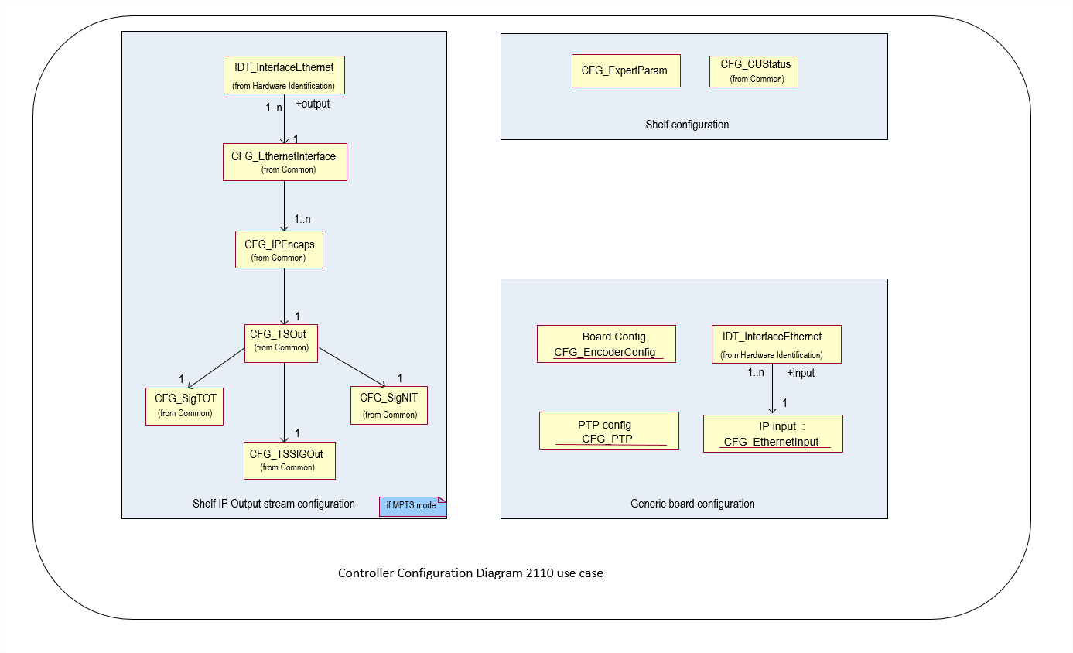

Descriptor CFG_PTP
The PTP descriptor gives the PTP configuration for two PTP clock source.
This descriptor shall be present upon the input_mode = ENU_INPUT_MODE_IP2110. When present the PTP is enabled.

CFG_PTP_descriptor()
{
descriptor_header (type = NCCPD_DESC_CFG_PTP, version = 2) byte[8]

genlock byte[1]
PTP_mode byte[1]
PTP_BMCA byte[1]
nb_source byte[1]
for (i = 1 ; i <= nb_source)
{
domain_number byte[1]
GM_id byte[8]
DSCP_value byte[1]
delay_mechanism byte[1]
join_IGMP byte[1]
delay_mechanism byte[1]
join_IGMP byte[1]
source_IP_address byte[4]
}
priority1 byte[1]
priority2 byte[1]
announce_interval byte[4]
}

genlock Possible values :
- ENU_GENLOCK_NONE
- ENU_GENLOCK_INTERNAL
- ENU_GENLOCK_BLACK_BURST
- ENU_GENLOCK_PTP
(default value = ENU_GENLOCK_PTP)
PTP_mode Possible values :
- ENU_PTP_MULTICAST
- ENU_PTP_UNICAST
- ENU_PTP_HYBRID
(default value = ENU_PTP_MULTICAST)
PTP_BMCA PTP Best Master Clock Algorithm
Possible values :
- ENU_PTP_AUTO
- ENU_PTP_MANUAL_SOURCE_1
- ENU_PTP_MANUAL_SOURCE_2
(default value = ENU_PTP_AUTO)
nb_source Possible values :
- from 0 to 2
(default value = 2)
domain_number The PTP domain is a number that identifies a group of devices that talk together
domains 1-2-3 are reserved per specifications. Other domain numbers can be 4-255
(default value = 4)
Possible values :
- from 0 to 255
(default value = 0)
GM_id PTP Grand Master Id
(default value = 0)
DSCP_value 802.1p class of service /ToS range /DSCP range traffic categories
Possible values :
- from 0 to 64
(default value = 46)
802.1p Class of Service | TOS Range | DSCP Range | Traffic Category
0 - Best Effort | 0x00-0x1f | 0-7 | Medium Priority
1 - Background | 0x20-0x3f | 8-15 | Low Priority
2 - Spare | 0x40-0x5f | 16-23 | Low Priority
3 - Excellent Effort | 0x60-0x7f | 24-25, 28-31 | Medium Priority
4 - Controlled Load | 0x80-0x9f | 32-39 | Medium Priority
5 - Video (<100ms latency) | 0xa0-0xbf | 40-45 | Medium Priority
6 - Voice (<10ms latency) | 0x68, 0xb8 | 26-27, 46-55 | High Priority
7 - Network Control | 0xe0-0xff | 56-63 | High Priority
delay_mechanism Possible values :
- ENU_PTP_MECH_E2E
- ENU_PTP_MECH_P2P
(default value = ENU_PTP_MECH_E2E)
join_IGMP Possible values :
- ENU_PTP_JOIN_UNICAST
- ENU_PTP_JOIN_IGMPV2
- ENU_PTP_JOIN_IGMPV3
(default value = ENU_JOIN_IGMPV2)
source_IP_address unicast source address (default value = 0)
priority1 Local clock Priority 1 attribute 0..255 (default value = 128)
priority2 Local clock Priority 2 attribute 0..255 (default value = 128)
announce_interval Announcement message interval
- ENU_PTP_AI_AES67_SMPTE_2059_2 // 1 per second
- ENU_PTP_AI_SMPTE_2059_2 // 4 per second
(default value = ENU_PTP_AI_AES67_SMPTE_2059_2)

Encoder Configuration Model
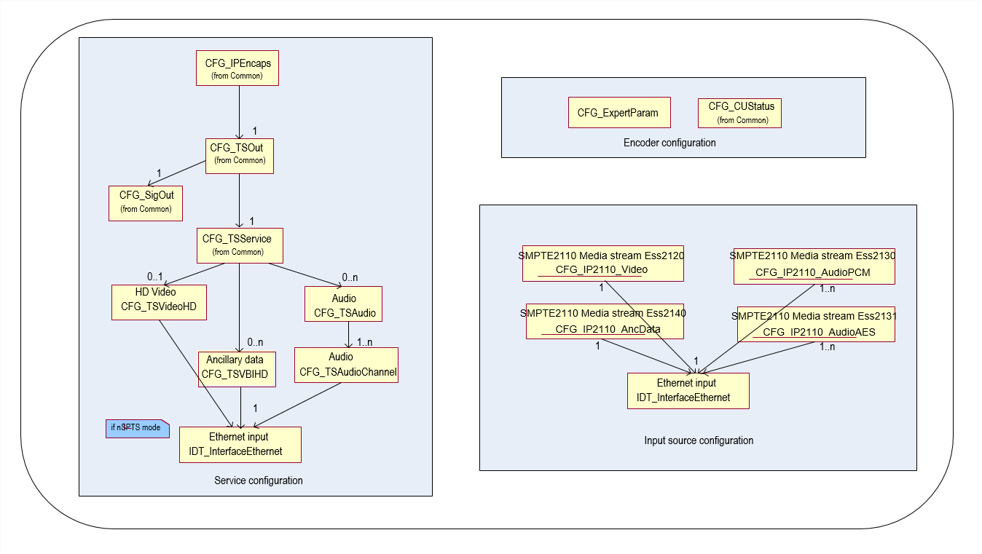
The SMPTE2110 media streams configuration (Video, Audio, Ancillary ….).contains the input transport stream part and the specific essence stream part.
The input transport stream part allow the configuration of 2 input streams one for the nominal and one for the redundant.
The 2022-7 strategy of redundancy is managed by the FPGA and does not required further configuration.
Note: By convention, whereas redundancy is enabled ONLY the 1st Ethernet interface input is present in the NCCP model.

Descriptor CFG_IPEss_Video
These descriptor contains the video configuration for a SPMTE2110-21 elementary essence stream

CFG_IPEss_Video descriptor()
{
descriptor_header (type = NCCPD_DESC_CFG_IPESSVIDEO, version = 2) byte[8]

nb_streams byte[1]
for (i = 1 ; i <= nb_streams)
{
SSRC_id byte[1]
stream_enable byte[1]
IP_subscribe_address byte[4]
UDP_subscribe_port byte[2]
source_IP_address byte[4]
physical_port byte[1]
RTP_payload_type byte[1]
VLAN_filter byte[1]
VLAN_identifier byte[2]
}
standard byte[1]
picture_resolution byte[1]
packing_mode byte[1]
buffer_mode byte[1]
}

// Transport stream Part
SSRC_id RTP Synchronization Source to identify the RTP media stream
Possible values :
- from 1 to n
(default value = 1)
nb_streams Possible values :
- from 0 to 2
(default value = 2)
stream_enable Possible values :
- ENU_ENABLE
- ENU_DISABLE
(default value = ENU_DISABLE)
IP_subscribe_address (default value = 0)
UDP_subscribe_port (default value = 0)
source_IP_address SSM address
(default value = 0)
physical_port Indicates which physical port is used.
Possible values :
- ENU_FIRST_PORT
- ENU_SECOND_PORT
(default value = ENU_FIRST_PORT)
RTP_payload_type Specifies the data format for transmitting digital media streams on (IP) networks.
Possible values :
- from 1 to 255
(default value = 96)
VLAN_filter VLAN filtering.
Possible values :
- ENU_ENABLE
- ENU_DISABLE
(default value = ENU_DISABLE)
VLAN_identifier If VLAN_filtring enabled, number identifying the virtual bridged LAN.
Possible values :
- from 0 to 4095
(default value = 0)
// Video stream Part
standard Possible values :
// HD standard
- ENU_STANDARD_1080_I_50
- ENU_STANDARD_1080_I_60_1001
- ENU_STANDARD_1080_I_60
- ENU_STANDARD_720_P_50
- ENU_STANDARD_720_P_60_1001
- ENU_STANDARD_720_P_60
- ENU_STANDARD_720_P_30
- ENU_STANDARD_720_P_30_1001
- ENU_STANDARD_720_P_25
- ENU_STANDARD_720_P_24
- ENU_STANDARD_1080_P_50
- ENU_STANDARD_1080_P_60_1001
- ENU_STANDARD_1080_P_60
- ENU_STANDARD_1080_P_30
- ENU_STANDARD_1080_P_30_1001
- ENU_STANDARD_1080_P_25
- ENU_STANDARD_1080_P_24
// UHD standard
- ENU_STANDARD_2160_P_50
- ENU_STANDARD_2160_P_60
- ENU_STANDARD_2160_P_60_1001
- ENU_STANDARD_2160_P_30
- ENU_STANDARD_2160_P_30_1001
- ENU_STANDARD_2160_P_24
- ENU_STANDARD_2160_P_25
(default value = ENU_STANDARD_1080_I_50)
picture_resolution picture resolution.
Possible values :
// HD standard
- ENU_PR_1080_I_1920
- ENU_PR_1080_I_1440
- ENU_PR_1080_I_1280
- ENU_PR_1080_I_960
- ENU_PR_720_P_1280
- ENU_PR_720_P_960
- ENU_PR_720_P_640
- ENU_PR_1080_P_1920
// UHD standard
- ENU_PR_2160_P_3840
(default value = ENU_PR_1080_P_1920)
packing_mode Packing Mode
Possible values :
- ENU_PACKING_GPM General Packing Mode
- ENU_PACKING_BPM Block Packing Mode
(default value = ENU_PACKING_GPM)
buffer_mode Synchronous transmitter profile .
Possible values :
- ENU_BUFFER_NARROW
- ENU_BUFFER_WIDE
(default value = ENU_BUFFER_WIDE)

Descriptor CFG_IPEss_AudioPCM
These descriptor contains the video configuration for a SPMTE2110-30 elementary essence stream

CFG_IPEssAudioPCM descriptor()
{
descriptor_header (type = NCCPD_DESC_CFG_IPESSAUDIOPM, version = 1) byte[8]

nb_streams byte[1]
for (i = 1 ; i <= nb_streams)
{
SSRC_id byte[1]
stream_enable byte[1]
IP_subscribe_address byte[4]
UDP_subscribe_port byte[2]
source_IP_address byte[4]
physical_port byte[1]
RTP_payload_type byte[1]
VLAN_filter byte[1]
VLAN_identifier byte[2]
}
channel_number byte[1]
packet_time byte[1]
encoding_mode byte[1]
}

// Transport stream Part
SSRC_id RTP Synchronization Source to identify the RTP media stream
Possible values :
- from 1 to n
(default value = 1)
nb_streams Possible values :
- from 0 to 2
(default value = 2)
stream_enable Possible values :
- ENU_ENABLE
- ENU_DISABLE
(default value = ENU_DISABLE)
IP_subscribe_address SSM address
(default value = 0)
UDP_subscribe_port (default value = 0)
source_IP_address (default value = 0)
physical_port Indicates which physical port is used.
Possible values :
- ENU_FIRST_PORT
- ENU_SECOND_PORT
(default value = ENU_FIRST_PORT)
RTP_payload_type Specifies the data format for transmitting digital media streams on (IP) networks.
Possible values :
- from 1 to 255
(default value = 96)
VLAN_filter VLAN filtering.
Possible values :
- ENU_ENABLE
- ENU_DISABLE
(default value = ENU_DISABLE)
VLAN_identifier If VLAN_filtring enabled, number identifying the virtual bridged LAN.
Possible values :
- from 0 to 4095
(default value = 0)
// Audio stream Part
channel_number Number of channels.
Possible values :
- from 1 to 8
(default value = 1)
packet_time gives the length of time represented by the media in a packet.
Possible values : Multiple of 125µs
- from 1 to 80
(default value = 1)
encoding_mode gives the length of time represented by the media in a packet.
Possible values :
- ENU_RTPMAP_ENC_L16 // audio PCM 16bits
- ENU_RTPMAP_ENC_L20 // audio PCM 20bits
- ENU_RTPMAP_ENC_L24 // audio PCM 24bits
(default value = ENU_RTPMAP_ENC_L24)

Descriptor CFG_IPEssAudioAES
These descriptor contains the video configuration for a SPMTE2110-31 elementary essence stream

CFG_IPEssAudioAES descriptor()
{
descriptor_header (type = NCCPD_DESC_CFG_IPESSAUDIOAES, version = 1) byte[8]

nb_streams byte[1]
for (i = 1 ; i <= nb_streams)
{
SSRC_id byte[1]
stream_enable byte[1]
IP_subscribe_address byte[4]
UDP_subscribe_port byte[2]
source_IP_address byte[4]
physical_port byte[1]
RTP_payload_type byte[1]
VLAN_filter byte[1]
VLAN_identifier byte[2]
}
channel_number byte[1]
packet_time byte[1]
}

// Transport stream Part
SSRC_id RTP Synchronization Source to identify the RTP media stream
Possible values :
- from 1 to n
(default value = 1)
nb_streams Possible values :
- from 0 to 2
(default value = 2)
stream_enable Possible values :
- ENU_ENABLE
- ENU_DISABLE
(default value = ENU_DISABLE)
IP_subscribe_address SSM address
(default value = 0)
UDP_subscribe_port (default value = 0)
source_IP_address (default value = 0)
physical_port Indicates which physical port is used.
Possible values :
- ENU_FIRST_PORT
- ENU_SECOND_PORT
(default value = ENU_FIRST_PORT)
RTP_payload_type Specifies the data format for transmitting digital media streams on (IP) networks.
Possible values :
- from 1 to 255
(default value = 96)
VLAN_filter VLAN filtering.
Possible values :
- ENU_ENABLE
- ENU_DISABLE
(default value = ENU_DISABLE)
VLAN_identifier If VLAN_filtring enabled, number identifying the virtual bridged LAN.
Possible values :
- from 0 to 4095
(default value = 0)
// Audio stream Part
channel_number Number of channels.
Possible values :
- from 1 to 8
(default value = 1)
packet_time gives the length of time represented by the media in a packet.
Possible values : Multiple of 125µs
- from 1 to 80
(default value = 1)

Descriptor CFG_IPEssAncillaryData
These descriptor contains the video configuration for a SPMTE2110-40 elementary essence stream

CFG_IPEssAncillaryData descriptor()
{
descriptor_header (type = NCCPD_DESC_CFG_IPESSANCILLARYDATA, version = 1) byte[8]

nb_streams byte[1]
for (i = 1 ; i <= nb_streams)
{
SSRC_id byte[1]
stream_enable byte[1]
IP_subscribe_address byte[4]
UDP_subscribe_port byte[2]
source_IP_address byte[4]
physical_port byte[1]
RTP_payload_type byte[1]
VLAN_filter byte[1]
VLAN_identifier byte[2]
}
}

// Transport stream Part
SSRC_id RTP Synchronization Source to identify the RTP media stream
Possible values :
- from 1 to n
(default value = 1)
nb_streams Possible values :
- from 0 to 2
(default value = 2)
stream_enable Possible values :
- ENU_ENABLE
- ENU_DISABLE
(default value = ENU_DISABLE)
IP_subscribe_address SSM address
(default value = 0)
UDP_subscribe_port (default value = 0)
source_IP_address (default value = 0)
physical_port Indicates which physical port is used.
Possible values :
- ENU_FIRST_PORT
- ENU_SECOND_PORT
(default value = ENU_FIRST_PORT)
RTP_payload_type Specifies the data format for transmitting digital media streams on (IP) networks.
Possible values :
- from 1 to 255
(default value = 96)
VLAN_filter VLAN filtering.
Possible values :
- ENU_ENABLE
- ENU_DISABLE
(default value = ENU_DISABLE)
VLAN_identifier If VLAN_filtring enabled, number identifying the virtual bridged LAN.
Possible values :
- from 0 to 4095
(default value = 0)

Front End

Front End Diagrams

GeneralModelFE
This diagram shows the generic model for a FE board configuration, composed of 4 configuration levels : physical output interface, logical output interface, logical input interface, physical input interface.

Most of the classes on this diagram are abstract classes and will not be instanciated as descriptors transmitted to configure boards, but they show the associations between descriptors.
Then next diagram shows all the descriptors that can be instanciated at each level.

Specific configuration models presented hereafter and actually sent to FE boards will only contain the configuration of one output interface. A physical interface will possibly be represented in different diagrams by different descriptors, according to the use of this interface (input or output) (no IN/OUT interface is allowed in order to avoid loops in tree management).
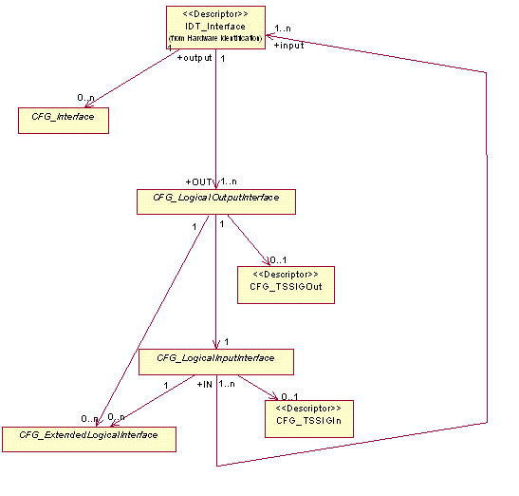
Figure 35 : GeneralModelFE

DetailedModelFE

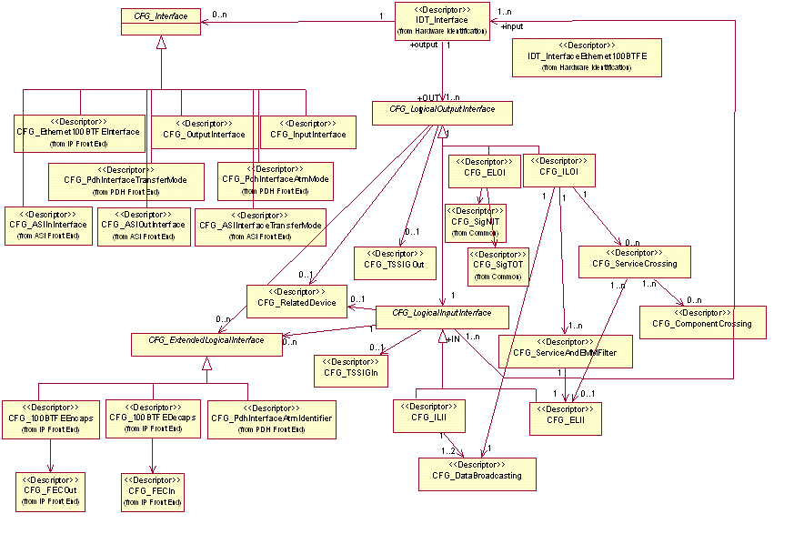
Figure 36 : DetailedModelFE

MultiEncaps FE

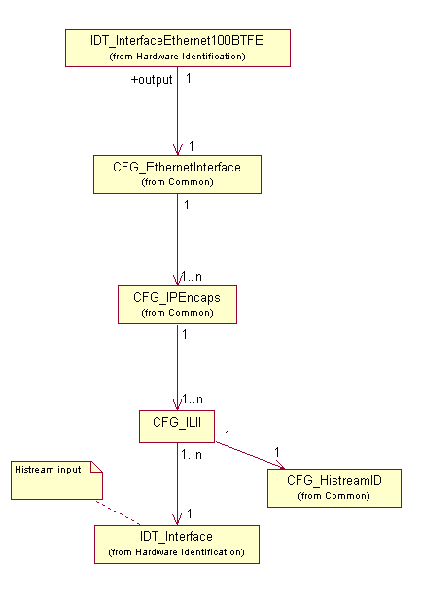
Figure 37 : MultiEncaps FE

100BTFEIn
In the following diagrams, dark-colored descriptors are mandatory, others are optional.
As soon as an optional descriptor is present, all optional descriptors between this descriptor and a mandatory one become mandatory.
IDT_Interface descriptor (for Histream interface) is mandatory as soon as CFG_ILxI is present.
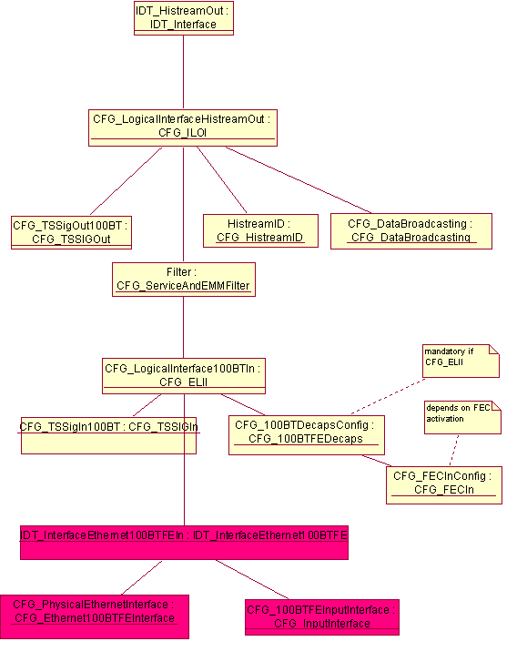
Figure 38 : 100BTFEIn

100BTFEOut

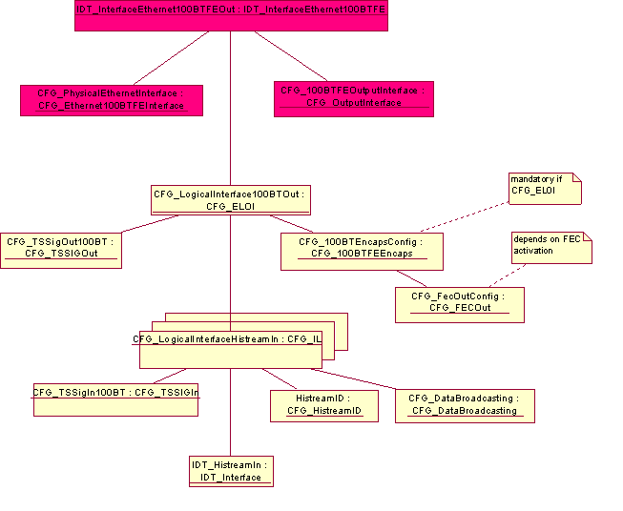
Figure 39 : 100BTFEOut

PDHFEIn

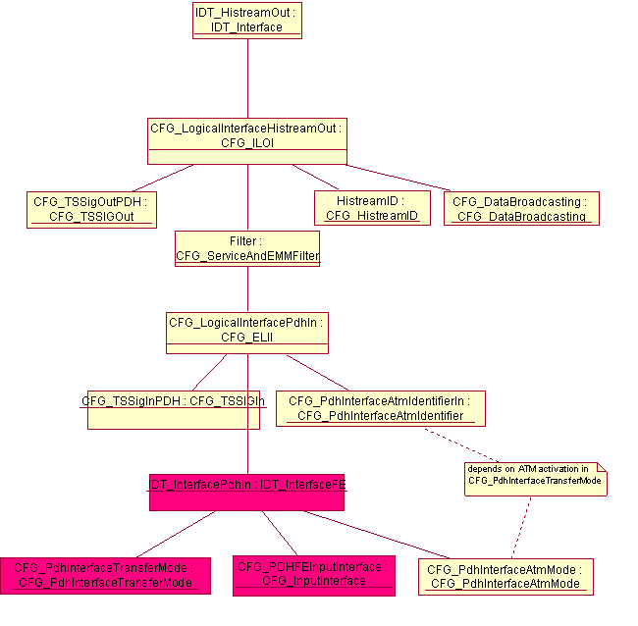
Figure 40 : PDHFEIn

PDHFEOut

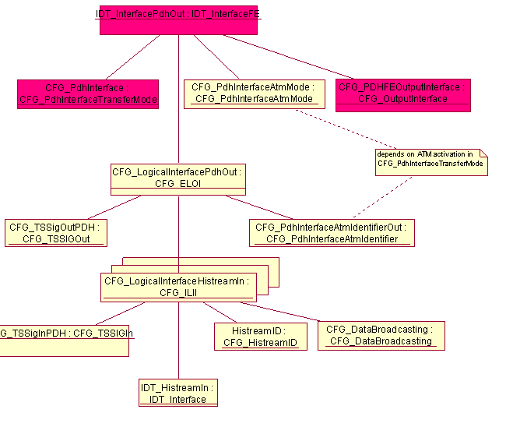
Figure 41 : PDHFEOut

ASIFEIn

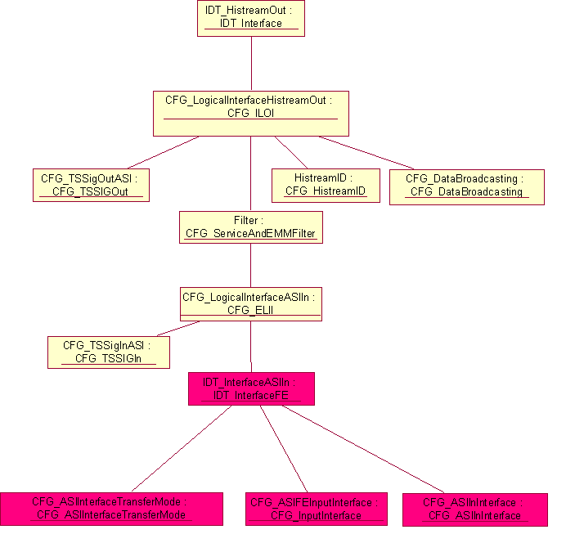
Figure 42 : ASIFEIn

ASIFEOut

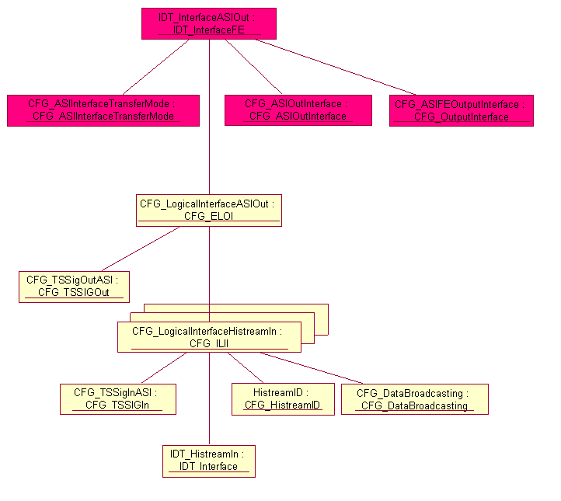
Figure 43 : ASIFEOut

100BT FE default configuration
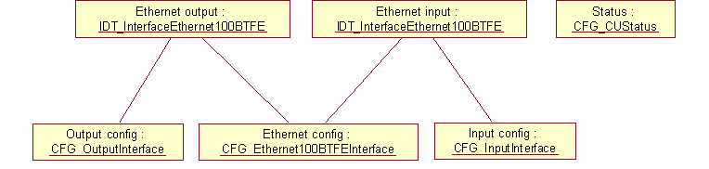
Figure 44 : 100BT FE default configuration

ASI FE default configuration
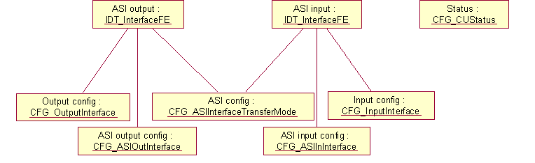
Figure 45 : ASI FE default configuration

PDH FE default configuration
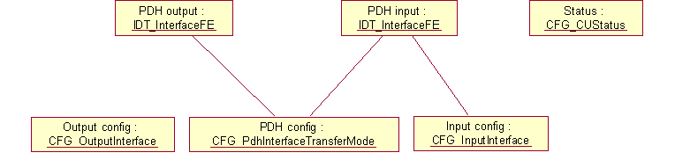
Figure 46 : PDH FE default configuration

MultiEncaps FE default configuration
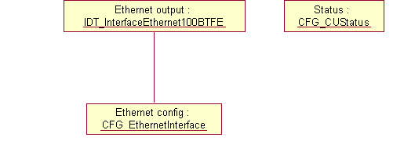
Figure 47 : MultiEncaps FE default configuration

Generic Front End Descriptors

Descriptor CFG_OutputInterface
CFG_OutputInterface_descriptor()
{
descriptor_header (type = NCCPD_DESC_CFG_OUTPUTINTERFACE, version = 1) byte[8]

output_enable byte[1]
}

output_enable Enable/Disable physical interface output.
In the case of a 100BT FE board, this attribute and input_enable attribute in CFG_InputInterface descriptor must have the same value.
Possible values :
- ENU_ENABLE
- ENU_DISABLE
(default value = ENU_DISABLE)

Descriptor CFG_InputInterface
CFG_InputInterface_descriptor()
{
descriptor_header (type = NCCPD_DESC_CFG_INPUTINTERFACE, version = 1) byte[8]

input_enable byte[1]
}

input_enable Enable/Disable physical interface input.
In the case of a 100BT FE board, this attribute and output_enable attribute in CFG_OutputInterface descriptor must have the same value.
Possible values :
- ENU_ENABLE
- ENU_DISABLE
(default value = ENU_DISABLE)

Descriptor CFG_ELII
Configuration of an External Logical Input Interface.
CFG_ELII_descriptor()
{
descriptor_header (type = NCCPD_DESC_CFG_ELII, version = 4) byte[8]

external_channel_id byte[1]
default_transmission_mode byte[1]
default_supplier_channel_id byte[1]
}

external_channel_id Logical channel number splitting a physical interface.
Possible values :
- from 1 to 4
(default value = 1)

default_transmission_mode Possible values :
- ENU_TRANSMITTED
- ENU_STOPPED
(default value = ENU_STOPPED)

default_supplier_channel_id Only significant when default_transmission_mode = ENU_TRANSMITTED.
Must be equal to supplier_channel_id of one of the related CFG_ILOI descriptors.
Possible values :
- from 1 to 255
(default value = 1)

Descriptor CFG_ELOI
Configuration of an External Logical Output Interface.
CFG_ELOI_descriptor()
{
descriptor_header (type = NCCPD_DESC_CFG_ELOI, version = 2) byte[8]

external_channel_id byte[1]
}

external_channel_id Logical channel number splitting a physical interface.
Possible values :
- from 1 to 4
(default value = 1)

Descriptor CFG_ILII
Configuration of an Internal Logical Input Interface.
CFG_ILII_descriptor()
{
descriptor_header (type = NCCPD_DESC_CFG_ILII, version = 3) byte[8]

consumer_channel_id byte[1]
}

consumer_channel_id Id of logical channel splitting a physical interface.
Possible values :
- from 1 to 255
(default value = 1)

Descriptor CFG_ILOI
Configuration of an Internal Logical Output Interface.
CFG_ILOI_descriptor()
{
descriptor_header (type = NCCPD_DESC_CFG_ILOI, version = 2) byte[8]

supplier_channel_id byte[1]
}

supplier_channel_id Id of logical channel splitting a physical interface.
Possible values :
- from 1 to 255
(default value = 1)

Descriptor CFG_ServiceCrossing
CFG_ServiceAndEMMFilter and CFG_ServiceCrossing descriptors must be coherent : when a service is described through a CFG_ServiceCrossing descriptor, it must not be explicitly filtered (using negative filtering + service id) or implicitly filtered (positive filtering without service id).
CFG_ServiceCrossing_descriptor()
{
descriptor_header (type = NCCPD_DESC_CFG_SERVICECROSSING, version = 2) byte[8]

service_id byte[2]
input_service_id byte[2]
default_component_filtering byte[1]
}

service_id Output service id.
(default value = 0)

input_service_id Input service id.
(default value = 0)

default_component_filtering Filtering type for components of the service.
Possible values :
- ENU_POSITIVE_FILTERING
- ENU_NEGATIVE_FILTERING
(default value = ENU_NEGATIVE_FILTERING)

Descriptor CFG_ComponentCrossing
CFG_ComponentCrossing_descriptor()
{
descriptor_header (type = NCCPD_DESC_CFG_COMPONENTCROSSING, version = 1) byte[8]

PID byte[2]
input_PID byte[2]
filter_type byte[1]
}

PID Output TS component PID.
(default value = 0)

input_PID Input TS component PID.
(default value = 0)

filter_type Possible values :
- ENU_POSITIVE_FILTERING
- ENU_NEGATIVE_FILTERING
(default value = ENU_POSITIVE_FILTERING)

Descriptor CFG_ServiceAndEMMFilter
CFG_ServiceAndEMMFilter and CFG_ServiceCrossing descriptors must be coherent : when a service is described through a CFG_ServiceCrossing descriptor, it must not be explicitly filtered (using negative filtering + service id) or implicitly filtered (positive filtering without service id).
CFG_ServiceAndEMMFilter_descriptor()
{
descriptor_header (type = NCCPD_DESC_CFG_SERVICEANDEMMFILTER, version = 1) byte[8]

service_filtering byte[1]
EMM_filtering byte[1]
nb_services byte[1]
for (i = 1 ; i <= nb_services)
{
service_id byte[2]

}

nb_EMM_channels byte[1]
for (i = 1 ; i <= nb_EMM_channels)
{
PID byte[2]

}

}

service_filtering Filtering type for services on downstream input.
Possible values :
- ENU_POSITIVE_FILTERING
- ENU_NEGATIVE_FILTERING
(default value = ENU_POSITIVE_FILTERING)

EMM_filtering Filtering type for EMM channels on downstream input.
Possible values :
- ENU_POSITIVE_FILTERING
- ENU_NEGATIVE_FILTERING
(default value = ENU_POSITIVE_FILTERING)

nb_services Number of services.
(default value = 0)

service_id Service id of the extracted service.
(default value = 0)

nb_EMM_channels Number of EMM channels.
(default value = 0)

PID EMM component PID.
(default value = 0)

Descriptor CFG_RelatedDevice
This descriptor contains information about the device related to a logical interface (unused in internal configuration model, defined only for external application needs).
CFG_RelatedDevice_descriptor()
{
descriptor_header (type = NCCPD_DESC_CFG_RELATEDDEVICE, version = 1) byte[8]

related_device_name byte[1+n]
}

related_device_name Text string which identifies the device related to logical interface.
(default value = "")

100BT Front End Descriptors

Descriptor CFG_100BTFEDecaps
CFG_100BTFEDecaps_descriptor()
{
descriptor_header (type = NCCPD_DESC_CFG_100BTFEDECAPS, version = 2) byte[8]

RX_source_IP_address byte[4]
RX_dest_UDP_port byte[2]
RX_dest_IP_address byte[4]
tolerated_jitter byte[1]
RX_input_bit_rate byte[4]
}

RX_source_IP_address Source IP address for received MPEG frames.
(default value = 0)

RX_dest_UDP_port Destination UDP port for received MPEG frames. This value MUST be an even value and is recommended to lie in the range above 5000. Granularity 4.
Possible values :
- from 2 to 65535
(default value = 5004)

RX_dest_IP_address Destination IP address for transmitted frames (which is the 100 BT FE board IP address in unicast mode and multicast group IP address in multicast mode).
(default value = 0)

tolerated_jitter Tolerated peak to peak jitter in ms.
Possible values :
- from 0 to 40
(default value = 20)

RX_input_bit_rate Bits 0-29 are used to indicate the throughput at the input on the 100BT FE (maximum input data rate in kbits/s).
If set to 0, input MPEG traffic is stopped.
Possible values :
- from 0 to 100000
Bit 30 is used to configure "High Network jitter handling" : 0 (default) means normal IPDV (the range for IPDV is 0-40 ms), 1 means enhanced IPDV.
Bit 31 is used to configure "Empty packet discard" : 0 (default) means null packets transmission is disabled (empty packets discard is made), 1 means null packets transmission is enabled.
(default value = 0)

Descriptor CFG_100BTFEEncaps
CFG_100BTFEEncaps_descriptor()
{
descriptor_header (type = NCCPD_DESC_CFG_100BTFEENCAPS, version = 3) byte[8]

TX_RTP_encapsulation byte[1]
TX_MPEG_packets_number byte[1]
TX_dest_UDP_port byte[2]
TX_dest_IP_address byte[4]
MPEG_TOS byte[1]
TX_dest_MAC_address byte[6]
TX_output_bit_rate byte[4]
MPEG_TTL byte[1]
IGMP_snooping byte[1]
}

TX_RTP_encapsulation Bits 0-6 are used to transmit RTP encapsulation for MPEG traffic.
Possible values :
- ENU_ENABLE
- ENU_DISABLE
MSB (Bit 7) is used to configure " PCR correction " : 0 (default) means PCR correction is enabled, 1 means PCR correction is disabled.
(default value = ENU_ENABLE)

TX_MPEG_packets_number Number of MPEG TS packets per transmitted frame.
Possible values :
- from 1 to 7
(default value = 7)

TX_dest_UDP_port Destination UDP port for transmitted MPEG frames. This value MUST be an even value and is recommended to lie in the range above 5000. Granularity 4.
Possible values :
- from 2 to 65535
(default value = 5000)

TX_dest_IP_address Destination IP address for transmitted frames (unicast or multicast address).
(default value = 0)

MPEG_TOS TOS value for transmitted MPEG frames.
Possible values :
- from 0 to 255
(default value = 0x10)

TX_dest_MAC_address Destination MAC address for transmitted frames. If set to 0, destination MAC address is internally computed.
(default value = 0)

TX_output_bit_rate Throughput at the output of the 100BT FE in kbits/s.
If set to 0, output MPEG traffic is stopped.
Possible values :
- from 0 to 100000
(default value = 0)

MPEG_TTL TTL value for transmitted FEC frames.
Possible values :
- from 1 to 255
(default value = 32)

IGMP_snooping Defines layer 2 IGMP snooping mode activation.
Possible values :
- ENU_FALSE
- ENU_TRUE
(default value = ENU_FALSE)

Descriptor CFG_Ethernet100BTFEInterface
CFG_Ethernet100BTFEInterface_descriptor()
{
descriptor_header (type = NCCPD_DESC_CFG_ETHERNET100BTFEINTERFACE, version = 3) byte[8]

gateway byte[4]
board_IP_address byte[4]
net_mask byte[4]
nb_routes byte[1]
for (i = 1 ; i <= nb_routes)
{
static_router_IP_address byte[4]

static_destination_IP_address byte[4]

static_netmask byte[4]

}

routing_protocol byte[1]
negotiation byte[1]
speed byte[1]
mode byte[1]
RIPv2_update_frequency byte[2]
RIPv2_disable_time_out byte[2]
RIPv2_garbage_time_out byte[2]
RIPv2_authentification byte[1]
RIPv2_password byte[1+n]
RIPv2_auth_key_id byte[1+n]
OSPF_area byte[1+n]
OSPF_stub_area byte[1]
OSPF_dead_interval byte[2]
OSPF_hello_interval byte[2]
OSPF_authentication byte[1]
OSPF_auth_string byte[1+n]
OSPF_auth_key_id byte[1+n]
OSPF_auth_key byte[1+n]
}

gateway Defines Gateway IP address.
(default value = 0)

board_IP_address Defines Board IP address.
(default value = 0)

net_mask Defines NetMask address.
(default value = 0)

nb_routes Number of static routes.
Set to 4.
(default value = 4)

static_router_IP_address Next hop intermediary via where packets with static_destination_IP_address should be routed.
(default value = 0)

static_destination_IP_address Destination IP address (host or network) added statically in the routing table and associated with static_router_IP_address and static_netmask.
(default value = 0)

static_netmask Static netmask in the routing table.
(default value = 0)

routing_protocol Possible values :
- ENU_NONE
- ENU_RIPv2
- ENU_OSPF
- ENU_RIPv2_OSPF
(default value = ENU_NONE)

negotiation Possible values :
- ENU_AUTO
- ENU_MANUAL
(default value = ENU_AUTO)

speed Possible values :
- ENU_10MBS
- ENU_100MBS
(default value = ENU_100MBS)

mode Possible values :
- ENU_HALF
- ENU_FULL
(default value = ENU_FULL)

RIPv2_update_frequency Defines the frequency of route update, in seconds (significant only if routing_protocol = ENU_RIPv2 or ENU_RIPv2_OSPF).
Possible values :
- from 1 to 65535
(default value = 30)

RIPv2_disable_time_out Defines the time out in seconds after which a route is disabled if no RIP message is received (significant only if routing_protocol = ENU_RIPv2 or ENU_RIPv2_OSPF).
Possible values :
- from 1 to 65535
(default value = 180)

RIPv2_garbage_time_out Defines the time out in seconds after which a disabled route is destroyed (significant only if routing_protocol = ENU_RIPv2 or ENU_RIPv2_OSPF).
Possible values :
- from 1 to 65535
(default value = 120)

RIPv2_authentification Defines the authentication mode (significant only if routing_protocol = ENU_RIPv2 or ENU_RIPv2_OSPF).
Possible values :
- ENU_NONE
- ENU_TEXT
- ENU_MD5
(default value = ENU_NONE)

RIPv2_password Text string which defines the password used for authentication (significant only if routing_protocol = ENU_RIPv2 or ENU_RIPv2_OSPF) (max size = 16).
(default value = "")

RIPv2_auth_key_id Text string which defines the MD5 key id (secret key used to encrypt password through MD5 configured in each router attached to a common network) in MD5 mode (significant only if routing_protocol = ENU_RIPv2 or ENU_RIPv2_OSPF) (max size = 16).
(default value = "")

OSPF_area Text string which identifies the OSPF area that the board belongs to (significant only if routing_protocol = ENU_OSPF or ENU_RIPv2_OSPF).
Possible values :
- from "0.0.0.0" to "255.255.255.255"
(default value = "0.0.0.0")

OSPF_stub_area Defines if the OSPF area that the board belongs to is a stub area (significant only if routing_protocol = ENU_OSPF or ENU_RIPv2_OSPF).
Possible values :
- ENU_TRUE
- ENU_FALSE
(default value = ENU_FALSE)

OSPF_dead_interval Defines the time in seconds after which a router is declared dead if no hello message is received (significant only if routing_protocol = ENU_OSPF or ENU_RIPv2_OSPF).
Possible values :
- from 1 to 65535
(default value = 40)

OSPF_hello_interval Defines the time in seconds between 2 hello messages (significant only if routing_protocol = ENU_OSPF or ENU_RIPv2_OSPF).
Possible values :
- from 1 to 65535
(default value = 10)

OSPF_authentication Defines the authentication mode (significant only if routing_protocol = ENU_OSPF or ENU_RIPv2_OSPF).
Possible values :
- ENU_NONE
- ENU_TEXT
- ENU_MD5
(default value = ENU_NONE)

OSPF_auth_string Text string which defines the authentication password in text mode (significant only if routing_protocol = ENU_OSPF or ENU_RIPv2_OSPF) (max size = 8).
(default value = "")

OSPF_auth_key_id Text string which defines the MD5 key id (secret key used to encrypt password through MD5 configured in each router attached to a common network) in MD5 mode (significant only if routing_protocol = ENU_OSPF or ENU_RIPv2_OSPF) (max size = 16).
(default value = "")

OSPF_auth_key Text string which defines the MD5 key (password) in MD5 mode (significant only if routing_protocol = ENU_OSPF or ENU_RIPv2_OSPF) (max size = 16).
(default value = "")

Descriptor CFG_FECIn
CFG_FECIn_descriptor()
{
descriptor_header (type = NCCPD_DESC_CFG_FECIN, version = 2) byte[8]

FEC_RX_dest_UDP_port byte[2]
}

FEC_RX_dest_UDP_port Destination UDP port for received RTP FEC frames. This value MUST be RX_dest_UDP_port + 2. Granularity 4.
Possible values :
- from 4 to 65535
(default value = 5006)

Descriptor CFG_FECOut
CFG_FECOut_descriptor()
{
descriptor_header (type = NCCPD_DESC_CFG_FECOUT, version = 4) byte[8]

burst_length_recovery byte[1]
burst_overhead byte[2]
line_overhead byte[2]
FEC_TX_dest_UDP_port byte[2]
FEC_TOS byte[1]
FEC_TTL byte[1]
FEC_conf_mode byte[1]
FEC_column_interleaving byte[1]
}

burst_length_recovery Length of the longest recoverable burst.
Possible values :
- from 0 to 30
(default value = 0)

burst_overhead Overhead induced by FEC frames to recover burst losses (significant only if burst_length_recovery is not null).
Possible values :
- 0
- from 500 to 5000
(default value = 0)

line_overhead Overhead induced by FEC frames to recover frames erasures.
Possible values :
- 0
- from 100 to 5000
(default value = 0)

FEC_TX_dest_UDP_port Destination UDP port for transmitted RTP FEC frames. This value MUST be TX_dest_UDP_port + 2. Granularity 4.
Possible values :
- from 4 to 65535
(default value = 5002)

FEC_TOS TOS value for transmitted RTP FEC frames (Network use). Should be greater than (or equal to) MPEG TOS.
Possible values :
- from 0 to 255
(default value = 0x10)

FEC_TTL TTL value for transmitted RTP FEC frames.
Possible values :
- from 1 to 255
(default value = 32)

FEC_conf_mode Defines FEC configuration mode.
Possible values :
- ENU_LOW_IPLR
- ENU_HIGH_IPLR
- ENU_EXPERT
(default value = ENU_LOW_IPLR)

FEC_column_interleaving Interleaving depth of the FEC column (significant only if burst_length_recovery is not null).
Possible values :
- 0
- from 1 to 20
(default value = 0)

PDH Front End Descriptors

Descriptor CFG_PdhInterfaceAtmIdentifier
CFG_PdhInterfaceAtmIdentifier_descriptor()
{
descriptor_header (type = NCCPD_DESC_CFG_PDHINTERFACEATMIDENTIFIER, version = 1) byte[8]

vpi byte[1]
vci byte[2]
pcr byte[4]
}

vpi Defines the virtual path identifier used in Atm Mode.
- from ENU_FE_PDH_MIN_VPI to ENU_FE_PDH_MAX_VPI
(default value = ENU_FE_PDH_DEFAULT_VPI)

vci Defines the virtual channel identifier used in atm.
Possible values :
- from ENU_FE_PDH_MIN_VCI to ENU_FE_PDH_MAX_VCI
(default value = ENU_FE_PDH_DEFAULT_VCI)

pcr Maximum peak cell rate.
Possible values :
- from ENU_FE_PDH_MIN_PCR to ENU_FE_PDH_MAX_PCR
(default value = ENU_FE_PDH_DEFAULT_PCR)

Descriptor CFG_PdhInterfaceAtmMode
This descriptor contains all configuration apllicable in ATM mode.
CFG_PdhInterfaceAtmMode_descriptor()
{
descriptor_header (type = NCCPD_DESC_CFG_PDHINTERFACEATMMODE, version = 1) byte[8]

ATM_scrambling byte[1]
ATM_HCS_correction byte[1]
ATM_HCS_cosset_add byte[1]
ATM_HCS_discard byte[1]
}

ATM_scrambling 1+x^43 scrambler/descrambler over ATM payload byte.
Possible values :
- ENU_FE_PDH_ENABLE
- ENU_FE_PDH_DISABLE
(default value = ENU_FE_PDH_ENABLE)

ATM_HCS_correction Allow correction HCS Atm cell header byte.
Possible values :
- ENU_FE_PDH_ENABLE
- ENU_FE_PDH_DISABLE
(default value = ENU_FE_PDH_ENABLE)

ATM_HCS_cosset_add Control the addition of the coset polynomial to the HCS octet prior comparison.
Possible values :
- ENU_FE_PDH_ENABLE
- ENU_FE_PDH_DISABLE
(default value = ENU_FE_PDH_DISABLE)

ATM_HCS_discard Control the dropping of cell based on the detection of uncorrectable HCS error.
Possible values :
- ENU_FE_PDH_ENABLE
- ENU_FE_PDH_DISABLE
(default value = ENU_FE_PDH_DISABLE)

Descriptor CFG_PdhInterfaceTransferMode
This descriptor contains all information common to all PDH interfaces.
CFG_PdhInterfaceTransferMode_descriptor()
{
descriptor_header (type = NCCPD_DESC_CFG_PDHINTERFACETRANSFERMODE, version = 1) byte[8]

rate byte[1]
framing byte[1]
OAM byte[1]
plcp byte[1]
ATM byte[1]
FEC byte[1]
clock byte[1]
loopback byte[1]
}

rate Bits 0-6 are used to indicate the Network Line rate.
Possible values :
- ENU_FE_PDH_E3
- ENU_FE_PDH_DS3
MSB (Bit 7) is used to configure "Empty packet discard" : 0 (default) means null packets transmission is disabled (empty packets discard is made), 1 means null packets transmission is enabled.
(default value = ENU_FE_PDH_E3)

framing Enable or disable framing functionnality.
Possible values :
- ENU_FE_PDH_DISABLE
- ENU_FE_PDH_ENABLE
(default value = ENU_FE_PDH_DISABLE)

OAM Enable or disable OAM management.
Possible values :
- ENU_FE_PDH_ENABLE
- ENU_FE_PDH_DISABLE
(default value = ENU_FE_PDH_DISABLE)

plcp Atm cell formating. Only applicable in DS3 mode.
Possible values :
- ENU_FE_PDH_ENABLE
- ENU_FE_PDH_DISABLE
(default value = ENU_FE_PDH_DISABLE)

ATM Atm encapsulate.
Possible values :
- ENU_FE_PDH_ENABLE
- ENU_FE_PDH_DISABLE
(default value = ENU_FE_PDH_DISABLE)

FEC Application of Forward Error Correction.
Possible values :
- ENU_FE_PDH_ENABLE
- ENU_FE_PDH_DISABLE
(default value = ENU_FE_PDH_DISABLE)

clock Local/Recovered interface clock.
Possible values :
- ENU_FE_PDH_INTERNAL_CLOCK
- ENU_FE_PDH_RECOVERED_CLOCK
(default value = ENU_FE_PDH_INTERNAL_CLOCK)

loopback Physical layer loopback mode.
Possible values :
- ENU_FE_PDH_NO_LOOPBACK
- ENU_FE_PDH_INTERNAL_LOOPBACK
- ENU_FE_PDH_EXTERNAL_LOOPBACK
(default value = ENU_FE_PDH_NO_LOOPBACK)

ASI Front End Descriptors

Descriptor CFG_ASIInInterface
CFG_ASIInInterface_descriptor()
{
descriptor_header (type = NCCPD_DESC_CFG_ASIININTERFACE, version = 1) byte[8]

input_max_rate byte[4]
input_packet_format byte[1]
}

input_max_rate Bits 0-30 are used to indicate the input maximum rate, in bits/second.
Possible values :
- from 300000 to 130000000
MSB (Bit 31) is used to configure "Empty packet discard" : 0 (default) means null packets transmission is disabled (empty packets discard is made), 1 means null packets transmission is enabled.
(default value = 130000000)

input_packet_format Possible values :
- ENU_188_BYTES (standard packet size)
- ENU_188_16_BYTES (packets are stuffed with 16 dummy bytes)
(default value = ENU_188_BYTES)

Descriptor CFG_ASIOutInterface
CFG_ASIOutInterface_descriptor()
{
descriptor_header (type = NCCPD_DESC_CFG_ASIOUTINTERFACE, version = 2) byte[8]

output_clock_rate byte[4]
output_packet_format byte[1]
output_enable byte[1]
}

output_clock_rate In bits/second.
Possible values :
- from 300000 to 130000000
(default value = 54000000)

output_packet_format Possible values :
- ENU_188_BYTES (standard packet size)
- ENU_188_16_BYTES (packets are stuffed with 16 dummy bytes)
(default value = ENU_188_BYTES)

output_enable Possible values :
- ENU_ENABLE
- ENU_DISABLE
(default value = ENU_DISABLE)

Descriptor CFG_ASIInterfaceTransferMode
CFG_ASIInterfaceTransferMode_descriptor()
{
descriptor_header (type = NCCPD_DESC_CFG_ASIINTERFACETRANSFERMODE, version = 1) byte[8]

loopback byte[1]
}

loopback Physical layer loopback mode.
Possible values :
- ENU_FE_NO_LOOPBACK
- ENU_FE_INTERNAL_LOOPBACK
- ENU_FE_EXTERNAL_LOOPBACK
(default value = ENU_FE_NO_LOOPBACK)

MPEG-4 HD Encoder
This sub-package defines descriptors for the configuration of an MPEG-4 HD encoder.

MPEG-4 HD Encoder Diagrams

MPEG-4 HD Encoder configuration

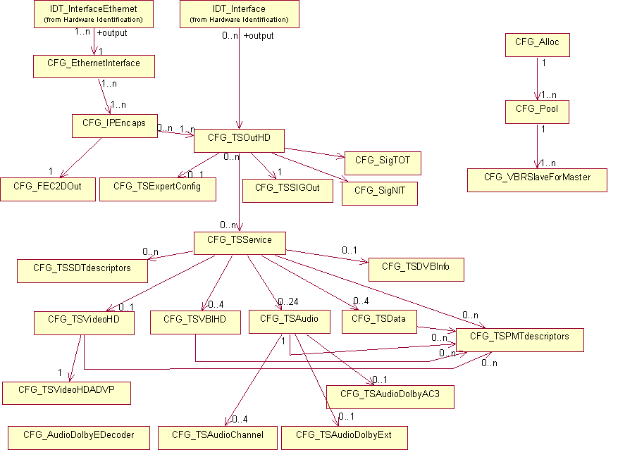
Figure 48 : MPEG-4 HD Encoder configuration

AUD_SUR configuration
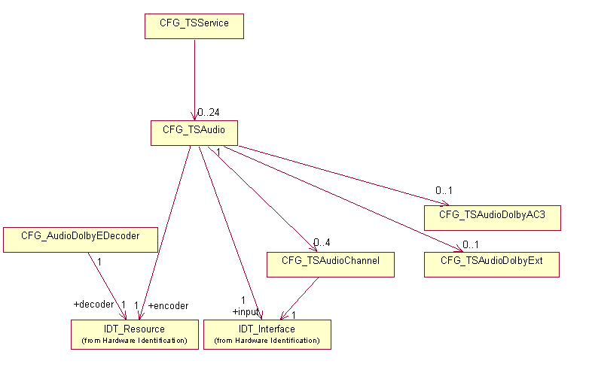
Figure 49 : AUD_SUR configuration

MPEG-4 HD Encoder default configuration
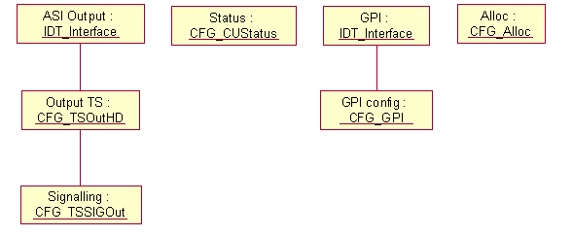
Figure 50 : MPEG-4 HD Encoder default configuration

AUD_SUR example

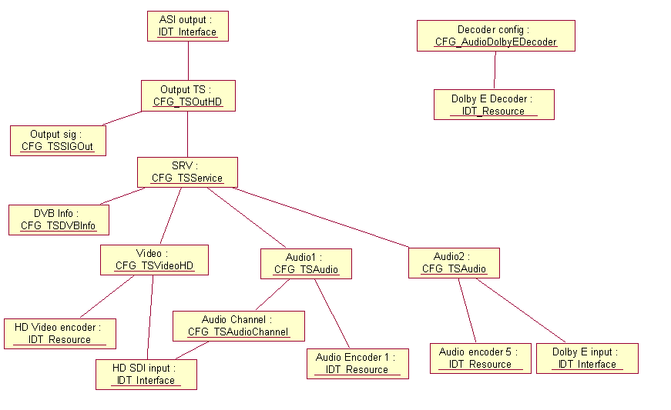
Figure 51 : AUD_SUR example

Mustang HD Encoder configuration
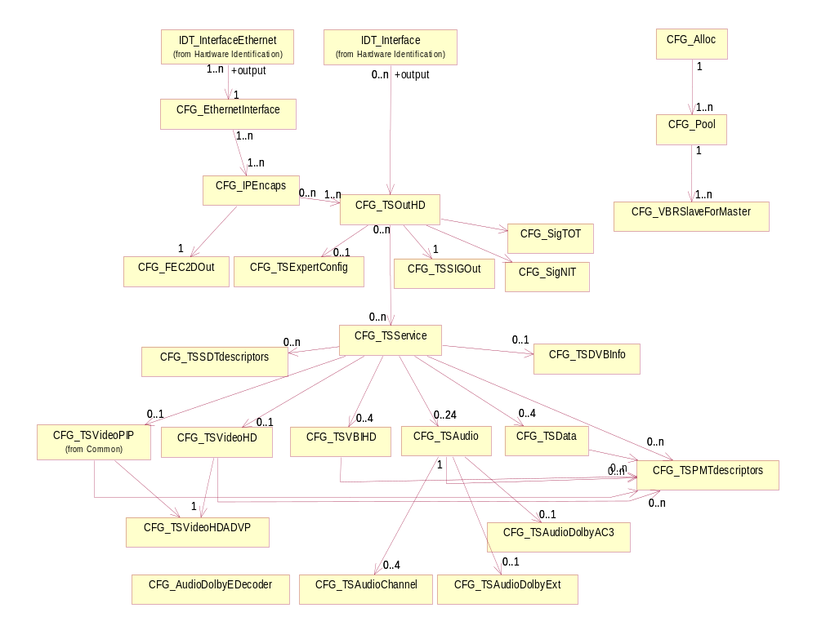
Figure 52 : Mustang HD Encoder configuration

MPEG-4 HD Encoder Descriptors

Descriptor CFG_TSOutHD
CFG_TSOutHD_descriptor()
{
descriptor_header (type = NCCPD_DESC_CFG_TSOUTHD, version = 1) byte[8]

output_packet_size byte[1]
synthetizer_clock_frequency byte[4]
}

output_packet_size Output TS packet size.
Possible values :
- ENU_WITHOUT_REED_SOLOMON (standardized TS packet size)
- ENU_WITH_REED_SOLOMON (The device adds 16 stuffing bytes after each 188-byte packet. This mode is used when the device is connected to a satellite or cable modulator. The 16 bytes may contain Reed Solomon data)
(default value = ENU_WITHOUT_REED_SOLOMON)

synthetizer_clock_frequency Output signal frequency (in Hz).
Possible values :
- from ENU_MP4_MIN_SYNTHETIZER_CLOCK to ENU_MP4_MAX_SYNTHETIZER_CLOCK (from 1 MHz to 54 MHz)
(default value = ENU_MP4_MAX_SYNTHETIZER_CLOCK)

Descriptor CFG_TSVideoHD
CFG_TSVideoHD_descriptor()
{
descriptor_header (type = NCCPD_DESC_CFG_TSVIDEOHD, version = 20) byte[8]

PID byte[2]
status byte[1]

default_pattern byte[1]
video_profile byte[1]
PCR_insertion byte[1]
encoder_bit_rate byte[4]
IP_frame byte[1]
GOP_size byte[1]
standard byte[1]
picture_resolution byte[1]
adaptativ_GOP byte[1]
entropy_coding byte[1]
deblocking_filter byte[1]
PES_priority byte[1]
copyright byte[1]
original_or_copy byte[1]
VITC byte[1]
closed_caption byte[1]
extended_data byte[1]
hierarchical_GOP byte[1]
direct_mode byte[1]
PAFF byte[1]
MBAFF byte[1]
PVR_descriptor byte[1]
film_mode byte[1]
station_id byte[1]
quantification_MB_adjust byte[1]
AFD_insertion byte[1]
AFD_reversion_data byte[1]
delay_mode byte[1]
closed_GOP_mode byte[1]
still_pictures byte[1]
conversion_mode byte[1]
reversion_mode byte[1]
VITC_line byte[1]
EIA708B byte[1]
VBI_missing byte[1]
temporal_scalability byte[1]
TEMI_insertion byte[1]
Gop_structure byte[1]
Tier byte[1]
Level byte[1]
pattern_noSource byte[1]
pattern_onLive byte[1]
IDR_interval byte[1]
}
PID TS component PID.
(default value = 256)

status Indicates if the component is actually broadcast or not.
Possible values :
- ENU_ON_AIR (the component is actually broadcast)
- ENU_OFF_AIR (the component is stopped)
(default value = ENU_ON_AIR)
default_pattern This pattern is used either when pattern source is selected or when no signal is detected on the input.
Possible values :
- ENU_DMH_VID_BLACK_PATTERN
- ENU_DMH_VID_BAR_PATTERN
- ENU_VID_CUSTOM_PATTERN_1
- ENU_VID_CUSTOM_PATTERN_2
- ENU_VID_CUSTOM_PATTERN_3
- ENU_VID_CUSTOM_PATTERN_4
- ENU_VID_CUSTOM_PATTERN_5
- ENU_VID_CUSTOM_PATTERN_6
- ENU_VID_CUSTOM_PATTERN_7
- ENU_VID_CUSTOM_PATTERN_8
- ENU_VID_NULL_BITRATE
- ENU_VID_DISABLE_TS
- ENU_VID_DISABLE_OUTPUT
- ENU_VID_BLUE_PATTERN
(default value = ENU_DMH_VID_BLACK_PATTERN)
video_profile Possible values :
- ENU_MPL4
- ENU_HPL4
- ENU_420_MP_HL
- ENU_HEVC_MAIN_L41_420
- ENU_HEVC_MAIN10_L41_420
- ENU_HEVC_MAIN10_L41_422
- ENU_AVC_MAIN_420
- ENU_AVC_HIGH_420
- ENU_AVC_HIGH10_420
- ENU_AVC_HIGH_422
- ENU_AVC_HIGH10_422
(default value = ENU_HPL4)
PCR_insertion This field is used to insert the Program Reference Clock in the headers of the TS packets transporting the video component.
Possible values :
- ENU_OFF (the component does not carry the PCR)
- ENU_ON (the component carries the PCR)
(default value = ENU_ON)
encoder_bit_rate In bits/s.
Possible values :
- from ENU_MP4_MIN_VIDEO_ENCODER_BITRATE to ENU_MP4_MAX_VIDEO_ENCODER_BITRATE (from 2 Mbits/s to 20 Mbits/s by steps of 1 kbits/s)
(default value = 8000000)
IP_frame This parameter defines the recurrence of non-bidirectional pictures (P or I pictures).
Possible values for HD DSP encoder :
- from ENU_MP4_MIN_IP_FRAME (1) to ENU_MP4_MAX_IP_FRAME (3)
Possible values for EM3000 :
- from ENU_MP4_MIN_IP_FRAME (1) to ENU_MP4_MAX_IP_FRAME (3) when hierarchical_GOP = ENU_OFF
- from ENU_MP4_GOP_MIN_IP_FRAME (4) to ENU_MP4_GOP_MAX_IP_FRAME (8) when hierarchical_GOP = ENU_ON
(default value = ENU_MP4_MAX_IP_FRAME)
GOP_size This parameter defines the recurrence of the Intra pictures.
Possible values for HD-DSP encoder :
- from ENU_MP4_MIN_GOP_SIZE (9) to ENU_MP4_MAX_GOP_SIZE (30)
Possible values for EM3000 :
- from ENU_EM_MIN_GOP_SIZE (1) to ENU_EM_MAX_GOP_SIZE (64)
(default value = 12)
standard Possible values :
- ENU_STANDARD_1080_I_50
- ENU_STANDARD_1080_I_60_1001
- ENU_STANDARD_1080_I_60
- ENU_STANDARD_720_P_50
- ENU_STANDARD_720_P_60_1001
- ENU_STANDARD_720_P_60
- ENU_STANDARD_AUTO
- ENU_STANDARD_1080_PSF_25
- ENU_STANDARD_1080_P_50
- ENU_STANDARD_1080_P_60_1001
- ENU_STANDARD_1080_P_60
- ENU_STANDARD_1080_P_25
- ENU_STANDARD_1080_P_30_1001
- ENU_STANDARD_1080_P_30
(default value = ENU_STANDARD_1080_I_50)
picture_resolution This field allows the picture resolution to be reduced in the event of a low video rate. The picture resolution depends on the picture rate.
Possible values :
- ENU_PR_1080_I_1920
- ENU_PR_1080_I_1440
- ENU_PR_1080_I_1280
- ENU_PR_1080_I_960
- ENU_PR_720_P_1280
- ENU_PR_720_P_960
- ENU_PR_720_P_640
- ENU_PR_1080_P_1920
(default value = ENU_PR_1080_I_1440)
adaptativ_GOP Defines the use of fixed, adaptative or full GOP.
Possible values :
- ENU_AGM_DISABLED (disabled)
- ENU_AGM_RESTRICTED (restrictive adaptative GOP)
- ENU_AGM_FULL (full adaptive GOP)
(default value = ENU_AGM_DISABLED)
entropy_coding Used in variable length coding for MPEG-4 encoding.
Possible values :
- ENU_ENTROPY_CAVLC
- ENU_ENTROPY_CABAC
(default value = ENU_ENTROPY_CABAC)
deblocking_filter Use of deblocking filter.
Possible values :
- ENU_ON (Filter always on with dynamic coef)
- ENU_OFF (Filter is off)
- ENU_AUTO_LOW (SOFT) (Filter always on with forced coef)
- ENU_AUTO_MEDIUM (STANDARD) (Filter is enabled/disabled on each picture with dynamic coef)
- ENU_AUTO_HIGH (SHARP) (Filter is enabled/disabled on each picture with forced coef)
- ENU_AUTO_MEDIUM2 (MEDIUM)
- ENU_PICTURE_DEF_SUPER_SHARP
(default value = ENU_ON)
PES_priority Flag in the PES packet header.
Possible values :
- ENU_PES_WITH_PRIORITY
- ENU_PES_WITHOUT_PRIORITY
(default value = ENU_PES_WITH_PRIORITY)
copyright Flag in the PES packet header.
Possible values :
- ENU_COPYRIGHT_NOT_PROTECTED
- ENU_COPYRIGHT_PROTECTED
(default value = ENU_COPYRIGHT_PROTECTED)
original_or_copy Flag in the PES packet header.
Possible values :
- ENU_PES_ORIGINAL
- ENU_PES_COPY
(default value = ENU_PES_ORIGINAL)
VITC Possible values :
- ENU_ON
- ENU_OFF
(default value = ENU_OFF)
closed_caption Possible values :
- ENU_ON
- ENU_OFF
(default value = ENU_OFF)
extended_data Possible values :
- ENU_ON
- ENU_OFF
(default value = ENU_OFF)
hierarchical_GOP Indicates if using B pictures as reference is allowed.
Possible values :
- ENU_ON
- ENU_OFF
(default value = ENU_ON)
direct_mode Possible values :
- ENU_MODE_OFF
- ENU_MODE_TEMPORAL
- ENU_MODE_SPATIAL
(default value = ENU_MODE_OFF)
PAFF Indicates if the Picture Adaptive Field Frame mode is enabled or not.
Possible values :
- ENU_FIELD_MODE
- ENU_FRAME_MODE
- ENU_PAFF_MODE
(default value = ENU_PAFF_MODE)
MBAFF Indicates if the MacroBlock Adaptive Field Frame mode is enabled or not.
Possible values :
- ENU_ON
- ENU_OFF
(default value = ENU_ON)
PVR_descriptor Insertion of PVR descriptor in the adaptation field.
Possible values :
- ENU_ON
- ENU_OFF
(default value = ENU_OFF)
film_mode Possible values :
- ENU_VIDEO_MODE
- ENU_AUTOMATIC_MODE
(default value = ENU_VIDEO_MODE)
station_id Control of the extraction of the ATSC_private_information_Descriptor containing the Broadcaster ID from the VANC, and insertion into the output MPEG transport stream.
Possible values :
- ENU_ON
- ENU_OFF
(default value = ENU_OFF)
quantification_MB_adjust Indicates if the local adjustment for macro blocks quantification must be used or not.
Possible values :
- ENU_OFF
- ENU_ON
(default value = ENU_OFF)
AFD_insertion Enable/disable the insertion of AFD (Active Format Descriptor) as SMPTE 2016 standard.
When enabled, the AFD data carried could be static or the data in VANC if present, otherwise the reversion data if not present.
When enabled, the AFD shall be carried within the SEI of the video Elementary Stream and shall be encoded and transported using the afd_data( ) structure specified in A/53.
Possible values :
- ENU_OFF
- ENU_ON_WITH_REVERSION_DATA (AFD data with reversion mode)
- ENU_ON_WITH_STATIC_DATA (AFD data static mode)
(default value = ENU_OFF)
AFD_reversion_data Data inserted when AFD_insertion is enabled :
- with static data : even if AFD information is present or not in VANC, AFD reversion data above shall be encoded and transported in accordance with A/53.
- with reversion data :
- if AFD information is present in VANC (Vertical Ancillary Data), data shall be encoded and transported in accordance with A/53,
- if AFD information is absent in VANC, AFD reversion data above shall be encoded and transported in accordance with A/53.
Possible values :
- ENU_AFD_1000 (16:9 Full-frame image in a 16:9 frame)(Follow user option for display)
- ENU_AFD_1001 (4:3 Pillarbox image in a 16:9 frame)
- ENU_AFD_1010 (16:9 Full-frame image in a 16:9 frame) (16:9 letterbox on 4:3 display)
- ENU_AFD_1011 (14:9 Pillarbox image in a 16:9 frame)
- ENU_AFD_1110 (16:9 image, shoot & protect 14:9 in a 16:9 frame)
- ENU_AFD_1111 (16:9 image, shoot & protect 4:3 centre in 16:9 frame)
(default value = ENU_AFD_1110)
delay_mode Encoding delay mode.
Possible values :
- ENU_ULTRA_LONG_DELAY
- ENU_LONG_DELAY
- ENU_NORMAL_DELAY
- ENU_LOW_DELAY
- ENU_ULTRA_LOW_DELAY
- ENU_SHORT_DELAY
- ENU_SUPER_SHORT_DELAY
- ENU_ULTRA_SHORT_DELAY
(default value = ENU_ULTRA_LONG_DELAY)
closed_GOP_mode Possible values :
- ENU_OFF
- ENU_ON
(default value = ENU_OFF)
still_pictures Still pictures mode.
Possible values :
- ENU_OFF
- ENU_SP_LOW_BITRATE
- ENU_SP_HIGH_BITRATE
(default value = ENU_OFF)
conversion_mode Indicates the conversion mode, in case of upscale.
Possible values :
- ENU_HD_CONV_AUTO_AFD
- ENU_HD_CONV_AUTO_WSS
- ENU_HD_CONV_FORCED_ADD_PILLARBOX
- ENU_HD_CONV_FORCED_ADD_14_9_PILLARBOX
- ENU_HD_CONV_FORCED_SCALE
- ENU_HD_CONV_FORCED_STRETCH
(default value = ENU_HD_CONV_AUTO_AFD)
reversion_mode Indicates the reversion mode, in case of upscale and AUTO conversion mode.
Possible values :
- ENU_HD_REV_KEEP_LAST
- ENU_HD_REV_ADD_PILLARBOX.
(default value = ENU_HD_REV_KEEP_LAST)
VITC_line VITC line number.
Possible values in 50Hz :
- from 7 to 22
Possible values in 59.94Hz :
- from 10 to 21
(default value = 10)
EIA708B Possible values :
- ENU_OFF
- ENU_FORCED_EIA708B
- ENU_LATAM
(default value = ENU_OFF)
VBI_missing Delay for VBI missing alarm (in seconds).
Possible values :
- from 0 to 90
- ENU_EM_VBI_DISABLE_ALARM (255)
(default value = 0)
temporal_scalability Possible values :
- ENU_ON
- ENU_OFF
(default value = ENU_OFF)
TEMI_insertion Possible values :
- ENU_OFF
- ENU_ON
(default value = ENU_OFF)
GOP_structure Possible values :
- ENU_GOP_STRUCTURE_I_ONLY
- ENU_GOP_STRUCTURE_IPPP
- ENU_GOP_STRUCTURE_FREE
(default value = ENU_GOP_STRUCTURE_FREE)
Tier Possible values :
- ENU_TIER_41
- ENU_TIER_50
- ENU_TIER_51
- ENU_TIER_52
- ENU_TIER_60
- ENU_TIER_61
- ENU_TIER_62
(default value = ENU_TIER_62)
Level Possible values :
ENU_AUTO_LEVEL
ENU_HIGH_LEVEL
ENU_MAIN_LEVEL
pattern_noSource Possible values :
- ENU_ON
- ENU_OFF
(default value = ENU_OFF)
pattern_onLive Possible values :
- ENU_ON
- ENU_OFF
(default value = ENU_OFF)
IDR_interval Specify the period between each IDR picture. (unit=gop count)
Possible values :
- from 2 to 100
(default value = 100)

Descriptor CFG_TSVideoHDADVP
CFG_TSVideoHDADVP_descriptor()
{
descriptor_header (type = NCCPD_DESC_CFG_TSVIDEOHDADVP, version = 6) byte[8]

processing byte[1]
RDB_status byte[1]
RDB_level byte[1]
RDB_clamp byte[1]
ADD_status byte[1]
ADD_level byte[1]
RDB_demo_mode byte[1]
FBD_status byte[1]
FBD_level byte[1]
FBD_temporal_status byte[1]
FBD_temporal_level byte[1]
auto_conf byte[1]
objective_measure byte[1]
mosquito_noise_reducer byte[1]
additional_filters byte[1]
entropy_shaping byte[1]
sharpness sbyte[1]
color_saturation byte[1]
}

processing Defines if pre-processing is activated or not.
If not, all following parameters are not significant.
Possible values :
- ENU_ENABLE
- ENU_DISABLE
(default value = ENU_ENABLE)

RDB_status Indicates if the noise reduction function must be used or not.
Possible values :
- ENU_WITHOUT_NOISE_REDUCTION (the noise reduction function is disabled)
- ENU_WITH_NOISE_REDUCTION (the noise reduction function is enabled)
(default value = ENU_WITH_NOISE_REDUCTION)

RDB_level Gain due to noise reduction.
Possible values :
- from ENU_NOISE_REDUCTION_LEVEL_MIN (1) to ENU_DMH_NOISE_REDUCTION_LEVEL_MAX (100)
Possible values for EM2000 :
- from 0 to 5
(default value = ENU_NOISE_REDUCTION_LEVEL_MAX)

RDB_clamp Filtering level.
Possible values :
- ENU_RDB_CLAMP_LOW
- ENU_RDB_CLAMP_MEDIUM
- ENU_RDB_CLAMP_HIGH
(default value = ENU_RDB_CLAMP_LOW)

ADD_status Use of adaptative video filter.
Possible values :
- ENU_MP4_WITH_RDD
- ENU_MP4_WITHOUT_RDD
- ENU_MP4_AUTOMATIC_RDD
(default value = ENU_MP4_WITH_RDD)

ADD_level Definition reduction level.
Possible values :
- from ENU_DEFINITION_REDUCTION_LEVEL_MIN (1) to ENU_DMH_DEFINITION_REDUCTION_LEVEL_MAX (5)
Possible values for EM2000 :
- from 0 to 5
(default value = ENU_DEFINITION_REDUCTION_LEVEL_MIN)

RDB_demo_mode Noise reduction mode.
Possible values :
- ENU_PICTURE_NOISE_REDUCTION (preprocessing video deals with all the picture)
- ENU_VERTICAL_NOISE_REDUCTION (preprocessing video deals with the left part)
- ENU_HORIZONTAL_NOISE_REDUCTION (preprocessing video deals with the upper part)
(default value = ENU_PICTURE_NOISE_REDUCTION)

FBD_status Indicates if the spatial entropy shaping function must be used or not.
Possible values :
- ENU_DMH_WITHOUT_ENTROPY (the spatial entropy shaping function is disabled)
- ENU_DMH_WITH_ENTROPY (the spatial entropy shaping function is enabled with level adjustment)
- ENU_DMH_AUTOMATIC_ENTROPY (the spatial entropy shaping function is enabled with automatic level)
(default value = ENU_DMH_WITH_ENTROPY)

FBD_level Possible values :
- from ENU_DMH_SPATIAL_ENTROPY_LEVEL_MIN to ENU_DMH_SPATIAL_ENTROPY_LEVEL_MAX
(default value = ENU_DMH_SPATIAL_ENTROPY_LEVEL_MIN)

FBD_temporal_status Indicates if the temporal entropy shaping function must be used or not.
Possible values :
- ENU_DMH_WITHOUT_ENTROPY (the temporal entropy shaping function is disabled)
- ENU_DMH_WITH_ENTROPY (the temporal entropy shaping function is enabled with level adjustment)
- ENU_DMH_AUTOMATIC_ENTROPY (the temporal entropy shaping function is enabled with automatic level)
(default value = ENU_DMH_WITH_ENTROPY )

FBD_temporal_level Possible values :
- from ENU_DMH_TEMPORAL_ENTROPY_LEVEL_MIN to ENU_DMH_TEMPORAL_ENTROPY_LEVEL_MAX
(default value = ENU_DMH_TEMPORAL_ENTROPY_LEVEL_MIN)
auto_conf Possible values :
- ENU_ON
- ENU_OFF
(default value = ENU_OFF)
objective_measure Possible values :
- ENU_ON
- ENU_OFF
(default value = ENU_OFF)
mosquito_noise_reducer Possible values :
- ENU_FILTER_AUTO
- ENU_OFF
(default value = ENU_FILTER_AUTO)
additional_filters Indicates if Entropy Shaping or Mosquito Noise Reducer filter shall be used.
Possible values :
- ENU_FILTER_ES
- ENU_FILTER_MNR
(default value = ENU_FILTER_ES)
entropy_shaping Indicates if entropy shaping is used, for EM4000.
Possible values :
- ENU_OFF
- from ENU_DMH_ENTROPY_LEVEL_MIN to ENU_DMH_ENTROPY_LEVEL_MAX
(default value = ENU_OFF)
sharpness Possible values :
- from ENU_SHARPNESS_MIN (-3) to ENU_SHARPNESS_MAX (3)
(default value = 0)
color_saturation Possible values :
- from ENU_COLOR_SATURATION_MIN (0) to ENU_COLOR_SATURATION_MAX (3)
(default value = 0)

Descriptor CFG_TSData
Used to configure a data component that is present in signalling and extracted from ASI input.
CFG_TSData_descriptor()
{
descriptor_header (type = NCCPD_DESC_CFG_TSDATA, version = 7) byte[8]

PID byte[2]
status byte[1]

maximum_bitrate byte[2]
stream_type byte[1]
encoder_bitrate byte[4]
input_synchro byte[1]
PCR_PID byte[2]
additional_delay sbyte[4]
input_index byte[1]
alarm_no_stream byte[2]
input_PID byte[2]
PCR_synchro_mode byte[1]
}
PID TS component PID.
(default value = 0x103)

status Indicates if the component is actually broadcast or not.
Possible values :
- ENU_ON_AIR (the component is actually broadcast)
- ENU_OFF_AIR (the component is stopped)
(default value = ENU_ON_AIR)

maximum_bitrate In packets per second. Used for bit rate reservation.
(default value = 0)

stream_type Stream type used for the PMT generation.
(default value = 0x06)
encoder_bitrate Bitrate in bits/s.
(default value = 0)
input_synchro Enables/disables the ASI input to be synchronized with an external PCR.
When enabled, the component from ASI input sent to the TS output is synchronized with the input PCR PID.
Typically could be used for DVB subtitling.
Possible values :
- ENU_ON
- ENU_OFF
(default value = ENU_OFF)
PCR_PID Input PCR PID for synchronization.
Possible values :
- from 32 to 8190
(default value = 0)
additional_delay Additional delay in steps of 0.1ms.
Possible values :
- from -5000 to 5000 (-500.0 to 500.0 ms)
(default value = 0)
input_index Index of the input PID defined in CFG_TSDataPassThru descriptor.
Possible values :
- from 0 to 4
(default value = 0)
alarm_no_stream Delay in seconds before raising an alarm.
(default value = 0)
input_PID For EM4000, TS input PID of the component filtered from the incoming stream.
(default value = 0)
PCR_synchro_mode PCR synchronization mode.
Possible values :
- ENU_PCR_SYNC_NONE
- ENU_PCR_SYNC_MASTER
- ENU_PCR_SYNC_SLAVE
(default value = ENU_PCR_SYNC_NONE)

Descriptor CFG_TSVBIHD
Description of a VBI component for MPEG-4 HD Encoder.
CFG_TSVBIHD_descriptor()
{
descriptor_header (type = NCCPD_DESC_CFG_TSVBIHD, version = 4) byte[8]

PID byte[2]
status byte[1]

VBI_type byte[1]
VBI_missing byte[1]
nb_lines byte[1]
for (i = 1 ; i <= nb_lines)
{
VBI_type byte[1]

line byte[2]

}
max_bitrate byte[4]
livesub_status byte[1]
livesub_mode byte[1]
livesub_delay byte[2]
livesub_alarm byte[1]
}
PID TS component PID.
(default value = 0x106)

status Indicates if the component is actually broadcast or not.
Possible values :
- ENU_ON_AIR (the component is actually broadcast)
- ENU_OFF_AIR (the component is stopped)
(default value = ENU_ON_AIR)

VBI_type Possible values :
- ENU_VBI_VITC_LTC
- ENU_VBI_GENERAL_INFO
- ENU_VBI_CAPTIONS
- ENU_VBI_CONTROL_SIGNAL_AND_USER_DATA
- ENU_VBI_HD_TELETEXT (incoming VBI data OP47)
- ENU_VBI_HD_TELETEXT_SMPTE_2031 (incoming VBI data SMPTE2031)
- ENU_VBI_HD_TELETEXT_AUTO (incoming VBI auto detection)
(default value = ENU_VBI_HD_TELETEXT)
VBI_missing Delay for VBI missing alarm (in seconds).
Possible values :
- from 0 to 90 for HD Encoder
- ENU_EM_VBI_DISABLE_ALARM (255)
(default value = 10)
nb_lines The maximum nb_lines is MAX_LINES_NUMBER.
(default value = 0)

VBI_type Possible values :
- ENU_TELETEXT_B_MAGAZINE (magazine)
- ENU_TELETEXT_B_SUBTITLE (subtitling)
- ENU_TELETEXT_B_AUTO (automatic magazine/subtitle selection mode)
- ENU_VPS (VPS data (only with line 16))
- ENU_WSS (WSS data (only with line 23))
- ENU_VBI_VITC
- ENU_VBI_VITS
- ENU_VBI_TRANSPARENT (transparent line)
- ENU_VBI_TEST_LINE (transparent test line)
- ENU_VBI_AMOL_1_2_LINE (Amol 1 & 2)
- ENU_VBI_GEMSTAR_2X_LINE (Gemstar TVGuide 2x)
- ENU_VBI_NABTS_LINE
- ENU_VBI_HD
(default value = ENU_TELETEXT_B_MAGAZINE)

line Possible values in 50Hz :
- from 7 to 22
- from 320 to 335
Possible values in 60Hz :
- from 10 to 22
- from 273 to 285
(default value = 0)
max_bitrate Max bitrate in bits/s.
(default value = 0)
livesub_status Possible values :
- ENU_ON
- ENU_OFF
livesub_mode Possible values :
- ENU_DVBSUB_LIVESUB_STATIC
- ENU_DVBSUB_LIVESUB_SCTE104_FORCED
- ENU_DVBSUB_LIVESUB_DYNAMIC
livesub _delay Compensation delay in ms.
(default value = 3000)
livesub _alarm Delay for SCTE104 missing alarm (in seconds).
Possible values :
- from 0 to 90
- ENU_EM_VBI_DISABLE_ALARM (255)
(default value = 0)

Descriptor CFG_TSAudioDolbyExt
This descriptor contains Dolby Digital extended parameters, used only with AUD_SUR board.
CFG_TSAudioDolbyExt_descriptor()
{
descriptor_header (type = NCCPD_DESC_CFG_TSAUDIODOLBYEXT, version = 4) byte[8]

metadata_source byte[1]
metadata_reversion_mode byte[1]
metadata_program_select byte[1]
copyright_bit byte[1]
original_bitstream_bit byte[1]
LFE_channel_present byte[1]
LFE_channel_filter byte[1]
surround_channels_3dB_att byte[1]
surround_channels_phase_shift byte[1]
center_mixing_level byte[1]
surround_mixing_level byte[1]
extended_bitstream_info byte[1]
preferred_downmix_mode byte[1]
XBSI_lt_rt_cmix_level byte[1]
XBSI_lt_rt_smix_level byte[1]
XBSI_lo_ro_cmix_level byte[1]
XBSI_lo_ro_smix_level byte[1]
XBSI_surround_ext byte[1]
XBSI_AD_converter_type byte[1]
metadata_transmission_mode byte[1]
SDID byte[1]
}

metadata_source Possible values :
- ENU_CAC3_MD_SRC_INTERNAL
- ENU_CAC3_MD_SRC_EXTERNAL_SERIAL
- ENU_CAC3_MD_SRC_EXTERNAL_DOLBY_E
- ENU_CAC3_MD_SRC_SMPTE2020
- ENU_CAC3_MD_SRC_NONE
(default value = ENU_CAC3_MD_SRC_INTERNAL)

metadata_reversion_mode Possible values :
- ENU_CAC3_MD_REV_LAST_VALID
- ENU_CAC3_MD_REV_INTERNAL
(default value = ENU_CAC3_MD_REV_LAST_VALID)

metadata_program_select Metadata program number.
Possible values :
- from 1 to 8
(default value = 1)

copyright_bit Possible values :
- ENU_ON
- ENU_OFF
(default value = ENU_ON)

original_bitstream_bit Possible values :
- ENU_ON
- ENU_OFF
(default value = ENU_ON)

LFE_channel_present Indicates whether LFE channel exists (available only in 3/2, 3/1, 3/0, 2/2 and 2/1 modes).
Possible values :
- ENU_ON
- ENU_OFF
(default value = ENU_ON)

LFE_channel_filter Possible values :
- ENU_ON
- ENU_OFF
(default value = ENU_ON)

surround_channels_3dB_att Possible values :
- ENU_ON
- ENU_OFF
(default value = ENU_OFF)

surround_channels_phase_shift Possible values :
- ENU_ON
- ENU_OFF
(default value = ENU_OFF)

center_mixing_level Possible values :
- ENU_3_DB_ATT
- ENU_4_5_DB_ATT
- ENU_6_DB_ATT
- ENU_NO_ATT
- ENU_1_5_DB_ATT
- ENU_999_DB_ATT
- ENU_7_5_DB_ATT
- ENU_9_DB_ATT
(default value = ENU_3_DB_ATT)

surround_mixing_level Possible values :
- ENU_3_DB_ATT
- ENU_4_5_DB_ATT
- ENU_6_DB_ATT
- ENU_NO_ATT
- ENU_1_5_DB_ATT
- ENU_999_DB_ATT
- ENU_7_5_DB_ATT
- ENU_9_DB_ATT
(default value = ENU_3_DB_ATT)

extended_bitstream_info Indicates if the following parameters are significant or not.
Possible values :
- ENU_ON
- ENU_OFF
(default value = ENU_ON)

preferred_downmix_mode Possible values :
- ENU_CAC3_PREF_DMIX_NOT_INDICATED
- ENU_CAC3_PREF_DMIX_LT_RT
- ENU_CAC3_PREF_DMIX_LO_RO
(default value = ENU_CAC3_PREF_DMIX_LT_RT)

XBSI_lt_rt_cmix_level Possible values :
- ENU_3_DB_GAIN
- ENU_1_5_DB_GAIN
- ENU_NO_ATT
- ENU_1_5_DB_ATT
- ENU_3_DB_ATT
- ENU_4_5_DB_ATT
- ENU_6_DB_ATT
- ENU_999_DB_ATT
(default value = ENU_3_DB_ATT)

XBSI_lt_rt_smix_level Possible values :
- ENU_3_DB_GAIN
- ENU_1_5_DB_GAIN
- ENU_NO_ATT
- ENU_1_5_DB_ATT
- ENU_3_DB_ATT
- ENU_4_5_DB_ATT
- ENU_6_DB_ATT
- ENU_999_DB_ATT
(default value = ENU_3_DB_ATT)

XBSI_lo_ro_cmix_level Possible values :
- ENU_3_DB_GAIN
- ENU_1_5_DB_GAIN
- ENU_NO_ATT
- ENU_1_5_DB_ATT
- ENU_3_DB_ATT
- ENU_4_5_DB_ATT
- ENU_6_DB_ATT
- ENU_999_DB_ATT
(default value = ENU_3_DB_ATT)

XBSI_lo_ro_smix_level Possible values :
- ENU_3_DB_GAIN
- ENU_1_5_DB_GAIN
- ENU_NO_ATT
- ENU_1_5_DB_ATT
- ENU_3_DB_ATT
- ENU_4_5_DB_ATT
- ENU_6_DB_ATT
- ENU_999_DB_ATT
(default value = ENU_3_DB_ATT)

XBSI_surround_ext Possible values :
- ENU_CAC3_SUR_EX_NOT_INDICATED
- ENU_CAC3_SUR_EX_NOT_SURROUND_EX
- ENU_CAC3_SUR_EX_SURROUND_EX
(default value = ENU_CAC3_SUR_EX_SURROUND_EX)

XBSI_AD_converter_type Possible values :
- ENU_CAC3_AD_CONV_STANDARD
- ENU_CAC3_AD_CONV_HDCD
(default value = ENU_CAC3_AD_CONV_STANDARD)
metadata_transmission_mode Possible values :
- ENU_MD_DVB
- ENU_MD_MPEG
- ENU_MD_NONE
(default value = ENU_MD_MPEG)
SDID SDID value in VANC packet.
Possible values :
- from 0 to 9 (0 = auto)
(default value = 0)

Descriptor CFG_AudioDolbyEDecoder
This descriptor contains the configuration parameters of the Dolby E decoder of an AUD_SUR board.
CFG_AudioDolbyEDecoder_descriptor()
{
descriptor_header (type = NCCPD_DESC_CFG_AUDIODOLBYEDECODER, version = 1) byte[8]

decoder_enable byte[1]
program_config byte[1]
main_input byte[1]
PCM_input byte[1]
mode_program_play byte[1]
mode_PCM_bypass byte[1]
mode_bypass_metadata byte[1]
mode_bypass_latency byte[1]
PCM_chan_config_out byte[1]
PCM_chan_config_delay_SRC byte[1]
}

decoder_enable Possible values :
- ENU_ON
- ENU_OFF
- ENU_AUTO_SENSING
(default value = ENU_OFF)

program_config Possible values :
- from 0 to 22
(default value = 1)

main_input Possible values :
- ENU_SILENCE
- ENU_DESEMBED1
- ENU_DESEMBED2
- ENU_AES1
- ENU_AES2
- ENU_DESEMBED3
- ENU_DESEMBED4
- ENU_AES3
- ENU_AES4
- ENU_AES5
- ENU_AES6
- ENU_DESEMBED5
(default value = ENU_AES1)

PCM_input Possible values :
- ENU_SILENCE
- ENU_DESEMBED1
- ENU_DESEMBED2
- ENU_AES1
- ENU_AES2
- ENU_DESEMBED3
- ENU_DESEMBED4
- ENU_AES3
- ENU_AES4
- ENU_AES5
- ENU_AES6
- ENU_DESEMBED5
(default value = ENU_AES2)

mode_program_play Possible values :
- ENU_ON
- ENU_OFF
(default value = ENU_OFF)

mode_PCM_bypass Possible values :
- ENU_ON
- ENU_OFF
(default value = ENU_ON)

mode_bypass_metadata Possible values :
- ENU_ON
- ENU_OFF
(default value = ENU_ON)

mode_bypass_latency Possible values :
- ENU_DB_E_DELAY_ONE_FRAME
- ENU_DB_E_DELAY_MINIMAL
(default value = ENU_DB_E_DELAY_ONE_FRAME)

PCM_chan_config_out Possible values :
- ENU_DB_E_CHAN_CFG_OUT_SWITCHED_OUT
- ENU_DB_E_CHAN_CFG_OUT_AUTO_SWITCHED_OUT
- ENU_DB_E_CHAN_CFG_OUT_DELAY_OUT
(default value = ENU_DB_E_CHAN_CFG_OUT_DELAY_OUT)

PCM_chan_config_delay_SRC Possible values :
- ENU_DB_E_PCM_CHAN_CFG_BYPASS_SRC
- ENU_DB_E_PCM_CHAN_CFG_NORMAL
(default value = ENU_DB_E_PCM_CHAN_CFG_BYPASS_SRC)

Descriptor CFG_TSAudioChannel
CFG_TSAudioChannel_descriptor()
{
descriptor_header (type = NCCPD_DESC_CFG_TSAUDIOCHANNEL, version = 2) byte[8]

source_type byte[1]
audio_group byte[1]
audio_channel byte[1]
PCM_reversion_audio_group byte[1]
PCM_reversion_audio_channel byte[1]
}

source_type Possible values :
- ENU_SOURCE_L_R
- ENU_SOURCE_C_LFE
- ENU_SOURCE_LS_RS
- ENU_SOURCE_BSL_BSR
(default value = ENU_SOURCE_L_R)

audio_group Possible values :
- ENU_GROUP1
- ENU_GROUP2
- ENU_GROUP3
- ENU_GROUP4
(default value = ENU_GROUP1)

audio_channel Possible values :
- ENU_CHANNEL1
- ENU_CHANNEL2
(default value = ENU_CHANNEL1)
PCM_reversion_audio_group Alternative audio group PCM input.
Used in conjunction with auto-switch mode to replace the DolbyE input.
Only significant if input_type == ENU_AUD_SUR_HD_SDI.
Possible values :
- ENU_GROUP1
- ENU_GROUP2
- ENU_GROUP3
- ENU_GROUP4
(default value = ENU_GROUP1)
PCM_reversion_audio_channel Alternative audio channel PCM input.
Used in conjunction with auto-switch mode to replace the DolbyE input.
Only significant if input_type == ENU_AUD_SUR_HD_SDI.
Possible values :
- ENU_CHANNEL1
- ENU_CHANNEL2
(default value = ENU_CHANNEL1)

Descriptor CFG_FEC2DOut
CFG_FEC2DOut_descriptor()
{
descriptor_header (type = NCCPD_DESC_CFG_FEC2DOUT, version = 3) byte[8]

L_columns byte[1]
D_rows byte[1]
L_column_FEC_dest_UDP_port byte[2]
D_row_FEC_dest_UDP_port byte[2]
FEC_mode byte[1]
packet_linearization byte[1]
}

L_columns Number of L columns, used for FEC packets generation in COP #3 (Pro-MPEG Forum Practice #3).
Possible values :
- from 1 to 20
(default value = 1)

D_rows Number of D rows, used for FEC packets generation in COP #3 (Pro-MPEG Forum Practice #3).
Possible values :
- from 4 to 20
(default value = 4)

L_column_FEC_dest_UDP_port Destination UDP port for transmitted Column FEC packets. This value must be TX_dest_UDP_port + 2.
Possible values :
- from 2 to 65535
(default value = 5002)

D_row_FEC_dest_UDP_port Destination UDP port for transmitted Row FEC packets. This value must be TX_dest_UDP_port + 4.
Possible values :
- from 4 to 65535
(default value = 5004)
FEC_mode Enables or disables the FEC 2D or FEC 1D mode (in the case of FEC-1D, only the L_column_FEC is sent on the associated UDP port).
Possible values :
- ENU_FEC_1D_MODE
- ENU_FEC_2D_MODE
(default value = ENU_FEC_2D_MODE)
packet_linearization Defines FEC packets arrangement into the output stream.
Possible values :
- ENU_FEC_COP3_ANNEX_A (non-bloc aligned FEC arrangement)
- ENU_FEC_COP3_ANNEX_B (bloc aligned FEC linearization)
(default value = ENU_FEC_COP3_ANNEX_A)

Descriptor CFG_SDIConfig
CFG_SDIConfig_descriptor()
{
descriptor_header (type = NCCPD_DESC_CFG_SDICONFIG, version = 3) byte[8]

input_standard byte[1]
input_number byte[1]
cross_conversion byte[1]
sdi_standard byte[1]
}

input_standard Indicates the SDI video input standard.
Possible values :
- ENU_SDI_SD (video input standard SD)
- ENU_SDI_HD (video input standard 1080i)
- ENU_SDI_HD_3G (video input standard 2160p)
- ENU_SDI_HD_DUAL_LINK
- ENU_SDI_HD_720P (video input standard 720p)
- ENU_SDI_HD_AUTO
- ENU_SDI_HDP (video input standard 1080p)
(default value = ENU_SDI_SD)
input_number Indicates the SDI input number, used by EM4000 in case of simulcast.
Possible values :
- from 1 to 8
- 0 if not used
(default value = 0)
cross_conversion Indicates if cross conversion between 1080i and 720p is allowed.
Possible values :
- ENU_ON
- ENU_OFF
(default value = ENU_OFF)
sdi_standard specify the SDI mapping standard
Possible values :
- ENU_SDI_STANDARD_HD (HD 1.5Gbs SMPTE 292M / SMPTE296M / SMPTE247M)
- ENU_SDI_STANDARD_HD_3G_LEVEL_A (HD 1x3Gb/s SMPTE ST425-1 level-A = one direct link)
- ENU_SDI_STANDARD_HD_3G_LEVEL_B (HD 1x3Gb/s SMPTE ST425-1 Level-B = 2x1.5Gb/s into a single 3G-SDI)
- ENU_SDI_STANDARD_HD_3G (HD 4x3Gb/s SMPTE ST425-5 quad link 4x3Gb/s Level-A Square Division)
- ENU_SDI_STANDARD_HD_3G_SID (HD 4x3Gb/s SMPTE ST425-5 quad link 4x3Gb/s Level-A 2-Sample Interleave Division)

Descriptor CFG_TSAudioLoudness
CFG_TSAudioLoudness_descriptor()
{
descriptor_header (type = NCCPD_DESC_CFG_TSAUDIOLOUDNESS, version = 2) byte[8]

preset_mode byte[1]

leveler_enable byte[1]
leveler_mode byte[1]
level_target sbyte[2]
level_max_gain sbyte[2]
freeze_level sbyte[2]
silent_level sbyte[2]
release_time byte[2]
transient_mode byte[1]
transient_gain sbyte[2]
peak_limiter_mode byte[1]
peak_limiter_enable byte[1]
peak_level_target sbyte[2]
level_control byte[1]
weighting_mode byte[1]
noise_level sbyte[1]
}
preset_mode Indicates the Preset Mode.
Possible values :
- ENU_LOUDNESS_ZERO_GAIN
- ENU_LOUDNESS_SOFT
- ENU_LOUDNESS_MEDIUM
- ENU_LOUDNESS_HARD
(default value = ENU_LOUDNESS_MEDIUM)

leveler_enable This parameter enables/disables the Leveler Loudness.
Possible values :
- ENU_ON
- ENU_OFF
(default value = ENU_OFF)
leveler_mode Indicates the Loudness mode.
Possible values :
- ENU_LOUDNESS_BYPASS (None)
- ENU_LOUDNESS_ITU_270_1 (ITU-R 270-1 loudness recommendation)
- ENU_LOUDNESS_ITU_270_2 (ITU-R 270-2 loudness recommendation)
- ENU_LOUDNESS_EBU (EBU R128 loudness recommendation)
- ENU_LOUDNESS_LEVEL_MAGIC (Jünger LEVEL MAGIC™ Loudness)
(default value = ENU_LOUDNESS_EBU)
level_target Indicates the Loudness Target / Operating level to be applied.
“Operating level” unit is the dBFS, “Loudness Target” unit is the LUFS or in the LKFS. This attribute is signed. The step is 1 unit.
Possible values :
- from -35 to -10
(default value = -18)
level_max_gain Indicates the Leveler Max Gain to be applied. This attribute is signed.
The unit is dB. The step is 1 dB.
Possible values :
- from 0 to 40
(default value = 0)
freeze_level Indicates the Freeze Level to be applied. This attribute is signed.
The unit is dBFS. The step is 1 dBFS.
Possible values :
- from -60 to -20
(default value = -50)
silent_level Indicates the Silent Level to be applied. This attribute is signed.
The unit is dBFS. The step is 1 dBFS.
Possible values :
- from -80 to -20
(default value = -65)
release_time Indicates the Release Time in seconds.
Possible values :
- from 10 to 7200
(default value = 40)
transient_mode Indicates the Transient Response Mode.
Possible values :
- ENU_LOUDNESS_SOFT
- ENU_LOUDNESS_MEDIUM
- ENU_LOUDNESS_HARD
(default value = ENU_LOUDNESS_MEDIUM)
transient_gain Indicates the Max Transient Gain to be applied. This attribute is signed.
The unit is dB. The step is 1 dB.
Possible values :
- from 0 to 15
(default value = 0)
peak_limiter_mode This parameter indicates the Peak Limiter Processing.
Possible values :
- ENU_LOUDNESS_LIVE
- ENU_LOUDNESS_SPEECH
- ENU_LOUDNESS_POP
- ENU_LOUDNESS_UNI
- ENU_LOUDNESS_CLASSIC
(default value = ENU_LOUDNESS_LIVE)
peak_limiter_enable This parameter enables/disables the Peak Limiter.
Possible values :
- ENU_ON
- ENU_OFF
(default value = ENU_ON)
peak_level_target Indicates the Max Level of the True Peak Limiter. This attribute is signed.
The unit is dBFS or dBTP. The step is 1 unit.
Possible values :
- from -20 to 0
(default value = -9)
level_control Possible values :
- ENU_LOUDNESS_ALC_JUNGER
- ENU_LOUDNESS_ALC_THVN
(default value = ENU_LOUDNESS_ALC_JUNGER)
weighting_mode Possible values :
- ENU_LOUDNESS_WEIGHTING_EBU_R128
- ENU_LOUDNESS_WEIGHTING_A
- ENU_LOUDNESS_WEIGHTING_FLAT
(default value = ENU_LOUDNESS_WEIGHTING_EBU_R128)
noise_level Possible values :
- from ENU_LOUDNESS_NOISE_LEVEL_MIN (-90) to ENU_LOUDNESS_NOISE_LEVEL_MAX (0)
(default value = -60)

Descriptor CFG_TSPCR
Description of a PCR component.
CFG_TSPCR_descriptor()
{
descriptor_header (type = NCCPD_DESC_CFG_TSPCR, version = 1) byte[8]

PID byte[2]
status byte[1]

maximum_bitrate byte[4]

}

PID TS component PID.
Possible values :
- from 32 to 8190
(default value = 0x103)

status Indicates if the component is actually broadcast or not.
Possible values :
- ENU_ON_AIR (the component is actually broadcast)
- ENU_OFF_AIR (the component is stopped)
(default value = ENU_ON_AIR)

maximum_bitrate Bitrate in kbit/s.
(default value = 0)

Descriptor CFG_PreservedAreasAuto
CFG_PreservedAreasAuto_descriptor()
{
descriptor_header (type = NCCPD_DESC_CFG_PRESERVEDAREASAUTO, version = 1) byte[8]

logo_banner_detection byte[1]
preservation_level byte[1]

}

logo_banner_detection Indicates if the automatic detection of logo/banner areas is enabled.
Possible values :
- ENU_OFF
- ENU_AUTOMATIC_DETECTION
(default value = ENU_OFF)

preservation_level Indicates the strength of area preservation.
Possible values :
- ENU_LEVEL_LOW
- ENU_LEVEL_MEDIUM
- ENU_LEVEL_HIGH
(default value = ENU_LEVEL_MEDIUM)

Descriptor CFG_GenericData
This descriptor may be used when generic data (file or buffer) must be saved within the current configuration.
CFG_GenericData_descriptor()
{
descriptor_header (type = NCCPD_DESC_CFG_GENERICDATA, version = 1) byte[8]

generic_data_length byte[2]
generic_data byte[n]

}

generic_data_length Buffer length.
Possible values :
- from 0 to 3062 (max descriptor length – 8 – 2)
(default value = 0)

generic_data Buffer storing generic data.

Descriptor CFG_PSIPGenerator
CFG_PSIPGenerator_descriptor()
{
descriptor_header (type = NCCPD_DESC_CFG_PSIPGENERATOR, version = 1) byte[8]

enable byte[1]
server_IP_address byte[4]
external_table_generator byte[1]
server_port_number byte[2]
PSIP_protocol byte[1]

}
enable Possible values :
- ENU_ENABLE
- ENU_DISABLE
(default value = ENU_DISABLE)

server_IP_address (default value = 0)
external_table_generator Possible values :
- ENU_ON
- ENU_OFF
(default value = ENU_OFF)
server_port_number Possible values :
- from 1024 to 65535
(default value = 1024)
PSIP_protocol Possible values :
- ENU_PSIP_PROTOCOL_PEARL
- ENU_PSIP_PROTOCOL_TRIVENI
(default value = ENU_PSIP_PROTOCOL_TRIVENI)

Descriptor CFG_DateTimeSettings
CFG_DateTimeSettings_descriptor()
{
descriptor_header (type = NCCPD_DESC_CFG_DATETIMESETTINGS, version = 1) byte[8]

NTP_sync_enable byte[1]
NTP_server_IP_address byte[4]
time_zone byte[1]
GPS_UTC_offset byte[1]
daylight_savings_enable byte[1]
start_month byte[1]
start_date byte[1]
start_hour byte[1]
end_month byte[1]
end_date byte[1]
end_hour byte[1]

}

NTP_sync_enable Possible values :
- ENU_ENABLE
- ENU_DISABLE
(default value = ENU_DISABLE)
NTP_server_IP_address (default value = 0)
time_zone Possible values :
- ENU_GMT
- ENU_GMT_PLUS_00_30
- ENU_GMT_PLUS_01_00
- ENU_GMT_PLUS_01_30
- ENU_GMT_PLUS_02_00
- ENU_GMT_PLUS_02_30
- ENU_GMT_PLUS_03_00
- ENU_GMT_PLUS_03_30
- ENU_GMT_PLUS_04_00
- ENU_GMT_PLUS_04_30
- ENU_GMT_PLUS_05_00
- ENU_GMT_PLUS_05_30
- ENU_GMT_PLUS_05_45
- ENU_GMT_PLUS_06_00
- ENU_GMT_PLUS_06_30
- ENU_GMT_PLUS_07_00
- ENU_GMT_PLUS_07_30
- ENU_GMT_PLUS_08_00
- ENU_GMT_PLUS_08_30
- ENU_GMT_PLUS_08_45
- ENU_GMT_PLUS_09_00
- ENU_GMT_PLUS_09_30
- ENU_GMT_PLUS_10_00
- ENU_GMT_PLUS_10_30
- ENU_GMT_PLUS_11_00
- ENU_GMT_PLUS_11_30
- ENU_GMT_PLUS_12_00
- ENU_GMT_PLUS_12_30
- ENU_GMT_PLUS_12_45
- ENU_GMT_PLUS_13_00
- ENU_GMT_PLUS_13_30
- ENU_GMT_PLUS_14_00
- ENU_GMT_MINUS_00_30
- ENU_GMT_MINUS_01_00
- ENU_GMT_MINUS_01_30
- ENU_GMT_MINUS_02_00
- ENU_GMT_MINUS_02_30
- ENU_GMT_MINUS_03_00
- ENU_GMT_MINUS_03_30
- ENU_GMT_MINUS_04_00
- ENU_GMT_MINUS_04_30
- ENU_GMT_MINUS_05_00
- ENU_GMT_MINUS_05_30
- ENU_GMT_MINUS_06_00
- ENU_GMT_MINUS_06_30
- ENU_GMT_MINUS_07_00
- ENU_GMT_MINUS_07_30
- ENU_GMT_MINUS_08_00
- ENU_GMT_MINUS_08_30
- ENU_GMT_MINUS_09_00
- ENU_GMT_MINUS_09_30
- ENU_GMT_MINUS_10_00
- ENU_GMT_MINUS_10_30
- ENU_GMT_MINUS_11_00
- ENU_GMT_MINUS_11_30
- ENU_GMT_MINUS_12_00
(default value = ENU_GMT)
GPS_UTC_offset Possible values :
- from ENU_GPS_UTC_OFFSET_MIN (0) to ENU_GPS_UTC_OFFSET_MAX (100)
(default value = 17)
daylight_savings_enable Possible values :
- ENU_ENABLE
- ENU_DISABLE
(default value = ENU_DISABLE)
start_month Possible values :
- from 1 to 12
(default value = 1)
start_date Possible values :
- from 1 to 31
(default value = 1)
start_hour Possible values :
- from 0 to 23
(default value = 0)
end_month Possible values :
- from 1 to 12
(default value = 1)
end_date Possible values :
- from 1 to 31
(default value = 1)
end_hour Possible values :
- from 0 to 23
(default value = 0)

Descriptor CFG_TextFiles
CFG_TextFiles_descriptor()
{
descriptor_header (type = NCCPD_DESC_CFG_TEXTFILES, version = 1) byte[8]

nb_files byte[1]
for (i = 1 ; i <= nb_files)
{
file_number byte[1]
FTP_upload_enable byte[1]
pathname byte[1+n]
filename byte[1+n]
file_encoding_type byte[1]

}
}
nb_files Number of text files loaded on the encoder.
Possible values :
- from 0 to 32
(default value = 0)
file_number Text file number.
Possible values :
- from 1 to 32
(default value = 1)
FTP_upload_enable Indicates if FTP upload is enabled or not.
Possible values :
- ENU_ENABLE
- ENU_DISABLE
(default value = ENU_DISABLE)
pathname If FTP upload is enabled, indicates the pathname on FTP server.
(default value = “”)
filename Indicates text file name.
(default value = “”)
file_encoding_type Possible values :
- ENU_ENCODING_UTF_8
- ENU_ENCODING_UTF_16
- ENU_ENCODING_UTF_32
- ENU_ENCODING_BIG_5
- ENU_ENCODING_GB_19030
- ENU_ENCODING_TIS_620
- ENU_ENCODING_SHIFT_JIS
- ENU_ENCODING_UTF_16_BE
- ENU_ENCODING_UTF_16_LE
- ENU_ENCODING_UTF_32_BE
- ENU_ENCODING_UTF_32_LE
(default value = ENU_ENCODING_UTF_8)

Descriptor CFG_TSVideoCrawlText
CFG_TSVideoCrawlText_descriptor()
{
descriptor_header (type = NCCPD_DESC_CFG_TSVIDEOCRAWLTEXT, version = 3) byte[8]

nb_lines byte[1]
for (i = 1 ; i <= nb_lines)
{
insertion_status byte[1]
display_in_front_of_logo byte[1]
text_source byte[1]
filename byte[1+n]
text byte[1+n]
font byte[1]
font_size byte[1]
text_transparency byte[1]
text_color_R byte[1]
text_color_G byte[1]
text_color_B byte[1]
scrolling_status byte[1]
scrolling_direction byte[1]
scrolling_speed byte[1]
scrolling_repetition byte[2]
scrolling_blank byte[2]
background_status byte[1]
background_transparency byte[1]
background_color_R byte[1]
background_color_G byte[1]
background_color_B byte[1]
margin_width byte[2]
margin_height byte[2]
overlay_width byte[1]
origin_position byte[1]
position_x byte[2]
position_y byte[2]
start_effect byte[1]
end_effect byte[1]
effect_duration byte[2]
stroke_status byte[1]
stroke_color_R byte[1]
stroke_color_G byte[1]
stroke_color_B byte[1]
stroke_width byte[1]
vertical_text byte[1]
custom_overlay_length byte[2]
custom_distance_border byte[2]
text2 byte[1+n]
file_number byte[1]

}
}
nb_lines Possible values :
- from 0 to 4
(default value = 0)
insertion_status Possible values :
- ENU_ON
- ENU_OFF
(default value = ENU_OFF)
display_in_front_of_logo Possible values :
- ENU_ON
- ENU_OFF
(default value = ENU_OFF)
text_source Possible values :
- ENU_SOURCE_FILE
- ENU_SOURCE_MANUAL
(default value = ENU_SOURCE_MANUAL)
filename (default value = “”)
text (default value = “”)
font Possible values :
- from 1 to 16
(default value = 1)
font_size Text height in pixels.
Possible values :
- from 50 to 100 for a HD config
- from 30 to 50 for a SD config
(default value = 70)
text_transparency Possible values :
- from 0 to 100 %
(default value = 0)
text_color_R Possible values :
- from 0 to 255
(default value = 255)
text_color_G Possible values :
- from 0 to 255
(default value = 255)
text_color_B Possible values :
- from 0 to 255
(default value = 255)
scrolling_status Possible values :
- ENU_ON
- ENU_OFF
(default value = ENU_OFF)
scrolling_direction Possible values :
- ENU_LEFT_TO_RIGHT
- ENU_RIGHT_TO_LEFT
- ENU_TOP_TO_BOTTOM
- ENU_BOTTOM_TO_TOP
(default value = ENU_LEFT_TO_RIGHT)
scrolling_speed Possible values :
- from 1 to 60 seconds
(default value = 10)
scrolling_repetition Possible values :
- from 1 to 999
- 0 = infinite
(default value = 10)
scrolling_blank Possible values :
- from 0 to 1920 pixels
(default value = 100)
background_status Possible values :
- ENU_ON
- ENU_OFF
(default value = ENU_ON)
background_transparency Possible values :
- from 0 to 100 %
(default value = 0)
background_color_R Possible values :
- from 0 to 255
(default value = 0)
background_color_G Possible values :
- from 0 to 255
(default value = 0)
background_color_B Possible values :
- from 0 to 255
(default value = 0)
margin_width Possible values :
- from 0 to 960 for HD
- from 0 to 360 for SD
(default value = 0)
margin_height Possible values :
- from 0 to 540 for HD
- from 0 to 288 for SD
(default value = 0)
overlay_width Possible values :
- ENU_OVERLAY_FULL_SCREEN
- ENU_OVERLAY_CUSTOM
- ENU_OVERLAY_CUSTOM_FROM_BORDER
(default value = ENU_OVERLAY_FULL_SCREEN)
origin_position Possible values :
- ENU_CORNER_TOP_LEFT
- ENU_CORNER_TOP_RIGHT
- ENU_CORNER_BOTTOM_LEFT
- ENU_CORNER_BOTTOM_RIGHT
(default value = ENU_CORNER_TOP_LEFT)
position_x Possible values :
- from 1 to 1920 for HD
- from 1 to 720 for SD
(default value = 1)
position_y Possible values :
- from 1 to 1080 for HD
- from 1 to 576 for SD
(default value = 1)
start_effect Possible values :
- ENU_EFFECT_NONE
- ENU_EFFECT_FADE
- ENU_EFFECT_FLY
- ENU_EFFECT_WIPE
(default value = ENU_EFFECT_NONE)
end_effect Possible values :
- ENU_EFFECT_NONE
- ENU_EFFECT_FADE
- ENU_EFFECT_FLY
- ENU_EFFECT_WIPE
(default value = ENU_EFFECT_NONE)
effect_duration Possible values :
- from 100 to 10000 ms
(default value = 5000)
stroke_status Possible values :
- ENU_ON
- ENU_OFF
(default value = ENU_OFF)
stroke_color_R Possible values :
- from 0 to 255
(default value = 0)
stroke_color_G Possible values :
- from 0 to 255
(default value = 0)
stroke_color_B Possible values :
- from 0 to 255
(default value = 0)
stroke_width Possible values :
- from 0 to 10 pixels
(default value = 5)
vertical_text Possible values :
- ENU_ON
- ENU_OFF
(default value = ENU_OFF)
custom_overlay_length Possible values :
- from 1 to 1920 for HD
- from 1 to 720 for SD
(default value = 1)
custom_distance_border Possible values :
- from 1 to 960 for HD
- from 1 to 360 for SD
(default value = 1)
text2 (default value = “”)
file_number Possible values :
- from 1 to 32
(default value = 1)

Descriptor CFG_TSTEMIComponent
CFG_TSTEMIComponent_descriptor()
{
descriptor_header (type = NCCPD_DESC_CFG_TSTEMICOMPONENT, version = 1) byte[8]

PID….. byte[2]
status.. byte[1]
maximum_bitrate.. byte[4]

}

PID TS component PID.
(default value = 102)
status Possible values :
- ENU_ON_AIR
- ENU_OFF_AIR
(default value = ENU_ON_AIR)
maximum_bitrate Bitrate in kbit/s.
(default value = 0)

Descriptor CFG_TSTEMIParameters
CFG_TSTEMIParameters_descriptor()
{
descriptor_header (type = NCCPD_DESC_CFG_TSTEMIPARAMETERS, version = 1) byte[8]

insertion_frequency byte[1]
insertion_period byte[1]
missing_delay byte[1]
interpolation_timeout_enable byte[1]
interpolation_timeout_value byte[4]
timeout_display_unit byte[1]

}
insertion_frequency Possible values :
- ENU_FREQ_VANC
- ENU_FREQ_FRAME
(default value = ENU_FREQ_VANC)
insertion_period Possible values :
- from 1 to 100
(default value = 1)
missing_delay Missing timeline detection, in seconds.
Possible values :
- from 1 to 60
(default value = 10)
interpolation_timeout_enable Possible values :
- ENU_ON
- ENU_OFF
(default value = ENU_OFF)
interpolation_timeout_value In seconds.
Possible values :
- from 1 to X
(default value = 10)
timeout_display_unit Unit used to display interpolation timeout in GUI.
Possible values :
- ENU_UNIT_SECONDS
- ENU_UNIT_MINUTES
- ENU_UNIT_HOURS
- ENU_UNIT_DAYS
- ENU_UNIT_WEEKS
(default value = ENU_UNIT_SECONDS)

Mustang SD Encoder

Mustang SD Encoder Diagrams

EM1000/2000 controller configuration

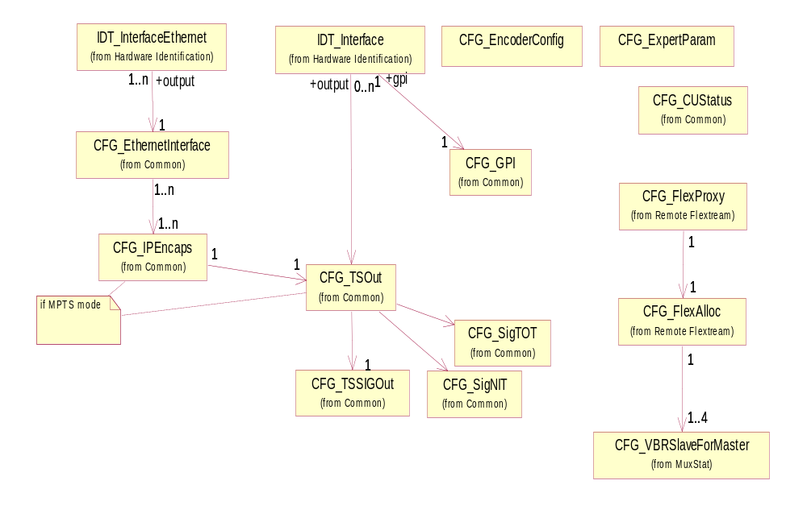
Figure 53 : EM1000/2000 controller configuration

EM1000 encoder configuration

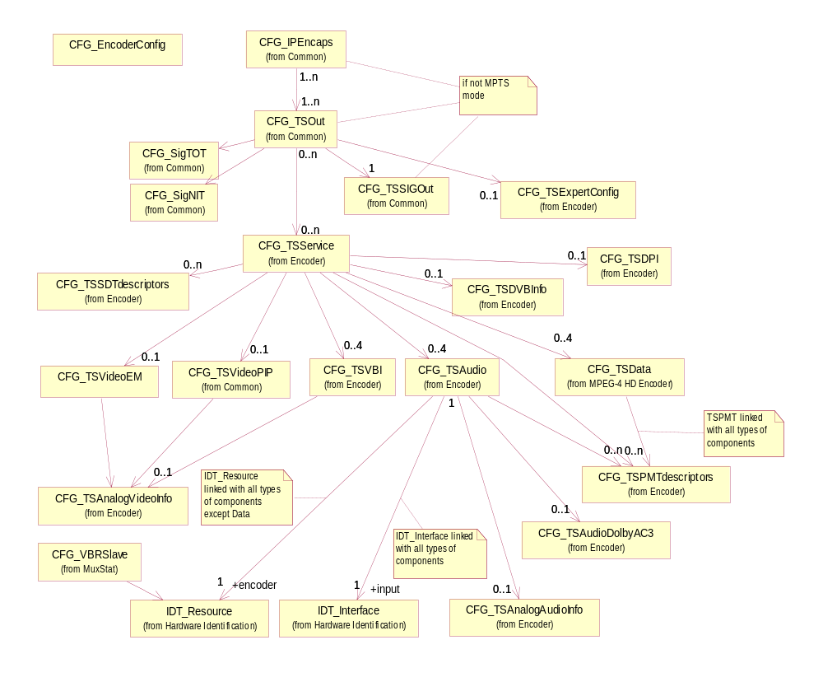
Figure 54 : EM1000 encoder configuration

EM2000 encoder configuration

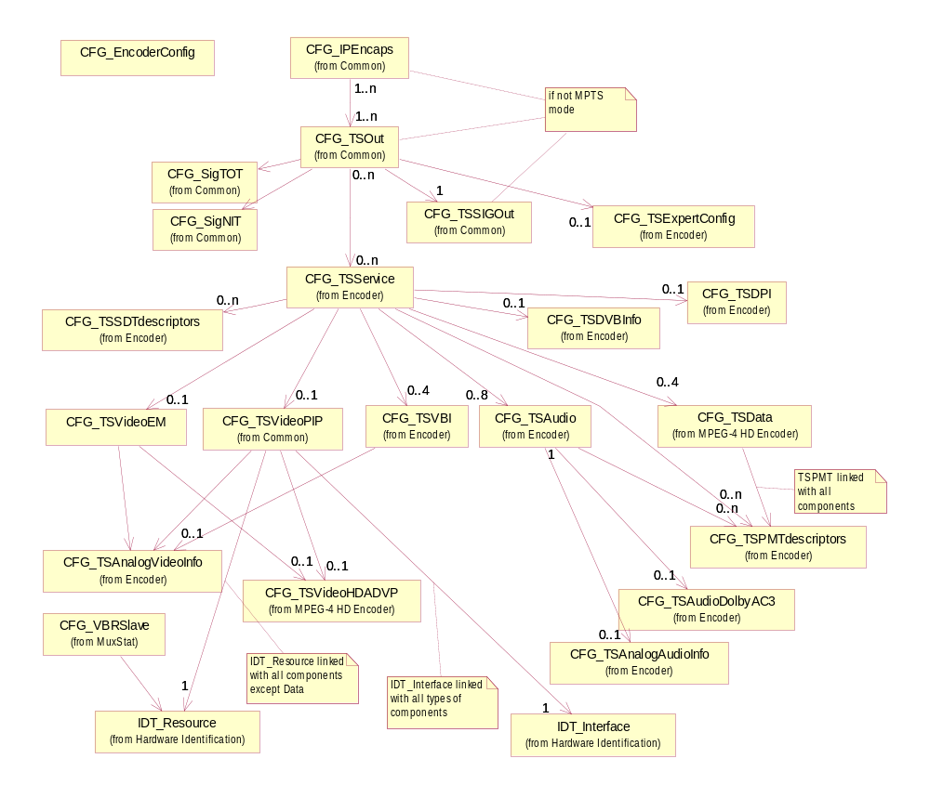
Figure 55 : EM2000 encoder configuration

EM1000 controller - n SPTS example
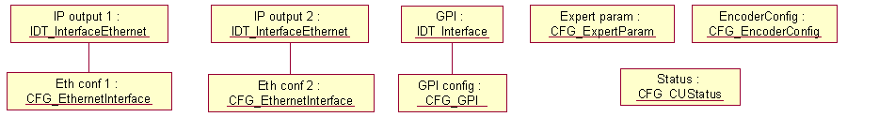
Figure 56 : EM1000 controller - n SPTS example

EM1000 controller - 1 MPTS - IP example
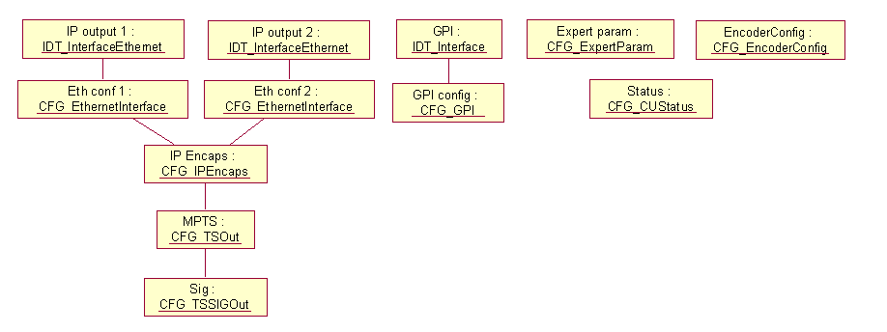
Figure 57 : EM1000 controller - 1 MPTS - IP example

EM1000 controller - 1 MPTS - ASI example
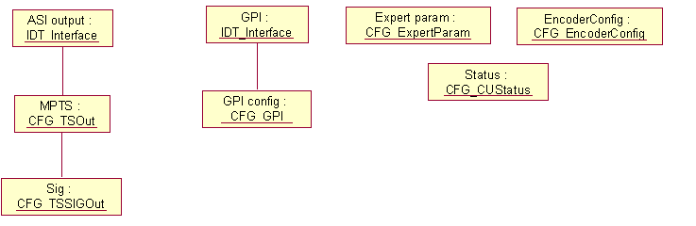
Figure 58 : EM1000 controller - 1 MPTS - ASI example

EM1000 encoder - 1 SPTS example

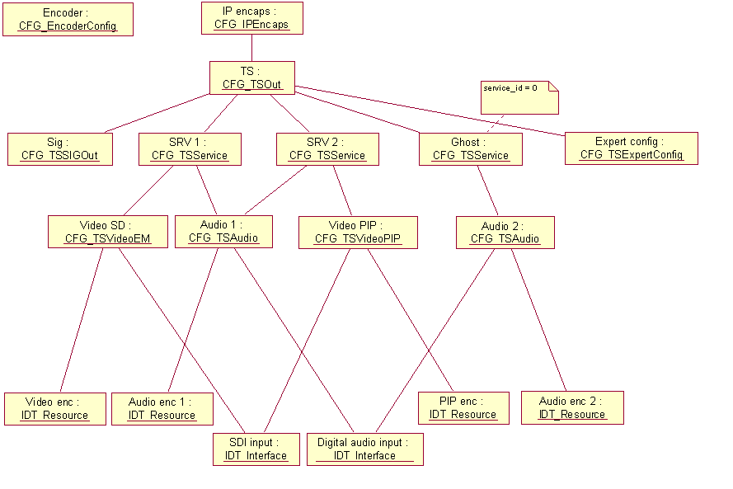
Figure 59 : EM1000 encoder - 1 SPTS example

EM1000 encoder - 2 SPTS example

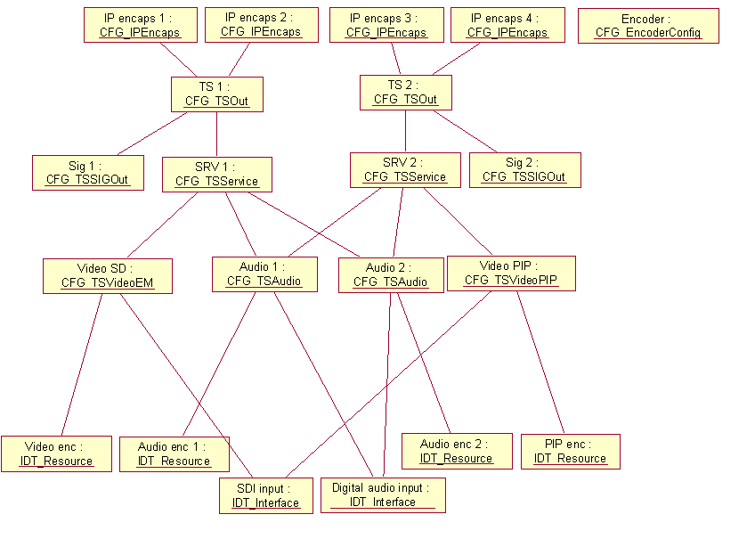
Figure 60 : EM1000 encoder - 2 SPTS example

EM1000 encoder - 1 MPTS example
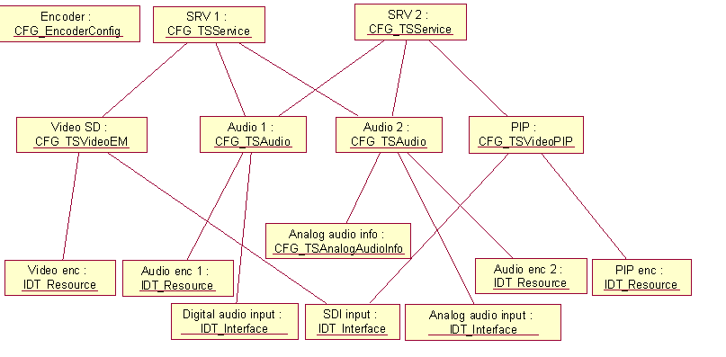
Figure 61 : EM1000 encoder - 1 MPTS example

EM1000/2000 controller default configuration
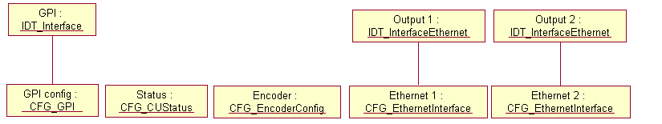
Figure 62 : EM1000/2000 controller default configuration

EM1000 encoder default configuration
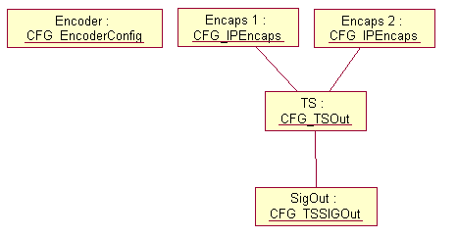
Figure 63 : EM1000 encoder default configuration

EM2000 encoder default configuration
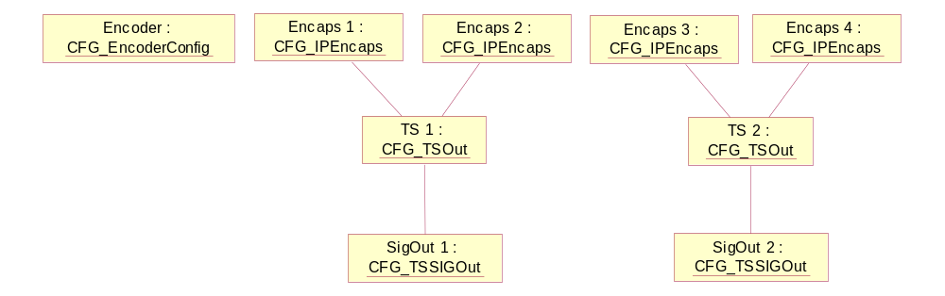
Figure 64 : EM2000 encoder default configuration

EM2000 controller - 1 SPTS example
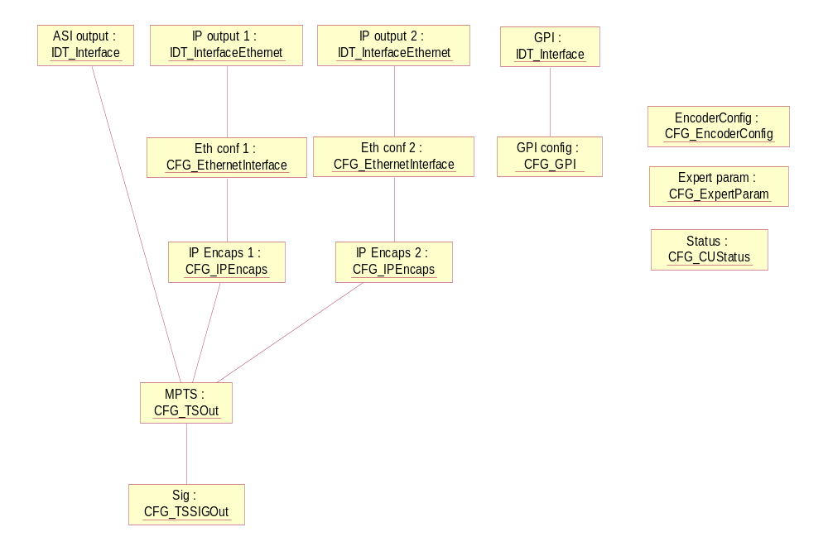
Figure 65 : EM2000 controller - 1 SPTS example

EM2000 controller – 2 SPTS example
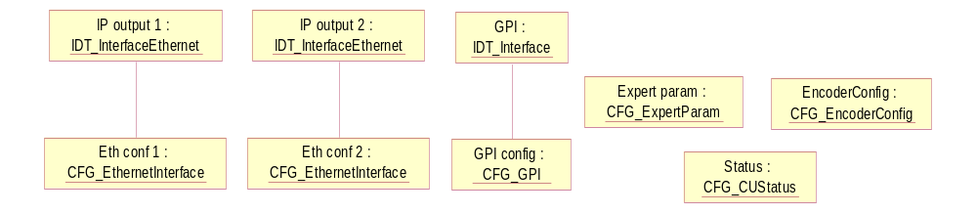
Figure 66 : EM2000 controller – 2 SPTS example

EM2000 encoder - 1 SPTS example
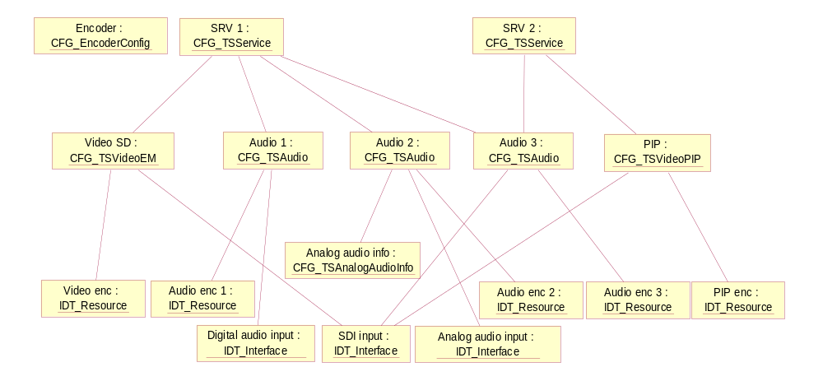
Figure 67 : EM2000 encoder - 1 SPTS example

EM2000 encoder – 2 SPTS example
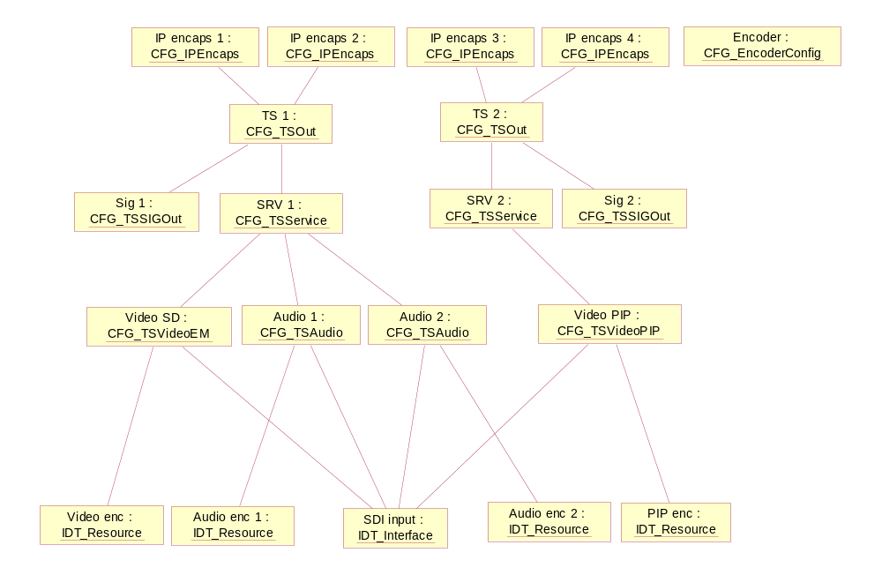
Figure 68 : EM2000 encoder – 2 SPTS example

Mustang SD Encoder Descriptors

Descriptor CFG_EncoderConfig
CFG_EncoderConfig_descriptor()
{
descriptor_header (type = NCCPD_DESC_CFG_ENCODERCONFIG, version = 10) byte[8]

cuid byte[2]
encoder_nb byte[1]
MPTS_mode byte[1]
coding_mode byte[1]
input_mode byte[1]
IP_mode byte[1]
TS_number byte[1]
PCR_synchro_mode byte[1]
PLL_timeout_value byte[2]
video_encoding_mode byte[1]
video_encoding_latency byte[1]
scrambling_mode byte[1]
UHD_downscale byte[1]
ucRobustMode byte[1]
ucRobustStill_Y byte[1]
ucRobustStill_CB byte[1]
ucRobustStill_CR byte[1]
}

cuid Control unit identifier.
Possible values :
- from ENU_MIN_CUID (1) to ENU_MAX_CUID (1023)
(default value = ENU_MIN_CUID)

encoder_nb Possible values :
- 0 for EM_CONTROLLER
- from 1 to 4 for EM_ENCODER
(default value = 0)

MPTS_mode Indicates if the encoder is in MPTS mode or not.
Possible values :
- ENU_OFF
- ENU_ON
(default value = ENU_OFF)
coding_mode Possible values :
- ENU_CODING_MPEG2
- ENU_CODING_MPEG4
- ENU_CODING_HEVC
- ENU_CODING_AVC
(default value = ENU_CODING_MPEG4)
input_mode In transcoder case, indicates which input is used.
Possible values :
- ENU_INPUT_MODE_SDI
- ENU_INPUT_MODE_IP
- ENU_INPUT_MODE_ASI
(default value = ENU_INPUT_MODE_SDI)
IP_mode Defines IP interfaces mode, significant if input_mode=ENU_INPUT_MODE_IP.
Possible values :
- ENU_BIDIR
- ENU_MONODIR
(default value = ENU_MONODIR)
TS_number Number of TS, per shelf if MPTS_mode=ENU_ON, per channel if MPTS_mode=ENU_OFF.
Possible values :
- from 1 to 2
(default value = 1)
PCR_synchro_mode PCR synchronization mode.
Possible values :
- ENU_PCR_SYNC_NONE
- ENU_PCR_SYNC_MASTER
- ENU_PCR_SYNC_SLAVE
(default value = ENU_PCR_SYNC_NONE)
PLL_timeout_value PLL timeout value in seconds.
Possible values :
- from 8 to 120
(default value = 8)
video_encoding_mode Possible values :
- ENU_UHD
- ENU_QUAD_HD
- ENU_SINGLE_HD
- ENU_QUAD_SD_HD
(default value = ENU_UHD)
video_encoding_latency : Possible values :
- ENU_LOW_LATENCY
- ENU_NORMAL_LATENCY
- ENU_ULTRA_LOW_LATENCY
(default value = ENU_NORMAL_LATENCY)
Scrambling_mode: Possible values :
- ENU_SCRAMBLING_MODE_OFF
- ENU_SCRAMBLING_MODE_BISS_1
- ENU_SCRAMBLING_MODE_BISS_2
(default value = ENU_SCRAMBLING_MODE_BISS_1)
UHD_downscale: UHD downscale to 1080p/720p control
Possible values :
- ENU_OFF
- ENU_ON
(default value = ENU_OFF)
UcRobustMode : Encoding operation on Video Signal Loss, possible values:
- ENU_ROBUST_MODE_NO_ENCODING
- ENU_ROBUST_MODE_BLUE_SCREEN
- ENU_ROBUST_MODE_CUSTOM_COLOR (1)
- ENU_ROBUST_MODE_LAST_PICTURE
- : When this mode is selected (Y,CR,CB) color is specified using the following parameters :
- ucRobustStill_Y : Y value in range {16…240}, default = 16 (black)
- ucRobustStill_CB : CB value in range {16…240}, default = 128 (black)
- ucRobustStill_CR : CR value in range {16…240}, default = 128 (black)

Descriptor CFG_ExpertParam
CFG_ExpertParam_descriptor()
{
descriptor_header (type = NCCPD_DESC_CFG_EXPERTPARAM, version = 1) byte[8]

expert_param byte[4]
}

expert_param Bits field used for specific configuration for EM_CONTROLLER function.
(default value = 0)

Descriptor CFG_TSVideoEM
Describes a video component for EM products.
CFG_TSVideoEM_descriptor()
{
descriptor_header (type = NCCPD_DESC_CFG_TSVIDEOEM, version = 13) byte[8]

PID byte[2]
status byte[1]

default_pattern byte[1]
video_profile byte[1]
standard byte[1]
PCR_insertion byte[1]
encoder_bit_rate byte[4]
film_mode byte[1]
aspect_ratio byte[1]
IP_frame byte[1]
GOP_size byte[1]
picture_resolution byte[1]
quantification_MB_adjust byte[1]
entropy_coding byte[1]
deblocking_filter byte[1]
PAFF byte[1]
MBAFF byte[1]
hierarchical_GOP byte[1]
adaptive_GOP byte[1]
VITC byte[1]
VITC_line byte[1]
closed_caption byte[1]
extended_data byte[1]
PES_priority byte[1]
copyright byte[1]
original_or_copy byte[1]
PVR_descriptor byte[1]
EIA708B byte[1]
delay_mode byte[1]
auto_conf byte[1]
closed_GOP_mode byte[1]
nb_lines_CC byte[1]
for (i = 1 ; i <= nb_lines_CC)
{
line byte[2]

}
still_pictures byte[1]
station_id byte[1]
conversion_mode byte[1]
reversion_mode byte[1]
VBI_missing byte[1]
ultra_low_bitrate_encoding byte[1]
fake_bitrate byte[4]
TEMI_insertion byte[1]
GOP_structure byte[1]
pattern_noSource byte[1]
pattern_onLive byte[1]
IDR_interval byte[1]
}
PID TS component PID.
(default value = 256)

status Indicates if the component is actually broadcast or not.
Possible values :
- ENU_ON_AIR (the component is actually broadcast)
- ENU_OFF_AIR (the component is stopped)
(default value = ENU_ON_AIR)

default_pattern This pattern is used either when pattern source is selected or when no signal is detected on the input.
Possible values :
- ENU_DMH_VID_BLACK_PATTERN
- ENU_DMH_VID_BAR_PATTERN
- ENU_VID_NULL_BITRATE
- ENU_VID_DISABLE_TS
- ENU_VID_DISABLE_OUTPUT
- ENU_VID_CUSTOM_PATTERN_1
- ENU_VID_CUSTOM_PATTERN_2
- ENU_VID_CUSTOM_PATTERN_3
- ENU_VID_CUSTOM_PATTERN_4
- ENU_VID_CUSTOM_PATTERN_5
- ENU_VID_CUSTOM_PATTERN_6
- ENU_VID_CUSTOM_PATTERN_7
- ENU_VID_CUSTOM_PATTERN_8
- ENU_VID_BLUE_PATTERN
(default value = ENU_DMH_VID_BLACK_PATTERN)

video_profile Possible values :
- ENU_MPL3
- ENU_HPL3
- ENU_420_MP_ML
- ENU_AVC_MAIN_420
- ENU_AVC_HIGH_420
- ENU_AVC_HIGH10_420
- ENU_AVC_HIGH_422
- ENU_AVC_HIGH10_422
(default value = ENU_MPL3)

standard Possible values :
- ENU_50HZ_AREA
- ENU_60HZ_AREA
(default value = ENU_50HZ_AREA)

PCR_insertion This field is used to insert the Program Reference Clock in the headers of the TS packets transporting the video component.
Possible values :
- ENU_OFF (the component does not carry the PCR)
- ENU_ON (the component carries the PCR)
(default value = ENU_ON)

encoder_bit_rate In bits/s.
Possible values :
- from ENU_EM_MIN_VIDEO_ENCODER_BITRATE to ENU_EM_MAX_VIDEO_ENCODER_BITRATE (from 200 kbits/s to 10 Mbits/s by steps of 1 kbits/s)
(default value = 3000000)

film_mode Possible values :
- ENU_VIDEO_MODE
- ENU_AUTOMATIC_MODE
(default value = ENU_VIDEO_MODE)

aspect_ratio Gives the aspect ratio of the image.
Possible values :
- ENU_4_3_FORMAT
- ENU_16_9_FORMAT
- ENU_4_3_AUTOMATIC_WSS (with a default 4/3 mode)
- ENU_16_9_AUTOMATIC_WSS (with a default 16/9 mode)
- ENU_4_3_AUTOMATIC_AFD (with a default 4/3 mode)
- ENU_16_9_AUTOMATIC_AFD (with a default 16/9 mode)
- ENU_FULL_AUTOMATIC_AFD
(default value = ENU_4_3_FORMAT)

IP_frame This parameter defines the recurrence of non-bidirectional pictures (P or I pictures).
Possible values :
- from 1 to 4
- 8
(default value = 1)

GOP_size This parameter defines the recurrence of the Intra pictures.
Possible values :
- from ENU_EM_MIN_GOP_SIZE (1) to ENU_EM_MAX_GOP_SIZE (64)
(default value = ENU_EM_MIN_GOP_SIZE)

picture_resolution This field allows the picture resolution to be reduced in the event of a low video rate. The picture resolution depends on the picture rate.
Possible values :
- ENU_EM_PR_720_576
- ENU_EM_PR_704_576
- ENU_EM_PR_640_576
- ENU_EM_PR_544_576
- ENU_EM_PR_528_576
- ENU_EM_PR_480_576
- ENU_EM_PR_352_576
(default value = ENU_EM_PR_720_576)

quantification_MB_adjust Indicates if the local adjustment for macro blocks quantification must be used or not.
Possible values :
- ENU_OFF (local quantification MB adjustment is disabled)
- ENU_ON (local quantification MB adjustment is enabled)
- ENU_PVE_STANDARD
- ENU_PVE_NEUTRAL
(default value = ENU_ON)

entropy_coding Used in variable length coding for MPEG-4 encoding.
Possible values :
- ENU_ENTROPY_CAVLC
- ENU_ENTROPY_CABAC
(default value = ENU_ENTROPY_CABAC)

deblocking_filter Use of deblocking filter.
Possible values :
- ENU_ON
- ENU_OFF
- ENU_AUTO_LOW (SOFT)
- ENU_AUTO_MEDIUM (STANDARD)
- ENU_AUTO_HIGH (SHARP)
- ENU_PICTURE_DEF_AUTO
- ENU_PICTURE_DEF_SUPER_SHARP
(default value = ENU_ON)

PAFF Indicates if the Picture Adaptive Field Frame mode is enabled or not.
Possible values :
- ENU_FIELD_MODE
- ENU_FRAME_MODE
- ENU_PAFF_MODE
(default value = ENU_PAFF_MODE)

MBAFF Indicates if the MacroBlock Adaptive Field Frame mode is enabled or not.
Possible values :
- ENU_ON
- ENU_OFF
(default value = ENU_ON)

hierarchical_GOP Indicates if using B pictures as reference is allowed.
Possible values :
- ENU_ON
- ENU_OFF
(default value = ENU_ON)

adaptive_GOP Defines the use of adaptive GOP.
Possible values :
- ENU_AGM_DISABLED
- ENU_AGM_RESTRICTED
- ENU_AGM_FULL
(default value = ENU_ AGM_RESTRICTED)

VITC Possible values :
- ENU_ON
- ENU_OFF
(default value = ENU_OFF)

VITC_line VITC line number.
Possible values in 50Hz :
- from 7 to 22
Possible values in 60Hz :
- from 10 to 21
(default value = TBD)

closed_caption Possible values :
- ENU_ON
- ENU_OFF
(default value = ENU_OFF)

extended_data Possible values :
- ENU_ON
- ENU_OFF
(default value = ENU_OFF)

PES_priority Flag in the PES packet header.
Possible values :
- ENU_PES_WITH_PRIORITY
- ENU_PES_WITHOUT_PRIORITY
(default value = ENU_PES_WITH_PRIORITY)

copyright Flag in the PES packet header.
Possible values :
- ENU_COPYRIGHT_NOT_PROTECTED
- ENU_COPYRIGHT_PROTECTED
(default value = ENU_COPYRIGHT_PROTECTED)

original_or_copy Flag in the PES packet header.
Possible values :
- ENU_PES_ORIGINAL
- ENU_PES_COPY
(default value = ENU_PES_ORIGINAL)

PVR_descriptor Possible values :
- ENU_ON
- ENU_OFF
(default value = ENU_OFF)
EIA708B Possible values :
- ENU_OFF
- ENU_FORCED_EIA708B
- ENU_LATAM
(default value = ENU_OFF)
delay_mode Encoding delay mode.
Possible values :
- ENU_ULTRA_LONG_DELAY
- ENU_LONG_DELAY
- ENU_SHORT_DELAY
- ENU_NORMAL_DELAY
- ENU_LOW_DELAY
- ENU_ULTRA_LOW_DELAY
- ENU_SUPER_SHORT_DELAY
- ENU_ULTRA_SHORT_DELAY
(default value = ENU_ULTRA_LONG_DELAY)
auto_conf Automatic configuration of video parameters.
Possible values :
- ENU_AUTO_OFF
- ENU_AUTO_BITRATE
- ENU_AUTO_VALUES
- ENU_AUTO_BITRATE_AND_VALUES
(default value = ENU_ AUTO_OFF)
closed_GOP_mode Possible values :
- ENU_ON
- ENU_OFF
(default value = ENU_OFF)
nb_lines_CC Number of lines for Close Caption.
Possible values :
- from 0 to 6
(default value = 0)
line Possible values : 17, 18, 21, 280, 281, 284
(default value = 0)
still_pictures Still pictures mode.
Possible values :
- ENU_OFF
- ENU_SP_LOW_BITRATE
- ENU_SP_HIGH_BITRATE
(default value = ENU_OFF)
station_id Possible values :
- ENU_ON
- ENU_OFF
(default value = ENU_OFF)
conversion_mode Indicates the conversion mode, in case of downscale.
Possible values :
- ENU_SD_CONV_AUTO_AFD (Full Auto AFD: Under AFD control)
- ENU_SD_CONV_FORCED_ADD_LETTERBOX
- ENU_SD_CONV_FORCED_ADD_14_9_LETTERBOX
- ENU_SD_CONV_FORCED_CUT_CENTER
- ENU_SD_CONV_FORCED_SQUEEZE
- ENU_SD_CONV_AUTO_4_3_AFD (4/3 Auto AFD: Under AFD control)
- ENU_SD_CONV_AUTO_16_9_AFD (16/9 Auto AFD: Under AFD control)
(default value = ENU_SD_CONV_AUTO_AFD)
reversion_mode Indicates the reversion mode, in case of downscale and AUTO conversion mode.
Possible values :
- ENU_SD_REV_KEEP_LAST
- ENU_SD_REV_ADD_LETTERBOX.
(default value = ENU_SD_REV_KEEP_LAST)
VBI_missing Delay for VBI missing alarm (in seconds).
Possible values :
- from 0 to 90
- ENU_EM_VBI_DISABLE_ALARM (255)
(default value = 0)
ultra_low_bitrate_encoding Indicates if ultra low bitrate encoding is enabled.
Possible values :
- ENU_ON
- ENU_OFF
(default value = ENU_OFF)
fake_bitrate Used to store the bitrate (in bits/s) set in Web interface. In MPEG-4, it can be upper than actual bitrate stored in encoder_bit_rate attribute.
Possible values :
- from 200000 to 15000000
(default value = 3000000)
TEMI_insertion Possible values :
- ENU_OFF
- ENU_ON
(default value = ENU_OFF)
GOP_structure Possible values :
- ENU_GOP_STRUCTURE_I_ONLY
- ENU_GOP_STRUCTURE_IPPP
- ENU_GOP_STRUCTURE_FREE
(default value = ENU_GOP_STRUCTURE_FREE)
pattern_noSource Possible values :
- ENU_ON
- ENU_OFF
(default value = ENU_OFF)
pattern_onLive Possible values :
- ENU_ON
- ENU_OFF
(default value = ENU_OFF)
IDR_interval Specify the period between each IDR picture. (unit=gop count)
Possible values :
- from 2 to 100
(default value = 100)

Descriptor CFG_TSVideoLogo
CFG_TSVideoLogo_descriptor()
{
descriptor_header (type = NCCPD_DESC_CFG_TSVIDEOLOGO, version = 3) byte[8]

insertion_status byte[1]
name byte[1+n]
position_x byte[2]
position_y byte[2]
transparency byte[1]
GPI_trigger byte[1]
GPI_level byte[1]
fade_in byte[2]
fade_out byte[2]
logo_number byte[1]
insertion_layer byte[1]
}
insertion_status Indicates if the logo is currently inserted or not.
Possible values :
- ENU_OFF
- ENU_ON
(default value = ENU_OFF)
name Logo file name.
(default value = “”)
position_x
Logo position.
Possible values :
- from 0 to 719
(default value = 0)
position_y
Logo position.
Possible values :
- from 0 to 575 (if 50 Hz) or 479 (if 59.94 Hz)
(default value = 0)
tr
ansparency Logo transparency in %, the bigger the more transparent.
Possible values :
- from 0 to 100
(default value = 0)
GPI_trigger Possible values :
- ENU_NONE
- ENU_GPI_INPUT1
- ENU_GPI_INPUT2
- ENU_GPI_INPUT3
- ENU_GPI_INPUT4
(default value = ENU_NONE)
GPI_level Possible values :
- ENU_LOW_LEVEL
- ENU_HIGH_LEVEL
(default value = TBD)

fade_in Fade in duration in ms.
Possible values :
- from 0 to TBD
(default value = 0)
fade_out Fade out duration in ms.
Possible values :
- from 0 to TBD
(default value = 0)
logo_number Logo number.
Possible values :
- from 1 to 32
(default value = 1)
insertion_layer Possible values :
- from 1 to 2
(default value = 1)

Descriptor CFG_FTP
CFG_FTP_descriptor()
{
descriptor_header (type = NCCPD_DESC_CFG_FTP, version = 1) byte[8]

primary_server_address byte[4]
primary_server_login byte[1+n]
primary_server_password byte[1+n]
backup_server_enable byte[1]
backup_server_address byte[4]
backup_server_login byte[1+n]
backup_server_password byte[1+n]
}
primary_server_address IP address of the primary FTP server.
(default value = 0)
primary_server_login (default value = “”)
primary_server_password (default value = “”)
backup_server_enable Indicates if a backup FTP server is defined
Possible values :
- ENU_ENABLE
- ENU_DISABLE
(default value = ENU_DISABLE)
backup_server_address IP address of the backup FTP server.
(default value = 0)
backup_server_login (default value = “”)
backup_server_password (default value = “”)

Descriptor CFG_Logos
CFG_Logos_descriptor()
{
descriptor_header (type = NCCPD_DESC_CFG_LOGOS, version = 3) byte[8]

nb_logos byte[1]
for (i = 1 ; i <= nb_logos)
{
logo_number byte[1]
FTP_upload_enable byte[1]
logo_pathname byte[1+n]
logo_filename byte[1+n]

}
multiple_logos byte[1]
nb_logos2 byte[1]
for (i = 1 ; i <= nb_logos2)
{
geometry byte[1]
}
}
nb_logos Number of logos loaded on the encoder.
Possible values :
- from 0 to 32
(default value = 0)
logo_number Logo number.
Possible values :
- from 1 to 32
(default value = 1)
FTP_upload_enable Indicates if FTP upload is enabled or not.
Possible values :
- ENU_ENABLE
- ENU_DISABLE
(default value = ENU_DISABLE)
logo_pathname If FTP upload is enabled, indicates the pathname on FTP server.
(default value = “”)
logo_filename Indicates logo filename.
(default value = “”)
multiple_logos Possible values :
- ENU_ON
- ENU_OFF
(default value = ENU_OFF)
nb_logos2 Number of logos loaded on the encoder.
Possible values :
- from 0 to 32
(default value = 0)
geometry Possible values :
- ENU_EM_WXH_NONE
- ENU_EM_WXH_1920_1080
- ENU_EM_WXH_1280_720
- ENU_EM_WXH_720_576
- ENU_EM_WXH_720_480
(default value = ENU_EM_WXH_NONE)

Descriptor CFG_Patterns
CFG_Patterns_descriptor()
{
descriptor_header (type = NCCPD_DESC_CFG_PATTERNS, version = 2) byte[8]

nb_patterns byte[1]
for (i = 1 ; i <= nb_patterns)
{
pattern_number byte[1]
FTP_upload_enable byte[1]
pattern_pathname byte[1+n]
pattern_filename byte[1+n]
pattern_geometry_wxh byte[1]

}
}
nb_patterns Number of patterns loaded on the encoder.
Possible values :
- from 0 to 8
(default value = 0)
pattern_number Pattern number.
Possible values :
- from 1 to 8
(default value = 1)
FTP_upload_enable Indicates if FTP upload is enabled or not.
Possible values :
- ENU_ENABLE
- ENU_DISABLE
(default value = ENU_DISABLE)
pattern_pathname If FTP upload is enabled, indicates the pathname on FTP server.
(default value = “”)
pattern_filename Indicates pattern filename.
(default value = “”)
pattern_geometry_wxh Indicates pattern geometry width x height size.
Possible values :
- ENU_EM_WXH_NONE
- ENU_EM_WXH_1920_1080
- ENU_EM_WXH_1280_720
- ENU_EM_WXH_720_576
- ENU_EM_WXH_720_480
(default value = ENU_EM_WXH_1920_1080)

Descriptor CFG_Fonts
CFG_Fonts_descriptor()
{
descriptor_header (type = NCCPD_DESC_CFG_FONTS, version = 1) byte[8]

nb_fonts byte[1]
for (i = 1 ; i <= nb_fonts)
{
font_number byte[1]
FTP_upload_enable byte[1]
font_pathname byte[1+n]
font_filename byte[1+n]

}
}
nb_fonts Number of fonts loaded on the encoder.
- from 0 to 4 for EM1000/2000
- from 0 to 32 for EM4000
(default value = 0)
font_number Font number.
Possible values :
- from 1 to 4 for EM1000/2000
- from 1 to 32 for EM4000
(default value = 1)
FTP_upload_enable Indicates if FTP upload is enabled or not.
Possible values :
- ENU_ENABLE
- ENU_DISABLE
(default value = ENU_DISABLE)
font_pathname If FTP upload is enabled, indicates the pathname on FTP server.
(default value = “”)
font_filename Indicates font filename.
(default value = “”)

Descriptor CFG_DVBSubtitle
Describes a DVB Subtitle component for EM products.
CFG_DVBSubtitle_descriptor()
{
descriptor_header (type = NCCPD_DESC_CFG_DVBSUBTITLE, version = 8) byte[8]

PID byte[2]
status byte[1]

stream_type byte[1]
font_default byte[1]
prioritize_center byte[1]
picture_standard byte[1]
display_width byte[2]
display_height byte[2]
max_bitrate byte[4]
presend byte[2]
display_segment_definition byte[1]
end_display_segment byte[1]
white_level byte[1]
box_transparency byte[1]
box_style byte[1]
nb_languages byte[1]
for (i = 1 ; i <= nb_languages)
{
pattern byte[1]
input_PID byte[2]
input_page_number byte[2]
input_code_page byte[1]
input_packet_26 byte[1]
ISO639_language_code byte[1+n]
page_id byte[1]

}
vertical_offset byte[1]
text_height byte[1]
border_width byte[1]
no_teletext byte[1]
left_margin byte[1]
right_margin byte[1]
box_height byte[1]
auto_wipe_out byte[1]
extended_vertical_offset byte[2]
extended_left_margin byte[2]
extended_right_margin byte[2]
default_alignment byte[1]
livesub_status byte[1]
livesub_mode byte[1]
livesub_delay byte[2]
livesub_alarm byte[1]
}
PID TS component PID.
PID inserted by the module for the transcoded sub-title stream. The same PID can be used to multiplex.
Possible values :
- from 32 to 8190
(default value = 0)

status Indicates if the component is actually broadcast or not.
Possible values :
- ENU_ON_AIR (the component is actually broadcast)
- ENU_OFF_AIR (the component is stopped)
(default value = ENU_ON_AIR)

stream_type (default value = 6)
font_default Identifies the font used to transcode teletext.
Possible values :
- ENU_DVBSUB_FONT_DEFAULT (default embedded font file)
- ENU_DVBSUB_FONT_DOWNLOADED (the downloaded font file for EM1000/2000).
- from 1 to 32 (for EM4000, one of the fonts downloaded on the encoder)
(default value = ENU_DVBSUB_FONT_DEFAULT)
prioritize_center Indicates whether the module shall activate an algorithm in order to position subtitles on the left, right or center of the picture.
Possible values :
- ENU_ON
- ENU_OFF
(default value = ENU_ON)
picture_standard For subtitles positioning in HD. In SD, the default value is General.
Possible values :
- ENU_DVBSUB_STANDARD_GENERAL
- ENU_DVBSUB_STANDARD_2_21_1
- ENU_DVBSUB_STANDARD_16_9
- ENU_DVBSUB_STANDARD_14_9
- ENU_DVBSUB_STANDARD_4_3
(default value = ENU_DVBSUB_STANDARD_GENERAL)
display_width Pixels per line. For subtitles positioning. Required by the latest version of the standard (v1.3.1). Shall be set to 720 for SD in 50Hz.
Possible values :
- from 0 to 4095
(default value = 720)
display_height Lines per frame. For subtitles positioning. Required by the latest version of the standard.Shall be set to 576 for SD in 50Hz.
Possible values :
- from 0 to 4095
(default value = 576)
max_bitrate Maximum burst bit rate for DVB subtitling in bits per second. Typical value is 192kbps even if average value bitrate is 30kbps. A lower value might delay the appearance of the subtitles. The same value should be used for all channels.
Possible values :
- from 32000 to 500000
(default value = 192000)
presend Delay in milliseconds between transmission of subtitles and transmission of video data. This parameter is used in conjunction with the Video_encoding_delay parameters to compute the injection time of the subtitles.
Possible values :
- from 200 to 2000
(default value = 500)
display_segment_definition This parameter is used for solving interoperability issues.
Possible values :
- ENU_NOT_COMPLIANT (Not compliant with the latest standard (v1.3.1))
- ENU_COMPLIANT (Compliant with the latest standard)
(default value = ENU_NOT_COMPLIANT)
end_display_segment Includes the End Of Display segment for the newer DVB subtitling revision (v1.3.1). Certain decoders have trouble is this is present (ADB). This parameter is used for solving interoperability issues.
Possible values :
- ENU_NOT_COMPLIANT (Not compliant with the latest standard (v1.3.1))
- ENU_COMPLIANT (Compliant with the latest standard)
(default value = ENU_COMPLIANT)
white_level Possible values :
- from 50 to 100
(default value = 83)
box_transparency Defines the type of background to use for rendering subtitles. Possible values :
- from 0 to 100
(default value = 0)
box_style Defines the visual style.
Possible values :
- ENU_DVBSUB_WIDE
- ENU_DVBSUB_SHORT
(default value = ENU_DVBSUB_WIDE)
nb_languages Identifies the number of languages managed by Scribe.
Possible values :
- from 1 to 2
(default value = 0)
pattern Pattern mode delivering DVB Subtitle when no teletext is provided for demo purpose.
Possible values :
- ENU_DVBSUB_NO_PATTERN
- ENU_DVBSUB_PATTERN_MODE
(default value = ENU_DVBSUB_NO_PATTERN)
input_PID Identifies the input PID containing the subtitles to transcode.
Possible values :
- from 32 to 8190
(default value = 0)
input_page_number Identifies the teletext stream containing the subtitles to transcode in the input stream.
Possible values :
- from 100 to 899
(default value = 888)
input_code_page Identifies the code page to use when interpreting the text.
Possible values :
- from 0 to 6
(default value = 0)
input_packet_26 Indicates if packet 26 G2 character tables are used in the incoming stream. This parameter is used for interoperability.
Possible values :
- ENU_ON
- ENU_OFF
(default value = ENU_ON)
ISO639_language_code ISO639 3 character language code.
(default value = “”)
page_id Identifies the subtitle service identification inserted by the module. This number allows selecting a subtitling stream when several streams are carried by the same PID.
Possible values :
- from 1 to 15
(default value = 1)
vertical_offset Defines the vertical offset in pixels for true type font.
Possible values :
- from 0 to 160
(default value = 40)
text_height Defines the text height in pixels for true type font.
Possible values :
- from 30 to 48
(default value = 40)
border_width Defines the border width in pixels for true type font.
Possible values :
- from 0 to 6
(default value = 2)
no_teletext Indicates what Scribe shall do if no teletext is present at input.
Possible values :
- ENU_NO_TXT_PID_MISSING (the DVB Sub PID disappears)
- ENU_NO_TXT_PID_WITH_STUFFING (the DVB Sub PID still exists and contains minimum stuffing data (about 10 kbits/s))
(default value = ENU_NO_TXT_PID_MISSING)
left_margin Defines the horizontal left adjustment, in pixels : allows to adjust the first left pixel of a DVB Sub line (first pixel = 0 + left_margin).
Possible values :
- from 20 to 100
(default value = 60)
right_margin Defines the horizontal right adjustment, in pixels : allows to adjust the last right pixel of a DVB Sub line (last pixel = display_width – right_margin).
Possible values :
- from 20 to 100
(default value = 60)
box_height Defines the Box height ( “Background” Height) in pixels : allows also to adjust the “transparent space” area vertical size between adjacent DVB Sub lines.
Possible values :
- from 34 to 48
(default value = 44)
auto_wipe_out Defines a timeout in seconds before the last subtitle deletion.
Possible values :
- from 5 to 60
- ENU_OFF (0)
(default value = 10)
extended_vertical_offset Defines the vertical offset in pixels for true type font (used for EM4000).
Possible values :
- from 0 to 300
(default value = 40)
extended_left_margin Defines the horizontal left adjustment, in pixels : allows to adjust the first left pixel of a DVB Sub line (first pixel = 0 + left_margin) (used for EM4000).
Possible values :
- from 20 to 500
(default value = 60)
extended_right_margin Defines the horizontal right adjustment, in pixels : allows to adjust the last right pixel of a DVB Sub line (last pixel = display_width – right_margin) (used for EM4000).
Possible values :
- from 20 to 500
(default value = 60)
default_alignment Indicates the default text alignment.
Possible values :
- ENU_ALIGN_LEFT
- ENU_ALIGN_CENTER
- ENU_ALIGN_RIGHT
(default value = ENU_ALIGN_CENTER)
livesub_status Possible values :
- ENU_ON
- ENU_OFF
livesub_mode Possible values :
- ENU_DVBSUB_LIVESUB_STATIC
- ENU_DVBSUB_LIVESUB_SCTE104_FORCED
- ENU_DVBSUB_LIVESUB_DYNAMIC
livesub _delay Compensation delay in ms.
(default value = 3000)
livesub _alarm Delay for SCTE104 missing alarm (in seconds).
Possible values :
- from 0 to 90
- ENU_EM_VBI_DISABLE_ALARM (255)
(default value = 0)

Descriptor CFG_TSDataPassThru
CFG_TSDataPassThru_descriptor()
{
descriptor_header (type = NCCPD_DESC_CFG_TSDATAPASSTHRU, version = 1) byte[8]

nb_data_PID byte[1]
for (i = 1 ; i <= nb_data_PID)
{
index byte[1]
PID byte[2]

}
}
nb_data_PID Identifies the number of input data PIDs.
Possible values :
- from 0 to 4
(default value = 0)
index Possible values :
- from 1 to 4
(default value = 1)
PID Input data PID.
Possible values :
- from 16 to 8190
(default value = 0)

Descriptor CFG_PreservedAreas
CFG_PreservedAreas_descriptor()
{
descriptor_header (type = NCCPD_DESC_CFG_PRESERVEDAREAS, version = 1) byte[8]

nb_preserved_areas byte[1]
for (i = 1 ; i <= nb_preserved_areas)
{
mode byte[1]
position_x byte[2]
position_y byte[2]
size_x byte[2]
size_y byte[2]
strength byte[1]

}
}
nb_preserved_areas Defines the number of preserved areas.
Possible values :
- from 0 to 3
(default value = 0)
mode Defines the mode of area preservation.
Possible values :
- ENU_OFF
- ENU_ON
- ENU_MODE_SETUP
(default value = ENU_OFF)
position_x Defines the position of the area (in pixels).
Possible values :
- from 0 to 720
(default value = 0)
position_y Defines the position of the area (in pixels).
Possible values :
- from 0 to 576
(default value = 0)
size_x Defines the size of the area (in pixels).
Possible values :
- from 0 to 720
(default value = 0)
size_y Defines the size of the area (in pixels).
Possible values :
- from 0 to 576
(default value = 0)
strength Defines the strength of area preservation.
Possible values :
- ENU_STRENGTH_LOW
- ENU_STRENGTH_MEDIUM
- ENU_STRENGTH_HIGH
(default value = ENU_STRENGTH_LOW)

AVDEC

AVDEC Diagrams

AVDEC Configuration

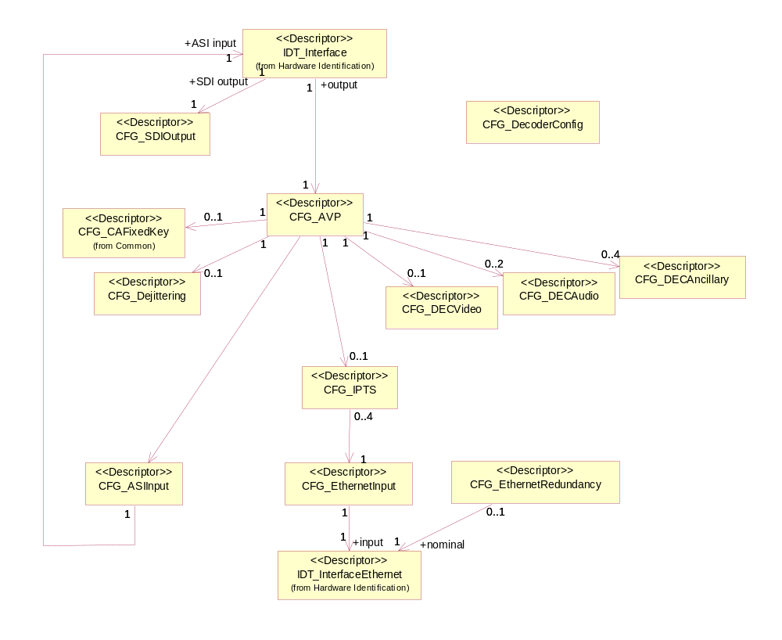
Figure 69 : AVDEC Configuration

AVDEC config example

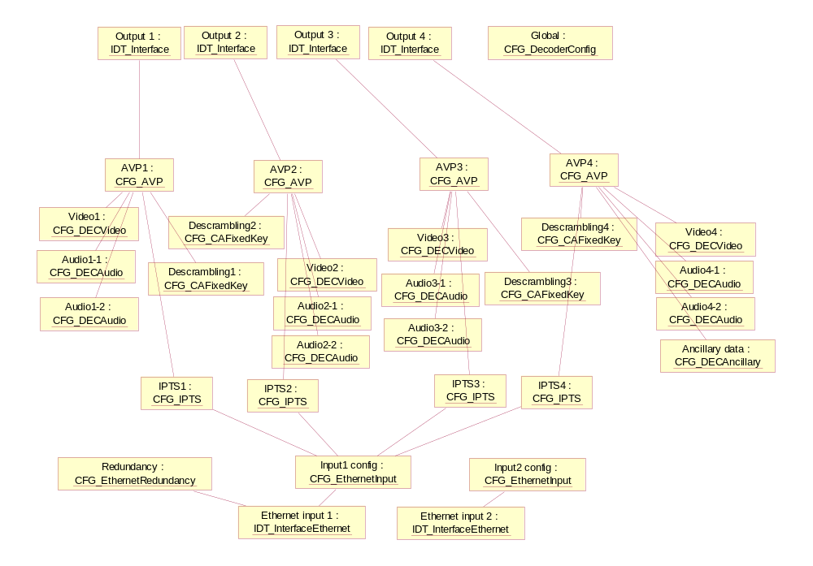
Figure 70 : AVDEC config example

AVDEC Descriptors

Descriptor CFG_SDIOutput
CFG_SDIOutput_descriptor()
{
descriptor_header (type = NCCPD_DESC_CFG_SDIOUTPUT, version = 1) byte[8]

upscaling byte[1]
}

upscaling (default value = 0)

Descriptor CFG_AVP
Configuration of an AudioVisual Program.
CFG_AVP_descriptor()
{
descriptor_header (type = NCCPD_DESC_CFG_AVP, version = 4) byte[8]

auto_decoding_by_service byte[1]
service_id byte[2]
PCR_PID byte[2]
TS_output_clock byte[1]
CCAP_enable byte[1]
WSS_enable byte[1]
VITC_DVITC_enable byte[1]
assistance_data_enable byte[1]
assistance_data_field byte[1]
assistance_data_first_VBI_line byte[1]
native_output_format byte[1]
automatic_AFD_downscaling byte[1]
downscaling_format byte[1]
video_downscale_mode byte[1]
video_upscale_mode byte[1]
ANC_CC_EIA608_enable byte[1]
ANC_CC_EIA708_enable byte[1]
ANC_AFD_ANC_enable byte[1]
ANC_MPEG2_headers_enable byte[1]
ANC_H264_headers_enable byte[1]
ANC_PES_data_info_enable byte[1]
ANC_PES_header_enable byte[1]
PLL_mode byte[1]
PLL_forced_mode byte[1]
rescale_mode byte[1]
}

auto_decoding_by_service Possible values :
- ENU_ENABLE
- ENU_DISABLE
(default value = ENU_ENABLE)

service_id Possible values :
- from 1 to 65535
(default value = 1)

PCR_PID Possible values :
- from 1 to 8191
(default value = 1)

TS_output_clock Possible values :
- ENU_INTERNAL_CLOCK
- ENU_EXTERNAL_CLOCK
(default value = ENU_EXTERNAL_CLOCK)

CCAP_enable Possible values :
- ENU_ENABLE
- ENU_DISABLE
(default value = ENU_ENABLE)

WSS_enable Possible values :
- ENU_ENABLE
- ENU_DISABLE
(default value = ENU_ENABLE)

VITC_DVITC_enable Possible values :
- ENU_ENABLE
- ENU_DISABLE
(default value = ENU_ENABLE)

assistance_data_enable Possible values :
- ENU_ENABLE
- ENU_DISABLE
(default value = ENU_ENABLE)

assistance_data_field Possible values :
- from 0 to 1
(default value = 0)

assistance_data_first_VBI_line Possible values :
- from 1 to 23
(default value = 1)

native_output_format Possible values :
- ENU_ENABLE
- ENU_DISABLE
(default value = ENU_ENABLE)

automatic_AFD_downscaling Possible values :
- ENU_ENABLE
- ENU_DISABLE
(default value = ENU_ENABLE)

downscaling_format (default value = 0)
video_downscale_mode Possible values :
- ENU_ENABLE
- ENU_DISABLE
(default value = ENU_DISABLE)
video_upscale_mode Possible values :
- ENU_ENABLE
- ENU_DISABLE
(default value = ENU_ENABLE)
ANC_CC_EIA608_enable Possible values :
- ENU_ENABLE
- ENU_DISABLE
(default value = ENU_ENABLE)
ANC_CC_EIA708_enable Possible values :
- ENU_ENABLE
- ENU_DISABLE
(default value = ENU_ENABLE)
ANC_AFD_ANC_enable Possible values :
- ENU_ENABLE
- ENU_DISABLE
(default value = ENU_ENABLE)
ANC_MPEG2_headers_enable Possible values :
- ENU_ENABLE
- ENU_DISABLE
(default value = ENU_ENABLE)
ANC_H264_headers_enable Possible values :
- ENU_ENABLE
- ENU_DISABLE
(default value = ENU_ENABLE)
ANC_PES_data_info_enable Possible values :
- ENU_ENABLE
- ENU_DISABLE
(default value = ENU_ENABLE)
ANC_PES_header_enable Possible values :
- ENU_ENABLE
- ENU_DISABLE
(default value = ENU_ENABLE)
PLL_mode Possible values :
- ENU_PLL_AUTO
- ENU_PLL_FORCED
(default value = ENU_PLL_FORCED)
PLL_forced_mode Significant only if PLL_mode = ENU_PLL_FORCED.
Possible values :
- ENU_PLL_FREE_RUN
- ENU_PLL_RCV_LOCK
(default value = ENU_PLL_RCV_LOCK)
rescale_mode Indicates if the upscale/downscale feature (according to the TS source that is currently being decoded (SD or HD)) shall be automatically activated.
Possible values :
- ENU_AUTO
- ENU_DISABLE
(default value = ENU_DISABLE)

Descriptor CFG_DECVideo
CFG_DECVideo_descriptor()
{
descriptor_header (type = NCCPD_DESC_CFG_DECVIDEO, version = 1) byte[8]

PID byte[2]

concealment_mode byte[1]
}
PID Possible values :
- from 1 to 8191
(default value = 1)

concealment_mode (default value = 0)

Descriptor CFG_DECAudio
CFG_DECAudio_descriptor()
{
descriptor_header (type = NCCPD_DESC_CFG_DECAUDIO, version = 3) byte[8]

PID byte[2]

decoding byte[1]
embedding_group byte[1]
embedding_channel byte[1]
audio_mode byte[1]
TS_passthru_test byte[1]
}
PID Possible values :
- from 1 to 8191
(default value = 1)

decoding (default value = 0)

embedding_group Possible values :
- ENU_GROUP1
- ENU_GROUP2
- ENU_GROUP3
- ENU_GROUP4
(default value = ENU_GROUP1)

embedding_channel Possible values :
- ENU_CHANNEL1
- ENU_CHANNEL2
(default value = ENU_CHANNEL1)
audio_mode Possible values :
- ENU_COMPRESSED
- ENU_UNCOMPRESSED
(default value = ENU_COMPRESSED)
TS_passthru_test Indicates if audio passthru without error masking is done.
Possible values :
- ENU_ON
- ENU_OFF
(default value = ENU_OFF)

Descriptor CFG_DECAncillary
CFG_DECAncillary_descriptor()
{
descriptor_header (type = NCCPD_DESC_CFG_DECANCILLARY, version = 1) byte[8]

PID byte[2]

embedding_mode byte[1]
embedding_field byte[1]
embedding_line byte[1]
}
PID Possible values :
- from 1 to 8191
(default value = 1)

embedding_mode Possible values :
- from 0 to 1
(default value = 0)

embedding_field Possible values :
- from 0 to 1
(default value = 0)

embedding_line Possible values :
- from 1 to 23
(default value = 1)

Descriptor CFG_ASIInput
CFG_ASIInput_descriptor()
{
descriptor_header (type = NCCPD_DESC_CFG_ASIINPUT, version = 2) byte[8]

packet_size byte[1]
input_enable byte[1]
}

packet_size Possible values :
- ENU_WITHOUT_REED_SOLOMON
- ENU_WITH_REED_SOLOMON
(default value = ENU_WITHOUT_REED_SOLOMON)
input_enable Indicates if the ASI input is enabled or not.
Possible values :
- ENU_ENABLE
- ENU_DISABLE
(default value = ENU_DISABLE)

Descriptor CFG_EthernetInput
CFG_EthernetInput_descriptor()
{
descriptor_header (type = NCCPD_DESC_CFG_ETHERNETINPUT, version = 3) byte[8]

MAC_address byte[6]
auto_negotiation byte[1]
speed byte[1]
duplex_mode byte[1]
IP_address byte[4]
IP_mask byte[4]
IP_gateway byte[4]
input_enable byte[1]
interface_desactivation byte[1]
}

MAC_address (default value = 0)

auto_negotiation Possible values :
- ENU_AUTO
- ENU_MANUAL
(default value = ENU_AUTO)

speed Possible values :
- ENU_10MBS
- ENU_100MBS
- ENU_1GBS
(default value = ENU_1GBS)

duplex_mode Possible values :
- ENU_FULL
- ENU_HALF
(default value = ENU_FULL)

IP_address (default value = 0)

IP_mask (default value = 0)

IP_gateway (default value = 0)
input_enable Indicates if the IP input is enabled or not.
Possible values :
- ENU_ENABLE
- ENU_DISABLE
(default value = ENU_DISABLE)
interface_desactivation Indicates the link status when the input is disabled.
Possible values :
- ENU_LINK_DOWN
- ENU_LINK_UP_NO_MULTICAST
(default value = ENU_LINK_DOWN)

Descriptor CFG_EthernetRedundancy
CFG_EthernetRedundancy_descriptor()
{
descriptor_header (type = NCCPD_DESC_CFG_ETHERNETREDUNDANCY, version = 1) byte[8]

automatic_redundancy byte[1]
criteria1_enable byte[1]
criteria2_enable byte[1]
criteria3_enable byte[1]
criteria4_enable byte[1]
timeout byte[1]
}

automatic_redundancy Possible values :
- ENU_AUTO
- ENU_MANUAL
(default value = ENU_AUTO)

criteria1_enable Possible values :
- ENU_ENABLE
- ENU_DISABLE
(default value = ENU_ENABLE)

criteria2_enable Possible values :
- ENU_ENABLE
- ENU_DISABLE
(default value = ENU_ENABLE)

criteria3_enable Possible values :
- ENU_ENABLE
- ENU_DISABLE
(default value = ENU_ENABLE)

criteria4_enable Possible values :
- ENU_ENABLE
- ENU_DISABLE
(default value = ENU_ENABLE)

timeout Possible values :
- from 0 to 60
(default value = 0)

Descriptor CFG_IPTS
CFG_IPTS_descriptor()
{
descriptor_header (type = NCCPD_DESC_CFG_IPTS, version = 3) byte[8]

source_IP_address byte[4]
IP_subscribe_address byte[4]
UDP_subscribe_port byte[2]
packet_reordering byte[1]
RTP_enable byte[1]
FEC_enable byte[1]
transport_resource_name byte[1+n]
enable byte[1]
}

source_IP_address (default value = 0)

IP_subscribe_address (default value = 0)

UDP_subscribe_port (default value = 0)

packet_reordering Possible values :
- ENU_ENABLE
- ENU_DISABLE
(default value = ENU_ENABLE)

RTP_enable Possible values :
- ENU_ENABLE
- ENU_DISABLE
(default value = ENU_ENABLE)

FEC_enable Possible values :
- ENU_ENABLE
- ENU_DISABLE
(default value = ENU_ENABLE)
transport_resource_name Descriptive label of the transport resource, configured by the management system.
(default value = “”)
enable Indicates if the transport resource is enabled or not.
Possible values :
- ENU_ENABLE
- ENU_DISABLE
(default value = ENU_DISABLE)

Descriptor CFG_Dejittering
CFG_Dejittering_descriptor()
{
descriptor_header (type = NCCPD_DESC_CFG_DEJITTERING, version = 1) byte[8]

correction_level byte[1]
}

correction_level Possible values :
- ENU_DEJITTER_BYPASS
- ENU_DEJITTER_TRANSPARENT
- ENU_DEJITTER_LOW
- ENU_DEJITTER_MEDIUM
- ENU_DEJITTER_HIGH
- ENU_DEJITTER_FULL
- ENU_DEJITTER_NO_PCR_LOW
- ENU_DEJITTER_NO_PCR_MEDIUM
- ENU_DEJITTER_NO_PCR_HIGH
- ENU_DEJITTER_NO_PCR_FULL
- ENU_DEJITTER_PCR_LOW
- ENU_DEJITTER_PCR_MEDIUM
- ENU_DEJITTER_PCR_HIGH
- ENU_DEJITTER_PCR_FULL
(default value = ENU_DEJITTER_BYPASS)

Descriptor CFG_DecoderConfig
CFG_DecoderConfig_descriptor()
{
descriptor_header (type = NCCPD_DESC_CFG_DECODERCONFIG, version = 1) byte[8]

IGMP_version byte[1]
}

IGMP_version (default value = 0)

Descriptor CFG_PatternGenerator
CFG_PatternGenerator_descriptor()
{
descriptor_header (type = NCCPD_DESC_CFG_PATTERNGENERATOR, version = 1) byte[8]

pattern_select byte[1]
pattern_picture_rate byte[1]
pattern_width byte[1]
pattern_height byte[1]
pattern_frame_type byte[1]
}

pattern_select Possible values :
- ENU_COLOR_BARS
- ENU_FREQUENCY_SWEEP
- ENU_BLACK
- ENU_PATHOLOGICAL_MATRIX
- ENU_LUMA_RAMP
- ENU_Y_C_FULLRANGE_RAMP
- ENU_SMPTE
- ENU_SMPTE_RP219
- ENU_PULSE_AND_BAR
(default value = ENU_COLOR_BARS)
pattern_picture_rate Possible values :
- ENU_RATE_24
- ENU_RATE_25
- ENU_RATE_29_9
- ENU_RATE_30
- ENU_RATE_50
- ENU_RATE_60
(default value = ENU_RATE_29_9)

pattern_width Possible values :
- ENU_WIDTH_352
- ENU_WIDTH_540
- ENU_WIDTH_708
- ENU_WIDTH_720
- ENU_WIDTH_1440
- ENU_WIDTH_1920
(default value = ENU_WIDTH_720)

pattern_height Possible values :
- ENU_HEIGHT_288
- ENU_HEIGHT_480
- ENU_HEIGHT_576
- ENU_HEIGHT_1080
(default value = ENU_HEIGHT_480)

pattern_frame_type Possible values :
- ENU_INTERLACED
- ENU_PROGRESSIVE
(default value = ENU_INTERLACED)

Descriptor CFG_DECData
CFG_DECData_descriptor()
{
descriptor_header (type = NCCPD_DESC_CFG_DECDATA, version = 2) byte[8]

PID byte[2]
mode byte[2]

}
PID Possible values :
- from 1 to 8191
(default value = 1)
mode Indicates decoding or passthru mode.
Possible values :
- ENU_MODE_TRANSPORT_TELETEXT
- ENU_MODE_DECODING_DVBSUB
- ENU_MODE_TRANSPORT_DVBSUB
- ENU_MODE_TRANSPORT_SCTE35
- ENU_MODE_TRANSPORT_EBIF
- ENU_MODE_TRANSPORT_SIPSI
- ENU_MODE_TRANSPORT_OTHERS
- ENU_MODE_TRANSPORT_ARIBCC
- ENU_MODE_DECODING_ARIBCC
(default value = ENU_MODE_TRANSPORT_TELETEXT)

Descriptor CFG_IPTSGroup
CFG_IPTSGroup_descriptor()
{
descriptor_header (type = NCCPD_DESC_CFG_IPTSGROUP, version = 1) byte[8]

active_stream byte[1]
nb_streams byte[1]
for (i = 1 ; i <= nb_streams)
{
stream_enable byte[1]
IP_subscribe_address byte[4]
UDP_subscribe_port byte[2]
source_IP_address byte[4]
FEC_enable byte[1]
physical_port byte[1]
transport_resource_name byte[1+n]

}

switching_strategy byte[1]
switch_back_delay byte[1]
nb_triggers byte[1]
for (i = 1 ; i <= nb_triggers)
{
trigger_code byte[1]
delay byte[1]
}
nb_streams2 byte[1]
for (i = 1 ; i <= nb_streams2)
{
transport_resource_name byte[1+n]

}

}
active_stream Indicates which input stream is active.
Possible values :
- from 1 to 4
(default value = 1)
nb_streams Possible values :
- from 0 to 4
(default value = 2)
stream_enable Possible values :
- ENU_ENABLE
- ENU_DISABLE
(default value = ENU_DISABLE)

IP_subscribe_address (default value = 0)

UDP_subscribe_port (default value = 0)
source_IP_address (default value = 0)

FEC_enable Possible values :
- ENU_ENABLE
- ENU_DISABLE
(default value = ENU_DISABLE)
physical_port Indicates which physical port is used.
Possible values :
- ENU_FIRST_PORT
- ENU_SECOND_PORT
(default value = ENU_FIRST_PORT)
switching_strategy Possible values :
- ENU_SWITCH_MAINTAIN_PRIMARY
- ENU_SWITCH_MAINTAIN_STABILITY
- ENU_SWITCH_OFF
- ENU_SWITCH_REMOTE
- ENU_SWITCH_MANUAL
(default value = ENU_SWITCH_OFF)
switch_back_delay Indicates switch back delay in seconds.
Significant if switching_strategy = ENU_MAINTAIN_PRIMARY.
(default value = 0)
nb_triggers Possible values :
- from 0 to 6
(default value = 0)
trigger_code Identifies a switching condition among a list of possible triggers.
Possible values :
- ENU_TRIGGER_NONE
- ENU_TRIGGER_LINK_DOWN
- ENU_TRIGGER_MCAST_ABSENCE
- ENU_TRIGGER_TS_SYNC_LOSS
- ENU_TRIGGER_SYNC_BYTE_ERROR
- ENU_TRIGGER_PAT_ERROR
- ENU_TRIGGER_CC_ERROR
- ENU_TRIGGER_PMT_ERROR
- ENU_TRIGGER_PID_ERROR
(default value = ENU_TRIGGER_NONE)
delay Indicates delay in seconds before switching.
(default value = 0)
nb_streams2 Possible values :
- from 0 to 4
(default value = 2)
transport_resource_name Descriptive label of the transport resource, configured by the management system.
(default value = “”)

ViBE 4K Encoder / CP9000 Encoder

Encoder Diagrams

ViBE 4K Controller config

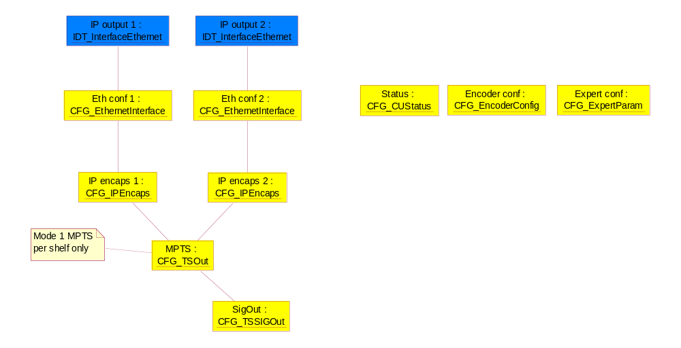
Figure 71 : ViBE 4K Controller config

ViBE CP9000 Controller config
- When ONE board is declared (and present in slot 1 or in slot 2), ONLY one CFG_EncoderConfig() shall be present
- When TWO boards are declared 2 descriptors CFG_EncoderConfig() are expected, so the 1st instance contains informations related to the 1st board (slot 1 on the top) while the 2nd instance have informtions about the 2nd board (slot 2 on bottom).
For one or two boards :
- This descriptor(s) contains the parameters dedicated per each board :
- board mode,
- video_encoding_mode,
- video_encoding_latency
- input_mode
- This descriptor(s) contains the parameters for the shelf. This parameters are duplicated on the 2 descriptors.
- encoder_nb,
- MPTS_mode

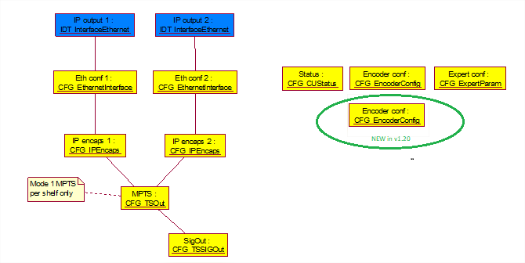

Figure 71 : ViBE CP9000 Controller config in SDI

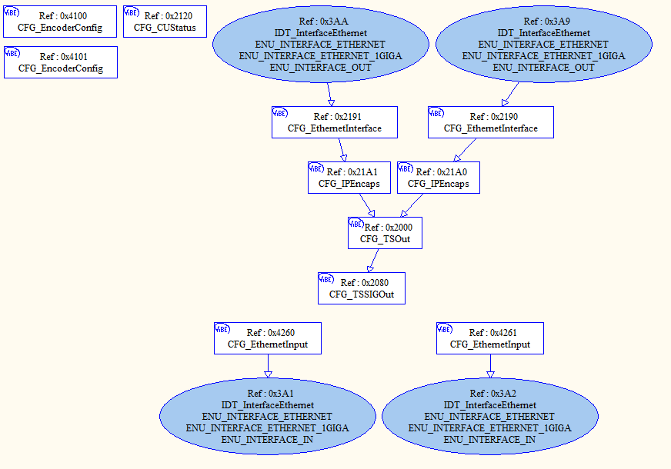Figure 72 : ViBE CP9000 Controller config in SDI over IP

ViBE 4K Encoder config

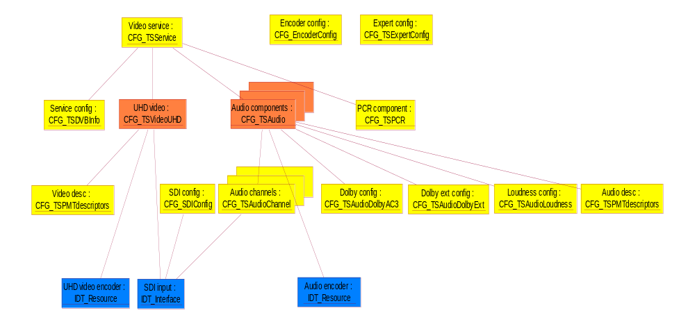
Figure 73 : ViBE 4K Encoder config

ViBE CP9000 Encoder config
Figure 74 : CP9000 Encoder config in SDI
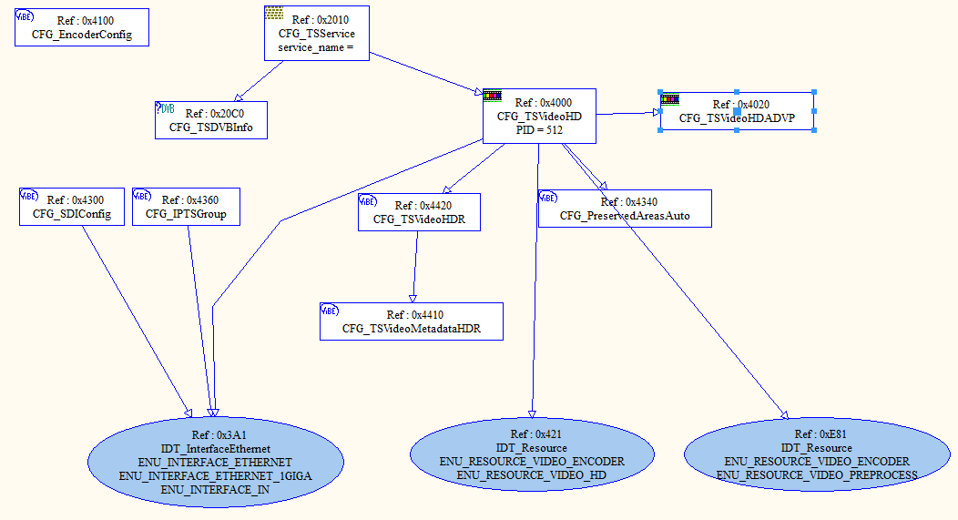
Figure 75 : CP9000 Encoder config in SDI over IP

ViBE 4K Encoder Descriptors

Descriptor CFG_TSVideoUHD
CFG_TSVideoUHD_descriptor()
{
descriptor_header (type = NCCPD_DESC_CFG_TSVIDEOUHD, version = 8) byte[8]

PID byte[2]
status byte[1]
default_pattern byte[1]
standard byte[1]
video_profile byte[1]
temporal_scalability byte[1]
delay_mode byte[1]
encoder_bit_rate byte[4]
PCR_insertion byte[1]
picture_resolution byte[1]
deblocking_filter byte[1]
PAFF byte[1]
IP_frame byte[1]
GOP_size byte[1]
adaptive_GOP byte[1]
closed_GOP_mode byte[1]
PVR_descriptor byte[1]
PES_priority byte[1]
copyright byte[1]
original_or_copy byte[1]
GOP_structure byte[1]
Tier byte[1]
Level byte[1]
VITC byte[1]
closed_caption byte[1]
EIA708B byte[1]
AFD_insertion byte[1]
pattern_noSource byte[1]
pattern_onLive byte[1]
IDR_interval byte[1]
}
PID TS component PID.
(default value = 256)
status Indicates if the component is actually broadcast or not.
Possible values :
- ENU_ON_AIR (the component is actually broadcast)
- ENU_OFF_AIR (the component is stopped)
(default value = ENU_ON_AIR)
default_pattern Possible values :
- ENU_VID_NULL_BITRATE
- ENU_VID_DISABLE_TS
- ENU_VID_DISABLE_OUTPUT
- ENU_VID_BLACK_PATTERN
- ENU_VID_BLUE_PATTERN
(default value = ENU_VID_NULL_BITRATE)
standard Possible values :
- ENU_STANDARD_2160_P_50
- ENU_STANDARD_2160_P_60_1001
- ENU_STANDARD_2160_P_60
- ENU_STANDARD_2160_P_25
- ENU_STANDARD_2160_P_30_1001
- ENU_STANDARD_2160_P_30
- ENU_STANDARD_4_1080_P_50
- ENU_STANDARD_4_1080_P_60_1001
- ENU_STANDARD_4_1080_P_60
- ENU_STANDARD_2160_P_24
- ENU_STANDARD_720_P_50
- ENU_STANDARD_720_P_60_1001
- ENU_STANDARD_720_P_60
- ENU_STANDARD_1080_P_50
- ENU_STANDARD_1080_P_60_1001
- ENU_STANDARD_1080_P_60
- ENU_STANDARD_1080_P_25
- ENU_STANDARD_1080_P_30_1001
- ENU_STANDARD_1080_P_30
(default value = ENU_STANDARD_2160_P_50)
video_profile Possible values :
- ENU_HEVC_MAIN10_L51_420
- ENU_HEVC_MAIN10_L51_422
- ENU_HEVC_MAIN_L51_420
- ENU_AVC_MAIN_420
- ENU_AVC_HIGH_420
- ENU_AVC_HIGH10_420
- ENU_AVC_HIGH_422
- ENU_AVC_HIGH10_422
(default value = ENU_HEVC_MAIN10_L51_420)
temporal_scalability Possible values :
- ENU_ON
- ENU_OFF
(default value = ENU_OFF)
delay_mode Encoding delay mode.
Possible values :
- ENU_LONG_DELAY
- ENU_SHORT_DELAY
(default value = ENU_LONG_DELAY)
encoder_bit_rate In bits/s.
Possible values :
- from 4 000 000 to 160 000 000
(default value = 18000000)
PCR_insertion This field is used to insert the Program Reference Clock in the headers of the TS packets transporting the video component.
Possible values :
- ENU_OFF (the component does not carry the PCR)
- ENU_ON (the component carries the PCR)
(default value = ENU_ON)
picture_resolution Possible values :
- ENU_PR_2160_P_3840
- ENU_PR_720_P_1280
- ENU_PR_1080_P_1920
(default value = ENU_PR_2160_P_3840)
deblocking_filter Possible values :
- ENU_PICTURE_DEF_STANDARD
- ENU_PICTURE_DEF_SHARP
(default value = ENU_ PICTURE_DEF_STANDARD)
PAFF Indicates if the Picture Adaptive Field Frame mode is enabled or not.
Possible values :
- ENU_FRAME_MODE
(default value = ENU_FRAME_MODE)
IP_frame This parameter defines the recurrence of non-bidirectional pictures (P or I pictures).
Possible values :
- 0/1/2/4/8
(default value = 8)
GOP_size This parameter defines the recurrence of the Intra pictures.
Possible values :
- 1/8/16/24/32/40/48/56/64/72/80/88/96
(default value = 64)
adaptive_GOP Defines the use of fixed, adaptive or full GOP.
Possible values :
- ENU_AGM_DISABLED
- ENU_AGM_FULL
(default value = ENU_AGM_DISABLED)
closed_GOP_mode Possible values :
- ENU_OFF
- ENU_ON
(default value = ENU_OFF)
PVR_descriptor Insertion of PVR descriptor in the adaptation field.
Possible values :
- ENU_ON
- ENU_OFF
(default value = ENU_OFF)
PES_priority Flag in the PES packet header.
Possible values :
- ENU_PES_WITH_PRIORITY
- ENU_PES_WITHOUT_PRIORITY
(default value = ENU_PES_WITH_PRIORITY)
copyright Flag in the PES packet header.
Possible values :
- ENU_COPYRIGHT_NOT_PROTECTED
- ENU_COPYRIGHT_PROTECTED
(default value = ENU_COPYRIGHT_PROTECTED)
original_or_copy Flag in the PES packet header.
Possible values :
- ENU_PES_ORIGINAL
- ENU_PES_COPY
(default value = ENU_PES_ORIGINAL)
GOP_structure Possible values :
- ENU_GOP_STRUCTURE_I_ONLY
- ENU_GOP_STRUCTURE_IPPP
- ENU_GOP_STRUCTURE_FREE
(default value = ENU_GOP_STRUCTURE_FREE)
Tier Possible values :
- ENU_TIER_41
- ENU_TIER_50
- ENU_TIER_51
- ENU_TIER_52
- ENU_TIER_60
- ENU_TIER_61
- ENU_TIER_62
(default value = ENU_TIER_62)
Level Possible values :
ENU_AUTO_LEVEL
ENU_HIGH_LEVEL
ENU_MAIN_LEVEL
VITC Possible values :
- ENU_ON
- ENU_OFF
(default value = ENU_OFF)
closed_caption EIA-608 Closed captionning
Possible values :
- ENU_ON
- ENU_OFF
(default value = ENU_OFF)
EIA708B EIA-708 Closed captionning
Possible values :
- ENU_OFF
- ENU_FORCED_EIA708B
(default value = ENU_OFF)
AFD_insertion Enable/disable the insertion of AFD (Active Format Descriptor) as SMPTE 2016 standard.
When enabled, the AFD dta present shall be carried within the SEI of the video Elementary Stream and shall be encoded and transported using the afd_data( ) structure specified in A/53.
Possible values :
- ENU_OFF
- ENU_ON_WITH_STATIC_DATA
(default value = ENU_OFF)
pattern_noSource Possible values :
- ENU_ON
- ENU_OFF
(default value = ENU_OFF)
pattern_onLive Possible values :
- ENU_ON
- ENU_OFF
(default value = ENU_OFF)
IDR_interval Specify the period between each IDR picture. (unit=gop count)
Possible values :
- from 2 to 100
(default value = 100)

Descriptor CFG_TSVideoMetadataHDR
CFG_TSVideoMetadataHDR_descriptor()
{
descriptor_header (type = NCCPD_DESC_CFG_TSVIDEOMETADATAHDR, version = 1) byte[8]

display_primaries_x_green byte[2]
display_primaries_y_green byte[2]
display_primaries_x_blue byte[2]
display_primaries_y_blue byte[2]
display_primaries_x_red byte[2]
display_primaries_y_red byte[2]
white_point_x byte[2]
white_point_y byte[2]
max_display_mastering_luminance byte[4]
min_display_mastering_luminance byte[4]
max_FALL byte[2]
max_CLL byte[2]
SEI_147_alt_transfer_charact byte[2]
}
display_primaries_x_green Possible values :
- from 0 to 50000
(default value = 13250)
display_primaries_y_green Possible values :
- from 0 to 50000
(default value = 34500)
display_primaries_x_blue Possible values :
- from 0 to 50000
(default value = 7500)
display_primaries_y_blue Possible values :
- from 0 to 50000
(default value = 3000)
display_primaries_x_red Possible values :
- from 0 to 50000
(default value = 34000)
display_primaries_y_red Possible values :
- from 0 to 50000
(default value = 16000)
white_point_x Possible values :
- from 0 to 50000
(default value = 15635)
white_point_y Possible values :
- from 0 to 50000
(default value = 16450)

max_display_mastering_luminance Possible values :
- from 0 to 100000000
(default value = 12000000)
min_display_mastering_luminance Possible values :
- from 0 to 100000000
(default value = 1968)
max_FALL Possible values :
- from 0 to 10000
(default value = 0)
max_CLL Possible values :
- from 0 to 10000
(default value = 0)
SEI_147_alt_transfer_charact Possible values :
- from 0 to 20
(default value = 18)

Descriptor CFG_TSVideoHDR
CFG_ TSVideoHDR _descriptor()
{
descriptor_header (type = NCCPD_DESC_CFG_TSVIDEOHDR, version = 1) byte[8]

HDR_color_space byte[1]
HDR_type byte[1]
video_signal_type byte[1]
video_ format byte[1]
video_full_range_flag byte[1]
colour_description_present_flag byte[1]
colour_primaries byte[1]
transfer_characteristics byte[1]
matrix_coeffs byte[1]
insert_SEI_137 byte[1]
insert_SEI_144 byte[1]
insert_SEI_147 byte[1]
}

HDR_color_space Indicates the use of HDR Color Space.
Possible values :
- ENU_HDR_DCI_P3_D65 0
- ENU_HDR_DCI_P3_THEATER 1
- ENU_HDR_COLOR_SPACE_CUSTOM 2
- ENU_HDR_COLOR_SPACE_BT2020 3
(default value = ENU_HDR_COLOR_SPACE_BT2020)

HDR_type Possible values :
- ENU_SDR_BT_709 0
- ENU_SDR_BT_2020 1
- ENU_HDR_PQ 2
- ENU_HDR_HLG 3
(default value = ENU_SDR_BT_709 )
video_signal_type Possible values :
- from 0 to 100
(default value = 0)
video_ format Possible values :
- from 0 to 100
(default value = 0)
video_full_range_flag Possible values :
- from 0 to 100
(default value = 0)
colour_description_present_flag Possible values :
- from 0 to 100
(default value = 0)
colour_primaries Possible values :
- from 0 to 100
(default value = 0)
transfer_characteristics Possible values :
- from 0 to 100
(default value = 0)
matrix_coeffs Possible values :
- from 0 to 100
insert_SEI_137 Possible values :
- ENU_ON
- ENU_OFF
(default value = 0)
insert_SEI_144 Possible values :
- ENU_ON
- ENU_OFF
(default value = 0)
insert_SEI_147 Possible values :
- ENU_ON
- ENU_OFF
(default value = 0)

Descriptor CFG_ZIXIOutputs
CFG_ZIXIOutputs_descriptor()
{
descriptor_header (type = NCCPD_DESC_CFG_ZIXI_OUTPUTS, version = 1) byte[8]

channelId byte[1+n]
channelName byte[1+n]
fecBlockMs byte[4]
fecOverhead byte[4]
latencyMode byte[1]
maxLatency byte[4]
password byte[1+n]
timeout byte[4]
user byte[1+n]
encryptionType byte[1]
encryptionKey byte[1+n]
}

channelId Possible values :
- from 0 to 50000
(default value = 13250)
channelId string
channelName string
fecBlockMs Possible values :
- from 0 to ?
(default value = 10)
fecOverhead Possible values :
- from 0 to ?
(default value = 20)
latencyMode Possible values :
ZIXI_LATENCY_STATIC, ZIXI_LATENCY_INCREASING, ZIXI_LATENCY_DYNAMIC
(default value = ZIXI_LATENCY_DYNAMIC)
maxLatency Possible values :
- from 0 to ?
(default value = 600)
password string
timeout Possible values :
- from 0 to ?
(default value = 10000)
user string
encryptionType Possible values :
ZIXI_AES_128, ZIXI_AES_192, ZIXI_AES_256, ZIXI_NO_ENCRYPTION
(default value = ZIXI_NO_ENCRYPTION)
encryptionKey string

Descriptor CFG_StandaloneRedundancy
CFG_StandaloneRedundancy_descriptor()
{
descriptor_header (type = NCCPD_DESC_CFG_STANDALONEREDUNDANCY, version = 1) byte[8]

mode byte[1]
device_role byte[1]
multicast_address byte[4]
multicast_port byte[2]
group_id byte[2]
system_params byte[4]
video_params byte[4]
audio_params byte[4]
vbi_params byte[4]
ipout_params byte[4]
}

mode Possible values :
- ENU_REDUND_MODE_NONE
- ENU_REDUND_MODE _MANUAL
- ENU_REDUND_MODE _AUTO
(default value = ENU_NONE)
device_role Possible values :
- ENU_REDUND_DEVICE_ROLE_PRIMARY
- ENU_REDUND_ DEVICE_ROLE _BACKUP
(default value = ENU_REDUND_ DEVICE_ROLE _PRIMARY)
multicast_address Possible values :
- from 224.0.0.0 to 239.255.255.255
(default value = 0)
multicast_port Possible values :
- from 1024 to 65535
(default value = 0)
group_id Possible values :
- from 1 to 65535
(default value = 1)
system_param bits field used as criteria trigger on system alarm
(default value = 0)
video_param bits field used as criteria trigger on video alarm
(default value = 0)
audio_param bits field used as criteria trigger on audio alarm
(default value = 0)
vbi_param bits field used as criteria trigger on vbi alarm
(default value = 0)
ipout_param bits field used as criteria trigger on ip interface alarm
(default value = 0)

Descriptor CFG_AutoConf
CFG_AutoConf_descriptor()
{
descriptor_header (type = NCCPD_DESC_CFG_STANDALONEREDUNDANCY, version = 1) byte[8]

nb_coder_auto_conf byte[1]
for (i = 1 ; i <= nb_coder_auto_conf)
{
cuid byte[1]
auto_conf_status byte[1]
auto_conf_number byte[1]
auto_conf_type byte[1]
auto_conf_filename byte[1+n]

}
}

nb_coder_auto_conf Possible values :
- from 0 to 32
(default value = 32)
cuid Possible values :
- from 0 to 8
(default value = 0)
auto_conf_status Possible values :
- ENU_ON
- ENU_OFF
(default value = 0)

auto_conf_number Possible values :
- from 0 to 32
(default value = 0)
auto_conf_type Possible values :
#define ENU_AUTO_CONF_1080I25 0
#define ENU_AUTO_CONF_1080I29 1
#define ENU_AUTO_CONF_720P50 2
#define ENU_AUTO_CONF_720P59 3
#define ENU_AUTO_CONF_1080P50 4
#define ENU_AUTO_CONF_1080P59 5

auto_conf_filename string

Descriptor CFG_SRTOutputs
CFG_SRTOutputs_descriptor()
{
descriptor_header (type = NCCPD_DESC_CFG_SRT_OUTPUTS, version = 1) byte[8]

output_enable byte[1]
mode byte[1]
latency byte[4]
}

output_enable Possible values :
ENU_ENABLE/ENU_DISBALE
(default value = ENU_DISABLE)
mode Possible values :
SRT_CALLER_MODE, SRT_LISTENER_MODE, SRT_RDV_MODE
(default value = SRT_CALLER_MODE)
latency Possible values :
- from 20 to 8000 ms
(default value = 120)

Descriptor CFG_DNSServer
CFG_DNSserver_descriptor()
{
descriptor_header (type = NCCPD_DESC_DNSSERVER, version = 1) byte[8]
nb_server byte[1]
for (i = 1 ; i <= nb_server)
{
TX_IP_address byte[4]
}
}

nb_server Possible values :
- from 0 to 3
(default value = 3)

TX_IP_address Destination IP address for transmitted frames (unicast or multicast address).
- default value DNS server 1 = "8.8.8.8"
- default value DNS server 2 = "8.8.4.4"
- default value DNS server 3 = "0.0.0.0"

Descriptor CFG_BissCAGroup
BISS-CA diagramm
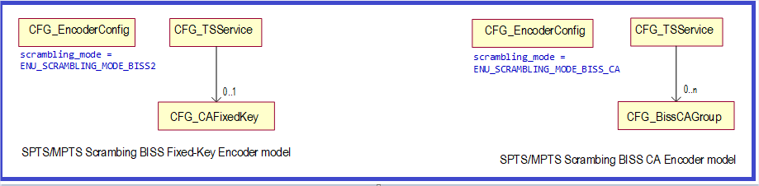

CFG_BissCAGroup_descriptor()
{
descriptor_header (type = NCCPD_DESC_BISSCAGROUP, version = 1) byte[8]
ESID byte[2]
entitledKeys_filename byte[1+n]
ECM_PID byte[2]
EMM_PID byte[2]
crypto_period byte[1]
prevent_descrambled_forward byte[1]
prevent_decoded_forward byte[1]
insert_watermark byte[1]
EMM_bitrate byte[2]
original_network_id byte[2]
}

ESID administrative Entitlement Session ID
- from 1 to 65535
(default value = 1)
entitledKeys_filename Entitled Public Key(s) file to use
file extension = .csv (may contains more than one Public Key).
(default value = “”)
ECM_PID PID of ECM component.
- from 32 to 8191
(default value = 33)
EMM_PID PID of EMM component.
- from 32 to 8191
(default value = 34)
crypto_period ECM period change (unit in second)
- from 5 to 120
(default value = 10)
prevent_descrambled_forward part of Entitlement_flags_descriptor()
Possible values :
- ENU_ON
- ENU_OFF
prevent_decoded_forward part of Entitlement_flags_descriptor()
Possible values :
- ENU_ON
- ENU_OFF
insert_watermark_forward part of Entitlement_flags_descriptor()
Possible values :
- ENU_ON
- ENU_OFF
EMM_bitrate bitrate of EMM component. unit Kbits/s
- from 15 to 1000
(default value = 15)
original_network_id Label identifying the network_id of the originating delivery system.
(default value = 1)

Supervision
This package groups together all the descriptors defined for Alarms and Events reporting and bit-rate monitoring.

Alarms
This sub-package defines the descriptor used for Alarms management.

Alarms Diagrams

Alarms Descriptors

Descriptor SUP_Alarm
This descriptor is used to report an alarm.
SUP_Alarm_descriptor()
{
descriptor_header (type = NCCPD_DESC_SUP_ALARM, version = 2) byte[8]

Id byte[2]
Notification_Time byte[8]
CU_Id byte[2]
CU_Type byte[1]
Object_Reference byte[2]
Probable_Cause byte[2]
Category byte[1]
Event_Type byte[1]
Severity byte[1]
Specific_Problem byte[4]
Extra_Info byte[2]
Old_Value byte[2]
New_Value byte[2]
}

Id Alarm identifier.

Notification_Time Date and time of alarm notification (local time).

CU_Id Control unit identifier.
Possible values :
- from ENU_MIN_CUID (1) to ENU_MAX_CUID (1023)

CU_Type Control unit type.
Possible values :
- ENU_CUNIT_CONTROLLER
- ENU_CUNIT_ENCODER
- ENU_CUNIT_DECODER
- ENU_CUNIT_FE_PDH
- ENU_CUNIT_FE_100BT
- ENU_CUNIT_FE_ASI
- ENU_CUNIT_FE_100ME
- ENU_CUNIT_HD_ENCODER
- ENU_CUNIT_EM_CONTROLLER
- ENU_CUNIT_EM_ENCODER
- ENU_CUNIT_AVDEC
- ENU_CUNIT_UNKNOWN

Object_Reference Object reference : slot address (4 MSB) + object reference id (12 LSB).

Probable_Cause Probable cause of the alarm.
Possible values : refer to "enu_alarms.h" file.

Category Possible values :
- CATEGORY_COMMUNICATION
- CATEGORY_QOS
- CATEGORY_PROCESSING
- CATEGORY_EQUIPMENT
- CATEGORY_ENVIRONMENT

Event_Type Possible values :
- TYPE_ATTRIBUTE_VALUE_CHANGE (used for event)
- TYPE_OBJECT_CREATION
- TYPE_OBJECT_DELETION
- TYPE_RAISING_ALARM (used for alarm on)
- TYPE_FALLING_ALARM (used for alarm off)

Severity Possible values :
- SEVERITY_CLEARED
- SEVERITY_NONE (used for event)
- SEVERITY_WARNING
- SEVERITY_MINOR
- SEVERITY_MAJOR
- SEVERITY_CRITICAL

Specific_Problem Additional info.

Extra_Info Value :
- attribute OID if Event_Type = TYPE_ATTRIBUTE_VALUE_CHANGE ;
- additional info if Event_Type = TYPE_OBJECT_CREATION/DELETION.

Old_Value Used only if Event_Type = TYPE_ATTRIBUTE_VALUE_CHANGE.

New_Value Used only if Event_Type = TYPE_ATTRIBUTE_VALUE_CHANGE.

Descriptor SUP_AlarmWording
This descriptor is used to report an alarm.
SUP_AlarmWording_descriptor()
{
descriptor_header (type = NCCPD_DESC_SUP_ALARMWORDING, version = 1) byte[8]

Id byte[2]
Notification_Time byte[8]
CU_Id byte[2]
CU_Type byte[1]
Object_Reference byte[2]
Probable_Cause byte[2]
Category byte[1]
Event_Type byte[1]
Severity byte[1]
Specific_Problem byte[4]
Extra_Info byte[2]
Old_Value byte[2]
New_Value byte[2]
wording byte[1+n]
}

Id Alarm identifier.

Notification_Time Date and time of alarm notification (local time).

CU_Id Control unit identifier.
Possible values :
- from ENU_MIN_CUID (1) to ENU_MAX_CUID (1023)

CU_Type Control unit type.
Possible values :
- ENU_CUNIT_CONTROLLER
- ENU_CUNIT_ENCODER
- ENU_CUNIT_DECODER
- ENU_CUNIT_FE_PDH
- ENU_CUNIT_FE_100BT
- ENU_CUNIT_FE_ASI
- ENU_CUNIT_FE_100ME
- ENU_CUNIT_HD_ENCODER
- ENU_CUNIT_EM_CONTROLLER
- ENU_CUNIT_EM_ENCODER
- ENU_CUNIT_AVDEC
- ENU_CUNIT_UNKNOWN

Object_Reference Object reference : slot address (4 MSB) + object reference id (12 LSB).

Probable_Cause Probable cause of the alarm.
Possible values : refer to "enu_alarms.h" file.

Category Possible values :
- CATEGORY_COMMUNICATION
- CATEGORY_QOS
- CATEGORY_PROCESSING
- CATEGORY_EQUIPMENT
- CATEGORY_ENVIRONMENT

Event_Type Possible values :
- TYPE_ATTRIBUTE_VALUE_CHANGE (used for event)
- TYPE_OBJECT_CREATION
- TYPE_OBJECT_DELETION
- TYPE_RAISING_ALARM (used for alarm on)
- TYPE_FALLING_ALARM (used for alarm off)

Severity Possible values :
- SEVERITY_CLEARED
- SEVERITY_NONE (used for event)
- SEVERITY_WARNING
- SEVERITY_MINOR
- SEVERITY_MAJOR
- SEVERITY_CRITICAL

Specific_Problem Additional info.

Extra_Info Value :
- attribute OID if Event_Type = TYPE_ATTRIBUTE_VALUE_CHANGE ;
- additional info if Event_Type = TYPE_OBJECT_CREATION/DELETION.

Old_Value Used only if Event_Type = TYPE_ATTRIBUTE_VALUE_CHANGE.

New_Value Used only if Event_Type = TYPE_ATTRIBUTE_VALUE_CHANGE.
wording Explicit wording for Probable_Cause and Object_Reference.

Monitoring
This sub-package defines descriptors used for monitoring.

Monitoring Diagrams

TS Monitoring
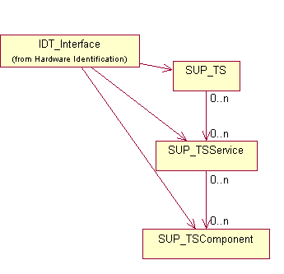
Figure 73 : TS Monitoring

AVDEC Monitoring

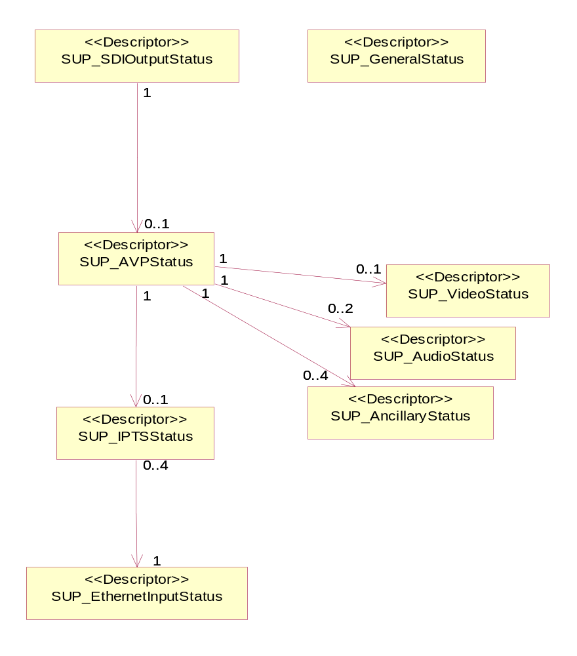

Figure 74 : AVDEC Monitoring

Monitoring Descriptors

Descriptor SUP_TS
This descriptor contains information relating to Transport Stream monitoring.
SUP_TS_descriptor()
{
descriptor_header (type = NCCPD_DESC_SUP_TS, version = 2) byte[8]

original_network_id byte[2]
transport_stream_id byte[2]
channel_bit_rate_unit byte[1]
channel_bit_rate byte[4]
useful_bit_rate_unit byte[1]
useful_bit_rate byte[4]
SI_bit_rate_unit byte[1]
SI_bit_rate byte[4]
null_packet_bit_rate_unit byte[1]
null_packet_bit_rate byte[4]
}

original_network_id Label identifying the network_id of the originating delivery system.

transport_stream_id Label for identification of the TS.

channel_bit_rate_unit Unit for channel_bit_rate measurement.
Possible values :
- ENU_UNIT_BIT_SECOND
- ENU_UNIT_KBIT_SECOND
- ENU_UNIT_MBIT_SECOND
- ENU_UNIT_GBIT_SECOND
- ENU_UNIT_TBIT_SECOND
- ENU_UNIT_BYTE_SECOND
- ENU_UNIT_KBYTE_SECOND
- ENU_UNIT_MBYTE_SECOND
- ENU_UNIT_GBYTE_SECOND
- ENU_UNIT_TBYTE_SECOND
- ENU_UNIT_PACK188_SECOND
- ENU_UNIT_KPACK188_SECOND
- ENU_UNIT_MPACK188_SECOND
- ENU_UNIT_PACK204_SECOND
- ENU_UNIT_KPACK204_SECOND
- ENU_UNIT_MPACK204_SECOND

channel_bit_rate Channel (input or output) bitrate.
Possible values :
- ENU_INVALID_VALUE = 0xFFFF if not valid value (ENU_INVALID_VALUE used by CORE_DEC board)
- all other values from 0 to 0xFFFE are authorized and significant

useful_bit_rate_unit Unit for useful_bit_rate measurement.
Possible values :
- ENU_UNIT_BIT_SECOND
- ENU_UNIT_KBIT_SECOND
- ENU_UNIT_MBIT_SECOND
- ENU_UNIT_GBIT_SECOND
- ENU_UNIT_TBIT_SECOND
- ENU_UNIT_BYTE_SECOND
- ENU_UNIT_KBYTE_SECOND
- ENU_UNIT_MBYTE_SECOND
- ENU_UNIT_GBYTE_SECOND
- ENU_UNIT_TBYTE_SECOND
- ENU_UNIT_PACK188_SECOND
- ENU_UNIT_KPACK188_SECOND
- ENU_UNIT_MPACK188_SECOND
- ENU_UNIT_PACK204_SECOND
- ENU_UNIT_KPACK204_SECOND
- ENU_UNIT_MPACK204_SECOND

useful_bit_rate Current useful (input or output) bitrate.
Possible values :
- ENU_INVALID_VALUE = 0xFFFF if not valid value (ENU_INVALID_VALUE used by CORE_DEC board)
- all other values from 0 to 0xFFFE are authorized and significant

SI_bit_rate_unit Unit for SI_bit_rate measurement.
Possible values :
- ENU_UNIT_BIT_SECOND
- ENU_UNIT_KBIT_SECOND
- ENU_UNIT_MBIT_SECOND
- ENU_UNIT_GBIT_SECOND
- ENU_UNIT_TBIT_SECOND
- ENU_UNIT_BYTE_SECOND
- ENU_UNIT_KBYTE_SECOND
- ENU_UNIT_MBYTE_SECOND
- ENU_UNIT_GBYTE_SECOND
- ENU_UNIT_TBYTE_SECOND
- ENU_UNIT_PACK188_SECOND
- ENU_UNIT_KPACK188_SECOND
- ENU_UNIT_MPACK188_SECOND
- ENU_UNIT_PACK204_SECOND
- ENU_UNIT_KPACK204_SECOND
- ENU_UNIT_MPACK204_SECOND

SI_bit_rate Signalling (input or output) bitrate.
Possible values :
- ENU_INVALID_VALUE = 0xFFFF if not valid value (ENU_INVALID_VALUE used by CORE_DEC board)
- all other values from 0 to 0xFFFE are authorized and significant

null_packet_bit_rate_unit Unit for null_packet_bit_rate measurement.
Possible values :
- ENU_UNIT_BIT_SECOND
- ENU_UNIT_KBIT_SECOND
- ENU_UNIT_MBIT_SECOND
- ENU_UNIT_GBIT_SECOND
- ENU_UNIT_TBIT_SECOND
- ENU_UNIT_BYTE_SECOND
- ENU_UNIT_KBYTE_SECOND
- ENU_UNIT_MBYTE_SECOND
- ENU_UNIT_GBYTE_SECOND
- ENU_UNIT_TBYTE_SECOND
- ENU_UNIT_PACK188_SECOND
- ENU_UNIT_KPACK188_SECOND
- ENU_UNIT_MPACK188_SECOND
- ENU_UNIT_PACK204_SECOND
- ENU_UNIT_KPACK204_SECOND
- ENU_UNIT_MPACK204_SECOND

null_packet_bit_rate Null packets (input or output) bitrate.
Possible values :
- ENU_INVALID_VALUE = 0xFFFF if not valid value (ENU_INVALID_VALUE used by CORE_DEC board)
- all other values from 0 to 0xFFFE are authorized and significant

Descriptor SUP_TSService
This descriptor contains information relating to service monitoring.
In the case of EMM components monitoring, an instance of SUP_TSService must be created for each SUP_TSComponent.
SUP_TSService_descriptor()
{
descriptor_header (type = NCCPD_DESC_SUP_TSSERVICE, version = 2) byte[8]

service_id byte[2]
service_type byte[1]
service_name byte[1+n]
PMT_PID byte[2]
PCR_PID byte[2]
}

service_id Gives the DVB service_id and ISO program_number information.
This id is set to 0 for "ghost service" grouping together all the ghost components.

service_type Service type : Video, Audio, Data, Ghost.
Possible values :
- ENU_DIGITAL_TELEVISION_SERVICE
- ENU_DIGITAL_RADIO_SOUND_SERVICE
- ENU_TELETEXT_SERVICE
- ENU_NVOD_REFERENCE_SERVICE
- ENU_NVOD_TIME_SHIFTED_SERVICE
- ENU_MOSAIC_SERVICE
- ENU_PAL_CODED_SIGNAL
- ENU_SECAM_CODED_SIGNAL
- ENU_D_D2_MAC
- ENU_FM_RADIO
- ENU_NTSC_CODED_SIGNAL
- ENU_SRV
- ENU_NO_SERVICE_TYPE
- ENU_EMM
- ENU_FIRST_USER_DEFINED_SERVICE
- ENU_LAST_USER_DEFINED_SERVICE
- ENU_ADVANCED_CODEC_HD_SERVICE
- ENU_HEVC_DIGITAL_TELEVISION_SERVICE

service_name Name of the service.
This name is set to "PHANTOM service" for "ghost service" grouping together all the ghost components.

PMT_PID PID used for PMT associated with the service.
This PID is set to 0 for "ghost service" grouping together all the ghost components.

PCR_PID PID of PCR component.
Possible values : TBD.

Descriptor SUP_TSComponent
This descriptor contains information relating to TS component monitoring.
SUP_TSComponent_descriptor()
{
descriptor_header (type = NCCPD_DESC_SUP_TSCOMPONENT, version = 2) byte[8]

PID byte[2]
stream_type byte[1]
bit_rate_unit byte[1]
bit_rate byte[4]
free_CA_mode byte[1]
}

PID TS component PID.

stream_type Component type.
Possible values :
- ENU_AUDIO_STREAM_TYPE
- ENU_VIDEO_STREAM_TYPE
- ENU_PRVD_STREAM_TYPE

bit_rate_unit Unit for bitrate measurement.
Possible values :
- ENU_UNIT_BIT_SECOND
- ENU_UNIT_KBIT_SECOND
- ENU_UNIT_MBIT_SECOND
- ENU_UNIT_GBIT_SECOND
- ENU_UNIT_TBIT_SECOND
- ENU_UNIT_BYTE_SECOND
- ENU_UNIT_KBYTE_SECOND
- ENU_UNIT_MBYTE_SECOND
- ENU_UNIT_GBYTE_SECOND
- ENU_UNIT_TBYTE_SECOND
- ENU_UNIT_PACK188_SECOND
- ENU_UNIT_KPACK188_SECOND
- ENU_UNIT_MPACK188_SECOND
- ENU_UNIT_PACK204_SECOND
- ENU_UNIT_KPACK204_SECOND
- ENU_UNIT_MPACK204_SECOND

bit_rate Component (input or output) bitrate.
Possible values :
- ENU_INVALID_VALUE = 0xFFFF if not valid value (ENU_INVALID_VALUE used by CORE_DEC board)
- all other values from 0 to 0xFFFE are authorized and significant

free_CA_mode Indicates if the component is scrambled or not.
Possible values :
- ENU_NOT_SCRAMBLED
- ENU_LOCALLY_SCRAMBLED
- ENU_EXTERNALLY_SCRAMBLED
- ENU_NOT_SIGNIFICANT

Descriptor SUP_ParamMonitoring
SUP_ParamMonitoring_descriptor()
{
descriptor_header (type = NCCPD_DESC_SUP_PARAMMONITORING, version = 1) byte[8]

IO_type byte[1]
IO_ref byte[2]
service_id byte[2]
PID byte[2]
}

IO_type Interface type (input or output).

IO_ref Interface descriptor reference.

service_id Service id.

PID Component PID.

Descriptor SUP_AudioDolbyEDecoder
Monitoring of programs on dolby E decoder output.
SUP_AudioDolbyEDecoder_descriptor()
{
descriptor_header (type = NCCPD_DESC_SUP_AUDIODOLBYEDECODER, version = 2) byte[8]

dolbyE_program_config byte[1]

}

dolbyE_program_config Program configuration value detected on the DolbyE input stream.
Possible values :
- from 0 to 22

Descriptor SUP_GeneralStatus
SUP_GeneralStatus_descriptor()
{
descriptor_header (type = NCCPD_DESC_SUP_GENERALSTATUS, version = 1) byte[8]

bank1_integrity byte[1]
bank1_bpk_version byte[1+n]
bank2_integrity byte[1]
bank2_bpk_version byte[1+n]
active_bank_number byte[1]
general_status byte[1]
}

bank1_integrity Possible values :
- ENU_TRUE
- ENU_FALSE

bank1_bpk_version Version of board package (set of firmwares) in bank#1.

bank2_integrity Possible values :
- ENU_TRUE
- ENU_FALSE

bank2_bpk_version Version of board package (set of firmwares) in bank#2.

active_bank_number Possible values :
- from 1 to 2

general_status General operational status.

Descriptor SUP_SDIOutputStatus
SUP_SDIOutputStatus_descriptor()
{
descriptor_header (type = NCCPD_DESC_SUP_SDIOUTPUTSTATUS, version = 1) byte[8]

locked byte[1]
}

locked Possible values :
- ENU_ON
- ENU_OFF

Descriptor SUP_AVPStatus
SUP_AVPStatus_descriptor()
{
descriptor_header (type = NCCPD_DESC_SUP_AVPSTATUS, version = 1) byte[8]

selected_service_name byte[1+n]
auto_decoding byte[1]
TS_output_clock byte[1]
reordered_packets_number byte[2]
lost_packets_number byte[2]
TS_packets_number byte[2]
PCR_locked byte[1]
redundancy_application byte[1]
AVP_primary byte[1]
AVP_status byte[1]
AVP_status_level byte[1]
AFD_enable byte[1]
CCAP_enable byte[1]
WSS_enable byte[1]
VITC_DVITC_enable byte[1]
assistance_data_enable byte[1]
assistance_data_field byte[1]
assistance_data_first_VBI_line byte[1]
H264_assistance_data_enable byte[1]
header_enable byte[1]
PES_info_enable byte[1]
}

selected_service_name Service name.

auto_decoding Possible values :
- ENU_ENABLE
- ENU_DISABLE

TS_output_clock Possible values :
- ENU_INTERNAL_CLOCK
- ENU_EXTERNAL_CLOCK

reordered_packets_number Number of reordered packets.

lost_packets_number Number of lost packets.

TS_packets_number Number of TS packets.

PCR_locked Possible values :
- ENU_TRUE
- ENU_FALSE

redundancy_application Possible values :
- ENU_TRUE
- ENU_FALSE

AVP_primary Possible values :
- ENU_TRUE
- ENU_FALSE

AVP_status Possible values :
- ENU_NO_ERROR
- ENU_ERROR

AVP_status_level Possible values :
- SEVERITY_NONE
- SEVERITY_MINOR
- SEVERITY_MAJOR
- SEVERITY_CRITICAL

AFD_enable Possible values :
- ENU_ENABLE
- ENU_DISABLE

CCAP_enable Possible values :
- ENU_ENABLE
- ENU_DISABLE

WSS_enable Possible values :
- ENU_ENABLE
- ENU_DISABLE

VITC_DVITC_enable Possible values :
- ENU_ENABLE
- ENU_DISABLE

assistance_data_enable Possible values :
- ENU_ENABLE
- ENU_DISABLE

assistance_data_field Possible values :
- from 0 to 1

assistance_data_first_VBI_line Possible values :
- from 1 to 23

H264_assistance_data_enable Possible values :
- ENU_ENABLE
- ENU_DISABLE

header_enable Possible values :
- ENU_ENABLE
- ENU_DISABLE

PES_info_enable Possible values :
- ENU_ENABLE
- ENU_DISABLE

Descriptor SUP_VideoStatus
SUP_VideoStatus_descriptor()
{
descriptor_header (type = NCCPD_DESC_SUP_VIDEOSTATUS, version = 2) byte[8]

bitrate_mode byte[1]
encoded_PES_bitrate byte[4]
PID byte[2]

concealment_mode byte[1]
display_mode byte[1]
downscale_mode_4_3 byte[1]
native_output_format byte[1]
encoded_level byte[1]
encoded_picture_rate byte[1]
encoded_width byte[1]
encoded_height byte[1]
encoded_ratio byte[1]
encoded_codec byte[1]
encoded_profile byte[1]
encoded_frame_type byte[1]
decoded_resolution byte[1]
decoded_aspect_ratio byte[1]
decoded_frame_type byte[1]
decoding_delay byte[2]
ANC_presence byte[1]
}
bitrate_mode Possible values :
- ENU_FAST_MODE
- ENU_SLOW_MODE

encoded_PES_bitrate PES bitrate in bits/s.

PID Possible values :
- from 1 to 8191

concealment_mode Possible values :
- ENU_BEST_EFFORT
- ENU_SLICE_MODE
- ENU_BLACK_PICTURE

display_mode Possible values :
- ENU_AUTO
- ENU_MANUAL

downscale_mode_4_3 Possible values :
- ENU_FULL_SCREEN
- ENU_LETTER_BOX

native_output_format Possible values :
- ENU_ENABLE
- ENU_DISABLE

encoded_level Possible values :
- ENU_LEVEL_ML
- ENU_LEVEL_L3
- ENU_LEVEL_L4_0
- ENU_LEVEL_L4_1

encoded_picture_rate Possible values :
- ENU_RATE_24
- ENU_RATE_25
- ENU_RATE_29_9
- ENU_RATE_30
- ENU_RATE_50
- ENU_RATE_60

encoded_width Possible values :
- ENU_WIDTH_352
- ENU_WIDTH_540
- ENU_WIDTH_708
- ENU_WIDTH_720
- ENU_WIDTH_1440
- ENU_WIDTH_1920
- ENU_WIDTH_1280

encoded_height Possible values :
- ENU_HEIGHT_288
- ENU_HEIGHT_480
- ENU_HEIGHT_576
- ENU_HEIGHT_1080
- ENU_HEIGHT_720

encoded_ratio Possible values :
- ENU_4_3_FORMAT
- ENU_16_9_FORMAT

encoded_codec Possible values :
- ENU_MPEG2
- ENU_H264

encoded_profile Possible values :
- ENU_MAIN_PROFILE
- ENU_HIGH_PROFILE

encoded_frame_type Possible values :
- ENU_INTERLACED
- ENU_PROGRESSIVE

decoded_resolution Possible values :
- ENU_RES_480
- ENU_RES_576
- ENU_RES_720
- ENU_RES_1080

decoded_aspect_ratio Possible values :
- ENU_4_3_FORMAT
- ENU_16_9_FORMAT

decoded_frame_type Possible values :
- ENU_INTERLACED
- ENU_PROGRESSIVE

decoding_delay Video decoding delay in ms.
ANC_presence Possible values :
- TBD

Descriptor SUP_AudioStatus
SUP_AudioStatus_descriptor()
{
descriptor_header (type = NCCPD_DESC_SUP_AUDIOSTATUS, version = 1) byte[8]

bitrate_mode byte[1]
encoded_PES_bitrate byte[4]
PID byte[2]

encoded_type byte[1]
MPEG_layer byte[1]
pass_through_enable byte[1]
}
bitrate_mode Possible values :
- ENU_FAST_MODE
- ENU_SLOW_MODE

encoded_PES_bitrate PES bitrate in bits/s.

PID Possible values :
- from 1 to 8191

encoded_type Possible values :
- ENU_MPEG1_LAYERII
- ENU_AAC_LC
- ENU_AAC_HE
- ENU_AC3

MPEG_layer Possible values :
- ENU_MPEG_1
- ENU_MPEG_2

pass_through_enable Possible values :
- ENU_ENABLE
- ENU_DISABLE

Descriptor SUP_AncillaryStatus
SUP_AncillaryStatus_descriptor()
{
descriptor_header (type = NCCPD_DESC_SUP_ANCILLARYSTATUS, version = 1) byte[8]

bitrate_mode byte[1]
encoded_PES_bitrate byte[4]
PID byte[2]

ancillary_type byte[1]
}
bitrate_mode Possible values :
- ENU_FAST_MODE
- ENU_SLOW_MODE

encoded_PES_bitrate PES bitrate in bits/s.

PID Possible values :
- from 1 to 8191

ancillary_type Possible values :
- ENU_DVB_SUBTITLE
- ENU_USER_DATA

Descriptor SUP_IPTSStatus
SUP_IPTSStatus_descriptor()
{
descriptor_header (type = NCCPD_DESC_SUP_IPTSSTATUS, version = 2) byte[8]

reordering_enable byte[1]
RTP_enable byte[1]
FEC_enable byte[1]
IP_source_address byte[4]
IP_subscribe_address byte[4]
UDP_port byte[2]
RTP_layer_presence byte[1]
TS_detection byte[1]
TS_bitrate byte[4]
FEC_detection byte[1]
FEC_columns byte[1]
FEC_rows byte[1]
TS_services_number byte[1]
for (i = 1 ; i <= TS_services_number)
{
service_id byte[2]

}
TS_packets_number byte[1]

}

reordering_enable Possible values :
- ENU_ENABLE
- ENU_DISABLE

RTP_enable Possible values :
- ENU_ENABLE
- ENU_DISABLE

FEC_enable Possible values :
- ENU_ENABLE
- ENU_DISABLE

IP_source_address Effective IP TS source address.

IP_subscribe_address Effective IP TS destination address.

UDP_port UDP subscribe port.

RTP_layer_presence Possible values :
- ENU_TRUE
- ENU_FALSE

TS_detection MPEG TS transport stream detection.
Possible values :
- ENU_TRUE
- ENU_FALSE

TS_bitrate MPEG TS transport stream bitrate in bits/s.

FEC_detection Possible values :
- ENU_TRUE
- ENU_FALSE

FEC_columns Number of FEC L columns.
Possible values :
- from 1 to 20

FEC_rows Number of FEC D rows.
Possible values :
- from 1 to 20

TS_services_number Number of MPEG TS stream services.

service_id Possible values :
- from 1 to 65535
TS_packets_number Number of MPEG TS packets per IP frame.

Descriptor SUP_EthernetInputStatus
SUP_EthernetInputStatus_descriptor()
{
descriptor_header (type = NCCPD_DESC_SUP_ETHERNETINPUTSTATUS, version = 1) byte[8]

MAC_address byte[6]
auto_negotiation byte[1]
auto_detection byte[1]
speed byte[1]
duplex_mode byte[1]
IP_address byte[4]
IP_mask byte[4]
IP_gateway byte[4]
negotiation_rate byte[1]
active_link byte[1]
}

MAC_address Ethernet effective MAC address.

auto_negotiation Possible values :
- ENU_AUTO
- ENU_MANUAL

auto_detection Possible values :
- ENU_TRUE
- ENU_FALSE

speed Possible values :
- ENU_10MBS
- ENU_100MBS
- ENU_1GBS

duplex_mode Possible values :
- ENU_FULL
- ENU_HALF

IP_address Ethernet effective IP address.

IP_mask Ethernet effective IP mask.

IP_gateway Ethernet effective IP gateway.

negotiation_rate Ethernet link negotiation rate.
Possible values :
- ENU_10MBS
- ENU_100MBS
- ENU_1GBS

active_link Ethernet effective active link.
Possible values :
- ENU_TRUE
- ENU_FALSE

Descriptor SUP_TimeStamp
SUP_TimeStamp_descriptor()
{
descriptor_header (type = NCCPD_DESC_SUP_TIMESTAMP, version = 1) byte[8]

timestamp byte[4]
}

timestamp TBD

Descriptor SUP_ASIInputStatus
SUP_ASIInputStatus_descriptor()
{
descriptor_header (type = NCCPD_DESC_SUP_ASIINPUTSTATUS, version = 1) byte[8]

packet_size byte[1]
}

packet_size Possible values :
- ENU_WITHOUT_REED_SOLOMON
- ENU_WITH_REED_SOLOMON

Descriptor SUP_DejitterStatus
SUP_DejitterStatus_descriptor()
{
descriptor_header (type = NCCPD_DESC_SUP_DEJITTERSTATUS, version = 2) byte[8]

jitter_compensated byte[1]
correction_level byte[1]
dejitter_mode byte[1]
}

jitter_compensated Possible values :
- ENU_TRUE
- ENU_FALSE

correction_level Possible values :
- ENU_LEVEL_TRANSPARENT
- ENU_LEVEL_SHORT (10 ms)
- ENU_LEVEL_MEDIUM (30 ms)
- ENU_LEVEL_LONG (100 ms)
- ENU_LEVEL_FULL
dejitter_mode Possible values :
- ENU_AEMC_PCR
- ENU_NO_AEMC_PCR
- ENU_AEMC_NO_PCR

Descriptor SUP_DescramblerStatus
SUP_DescramblerStatus_descriptor()
{
descriptor_header (type = NCCPD_DESC_SUP_DESCRAMBLERSTATUS, version = 1) byte[8]

CW_odd byte[8]
CW_even byte[8]
}

CW_odd Odd control word.

CW_even Even control word.

Descriptor SUP_PatternGenerator
SUP_PatternGenerator_descriptor()
{
descriptor_header (type = NCCPD_DESC_SUP_PATTERNGENERATOR, version = 1) byte[8]

pattern_select byte[1]
pattern_format byte[1]
}

pattern_select Possible values :
- ENU_COLOR_BARS
- ENU_FREQUENCY_SWEEP
- ENU_BLACK
- ENU_PATHOLOGICAL_MATRIX
- ENU_LUMA_RAMP
- ENU_Y_C_FULLRANGE_RAMP
- ENU_SMPTE
- ENU_SMPTE_RP219
- ENU_PULSE_AND_BAR

pattern_format Possible values :
- ENU_4_3_FORMAT
- ENU_16_9_FORMAT

Descriptor SUP_EthernetRedundancy
SUP_EthernetRedundancy_descriptor()
{
descriptor_header (type = NCCPD_DESC_SUP_ETHERNETREDUNDANCY, version = 1) byte[8]

automatic_redundancy byte[1]
criteria1_enable byte[1]
criteria2_enable byte[1]
criteria3_enable byte[1]
criteria4_enable byte[1]
timeout byte[1]
}

automatic_redundancy Possible values :
- ENU_AUTO
- ENU_MANUAL

criteria1_enable Possible values :
- ENU_ENABLE
- ENU_DISABLE

criteria2_enable Possible values :
- ENU_ENABLE
- ENU_DISABLE

criteria3_enable Possible values :
- ENU_ENABLE
- ENU_DISABLE

criteria4_enable Possible values :
- ENU_ENABLE
- ENU_DISABLE

timeout Possible values :
- from 0 to 60

Descriptor SUP_TSPMTdescriptors
SUP_TSPMTdescriptors_descriptor()
{
descriptor_header (type = NCCPD_DESC_SUP_TSPMTDESCRIPTORS, version = 1) byte[8]

nb_SI_descriptors byte[1]
for (i = 1 ; i <= nb_SI_descriptors)
{
descriptor_tag byte[1]

descriptor_length byte[1]

descriptor_body byte[n]

}
}

nb_SI_descriptors Number of PMT descriptors.
(default value = 0)

descriptor_tag Descriptor tag.
(default value = 0)

descriptor_length Descriptor length.
(default value = 0)

descriptor_body Descriptor body.

Descriptor SUP_TSSDTdescriptors
SUP_TSSDTdescriptors_descriptor()
{
descriptor_header (type = NCCPD_DESC_SUP_TSSDTDESCRIPTORS, version = 1) byte[8]

nb_SI_descriptors byte[1]
for (i = 1 ; i <= nb_SI_descriptors)
{
descriptor_tag byte[1]

descriptor_length byte[1]

descriptor_body byte[n]

}
}

nb_SI_descriptors Number of SDT descriptors.
(default value = 0)

descriptor_tag Descriptor tag.
(default value = 0)

descriptor_length Descriptor length.
(default value = 0)

descriptor_body Descriptor body.

Descriptor SUP_TSCATdescriptors
SUP_TSCATdescriptors_descriptor()
{
descriptor_header (type = NCCPD_DESC_SUP_TSCATDESCRIPTORS, version = 1) byte[8]

nb_SI_descriptors byte[1]
for (i = 1 ; i <= nb_SI_descriptors)
{
descriptor_tag byte[1]

descriptor_length byte[1]

descriptor_body byte[n]

}
}

nb_SI_descriptors Number of CAT descriptors.
(default value = 0)

descriptor_tag Descriptor tag.
(default value = 0)

descriptor_length Descriptor length.
(default value = 0)

descriptor_body Descriptor body.

Descriptor SUP_RTPStatus
SUP_RTPStatus_descriptor()
{
descriptor_header (type = NCCPD_DESC_SUP_RTPSTATUS, version = 1) byte[8]

valid_packets_high byte[4]
valid_packets_low byte[4]
missing_packets_high byte[4]
missing_packets_low byte[4]
fixed_packets_high byte[4]
fixed_packets_low byte[4]
duplicated_packets_high byte[4]
duplicated_packets_low byte[4]
reordered_packets_high byte[4]
reordered_packets_low byte[4]
out_of_range_packets_high byte[4]
out_of_range_packets_low byte[4]
}

valid_packets_high Most significant bytes of valid packets count.
(default value = 0)

valid_packets_low Least significant bytes of valid packets count.
(default value = 0)
missing_packets_high Most significant bytes of missing packets count.
(default value = 0)

missing_packets_low Least significant bytes of missing packets count.
(default value = 0)
fixed_packets_high Most significant bytes of fixed packets count.
(default value = 0)

fixed_packets_low Least significant bytes of fixed packets count.
(default value = 0)
duplicated_packets_high Most significant bytes of duplicated packets count.
(default value = 0)

duplicated_packets_low Least significant bytes of duplicated packets count.
(default value = 0)
reordered_packets_high Most significant bytes of reordered packets count.
(default value = 0)

reordered_packets_low Least significant bytes of reordered packets count.
(default value = 0)
out_of_range_packets_high Most significant bytes of out of range packets count.
(default value = 0)
out_of_range
_packets_low Least significant bytes of out of range packets count.
(default value = 0)

Status
This sub-package defines the descriptors used for Status and Statistics management.

Status Diagrams

Status Descriptors

Descriptor SUP_Statistics
SUP_Statistics_descriptor()
{
descriptor_header (type = NCCPD_DESC_SUP_STATISTICS, version = 1) byte[8]

nb_alarms byte[2]
nb_critical_alarms byte[2]
nb_major_alarms byte[2]
nb_minor_alarms byte[2]
nb_warnings byte[2]
}

nb_alarms Total number of alarms.

nb_critical_alarms Number of "critical" severity alarms.

nb_major_alarms Number of "major" severity alarms.

nb_minor_alarms Number of "minor" severity alarms.

nb_warnings Number of "warning" severity alarms.

EM4000 monitoring

EM4000 monitoring Diagrams

EM4000 monitoring Descriptors

Descriptor SUP_TSComponentMonitoring
This descriptor contains information relating to TS component monitoring.
SUP_TSComponent_descriptor()
{
descriptor_header (type = NCCPD_DESC_SUP_TSCOMPONENTMONITORING, version = 2) byte[8]

input_PID byte[2]
PID byte[2]
stream_type byte[1]
extended_stream_type byte[1]
bit_rate byte[4]
bit_rate_unit byte[1]
scrambling_mode byte[1]
component_tag byte[1]
input_LII_ref byte[2]
input_service_id byte[2]
component_tag_status byte[1]
nb_CAS_id byte[1]
for (i = 1 ; i <= nb_CAS_id)
{
PID byte[2]

CAS_id byte[2]

}
shared_component byte[1]
continuity_counter_error byte[4]
PID_error byte[4]
}
i
nput_PID If component is monitored from input then input_PID=PID.
If component is monitored from output then input_PID is set.
(default value = 0)

PID TS component PID.
(default value = 0)

stream_type Type of the stream.
See ISO/IEC 13818-1 Table 2-29 for possible values.
(default value = 0)

extended_stream_type . Significiant only if stream_type field is 0x06 (private value).
Indicates if stream is really a private one or an audio AC3.
Possible values :
- 0x6A (audio AC3)
- 0xFF (private)
(default value = 0xFF)

bit_rate Component bitrate.
Possible values :
- ENU_LONG_INVALID_VALUE (0xFFFFFFFF)
- from 0 to 0xFFFFFFFE
(default value = 0)
bit_rate_unit Unit for bitrate measurement.
Possible values :
- ENU_UNIT_BIT_SECOND
- ENU_UNIT_KBIT_SECOND
- ENU_UNIT_MBIT_SECOND
- ENU_UNIT_GBIT_SECOND
- ENU_UNIT_TBIT_SECOND
- ENU_UNIT_BYTE_SECOND
- ENU_UNIT_KBYTE_SECOND
- ENU_UNIT_MBYTE_SECOND
- ENU_UNIT_GBYTE_SECOND
- ENU_UNIT_TBYTE_SECOND
- ENU_UNIT_PACK188_SECOND
- ENU_UNIT_KPACK188_SECOND
- ENU_UNIT_MPACK188_SECOND
- ENU_UNIT_PACK204_SECOND
- ENU_UNIT_KPACK204_SECOND
- ENU_UNIT_MPACK204_SECOND
(default value = ENU_UNIT_KBIT_SECOND)

scrambling_mode Indicates if the component is scrambled or not.
Possible values :
- ENU_SCRAMBLING_MODE_NO
- ENU_SCRAMBLING_MODE_LOCALLY
- ENU_SCRAMBLING_MODE_EXTERNALLY
- ENU_SCRAMBLING_MODE_NOT_SIGNIFICANT
(default value = ENU_SCRAMBLING_MODE_NOT_SIGNIFICANT)
component_tag Component tag information extracted from PMT and Stream Identifier descriptor.
(default value = 0x0)
i
nput_LII_ref NCCP reference identifying the input of the original component.
(default value = 0)
i
nput_service_id Identifies the input service_id that includes the original input component (if exists).
(default value = 0)
component_tag_status Indicates if the component tag is activated for the component.
Possible values :
- ENU_ENABLE
- ENU_DISABLE
(default value = ENU_DISABLE)
nb_CAS_id Number of CAS id.
(default value = 0)

PID PID of ECM.
(default value = 0)

CAS_id ECM CAS id.
(default value = 0)
shared_component Indicates if the component is shared.
Possible values :
- ENU_ENABLE
- ENU_DISABLE
(default value = ENU_DISABLE)
continuity_counter_error Indicates the number of continuity counter errors detected on this pid.
(default value = 0)
PID_error Indicates pid error occurencies.
(default value = 0)

Descriptor SUP_TSMonitoring
This descriptor contains information relating to Transport Stream monitoring.
SUP_TS_descriptor()
{
descriptor_header (type = NCCPD_DESC_SUP_TSMONITORING, version = 2) byte[8]

original_network_id byte[2]
transport_stream_id byte[2]
channel_id byte[2]
channel_bit_rate_unit byte[1]
channel_bit_rate byte[4]
useful_bit_rate_unit byte[1]
useful_bit_rate byte[4]
SI_bit_rate_unit byte[1]
SI_bit_rate byte[4]
null_packet_bit_rate_unit byte[1]
null_packet_bit_rate byte[4]
stream_overflow byte[1]
ECM_cleaning byte[1]
TS_sync_loss byte[4]
sync_byte_error byte[4]
PAT_error byte[4]
PMT_error byte[4]
}
original_network_id Label identifying the network_id of the original delivery system.
(default value = 0xFFFF)
transport_stream_id Label for TS identification.
(default value = 0xFFFF)
channel_id Reference to LII or LOI descriptor.
(default value = 0xFFFF)
channel_bit_rate_unit Unit for channel_bit_rate measurement.
Possible values :
- ENU_UNIT_BIT_SECOND
- ENU_UNIT_KBIT_SECOND
- ENU_UNIT_MBIT_SECOND
- ENU_UNIT_GBIT_SECOND
- ENU_UNIT_TBIT_SECOND
- ENU_UNIT_BYTE_SECOND
- ENU_UNIT_KBYTE_SECOND
- ENU_UNIT_MBYTE_SECOND
- ENU_UNIT_GBYTE_SECOND
- ENU_UNIT_TBYTE_SECOND
- ENU_UNIT_PACK188_SECOND
- ENU_UNIT_KPACK188_SECOND
- ENU_UNIT_MPACK188_SECOND
- ENU_UNIT_PACK204_SECOND
- ENU_UNIT_KPACK204_SECOND
- ENU_UNIT_MPACK204_SECOND
(default value = ENU_UNIT_KBIT_SECOND)
channel_bit_rate Channel bitrate.
Possible values :
- ENU_LONG_INVALID_VALUE (0xFFFFFFFF)
- from 0 to 0xFFFFFFFE
(default value = 0)
useful_bit_rate_unit Unit for useful_bit_rate measurement.
Possible values :
- ENU_UNIT_BIT_SECOND
- ENU_UNIT_KBIT_SECOND
- ENU_UNIT_MBIT_SECOND
- ENU_UNIT_GBIT_SECOND
- ENU_UNIT_TBIT_SECOND
- ENU_UNIT_BYTE_SECOND
- ENU_UNIT_KBYTE_SECOND
- ENU_UNIT_MBYTE_SECOND
- ENU_UNIT_GBYTE_SECOND
- ENU_UNIT_TBYTE_SECOND
- ENU_UNIT_PACK188_SECOND
- ENU_UNIT_KPACK188_SECOND
- ENU_UNIT_MPACK188_SECOND
- ENU_UNIT_PACK204_SECOND
- ENU_UNIT_KPACK204_SECOND
- ENU_UNIT_MPACK204_SECOND
(default value = ENU_UNIT_MBIT_SECOND)
useful_bit_rate Current useful bitrate.
Possible values :
- ENU_LONG_INVALID_VALUE (0xFFFFFFFF)
- from 0 to 0xFFFFFFFE
(default value = 0)
SI_bit_rate_unit Unit for SI_bit_rate measurement.
Possible values :
- ENU_UNIT_BIT_SECOND
- ENU_UNIT_KBIT_SECOND
- ENU_UNIT_MBIT_SECOND
- ENU_UNIT_GBIT_SECOND
- ENU_UNIT_TBIT_SECOND
- ENU_UNIT_BYTE_SECOND
- ENU_UNIT_KBYTE_SECOND
- ENU_UNIT_MBYTE_SECOND
- ENU_UNIT_GBYTE_SECOND
- ENU_UNIT_TBYTE_SECOND
- ENU_UNIT_PACK188_SECOND
- ENU_UNIT_KPACK188_SECOND
- ENU_UNIT_MPACK188_SECOND
- ENU_UNIT_PACK204_SECOND
- ENU_UNIT_KPACK204_SECOND
- ENU_UNIT_MPACK204_SECOND
(default value = ENU_UNIT_MBIT_SECOND)
SI_bit_rate Signalling bitrate.
Possible values :
- ENU_LONG_INVALID_VALUE (0xFFFFFFFF)
- from 0 to 0xFFFFFFFE
(default value = 0)
null_packet_bit_rate_unit Unit for null_packet_bit_rate measurement.
Possible values :
- ENU_UNIT_BIT_SECOND
- ENU_UNIT_KBIT_SECOND
- ENU_UNIT_MBIT_SECOND
- ENU_UNIT_GBIT_SECOND
- ENU_UNIT_TBIT_SECOND
- ENU_UNIT_BYTE_SECOND
- ENU_UNIT_KBYTE_SECOND
- ENU_UNIT_MBYTE_SECOND
- ENU_UNIT_GBYTE_SECOND
- ENU_UNIT_TBYTE_SECOND
- ENU_UNIT_PACK188_SECOND
- ENU_UNIT_KPACK188_SECOND
- ENU_UNIT_MPACK188_SECOND
- ENU_UNIT_PACK204_SECOND
- ENU_UNIT_KPACK204_SECOND
- ENU_UNIT_MPACK204_SECOND
(default value = ENU_UNIT_MBIT_SECOND)
null_packet_bit_rate Null packets bitrate.
Possible values :
- ENU_LONG_INVALID_VALUE (0xFFFFFFFF)
- from 0 to 0xFFFFFFFE
(default value = 0)
stream_overflow Indicates if the stream out is overflow.
Possible values :
- ENU_TRUE
- ENU_FALSE
(default value = ENU_FALSE)
ECM_cleaning Indicates if the ECM cleaning at the input is enabled or not.
Possible values :
- ENU_ENABLE
- ENU_DISABLE
(default value = ENU_DISABLE)
TS_sync_loss Indicates a synchronization loss has occurred.
(default value = 0)
sync_byte_error Indicates a sync byte not equal to 0x47 has been detected.
(default value = 0)
PAT_error Indicates PAT error occurencies (pid not detected for 0,5 second).
(default value = 0)
PMT_error Indicates PMT error occurencies (pid not detected for 0,5 second).
(default value = 0)

Descriptor SUP_TSServiceMonitoring
This descriptor contains information relating to service monitoring.
SUP_TSServiceMonitoring_descriptor()
{
descriptor_header (type = NCCPD_DESC_SUP_TSSERVICEMONITORING, version = 1) byte[8]

input_service_id byte[2]
service_id byte[2]
service_type byte[1]
service_name byte[1+n]
service_status byte[1]
provider_name byte[1+n]
LII_ref byte[2]
PMT_PID byte[2]
PCR_PID byte[2]
bit_rate byte[4]
bit_rate_unit byte[1]
scrambling_mode byte[1]
running_status byte[1]
nb_CAS_id byte[1]
for (i = 1 ; i <= nb_CAS_id)
{
PID byte[2]

CAS_id byte[2]

}
}
i
nput_service_id Gives the DVB service_id of the input service that is "cross-connected" to the ouput (in output context).
Same value than service_id in case of input service monitoring.
(default value = 0)

service_id Gives the DVB service_id and ISO program_number information.
This id is set to 0 for "ghost service" grouping together all the ghost components.
(default value = 0)

service_type Service type : Video, Audio, Data, Ghost.
Possible values :
- ENU_DIGITAL_TELEVISION_SERVICE
- ENU_DIGITAL_RADIO_SOUND_SERVICE
- ENU_TELETEXT_SERVICE
- ENU_NVOD_REFERENCE_SERVICE
- ENU_NVOD_TIME_SHIFTED_SERVICE
- ENU_MOSAIC_SERVICE
- ENU_PAL_CODED_SIGNAL
- ENU_SECAM_CODED_SIGNAL
- ENU_D_D2_MAC
- ENU_SRV
- ENU_NO_SERVICE_TYPE
- ENU_EMM
- ENU_FIRST_USER_DEFINED_SERVICE
- ENU_LAST_USER_DEFINED_SERVICE
(default value = ENU_NO_SERVICE_TYPE)
service_name Name of the service.
This name is set to "PHANTOM service" for "ghost service" grouping together all the ghost components.
(default value = “”)
service_status Possible values :
- ENU_ON_AIR
- ENU_OFF_AIR
(default value = ENU_ON_AIR)
provider_name Name of the provider of the monitored service.
(default value = “”)

LII_ref Indicates the NCCP LII reference if current service is crossing, otherwise unused value (0xFFFF).
(default value = 0)
PMT_PID PID used for PMT associated with the service.
This PID is set to 0 for "ghost service" grouping together all the ghost components.
(default value = 0)
PCR_PID PID of PCR component.
(default value = 0)

bit_rate Service bitrate.
Possible values :
- ENU_LONG_INVALID_VALUE (0xFFFFFFFF)
- from 0 to 0xFFFFFFFE
(default value = 0)
bit_rate_unit Unit for bit_rate measurement.
Possible values :
- ENU_UNIT_BIT_SECOND
- ENU_UNIT_KBIT_SECOND
- ENU_UNIT_MBIT_SECOND
- ENU_UNIT_GBIT_SECOND
- ENU_UNIT_TBIT_SECOND
- ENU_UNIT_BYTE_SECOND
- ENU_UNIT_KBYTE_SECOND
- ENU_UNIT_MBYTE_SECOND
- ENU_UNIT_GBYTE_SECOND
- ENU_UNIT_TBYTE_SECOND
- ENU_UNIT_PACK188_SECOND
- ENU_UNIT_KPACK188_SECOND
- ENU_UNIT_MPACK188_SECOND
- ENU_UNIT_PACK204_SECOND
- ENU_UNIT_KPACK204_SECOND
- ENU_UNIT_MPACK204_SECOND
(default value = ENU_UNIT_KBIT_SECOND)

scrambling_mode Indicates if the service is scrambled or not.
Possible values :
- ENU_SCRAMBLING_MODE_NO
- ENU_SCRAMBLING_MODE_LOCALLY
- ENU_SCRAMBLING_MODE_EXTERNALLY
- ENU_SCRAMBLING_MODE_NOT_SIGNIFICANT
(default value = ENU_SCRAMBLING_MODE_NOT_SIGNIFICANT)
running_status Indicates the status of the service.
Possible values :
- ENU_UNDEFINED
- ENU_NOT_RUNNING
- ENU_STARTS_IN_FEW_SECONDS
- ENU_PAUSING
- ENU_RUNNING
(default value = ENU_NOT_RUNNING)
nb_CAS_id Number of CAS id.
(default value = 0)

PID PID of ECM.
(default value = 0)

CAS_id ECM CAS id.
(default value = 0)

Descriptor SUP_ParamsMonitoring
SUP_ParamsMonitoring_descriptor()
{
descriptor_header (type = NCCPD_DESC_SUP_PARAMSMONITORING, version = 1) byte[8]

request_type byte[1]
transport_ref byte[2]
logical_ref byte[2]
service_id byte[2]
component_PID byte[2]
}
request_type Type of request.
Possible values :
- ENU_REQUEST_GLOBAL_TREE
- ENU_REQUEST_TARGETED_TREE
(default value = ENU_REQUEST_GLOBAL_TREE)
transport_ref Identifies the NCCP IDT_Transport reference for this monitoring request.
(default value = 0xFFFF)
logical_ref NCCP logical interface reference (i.e LOI ref or LII ref).
(default value = 0xFFFF)
service_id Service identifier.
(default value = 0xFFFF)
component_PID Component PID.
(default value = 0xFFFF)

Descriptor SUP_TSEMMMonitoring
This descriptor allows to provide bitrate data for a given EMM.
SUP_TSEMMMonitoring_descriptor()
{
descriptor_header (type = NCCPD_DESC_SUP_TSEMMMONITORING, version = 1) byte[8]

PID byte[2]
bit_rate byte[4]
bit_rate_unit byte[1]
}
PID PID that identifies the EMM.
(default value = 0)
bit_rate EMM bitrate.
Possible values :
- ENU_LONG_INVALID_VALUE (0xFFFFFFFF)
- from 0 to 0xFFFFFFFE
(default value = 0)
bit_rate_unit Unit for bitrate measurement.
Possible values :
- ENU_UNIT_BIT_SECOND
- ENU_UNIT_KBIT_SECOND
- ENU_UNIT_MBIT_SECOND
- ENU_UNIT_GBIT_SECOND
- ENU_UNIT_TBIT_SECOND
- ENU_UNIT_BYTE_SECOND
(default value = ENU_UNIT_KBIT_SECOND)

Descriptor SUP_TableMonitoring
This descriptor is used (by Web, DIGITest ...) to request table(s) header or table content (section) from the logical interface.
SUP_TableMonitoring_descriptor()
{
descriptor_header (type = NCCPD_DESC_SUP_TABLEMONITORING, version = 1) byte[8]

request_type byte[1]
logical_ref byte[2]
PID byte[2]
table_id byte[1]
nb_table_id_ext byte[1]
table_id_ext1 byte[2]
table_id_ext2 byte[2]
table_id_ext3 byte[2]
total_nb_detected_sub_tables byte[4]
}
request_type Type of request.
Possible values :
- ENU_REQUEST_HEADER
- ENU_REQUEST_SECTION
(default value = ENU_REQUEST_HEADER)
logical_ref NCCP logical interface reference (i.e LOI ref or LII ref).
(default value = 0xFFFF)
PID PID of subtable.
(default value = 0xFFFF)
table_id Table id of subtable.
(default value = 0xFF)
nb_table_id_ext Number of table id ext used by subtable.
(default value = 0)
table_id_ext1 Value of table id ext1.
(default value = 0)
table_id_ext2 Value of table id ext2.
(default value = 0)
table_id_ext3 Value of table id ext3.
(default value = 0)
total_nb_detected_sub_tables Total number of signalling sub-tables detected by monitor (only first 500 sub-tables are included in the monitoring tree).
(default value = 0)

Descriptor SUP_TableHeaderMonitoring
The descriptor is used to retrieve header table requested by the command from the SUP_TableMonitoring descriptor.
SUP_TableHeaderMonitoring_descriptor()
{
descriptor_header (type = NCCPD_DESC_SUP_TABLEHEADERMONITORING, version = 1) byte[8]

PID byte[2]
table_id byte[1]
nb_table_id_ext byte[1]
table_id_ext1 byte[2]
table_id_ext2 byte[2]
table_id_ext3 byte[2]
}
PID PID of subtable.
(default value = 0xFFFF)
table_id Table id of subtable.
(default value = 0xFF)
nb_table_id_ext Number of table id ext used by subtable.
(default value = 0)
table_id_ext1 Value of table id ext1.
(default value = 0)
table_id_ext2 Value of table id ext2.
(default value = 0)
table_id_ext3 Value of table id ext3.
(default value = 0)

Descriptor SUP_TSECMMonitoring
This descriptor allows to provide bitrate data for a given ECM.
SUP_TSECMMonitoring_descriptor()
{
descriptor_header (type = NCCPD_DESC_SUP_TSECMMONITORING, version = 1) byte[8]

PID byte[2]
bit_rate byte[4]
bit_rate_unit byte[1]
}
PID PID that identifies the ECM.
(default value = 0)
bit_rate ECM bitrate.
Possible values :
- ENU_LONG_INVALID_VALUE (0xFFFFFFFF)
- from 0 to 0xFFFFFFFE
(default value = 0)
bit_rate_unit Unit for bitrate measurement.
Possible values :
- ENU_UNIT_BIT_SECOND
- ENU_UNIT_KBIT_SECOND
- ENU_UNIT_MBIT_SECOND
- ENU_UNIT_GBIT_SECOND
- ENU_UNIT_TBIT_SECOND
- ENU_UNIT_BYTE_SECOND
(default value = ENU_UNIT_KBIT_SECOND)

Descriptor SUP_IPTSGroupStatus
SUP_IPTSGroupStatus_descriptor()
{
descriptor_header (type = NCCPD_DESC_SUP_IPTSGROUPSTATUS, version = 1) byte[8]

active_stream byte[1]
nb_streams byte[1]
for (i = 1 ; i <= nb_streams)
{

status byte[1]

}
}

active_stream Indicates which input stream is currently active.
Possible values :
- from 1 to 4
(default value = 1)
nb_streams Number of streams.
Possible values :
- from 0 to 4
(default value = 2)

status Indicates if the input stream is erroneous according to the triggers activated in the configuration.
Possible values :
- ENU_OK
- ENU_ERROR
(default value = ENU_OK)

CP9000 monitoring

CP9000 monitoring Diagrams

CP9000 monitoring Descriptors

structure SUP_SDI_Audio_status
This structure contains information relating to SDI audio monitoring.
SUP_SDI_Audio_status structure()
{
group1_sample_rate byte[1]
group2_sample_rate byte[1]
group3_sample_rate byte[1]
group4_sample_rate byte[1]
group1_ch1_present byte[1]
group1_ch2_present byte[1]
group1_ch3_present byte[1]
group1_ch4_present byte[1]
group2_ch1_present byte[1]
group2_ch2_present byte[1]
group2_ch3_present byte[1]
group2_ch4_present byte[1]
group3_ch1_present byte[1]
group3_ch2_present byte[1]
group3_ch3_present byte[1]
group3_ch4_present byte[1]
group4_ch1_present byte[1]
group4_ch2_present byte[1]
group4_ch3_present byte[1]
group4_ch4_present byte[1]
group12_error byte[1]
group34_error byte[1]
}
groupX_sample_rate Indicates audio group X sample rate in SDI.
Possible values :
- ENU_MON_AUDIO_SAMPLE_RATE_32K
- ENU_MON_AUDIO_SAMPLE_RATE_44_1K
- ENU_MON_AUDIO_SAMPLE_RATE_48K
- ENU_MON_AUDIO_SAMPLE_RATE_96K
- ENU_MON_AUDIO_SAMPLE_RATE_192K
- ENU_MON_AUDIO_SAMPLE_RATE_UNKNOWN
(default value = ENU_MON_AUDIO_SAMPLE_RATE_32K)
groupX_chY_present Indicates whether if audio channel Y is present in group X in SDI signal.
Possible values :
- ENU_MON_SDI_AUDIO_CHANNEL_ABSENT
- ENU_MON_SDI_AUDIO_CHANNEL_PRESENT
(default value = ENU_MON_SDI_AUDIO_CHANNEL_ABSENT)
group12_error, group34_error Indicates whether audio group status
Possible values :
- ENU_MON_SDI_LOCKED
- ENU_MON_SDI_UNLOCKED
(default value = ENU_MON_SDI_MON_UNLOCKED)

structure SUP_SDIoIP_status
This structure contains status information relating to a SFP module
SUP_SDIoIP_status structure()
{
SFP_eth_tx_status byte[2]
SFP_eth_tx_state byte[4]
SFP_eth_rx_status byte[1]
}
SFP_eth_tx_status gives SFP TX status.
- ENU_MON_SFP_TX_OK
- ENU_MON_SFP_TX_FAULT
(default value = ENU_MON_SFP_TX_FAULT)
SFP_eth_tx_state gives SFP TX state.
- ENU_MON_SFP_TX_ENABLE
- ENU_MON_SFP_TX_DISABLE
(default value = ENU_MON_SFP_TX_DISABLE)
SFP_eth_rx_status gives SFP RX status.
- ENU_MON_SFP_RX_LOCKED
- ENU_MON_SFP_RX_UNLOCKED
(default value = ENU_MON_SFP_RX_UNLOCKED)

structure SUP_IP_PTP_status
This structure contains status information relating to PTP clock over SMPTE2110
SUP_IP_PTP_status structure()
{
PTP_lock_state byte[2]
video_pll_state byte[4]
audio_pll_state byte[1]
}
PTP_lock_state gives PTP locked status.
- ENU_PLL_STATE_UNLOCKED
- ENU_PLL_STATE_LOCKED
- ENU_PLL_STATE_LOCKING
- ENU_PLL_STATE_FREERUN
(default value = ENU_PLL_STATE_FREERUN)
video_pll_state gives Video Media PLL locked status.
- ENU_PLL_STATE_UNLOCKED
- ENU_PLL_STATE_LOCKED
- ENU_PLL_STATE_LOCKING
- ENU_PLL_STATE_FREERUN
(default value = ENU_PLL_STATE_FREERUN)
audio_pll_state gives Video Media PLL locked status.
Possible values :
- ENU_PLL_STATE_UNLOCKED
- ENU_PLL_STATE_LOCKED
- ENU_PLL_STATE_LOCKING
- ENU_PLL_STATE_FREERUN
(default value = ENU_PLL_STATE_FREERUN)

structure SUP_SDI_AES_status
This structure contains status information relating to AES audio status
SUP_SDI_AES_status structure()
{
AES_S1_sample_rate byte[1]
AES_S1_packet_time byte[1]
AES_S1_pair1_presence byte[1]
AES_S1_pair2_presence byte[1]
AES_S1_pair1_presence byte[1]
AES_S1_pair3_presence byte[1]
AES_S1_pair4_presence byte[1]
AES_S1_pair4_presence byte[1]
AES_S1_error byte[1]
}
AES_S1_sample_rate Indicates AES audio sample rate in SDI.
Possible values :
- ENU_MON_AUDIO_SAMPLE_RATE_32K
- ENU_MON_AUDIO_SAMPLE_RATE_44_1K
- ENU_MON_AUDIO_SAMPLE_RATE_48K
- ENU_MON_AUDIO_SAMPLE_RATE_96K
- ENU_MON_AUDIO_SAMPLE_RATE_192K
- ENU_MON_AUDIO_SAMPLE_RATE_UNKNOWN
(default value = ENU_MON_AUDIO_SAMPLE_RATE_32K)
AES_S1_packet_time packet time.
Possible values :
- from 1 to 255 (unit of 125µs)
(default value = 0)
AES_S1_pair_X_presence_rate Indicates whether if audio pair is present in SDI signal.
Possible values :
- ENU_ABSENT
- ENU_PRESENT
(default value = ENU_ABSENT)
AES_S1_error Indicates error on AES signal.
Possible values :
- ENU_MON_SDI_LOCKED
- ENU_MON_SDI_UNLOCKED
(default value = ENU_MON_SDI_MON_UNLOCKED)

structure SUP_MediaSDI_ANC_status
This structure contains status information relating to AES audio status
SUP_MediaSDI_ANC_status structure()
{
ANC_presence byte[1]
ANC_state byte[1]
ANC_error byte[1]
}
ANC_presence Indicates if Ancillary data is present in SDI signal.
Possible values :
- ENU_ABSENT
- ENU_PRESENT
(default value = ENU_ABSENT)
ANC_state Indicates Ancillary data state
Possible values :
- ENU_ON
- ENU_OFF
(default value = ENU_OFF)
ANC_error Indicates error on Ancillary data signal.
Possible values :
- ENU_MON_SDI_LOCKED
- ENU_MON_SDI_UNLOCKED
(default value = ENU_MON_SDI_MON_UNLOCKED)

Descriptor SUP_SDIMonitoring
This descriptor contains information relating to SDI monitoring.
SUP_SDIMonitoring_descriptor ()
{
descriptor_header (type = NCCPD_DESC_SUP_SDIMONITORING, version = 4) byte[8]
sdi_board byte[1]
sdi_channel byte[1]
sdi_locked byte[1]
sdi_level_b byte[1]
sdi_resolution byte[1]
sdi_fps byte[1]
sdi_color_deeps byte[1]
sdi_sample_struct byte[1]
sdi_interlace byte[1]
audio_status (type = SUP_SDI_Audio_status structure) byte[n]
sfp_primary_status (type = SUP_SDI_SDIoIP_status structure) byte[n]
sfp_secondary_status (type = SUP_SDI_SDIoIP_status structure) byte[n]
ptp_status (type = SUP_IP_PTP_status structure) byte[n]
aes_status (type = SUP_SDI_AES_status structure) byte[n]
anc_status (type = SUP_MediaSDI_ANC_status structure) byte[n]
}

sdi_board Board ID.
(default value = 0)
sdi_channel Channel ID.
(default value = 0)
sdi_locked Indicates whether if SDI is locked or not.
Possible values :
- ENU_MON_SDI_UNLOCKED
- ENU_MON_SDI_LOCKED
(default value = ENU_MON_SDI_UNLOCKED)
sdi_level Indicates SDI input signal type.
Possible values :
- ENU_MON_SDI_LEVEL_A
- ENU_MON_SDI_LEVEL_B
(default value = ENU_MON_SDI_LEVEL_A)
sdi_resolution Indicates video resolution in SDI signal.
Possible values :
- ENU_MON_VIDEO_RESOLUTION_1920_1080
- ENU_MON_VIDEO_RESOLUTION_1280_720
- ENU_MON_VIDEO_RESOLUTION_2048_1080
- ENU_MON_VIDEO_RESOLUTION_1920_1080_1
- ENU_MON_VIDEO_RESOLUTION_720_486
- ENU_MON_VIDEO_RESOLUTION_720_576
- ENU_MON_VIDEO_RESOLUTION_3840_2160
- ENU_MON_VIDEO_RESOLUTION_UNKNOWN
(default value = ENU_MON_VIDEO_RESOLUTION_1920_1080)
sdi_fps Indicates video frame rate in SDI signal.
Possible values :
- ENU_MON_VIDEO_FRAME_RATE_23P98
- ENU_MON_VIDEO_FRAME_RATE_24P01
- ENU_MON_VIDEO_FRAME_RATE_47P95
- ENU_MON_VIDEO_FRAME_RATE_25
- ENU_MON_VIDEO_FRAME_RATE_29P97
- ENU_MON_VIDEO_FRAME_RATE_30
- ENU_MON_VIDEO_FRAME_RATE_48
- ENU_MON_VIDEO_FRAME_RATE_50
- ENU_MON_VIDEO_FRAME_RATE_59P94
- ENU_MON_VIDEO_FRAME_RATE_60
- ENU_MON_VIDEO_FRAME_RATE_UNKNOWN
- (default value = ENU_MON_VIDEO_FRAME_RATE_50)
sdi_color_deeps Indicates video color depths in SDI signal.
Possible values :
- ENU_MON_VIDEO_COLOR_DEEP_8
- ENU_MON_VIDEO_COLOR_DEEP_10
- ENU_MON_VIDEO_COLOR_DEEP_12
- ENU_MON_VIDEO_COLOR_DEEP_UNKNOWN
(default value = ENU_MON_VIDEO_COLOR_DEEP_8)
sdi_sample_struct Indicates video sample struct in SDI signal.
Possible values :
- ENU_MON_VIDEO_SAMPLE_STRUCT_422
- ENU_MON_VIDEO_SAMPLE_STRUCT_420
- ENU_MON_VIDEO_SAMPLE_STRUCT_444
- ENU_MON_VIDEO_SAMPLE_STRUCT_UNKNOWN
(default value = ENU_MON_VIDEO_SAMPLE_STRUCT_422)
sdi_interlace Indicates whether video is interlace or progressive in SDI signal.
Possible values :
- ENU_MON_SDI_PROGRESSIVE
- ENU_MON_SDI_INTERLACED
(default value = ENU_MON_SDI_PROGRESSIVE)
audio_status SDI audio monitoring signal.
sfp_primary_status SFP primary status.
sfp_secondary_status SFP secondary status.
ptp_status PTP clock status.
aes_status AES status.
anc_status AncillaryData over SMPTE2110 status.

Data
This section describes descriptors used for data transmission. Data package contains some sub-packages dealing with firmware downloading and Signalling descriptors.

SI
This sub-package defines descriptors used to transport signalling data between ViBE boards.

SI Diagrams

SI Descriptors

Descriptor DAT_SIG
DAT_SIG_descriptor()
{
descriptor_header (type = NCCPD_DESC_DAT_SIG, version = 1) byte[8]

SI_type byte[1]
SI_length byte[2]
SI_data byte[n]
}

SI_type Type of transmitted information.
Possible values :
- ENU_SIG_TABLE
- ENU_SIG_SUBTABLE
- ENU_SIG_SECTION

SI_length

SI_data

Service

Histream Clock Backup

Histream Clock Backup Diagrams

Histream Clock Backup Descriptors

Descriptor SRV_HistreamClockBackup
SRV_HistreamClockBackup_descriptor()
{
descriptor_header (type = NCCPD_DESC_SRV_HISTREAMCLOCKBACKUP, version = 1) byte[8]

hsb_version byte[4]
redundancy_status byte[1]
redundancy_alarms byte[1]
switch_off byte[1]
board_type byte[1]
}

hsb_version Possible values :
- from 0x000000 to 0x00FFFF
- ENU_HSB_VERSION_NO_MEANING

redundancy_status Possible values :
- from 0x00 to 0x1F
- ENU_REDUNDANCY_STATUS_NO_MEANING

redundancy_alarms Possible values :
- from 0x00 to 0x3F
- ENU_REDUNDANCY_ALARMS_NO_MEANING

switch_off Possible values :
- ENU_SWITCH_OFF_ACTIVATION
- ENU_SWITCH_OFF_NO_MEANING

board_type Possible values :
- ENU_SLAVE
- ENU_MASTER
- ENU_BACKUP
- ENU_BOARD_TYPE_NO_MEANING

Option

Option Diagrams

Option Descriptors

Descriptor SRV_Option
SRV_Option_descriptor()
{
descriptor_header (type = NCCPD_DESC_SRV_OPTION, version = 4) byte[8]

option_id byte[1]
option_code byte[1+n]
key byte[1+n]
status byte[1]
option_comment byte[1+n]
hide byte[1]

}
option_id Option identifier.
Possible values for Encoder :
- ENU_CUNIT_ENC_N601SATR (Uncompressed and AC3 transport and transparent audio)
- ENU_CUNIT_ENC_N601SADL (Dolby AC3 stereo encoding)
- ENU_CUNIT_ENC_N601SFKS (Fixed key scrambling (BISS 1 and BISS mode E))
- ENU_CUNIT_ENC_N601SFLX (Flextream)
- ENU_CUNIT_ENC_N601S2ST (2nd MPEG1 LII stereo channel (or mono # 3&4))
- ENU_CUNIT_ENC_N601S1DL (Dolby Digital Encoding on the first stereo channel (or 1 mono channel))
- ENU_CUNIT_ENC_N601S2DL (Dolby Digital Encoding on the second stereo channel (or 2 mono channel))
- ENU_CUNIT_ENC_N601S1X4 (4 audio channels on 1st AUD_ENC board)
- ENU_CUNIT_ENC_N601S1X6 (6 audio channels on 1st AUD_ENC board)
- ENU_CUNIT_ENC_N601S2X4 (4 audio channels on 2nd AUD_ENC board)
- ENU_CUNIT_ENC_N601S2X6 (6 audio channels on 2nd AUD_ENC board)
- ENU_CUNIT_ENC_N601S1XT (Linear and AC3 pass through - 6 channels on 1st AUD_ENC)
- ENU_CUNIT_ENC_N601S2XT (Linear and AC3 pass through - 6 channels on 2nd AUD_ENC)
- ENU_CUNIT_ENC_N601S1XD (Dolby Digital (AC3 stereo) encoding - 6 channels on 1st AUD_ENC)
- ENU_CUNIT_ENC_N601S2XD (Dolby Digital (AC3 stereo) encoding - 6 channels on 2nd AUD_ENC)
- ENU_CUNIT_ENC_N601SSHA (Entropy Shaping)
- ENU_CUNIT_ENC_N601SAAC (AAC Encoding (one stereo channel))
- ENU_CUNIT_ENC_N601S1XA (Audio AAC encoding extension (aud-enc1))
- ENU_CUNIT_ENC_N601S2XA (Audio AAC encoding extension (aud-enc2))
- ENU_CUNIT_ENC_N601SDP1 (Digital Program Insertion)
Possible values for Decoder :
- ENU_CUNIT_DEC_N602SAUN (Audio-Transparent)
Possible values for Front End :
- ENU_CUNIT_FE_100BT_N605S100 (100BT Front End Smart Mux)
- ENU_CUNIT_FE_100BT_N605S1FC (100BT Front End Forward Error Correction)
- ENU_CUNIT_FE_PDH_N605S200 (PDH Front End Smart Mux)
- ENU_CUNIT_FE_PDH_N605S2FC (PDH Front End Forward Error Correction)
- ENU_CUNIT_FE_ASI_N605SA00 (ASI Front End Smart Mux)
Possible values for HD Encoder :
- ENU_CUNIT_HD_ENC_NHDESAAC (3 audio channels AAC stereo on 1st AUD-ENC)
- ENU_CUNIT_HD_ENC_NHDESAC3 (6 audio channels AC3 stereo on 1st AUD-ENC)
- ENU_CUNIT_HD_ENC_NHDESBAC (3 audio channels AAC stereo on 2nd AUD-ENC)
- ENU_CUNIT_HD_ENC_NHDESBC3 (6 audio channels AC3 stereo on 2nd AUD-ENC)
- ENU_CUNIT_HD_ENC_NHDEFLEX (Statistical multiplexing (Flextream))
- ENU_CUNIT_HD_ENC_NHDESFEC (FEC-2D Pro-MPEG COP #3)
- ENU_CUNIT_HD_ENC_NEMS3P1P (Picture In Picture on HD Mustang)
- ENU_CUNIT_HD_ENC_NEMS3D2D (AC3 to E-AC3 Transcoding on AUD_SUR)
- ENU_CUNIT_HD_ENC_NEMS3FLA (Statistical multiplexing (Flextream) WAN/LAN)
Possible values for EM1000 :
- ENU_CUNIT_EM_NEMS1P1P (Picture In Picture on EM1000)
- ENU_CUNIT_EM_NEMS1FLE (Flextream btw equipment located on the same site on EM1000 )
- ENU_CUNIT_EM_NEMS1AAC (AAC audio encoding on EM1000)
- ENU_CUNIT_EM_NEMS1D0L (Dolby audio encoding on EM1000)
- ENU_CUNIT_EM_NEMS1MP1 (MPEG1 L2 stereo audio encoding on EM1000)
- ENU_CUNIT_EM_NEMS1FSK (Fixed Key Scrambling BISS1, BISS E on EM1000)
- ENU_CUNIT_EM_NEMS1MP4 (MPEG-4 software license on EM1000)
- ENU_CUNIT_EM_NEMS1MP2 (MPEG-2 software license on EM1000)
- ENU_CUNIT_EM_NEMS1FLA (Flextream btw equipment located on the same site and/or on distant sites on EM1000)
- ENU_CUNIT_EM_NEMS1LOG (Logo insertion on EM1000)
- ENU_CUNIT_EM_NEMS1SUB (First DVB subtitle on EM1000)
- ENU_CUNIT_EM_NEMS1ASB (Additional DVB subtitle on EM1000)
- ENU_CUNIT_EM_NEMS1FEC (FEC generation on EM1000)
- ENU_CUNIT_EM_NEMS1D20 (Dolby audio decoding for MPEG IN on EM1000)
- ENU_CUNIT_EM_NEMS1FLS (FlexService on EM1000)
- ENU_CUNIT_EM_NEMS1J20 (Automatic Loudness Control on EM1000)
Possible values for EM2000 :
- ENU_CUNIT_EM_NEMS2P1P (Picture In Picture on EM2000)
- ENU_CUNIT_EM_NEMS2FLE (Flextream btw equipment located on the same site on EM2000)
- ENU_CUNIT_EM_NEMS2AAC (AAC audio encoding on EM2000)
- ENU_CUNIT_EM_NEMS2D0L (Dolby audio encoding on EM2000)
- ENU_CUNIT_EM_NEMS2MP1 (MPEG1 L2 stereo audio encoding on EM2000)
- ENU_CUNIT_EM_NEMS2FSK (Fixed Key Scrambling BISS1, BISS E on EM2000)
- ENU_CUNIT_EM_NEMS2L0W (MPEG-4 low latency software license on EM2000)
- ENU_CUNIT_EM_NEMS2MP4 (MPEG-4 software license on EM2000)
- ENU_CUNIT_EM_NEMS2MP2 (MPEG-2 software license on EM2000)
- ENU_CUNIT_EM_NEMS2FLA (Flextream btw equipment located on the same site and/or on distant sites on EM2000)
- ENU_CUNIT_EM_NEMS2LOG (Logo insertion on EM2000)
- ENU_CUNIT_EM_NEMS2SUB (First DVB subtitle on EM2000)
- ENU_CUNIT_EM_NEMS2ASB (Additional DVB subtitle on EM2000)
- ENU_CUNIT_EM_NEMS2FEC (FEC generation on EM2000)
- ENU_CUNIT_EM_NEMS2D20 (Dolby audio decoding for MPEG IN on EM2000)
- ENU_CUNIT_EM_NEMS2DDE (Dolby E decoding on EM2000)
- ENU_CUNIT_EM_NEMS2FLS (FlexService on EM2000)
- ENU_CUNIT_EM_NEMS2J20 (Automatic Loudness Control on EM2000)
Possible values for EM4000 :
- ENU_CUNIT_NEMS4H4A (One channel HD/SD AVC encoding)
- ENU_CUNIT_NEMS4FLA (WAN+LAN Flextream)
- ENU_CUNIT_NEMS4FLE (LAN Flextream)
- ENU_CUNIT_NEMS4H2A (One channel HD/SD MP2 encoding)
- ENU_CUNIT_NEMS4S4A (One channel SD/AVC encoding)
- ENU_CUNIT_NEMS4S2A (One channel SD/MP2 encoding)
- ENU_CUNIT_NEMS4PIP (One channel PIP encoding)
- ENU_CUNIT_NEMS4HDE (One channel HD AVC/MPEG2 and 6 MPEG1 L2/AAC decoding)
- ENU_CUNIT_NEMS4SDE (One channel SD AVC/MPEG2 and 6 MPEG1 L2/AAC decoding)
- ENU_CUNIT_NEMS4SU2 (One channel ultra low SD MP2 enhancement)
- ENU_CUNIT_NEMS4D51 (DD-DD+ surround encoding (1x5.1/3x2.0))
- ENU_CUNIT_NEMS4DDE (Dolby E decoding)
- ENU_CUNIT_NEMS4D0L (DD-DD+ stereo encoding)
- ENU_CUNIT_NEMS4AAC (AAC stereo encoding)
- ENU_CUNIT_NEMS4A51 (AAC-HE surround encoding (1x5.1/3x2.0))
- ENU_CUNIT_NEMS4MP1 (MPEG1 L2 stereo encoding)
- ENU_CUNIT_NEMS4J20 (Jünger Loudness control (1 mono/stereo))
- ENU_CUNIT_NEMS4J51 (Jünger Loudness control (1 surround))
- ENU_CUNIT_NEMS4DDD (DD-DD+ surround decoding (1x5.1/1x2.0))
- ENU_CUNIT_NEMS4SUB (First DVB subtitle)
- ENU_CUNIT_NEMS4ASB (Additional DVB subtitle)
- ENU_CUNIT_NEMS4FEC (FEC generation)
- ENU_CUNIT_NEMS4UCV (SD to HD upconversion (1 per output channel))
- ENU_CUNIT_NEMS4LOG (One video channel Logo Insertion)
- ENU_CUNIT_NEMS4FLS (FlexService)
- ENU_CUNIT_NEMS4TGA (Bitstream customization for targeted video insertion)
- ENU_CUNIT_NEMS4HCV (One channel 1080i to 720P conversion)
- ENU_CUNIT_NEMS4PSP (One TS PSIP Spooling)
- ENU_CUNIT_NEMS4D2D (DD to DD+ transcoding)
- ENU_CUNIT_NEMS4CTX (One video channel Crawl text insertion)
- ENU_CUNIT_NEMS4L20 (One stereo Harmonic Auto Loudness Control)
- ENU_CUNIT_NEMS4L51 (One surround Harmonic Auto Loudness Control)
Possible values for ViBE4K :
- ENU_CUNIT_N4KS4H4A (One channel UHD HEVC 4:2:0 Main10 encoding)
- ENU_CUNIT_N4KS4422 (4:2:2 profile encoding)
- ENU_CUNIT_N4KS4HHA (One channel HD HEVC 4:2:0 Main10 encoding)
- ENU_CUNIT_N4KS4HPQ (HDR encoding compliant with SMPTE 2084 (PQ) gamma law)
- ENU_CUNIT_N4KS4HLG (HDR encoding compliant with HLG gamma law)
- ENU_CUNIT_N4KS4MP1 (One MPEG1 L2 stereo encoding)
- ENU_CUNIT_N4KS4D0L (One DD-DD+ stereo encoding)
- ENU_CUNIT_N4KS4AAC (One AAC/HE-AAC stereo encoding)
- ENU_CUNIT_N4KS4D51 (DD-DD+ surround encoding (1x5.1/3x2.0))
- ENU_CUNIT_N4KS4A51 (AAC-LC or HE-AAC surround encoding (1x5.1/3x2.0))
Possible values for CP9000 :
- ENU_CUNIT_CP9X00_ENC_HEVC_1HD420 (First HD HEVC 4:2:0)
- ENU_CUNIT_CP9X00_ENC_HEVC_1HD422 (First HD HEVC 4:2:0/4:2:2)
- ENU_CUNIT_CP9X00_ENC_HEVC_HD420 (Add HD HEVC 4:2:0)
- ENU_CUNIT_CP9X00_ENC_HEVC_HD422 (Add HD HEVC 4:2:0/4:2:2)
- ENU_CUNIT_CP9X00_ENC_HEVC_UHD420 (one UHD HEVC or 4xHD HEVC 4:2:0)
- ENU_CUNIT_CP9X00_ENC_HEVC_UHD422 (one UHD HEVC or 4xHD HEVC 4:2:0/4:2:2)
- ENU_CUNIT_CP9X00_ENC_HDR_PQ (HDR with SMPTE 2084 (PQ) gamma law)
- ENU_CUNIT_CP9X00_ENC_HDR_HLG (HDR with HLG gamma law)
- ENU_CUNIT_CP9X00_ENC_HEVC_ULL (one HD HEVC Ultra Low Latency)
- ENU_CUNIT_CP9X00_ENC_MP1L2_AAC (one stereo MPEG1 or AAC-LC/HE)
- ENU_CUNIT_CP9X00_ENC_DD (one stereo DD-DD+)
- ENU_CUNIT_CP9X00_TRX_DD2DDPLUS (one DD to DD+ transcoding)
- ENU_CUNIT_CP9X00_DEC_DE (one Dolby E decoding)
- ENU_CUNIT_CP9X00_ENC_AC4 (one stereo AC4)
- ENU_CUNIT_CP9X00_JUNG (one stereo Junger Loudness control)
- ENU_CUNIT_CP9X00_FEC (FEC generation)
- ENU_CUNIT_CP9X00_SCTE (one channel SCTE104 to SCTE35)

option_code Unique code for the option.

key Option key.

status Option status : installed or not.
Possible values :
- ENU_OPTION_INSTALLED (only installed)
- ENU_OPTION_NOT_INSTALLED (declared but not installed)
- ENU_OPTION_USED (declared and installed)
- ENU_OPTION_DECLARED (declared off-line)

option_comment Option description.

hide Indicates if the option is hidden or not.
Possible values :
- ENU_OPTION_NOT_HIDDEN
- ENU_OPTION_HIDDEN

Conditional Access

Conditional Access Diagrams

Conditional Access Descriptors

Descriptor SRV_InjectedKey
Used to load "injected_id" key on a ViBE equipment.
SRV_InjectedKey_descriptor()
{
descriptor_header (type = NCCPD_DESC_SRV_INJECTEDKEY, version = 1) byte[8]

key byte[7]
}

key Active key to be used to compute the CW in clear.

Descriptor SRV_CAMessage
This descriptor allows MANAGER and ENCODER boards to exchange CA private messages.
SRV_CAMessage_descriptor()
{
descriptor_header (type = NCCPD_DESC_SRV_CAMESSAGE, version = 1) byte[8]

message_id byte[1]
message_size byte[2]
CA_message byte[n]
}

message_id Message identifier.

message_size Length of CA_message.

CA_message Message content : private data such as DAD (dynamical access control information - CW, ECM…), MUX_REF data message, and internal messages exchanged between MANAGER and an ENCODER.

Autotest

Autotest Diagrams

Autotest Descriptors

Descriptor SRV_Autotest
SRV_Autotest_descriptor()
{
descriptor_header (type = NCCPD_DESC_SRV_AUTOTEST, version = 1) byte[8]

autotest_type byte[1]
}

autotest_type Possible values :
- ENU_LONG_AUTOTEST
- ENU_SHORT_AUTOTEST
- ENU_NO_AUTOTEST

Common

Common Diagrams

Common Descriptors

Descriptor SRV_Reboot
SRV_Reboot_descriptor()
{
descriptor_header (type = NCCPD_DESC_SRV_REBOOT, version = 1) byte[8]

cuid byte[2]
}

cuid Identifies the function to reboot : 0 if all chassis, otherwise the identifier of a control unit.

Descriptor SRV_StandBy
SRV_StandBy_descriptor()
{
descriptor_header (type = NCCPD_DESC_SRV_STANDBY, version = 1) byte[8]

standby_mode byte[1]
}

standby_mode Possible values :
- ENU_ON
- ENU_OFF

Encoder

Encoder Diagrams

Encoder Descriptors

Descriptor SRV_VideoTimeControl
SRV_VideoTimeControl_descriptor()
{
descriptor_header (type = NCCPD_DESC_SRV_VIDEOTIMECONTROL, version = 2) byte[8]

hour byte[1]
minute byte[1]
second byte[1]
frame byte[1]
TC_source byte[1]
}

hour Possible values :
- from 0 to 23
- 99 for time code suppression

minute Possible values :
- from 0 to 59
- 99 for time code suppression

second Possible values :
- from 0 to 59
- 99 for time code suppression

frame Possible values :
- from 0 to 30
- 99 for time code suppression
TC_source Possible values :
- ENU_DPI_VIDEO_INPUT_TC (for inserting I picture on true TC (used for ingest application))
- ENU_DPI_EMULATED_TC (used for splicing SCTE104 application)

Descriptor SRV_EncoderInfo
SRV_EncoderInfo_descriptor()
{
descriptor_header (type = NCCPD_DESC_SRV_ENCODERINFO, version = 1) byte[8]

info_length byte[2]
info byte[n]
}

info_length Length of following data.

info Data to transmit to the encoder.

Descriptor SRV_StandardDetected
SRV_StandardDetected_descriptor()
{
descriptor_header (type = NCCPD_DESC_SRV_STANDARDDETECTED, version = 1) byte[8]

standard_detected byte[1]
}
standard_detected
Possible values :
- ENU_STANDARD_1080_I_50
- ENU_STANDARD_1080_I_60_1001
- ENU_STANDARD_1080_I_60
- ENU_STANDARD_720_P_50
- ENU_STANDARD_720_P_60_1001
- ENU_STANDARD_720_P_60

Predefined Configurations

Predefined Configurations Diagrams

Predefined Configurations Descriptors

Descriptor SRV_ConfRequest
Defines a request about predefined configurations.
SRV_ConfRequest_descriptor()
{
descriptor_header (type = NCCPD_DESC_SRV_CONFREQUEST, version = 1) byte[8]

action byte[1]
conf_number byte[1]
author byte[1+n]
comment byte[1+n]
}

action Possible values :
- ENU_ACTION_SAVE_CONF
- ENU_ACTION_LOAD_CONF
- ENU_ACTION_REMOVE_CONF
- ENU_ACTION_GET_CONF
- ENU_ACTION_GET_MEMORY

conf_number Possible values :
- from ENU_MIN_CONF_NUMBER to ENU_MAX_CONF_NUMBER
- 0 for all configurations

author Name of the author.

comment Configuration description.

Descriptor SRV_ConfDescription
Describes a predefined configuration.
SRV_ConfDescription_descriptor()
{
descriptor_header (type = NCCPD_DESC_SRV_CONFDESCRIPTION, version = 3) byte[8]

conf_number byte[1]
conf_type byte[1]
status byte[1]
author byte[1+n]
comment byte[1+n]
date byte[8]
access_mode byte[1]
size byte[2]
data_model_version byte[1+n]
}

conf_number Possible values :
- from ENU_MIN_CONF_NUMBER to ENU_MAX_CONF_NUMBER

conf_type Configuration type (for a chassis or a function).
Possible values :
- ENU_CONF_CHASSIS
- ENU_CUNIT_CONTROLLER
- ENU_CUNIT_ENCODER
- ENU_CUNIT_DECODER
- ENU_CUNIT_FE_PDH
- ENU_CUNIT_FE_100BT
- ENU_CUNIT_FE_ASI
- ENU_CUNIT_FE_100ME
- ENU_CUNIT_HD_ENCODER
- ENU_CUNIT_EM_CONTROLLER
- ENU_CUNIT_EM_ENCODER

status Configuration status.
Possible values :
- ENU_STATUS_UNUSED
- ENU_STATUS_USED
- ENU_STATUS_CORRUPTED

author Name of the author.

comment Configuration description.

date Last date of modification (local time).

access_mode Possible values :
- ENU_ACCESS_READONLY
- ENU_ACCESS_READWRITE

size Size of the configuration (in kbytes).

data_model_version NCCP Data Model version.

Descriptor SRV_ConfMemory
Gives information about NVRAM use.
SRV_ConfMemory_descriptor()
{
descriptor_header (type = NCCPD_DESC_SRV_CONFMEMORY, version = 1) byte[8]

nvram_size byte[2]
pdc_total byte[2]
pdc_used byte[2]
current_total byte[2]
current_used byte[2]
compression_rate byte[1]
}

nvram_size Size of the NVRAM (in kbytes).

pdc_total Size allocated for predefined configurations storage (in kbytes).

pdc_used Size used for predefined configurations (in kbytes).

current_total Size allocated for current configuration storage (in kbytes).

current_used Size of the current configuration (in kbytes).

compression_rate % of compression for stored files.

File

File Diagrams

File Descriptors

Descriptor SRV_FileRequest
SRV_FileRequest_descriptor()
{
descriptor_header (type = NCCPD_DESC_SRV_FILEREQUEST, version = 2) byte[8]

action byte[1]
filename byte[1+n]
param byte[2]
param2 byte[2]
}

action Possible values :
- ENU_ACTION_GET_FILE
- ENU_ACTION_PUSH_FILE
- ENU_ACTION_PUSH_TBL
- ENU_ACTION_GET_TBL

filename File name.

param Possible values :
- conf_nb in the case of configuration file upload or download
Param2 Possible values : zipped field format
- ENU_PARAM_TARGZ_FORMAT
- ENU_PARAM_ZIP_FORMAT

DPI

DPI Diagrams

DPI Descriptors

Descriptor SRV_DPIMessage
This descriptor allows MANAGER and ENCODER boards to exchange DPI messages.
SRV_DPIMessage_descriptor()
{
descriptor_header (type = NCCPD_DESC_SRV_DPIMESSAGE, version = 2) byte[8]

message_size byte[1]
DPI_command_message byte[n]
protocol_version byte[1]
DPI_command_message_type byte[1]
}

message_size Size of the message.

DPI_command_message Message payload : DPI command message defined in DVS525 protocol.

protocol_version Version of protocol used.

DPI_command_message_type Type of message (single or multiple).

Test
This package contains descriptors used to send test information.

Test Board

Test Board Diagrams

Test Board Descriptors

Descriptor TST_BoardMode
Describes test board mode.
TST_BoardMode_descriptor()
{
descriptor_header (type = NCCPD_DESC_TST_BOARDMODE, version = 1) byte[8]

wanted_msg byte[1]
mode byte[1]
address byte[4]
port byte[2]
}

wanted_msg Possible values :
- ENU_ALL
- ENU_NONE

mode Possible values :
- ENU_SIMULATION_MODE
- ENU_SPY_MODE

address

port

NCCPTest

NCCPTest Diagrams

NCCPTest Descriptors

Descriptor TST_NCCPTest
This descriptor is used to send a test command to a specific process of a board.
TST_NCCPTest_descriptor()
{
descriptor_header (type = NCCPD_DESC_TST_NCCPTEST, version = 2) byte[8]

process_id byte[1]
cde_id byte[2]
reply_waited byte[1]
data_length byte[2]
data byte[n]
}

process_id Process id.

cde_id Command id.

reply_waited Possible values :
- ENU_TRUE
- ENU_FALSE

data_length Length of the data.

data Data.

