DWD 505 Systems Analysis Assessment 2
Cover Sheet
Project Title: Systems Analysis Proposal (Group Project)
Student Name: Thanh Nguyen Tien
Student ID: 3204093
Course: Web Development Level 5
Instructor: Harpreet Kaur
Submission Date: June 30, 2025
Institution: Vision College

Section 1: Proposal for a Restaurant Online Ordering System
This section outlines a proposal for a restaurant online ordering system, addressing the requirements specified in the assessment brief.
1. Research and Feature Analysis
Our team explored online ordering systems of three local restaurants: Buns N Rolls, Mexitup, and Valentine. These platforms reflect a modern approach to food ordering, offering convenience and personalization to meet customer expectations. Buns N Rolls focuses on fast ordering and combo customization. Mexitup promotes dietary flexibility and meal presets for Mexican-style dishes. Valentine, a popular New Zealand chain, supports scheduled ordering and detailed allergen filters. These features show a strong emphasis on user control, clarity, and efficient service. Understanding these systems helps us design better user experiences that cater to a wide range of food preferences and ordering behaviors.
Group member Name | Name of restaurants | Features
Member 1 | Buns N Rolls | 1 Quick meal combo selection  2 Live order preparation tracking  3 Customizable burgers and sides  4 Mobile-friendly interface
Member 2 | Mexitup | 1 Build-your-own burrito/taco tool  2 Vegan/vegetarian meal filters  3 Pre-set Mexican combos  4 Secure online payment gateway
Member 3 | Valentine | 1 Schedule meal orders in advance  2 Allergen and dietary info displayed  3 Table booking with meal pre-order  4 Loyalty membership discounts

2. User Requirements [4 Marks]
Based on client specifications and research on similar systems, we identified the following expectations for each type of user:
- Customer: Ability to browse menu easily with categories, images, and clear pricing.
- Customer: Customize food (e.g., toppings, spice level) and order in a few simple steps.
- Owner: View daily/weekly reports and customer feedback to improve business decisions.
- Chef/Kitchen Staff: Receive real-time order notifications with special instructions.
- Admin: Update menu, prices, item availability, and manage user roles.
- Customer: Use secure payment methods such as card or mobile wallet.
- All Users: Experience a smooth and responsive interface across devices (mobile/tablet/PC).

3. System Requirements [4 Marks]
Functional Requirements:
- Menu Display and Customization – Users can browse food items, view pictures, and customize orders.
- Online Ordering and Checkout – Users add to cart, choose pickup/delivery, and complete payment.
- Admin Dashboard – Allows menu edits, price updates, availability management.
- Order Notification – Chefs/staff receive real-time order details and special notes.
Non-Functional Requirements:
- Mobile Responsiveness – System works on desktops, tablets, and smartphones.
- System Security – Secure payment with SSL and encrypted transaction data.
- High Usability – Clean layout, intuitive navigation, and minimal steps to order.
- Scalability – Capable of handling more menu items and users as business grows.

4. Proposed Solution [20 Marks]
a) Use Case Diagram – User Interaction
- Actors: Customer, Admin, Chef, Owner
- Main Cases: Browse Menu, Customize Item, Place Order, Manage Menu, View Reports, Receive Order, Process Payment
(Figure 1)
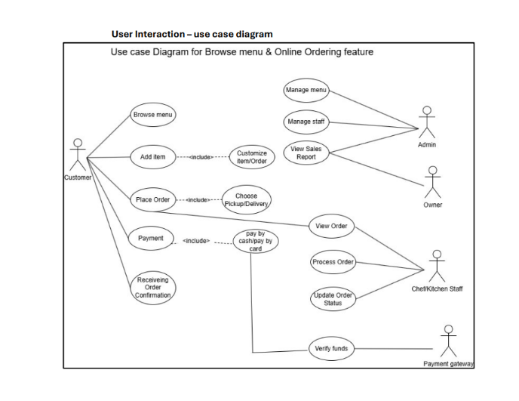
Figure 1
b) Activity Flow
- Customer logs in → browses menu → customizes order → selects pickup/delivery → pays → gets confirmation
Figure 2
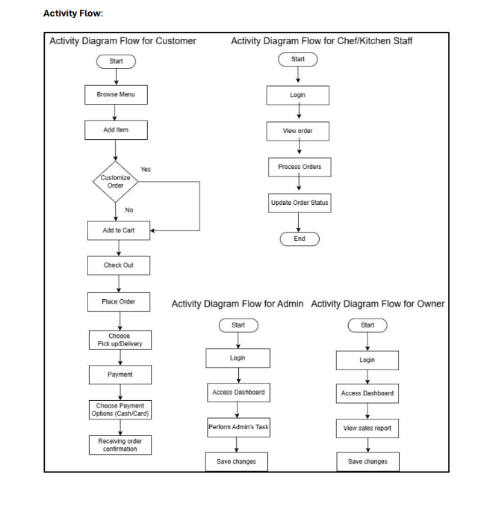
Figure 2
c) System Workflow
- Admin sets up menu → customer places order → chef gets notified → order prepared → customer picks up or receives delivery → feedback submitted
(Visual diagram showing interaction between system parts)
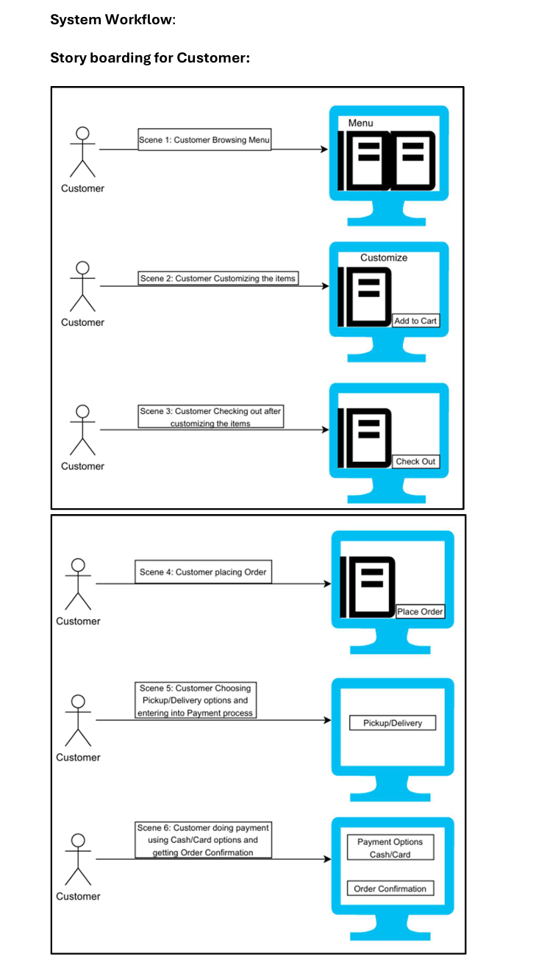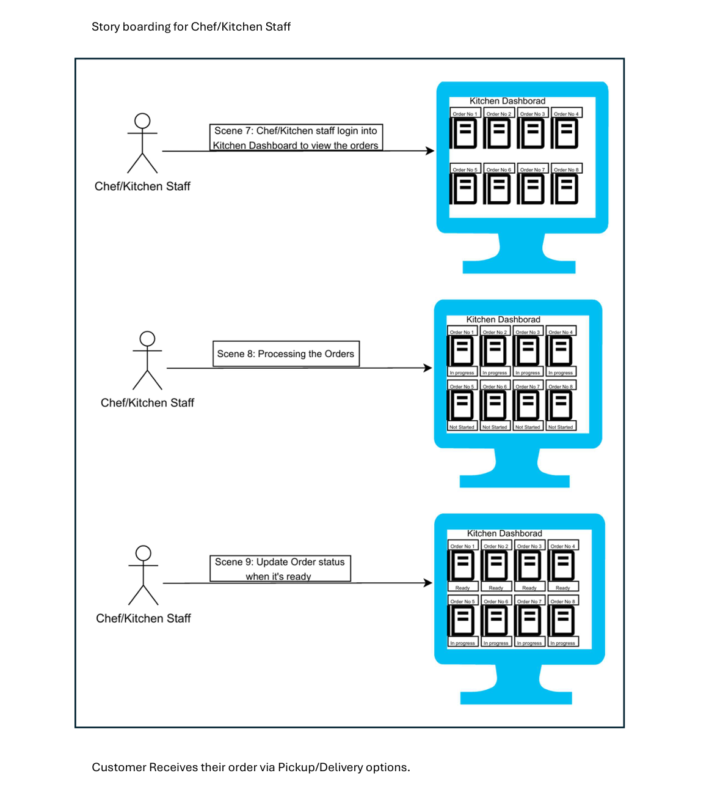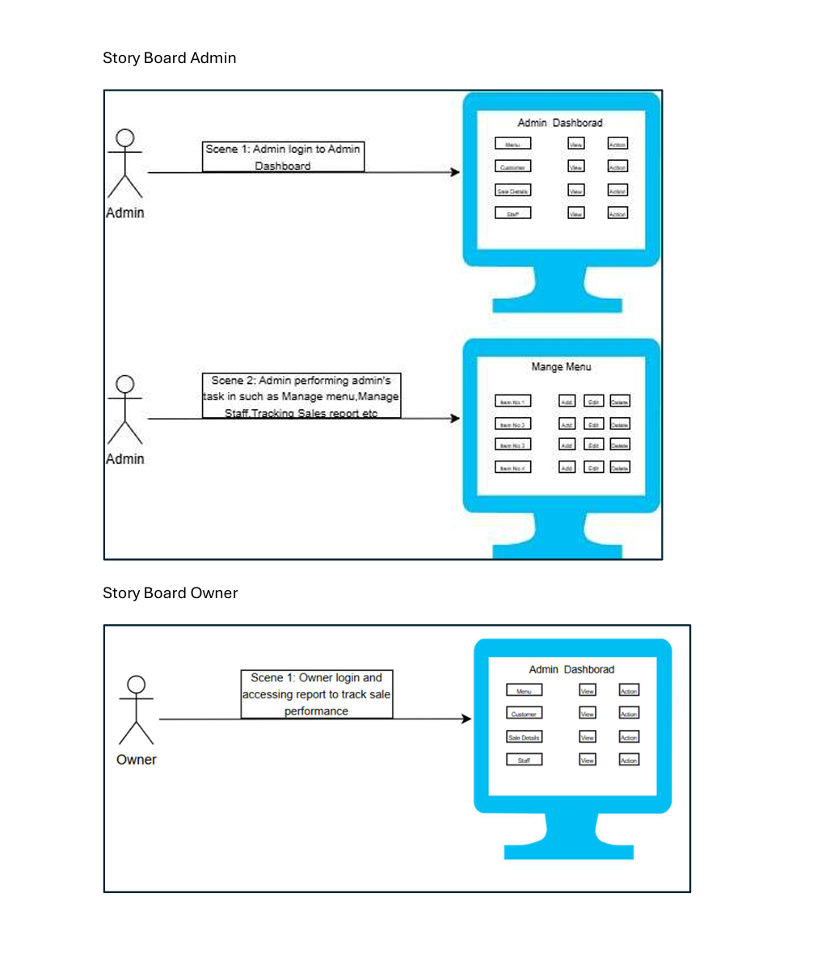
d) Component Relationship (Architecture)
- Frontend (HTML, CSS, Bootstrap, JavaScript)
- Backend (PHP, MySQL)
- Database (MySQL for menu, orders, users)
- Payment Gateway (PayPal)
- Third-Party APIs (Google Maps, Twilio/SendGrid)
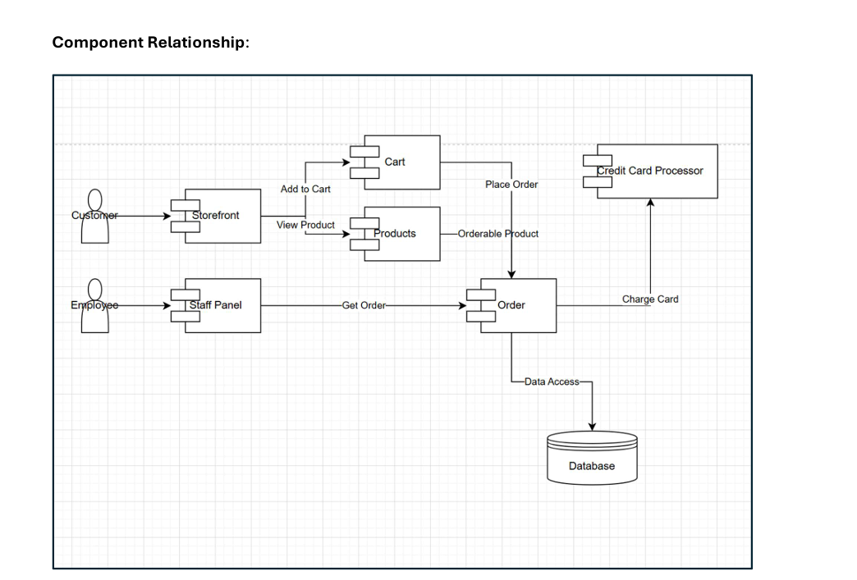

5. Technical Requirements [4 Marks]
- Frontend Tools: HTML, CSS, JavaScript, Bootstrap, jQuery
- Backend: PHP with MySQL
- Hosting: GoDaddy, with SSL Certificate
- CMS: WordPress for updating menu easily
- Payment: PayPal gateway
- APIs:
  - Google Maps (for address and delivery time)
  - Twilio/SendGrid (for order confirmations)
  - Uber Eats integration (optional for future delivery support)
- Future Maintenance:
  - Admin can handle daily updates
  - Backups set via hosting panel
  - Scalable database to support expansion

6. Documentation [4 Marks]
This report is presented in a professional format with clear headings and logical sections. All language is concise, easy to understand, and free from spelling and grammar mistakes. Each part of the proposal is structured to follow a clear thought process — starting from client problems, research, user needs, proposed solution, technical tools, and system planning. Visuals such as diagrams and system flows are included to aid understanding and demonstrate system logic effectively.

Section 2
7. Individual Contribution – Weekly Journal [6 marks]
Member: Tien – Buns N Rolls
Week 1
- Goal: Research features of Buns N Rolls and share with team.
- Tasks Completed: Identified 4 features: quick combo selection, live tracking, customizable burgers, mobile-friendly UI.
- Questions: Should we include mobile app comparison too?
- Reflection: I'm confident in research and summarizing. I need to communicate faster.
Example: I suggested choosing Buns N Rolls for its clean, modern ordering process.
Week 2
- Goal: Finalize system features and interface design.
- Tasks Completed: Helped with interface sketch, proposed loyalty feature.
- Questions: Should ordering be on one page or multiple steps?
- Reflection: I’m getting better at giving feedback. Still improving in quick decision-making.
Example: I decided to include a loyalty system after comparing all three restaurants.

Member: Priya – Mexitup
Week 1
- Goal: Research online system of Mexitup.
- Tasks Completed: Found 4 features: build-your-own meals, vegan filter, preset combos, secure payment.
- Questions: Should we include multiple payment methods in our design?
- Reflection: Priya worked independently and shared research on time.
Example: Priya suggested we allow users to customize burritos like in Mexitup’s system.
Week 2
- Goal: Suggest system features and contribute to layout.
- Tasks Completed: Helped plan dietary filter, proposed secure payment integration.
- Questions: Should we use login/signup for users?
- Reflection: Priya supported the team in feature planning and communicated clearly.
Example: She recommended using icons for vegetarian/gluten-free dishes.

Member: Ryan – Valentine
Week 1
- Goal: Analyze Valentine’s ordering system.
- Tasks Completed: Listed features: schedule orders, dietary info, pre-order with booking, loyalty discounts.
- Questions: Should we include table booking or just takeaway?
- Reflection: Ryan gave good insights into local user preferences.
Example: He introduced the idea of scheduling orders like in Valentine.
Week 2
- Goal: Finalize group feature list and update task progress.
- Tasks Completed: Helped list features on Trello, reviewed design suggestions.
- Questions: Do we need to add allergen warnings visually?
- Reflection: Ryan gave structured input during meetings and stayed on task.
Example: He confirmed that allergen info is important for user trust.
8.
Meeting Minutes (MoM)
Meeting 1 – Initial Planning
- Date: 17 June 2025
- Platform: Microsoft Teams
- Attendees: Tiến, Priya, Ryan
- Agenda:
• Review client requirements
• Assign research on selected restaurants
- Decisions Made:
• Tiến – Buns N Rolls
• Priya – Mexitup
• Ryan – Valentine
- Next Steps: Each member completes feature analysis and prepares summary
Meeting Minutes (MoM)
Meeting 2 – Feature Finalization & Tutor Consultation
- Date: 19 June 2025
- Platform: Microsoft Teams
- Attendees: Tiến, Priya, Harpreet
- Agenda:
• Present initial research findings to tutor
• Finalize system features based on client needs and tutor feedback
• Define functional and non-functional requirements
- Discussions:
• Tutor provided feedback on system scope and suggested including scalability and admin dashboard
• Team clarified approach for user interaction and admin roles
- Decisions Made:
• Final features confirmed: menu customization, order tracking, secure payment, mobile responsiveness, admin dashboard
• Responsibility divided for system requirement documentation and diagram preparation
- Next Steps:
• Tiến – Technical requirements and formatting
• Priya – Use case and activity diagrams
• Ryan – System workflow and component architecture
Meeting 3 – Design Review & Task Distribution
- Date: 24 June 2025
- Platform: Microsoft Teams
- Attendees: Tiến, Priya, Ryan
- Agenda:
• Review completed system diagrams
• Finalize documentation and assign final tasks
- Decisions Made:
• Tiến – Activity Diagram & Component Diagram
• Priya – Use Case Diagram & Formatting
• Ryan – System Workflow & Technical Requirements
- Next Steps: Each member to finalize their assigned section and upload to shared folder for submission
Evidence:
