BÁO CÁO THỰC HÀNH LAB 2  
LẬP TRÌNH HƯỚNG ĐỐI TƯỢNG

# 1. UML & Astah

*Result:*

# 3. Use case diagram



*Result:*

# 4. UML Class Diagram for use cases related to cart management

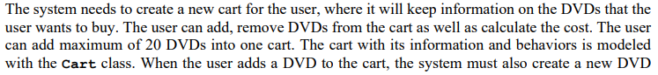

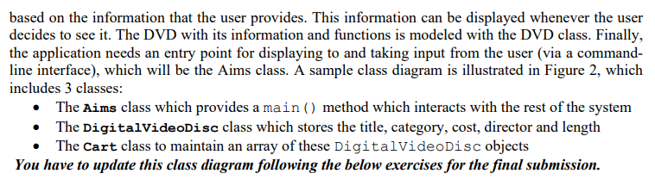

*Result:*

# 5. Create Aims class

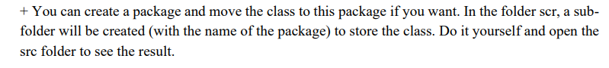

*Result:*

# 6. Create the DigitalVideoDisc class and its attributes

*Result:*

# 7. Create accessors and mutators for the class DigitalVideoDisc

*Result:*

# 8. UML & Astah

*Result:*

# Question



Answer: We could not do this because JAVA doesn't allow us to create two constructors with same signature.

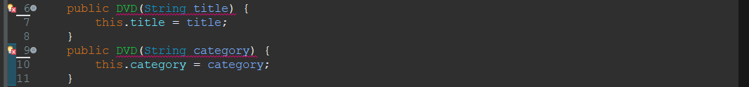

# 9. Create the Cart class to work with DigitalVideoDisc

*Result:*

# 10. Create Carts of DigitalVideoDiscs

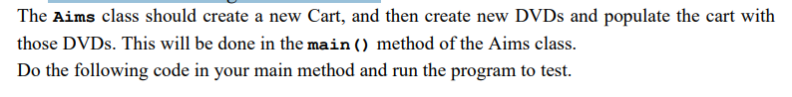

*Result:*

# 11. UML & Astah



*Result:*

