**JAVA_FLORIST PROJECT INSTALLATION GUIDE**

To be able to run the project you need to install the following tools and software:

**VISUAL STUDIO, MICROSOFT SQL SERVER, GIT, .NET Framework 4.7.2**

**Package in project: Linq to SQL Tools, Jwt (Json web token)**

* Step 1: Create Folder Project.
* Step 2: In this folder, open GIT Bash Here and input cmd: git clone: ‘link of github’.

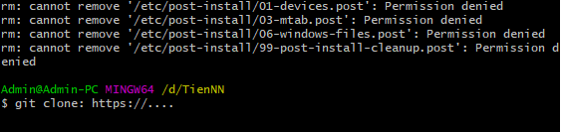

* Step 3: Create Database (any name you like) with SQL Server Management. We set database name is Java_Florist.

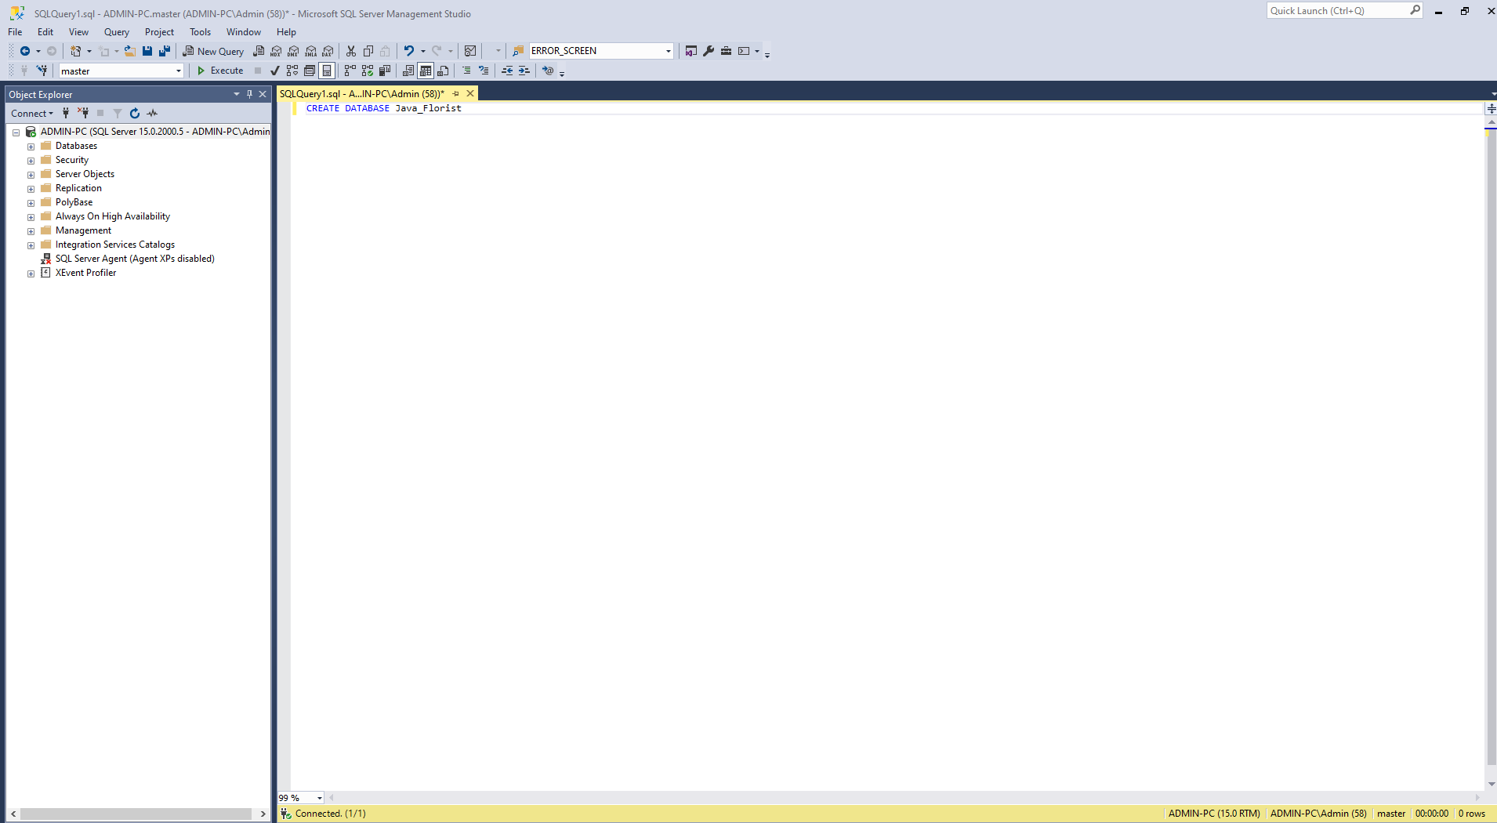

* Step 4: After having db. Open solution project.

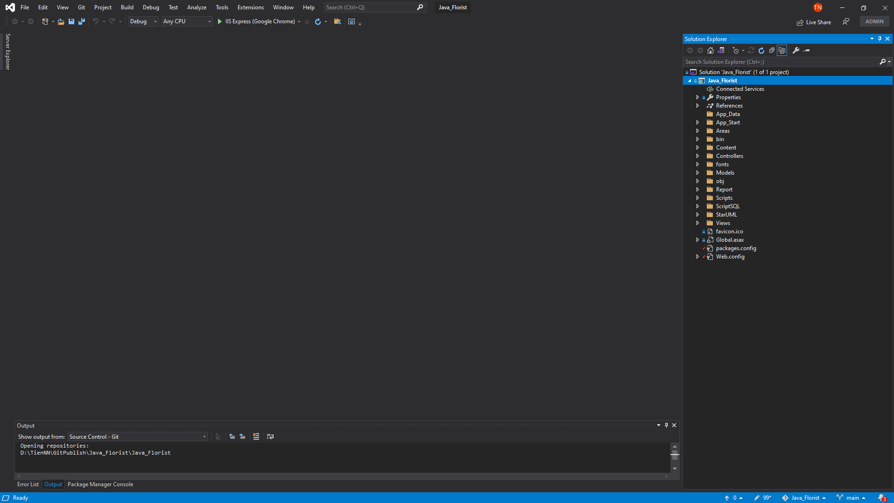

* Step 5: Add package LINQ to SQL tools, you can see tutorial here: <https://www.completecsharptutorial.com/mvc-articles/add-missing-linq-sql-class-vs-2017-2019.php>

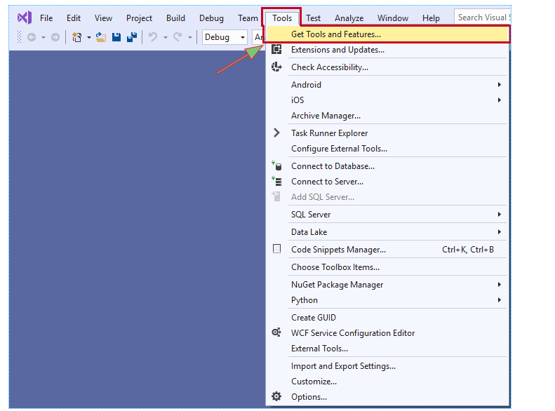

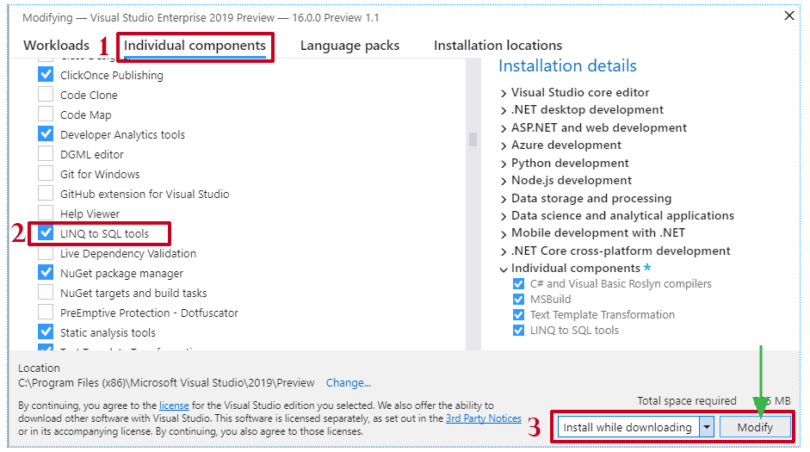

* Step 6: Open file sql in folder ScriptSQL. Copy paste and run in SQL Management to insert table, schema and data. So, we have database of project.

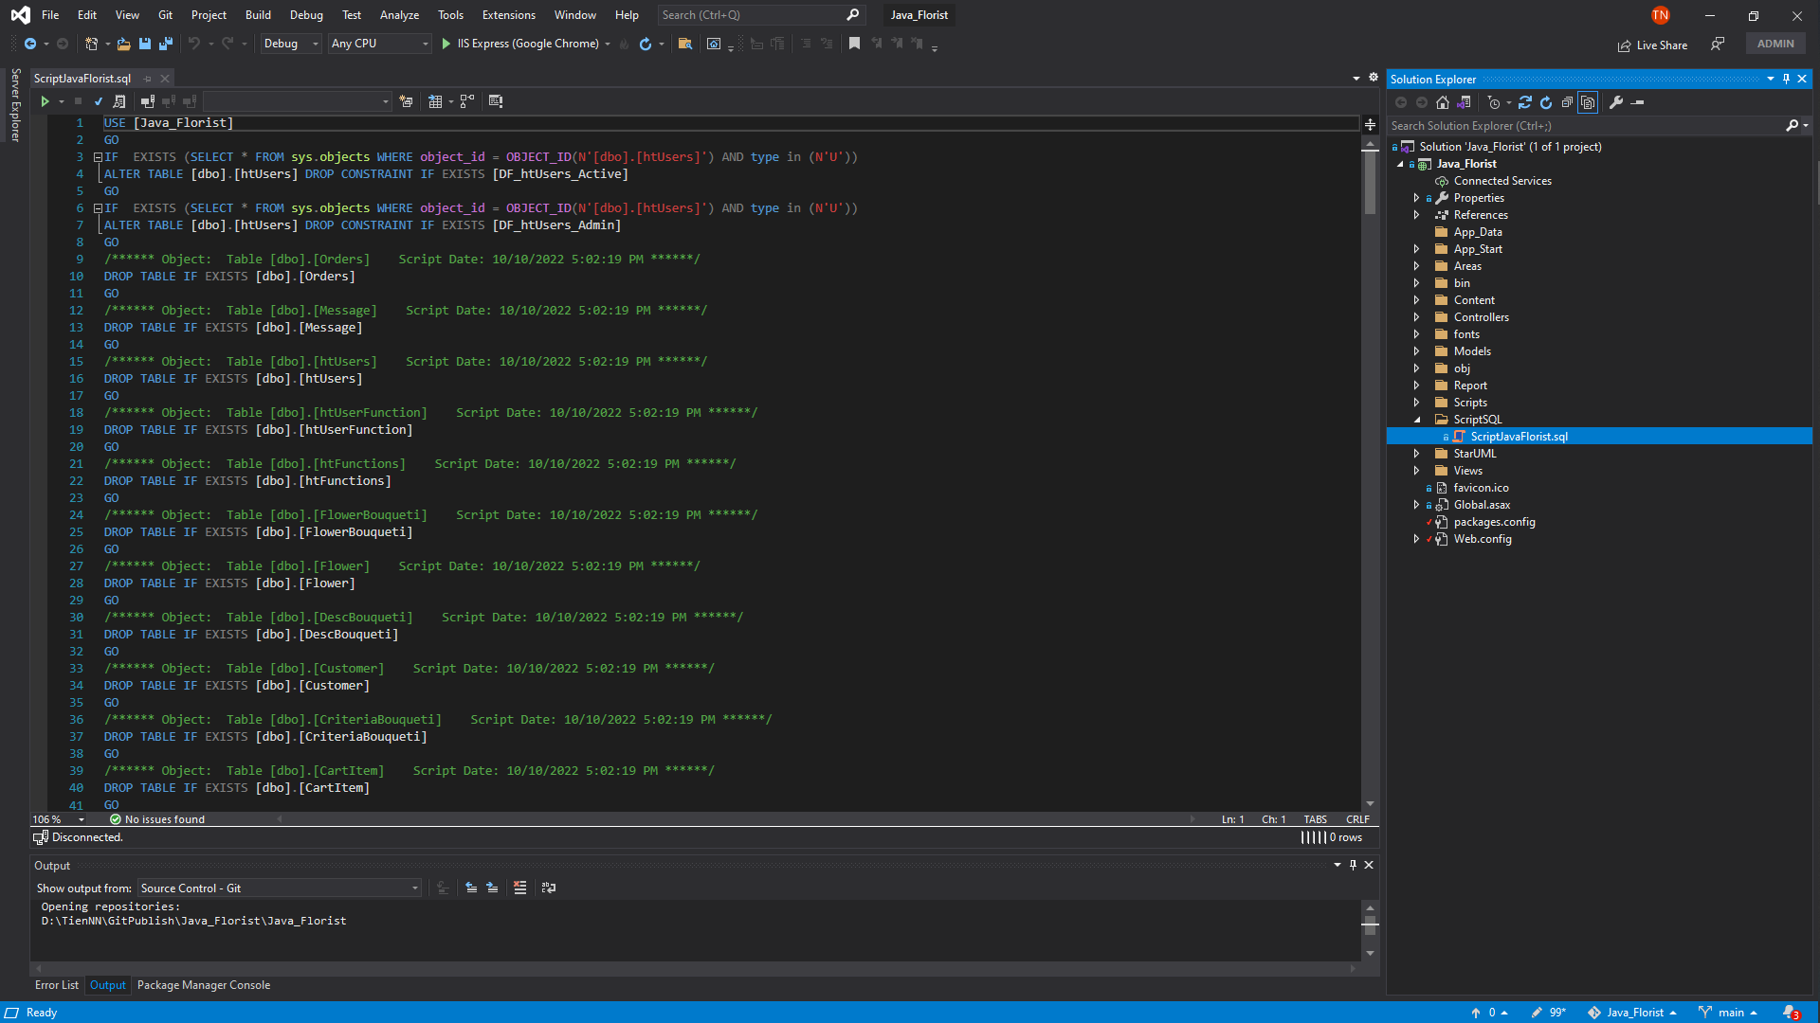

* Step 7: Connect database into project in visual. Tutorial : <https://learn.microsoft.com/en-us/visualstudio/data-tools/add-new-connections?view=vs-2022>.

* Graphical user interface, application

  Description automatically generatedOpen file Linq.dbml in folder Models. Pull all tables into interface:
* Step 8: Rebuild Project. The ConnectionString will created in file Web.config.

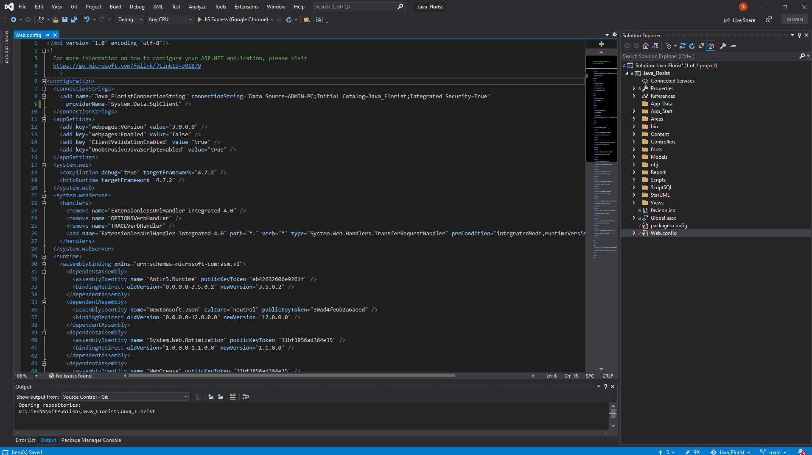

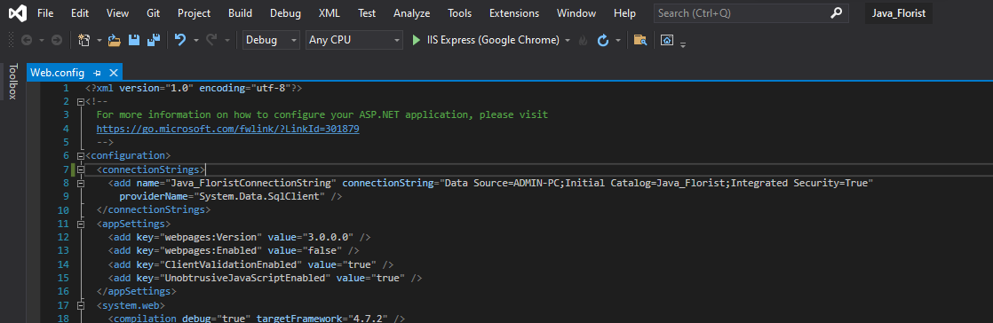

* Step 9: Run project with ‘IIS Express’. That’s all ^ ^ !.

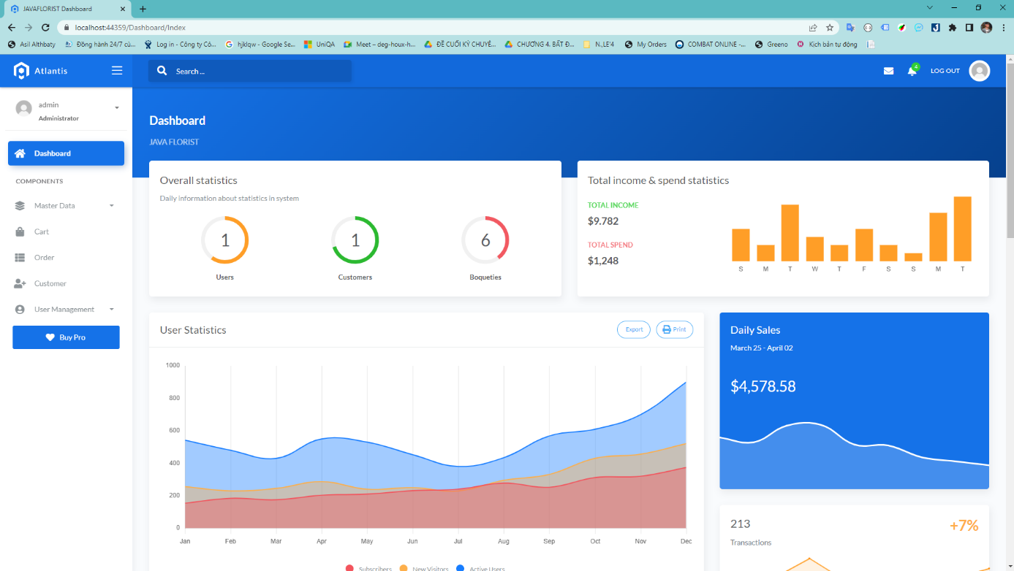We have 2 pages: ADMIN (Login with role) and USER

