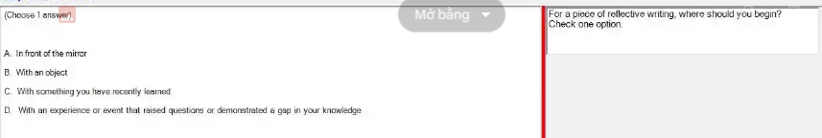

With an experience or event that raised questions or demonstrated a gap in your knowledge

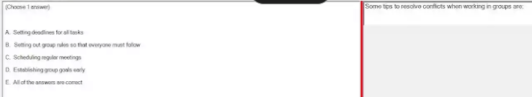

E. All of the answers are correct

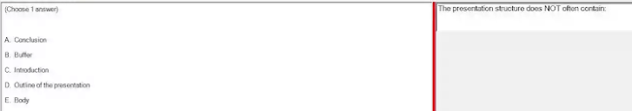

Buffer

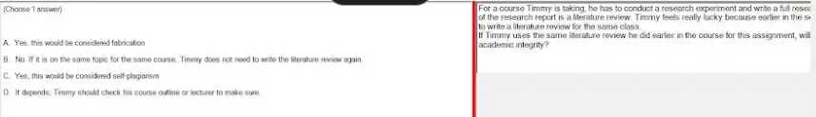

It depends; Timmy should check his course outline or lecturer to make sure.

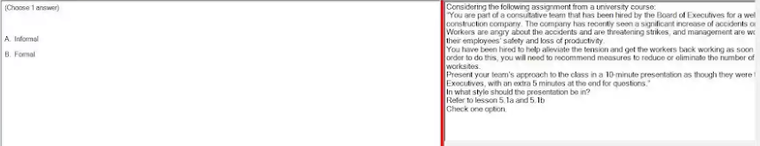

Formal

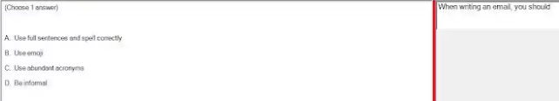

A. Use full sentences and spell correctly

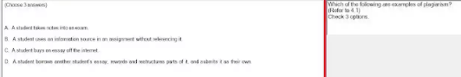

B/ A student uses an information source in an assignment without referencing it.

C/ A student buys an essay off the internet.

D/ A student borrows another student's essay, rewords and restructures parts of it, and submits it as their own.

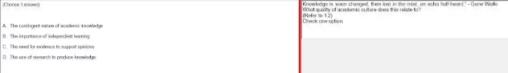

A/ The contingent nature of academic knowledge.

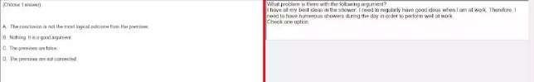

A/ The conclusion is not the most logical outcome from the premises.

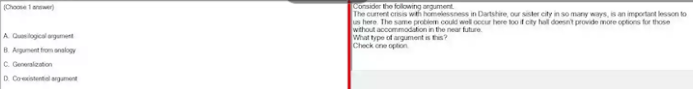

B/ Argument from analogy

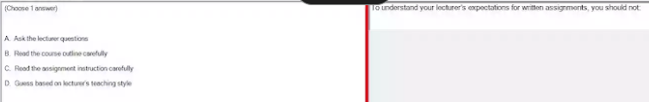

D/ Guess based on lecturer's teaching style

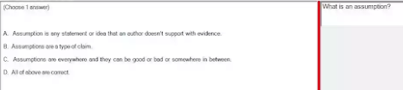

C/ Assumptions are everywhere and they can be good or bad or somewhere in between

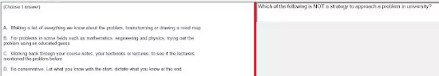

D/ Be conservative. Let what you know with the start, dictate what you know at the end

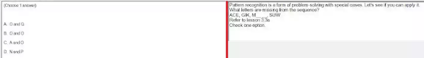

A/ O and Q

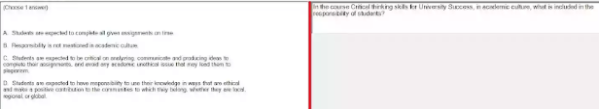

D/ Students are expected to have responsibility to use their knowledge in ways that are ethical and make a positive contribution to the communities to which they belong, whether they are local, regional, or global.

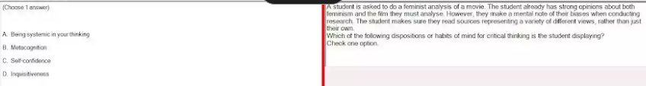

B/ Metacognition

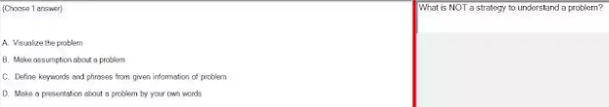

B/ Make assumption about a problem

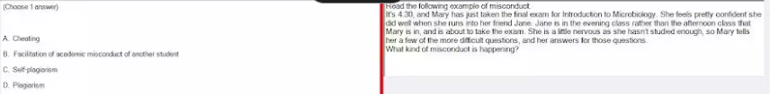

B/ Facilitation of academic misconduct of another student

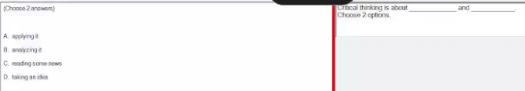

A/ applying it

B/ analyzing it

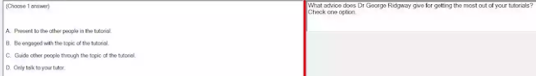

B/ Be engaged with the topic of the tutorial.

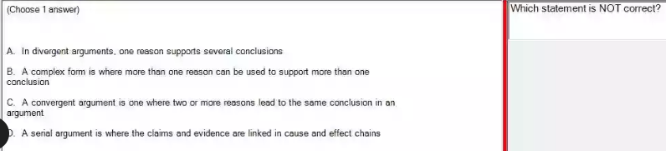

A/ In divergent arguments, one reason supports several conclusions

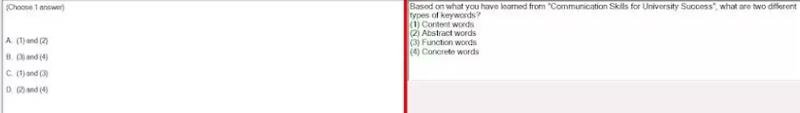

C/ (1) and (3)

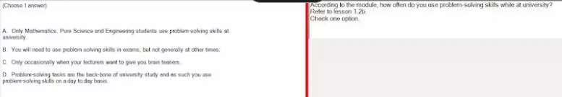

D/ Problem-solving tasks are the back-bone of university study and as such you use problem-solving skills on a day to day basis.

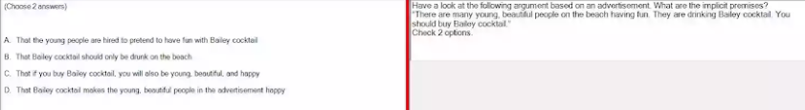

That if you buy Bailey cocktail, you will also be young, beautiful, and happy D. That Bailey cocktail makes the young, beautiful people in the advertisement happy

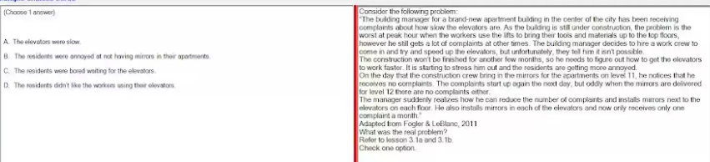

A/ The elevators were slow.

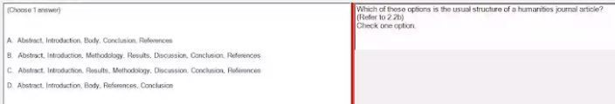

A. Abstract, Introduction, Body. Conclusion, References

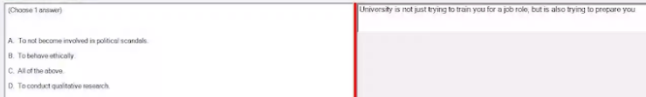

B. To behave ethically.

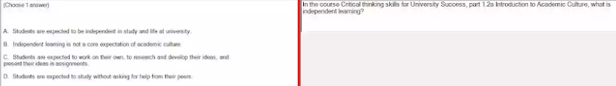

C/ Students are expected to work on their own, to research and develop their ideas, and present their ideas in assignments

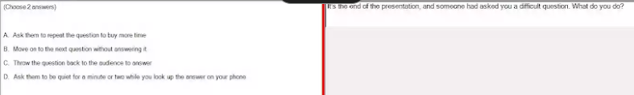

A/ Ask them to repeat the question to buy more time

C/ Throw the question back to the audience to answer

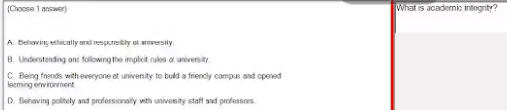

A/ Behaving ethically and responsibly at university.

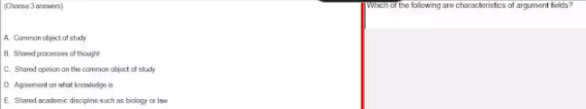

A/ Common object of study

B/ Shared processes of thought

E/ Shared academic discipline such as biology or law

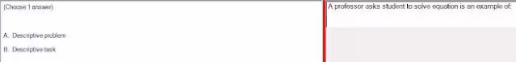

B/ Descriptive task

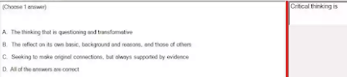

D/ All of the answers are correct.

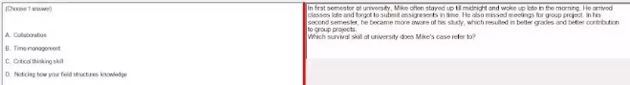

1. Time management

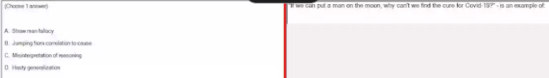

B/ Jumping from correlation to cause

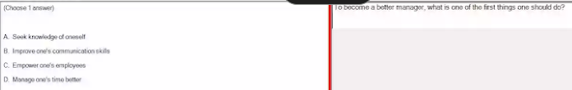

A/ Seek knowledge of oneself

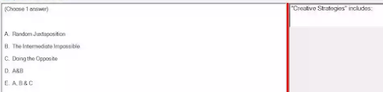

E. A, B & C.

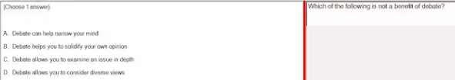

A. Debate can help narrow your mind is not a benefit of debate.

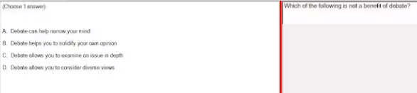

A. Debate can help narrow your mind is not a benefit of debate.

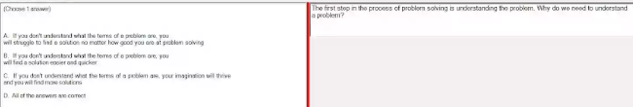

A. If you don't understand what the terms of a problem are, you will struggle to find a solution no matter how good you are at problem solving.

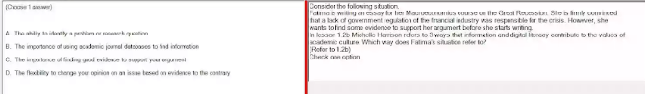

C. The importance of finding good evidence to support your argument.

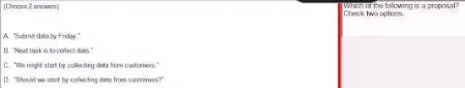

C/ "We might start by collecting data from customers."

D/ "Should we start by collecting data from customers?"

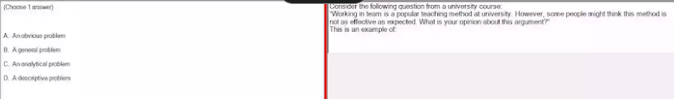

C/ An analytical problem

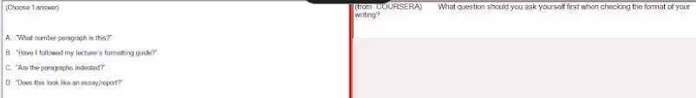

D/ "Does this look like an essay/report?"

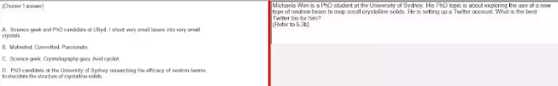

D. PhD candidate at the University of Sydney researching the efficacy of neutron beams to elucidate the structure of crystalline solids.

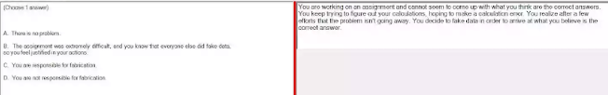

C. You are responsible for fabrication.

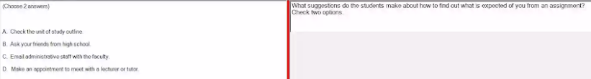

A/ Check the unit of study outline. D. Make an appointment to meet with a lecturer or tutor.

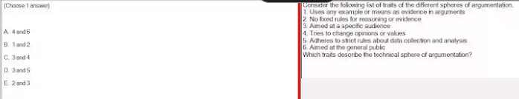

D/ 3 and 5

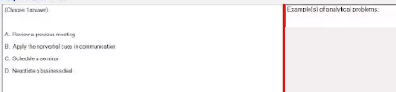

D. Negotiate a business deal

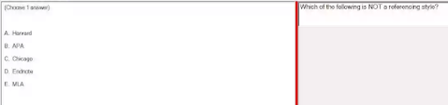

D. Endnote

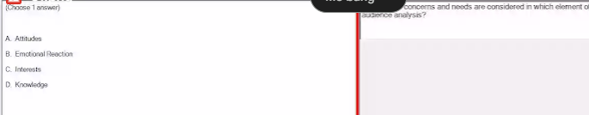

C/ Interests

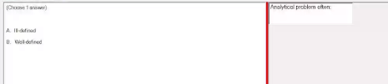

A. Ill-defined b