bus that connects major computer components (processor, memory, V/O) is called a ____

system bus

The System bus is made up of ___

Control bus, Data bus and Address bus.

Data are transferred to and from the disk in ____

Sectors

The unary operation ___ inverts the value of its operand.

NOT

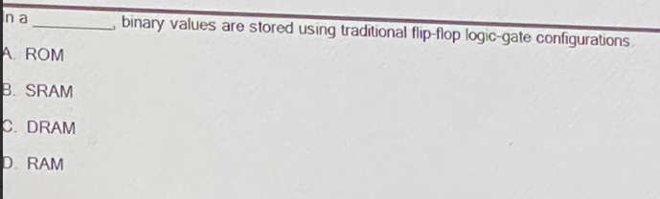 B. SRAM

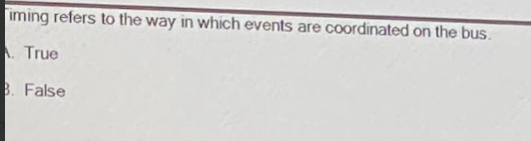

True

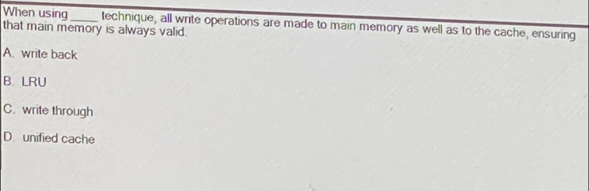

1. write through.

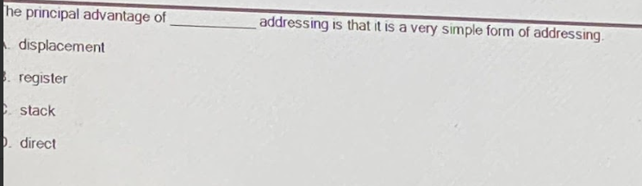

1. direct.

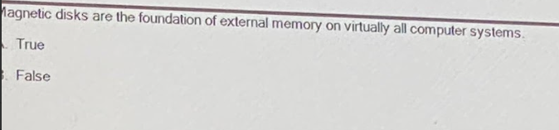

1. True

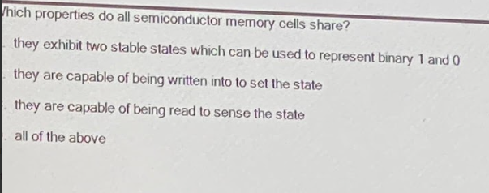

D/ all of the above.

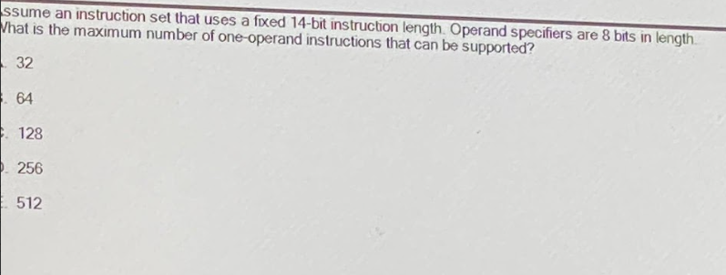

D/ 256.

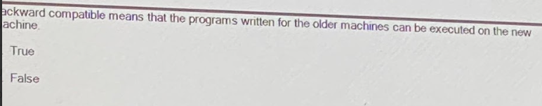

A/ true

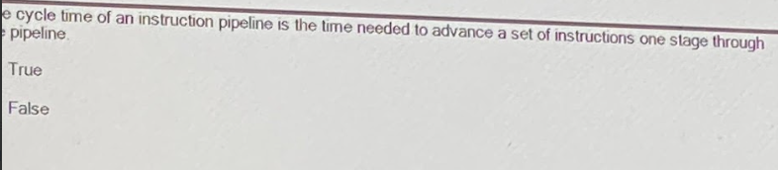

True

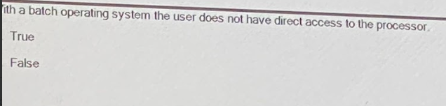

True

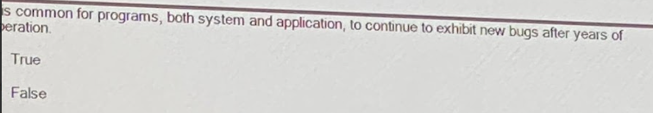

True

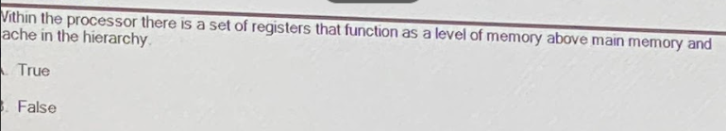

True

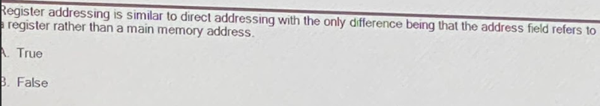

True

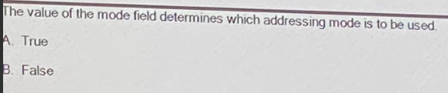

True

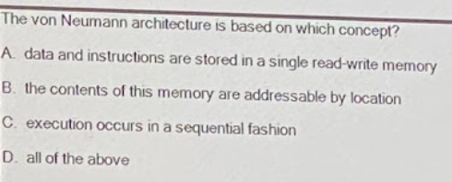

D/ all of the above

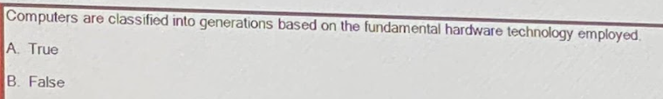

1. True

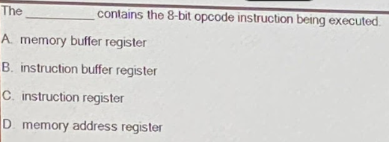

C/ instruction register.

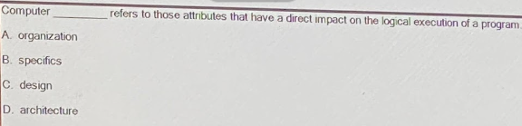

D/ architecture.

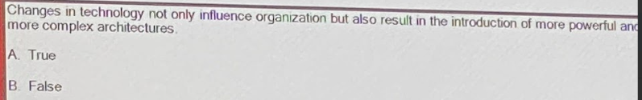

 A. True.

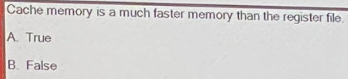

B. False.

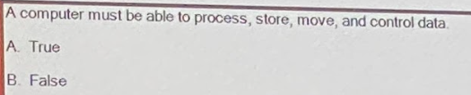

A. True.

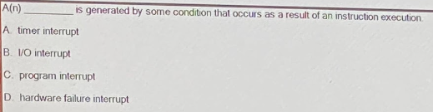

program interrupt

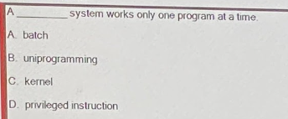

uniprogramming

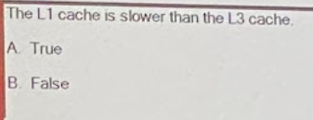

B. False.