**INSTALLATION GUIDE**

**\*\*\***

**Auto Ancillaries Limited**

***Table of content***

**Table of Contents**

1. Setup Microsoft SQL Server 2012.

*2.* *Setup NetBean IDE*

3. Attach dataDase :

4. Setup Website

# Setup Microsoft SQL Server 2012.

# SQL Server 2012 Installation:

## Step 1

Insert SQL Server 2012 installation media into your dvd drive/virtual disc drive.

At this point, you will be prompted (based on your Windows settings) with AutoPlay dialog as shown in the image below:

[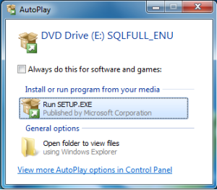](https://sqlbaba.files.wordpress.com/2012/03/disc-run.png)

Click on Run SETUP.EXE (Alternatively you can launch set up by locating and double clicking on SETUP.EXE file on the media drive)

At this time, SQL Server 2012 install will run background processes and you should see the following dialog.

[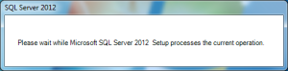](https://sqlbaba.files.wordpress.com/2012/03/waiting.png)

## STEP 2:

If your OS is compatible, at this point the install should show you the SQL Server Installation Center.

Click on ‘Installation’ link (2nd in the list)

[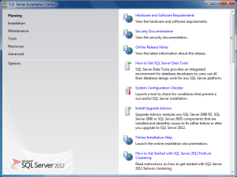](https://sqlbaba.files.wordpress.com/2012/03/installation-center.png)

## STEP 3:

Click on ‘New SQL Server stand-alone installation or add features to an existing installation’ (See the image below).  All the options on this screen are self-explanatory and I recommend you to explore and read through the options for your learning.

[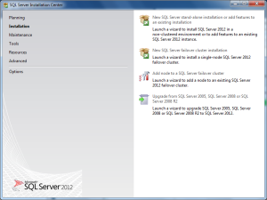](https://sqlbaba.files.wordpress.com/2012/03/installation-center-installation.png)

At this point, the install wizard will check for various setup rules and present you with any issues that needs to be resolved for set up to continue (See image below).

## [https://sqlbaba.files.wordpress.com/2012/03/sql-server-2012-installation-setup-rules.png?w=300&h=225](https://sqlbaba.files.wordpress.com/2012/03/sql-server-2012-installation-setup-rules.png)

## STEP 4:

In this step the install will ask for product key.  A default option of ‘Specify a free edition’ should be alreadt selected and ‘Evaluation’ is selected from the drop-down list (See image below).

## STEP 5:

Accept SQL Server 2012 Evaluation license terms and conditions (See image below).

Click Next.

[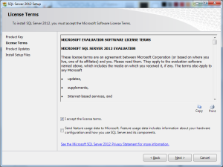](https://sqlbaba.files.wordpress.com/2012/03/sql-server-2012-installation-licenseterms.png)

## STEP 6:

In the next screen, SQL Server 2012 install wizard will ask you to install setup files needed. Click on ‘Install’ button (see image below).

[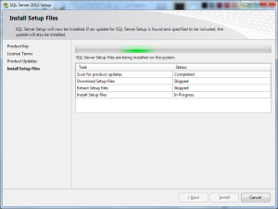](https://sqlbaba.files.wordpress.com/2012/03/sql-server-2012-installation-setup-files.png)

Once the setup files are installed, you should see the install complete screen (see image below).

Click Next.

[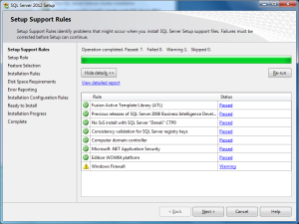](https://sqlbaba.files.wordpress.com/2012/03/sql-server-2012-installation-setup-rules-2.png)

## STEP 7:

In this step make sure ‘SQL Server Feature Installation’ is selected and click Next to continue (see image below).

[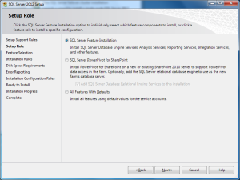](https://sqlbaba.files.wordpress.com/2012/03/sql-server-2012-installation-setup-roles.png)

## Step 8:

At this time you should see ‘Feature Selection’ screen.  I recommend you to click on ‘Select All’ if you are new to installing SQL Server (which is why I guess you are using these instructions).

See image below.

[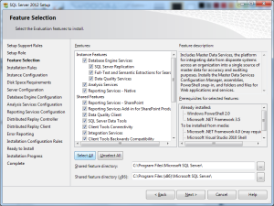](https://sqlbaba.files.wordpress.com/2012/03/sql-server-2012-installation-feature-selection.png)

At this point, the wizard will again check your system for any blocking issues (see image below). Upon successful completion click ‘Next’

## STEP 9:

In this step you will be able to create a new SQL Server Instance.  However, I recommend to go with default settings i.e, default instance (see image below).

Click ‘Next’ to continue.

[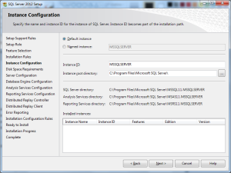](https://sqlbaba.files.wordpress.com/2012/03/sql-server-2012-installation-instance-configuration.png)

## STEP 10:

Installer will check your system for required disk space and provide you a summary (see image below). Click Next.

[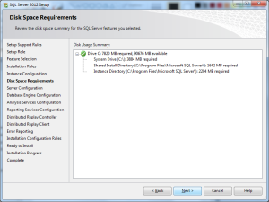](https://sqlbaba.files.wordpress.com/2012/03/sql-server-2012-installation-disk-space-requirements.png)

## STEP 11:

Unlike previous versions of SQL Server, SQL Server 2012 uses an already created individual and independent service accounts for running various SQL Server services. Review and leave default options as-is (See image below).

[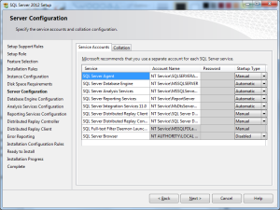](https://sqlbaba.files.wordpress.com/2012/03/sql-server-2012-installation-server-configuration.png)

Before clicking on Next to continue, click on collation tab and read through descriptions for your learning. Leave default selections as-is (see image below).

[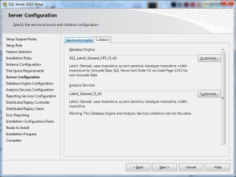](https://sqlbaba.files.wordpress.com/2012/03/sql-server-2012-installation-server-configuration-collation.png)

Click Next to continue.

## STEP 12:

In this step, please follow the instructions carefully!!!

As you can see in the image below, you can have either windows authentication mode or mixed mode. Windows authentication mode lets you add only windows users while mixed mode lets you create users with a unique login and password.

Make sure you select Mixed Mode (converse to what is shown in the image below).

Enter a password for ‘sa’ account.

Also make sure to click on ‘Add Current User ‘ which will add the account with which you are currently logged in into windows as a admin account to SQL Server.

Note: Image below does not reflect the instructions above. Follow the instructions above carefully.

Click on Data Directories and FILESTREAM tabs and review for your learning (See images below).

[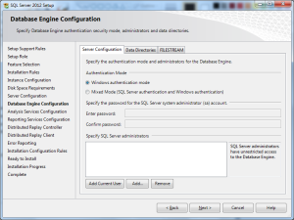](https://sqlbaba.files.wordpress.com/2012/03/sql-server-2012-installation-database-configuration.png)

[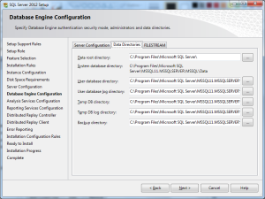](https://sqlbaba.files.wordpress.com/2012/03/sql-server-2012-installation-database-configuration-data-directories.png)

Click Next to continue.

## STEP 13:

Leave default selections as-is.

Make sure to click on ‘Add Current User’ which will add the account with which you are currently logged in into windows as an administrator account for Analysis Service Engine.

[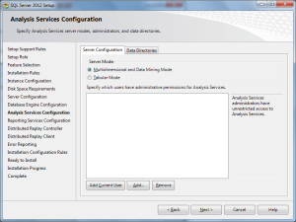](https://sqlbaba.files.wordpress.com/2012/03/sql-server-2012-installation-analysis-services-configuration-server-configuration.png)

Click on Data Directories tab to review (see image below).

[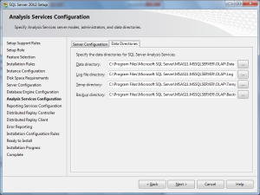](https://sqlbaba.files.wordpress.com/2012/03/sql-server-2012-installation-analysis-services-configuration-data-directories.png)

Click Next to continue.

## STEP 14:

In this step leave the default options as-is.

Click Next to continue.

[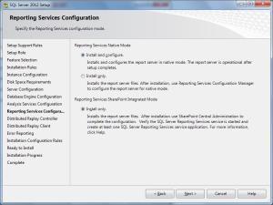](https://sqlbaba.files.wordpress.com/2012/03/sql-server-2012-installation-reporting-services-configuration.png)

## STEP 15:

In this step Click Add Current User to add your windows account as an administrator account for Distributed Replay Controller.

[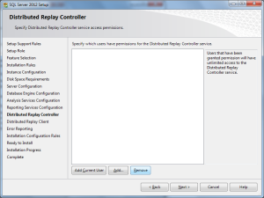](https://sqlbaba.files.wordpress.com/2012/03/sql-server-2012-installation-distributed-replay-controller.png)

Click Next to continue.

## STEP 16:

Leave the Controller Name blank and Click Next to Continue (see image below).

[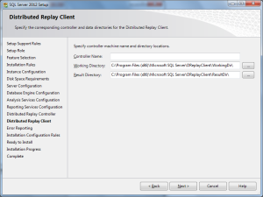](https://sqlbaba.files.wordpress.com/2012/03/sql-server-2012-installation-distributed-replay-client.png)

## STEP 17:

Check box if you would like to send error reports to Microsoft. I have left it as-is (see image below).

[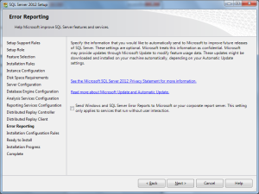](https://sqlbaba.files.wordpress.com/2012/03/sql-server-2012-installation-error-reporting.png)

Click Next to Continue.

At this point, set up will again verify your system for any potential blocking issues.

Once the operation is completed, click Next to continue (see image below).

[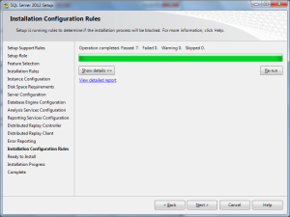](https://sqlbaba.files.wordpress.com/2012/03/sql-server-2012-installation-installation-configuration-rules.png)

## STEP 18:

Review the options you selected for the install and verify the path to which configuration file will be stored. You can take advantage of this configuration file for future installs.

Click ‘Install’ to begin Installation.

[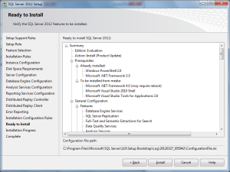](https://sqlbaba.files.wordpress.com/2012/03/sql-server-2012-installation-ready-to-install.png)

Installer will take a while in this step before the installation is complete.

[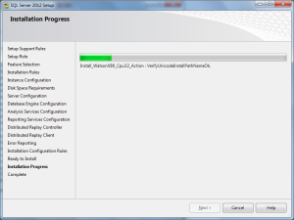](https://sqlbaba.files.wordpress.com/2012/03/sql-server-2012-installation-installation-progress.png)

[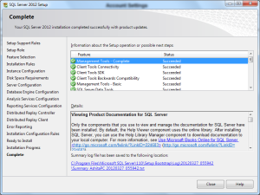](https://sqlbaba.files.wordpress.com/2012/03/sql-server-2012-installation-installation-complete.png)

# *2.Setup Visual 2010*

After the preparation has been done, we double-click the setup.exe file to start Visual Studio 2010 products installation.

[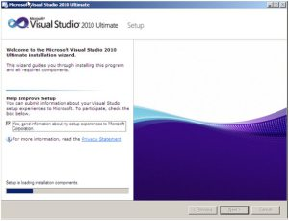](http://chenyichun0407.files.wordpress.com/2010/05/443164bcd441ea18de4f134f23fe98b6.png?w=300)

(The setup is loading installation components)

[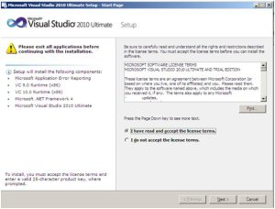](http://chenyichun0407.files.wordpress.com/2010/05/b4cf9c22d59f653dfba701bfc685f90c.png?w=300)

(Accept the license terms to continue the installation)

[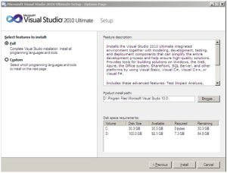](http://chenyichun0407.files.wordpress.com/2010/05/b15d1b293ea504b82ad984b39f9c6d4a.png?w=300)

(Select the features that we want to install and the path we want VS2010 to be installed)

[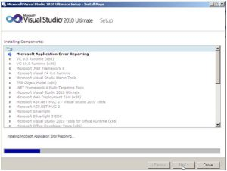](http://chenyichun0407.files.wordpress.com/2010/05/3e593b93fa37f5c33a5c570ed5beaf05.png?w=300)

(The setup is installing components)

[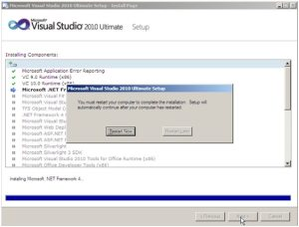](http://chenyichun0407.files.wordpress.com/2010/05/e00c6765ddfa91d3a8a83c143acb48a7.png?w=300)

(The setup needs rebooting after .NET Framework 4.0 has been installed)

[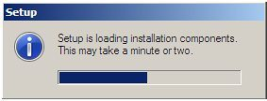](http://chenyichun0407.files.wordpress.com/2010/05/6c7c9e205d545cf3241bac8c80e2dc45.png?w=283)

(After the rebooting, the setup starts again)

[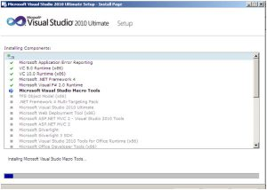](http://chenyichun0407.files.wordpress.com/2010/05/58144a7e5655a065b3b26a02b071e471.png?w=300)

(The setup starts to install the rest components)

[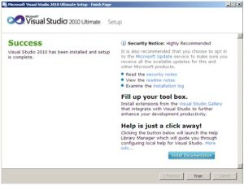](http://chenyichun0407.files.wordpress.com/2010/05/1c20546451d03ab4d5beb75deb2abc1a.png?w=300)

(The installation is completed)

# Attach dataDase :

1. **Connect SQL**
   * Run SQL Server Management Studio

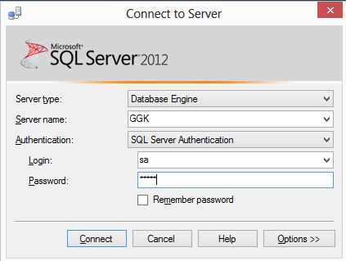

* + Right click to Database then choose Attach…

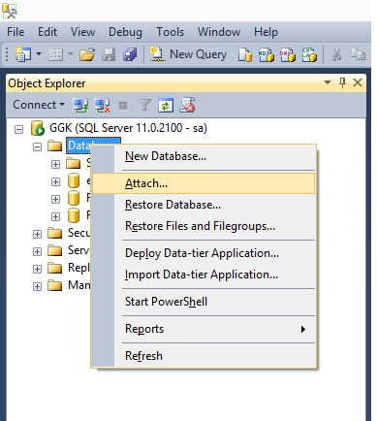

* Click to Add , Locate Database File windows open, then choose destination folder which contains **eProject.mdf** file, then click OK.
* Click OK to finish adding database, then close SQL Server Management Studio
* Run SQL Server Configuration Manager 🡪 SQL Server 2005 Network Configuration 🡪 Protocols for MSSQLSERVER

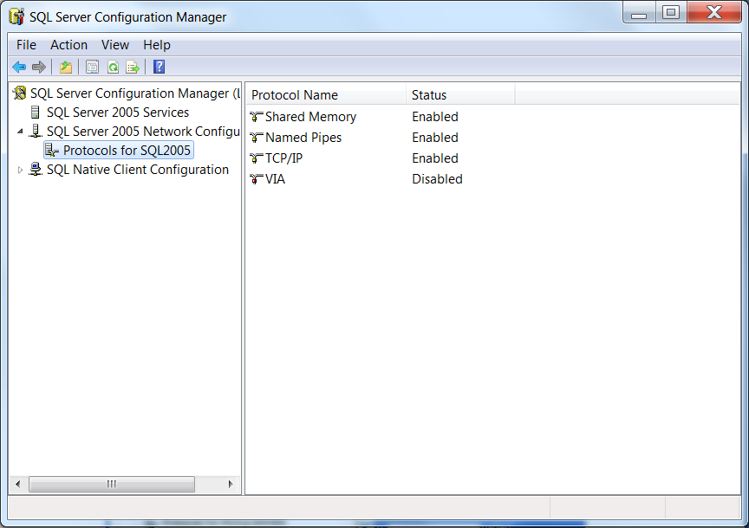

* Right click to TCP/IP then choose Properties, a TCP/IP Properties window open

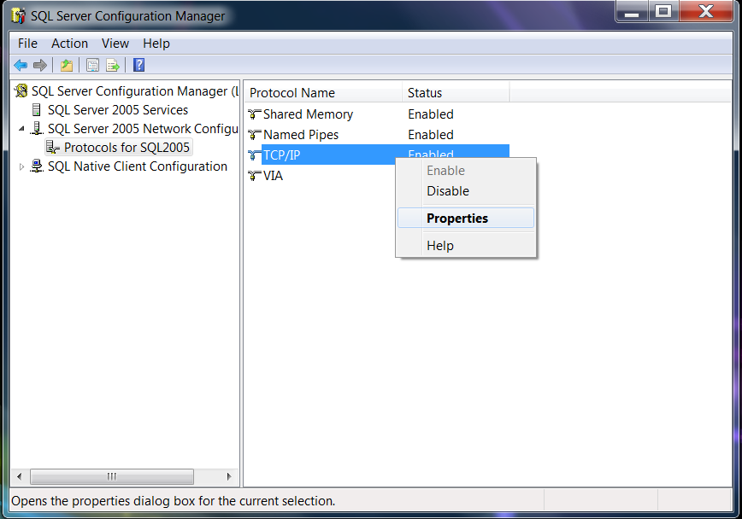

* + On tab Protocol, set Enabled is Yes

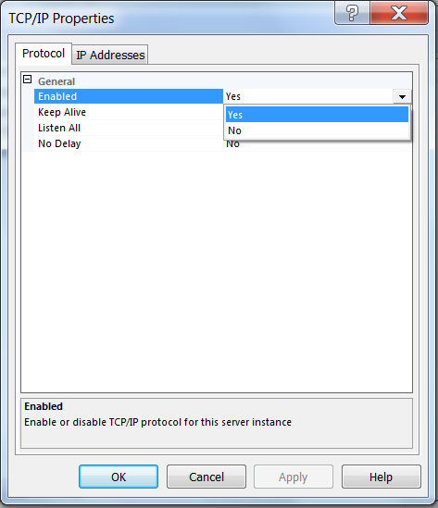

* + On tab Ip Addresses, set all TCP Port is 1433 then click Apply, and Ok

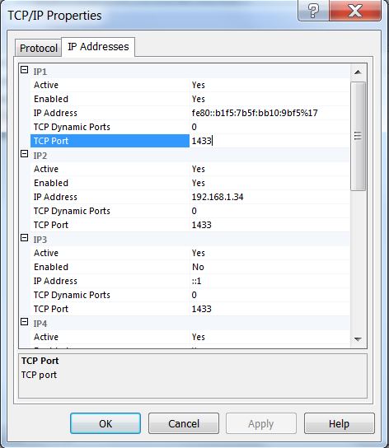

* Click to SQL Server 2012 Services, right click to SQL Server (SQLExpress), then choose Restart, after restart successfully, close SQL Server Configuration Manager. If can not restart, you need restart computer.

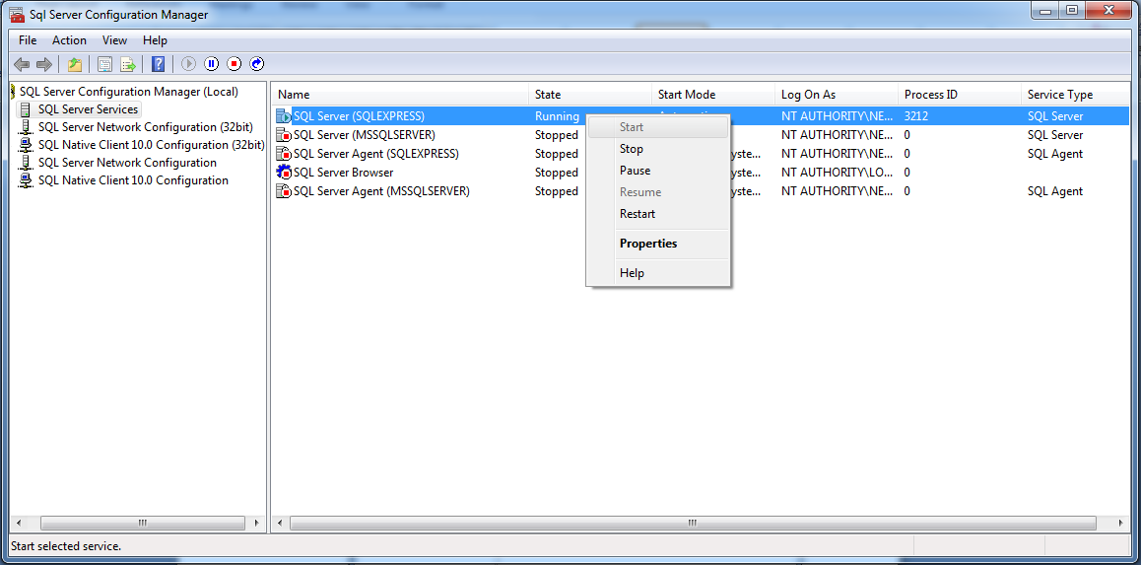

# Setup Website

* 1. Open your **visual** then click to “**File**” -> “**Open** ” ->”Project- Solution”

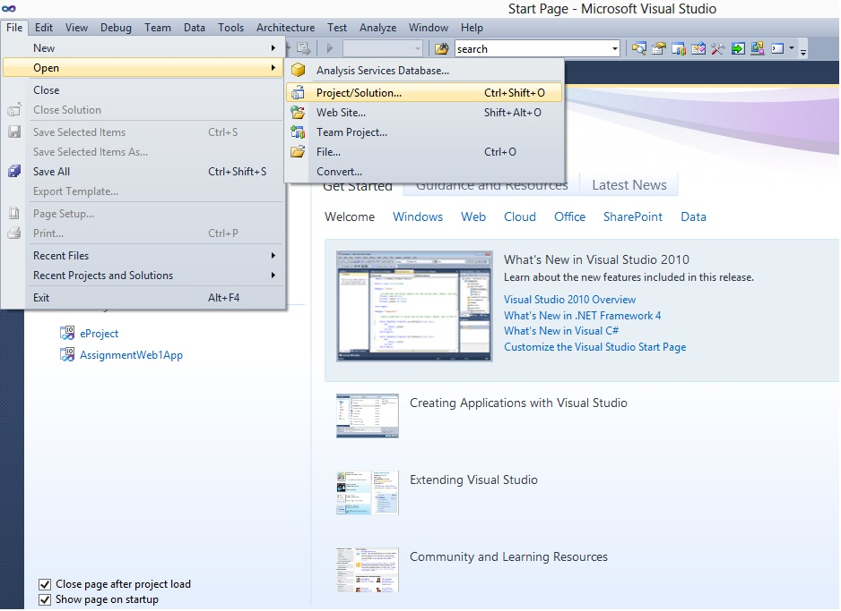

* 1. Click “**eProject** ” then click to Open

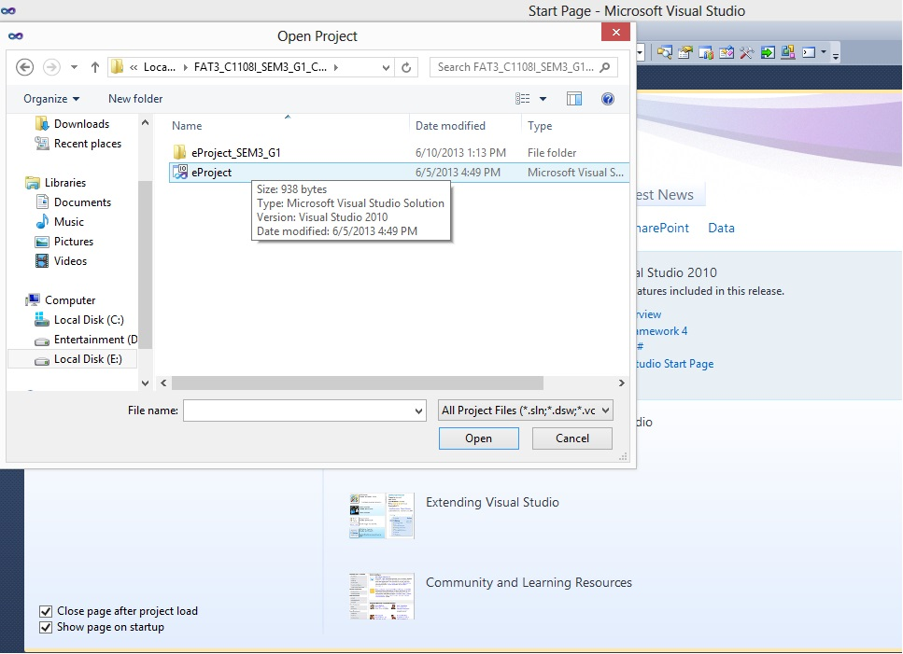

* 1. **Run website:**
     1. ***Admin page***: go to folder “admin” then run admin page you run file “Login.aspx”:

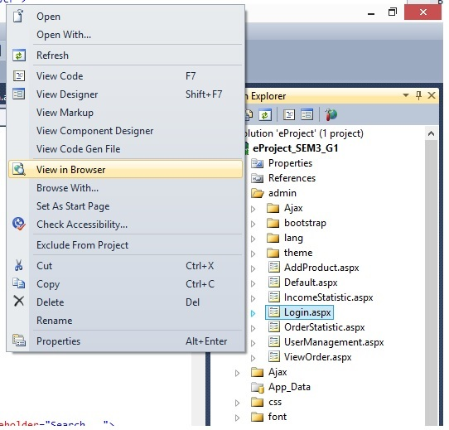

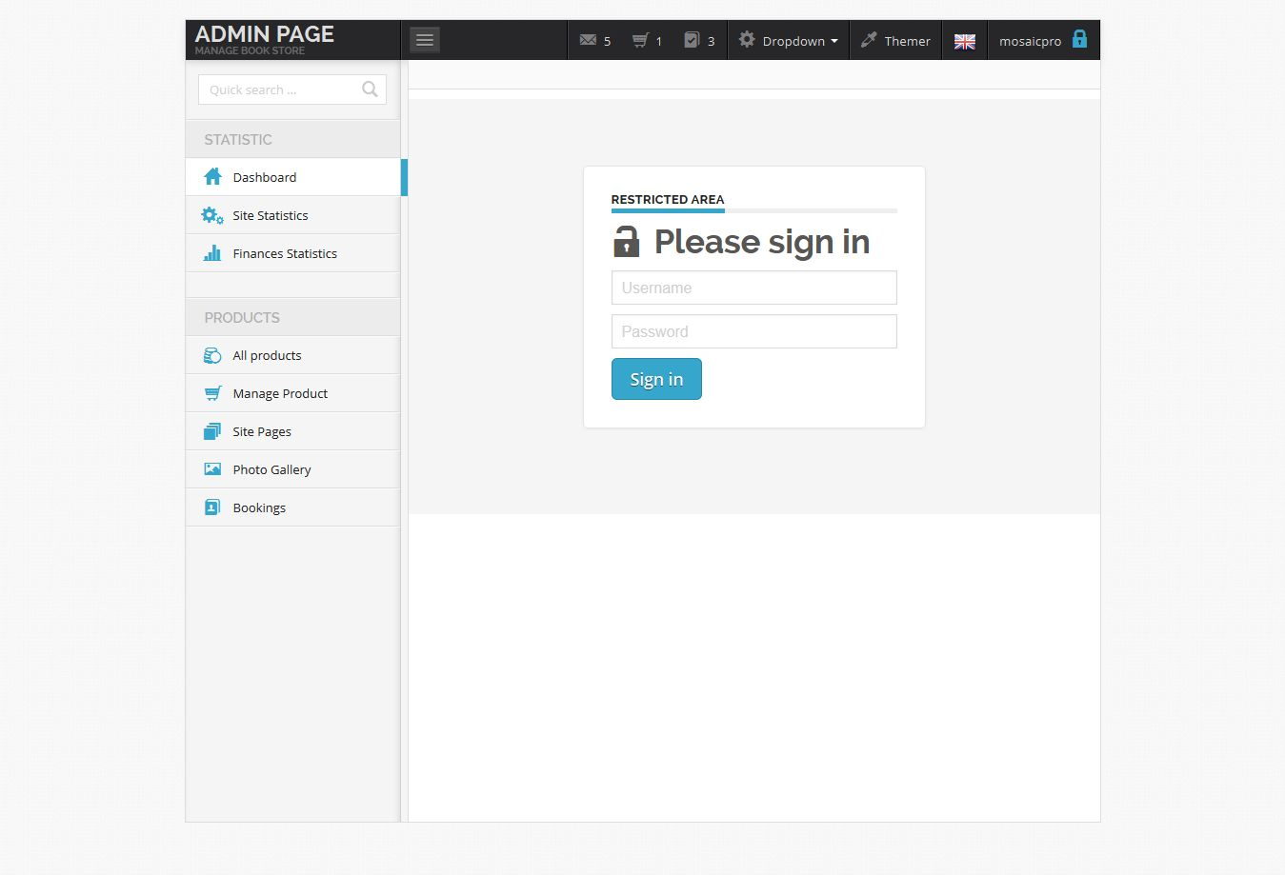

*Note :you can login to admin page with username :”**admin”** and password “**123456**”

* + 1. ***User page***: to run User Login pa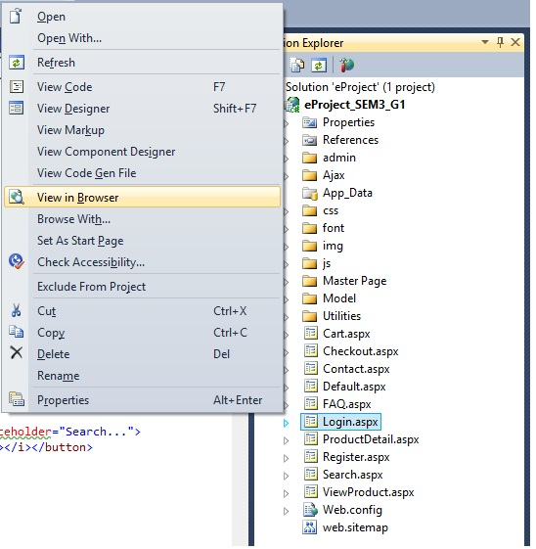ge you run file “Login.aspx”:

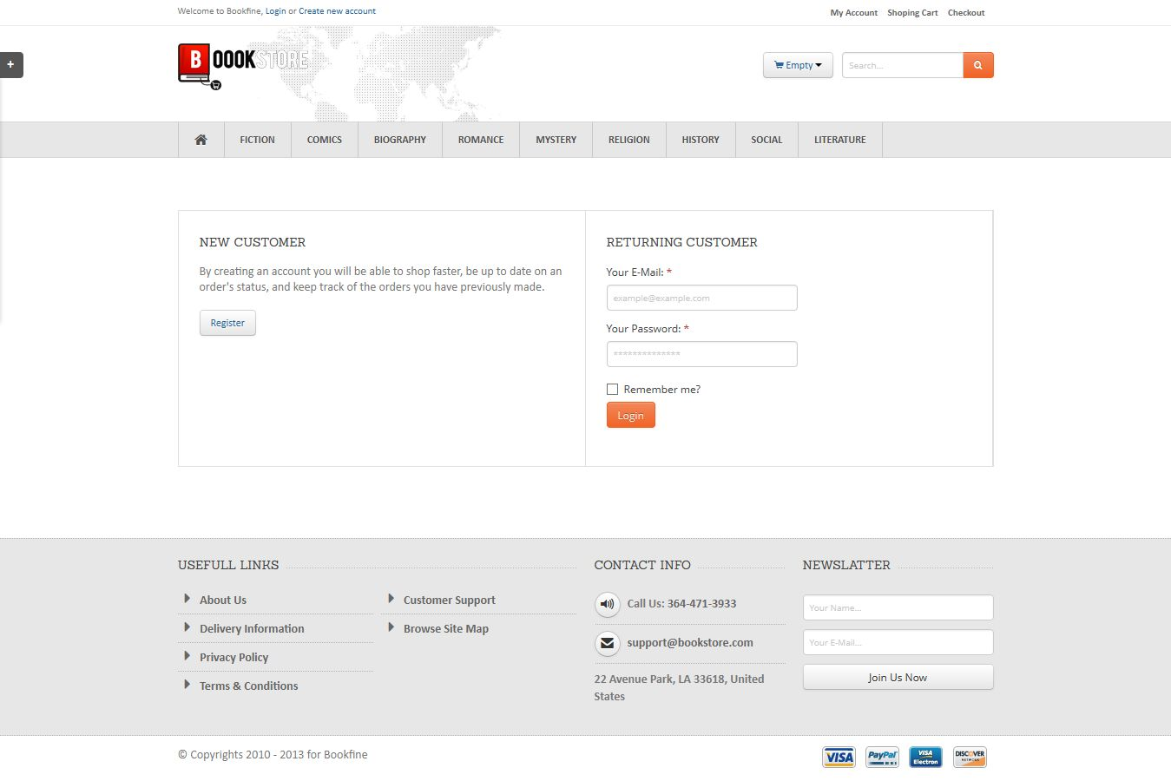

*Note :you can login to dealer page with username s :”**trung”** and password “**123456**” …

4.5.3 ***Customer*** ***page:*** to run customer page you run file “index.aspx”

