UNIVERSITY OF GHANA
DEPARTMENT OF COMPUTER SCIENCE
Individual Assignment: Ghana Local Service Queue Simulator
Stacks, queues, circular queues, deques and priority queues
DCIT 308: Data Structures and Algorithms II | Lectures 2 and 3

1. Assignment overview
You will individually design and implement a Java-based queue management simulator for a real or realistic Ghanaian service setting. The assignment must demonstrate stacks, circular queues, deques and priority queues through a localised scenario such as a campus clinic, ECG prepaid vending point, Ghana Card/NIA registration point, STC bus terminal, UG shuttle stop, bank hall, mobile money dispute desk, hospital records unit, district assembly service desk, or a faculty help desk.
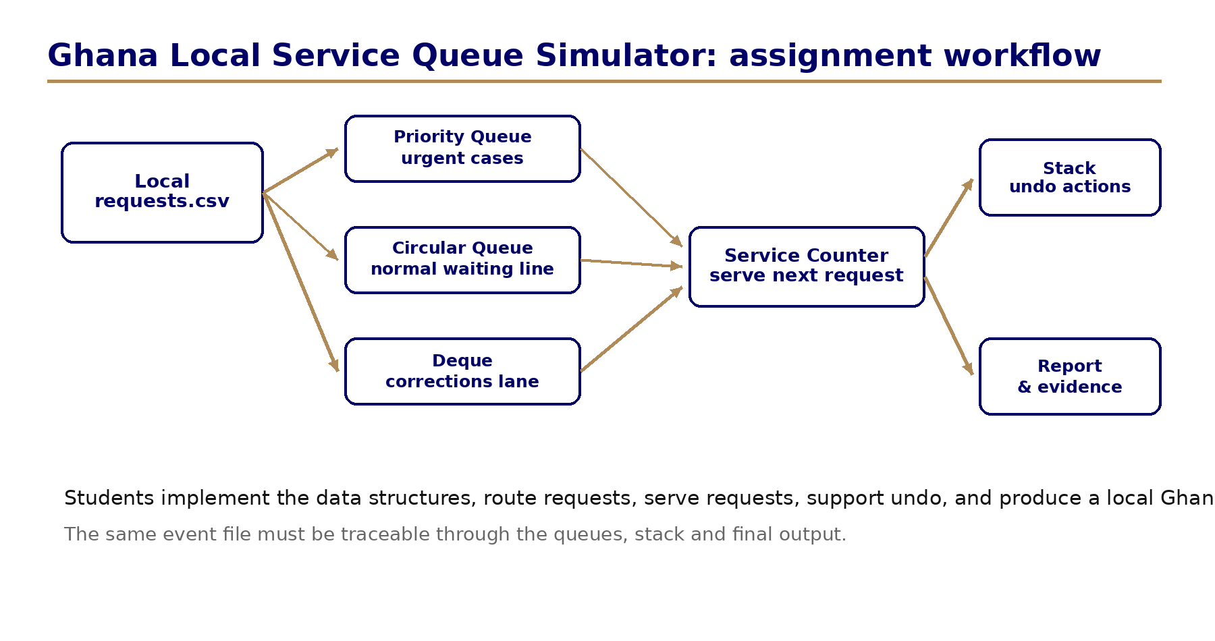

2. What exactly you must build
Build a console-based Java program called GhanaServiceSimulator. The program must read a CSV file of service requests, admit each request into the correct data structure, serve requests according to defined rules, allow at least one undo operation, and produce a final report.
Component | What it represents in a Ghana context | Required data structure | Required implementation
Normal waiting line | People waiting normally at a service point, e.g., students waiting for shuttle tokens or clients waiting at ECG/NHIS/Ghana Card desk. | Circular queue | You must implement your own CircularQueue class using an array, front, rear, size and capacity.
Urgent line | Medical emergency, disability/accessibility support, deadline-sensitive registration, payment deadline or security case. | Priority queue | Use Java PriorityQueue with a custom comparator OR implement your own priority queue. You must explain the priority rule.
Correction lane | A person whose details/documents are incomplete and may rejoin from front or rear after correction. | Deque | You must implement your own deque OR use ArrayDeque only if you add a written explanation of every operation used.
Undo history | The last admission/service action that can be reversed if the operator made a mistake. | Stack | You must implement your own ActionStack class or clearly adapt a stack class from your lecture code.
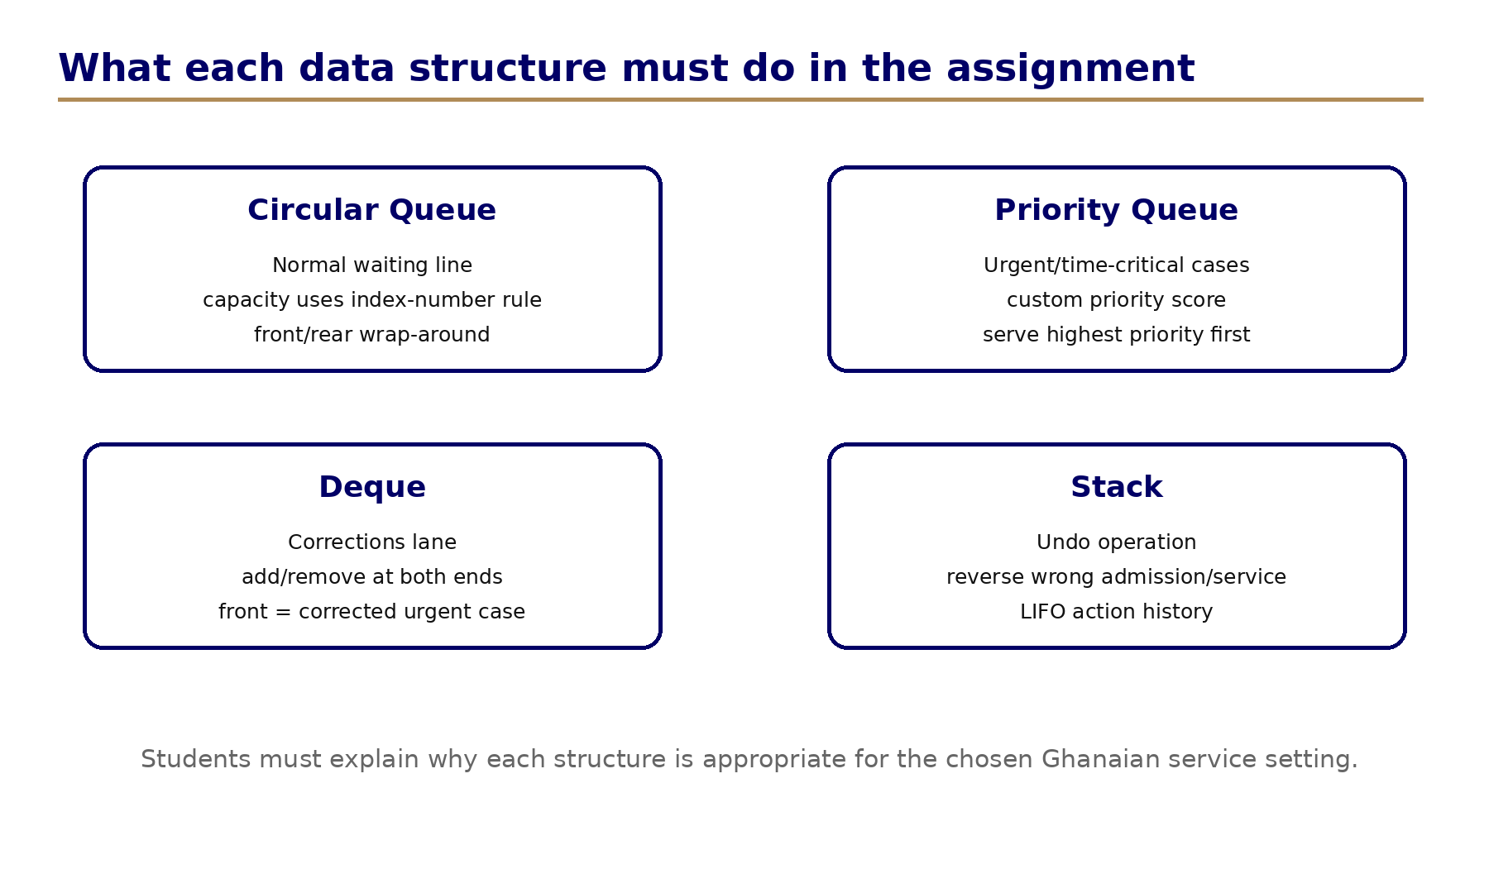

3. Ghana localisation requirement
Your submission must not be generic. It must be linked to a Ghanaian service environment. You may use real observation, a realistic reconstruction based on a service you know, or a simulated dataset that reflects local conditions. Do not record personal names, phone numbers, national ID numbers, medical details, faces or sensitive private information.
- Use anonymised request IDs such as REQ001, REQ002 and not real names.
- Mention the local service setting and why queues occur there.
- Use realistic Ghanaian service types, for example: SHUTTLE_BOARDING, CLINIC_TRIAGE, ECG_TOKEN, GHANA_CARD_CORRECTION, STUDENT_HELPDESK, BANKING, MOBILE_MONEY_DISPUTE, BUS_TERMINAL_TICKET.
- Include at least 35 request records in your CSV file; at least 8 must be urgent and at least 6 must require correction.
- Include one paragraph explaining the ethical limits of your data collection or simulation.

4. Individual parameter rule: make your work unique
Use the last two digits of your student index number to set your simulator parameters. This makes each submission different and reduces generic AI-generated answers.
Parameter | Rule | Example if index ends with 47
Normal circular queue capacity | 5 + last digit | 5 + 7 = 12
Correction deque capacity | 4 + second last digit | 4 + 4 = 8
Urgency bonus | last digit modulo 3 | 7 mod 3 = 1
Minimum service steps to simulate | 20 + second last digit | 20 + 4 = 24
Trace table length | 10 + last digit modulo 5 | 10 + 2 = 12 events

5. Required program behaviour
- Read requests.csv. Each record must contain requestId, arrivalOrder, location, serviceType, urgencyLevel, estimatedMinutes, needsCorrection and notes.
- For each arriving request, route it to exactly one of the main structures: urgent priority queue, correction deque or normal circular queue.
- A request with needsCorrection = true must first enter the correction deque. After correction, it may be moved to the front or rear based on your policy.
- A request with urgencyLevel >= 4 must enter the priority queue unless it first needs correction.
- All other requests must enter the normal circular queue. If the circular queue is full, record the request as overflow and explain how your system handles it.
- During service, your program must apply this default service policy: serve urgent priority queue first; if empty, serve correction deque from the front; if empty, serve normal circular queue.
- Every admit and serve action must be pushed onto the ActionStack so that undoLastAction() can reverse the most recent action.
- After simulation, print the number served, urgent served, normal served, correction served, overflow count, average estimated service time and remaining queue sizes.

6. Required algorithms and pseudocode in your report
Your report must include clear pseudocode for the following algorithms. These must match your Java implementation.
Algorithm | Minimum details expected
enqueueCircular(request) | Check full condition; insert at rear; update rear using modulo; increase size.
dequeueCircular() | Check empty condition; remove front; update front using modulo; decrease size.
admitRequest(request) | Apply correction, urgency and normal routing rules.
serveNextRequest() | Serve urgent first, then correction deque, then normal queue. Record action in stack.
undoLastAction() | Pop last action and reverse its effect safely.
computePriority(request) | Use urgencyLevel, estimatedMinutes, arrivalOrder and your index-based urgency bonus.
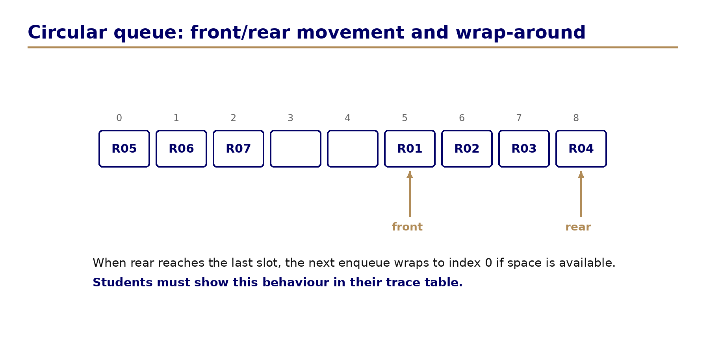

7. Starter code: what you are expected to complete
The starter code in the ZIP file contains TODO markers. You must not remove the TODO comments until you have implemented them. Each TODO corresponds to a required assignment behaviour.
File | What you must complete
CircularQueue.java | Implement isFull, isEmpty, enqueue, dequeue, peek, size and toString. The enqueue/dequeue methods must use modulo arithmetic.
ActionStack.java | Implement push, pop, peek, isEmpty and size using an array or linked nodes. It stores actions for undo.
CorrectionDeque.java | Implement addFront, addRear, removeFront, removeRear, isFull, isEmpty and size. Explain your front/rear policy.
GhanaServiceCentre.java | Implement admitRequest, serveNextRequest, undoLastAction, computePriority and printReport.
GhanaServiceSimulator.java | Load your CSV file, create the service centre using your index-number parameters, run the simulation and print outputs.
requests.csv | Replace the sample data with your own Ghana-context dataset of at least 35 anonymised records.

8. Submission deliverables
Deliverable | Depth expected | Format
A. Java project folder | All source files, your CSV dataset and instructions to run. Program must compile from command line. | ZIP folder
B. Short report | 1500-2200 words covering context, ADTs, pseudocode, implementation choices, test results and complexity. | PDF or DOCX
C. Trace table | Manual trace of the first N events using your index-number trace rule. Must show front, rear, size, top/action and served request. | Included in report
D. Evidence of originality | Screenshot of program output, brief implementation diary and AI-use declaration. | Included in report
E. Oral defence readiness | Be ready to explain any method, data record and output during tutorial or lab interview. | No file unless requested

9. AI-resistance and academic integrity rules
This assignment is designed to discourage generic AI-generated submissions. You are responsible for understanding and defending your own work.
- Your dataset must be localised to a Ghanaian service setting and must follow your individual index-number parameters.
- You must include a trace table based on your actual input file; generic trace tables will not be accepted.
- Your code must contain meaningful comments explaining your own logic, especially in circular queue, deque, stack and priority methods.
- You must submit an AI-use declaration. If you used AI for explanation or debugging, state exactly where and how. You remain responsible for correctness.
- The lecturer or TA may ask you to modify one rule during oral defence and rerun your program. Inability to explain the implementation may lead to loss of implementation marks.
- Do not submit real private data, copied online code or another student’s dataset.

10. Marking rubric
Criteria | Description | Marks
Localised problem context and dataset | Clear Ghanaian service setting, ethical anonymisation, at least 35 records, realistic queue conditions. | 10
ADT and design explanation | Correct explanation of stack, circular queue, deque, priority queue and why each fits the scenario. | 15
Correct implementation | Compiling Java program with working stack, circular queue, deque, priority routing, service simulation and undo. | 30
Algorithms and pseudocode | Clear pseudocode matching the implementation, including priority scoring and modulo-based circular queue. | 15
Testing and trace evidence | Trace table, screenshots/output, edge cases: empty, full, overflow, correction and undo. | 15
Complexity analysis and reflection | Time/space complexity and discussion of limitations/fairness in the chosen Ghanaian service context. | 10
Code quality and originality | Readable structure, comments, naming, no generic unexplained code, AI-use declaration. | 5
Total |  | 100

11. Submission checklist
- My code compiles using javac *.java or the run command in my README.
- My dataset has at least 35 anonymised Ghana-context records.
- My circular queue capacity and service steps follow my index-number rule.
- My report includes pseudocode for the six required algorithms.
- My trace table uses my actual dataset and shows front/rear/top states.
- My final output screenshot is included in the report.
- My AI-use declaration is included and honest.

