Option A: Inverted United Nations Scale of Assessment model (IUSAF)

Balance Point Briefing Note

I. Purpose
1. The inverted United Nations scale of assessment model (IUSAF model) identifies three analytically grounded parameter settings — referred to in this paper as balance points — at which the stewardship components of the allocation formula stand in a defined relationship to the equity base. These three settings are described in the technical background note on the IUSAF model (document XXXXX).
2. The purpose of the present paper is to present those three balance points as distinct policy positions for the consideration of Parties. Each position rests on a coherent and defensible principle. The selection among them is a policy judgement rather than a technical determination. The paper presents the distributional implications of each position at different illustrative fund sizes to assist Parties in assessing the financial stakes involved.
3. All allocations in this paper are illustrative modelling outputs on a $1 billion fund unless otherwise stated. They do not represent entitlements or predetermined disbursements. The model has no formal status under the Convention.

II. The three positions

Table 1. Summary of the three balance point positions. All allocations on a $1 billion illustrative fund with SOSAC held at 3.0%.
Position | TSAC | Core principle | Gini | LDC total | SIDS total
A — Strict | 1.5% | IUSAF equity base is dominant for every eligible Party without exception. Stewardship supplements equity; it never exceeds it for any Party. | 0.093 | $333.9m | $321.1m
B — Bounded | 3.5% | IUSAF is dominant for most Parties. Stewardship may exceed the equity base only for the Party whose equity base was already specifically reduced to reflect an exceptional UN contribution. | 0.085 | $332.3m | $315.4m
C — Even | 5.0% | The most equal per-Party distribution (minimum Gini). Stewardship may exceed the equity base for large-landmass Parties because doing so produces the most equal overall allocation. | 0.083 | $331.1m | $311.0m

4. The three positions reflect three distinct answers to the same underlying question: what is the appropriate relationship between the equity base — derived from inverting the United Nations scale of assessments — and the stewardship components of the formula? The equity base is the mechanism through which smaller UN contributors receive proportionally larger allocations. The stewardship components — TSAC for terrestrial responsibilities and SOSAC for small island developing States ocean responsibilities — supplement that base. The question is how large that supplement should be, and under what conditions stewardship recognition may exceed the equity base for a given Party.

III. What each position means

Position A — Strict (TSAC 1.5%)
5. Position A holds that the equity base must be the dominant driver of each Party's allocation without exception. At TSAC=1.5%, the stewardship component does not exceed the equity base for any eligible Party, including China and Brazil. Band 1 Parties — predominantly least developed countries and small States — receive the largest per-Party allocations ($8.69 million mean on a $1 billion fund). The combined total for all least developed countries is $333.9 million and for all small island developing States $321.1 million.
6. The principle underlying this position is that the inversion of the UN scale — smaller contributors receive more — is the foundational equity commitment of the formula, and no stewardship adjustment should be large enough to override it for any Party. Stewardship recognition is a valued supplement but must remain subordinate to the equity base for all Parties.

Position B — Bounded (TSAC 3.5%)
7. Position B holds that the equity base must remain dominant for most Parties, but accepts one specific and named exception. China's equity base allocation was already reduced below Band 5 specifically because its UN assessed contribution — 20 per cent of the UN regular budget — is of a substantially different order of magnitude from all other eligible Parties. Under Position B, the combined effect of the equity adjustment (Band 6) and the stewardship adjustment (TSAC) together is accepted as the intended outcome for China. For all other Parties, including Brazil, India and Mexico, the equity base remains the dominant component.
8. At TSAC=3.5%, Brazil's stewardship component is 0.938 times its equity base — equity remains just dominant. China's stewardship component is 1.976 times its equity base, reflecting the combined effect of the two adjustments working together. The least developed country total is $332.3 million and the small island developing States total is $315.4 million.

Position C — Even (TSAC 5.0%)
9. Position C holds that the most equal distribution of the fund across all eligible Parties — measured by the Gini coefficient — is itself an equity objective and provides an independent justification for the TSAC weight. At TSAC=5.0%, the Gini coefficient reaches its minimum value (0.083), meaning that per-Party allocations are more similar across all 142 eligible Parties than at any other TSAC setting. The justification for allowing stewardship to exceed the equity base for China and Brazil is not simply that their land areas are large, but that doing so produces the most equal overall distribution.
10. At TSAC=5.0%, China's stewardship component is 2.87 times its equity base and Brazil's is 1.36 times. The least developed country total is $331.1 million and the small island developing States total is $311.0 million.

IV. The three negotiating questions

11. The choice among these three positions turns on three underlying questions of principle. These questions are not technical in nature — they are policy judgements about the purpose and limits of the formula's components. Table 2 summarises how each position answers each question.

Table 2. The three negotiating questions and the answer given by each position.
Question | A — Strict | B — Bounded | C — Even
Is IUSAF dominance a hard rule or a preference? | Hard rule — for every Party without exception. | Hard rule for most Parties. One named exception accepted where the equity base was already separately reduced. | A strong preference. Distributional equality provides an independent justification for departing from it.
Should a Party's stewardship responsibilities be able to exceed its equity base? | No — for every Party. Stewardship always supplements, never exceeds. | Only for the Party whose equity base was already reduced to reflect an exceptional contribution. | For large-landmass Parties, yes — because it produces the most equal overall distribution.
What is stewardship recognition for? | A modest supplement that acknowledges responsibility without overriding equity. | Meaningful recognition within the constraint that equity remains primary for all standard Parties. | Both individual recognition and a tool for producing the most equal allocation across all Parties.

12. These three questions are sequential in the sense that the first question is the most fundamental. A delegation that holds that IUSAF dominance is a hard rule for every Party without exception can only accept Position A. A delegation that accepts a named exception for China — on the basis that Band 6 already adjusted China's equity base — can accept Positions B or C. A delegation that accepts distributional equality as a co-equal equity objective can accept Position C.

V. Distributional implications
13. Figure 1 shows the Gini coefficient across the full range of TSAC settings from 0 to 10 per cent, with the three balance point positions marked. The Gini coefficient falls as TSAC rises from zero because the stewardship component lifts the lowest-allocated Parties (Bands 5 and 6) toward the mean, narrowing the overall spread. The minimum is reached at TSAC 5.0 to 5.5 per cent. Beyond that point, continued increases in TSAC cause concentration to rise again as the largest-landmass Parties begin to pull ahead. The Spearman rank correlation against the pure IUSAF baseline is shown on the right axis; the 0.85 threshold marks the boundary between a moderate and dominant overlay on the equity base.

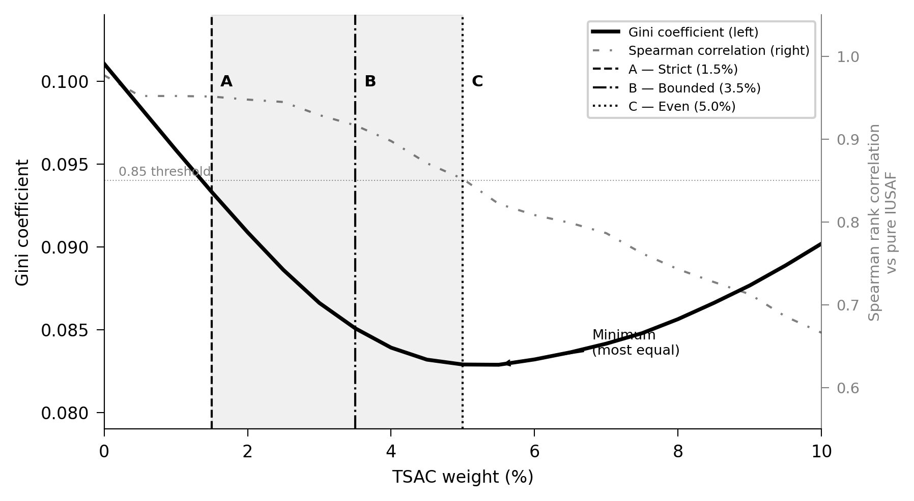
Figure 1. Gini coefficient (left axis, solid line) and Spearman rank correlation against pure IUSAF (right axis, dashed line) across the TSAC range (0–10%). SOSAC held at 3.0% throughout. Vertical lines mark Position A — Strict (1.5%), Position B — Bounded (3.5%) and Position C — Even (5.0%). Shaded region indicates the negotiating envelope. A lower Gini coefficient indicates a more equal per-Party distribution. $1 billion illustrative fund, 142 eligible Parties.

14. Figure 2 shows the per-Party change in allocation moving from Position A to Positions B and C, for 21 representative Parties selected to illustrate the full range of outcomes across all 142 eligible Parties. Countries are ordered from largest decrease to largest increase. Of the 142 eligible Parties, 100 (70 per cent) receive less under Position C than under Position A — all by less than $0.30 million on a $1 billion fund. The 42 Parties that receive more under Position C range from near-zero increases to $4.12 million for China.

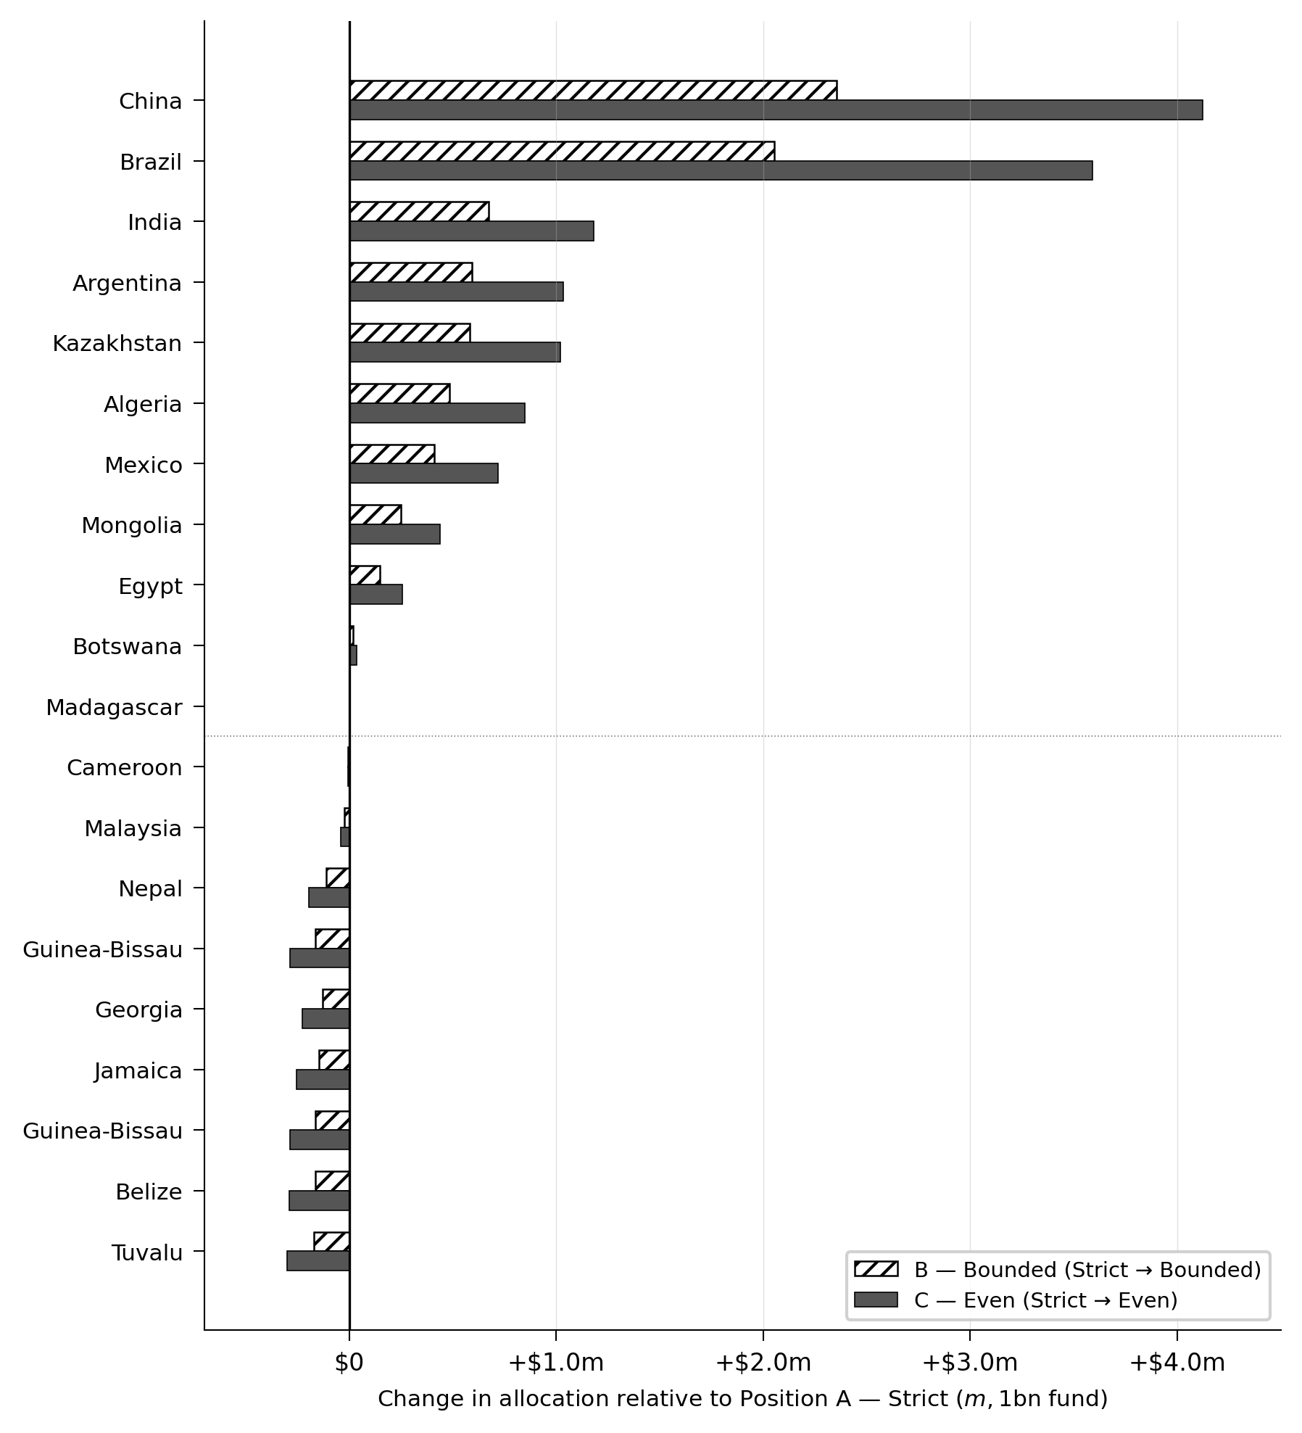
Figure 2. Change in indicative allocation relative to Position A (Strict), for 21 representative Parties spanning the full range of outcomes across 142 eligible Parties. Hatched bars: change from Position A to Position B (Bounded). Solid bars: change from Position A to Position C (Even). Countries are ordered from largest decrease to largest increase. $1 billion illustrative fund.

15. Figure 3 illustrates the mechanism underlying the Gini result. Under pure IUSAF, Band 1 Parties receive the highest per-Party allocations and China (Band 6) the lowest, reflecting the inversion principle. As TSAC rises, China's and Brazil's allocations increase while Band 1 allocations decline slightly. At Position C, Band 1 mean and China are nearly equal at around $8.1–8.4 million — the gap between the highest and lowest allocations is at its narrowest, which is why the Gini is minimised there. Beyond 5.5 per cent, China and Brazil continue rising while Band 1 falls, and concentration increases again.

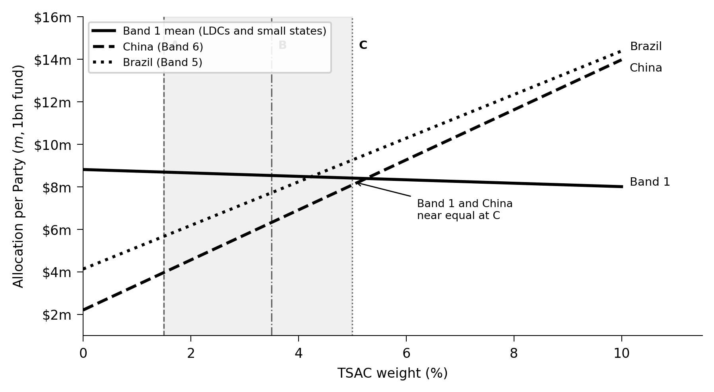
Figure 3. Mean per-Party allocation for Band 1 Parties (solid line), China — Band 6 (dashed line) and Brazil — Band 5 (dotted line) across the TSAC range. Vertical lines mark the three positions. $1 billion illustrative fund. The near-convergence of Band 1 and China at Position C is the mechanism through which the Gini is minimised.

VI. Fund size and the financial stakes
16. The Cali Fund is at an early stage of development and the volume of contributions in any given period is uncertain. The financial implications of the choice among positions scale linearly with the fund size. Table 3 shows the key differences between Position A and Position C at each of the model's illustrative fund sizes, to assist Parties in calibrating the financial stakes in the context of realistic near-term fund volumes.

Table 3. Key differences between Position A (Strict) and Position C (Even) at different fund sizes.
 | $50m | $100m | $200m | $500m | $1 billion
China — change, Position A to C | +$206k | +$412k | +$0.82m | +$2.06m | +$4.12m
Brazil — change, Position A to C | +$180k | +$359k | +$0.72m | +$1.80m | +$3.59m
India — change, Position A to C | +$59k | +$118k | +$0.24m | +$0.59m | +$1.18m
SIDS — maximum decrease, A to C | -$15k | -$30k | -$60k | -$0.15m | -$0.30m
LDC — typical decrease, A to C | -$11k | -$22k | -$44k | -$0.11m | -$0.22m

17. At a fund size of $50 million — which may be representative of early operational periods — the maximum increase for China moving from Position A to Position C is $206,000 and the maximum decrease for any small island developing State Party is $15,000. At $200 million, these figures are $820,000 and $60,000 respectively. Parties may wish to consider whether the financial difference between positions is sufficient to justify the political cost of holding a position, in the context of the current fund size and the pace at which the fund is expected to grow.

VII. The SOSAC dimension
18. The Small Island Developing States Ocean Stewardship Allocation Component (SOSAC) weight is a separable negotiating dimension from the TSAC choice described in sections II to VI. The current SOSAC weight of 3.0 per cent distributes $30 million per $1 billion of fund resources as an equal-share pool across all eligible small island developing States.
19. Each additional percentage point of SOSAC adds approximately $3.5 million to the combined SIDS total and reduces allocations available to non-SIDS least developed countries by approximately $0.8 million. The current 3.0 per cent setting sits in a stable region of the parameter space — Spearman rank correlation against pure IUSAF remains at 0.977 — and significant step-change rank disruptions occur at 4.5 and 7.5 per cent. There is no strong analytical argument for increasing SOSAC beyond 3.0 per cent unless Parties explicitly wish to direct additional resources to SIDS, with the associated reduction in non-SIDS LDC allocations understood and accepted.
20. The SOSAC weight can be set independently of the TSAC position. A delegation that accepts Position A on TSAC while seeking additional recognition for SIDS through SOSAC can negotiate those two parameters on separate tracks without any inconsistency in principle.

Appendix. Indicative allocations for all eligible Parties

The table below sets out the indicative allocation for each of the 142 eligible Parties under Position A (Strict, TSAC=1.5%), Position B (Bounded, TSAC=3.5%) and Position C (Even, TSAC=5.0%). SOSAC is held at 3.0% throughout. The final column shows the change in allocation moving from Position A to Position C; a positive figure indicates a higher allocation under Position C and a negative figure indicates a lower allocation. All figures are on a $1 billion illustrative fund. Parties are grouped by UN assessment band and listed alphabetically within each band.

Table A1. Indicative allocations under the three positions, all 142 eligible Parties. $1 billion illustrative fund, SOSAC=3.0%.
Party | Band | LDC | SIDS | A — Strict | B — Bounded | C — Even | Change A→C
Band 1
Belize | B1 |  | Yes | $8.92m | $8.75m | $8.63m | −$0.29m
Bhutan | B1 |  |  | $8.15m | $7.99m | $7.87m | −$0.28m
Burundi | B1 | Yes |  | $8.15m | $7.98m | $7.86m | −$0.29m
Cabo Verde | B1 |  | Yes | $8.91m | $8.74m | $8.61m | −$0.30m
Central African Republic | B1 | Yes |  | $8.26m | $8.25m | $8.24m | −$0.02m
Comoros | B1 | Yes | Yes | $8.91m | $8.74m | $8.61m | −$0.30m
Cook Islands | B1 |  | Yes | $8.91m | $8.74m | $8.61m | −$0.30m
Dominica | B1 |  | Yes | $8.91m | $8.74m | $8.61m | −$0.30m
Eritrea | B1 | Yes |  | $8.16m | $8.03m | $7.92m | −$0.24m
Gambia | B1 | Yes |  | $8.14m | $7.98m | $7.85m | −$0.29m
Grenada | B1 |  | Yes | $8.91m | $8.74m | $8.61m | −$0.30m
Guinea-Bissau | B1 | Yes | Yes | $8.92m | $8.75m | $8.63m | −$0.29m
Kiribati | B1 | Yes | Yes | $8.91m | $8.74m | $8.61m | −$0.30m
Lesotho | B1 | Yes |  | $8.15m | $7.98m | $7.86m | −$0.28m
Liberia | B1 | Yes |  | $8.16m | $8.01m | $7.90m | −$0.26m
Marshall Islands | B1 |  | Yes | $8.91m | $8.74m | $8.61m | −$0.30m
Micronesia (Federated States of) | B1 |  | Yes | $8.91m | $8.74m | $8.61m | −$0.30m
Nauru | B1 |  | Yes | $8.91m | $8.74m | $8.61m | −$0.30m
Niue | B1 |  | Yes | $8.91m | $8.74m | $8.61m | −$0.30m
Palau | B1 |  | Yes | $8.91m | $8.74m | $8.61m | −$0.30m
Saint Kitts and Nevis | B1 |  | Yes | $8.91m | $8.74m | $8.61m | −$0.30m
Saint Vincent and the Grenadines | B1 |  | Yes | $8.91m | $8.74m | $8.61m | −$0.30m
Samoa | B1 |  | Yes | $8.91m | $8.74m | $8.61m | −$0.30m
Sao Tome and Principe | B1 |  | Yes | $8.91m | $8.74m | $8.61m | −$0.30m
Sierra Leone | B1 | Yes |  | $8.16m | $8.00m | $7.89m | −$0.27m
Solomon Islands | B1 | Yes | Yes | $8.92m | $8.75m | $8.63m | −$0.29m
State of Palestine | B1 |  |  | $8.14m | $7.97m | $7.85m | −$0.30m
Timor-Leste | B1 | Yes | Yes | $8.91m | $8.75m | $8.62m | −$0.29m
Tonga | B1 |  | Yes | $8.91m | $8.74m | $8.61m | −$0.30m
Tuvalu | B1 | Yes | Yes | $8.91m | $8.74m | $8.61m | −$0.30m
Vanuatu | B1 |  | Yes | $8.91m | $8.75m | $8.62m | −$0.29m
Band 2
Afghanistan | B2 | Yes |  | $7.18m | $7.20m | $7.21m | +$0.03m
Albania | B2 |  |  | $7.06m | $6.92m | $6.81m | −$0.25m
Angola | B2 | Yes |  | $7.30m | $7.47m | $7.59m | +$0.30m
Antigua and Barbuda | B2 |  | Yes | $7.83m | $7.68m | $7.57m | −$0.26m
Armenia | B2 |  |  | $7.06m | $6.92m | $6.82m | −$0.25m
Bangladesh | B2 | Yes |  | $7.08m | $6.97m | $6.88m | −$0.20m
Barbados | B2 |  | Yes | $7.83m | $7.68m | $7.57m | −$0.26m
Benin | B2 | Yes |  | $7.08m | $6.96m | $6.87m | −$0.21m
Burkina Faso | B2 | Yes |  | $7.11m | $7.03m | $6.97m | −$0.14m
Cambodia | B2 | Yes |  | $7.09m | $6.99m | $6.91m | −$0.18m
Chad | B2 | Yes |  | $7.30m | $7.47m | $7.60m | +$0.30m
Congo | B2 |  |  | $7.12m | $7.06m | $7.02m | −$0.11m
Democratic People's Republic of Korea | B2 |  |  | $7.08m | $6.96m | $6.87m | −$0.20m
Democratic Republic of the Congo | B2 | Yes |  | $7.49m | $7.92m | $8.25m | +$0.76m
Djibouti | B2 | Yes |  | $7.06m | $6.92m | $6.81m | −$0.25m
Equatorial Guinea | B2 |  |  | $7.06m | $6.92m | $6.82m | −$0.25m
Eswatini | B2 |  |  | $7.06m | $6.92m | $6.81m | −$0.25m
Ethiopia | B2 | Yes |  | $7.27m | $7.41m | $7.52m | +$0.25m
Fiji | B2 |  | Yes | $7.83m | $7.69m | $7.58m | −$0.25m
Georgia | B2 |  |  | $7.07m | $6.94m | $6.84m | −$0.23m
Guinea | B2 | Yes |  | $7.10m | $7.02m | $6.95m | −$0.15m
Haiti | B2 | Yes | Yes | $7.83m | $7.69m | $7.58m | −$0.25m
Honduras | B2 |  |  | $7.08m | $6.96m | $6.87m | −$0.21m
Jamaica | B2 |  | Yes | $7.83m | $7.68m | $7.57m | −$0.25m
Kyrgyzstan | B2 |  |  | $7.09m | $6.99m | $6.92m | −$0.17m
Lao People's Democratic Republic | B2 | Yes |  | $7.10m | $7.01m | $6.94m | −$0.16m
Madagascar | B2 | Yes |  | $7.17m | $7.17m | $7.17m | +$0.00m
Malawi | B2 | Yes |  | $7.07m | $6.95m | $6.86m | −$0.22m
Maldives | B2 |  | Yes | $7.83m | $7.68m | $7.57m | −$0.26m
Mali | B2 | Yes |  | $7.29m | $7.45m | $7.58m | +$0.29m
Mauritania | B2 | Yes |  | $7.25m | $7.37m | $7.46m | +$0.20m
Mauritius | B2 |  | Yes | $7.83m | $7.68m | $7.57m | −$0.26m
Mongolia | B2 |  |  | $7.35m | $7.61m | $7.79m | +$0.44m
Montenegro | B2 |  |  | $7.06m | $6.91m | $6.81m | −$0.25m
Mozambique | B2 | Yes |  | $7.21m | $7.26m | $7.30m | +$0.09m
Myanmar | B2 | Yes |  | $7.18m | $7.20m | $7.21m | +$0.03m
Namibia | B2 |  |  | $7.21m | $7.28m | $7.32m | +$0.11m
Nepal | B2 | Yes |  | $7.08m | $6.97m | $6.89m | −$0.19m
Nicaragua | B2 |  |  | $7.08m | $6.96m | $6.87m | −$0.20m
Niger | B2 | Yes |  | $7.30m | $7.48m | $7.61m | +$0.31m
North Macedonia | B2 |  |  | $7.06m | $6.92m | $6.81m | −$0.25m
Papua New Guinea | B2 |  | Yes | $7.91m | $7.88m | $7.86m | −$0.06m
Republic of Moldova | B2 |  |  | $7.06m | $6.92m | $6.82m | −$0.24m
Rwanda | B2 | Yes |  | $7.06m | $6.92m | $6.81m | −$0.25m
Saint Lucia | B2 |  | Yes | $7.83m | $7.68m | $7.57m | −$0.26m
Senegal | B2 | Yes |  | $7.09m | $6.99m | $6.92m | −$0.17m
Seychelles | B2 |  | Yes | $7.83m | $7.68m | $7.57m | −$0.26m
Somalia | B2 | Yes |  | $7.18m | $7.19m | $7.20m | +$0.02m
South Sudan | B2 | Yes |  | $7.18m | $7.19m | $7.20m | +$0.02m
Sudan | B2 | Yes |  | $7.41m | $7.74m | $7.99m | +$0.58m
Suriname | B2 |  | Yes | $7.86m | $7.75m | $7.67m | −$0.19m
Syrian Arab Republic | B2 |  |  | $7.09m | $6.99m | $6.91m | −$0.18m
Tajikistan | B2 |  |  | $7.08m | $6.97m | $6.89m | −$0.20m
Togo | B2 | Yes |  | $7.07m | $6.93m | $6.83m | −$0.23m
Uganda | B2 | Yes |  | $7.09m | $7.00m | $6.93m | −$0.17m
United Republic of Tanzania | B2 | Yes |  | $7.23m | $7.30m | $7.36m | +$0.14m
Yemen | B2 | Yes |  | $7.16m | $7.14m | $7.13m | −$0.02m
Zambia | B2 | Yes |  | $7.20m | $7.24m | $7.27m | +$0.07m
Zimbabwe | B2 |  |  | $7.13m | $7.08m | $7.04m | −$0.09m
Band 3
Algeria | B3 |  |  | $6.43m | $6.91m | $7.27m | +$0.85m
Azerbaijan | B3 |  |  | $5.99m | $5.88m | $5.80m | −$0.18m
Bahamas | B3 |  | Yes | $6.74m | $6.62m | $6.53m | −$0.21m
Belarus | B3 |  |  | $6.01m | $5.94m | $5.88m | −$0.13m
Bolivia (Plurinational State of) | B3 |  |  | $6.18m | $6.33m | $6.44m | +$0.27m
Bosnia and Herzegovina | B3 |  |  | $5.98m | $5.87m | $5.78m | −$0.20m
Botswana | B3 |  |  | $6.08m | $6.10m | $6.11m | +$0.03m
Cameroon | B3 |  |  | $6.06m | $6.06m | $6.05m | −$0.01m
Côte d’Ivoire | B3 |  |  | $6.03m | $5.99m | $5.95m | −$0.08m
Dominican Republic | B3 |  | Yes | $6.75m | $6.64m | $6.55m | −$0.20m
Ecuador | B3 |  |  | $6.02m | $5.96m | $5.91m | −$0.11m
El Salvador | B3 |  |  | $5.97m | $5.85m | $5.76m | −$0.21m
Gabon | B3 |  |  | $6.02m | $5.96m | $5.92m | −$0.10m
Ghana | B3 |  |  | $6.01m | $5.95m | $5.90m | −$0.12m
Guatemala | B3 |  |  | $5.99m | $5.89m | $5.82m | −$0.17m
Guyana | B3 |  | Yes | $6.78m | $6.71m | $6.66m | −$0.12m
Jordan | B3 |  |  | $5.99m | $5.89m | $5.81m | −$0.18m
Kenya | B3 |  |  | $6.08m | $6.11m | $6.12m | +$0.04m
Lebanon | B3 |  |  | $5.97m | $5.85m | $5.76m | −$0.21m
Libya | B3 |  |  | $6.31m | $6.63m | $6.88m | +$0.57m
Morocco | B3 |  |  | $6.06m | $6.05m | $6.04m | −$0.02m
Paraguay | B3 |  |  | $6.05m | $6.02m | $6.00m | −$0.04m
Serbia | B3 |  |  | $5.99m | $5.88m | $5.81m | −$0.18m
Sri Lanka | B3 |  |  | $5.98m | $5.87m | $5.79m | −$0.19m
Trinidad and Tobago | B3 |  | Yes | $6.74m | $6.62m | $6.52m | −$0.22m
Tunisia | B3 |  |  | $6.00m | $5.91m | $5.85m | −$0.15m
Turkmenistan | B3 |  |  | $6.06m | $6.06m | $6.05m | −$0.01m
Ukraine | B3 |  |  | $6.08m | $6.10m | $6.12m | +$0.04m
Uzbekistan | B3 |  |  | $6.05m | $6.04m | $6.03m | −$0.02m
Venezuela (Bolivarian Republic of) | B3 |  |  | $6.14m | $6.24m | $6.32m | +$0.18m
Band 4
Argentina | B4 |  |  | $5.68m | $6.27m | $6.72m | +$1.04m
Colombia | B4 |  |  | $5.37m | $5.54m | $5.68m | +$0.31m
Cuba | B4 |  | Yes | $5.95m | $5.86m | $5.80m | −$0.14m
Egypt | B4 |  |  | $5.35m | $5.49m | $5.60m | +$0.26m
Indonesia | B4 |  |  | $5.52m | $5.90m | $6.18m | +$0.66m
Iran (Islamic Republic of) | B4 |  |  | $5.47m | $5.77m | $6.00m | +$0.54m
Iraq | B4 |  |  | $5.24m | $5.24m | $5.24m | +$0.01m
Kazakhstan | B4 |  |  | $5.67m | $6.26m | $6.69m | +$1.02m
Malaysia | B4 |  |  | $5.22m | $5.20m | $5.18m | −$0.04m
Nigeria | B4 |  |  | $5.33m | $5.46m | $5.55m | +$0.22m
Pakistan | B4 |  |  | $5.30m | $5.39m | $5.46m | +$0.16m
Peru | B4 |  |  | $5.40m | $5.62m | $5.79m | +$0.38m
Philippines | B4 |  |  | $5.21m | $5.18m | $5.16m | −$0.06m
Singapore | B4 |  | Yes | $5.93m | $5.82m | $5.74m | −$0.19m
South Africa | B4 |  |  | $5.39m | $5.59m | $5.74m | +$0.35m
Thailand | B4 |  |  | $5.25m | $5.28m | $5.29m | +$0.04m
Türkiye | B4 |  |  | $5.30m | $5.39m | $5.46m | +$0.16m
Viet Nam | B4 |  |  | $5.22m | $5.19m | $5.17m | −$0.05m
Band 5
Brazil | B5 |  |  | $5.67m | $7.73m | $9.26m | +$3.59m
India | B5 |  |  | $4.64m | $5.32m | $5.82m | +$1.18m
Mexico | B5 |  |  | $4.44m | $4.86m | $5.16m | +$0.72m
Band 6
China | B6 |  |  | $3.97m | $6.33m | $8.09m | +$4.12m

All figures are illustrative modelling outputs. They do not represent entitlements or predetermined disbursements. The model has no formal status under the Convention.

