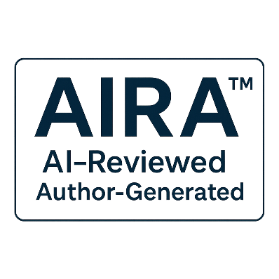
AIRA Annex C – Rationale v1.0
Rationale and explanatory context supporting the structure and scope of AIRA.

© 2025 B.L. Jensen
Licensed under Creative Commons Attribution 4.0 International (CC-BY 4.0)
tierverify-org is the steward and maintainer of the AIRA Standard.

Table of Contents
C.1 Introduction 2
C.2 Purpose of the Standard 2
C.3 Scope and Boundaries 2
C.4 Definitions and Terminology 3
C.4.1 “Human-Generated Content” 3
C.4.2 “Non-Material AI Assistance” 3
C.4.3 “Material AI Contributions” 3
C.5 Disclosure Philosophy 3
C.6 Implementation Considerations 3
C.7 Exclusions and Non-Goals 4
C.8 Evolution and Future Work 4
C.9 Summary 4

C.1 Introduction
This annex explains the rationale behind the structure, scope, and terminology of the AIRA Standard. It provides the reasoning that informed the development of definitions, requirements, and boundaries. This material is informative and does not introduce new obligations. Its purpose is to support transparency, interpretability, and consistent implementation.

C.2 Purpose of the Standard
AIRA was created to address a growing need for clarity in how AI assistance is disclosed in human-generated content. As AI systems become embedded in everyday tools, the distinction between human authorship and AI contribution becomes increasingly important.
The rationale for AIRA’s existence is based on three principles:
- Transparency - Audiences deserve to understand when AI has played a role.
- Simplicity - Disclosures must be lightweight and easy to apply.
- Consistency - A uniform standard prevents confusion and misinterpretation.
AIRA focuses exclusively on non-material assistance to avoid conflating human authorship with AI-generated content.

C.3 Scope and Boundaries
AIRA’s scope is intentionally narrow. It applies only to human-generated content that has received non-material AI assistance. This boundary ensures:
- The human remains the primary author
- The meaning and intent of the work are preserved
- Disclosures remain simple and unambiguous
AIRA does not cover:
- AI-generated content
- Material AI contributions
- Autonomous or synthetic outputs
- Governance, safety, or risk frameworks
These exclusions prevent scope creep and maintain the clarity of the standard.

C.4 Definitions and Terminology
The terminology used in AIRA was selected to be:
- Clear - avoiding ambiguous or overloaded terms
- Neutral - not implying value judgments
- Interoperable - compatible with existing editorial, technical, and organizational workflows

C.4.1 “Human-Generated Content”
This term emphasizes authorship and intent. It distinguishes human-created work from AI-generated output without requiring complex classification.

C.4.2 “Non-Material AI Assistance”
This definition focuses on impact, not mechanism.
The key criterion is whether AI changed the meaning or introduced new ideas.

C.4.3 “Material AI Contributions”
This term provides a clear boundary for what AIRA does not cover.
It prevents misuse of the standard for content that is substantially AI-generated.

C.5 Disclosure Philosophy
AIRA disclosures are designed to be:
- Short - typically one sentence
- Visible - placed where audiences can reasonably expect them
- Flexible - adaptable to different media and platforms
- Non-intrusive - not distracting from the content itself
The rationale is to support transparency without burdening creators or readers.

C.6 Implementation Considerations
AIRA is designed to integrate seamlessly into existing workflows. The rationale for this approach includes:
- Editorial compatibility - Works with existing review processes
- Technical compatibility - Fits into code review and commit workflows
- Organizational compatibility - Can be adopted without restructuring governance
AIRA avoids prescriptive requirements to ensure broad applicability across industries and content types.

C.7 Exclusions and Non-Goals
AIRA intentionally avoids:
- Regulating AI system behavior
- Defining authorship in legal terms
- Addressing safety, risk, or compliance
- Governing AI-generated content
- Mandating specific tools or platforms
These exclusions ensure the standard remains focused, stable, and easy to adopt.

C.8 Evolution and Future Work
AIRA is expected to evolve as AI tools and practices change. The rationale for versioning and annex structure includes:
- Allowing incremental updates
- Supporting new disclosure patterns
- Maintaining backward compatibility
- Preserving clarity for implementers
Annexes provide a flexible mechanism for expansion without altering the core standard.

C.9 Summary
Annex C explains the reasoning behind AIRA’s definitions, scope, and structure. The standard is intentionally narrow, transparent, and easy to implement. Its focus on non-material AI assistance ensures clarity in authorship while supporting consistent disclosure practices across diverse workflows.

