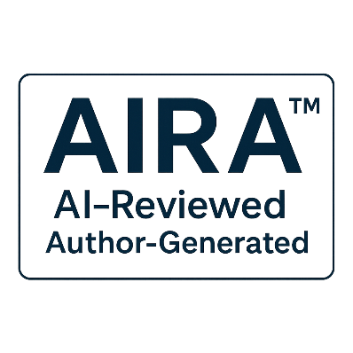
AIRA Annex D – Change History v1.0
Version history and documented changes to the AIRA Standard and supporting materials.

© 2025 B.L. Jensen
Licensed under Creative Commons Attribution 4.0 International (CC-BY 4.0)
tierverify-org is the steward and maintainer of the AIRA Standard.

Table of Contents
C.1 Introduction Error! Bookmark not defined.
C.2 Purpose of the Standard Error! Bookmark not defined.
C.3 Scope and Boundaries Error! Bookmark not defined.
C.4 Definitions and Terminology Error! Bookmark not defined.
C.4.1 “Human-Generated Content” Error! Bookmark not defined.
C.4.2 “Non-Material AI Assistance” Error! Bookmark not defined.
C.4.3 “Material AI Contributions” Error! Bookmark not defined.
C.5 Disclosure Philosophy Error! Bookmark not defined.
C.6 Implementation Considerations Error! Bookmark not defined.
C.7 Exclusions and Non-Goals Error! Bookmark not defined.
C.8 Evolution and Future Work Error! Bookmark not defined.
C.9 Summary Error! Bookmark not defined.

D.1 Introduction
This annex provides the official change history for the AIRA Standard and its associated documents. It records substantive updates, clarifications, additions, and structural revisions across versions. This annex is informative and is intended to support transparency, traceability, and long-term maintenance of the standard.

D.2 Versioning Model
AIRA follows semantic versioning:
- Major versions (X.0) introduce structural changes or new conceptual frameworks.
- Minor versions (X.Y) add annexes, clarifications, or non-breaking improvements.
- Patch versions (X.Y.Z) correct errors without altering meaning or requirements.
This annex documents changes according to this model.

D.3 Change Log
The following table summarizes all changes made to the AIRA Standard and its supporting documents.
Version | Date | Description of Changes
v1.0 | December 2025 | Initial publication of the AIRA Standard, Overview, Annex A (Disclosure Templates), Annex B (Examples), Annex C (Rationale), and supporting documentation.

D.4 Notes on Future Updates
Future versions may include:
- Additional annexes
- Expanded examples
- Clarifications based on community feedback
- Adjustments to definitions as AI tooling evolves
- Editorial improvements
All changes will be recorded in this annex to maintain a clear historical record.

D.5 Summary
Annex D provides a transparent record of changes to the AIRA Standard and its supporting documents. Version 1.0 represents the initial publication of the standard and establishes the baseline for future updates.

