PHASE 1 · ENGINEERING REPORT & CODE REVIEW
SAM 2 Video Segmentation & Tracking Platform
Can a segmentation mask be kept on an object across a whole video, and how do you prove it?
Built on: ML Model Serving Platform (FastAPI · PostgreSQL registry · Prometheus · Grafana)
Model: sam2.1-hiera-tiny (38,962,498 parameters) · runtime: PyTorch 2.14.1+cu130 on cpu (2 threads) · date: 2026-10-13
Author: Nirvana Fanaelahi · Repository: sam2-video-seg-platform
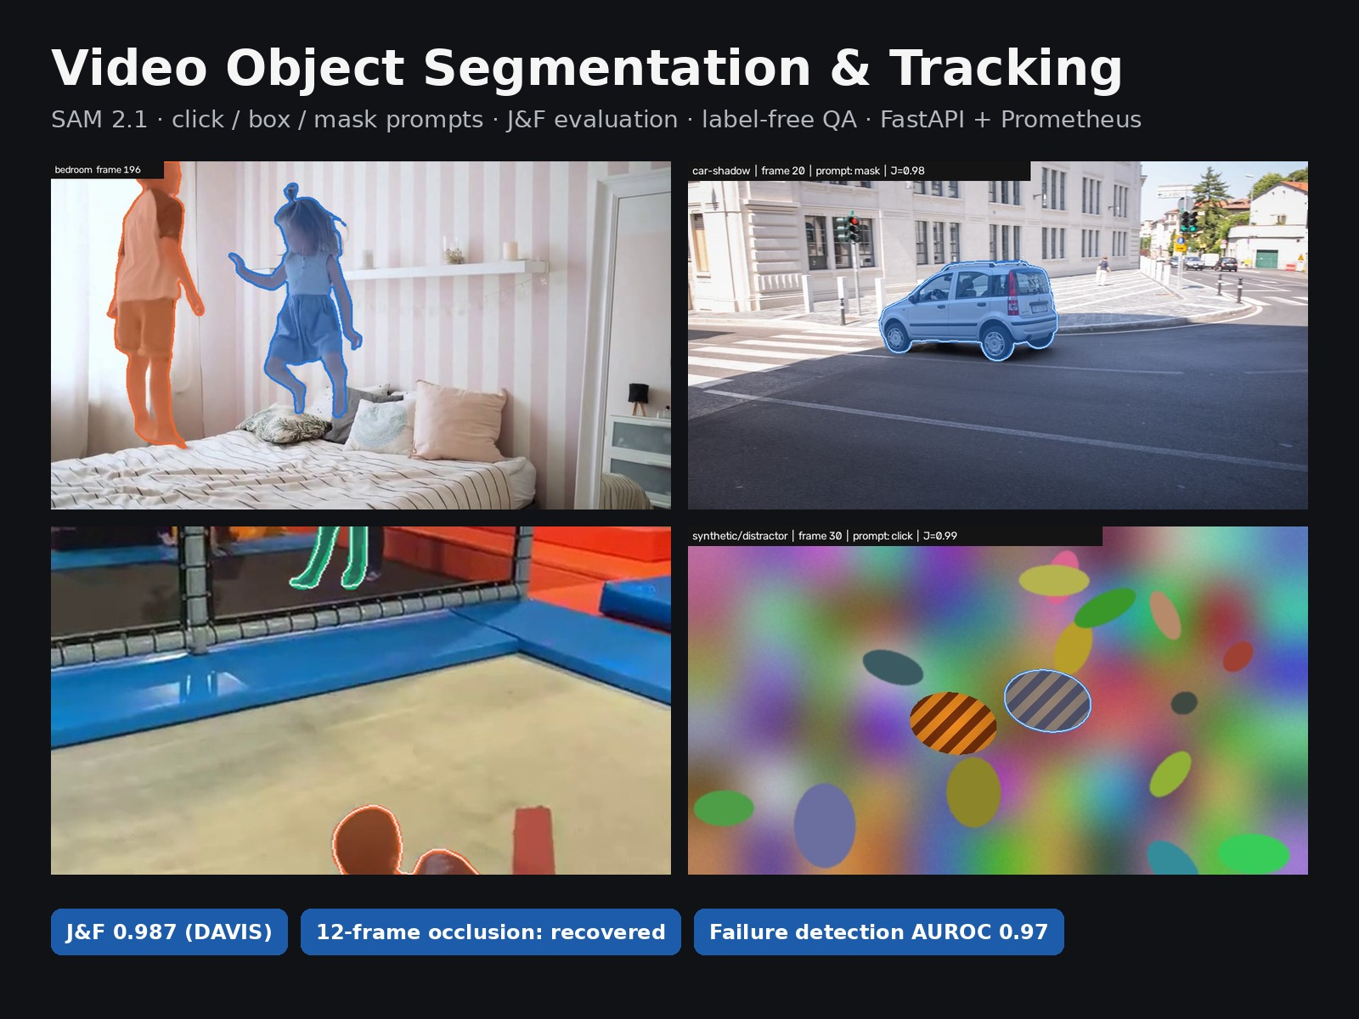

Contents
1 Executive summary · the answer, key findings, what was built
2 Question, protocol and data · what is measured and on which clips
3 Results · accuracy, persistence, failure modes, label-free signals, cost
4 Architecture · what changed in the base platform; file inventory
5 Code review · per script: purpose, technique, findings, status; key code explained
6 Techniques explained · learning notes: SAM 2 memory, VOS metrics, flow, caching, tracking
7 Recommendations and roadmap · prioritised fixes, Phases 2–5
8 Reproducibility · commands, environment, checksums
A Upwork portfolio entry · form fields and content blocks

1. Executive summary
Yes, with one specific exception. SAM 2.1 (tiny) holds a pixel-accurate mask through a whole clip (J&F 0.987 on DAVIS car-shadow, J-decay ≈ 0.01). One click is as good as a full mask on a salient object. It returns an empty mask while an object is fully occluded and re-acquires it on the first visible frame. A look-alike crossing in front does not steal the identity. The exception is an object that leaves the frame and comes back changed: SAM 2 re-detected it, lost it again for 14 frames, then recovered. That failure is visible without labels, because SAM 2's own object-presence score hovers just below zero the whole time. That is the trigger a production system needs for automatic re-prompting, which is the subject of Phase 2.

Key findings
- Accuracy: J&F 0.987 on DAVIS car-shadow from a full mask. Box, 3 clicks and 1 click give 0.987, 0.987 and 0.987: for a salient object, user effort is one click.
- Persistence through occlusion: 12 fully hidden frames → hidden-frame J = 1.00 (empty on every hidden frame), re-detection delay [0] frames, J&F 0.988.
- Look-alike distractor: no identity switch. The mask leaks onto the distractor for 1–2 frames at the crossing (max 64 % of the mask), J&F 0.976.
- Failure mode found: exit and re-entry gives J&F 0.672, J-decay 0.41. After re-detection the object was lost again for 14 frames while fully visible, with the object score just below 0 (median -0.42).
- Fast motion with blur: the object is never lost (J recall 0.98), but masks swell over the blur streak, so F drops to 0.56. Binary masks are the wrong output for motion blur; roto work needs soft alpha (matting).
- Label-free monitoring works: the SAM 2 object score flags frames with J < 0.5 at AUROC 0.97 (32 failure frames among 988 scored). It is wired into Prometheus as quality alerts.
- Real footage: on the SA-V example (5 objects, 6 fps) J&F is 0.944. In the bedroom clip (no GT) both children keep their identity through a mutual occlusion and partial exits at the frame edge, processing only every 4th frame.
- Cost (2 vCPU, no GPU): image encoder ≈ 2.3 s/frame plus ≈ 3.6 s per object per frame for memory attention. Cost grows linearly with the number of objects, which is exactly what SAM 3.1's Object Multiplex targets. Processing every 4th frame cut the encoder cost 4× with no loss on smooth motion.

What was built
- Evaluation harness (src/vos): a DAVIS-protocol port of J, F, J&F, recall and decay, with an upstream decay bug fixed. It adds event metrics for occlusion, re-entry and distractors, and GT-free stability metrics.
- Synthetic stress tests with exact ground truth, one per failure mode: 12-frame full occlusion, an identical distractor crossing in front, a 12-frame exit and re-entry, and 50 px/frame motion with blur.
- SAM 2.1 wrapper with a persistent feature cache (bit-identical masks; re-runs ≈ 1.7× faster for one object), the object-presence score exposed, and late-appearing objects handled.
- Serving: SAM 2 checkpoints go through the existing registry, storage, LRU cache and lifecycle. A new multipart video endpoint returns COCO-RLE masks, a stability report and quality alerts. Prometheus metrics and a Grafana dashboard cover it.
- Rotoscoping CLI: clicks or a box in; alpha-matte PNGs, an overlay MP4, masks and a stability report out.
- Quality gates: 116 fast tests (SQLite, fake segmenter) + 6 slow tests with real SAM 2 inference, Ruff lint and format checks, and a CI job with PostgreSQL.

2. Question, protocol and data

2.1 The Phase-1 question
A client asking for “AI rotoscoping”, “track this object” or “blur every face” really asks three things. Does the mask stay accurate on every frame? Does it persist through occlusions, exits and look-alikes? Will I know when it fails, without labelling every frame? Phase 1 answers each with a measurable quantity:
Client question | Measured as | Where
Is the mask accurate? | J (IoU) and F (boundary F-measure), J&F, DAVIS protocol | metrics.py
Does it persist over time? | J-decay (first vs. last quarter); per-frame J curves | metrics.py, report.py
Does it survive occlusion / exit? | hidden-frame J (empty is correct), re-detection delay | benchmark.py
Does it jump to a look-alike? | distractor leakage, identity-switch flag | benchmark.py
How much user effort? | J&F for mask vs. box vs. 3 clicks vs. 1 click | prompts.py
What does it cost? | ms/frame, encoder vs. per-object memory cost, stride trade-off | cli.py profile
Will I know when it fails? | AUROC of GT-free signals for detecting frames with J < 0.5 | stability.py, drift_detector.py

2.2 Protocol
- Semi-supervised VOS. Each object is prompted once, on its first visible frame, with a prompt derived from the ground truth. Nothing else is given; SAM 2 propagates forward.
- Scoring. DAVIS conventions: the first (prompt) and last annotated frames are excluded; an empty prediction on an empty GT scores J = 1; dataset scores average over objects. Boundary tolerance is ⌈0.008 × image diagonal⌉ (8 px at 480p).
- Sparse GT. SA-V is annotated at 6 fps (every 4th frame), so it runs at stride 4 and only annotated frames are scored.
- Determinism. Inference is deterministic, so accuracy numbers are exact. Timings come from a shared 2-vCPU sandbox and carry about ±20 % noise.

2.3 Data
Sequence | Frames | Objects | What it tests | Caveat
DAVIS car-shadow (val) | 40 | 1 | Standard VOS benchmark clip | One easy sequence. The full DAVIS 2017 val host was not reachable from the build environment.
SA-V sav_000001 | 483 (121 scored) | 4 visible | Real multi-object video; one object with 10 visibility changes | SA-V train split: SAM 2 was trained on it. Treat as a pipeline check.
synthetic/occlusion | 48 | 2 | 12 frames fully hidden behind a pillar; never-occluded control object | Synthetic
synthetic/exit_reentry | 48 | 1 | 12 frames outside the image | Synthetic
synthetic/distractor | 48 | 1 (+1 look-alike) | Identical object crosses in front of the target | Synthetic
synthetic/fast_motion | 48 | 1 | ≈50 px/frame zig-zag, blur, rotation, scale change | Synthetic
bedroom (SAM 2 repo) | 200 (50 used) | 2 | Two children crossing; GT-free stability + demo | No ground truth

3. Results
All numbers come from results/phase1/runs.json, produced by make benchmark (config configs/phase1.yaml) on x86_64 with 2 threads. Checkpoint SHA-256: 3c1e81ca9b037dd3… (torch.float16).

3.1 Overview
Sequence | Prompt | Stride | Frames | Obj. | J&F | J | F | J-decay | ms/frame
car-shadow | mask | 1 | 40 | 1 | 0.987 | 0.976 | 0.998 | +0.013 | 6,136
car-shadow | box | 1 | 40 | 1 | 0.987 | 0.976 | 0.998 | +0.012 | 3,298
car-shadow | click | 1 | 40 | 1 | 0.987 | 0.976 | 0.997 | +0.011 | 3,096
car-shadow | click3 | 1 | 40 | 1 | 0.987 | 0.977 | 0.998 | +0.010 | 3,085
car-shadow | mask | 2 | 20 | 1 | 0.987 | 0.976 | 0.998 | +0.013 | 5,127
car-shadow | mask | 4 | 10 | 1 | 0.988 | 0.977 | 0.998 | +0.010 | 2,201
synthetic/occlusion | mask | 1 | 48 | 2 | 0.988 | 0.976 | 1.000 | -0.001 | 9,412
synthetic/exit_reentry | mask | 1 | 48 | 1 | 0.672 | 0.670 | 0.674 | +0.412 | 5,529
synthetic/fast_motion | mask | 1 | 48 | 1 | 0.640 | 0.718 | 0.561 | +0.020 | 5,652
synthetic/distractor | mask | 1 | 48 | 1 | 0.976 | 0.968 | 0.984 | +0.001 | 5,680
synthetic/distractor | click | 1 | 48 | 1 | 0.975 | 0.968 | 0.982 | -0.003 | 3,407
sav_000001 | mask | 4 | 121 | 5 | 0.944 | 0.918 | 0.970 | +0.045 | 16,166
synthetic/fast_motion | mask | 2 | 24 | 1 | 0.634 | 0.719 | 0.549 | +0.034 | 5,287
synthetic/fast_motion | mask | 4 | 12 | 1 | 0.693 | 0.754 | 0.633 | -0.007 | 2,561
synthetic/occlusion | mask | 2 | 24 | 2 | 0.989 | 0.978 | 1.000 | -0.002 | 8,217
synthetic/occlusion | mask | 4 | 12 | 2 | 0.990 | 0.981 | 1.000 | +0.011 | 5,107
J-decay is the mean J over the first quarter of the scored frames minus the mean over the last quarter. A value near zero means the mask does not degrade over time. The ms/frame column includes cache effects (the first run on a video computes the image encoder; later runs reuse it). See §3.6 for the clean cost model.

3.2 How much user input is needed?
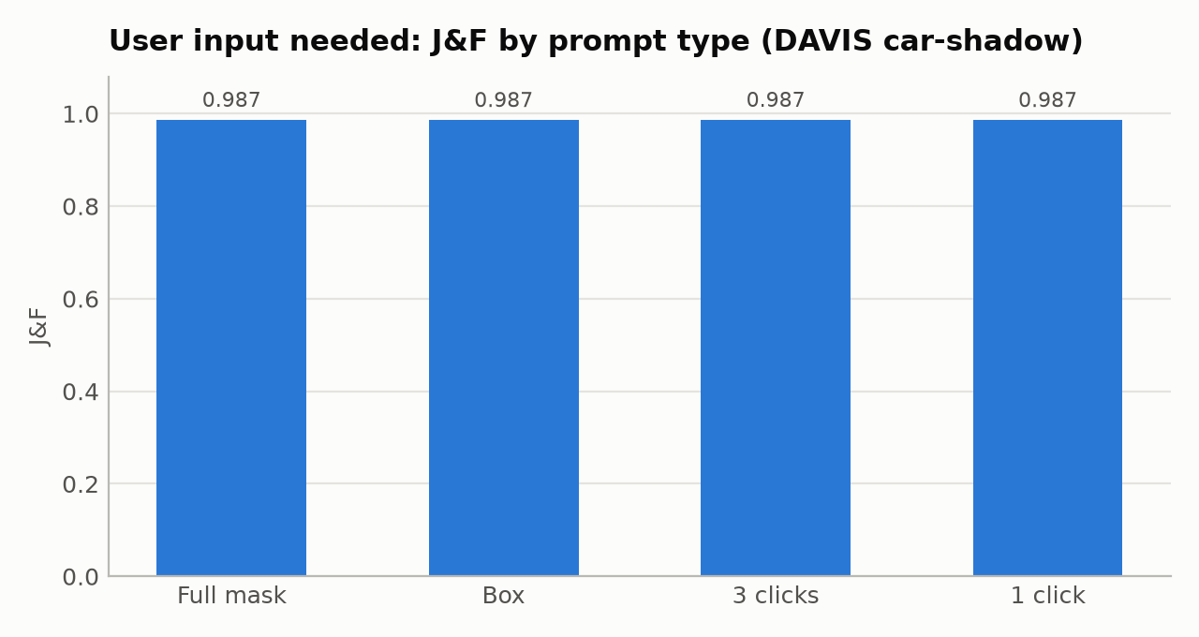
Figure 1 – J&F on DAVIS car-shadow for four prompt types (single run each, deterministic).
car-shadow is a salient, well-separated object, so the prompt type barely matters: every prompt converges to the same mask after a few frames. That is useful to a client, because one click per object is enough for this class of shot. The prompt type will matter for thin, multi-part or cluttered objects; the harness makes that a one-line config change on any DAVIS sequence.

3.3 Frame sub-sampling: accuracy vs. cost
Sequence | Stride | Effective rate | Frames | J&F | J | J-decay | Encoder cost
car-shadow | 1 | 24 fps | 40 | 0.987 | 0.976 | +0.013 | 1.00×
car-shadow | 2 | 12 fps | 20 | 0.987 | 0.976 | +0.013 | 0.50×
car-shadow | 4 | 6 fps | 10 | 0.988 | 0.977 | +0.010 | 0.25×
synthetic/fast_motion | 1 | 24 fps | 48 | 0.640 | 0.718 | +0.020 | 1.00×
synthetic/fast_motion | 2 | 12 fps | 24 | 0.634 | 0.719 | +0.034 | 0.50×
synthetic/fast_motion | 4 | 6 fps | 12 | 0.693 | 0.754 | -0.007 | 0.25×
synthetic/occlusion | 1 | 24 fps | 48 | 0.988 | 0.976 | -0.001 | 1.00×
synthetic/occlusion | 2 | 12 fps | 24 | 0.989 | 0.978 | -0.002 | 0.50×
synthetic/occlusion | 4 | 6 fps | 12 | 0.990 | 0.981 | +0.011 | 0.25×
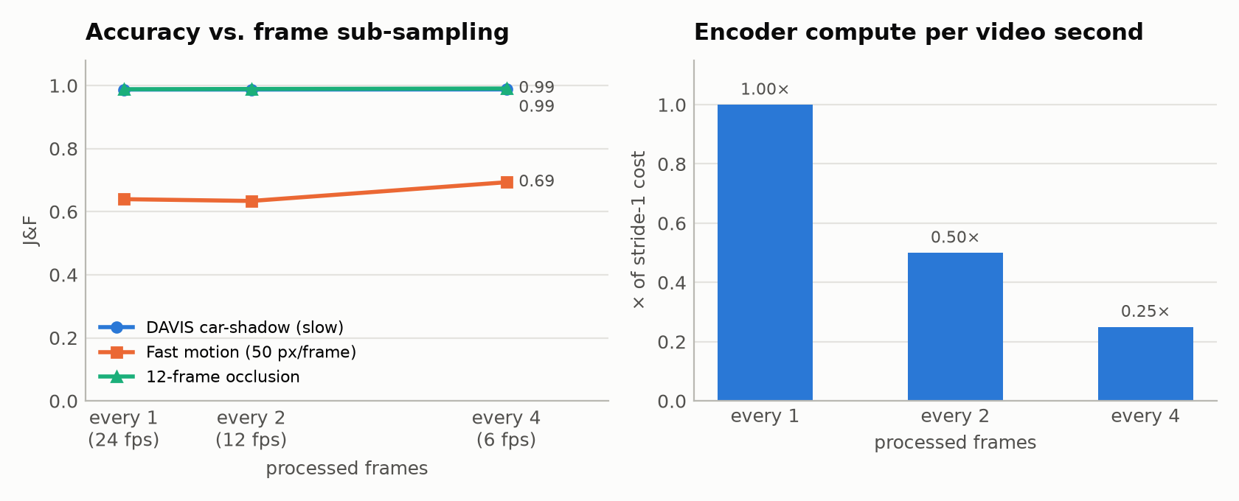
Figure 2 – Accuracy (left) and relative encoder compute (right) when only every 2nd / 4th frame is processed.
On car-shadow (slow, smooth motion), processing only every 4th frame keeps J&F at 0.988, a 4× saving on the encoder. The 12-frame occlusion is also unaffected (0.988 / 0.989 / 0.990 at stride 1 / 2 / 4): with 6 hidden frames instead of 12, re-detection is still immediate. The fast-motion clip stays at 0.640 / 0.634 / 0.693. Its error comes from the mask covering the motion-blur streak, not from losing the object, so skipping frames neither helps nor hurts much. Rule of thumb for quoting a job: sub-sample when the displacement between processed frames stays well below the object size. Measure it on a sample clip with this harness before promising a frame rate.

3.4 Failure modes: does the mask persist?
Scenario | J&F (object) | Hidden frames | Hidden-J | Re-detect delay (frames) | J after 1st hide | Distractor leakage | ID switch
synthetic/occlusion | 0.990 | 12 | 1.000 | 0 | 0.971 | – | –
synthetic/exit_reentry | 0.672 | 12 | 1.000 | 1 | 0.372 | – | –
synthetic/distractor | 0.976 | 0 | – | – | – | 2.3 % | no
synthetic/distractor (click) | 0.975 | 0 | – | – | – | 1.5 % | no
synthetic/fast_motion | 0.640 | 0 | – | – | – | – | –
sav_000001 obj 1 | 0.872 | 1 | 1.000 | 0 | 0.823 | – | –
sav_000001 obj 3 | 0.912 | 11 | 0.818 | 0, 0, 0, 0, 0 | 0.872 | – | –
sav_000001 obj 4 | 0.997 | 113 | 1.000 | 0 | 0.901 | – | –
Hidden-J is the J over frames where the object is fully invisible; 1.0 means SAM 2 correctly returned an empty mask on every one of them. Re-detection delay counts the frames after reappearance until J ≥ 0.5 (0 means the first visible frame). Distractor leakage is the share of the predicted mask that lies on the look-alike object.
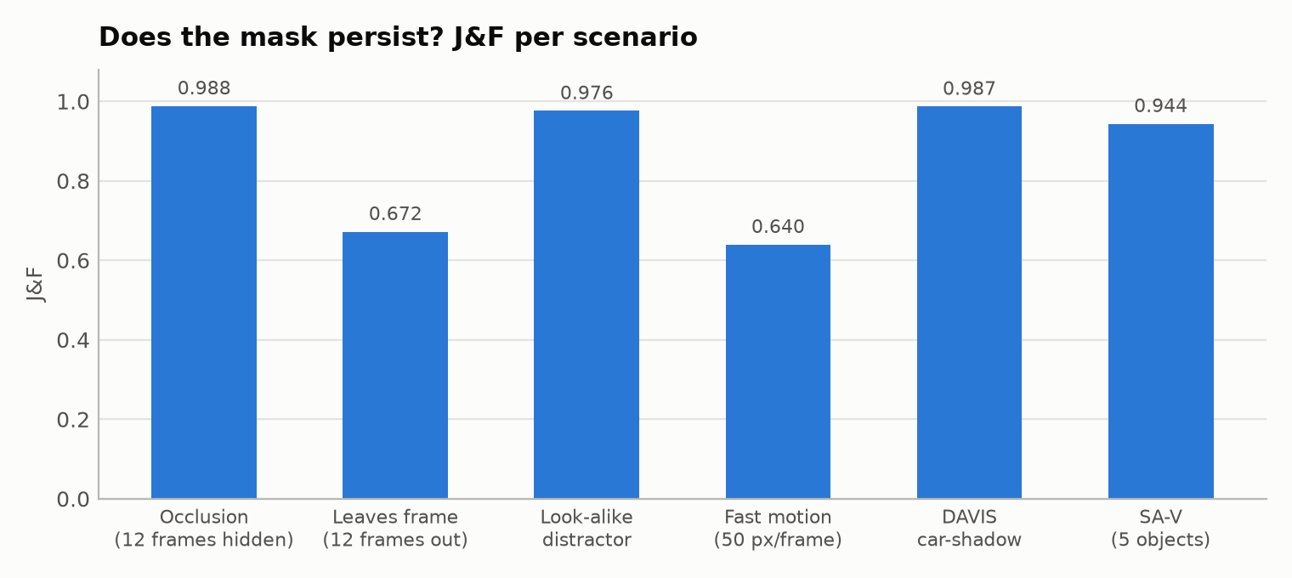
Figure 3 – J&F per scenario (mask prompt on the first frame).
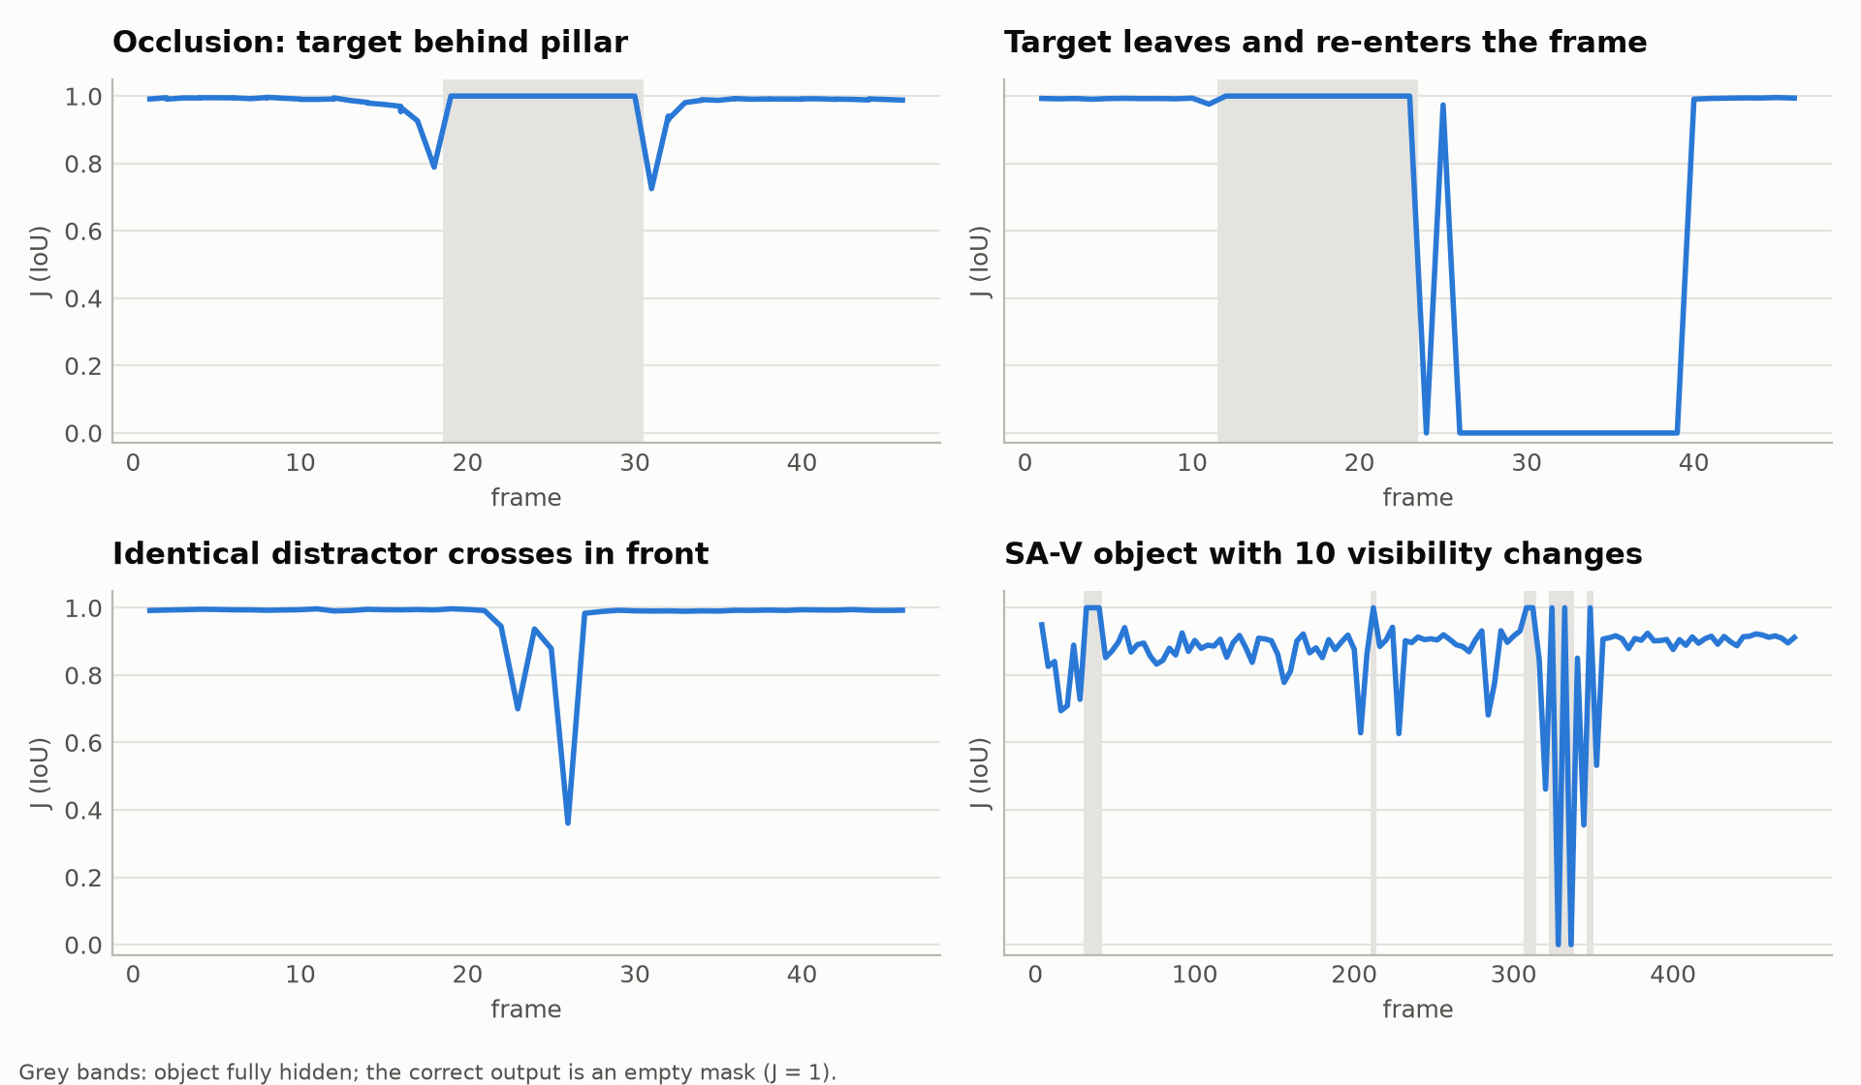
Figure 4 – Per-frame J. Grey bands are frames where the object is fully hidden; the correct output there is an empty mask (J = 1).
Occlusion. SAM 2's object-presence score went negative exactly on the hidden frames (≈ −3.6 to −5.2) and the mask was empty on all 12 of them. The control object, never occluded, stayed at J ≈ 0.99. This is the memory bank working as designed: the prompted frame stays in memory, so the object is recognised again even after it vanished.
Exit and re-entry: the instructive failure. The target left the frame for 12 frames and came back rotated. SAM 2 caught it on the second visible frame (J 0.97), then lost it again for 14 frames while it was fully visible. Its object score stayed between −1.2 and 0 until it crossed zero and tracking resumed. The memory window was full of “absent” frames and the rotated appearance only weakly matched the prompt. This is precisely what SAMURAI (motion-aware memory selection) and DAM4SAM (distractor-aware memory) address. A cheap production fix is a hybrid: when the object score sits between about −2 and 0.5 for several frames, re-prompt SAM 2 from a detector box.
Look-alike distractor. An identical object crossing in front pulled up to 64 % of the mask onto itself for one or two frames, but no identity switch occurred and J was back at 0.98 one frame later. With a single click the result is the same (J&F 0.975, max leakage 32 %).
Real clip without labels (bedroom). Two children, two clicks each, processed at 6 fps. Both keep their identity when the girl passes in front of the boy and when the boy is cut off at the left edge of the frame. The object score never goes negative (min 3.3). Temporal IoU is low (≈0.4–0.5) only because limbs move a lot between frames 4 apart at 24 fps; flow-warped IoU is higher, but optical flow itself is unreliable at that displacement.
Fast motion. At ≈ 50 px/frame with motion blur the object is never lost, but the mask covers the blur streak while the ground truth is the sharp silhouette. Both answers are defensible, so for VFX the right deliverable is a soft alpha matte (SAM 2 mask → matting model), not a binary mask.

3.5 Real multi-object video (SA-V example)
Object | Frames scored | J&F | J mean | J recall | J-decay | Hidden frames | Reappearances | Lost again
1 | 119 | 0.872 | 0.831 | 0.908 | +0.223 | 1 | 1 | 11
2 | 119 | 0.971 | 0.958 | 1.000 | -0.001 | 0 | 0 | 0
3 | 119 | 0.912 | 0.863 | 0.966 | -0.030 | 11 | 5 | 2
4 | 119 | 0.997 | 0.994 | 1.000 | +0.024 | 113 | 1 | 0
5 | 119 | 0.967 | 0.942 | 1.000 | +0.009 | 0 | 0 | 0
Mean J&F 0.944 over 5 objects at 6 fps. The object with 10 visibility changes (#3) was re-detected on the first visible frame at each of its 5 reappearances, but SAM 2 predicted a mask on 2 of its 11 hidden frames (hidden-J 0.82). The smallest object (#1, 0.35 % of the image) is the only one that degrades over time (J-decay 0.22). Small objects are where memory drift shows first. Object #4 appears only in the last 8 annotated frames; it was tracked in a separate pass from its first appearance, and its high score is dominated by correctly empty frames (the same convention as DAVIS). This video is from SA-V train, so it is a pipeline check, not a generalisation claim. Peak RAM was 5.5 GB for 121 frames, which is why the API caps frames per request.

3.6 GT-free quality signals and the cost model
Signal (no ground truth needed) | Spearman ρ with J | AUROC: detect J < 0.5
SAM 2 object-presence logit | 0.47 | 0.97
Mean foreground probability in mask | 0.86 | 0.94
Share of uncertain pixels (0.3 < p < 0.7) | -0.03 | 0.18
Computed over 988 visible-object frames, of which 32 have J < 0.5. SAM 2's object-presence logit is the best single signal (AUROC 0.97): it goes negative when the model believes the object is gone, so it catches both correct “hidden” frames and the exit-and-re-entry failure. Mask confidence also separates good from bad frames (AUROC 0.94), but it is only defined when the mask is non-empty (13 of 32 failure frames), so it cannot see an object that was dropped. The uncertain-pixel share is inverted (AUROC 0.18): a lost object produces a confidently empty mask with no uncertain pixels. So it is not a failure detector on its own. The production monitor therefore combines object score, temporal IoU and drop-out counts.
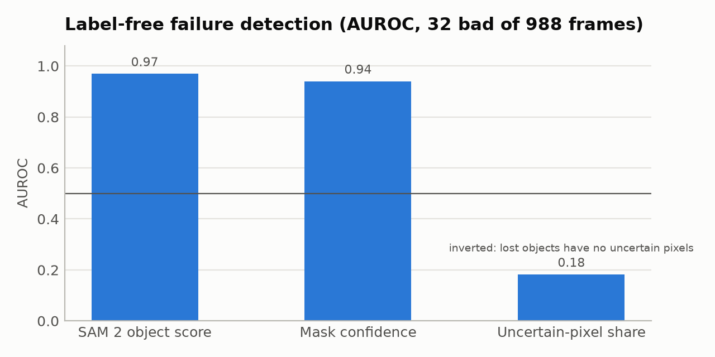
Figure 5 – How well each label-free signal separates failed frames from good ones (0.5 = chance).
Object | Temporal IoU | Aligned IoU | Flow-warped IoU | Empty frames | Isolated drop-outs | Min object score | Confi-dence
car-shadow #1 | 0.95 | 0.97 | 0.98 | 0 | 0 | 7.66 | 0.990
synthetic/occlusion #1 | 0.72 | 0.85 | 0.93 | 12 | 0 | -5.21 | 0.993
synthetic/occlusion #2 | 0.86 | 0.98 | 0.98 | 0 | 0 | 9.07 | 0.992
synthetic/exit_reentry #1 | 0.51 | 0.93 | 0.86 | 27 | 0 | -5.43 | 0.994
synthetic/fast_motion #1 | 0.20 | 0.85 | 0.29 | 0 | 0 | 2.67 | 0.970
synthetic/distractor #1 | 0.73 | 0.93 | 0.92 | 0 | 0 | 2.48 | 0.990
sav_000001 #1 | 0.06 | 0.65 | 0.22 | 5 | 1 | -2.99 | 0.977
sav_000001 #2 | 0.42 | 0.61 | 0.51 | 0 | 0 | 7.55 | 0.979
sav_000001 #3 | 0.56 | 0.75 | 0.75 | 9 | 4 | -4.59 | 0.972
sav_000001 #4 | 0.08 | 0.50 | 0.26 | 0 | 0 | 5.65 | 0.975
sav_000001 #5 | 0.10 | 0.69 | 0.19 | 0 | 0 | 5.23 | 0.979
bedroom #1 (no GT) | 0.49 | – | 0.70 | 0 | 0 | 8.21 | 0.975
bedroom #2 (no GT) | 0.38 | – | 0.52 | 0 | 0 | 3.27 | 0.962
Raw temporal IoU mixes real motion with mask instability. Aligned IoU removes translation by matching centroids, so what remains is change of shape. Flow-warped IoU removes all motion when optical flow works, but it breaks down at large displacements (see the fast-motion and 6 fps rows). A negative object score marks frames where SAM 2 itself says the object is not visible. The bedroom row has no aligned IoU because its masks were not stored.

Do the rule-based alerts fire on the right runs?
Run / object | J&F | Aligned IoU | Alerts (default thresholds)
car-shadow (mask, s1) #1 | 0.987 | 0.97 | none
car-shadow (box, s1) #1 | 0.987 | 0.97 | none
car-shadow (click, s1) #1 | 0.987 | 0.97 | none
car-shadow (click3, s1) #1 | 0.987 | 0.97 | none
car-shadow (mask, s2) #1 | 0.987 | 0.93 | none
car-shadow (mask, s4) #1 | 0.988 | 0.87 | none
synthetic/occlusion (mask, s1) #1 | 0.990 | 0.85 | area_jump
synthetic/occlusion (mask, s1) #2 | 0.986 | 0.98 | none
synthetic/exit_reentry (mask, s1) #1 | 0.672 | 0.93 | object_lost
synthetic/fast_motion (mask, s1) #1 | 0.640 | 0.85 | none
synthetic/distractor (mask, s1) #1 | 0.976 | 0.93 | none
synthetic/distractor (click, s1) #1 | 0.975 | 0.93 | none
sav_000001 (mask, s4) #1 | 0.872 | 0.65 | flicker, frame_dropout, area_jump
sav_000001 (mask, s4) #2 | 0.971 | 0.61 | flicker
sav_000001 (mask, s4) #3 | 0.912 | 0.75 | frame_dropout, area_jump
sav_000001 (mask, s4) #4 | 0.997 | 0.50 | flicker, area_jump
sav_000001 (mask, s4) #5 | 0.967 | 0.69 | flicker, area_jump
synthetic/fast_motion (mask, s2) #1 | 0.634 | 0.76 | area_jump
synthetic/fast_motion (mask, s4) #1 | 0.693 | 0.71 | area_jump
synthetic/occlusion (mask, s2) #1 | 0.990 | 0.78 | area_jump
synthetic/occlusion (mask, s2) #2 | 0.988 | 0.98 | none
synthetic/occlusion (mask, s4) #1 | 0.993 | 0.70 | flicker, area_jump
synthetic/occlusion (mask, s4) #2 | 0.987 | 0.98 | none
bedroom (no GT) #1 | n/a | n/a | none
bedroom (no GT) #2 | n/a | n/a | flicker, area_jump
The rule-based monitor caught the clear failure (exit and re-entry → object_lost). It cannot see the fast-motion failure at stride 1: there the mask is consistently too large, and stability metrics only detect *changes*, not a constant bias. It also raises alerts on runs that are fine: area_jump when the visible area legitimately changes under partial occlusion, and flicker / frame_dropout on the 6 fps SA-V clip, where articulated objects really do change shape between processed frames and single-frame absences can be correct. Read the alerts as triage signals for a human reviewer, calibrated per frame rate and footage type. For per-frame decisions such as automatic re-prompting, the object score is the precise signal. One more lesson: flow-warped IoU collapsed (0.0–0.3) at large displacements where tracking was fine, because dense optical flow fails there. That is why the flicker rule now uses centroid-aligned IoU first.

Cost model on this machine
Quantity | Value
Image encoder (Hiera-T, 1024²) per frame | 2,284 ms
Memory attention + decoder per object per frame | 3,557 ms
Fixed per-frame overhead (fit intercept) | ≈ 0 (fit: -322 ms, within noise)
Measured, 1 object(s), encoder cached | 3,328 ms/frame
Measured, 2 object(s), encoder cached | 6,654 ms/frame
Measured, 4 object(s), encoder cached | 13,953 ms/frame
Projected throughput, 1 object(s) | 0.18 fps
Projected throughput, 2 object(s) | 0.11 fps
Projected throughput, 4 object(s) | 0.06 fps
Projected throughput, 8 object(s) | 0.03 fps
Projected throughput, 16 object(s) | 0.02 fps
The model has two cost blocks. The image encoder runs once per frame (≈ 2.3 s here). Memory attention + mask decoder run once per object per frame (≈ 3.6 s here; the fitted fixed overhead is ≈ 0). With 4 objects that is ≈ 14 s per frame on 2 vCPU, so SAM 2.1 runs every object separately and cost grows linearly. That is the bottleneck SAM 3.1's Object Multiplex removes (up to 16 objects in one pass). On a GPU both blocks shrink by one to two orders of magnitude. The feature cache removes the encoder block whenever the same video is re-run with new prompts or strides, which is the normal interactive-roto loop (click, inspect, add a correction, re-propagate).

3.7 Threats to validity
- Small real-data sample. One DAVIS sequence, and one SA-V video that belongs to SAM 2's training split. Headline numbers need the full DAVIS 2017 val / MOSEv2. The harness supports them; only the download was blocked.
- Oracle prompts. Clicks are derived from ground truth (deepest interior point). Real users click less precisely.
- Synthetic domain gap. The stress clips isolate failure modes; they do not predict real-world rates.
- Weights. A public fp16 mirror of SAM 2.1 tiny, upcast to fp32. Expect small differences from Meta's fp32 file.
- Timing noise. A shared 2-vCPU sandbox (±20 %). Accuracy numbers are deterministic and unaffected.
- Monitor thresholds were set on the same small benchmark they are evaluated on. Recalibrate them on production traffic before trusting alert rates.

4. Architecture: what changed in the base platform
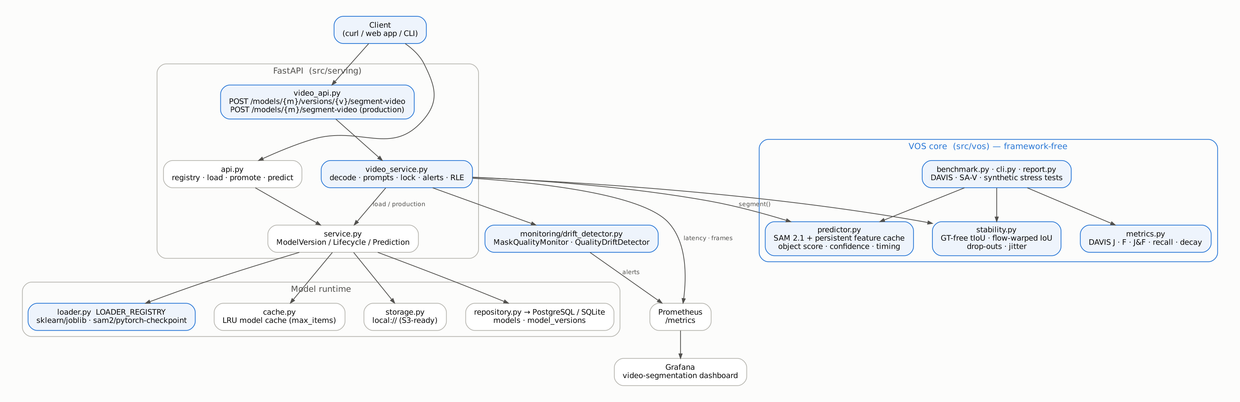
Figure 6 – Blue = added or extended in this phase; grey = reused from the ML Model Serving Platform.
Concern | Before (MSP) | After (this phase)
Model runtimes | scikit-learn/joblib, hard-coded in the service | Loader registry: scikit-learn/joblib + SAM 2/pytorch-checkpoint (variant auto-detected)
Inference API | /predict with a feature vector | + multipart /segment-video (versioned and production), COCO-RLE masks, stability report, alerts
Model cache | Unbounded dict | Thread-safe LRU with max_items
Database | PostgreSQL only | PostgreSQL or SQLite (DATABASE_URL); partial index on both
Observability | Tabular prediction metrics | + video latency/frames, temporal IoU, empty-frame ratio, quality alerts; new Grafana dashboard
Monitoring | drift_detector.py was an empty placeholder | MaskQualityMonitor (per request) + QualityDriftDetector (across requests)
Tests / CI | 63 tests, only pass against a pre-initialised DB | 122 tests; isolated DB; CI lint + PostgreSQL + SAM 2 smoke
Container | Single stage, root, no .dockerignore | Multi-stage, non-root, CPU torch, pinned SAM 2 commit

File inventory
File | Status | Lines (now / base)
src/models/seed.py | unchanged | 61 / 61
src/models/seed_sam2.py | new | 51
src/models/train.py | unchanged | 167 / 167
src/monitoring/drift_detector.py | modified | 106
src/serving/api.py | modified | 166 / 159
src/serving/app.py | modified | 61 / 44
src/serving/cache.py | modified | 78 / 51
src/serving/config.py | modified | 50 / 23
src/serving/database.py | modified | 25 / 21
src/serving/db_models.py | modified | 97 / 85
src/serving/dependency.py | unchanged | 8 / 8
src/serving/loader.py | modified | 110 / 52
src/serving/observability.py | modified | 193 / 105
src/serving/repository.py | unchanged | 95 / 95
src/serving/schemas.py | modified | 147 / 54
src/serving/service.py | modified | 219 / 210
src/serving/storage.py | unchanged | 79 / 79
src/serving/video_api.py | new | 124
src/serving/video_service.py | new | 197
src/vos/__init__.py | new | 19
src/vos/benchmark.py | new | 409
src/vos/cli.py | new | 544
src/vos/data.py | new | 190
src/vos/metrics.py | new | 268
src/vos/predictor.py | new | 341
src/vos/prompts.py | new | 68
src/vos/report.py | new | 537
src/vos/rle.py | new | 113
src/vos/stability.py | new | 222
src/vos/synthetic.py | new | 211
src/vos/types.py | new | 110
src/vos/visualize.py | new | 103
tests/conftest.py | new | 32
tests/test_health.py | unchanged | 22 / 22
tests/test_infrastructure.py | unchanged | 57 / 57
tests/test_lifecycle.py | unchanged | 244 / 244
tests/test_loader.py | unchanged | 172 / 172
tests/test_observability.py | unchanged | 231 / 231
tests/test_prediction.py | modified | 228 / 228
tests/test_registry.py | unchanged | 75 / 75
tests/test_sam2_integration.py | new | 136
tests/test_storage.py | unchanged | 67 / 67
tests/test_video_api.py | new | 225
tests/test_vos_metrics.py | new | 99
tests/test_vos_rle.py | new | 44
tests/test_vos_stability_prompts.py | new | 126
tests/test_vos_synthetic.py | new | 49

5. Code review

5.1 Method and severity scale
Every file was read line by line. Findings are rated as follows:
Severity | Meaning
High | Security exposure or a defect that breaks a documented workflow (e.g. CI on a fresh database).
Medium | Wrong behaviour under realistic load or inputs; design that blocks the next feature.
Low | Maintainability, consistency, small inefficiencies.
Info | Strengths and design notes worth keeping.
Status: Fixed means changed and tested in this phase; Open means a recommendation with a concrete next step; By design means an accepted trade-off.

5.2 Base platform (reviewed, then extended)

Repository packaging (zip, .env, .venv, .idea, bk/)
Purpose | Technique
How the project is shared and built. | Git-ignored local artefacts; Docker build context.

Severity | Finding | Resolution / status
High | The shared archive contains .env with real database and Grafana passwords. It is git-ignored, but the zip bypasses that. | Fixed: excluded from the new project; only env.example ships. Rotate those passwords.
Medium | The archive ships .venv (484 MB, 33 k files), .idea, .ruff_cache, __pycache__ and the bk/ scratch folder. There is no .dockerignore, so COPY . . would copy the venv into the image. | Fixed: .dockerignore added; clean export.

src/serving/config.py + database.py
Purpose | Technique
Settings from environment; SQLAlchemy engine and session factory. | pydantic-settings BaseSettings; dependency-injected get_db() session.

Severity | Finding | Resolution / status
Medium | The DB URL is hard-wired to PostgreSQL and all POSTGRES_* fields are required, so nothing (not even unit tests) runs without Docker. | Fixed: DATABASE_URL override (SQLite for local / tests), check_same_thread=False for SQLite, pool_pre_ping=True.
Low | Inconsistent field casing (ARTIFACT_STORAGE_BACKEND vs postgres_user); env.example used KEY = 'value' with spaces and quotes. | Fixed: env.example normalised; field names kept for backward compatibility.
Info | New settings: model_cache_max_items, vos_device, vos_max_frames, vos_max_upload_mb, vos_num_threads. | Added.

src/serving/db_models.py + repository.py
Purpose | Technique
Registry tables (models, model_versions, scaffolded model_deployments) and the only place that issues SQL. | Partial unique index = “at most one production version per model”, enforced by the database. Promotion and archiving run in one transaction.

Severity | Finding | Resolution / status
Low | The partial index only had postgresql_where, so the guarantee disappeared on any other engine. | Fixed: matching sqlite_where.
Low | status is free text; DBModelDeployment (canary) is unused scaffolding; tables come from create_all() with no migrations. | Open: DB Enum/CHECK, Alembic, implement or remove the canary table.
Info | Strength: the transactional promote/rollback with a DB-level invariant is production-grade and was reused unchanged for SAM 2 versions. | By design

src/serving/loader.py
Purpose | Technique
Turn artifact bytes into an in-memory model. | Protocol interface + loader registry keyed by (framework, model_format).

Severity | Finding | Resolution / status
Medium | The service layer hard-coded if framework != 'scikit-learn'. That contradicts the README's own claim that the platform is algorithm-agnostic; adding PyTorch meant editing business logic. | Fixed: LOADER_REGISTRY + get_loader(); a new runtime is one registry entry. Sam2CheckpointLoader added.
High | joblib.load (pickle) executes arbitrary code. Anyone who can register an artifact_uri and write to storage can run code in the API process. | Open: store an artifact SHA-256 in the registry and verify it at load time; add auth on registry endpoints; prefer skops/ONNX. The SAM 2 path already uses torch.load(weights_only=True).
Info | SAM 2 variant (tiny / small / base+ / large) is inferred from tensor shapes, so the registry needs no schema change. | Added

src/serving/service.py
Purpose | Technique
Business rules: registry, loading, lifecycle (promote / production), prediction. | Three-layer architecture (API → Service → Repository).

Severity | Finding | Resolution / status
Medium | Calling /predict on a model without .predict (a video model) caused an AttributeError, which surfaced as a 500. | Fixed: TaskMismatchError → 400 with a clear message.
Low | Latency was measured with time.time() (wall clock, can jump under NTP adjustments). | Fixed: time.perf_counter().
Low | The service raises FastAPI HTTPException, so HTTP concerns leak into the business layer. The rest of the code uses domain exceptions. | Open: domain exceptions + app.exception_handler.
Low | Promotion loads the full model only to check that it loads. For SAM 2 that means seconds and hundreds of MB. | By design (safety first). Option: cache the validated model after a successful promotion.

src/serving/api.py
Purpose | Technique
REST routes for the registry, lifecycle and tabular prediction. | FastAPI routers, Pydantic I/O models, explicit exception → status-code mapping, labelled error metrics.

Severity | Finding | Resolution / status
Low | POST /models/{name}/predict accepts a raw dict instead of PredictionRequest. Validation differs from the versioned route and errors are not counted in metrics. | Open: reuse the schema and the same error mapping.
Low | POST returns 200 instead of 201; no pagination or auth (already listed in the original README). | Open

src/serving/cache.py
Purpose | Technique
Keep hot models in RAM. | ModelCache protocol; process-local singleton.

Severity | Finding | Resolution / status
Medium | The cache was an unbounded dict. That is fine for kilobyte scikit-learn models, but a few SAM 2 checkpoints (80 MB – 900 MB each) would exhaust memory. | Fixed: LRU with max_items (default 4), RLock for thread-pool safety, eviction counter. max_items=None keeps the old behaviour.
Low | The cache is per process: N uvicorn workers hold N copies of each model. | By design: torch modules cannot live in Redis. Use one worker per GPU, or a model server (Triton / TorchServe) when scaling out.

src/serving/storage.py + dependency.py
Purpose | Technique
Artifact storage abstraction (local://, S3-ready). | Path-traversal protection via os.path.commonpath; DI factory.

Severity | Finding | Resolution / status
Info | Strength: the traversal check is correct, and the tests cover it. | By design
Low | get() reads the whole artifact into memory. That is acceptable for an 80 MB checkpoint but wasteful for 900 MB; a new LocalArtifactStorage object is built on every call. | Open: streaming / local_path() API; cache the storage instance.

src/serving/observability.py
Purpose | Technique
Prometheus metrics, structured JSON logs, request IDs via ContextVar. | Counters and histograms labelled by model and version; no PII in logs.

Severity | Finding | Resolution / status
Medium | Default histogram buckets (5 ms – 10 s) suit tabular inference only; video requests take seconds to minutes and would all land in +Inf. | Fixed: explicit buckets for video_segmentation_latency_seconds (0.5 s – 600 s) and video_frame_latency_seconds.
Info | New metrics: video requests / errors / latency / frames, mask_temporal_iou, mask_empty_frame_ratio, mask_quality_alerts_total{reason}. | Added

deployment/Dockerfile + docker-compose.yml
Purpose | Technique
Container image and local stack (api · postgres · prometheus · grafana). | Health checks; Grafana provisioning as code.

Severity | Finding | Resolution / status
Medium | The image was single-stage, ran as root, and shipped build-essential at runtime. | Fixed: multi-stage build, non-root user, CPU PyTorch wheels, pinned SAM 2 commit. Not built in this environment (no Docker daemon).
Low | The README's --shm-size=2gb advice was not in compose; prometheus and grafana use latest tags. | Fixed: shm_size: 2gb; weights volume. Open: pin monitoring images.

tests/ + .github/workflows/ci-cd.yaml
Purpose | Technique
8 pytest suites (63 tests) and lint/test CI. | Integration tests through TestClient; mocking for cache hits.

Severity | Finding | Resolution / status
High | Tables are created in the FastAPI lifespan, but the tests use TestClient(app) without a context manager, so the lifespan never runs. The suite only passed because the running API container had already created the tables. On the fresh PostgreSQL in CI every DB test fails. | Fixed: tests/conftest.py creates the tables once per session and defaults to an isolated temporary SQLite database.
Low | One test patched src.serving.service.SklearnJoblibLoader, which ties it to an import location. | Fixed: it now patches the loader module.
Info | CI now runs lint, the fast suite (PostgreSQL service) and a push-only SAM 2 CPU smoke job. | Added

5.3 New video-segmentation code

src/vos/predictor.py
Purpose | Technique
SAM 2.1 video segmenter behind a small VideoSegmenter protocol. | Streaming memory propagation; prompts as mask, box or clicks; late-appearing objects tracked in a separate pass (same policy as Meta's vos_inference.py). A persistent backbone-feature cache reuses Hiera features across runs on the same video. SAM 2's object-presence logit and per-pixel probabilities are exposed as GT-free confidence signals.

Severity | Finding | Resolution / status
Info | The feature cache returns bit-identical masks (verified in a test). Position encodings (≈80 MB of the ≈100 MB per frame) are deduplicated, so a cached frame costs ≈20 MB. | By design
Medium | init_state loads every frame as a float32 1024² tensor (≈12.6 MB/frame). Measured peak RSS: 5.6 GB for 121 frames × 5 objects (frames + memory bank + feature cache). | Mitigated: API limit vos_max_frames=300, stride. Open: windowed / streaming frame loading for long videos.
Medium | The predictor keeps per-call state on the instance, so one model instance must not run two videos at once. | Mitigated: per-model lock in video_service.py. Open: job queue + worker pool for throughput.
Low | The optional CUDA extension sam2._C is not built on CPU, so the hole-filling post-processing is skipped (Meta notes the effect is small). | By design on CPU; build the extension in the GPU image.
Low | The weights come from a public mirror stored in fp16 and upcast to fp32. Scores may differ slightly from Meta's fp32 release. | Open: fetch-weights tries Meta's URL first; the SHA-256 is recorded in runs.json.

src/vos/metrics.py
Purpose | Technique
DAVIS region similarity J, contour accuracy F, J&F, recall and decay. | Port of davis2017-evaluation: one-pixel boundary maps (seg2bmap) dilated by a disk of radius ⌈0.008 × diagonal⌉; empty-vs-empty scores 1. Supports sparse GT (SA-V, 6 fps) and stride sub-sampling.

Severity | Finding | Resolution / status
Medium | Fixed an upstream bug: the official db_statistics casts decay-bin indices to uint8, so decay is wrong for videos longer than 255 frames (tested). | Fixed
Low | Not yet cross-checked against the official toolkit on full DAVIS 2017 val (the dataset host is not reachable from this environment). | Open: run davis2017-evaluation on the same predictions.

src/vos/stability.py
Purpose | Technique
Ground-truth-free temporal metrics per tracked object. | Temporal IoU; centroid-aligned IoU (translation removed, no flow needed); flow-compensated IoU (Farnebäck backward flow; warp mask t into t+1 and compare); area volatility; isolated drop-outs; lost / recovered events; centroid jitter; confidence and object score.

Severity | Finding | Resolution / status
Medium | Flow-warped IoU collapsed to 0.0–0.3 at large displacements (fast motion, 6 fps SA-V) while tracking was fine, because dense optical flow fails there. Raw temporal IoU has the same problem for any fast object. | Fixed: added centroid-aligned IoU; the monitor uses it first.
Low | Stability metrics detect *change*, not a constant bias. A mask that is consistently too large (motion blur) looks perfectly stable. | By design: pair with the object score and periodic GT spot checks.
Low | Flow is computed at half resolution, ≈40 ms per frame pair at 480p on CPU, so it is opt-in in the API (flow_stability). | By design

src/vos/synthetic.py
Purpose | Technique
Stress-test videos with exact (modal) ground truth. | Procedural textured background and clutter; striped sprites with shading; foreground occluder; identical distractor drawn in front; exit / re-entry; 50 px/frame zig-zag with 7-sample motion blur. JPEG-encoded like real footage.

Severity | Finding | Resolution / status
Low | Rendering builds a full-frame mesh grid per sprite (≈0.15 s/frame). | Open: render inside the sprite's bounding box.
Info | There is a domain gap to real video. These clips isolate failure modes; they do not replace a real benchmark. | By design

src/vos/prompts.py
Purpose | Technique
Derive mask, box, 1-click and 3-click prompts from GT. | First click at the maximum of the distance transform (always inside, even for rings); extra clicks by farthest-point sampling over deep interior pixels.

Severity | Finding | Resolution / status
Low | Oracle prompts are cleaner than real users' clicks. | Open: add click jitter / noisy boxes in Phase 2.

src/vos/data.py + rle.py
Purpose | Technique
DAVIS (palette PNG, void = 255), SA-V train format (compressed COCO RLE) and unlabeled-video loaders; frame materialisation for SAM 2. | Pure-NumPy port of pycocotools' compressed RLE (LEB128-like 5-bit groups, delta-to-two-back), verified against pycocotools. Frames are hard-linked, not copied.

Severity | Finding | Resolution / status
Info | No C build dependency for masks; the API returns uncompressed RLE (column-major), which any COCO tool can read. | By design
Low | For long clips, uncompressed RLE in JSON is large. | Open: offer compressed RLE strings or a ZIP of PNGs.

src/vos/benchmark.py + cli.py + report.py
Purpose | Technique
Config-driven experiments, CSV/JSON results, plots, demo media. | Run matrix (sequence × prompt × stride); event metrics (hidden-frame J, re-detection delay, distractor leakage, identity switch); AUROC / Spearman of GT-free signals against J; --append to add experiments; profile cost model.

Severity | Finding | Resolution / status
Low | Runtime numbers come from a shared 2-vCPU sandbox (±20 %). Accuracy numbers are deterministic. | By design: profile measures the cost model on a quiet machine.
Info | The run environment (torch version, threads, checkpoint SHA-256 and dtype) is stored with the results. | Added

src/serving/video_api.py + video_service.py
Purpose | Technique
POST /models/{m}/versions/{v}/segment-video and production routing. | Multipart upload streamed to disk; size and frame guards (413); prompt validation (422 for unprocessed frames or points outside the frame); registry → LRU cache → SAM 2; per-model lock; stability report + alerts + Prometheus; COCO RLE masks.

Severity | Finding | Resolution / status
Medium | The endpoint is synchronous. A 300-frame clip on CPU takes minutes and holds an HTTP worker. | Open: job queue (Celery / RQ / Arq) with the same service function as the worker body; GPU node.
Low | The upload-size limit is checked after the file is written. | Open: enforce at the proxy (client_max_body_size) or count bytes while streaming.

src/monitoring/drift_detector.py
Purpose | Technique
Per-request quality rules and cross-request drift detection without labels. | Threshold rules map to client-visible failures (flicker, object lost, frame drop-out, area jump, low confidence). One-sided mean-shift z-test of a quality signal: reference window vs recent window.

Severity | Finding | Resolution / status
Medium | On the benchmark the default rules caught the clear failure (exit and re-entry) but also alerted on good runs: area_jump under legitimate partial occlusion, and flicker / frame_dropout on the 6 fps SA-V clip (§3.6). | Open: calibrate per frame rate and footage type; gate area_jump on the object score; treat alerts as triage.
Low | Thresholds come from a small benchmark, and the z-test assumes independent requests. | Open: recalibrate on production traffic; consider CUSUM / Page-Hinkley.

5.4 Key code, explained

Feature cache hook (predictor.py)
SAM 2 keeps the backbone features of one frame only. The hook below serves features from a persistent LRU keyed by (video, original frame index), so mask, box and click runs, and different strides, share one encoder pass. On a hit it rebuilds the image view from the current inference state, so the previous run's frame tensor is not kept alive.
def cached_get_image_feature(inference_state, frame_idx, batch_size):
ids = segmenter._frame_ids
key = (segmenter._video_key, ids[frame_idx] if ids is not None else frame_idx)
backbone_out = cache.get(key) if segmenter._video_key else None
if backbone_out is not None:
# Re-use the features but take the image view from the *current* state:
# caching the image would pin the previous run's whole frame tensor in RAM.
device = inference_state["device"]
image = inference_state["images"][frame_idx].to(device).float().unsqueeze(0)
inference_state["cached_features"] = {frame_idx: (image, backbone_out)}
out = original(inference_state, frame_idx, batch_size)
if backbone_out is None and segmenter._video_key:
cache.put(key, inference_state["cached_features"][frame_idx][1])
return out

Object-presence score (predictor.py)
Besides the mask, the SAM 2 decoder predicts whether the object is visible at all. Reading it from the inference state gives a free occlusion detector (see §3.6).
def _object_score(state, obj_id: int, frame_idx: int) -> float | None:
"""SAM 2's object-presence logit for (object, frame); > 0 means 'object visible'."""
try:
obj_idx = state["obj_id_to_idx"][obj_id]
out = state["output_dict_per_obj"][obj_idx]
d = out["cond_frame_outputs"].get(frame_idx) or out["non_cond_frame_outputs"].get(frame_idx)
if d is None or d.get("object_score_logits") is None:
return None

Contour accuracy F (metrics.py)
def f_measure(gt: np.ndarray, pred: np.ndarray, void: np.ndarray | None = None, bound_th: float = 0.008) -> float:
"""Boundary F-measure with a distance tolerance (port of DAVIS ``f_measure``)."""
gt = gt.astype(bool)
pred = pred.astype(bool)
if void is not None:
keep = ~void.astype(bool)
gt = gt & keep
pred = pred & keep

bound_pix = boundary_tolerance_px(gt.shape, bound_th)
fg_boundary = seg2bmap(pred)
gt_boundary = seg2bmap(gt)
kernel = _disk(bound_pix)
fg_dil = cv2.dilate(fg_boundary.astype(np.uint8), kernel).astype(bool)
gt_dil = cv2.dilate(gt_boundary.astype(np.uint8), kernel).astype(bool)

gt_match = gt_boundary & fg_dil
fg_match = fg_boundary & gt_dil
n_fg = int(np.count_nonzero(fg_boundary))
n_gt = int(np.count_nonzero(gt_boundary))

if n_fg == 0 and n_gt > 0:
precision, recall = 1.0, 0.0
elif n_fg > 0 and n_gt == 0:
precision, recall = 0.0, 1.0
elif n_fg == 0 and n_gt == 0:
precision, recall = 1.0, 1.0
else:
precision = np.count_nonzero(fg_match) / n_fg
recall = np.count_nonzero(gt_match) / n_gt

if precision + recall == 0:
return 0.0
return float(2 * precision * recall / (precision + recall))

Decay with the uint8 fix (metrics.py)
def statistics(per_frame: np.ndarray) -> Stat:
"""Mean, recall (>0.5) and decay of a per-frame score vector (NaNs ignored)."""
v = np.asarray(per_frame, dtype=float)
if v.size == 0 or np.all(np.isnan(v)):
return Stat(float("nan"), float("nan"), float("nan"))
with warnings.catch_warnings():
warnings.simplefilter("ignore", category=RuntimeWarning)
mean = float(np.nanmean(v))
recall = float(np.nanmean(v[~np.isnan(v)] > 0.5))
n_bins = 4
# FIX vs. official toolkit: int64 instead of uint8 (overflow for > 255 frames)
ids = (np.round(np.linspace(1, len(v), n_bins + 1) + 1e-10) - 1).astype(np.int64)
bins = [v[ids[i] : ids[i + 1] + 1] for i in range(n_bins)]
decay = float(np.nanmean(bins[0]) - np.nanmean(bins[3]))
return Stat(mean, recall, decay)

Motion-compensated stability (stability.py)
Two ways to take motion out of temporal IoU: shift the previous mask so the centroids coincide (cheap and robust), or warp it with dense backward optical flow (exact when the flow is right, useless when the displacement is too large).
def aligned_iou(a: np.ndarray, b: np.ndarray) -> float:
"""IoU after translating ``a`` so that its centroid coincides with ``b``'s (integer pixels)."""
ya, xa = np.nonzero(a)
yb, xb = np.nonzero(b)
if xa.size == 0 or xb.size == 0:
return float("nan")
dy = int(round(yb.mean() - ya.mean()))
dx = int(round(xb.mean() - xa.mean()))
h, w = a.shape
ys, xs = ya + dy, xa + dx
keep = (ys >= 0) & (ys < h) & (xs >= 0) & (xs < w)
shifted = np.zeros_like(a, dtype=bool)
shifted[ys[keep], xs[keep]] = True
return _iou(shifted, b)
def warp_mask(mask_t: np.ndarray, flow_back: np.ndarray) -> np.ndarray:
"""Warp mask_t into frame t+1 using backward flow (t+1 → t)."""
h, w = mask_t.shape
gx, gy = np.meshgrid(np.arange(w, dtype=np.float32), np.arange(h, dtype=np.float32))
map_x = gx + flow_back[..., 0].astype(np.float32)
map_y = gy + flow_back[..., 1].astype(np.float32)
warped = cv2.remap(mask_t.astype(np.float32), map_x, map_y, cv2.INTER_LINEAR, borderValue=0)
return warped > 0.5

Loader registry (loader.py)
LOADER_REGISTRY: dict[tuple[str, str], Any] = {
("scikit-learn", "joblib"): SklearnJoblibLoader,
("sam2", "pytorch-checkpoint"): _sam2_factory,
}

# what each framework is able to do (used to reject e.g. /predict on a video model)
TASK_BY_FRAMEWORK = {"scikit-learn": "tabular-prediction", "sam2": "video-segmentation"}

def get_loader(framework: str, model_format: str) -> ModelLoader:
factory = LOADER_REGISTRY.get((framework, model_format))
if factory is None:
supported = ", ".join(f"{f}/{m}" for f, m in LOADER_REGISTRY)
raise UnsupportedModelFormat(f"Unsupported format {framework}/{model_format} (supported: {supported})")
return factory()

Video endpoint guard-rails (video_service.py)
def _to_prompts(req: VideoSegmentationRequest, meta: dict) -> dict[int, Prompt]:
pos_of = {orig: k for k, orig in enumerate(meta["original_indices"])}
h, w = meta["height"], meta["width"]
prompts: dict[int, Prompt] = {}
for o in req.objects:
if o.frame_idx not in pos_of:
raise InvalidPromptError(
f"object {o.obj_id}: frame_idx {o.frame_idx} is not processed "
f"(stride={req.stride}, processed frames are multiples of the stride)"
)
coords = (o.points or []) + ([o.box[:2], o.box[2:]] if o.box else [])
for x, y in coords:
if not (0 <= x <= w and 0 <= y <= h):
raise InvalidPromptError(f"object {o.obj_id}: point ({x}, {y}) is outside the {w}x{h} frame")

Quality rules (drift_detector.py)
def evaluate(self, report: dict) -> list[str]:
"""Return the list of alert reasons for one object's stability report."""
t = self.t
alerts: list[str] = []

def val(key):
v = report.get(key)
return None if v is None or (isinstance(v, float) and math.isnan(v)) else v

# Flicker = the mask's *shape* changes between frames. Raw temporal IoU also drops for fast
# but perfectly tracked objects (false alarms on sports / kids footage), so use a
# motion-compensated estimate. Centroid-aligned IoU comes first: in the Phase-1 benchmark,
# flow-warped IoU collapsed (0.0–0.3) at large displacements where tracking was fine,
# because dense optical flow itself fails there.
for key, threshold in (
("aligned_iou_mean", t.min_aligned_iou),
("warped_iou_mean", t.min_warped_iou),
("tiou_mean", t.min_tiou),
):
if val(key) is not None:
if val(key) < threshold:
alerts.append("flicker")
break
if val("empty_rate") is not None and val("empty_rate") > t.max_empty_rate:
alerts.append("object_lost")
if (val("isolated_dropouts") or 0) > t.max_isolated_dropouts:
alerts.append("frame_dropout")
if val("area_jump_rate") is not None and val("area_jump_rate") > t.max_area_jump_rate:
alerts.append("area_jump")
if val("confidence_mean") is not None and val("confidence_mean") < t.min_confidence:
alerts.append("low_confidence")
return alerts

6. Techniques explained (learning notes)

SAM 2: promptable segmentation with streaming memory
Each frame is encoded once by a hierarchical vision transformer (Hiera). Memory attention then cross-attends the current frame's features to a memory bank. The bank holds the prompted (conditioning) frames, the most recent frames (6 by default) and compact object pointers. The mask decoder outputs a mask, an IoU estimate and an object-presence score.
The memory is why a mask persists: the model does not re-detect from scratch, it re-identifies what it has already seen. The fixed recent-frame window is also why long absences are hard; the exit-and-re-entry case shows it.

Semi-supervised VOS protocol and metrics
Prompt once, propagate, then score every annotated frame except the first and last. J is IoU; F is a boundary F-measure with a distance tolerance. J&F averages the two, recall is the share of frames above 0.5, and decay compares the first and last quarter of the video. Decay is the most direct answer to “does the mask persist?”.

GT-free stability and flow compensation
Without labels you can still measure consistency. Temporal IoU between consecutive masks penalises flicker but also real motion. Warping the previous mask with dense optical flow (Farnebäck, backward flow + cv2.remap) before comparing removes the motion term, so the remaining disagreement is segmentation instability. Drop-outs (a single empty frame between visible ones) are the “frame drop” a roto client complains about.

Feature caching
The image encoder is about 40 % of the per-frame cost for one object on CPU (2.3 of 5.6 s) and does not depend on the prompt. Caching its output per (video, frame) turns every extra prompt experiment, and every interactive correction, into a memory-attention-only pass. Results are bit-identical; the cache deduplicates the input-independent position encodings to cut memory 5×.

Segmentation propagation vs. tracking-by-detection
Tracking-by-detection (SORT, ByteTrack, OC-SORT) runs a detector on every frame and associates boxes over time with a Kalman motion model and IoU or appearance matching. It finds new objects automatically and recovers after exits, but outputs boxes and suffers ID switches. SAM 2 propagation needs a prompt, outputs pixel masks and keeps identity through appearance memory, but it does not discover new objects and can stay lost after long absences.
The two are complementary. The hybrid in Phase 2 lets a detector re-prompt SAM 2 whenever the object score indicates loss. Multi-object variants of the same idea are SAM2MOT, and SAM 3/3.1 with text prompts.

Serving patterns used
Model registry with a DB-enforced single production version; a loader registry for pluggable runtimes; a bounded LRU model cache; per-model locks around stateful predictors; explicit Prometheus buckets for long-running requests; COCO RLE for compact, tool-agnostic mask transport; rule-based quality alerts plus a rolling mean-shift detector for label-free drift.

7. Recommendations and roadmap

7.1 Prioritised fixes
- Verify an artifact hash at load time and add auth on registry endpoints (pickle RCE exposure, inherited from the base platform).
- Move video segmentation to a job queue with GPU workers; keep the synchronous endpoint for short clips.
- Add the detector re-prompt hybrid, triggered by the object score, to fix the exit and re-entry failure.
- Stream frames instead of loading the whole clip (RAM grows by 12.6 MB per frame today).
- Run the full DAVIS 2017 val and MOSEv2 and cross-check metrics with the official toolkit.
- Replace binary masks with soft alpha for motion-blurred objects (matting stage).

7.2 Next phases
- Phase 2: YOLO-seg + ByteTrack vs. SAM 2 vs. a hybrid on the same clips; HOTA and IDF1 next to J&F.
- Phase 3: memory improvements (SAMURAI, DAM4SAM, SAM2Long) evaluated per failure mode and on MOSEv2.
- Phase 4: multi-object tracking (SAM2MOT vs. ByteTrack on DanceTrack); SAM 3.1 text prompts.
- Phase 5: production hardening: async jobs, GPU image, streaming loader, artifact signing, auth.

8. Reproducibility
make setup setup-vos # venv, API deps, CPU PyTorch, official SAM 2 @ 2b90b9f
make weights samples synth # checkpoint, DAVIS car-shadow + SA-V example + demo clips, synthetic videos
make test # fast suite (SQLite + fake segmenter)
make test-slow # real SAM 2 inference
make benchmark # configs/phase1.yaml -> results/phase1
python -m src.vos.cli profile # encoder vs per-object cost on this machine
make report # plots, demo videos, portfolio cover
Item | Value
Python / PyTorch | 3.13.16 / 2.14.1+cu130
Platform | Linux-6.18.44-fc-v114-x86_64-with-glibc2.39
Threads / device | 2 / cpu
Checkpoint | sam2.1_t.pt (torch.float16)
Checkpoint SHA-256 | 3c1e81ca9b037dd39d70a014ddb9a813d6c4c4e12555420db7eaff31689bd4e3
Source of weights | github.com/ultralytics/assets v8.3.0 mirror of Meta SAM 2.1 hiera-tiny (fp16)
SAM 2 code | facebookresearch/sam2 @ 2b90b9f5 (Dec 2024)
Benchmark wall time | ≈ 81 min (main run) + ≈ 8 min (appended stride sweep), 2 vCPU

Appendix A – Upwork portfolio entry
Field | Text
Project title (≤ 70) | AI Video Object Tracking & Segmentation with SAM 2 (PyTorch, FastAPI) [69 chars]
Your role (≤ 100) | Computer Vision / ML Engineer: SAM 2 pipeline, J&F evaluation, FastAPI serving, monitoring [90 chars]
Project description (≤ 600) | Goal: prove whether AI can keep a pixel-accurate mask on objects through a whole video (rotoscoping, privacy blur, tracking). Solution: SAM 2.1 pipeline with click/box prompts, DAVIS-standard J&F evaluation, stress tests (occlusion, exit/re-entry, look-alikes, fast motion) and label-free quality alerts, served via a FastAPI model registry with Prometheus/Grafana. Impact: J&F 0.987 from one click, instant recovery after a 12-frame occlusion, tracking failures flagged without labels (AUROC 0.97). 122 tests, Docker, CI. [522 chars]
Skills and deliverables (5) | Computer Vision · Object Tracking · Image Segmentation · PyTorch · Deep Learning

Content blocks to add
- Image (first = thumbnail): portfolio/01_cover.jpg: four tracked clips with headline metrics.
- Video: portfolio/02_demo.mp4: real two-person tracking, DAVIS, occlusion recovery, the exit failure, the distractor.
- Image: portfolio/03_results.png: J&F per scenario + per-frame J (persistence and recovery).
- Image: portfolio/04_architecture.png: registry → loader → SAM 2 → monitoring.
- Text: the deliverables list (rotoscoping CLI, video API, evaluation harness, GT-free alerts, stress tests).
- Link: your GitHub repository URL.
- File: portfolio/05_code_review.pdf: this report.

