Jason Tieu

304047667

CS174A

Dis 1A

***Assignment 1 Part 1***

1.

A: $p=2i_{A}+(-2)j_{A}$

B: $p=3i_{B}+0.5j_{B}$

C: $p=-4i_{C}+3j_{C}$

2.

$\begin{matrix}\begin{matrix}1 & 0 \\ 0 & 2\end{matrix} & \begin{matrix}0 & 0 \\ 0 & 0\end{matrix} \\ \begin{matrix}0 & 0 \\ 0 & 0\end{matrix} & \begin{matrix}3 & 0 \\ 0 & 1\end{matrix}\end{matrix}$

3.

modelMatrix.setAsIdentity();

modelMatrix *= Translate(1,1,1);

modelMatrix *= Scale(1,1,2);

4.

${[0.5 2.5 2]}^{T}$

5.

A: $\begin{matrix}\begin{matrix}1 & 0 \\ 0 & 0\end{matrix} & \begin{matrix}0 & 2 \\ 0 & 3\end{matrix} \\ \begin{matrix}0 & 0 \\ 0 & 0\end{matrix} & \begin{matrix}1 & 0 \\ 0 & 1\end{matrix}\end{matrix}$ B: $\begin{matrix}\begin{matrix}0 & 0 \\ 0 & 1\end{matrix} & \begin{matrix}1 & 2 \\ 0 & 3\end{matrix} \\ \begin{matrix}-1 & 0 \\ 0 & 0\end{matrix} & \begin{matrix}0 & 0 \\ 0 & 1\end{matrix}\end{matrix}$ C: $\begin{matrix}\begin{matrix}0 & 0 \\ 0 & 0.5\end{matrix} & \begin{matrix}1 & 2 \\ 0 & 3.5\end{matrix} \\ \begin{matrix}-1 & 0 \\ 0 & 0\end{matrix} & \begin{matrix}0 & -1 \\ 0 & 1\end{matrix}\end{matrix}$ D: $\begin{matrix}\begin{matrix}0 & 0 \\ 0 & 1\end{matrix} & \begin{matrix}1 & 2 \\ 0 & 3\end{matrix} \\ \begin{matrix}-2 & 0 \\ 0 & 0\end{matrix} & \begin{matrix}0 & 0 \\ 0 & 1\end{matrix}\end{matrix}$

6.

***For arbitrary tilted line y = mx + b***

M = $\begin{matrix}1 & 0 & 0 \\ 0 & 1 & b \\ 0 & 0 & 1\end{matrix} * \begin{matrix}cosθ & -sinθ & 0 \\ sinθ & cosθ & 0 \\ 0 & 0 & 1\end{matrix} * \begin{matrix}1 & 0 & 0 \\ 0 & -1 & 0 \\ 0 & 0 & 1\end{matrix} * \begin{matrix}cosθ & sinθ & 0 \\ -sinθ & cosθ & 0 \\ 0 & 0 & 1\end{matrix} * \begin{matrix}1 & 0 & 0 \\ 0 & 1 & -b \\ 0 & 0 & 1\end{matrix}$

M = Translate(0,b,0) * RotateX($θ$) * Scale(1,-1,1) * RotateX(- $θ$) * Translate(0,-b,0)

***For arbitrary tilted line y = x - 1 and $θ$ = 45***

In OpenGL Shader code:

modelMatrix.setAsIdentity();

modelMatrix *= Translate(0,b,0);

modelMatrix *= RotateX($θ$);

modelMatrix *= Scale(1,-1,1);

modelMatrix *= RotateX(- $θ$);

modelMatrix *= Translate(0,-b,0);

***For arbitrary tilted line y = x - 1 and $θ$ = 45***

M = $\begin{matrix}1 & 0 & 0 \\ 0 & 1 & -1 \\ 0 & 0 & 1\end{matrix} * \begin{matrix}cos45 & -sin45 & 0 \\ \sin{45} & cos45 & 0 \\ 0 & 0 & 1\end{matrix} * \begin{matrix}1 & 0 & 0 \\ 0 & -1 & 0 \\ 0 & 0 & 1\end{matrix} * \begin{matrix}cos45 & sin45 & 0 \\ -sin45 & cos45 & 0 \\ 0 & 0 & 1\end{matrix} * \begin{matrix}1 & 0 & 0 \\ 0 & 1 & 1 \\ 0 & 0 & 1\end{matrix}$

M = $\begin{matrix}0 & 1 & 1 \\ 1 & 0 & -1 \\ 0 & 0 & 1\end{matrix}$

***For arbitrary tilted line y = x - 1***

In OpenGL Shader code:

modelMatrix.setAsIdentity();

modelMatrix *= Translate(0,-1,0);

modelMatrix *= RotateX($45$);

modelMatrix *= Scale(1,-1,1);

modelMatrix *= RotateX($-45$);

modelMatrix *= Translate(0,1,0);

7.

a)L' = ABCL

modelMatrix *= Scale(2,1,1);

modelMatrix *= Translate(1,1,0);

modelMatrix *= RotateZ(90);

drawL();

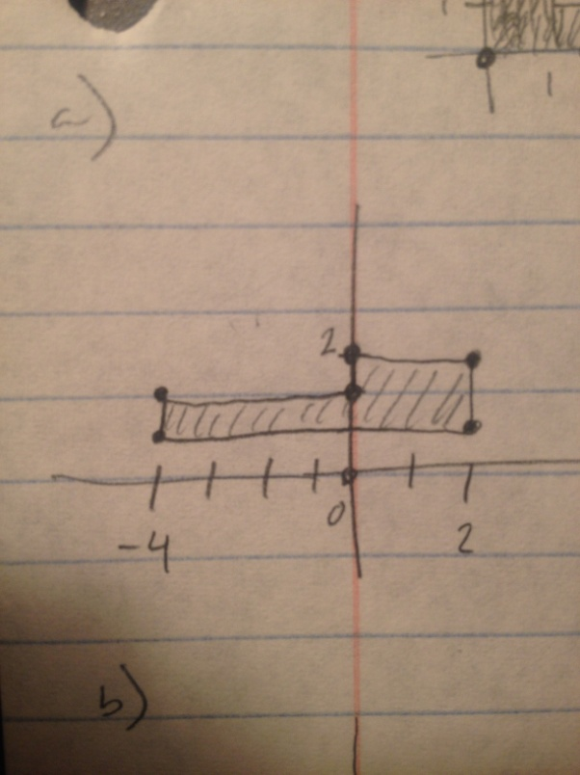

b) L' = CADL

modelMatrix = matrixStack.pop();

matrixStack.push(modelMatrix); //saves for part c

modelMatrix *= RotateZ(90);

modelMatrix *= Scale(2,1,1);

modelMatrix *= Scale(-1,1,1);

drawL();

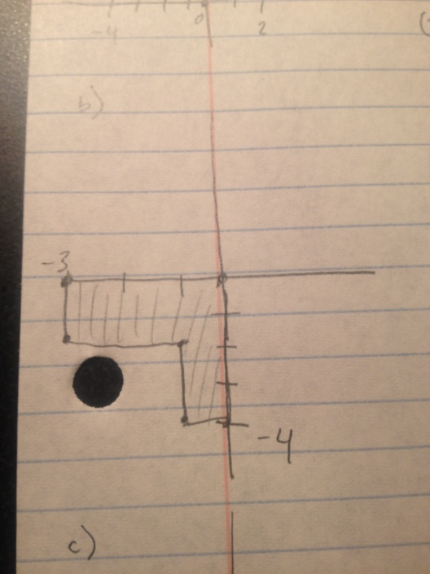

c) L' = CBDL

modelMatrix = matrixStack.pop();

matrixStack.push(modelMatrix); //saves for part d

modelMatrix *= RotateZ(90);

modelMatrix *= Translate(1,1,0);

modelMatrix *= Scale(-1,1,1);

drawL();

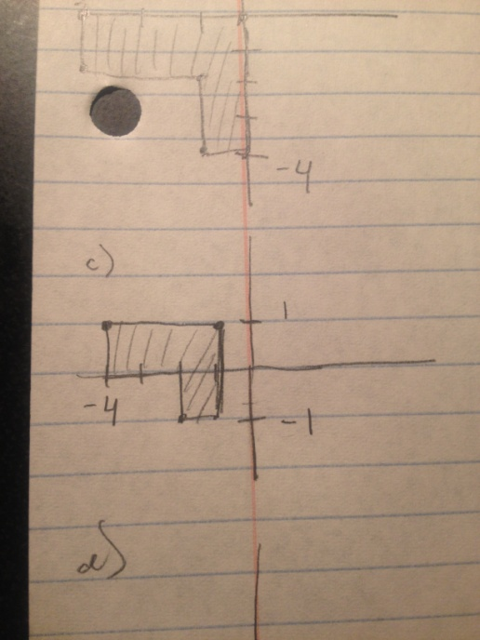

d) L' = DCCADL

modelMatrix = matrixStack.pop();

modelMatrix *= Scale(-1,1,1);

modelMatrix *= RotateZ(90);

modelMatrix *= RotateZ(90);

modelMatrix *= Scale(2,1,1);

modelMatrix *= Scale(-1,1,1);

drawL();

