User Requirement Specifications

REVISION HISTORY

Version | Changes
0.1 | -Initial version
0.2 | -Updates according to feedback  -GUI added

Contents
1. Agreements with the company 3
2. User Requirements 4
2.1 Functional requirements 4
2.1.1 C# application – Staff Members 4
2.1.2 Website – Customers 4
Non-Functional requirements 5
3. Use Cases C# Application 5
UC-01: Logging in the application. 5
UC-02: See the menu. 5
UC-03: User is able to register for an account on the website. 6
UC-04: Logging into the website 6
UC-05: Checking the profile on the website 6
4. GUI for Desktop Application 7
Login screen 7
Main Menu 8
4. GUI for Website 9
Login page 9
Personal information 9

- Agreements with the company

The first six weeks of working on this project, we have agreed to create a C# application, that will allow the admin to manage their employees and managers being able to view and change information on the equipment. Aside from that a website where customers can login/register and reserve equipment should be created and both the windows forms application and the website should be connected to a database.

User Requirements

Functional requirements

The application’s functional requirements can be seen below, prioritized following the MoSCoW model. This is a technique, which is used to reach common understanding with stakeholders on the importance placed on each of the functionalities regarding a product. The term MoSCoW itself is an acronym derived from the first letter of each of four prioritization categories: M - Must have S - Should have C - Could have W - Won't have.

C# application – Staff Members

FR ID | FR | Priority (MSCW)
FR-01 | The system must allow staff members to log in securely using their credentials. | M
FR-02 | The system must provide access to the application features upon successful login. | M
FR-03 | The system should notify the staff member upon successful login. | S
FR-04 | The system must restrict access to unauthorized users. | M
FR-05 | The system must allow admins to create new staff member accounts. | M
FR-06 | The system must allow admins to read/view a list of all staff members. | M
FR-07 | The system must allow admins to update staff member details. | M
FR-08 | The system must allow admins to delete staff member accounts. | M
FR-09 | The system must allow admins to create new equipment. | M
FR-10 | The system must allow admins to read/view a list of all equipment. | M
FR-11 | The system must allow admins to update equipment details. | M
FR-12 | The system must allow admins to delete equipment entries. | M

2.1.2 Website – Customers
FR–03 | The system must allow users to register for a new account. | M
 | The system must allow registered users to log in securely. | M
 | The system must display user account details after login. | M
 | The system should allow users to update their profile information. | S
 | The system must notify users of successful updates to their account. | M
 | The system should allow users to recover their password if forgotten. | M

Non-Functional requirements

NFR-01: The Program can be extended in the future. The code is maintainable and readable, which allows future developers to easily understand how the application works and allows them to add new features without having to communicate with the previous developers.
NFR-02: The program is reliable, which means the state of the application is going to be stable and will not have frequent crashes. This can be achieved by writing a high-quality code, which can avoid many of the errors a program can usually encounter while running. Proper error-handling will be implemented as well as different object-oriented concepts.

3. Use Cases C# Application

UC-01: Staff Member Login
- FR: 01, 02, 03, 04
- Actor: Staff member
- Pre-condition: Staff member has valid login credentials.
- Main Success Scenario:
  - Staff member provides valid credentials and attempts to log in.
  - The system verifies the credentials.
  - The system grants access to the staff member.
  - The system notifies the staff member of a successful login.
- Extensions:
  - 2a. If the credentials are incorrect, the system denies access and displays an error message.
  - 2b. If the user is unauthorized, the system restricts access and logs the attempt.

UC-02: Admin Creates a New Staff Member
- FR: 05
- Actor: Admin user
- Pre-condition: Admin must be logged in with the appropriate permissions.
- Main Success Scenario:
  - Admin selects the option to create a new staff member account.
  - Admin enters the required staff member details (e.g., name, role, credentials).
  - The system validates the information and creates the new staff member account.
  - The system confirms the successful creation of the account.
- Extensions:
  - 3a. If the entered details are invalid the system displays an error message.

UC-03: Admin Views a List of All Staff Members
- FR: 06
- Actor: Admin user
- Pre-condition: Admin must be logged in with appropriate permissions.
- Main Success Scenario:
  - Admin selects the option to view the list of all staff members.
  - The system retrieves and displays the list of staff members with relevant details (e.g., name, role, status).
- Extensions:
  - 2a. If there are no staff members in the system, the system displays an empty list message.

UC-04: Admin Updates Staff Member Details
- FR: 07
- Actor: Admin user
- Pre-condition: Admin must be logged in with appropriate permissions.
- Main Success Scenario:
  - Admin selects a staff member from the list to update their details.
  - Admin updates the desired fields (e.g., role, contact information).
  - The system validates and saves the updated information.
  - The system confirms the update was successful.
- Extensions:
  - 3a. If the update fails (e.g., due to validation errors), the system displays an error message.

UC-05: Admin Deletes a Staff Member Account
- FR: 08
- Actor: Admin user
- Pre-condition: Admin must be logged in with appropriate permissions.
- Main Success Scenario:
  - Admin selects a staff member account to delete.
  - The system prompts for confirmation before proceeding with the deletion.
  - Admin confirms the deletion.
  - The system deletes the staff member account and confirms the action.
- Extensions:
  - 2a. If the staff member is linked to active tasks, the system prevents deletion and displays a warning message.

UC-06: Admin Creates New Equipment Entry
- FR: 09
- Actor: Admin user
- Pre-condition: Admin must be logged in with appropriate permissions.
- Main Success Scenario:
  - Admin selects the option to create a new equipment entry.
  - Admin enters the equipment details (e.g., name, type, status).
  - The system validates and saves the new equipment entry.
  - The system confirms the successful creation of the equipment entry.
- Extensions:
  - 3a. If the entered details are incomplete, the system prompts the admin to fill in the missing information.

UC-07: Admin Views a List of All Equipment
- FR: 10
- Actor: Admin user
- Pre-condition: Admin must be logged in with appropriate permissions.
- Main Success Scenario:
  - Admin selects the option to view all equipment.
  - The system retrieves and displays a list of all equipment, including relevant details (e.g., name, status, availability).
- Extensions:
  - 2a. If no equipment entries exist, the system displays an empty list message.

4. GUI for Desktop Application

Login screen
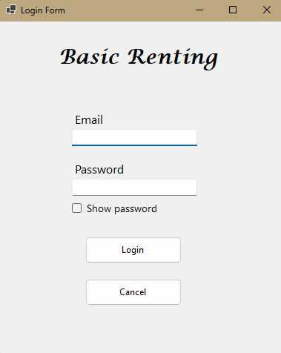
After opening the application, the user will see the Login screen. Here they can enter their credentials to access the rest of the system.

Main Menu
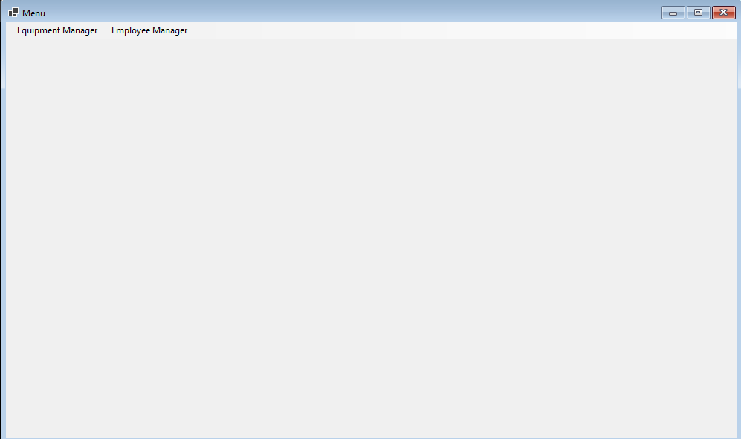
While it does not have any specific functionality of its own, this page allows the user to choose which kind of task they want to do. Each of the buttons leads to a different part of the application.

4. GUI for Website

Login page
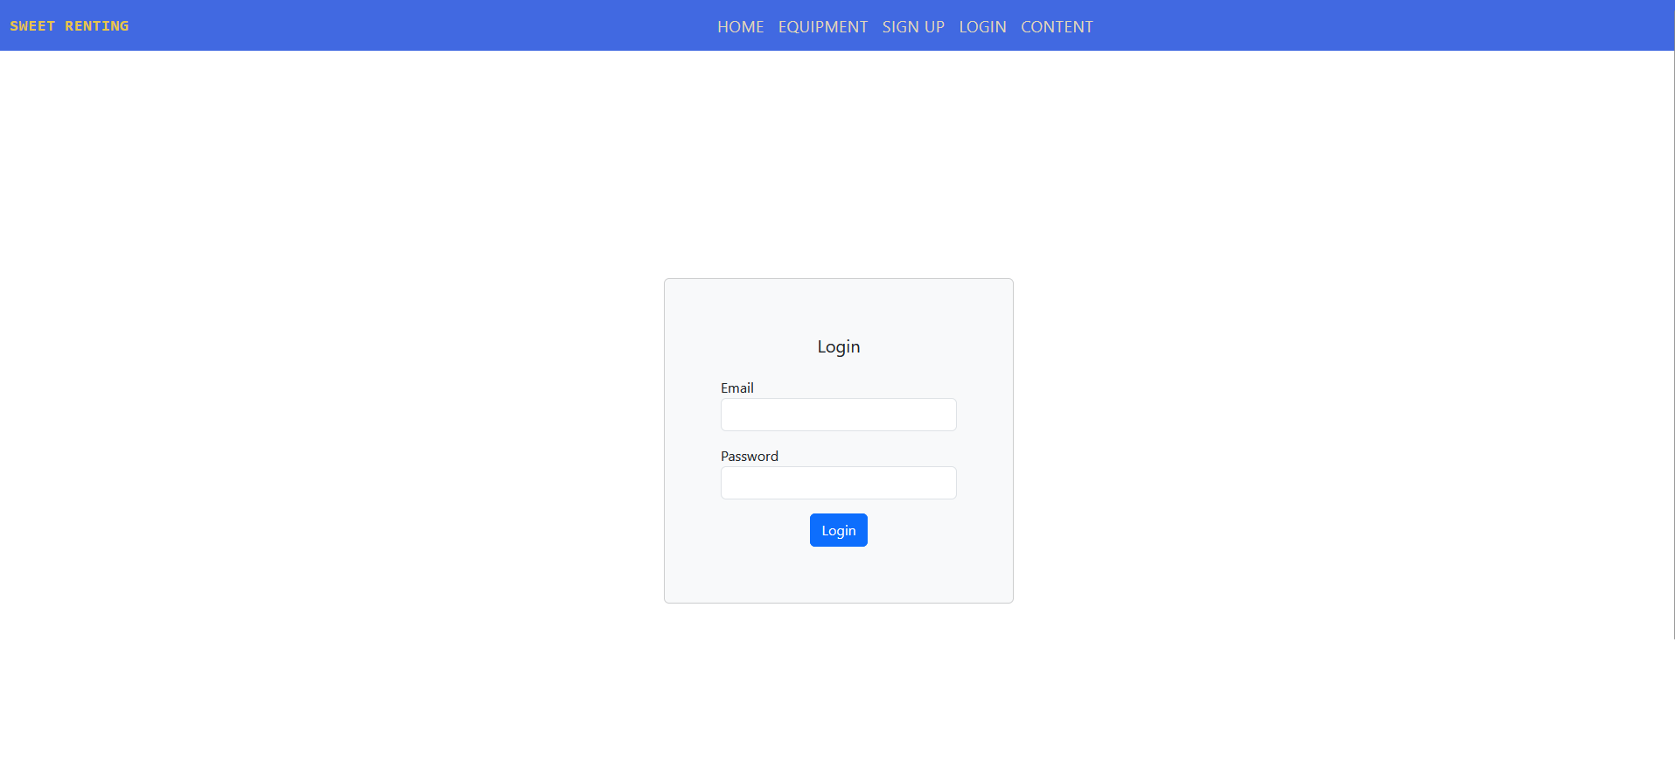
Here the user can fill in their credentials.

Personal information
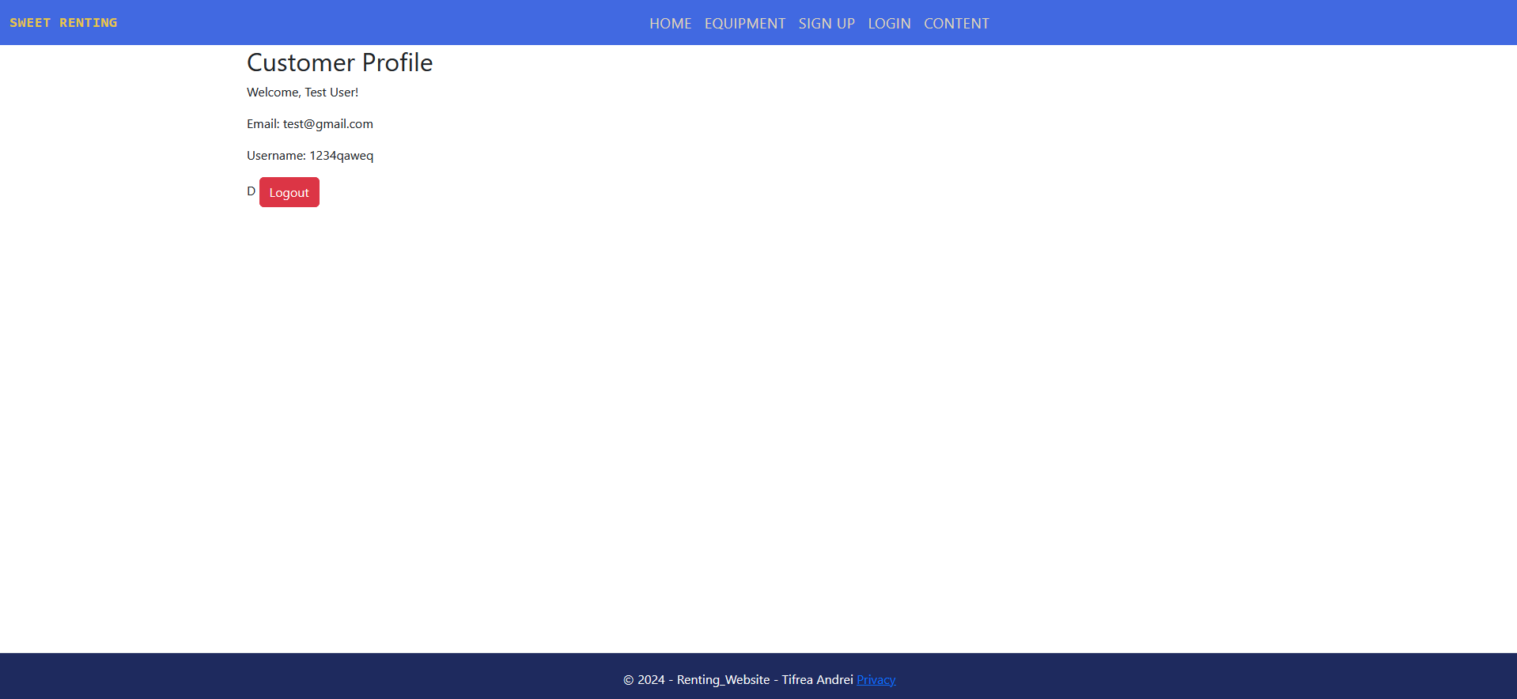
An overview of the details of the employee who is currently logged in.

