Tiffany Wang

260684152

ECSE 543 – Assignment 2

TABLE OF CONTENTS

Question 1 2

Question 2 4

Question 3 7

Appendix 13

Matrix function: 13

First Order Class 15

Conjugate Gradient approximation method 17

# Question 1

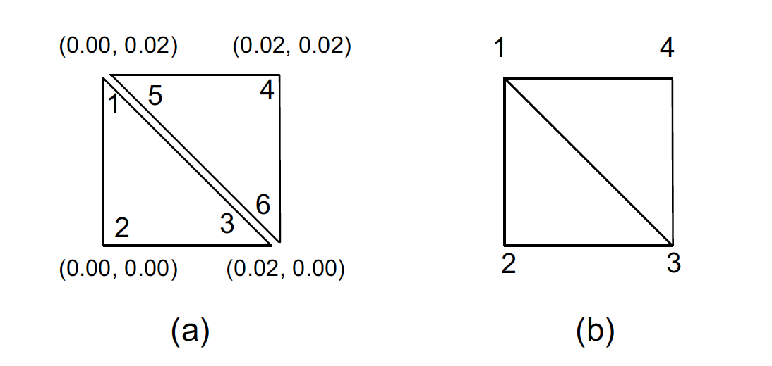

*Figure 1. (a) disjoint node numbering (b) global node numbering*

* $α$ calculations:
$$α_{1}= \frac{1}{2A}\left[\left(x_{2}y_{3 }- x_{3}y_{2 }\right)+\left(y_{2}{ - y}_{3}\right)x+(x_{3}-x_{2})y\right]$$

$${∇α}_{1}= \frac{1}{2A}\left[\left(y_{2}{ - y}_{3}\right)\hat{x}+(x_{3}-x_{2})\hat{y}\right]$$

$$α_{2}= \frac{1}{2A}\left[\left(x_{3}y_{1 }- x_{1}y_{3 }\right)+\left(y_{3}{ - y}_{1}\right)x+(x_{1}-x_{3})y\right]$$

$${∇α}_{2}= \frac{1}{2A}\left[\left(y_{3}{ - y}_{1}\right)\hat{x}+(x_{1}-x_{3})\hat{y}\right]$$

$$α_{3}= \frac{1}{2A}\left[\left(x_{1}y_{2 }- x_{2}y_{1 }\right)+\left(y_{1}{ - y}_{2}\right)x+(x_{2}-x_{1})y\right]$$

$${∇α}_{3}= \frac{1}{2A}\left[\left(y_{1}{ - y}_{2}\right)\hat{x}+(x_{2}-x_{1})\hat{y}\right]$$

* S calculation:

$$S_{ij}= {∇α}_{i} ∙ {∇α}_{j} ∙A$$

$$e.g. :S_{12}= \frac{1}{4A}\left[\left(y_{2}{ - y}_{3}\right)\left(y_{3}{ - y}_{1}\right)+(x_{3}-x_{2})(x_{1}-x_{3})\right]$$

$$e.g. :S_{11}= \frac{1}{4A}\left[{\left(y_{2}{ - y}_{3}\right)}^{2}+{(x_{3}-x_{2})}^{2}\right]$$

$\begin{matrix}i & x_{i} & y_{i} \\ 1 & 0.00 & 0.02 \\ 2 & 0.00 & 0.00 \\ 3 & 0.02 & 0.00\end{matrix}$ $A=\frac{0.02 ∙0.02}{2}=0.0002$

$$S_{123}=\left[\begin{matrix}0.5 & -0.5 & 0 \\ -0.5 & 1 & -0.5 \\ 0 & -0.5 & 0.5\end{matrix}\right]$$

$\begin{matrix}i & x_{i} & y_{i} \\ 4 & 0.02 & 0.02 \\ 5 & 0.00 & 0.02 \\ 6 & 0.02 & 0.00\end{matrix}$ $A=\frac{0.02 ∙0.02}{2}=0.0002$

$$S_{456}=\left[\begin{matrix}1 & -0.5 & -0.5 \\ -0.5 & 0.5 & 0 \\ -0.5 & 0 & 0.5\end{matrix}\right]$$

$$S_{dis}=\left[\begin{matrix}0.5 & -0.5 & 0 & 0 & 0 & 0 \\ -0.5 & 1 & -0.5 & 0 & 0 & 0 \\ 0 & -0.5 & 0.5 & 0 & 0 & 0 \\ 0 & 0 & 0 & 1 & -0.5 & -0.5 \\ 0 & 0 & 0 & -0.5 & 0.5 & 0 \\ 0 & 0 & 0 & -0.5 & 0 & 0.5\end{matrix}\right]$$

# Question 2

I used the following node numbering to solve the problem

*y*

*x*

|  |  |  |  |  |  |
| --- | --- | --- | --- | --- | --- |
| 6 | 12 | 18 | 24 |  | 15 V |
| 5 | 11 | 17 | 23 | 29 | 34 |
| 4 | 10 | 16 | 22 | 28 | 33 |
| 3 | 9 | 15 | 21 | 27 | 32 |
| 2 | 8 | 14 | 20 | 26 | 31 |
| 1 | 7 | 13 | 19 | 25 | 30 |

There is a total of 34 nodes and 46 elements (triangles).

Nodes 1, 2, 3, 4, 5, 6, 7, 13, 19, 25, 30 are fixed at 0V

Nodes 23, 24, 29, 34 are fixed at 15V

The columns on the following page are the inputs into the Matlab SIMPLE2D program.

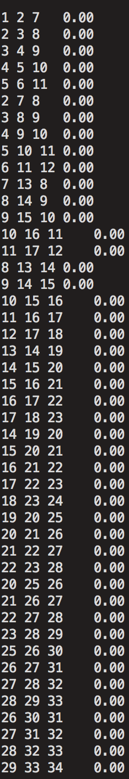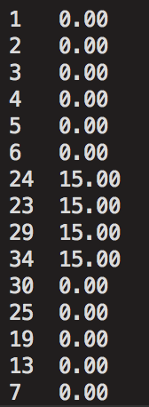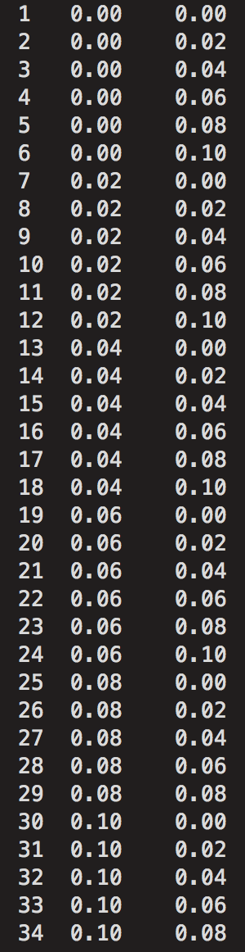

*Figure 4. Fixed node potentials*

*Figure 2. Node numbering and coordinates*

*Figure 3. Triangle definition*

b) Potential at each of the 34 nodes, computed by Matlab SIMPLE_2D

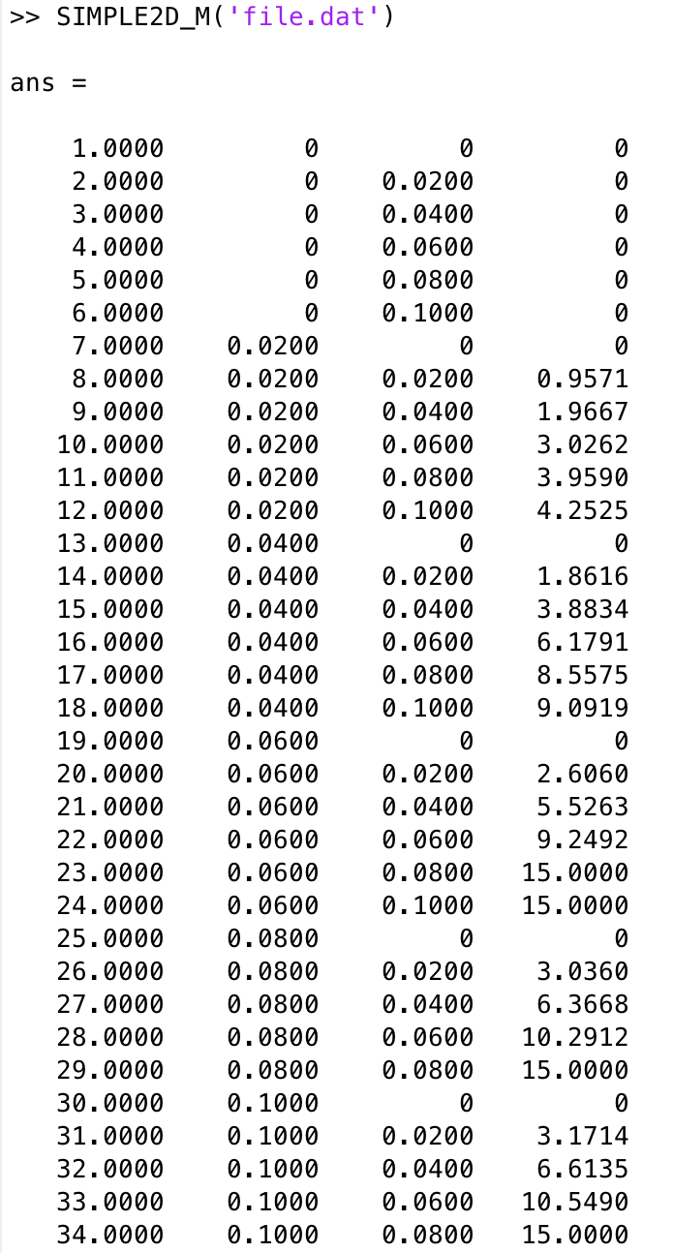

*Figure 5. Potential approximation obtained with Matlab SIMPLE_2D*

The potential at (0.06, 0.04) is 5.53V, which is at node 21.

c) Since we have the nodes potential approximated in b, I will use the following formula to compute the energy inside the quarter of the coaxial cable:

I wrote a function which parse the file.dat file into the triangle coordinates, local and global S matrices. The code for the function can be found in the appendix.

Since since the coaxial cable is symmetrical, the total energy of the whole cross-section of the cable would be four times that of the quarter cable we studied in this problem.

Finally, the capacitance per meter of the cable is found using:

The capacitance per meter of the coaxial cable is found to be: ../../../../../../Desktop/Screen%20Shot%202017-11-18%20at%201.26.01

# Question 3

The potential of the quarter coaxial cable will be approximated using the Conjugate Gradient method.

*A:=* five points difference matrix

*x:=* approximated potential at the nodes

blue:

|  |  |  |  |  |  |
| --- | --- | --- | --- | --- | --- |
| 0V | 4 | 9 | 15 V | | |
| 3 | 8 |
| 2 | 7 | 12 | 15 | 18 |
| 1 | 6 | 11 | 14 | 17 |
| 0 | 5 | 10 | 13 | 16 |
|  | | | | |

The *b* value is equal to -1 x fixed potential directly neighboring the corresponding node. In this case, every value in *b* is *0*, except for index 8, 9, 12, 15 where *b[index] = -15*

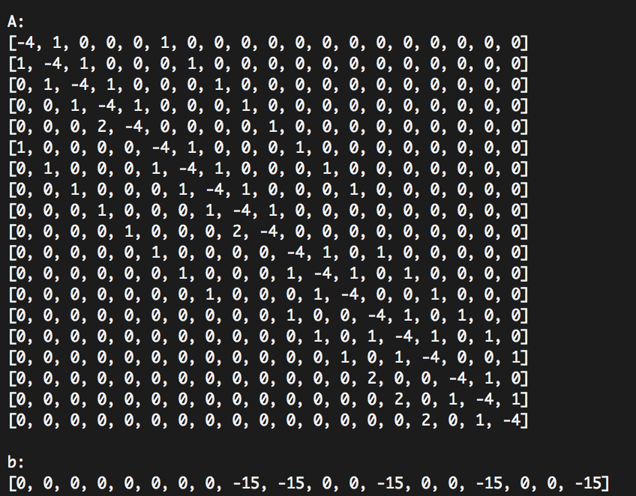

*Figure 6. A and b generated for the conjugate gradient*

1. A is not a symmetric matrix: A[4][3] ≠ A[3][4]

In order to obtain a singular symmetric positive definite matrix, we will multiple both side of the equation by *AT*

We know that where *B* is a symmetric matrix.

The resulting equation to be solved is:

:

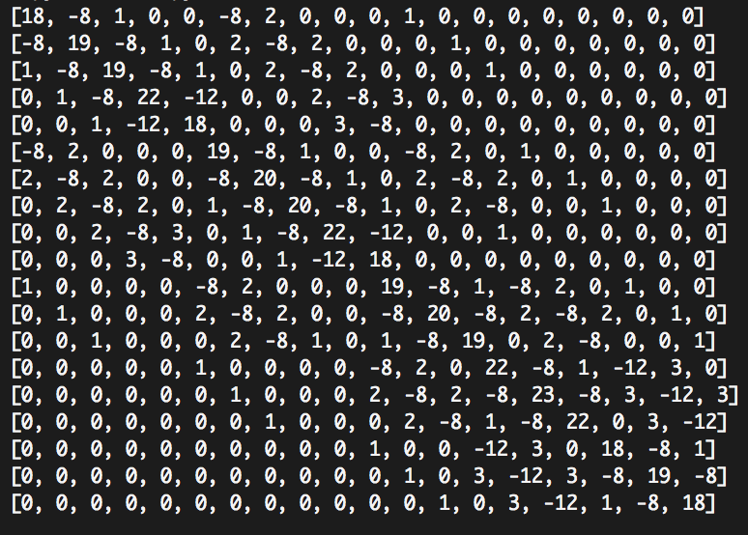

*ATA* is a singular symmetric positive definite matrix.

= ../../../../../../../Desktop/Screen%20Shot%202017-11-19%20at%207.37

1. The results obtained from Choleski and Conjugate Gradient methods are really identical to two decimal places precision.

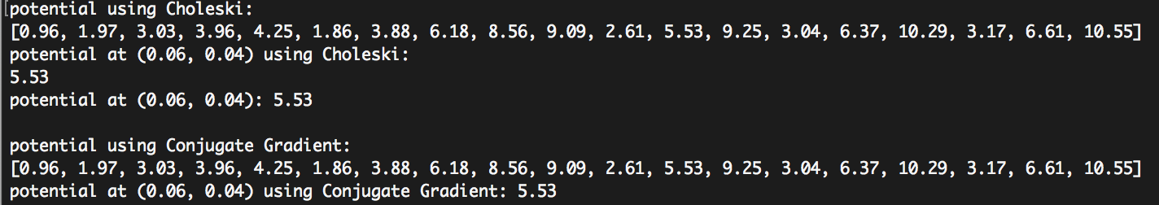

*Figure 8. Potential approximation obtained using Choleski and Conjugate Gradient with residuals*

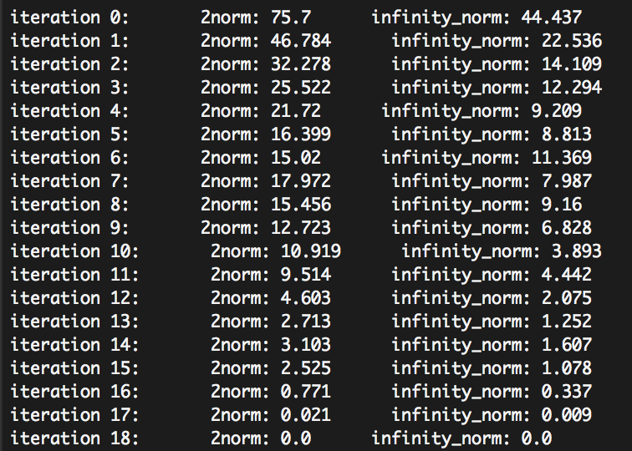

In order to obtain more accurate results, I programmed the method to compute new approximations until the residue is smaller than a threshold of 0.005. However, from the results, we can observe convergence of the approximation with *O(n)* complexity – 19 iterations for 19 nodes. This is consistent with the theoretical expectation of *O(n)* complexity.

The residue vectors norms are calculated using:

We observe a general decreasing trend of the residue norms. The residue (error) eventually reaches 0 as the iteration count reaches N (19) as expected. The best fitting trend line would be that of an inverse function.

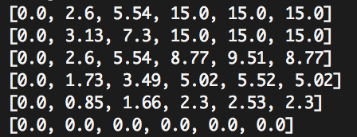

*Figure 9. Potential approximation results using SOR (from Assignment 1)*

The results were really different compared to the results obtained with both Choleski and Conjugate Gradient.

The results from Choleski, SIMPLE2D and Conjugate Gradient are identical up to a 2-decimal place rounding for all nodes in the quarter coaxial cable. The results are however higher than those obtained from SOR. For instance, the SOR potential at (0.06, 0.04) is 10% lower than the 5.53V.

|  |  |  |  |  |
| --- | --- | --- | --- | --- |
| Potential approximation | Choleski | Conjugate Gradient | SIMPLE2D | SOR |
| (0.02, 0.02) | 0.96 | 0.96 | 0.96 | 0.85 |
| (0.02, 0.04) | 1.97 | 1.97 | 1.97 | 1.73 |
| (0.02, 0.06) | 3.03 | 3.03 | 3.03 | 2.60 |
| (0.02, 0.08) | 3.96 | 3.96 | 3.96 | 3.13 |
| (0.02, 0.10) | 4.25 | 4.25 | 4.25 | 2.60 |
| (0.04, 0.02) | 1.86 | 1.86 | 1.86 | 1.66 |
| (0.04, 0.04) | 3.88 | 3.88 | 3.88 | 3.49 |
| (0.04, 0.06) | 6.18 | 6.18 | 6.18 | 5.54 |
| (0.04, 0.08) | 8.56 | 8.56 | 8.56 | 7.30 |
| (0.04, 0.10) | 9.09 | 9.09 | 9.09 | 5.54 |
| (0.06, 0.02) | 2.61 | 2.61 | 2.61 | 2.30 |
| (0.06, 0.04) | 5.53 | 5.53 | 5.53 | 5.02 |
| (0.06, 0.06) | 9.25 | 9.25 | 9.25 | 8.77 |
| (0.06, 0.08) | 15.0 | 15.0 | 15.0 | 15.0 |
| (0.06, 0.10) | 15.0 | 15.0 | 15.0 | 15.0 |
| (0.08, 0.02) | 3.04 | 3.04 | 3.04 | 2.53 |
| (0.08, 0.04) | 6.37 | 6.37 | 6.37 | 5.52 |
| (0.08, 0.06) | 10.29 | 10.29 | 10.29 | 9.51 |
| (0.08, 0.08) | 15.0 | 15.0 | 15.0 | 15.0 |
| (0.08, 0.10) | 15.0 | 15.0 | 15.0 | 15.0 |
| (0.10, 0.02) | 3.17 | 3.17 | 3.17 | 2.30 |
| (0.10, 0.04) | 6.61 | 6.61 | 6.61 | 5.02 |
| (0.10, 0.06) | 10.55 | 10.55 | 10.55 | 8.77 |
| (0.10, 0.08) | 15.0 | 15.0 | 15.0 | 15.0 |
| (0.10, 0.10) | 15.0 | 15.0 | 15.0 | 15.0 |

*Table 1. Potential approximation using Choleski, Conjugate Gradient, SIMPLE2D and SOR*

1. The capacitance per meter of the coaxial cable would be computed using

The total energy stored can be calculated using =

Since we are only interested in the capacitance per unit length, we will use

Knowing that

With the same idea as in Question 2 c., the total energy of the coaxial cable is four times that of the quarter cross section.

# Appendix

Please refer to matrix functions written for Assignment 1 in its appendix.

## Matrix function:

* Vector addition

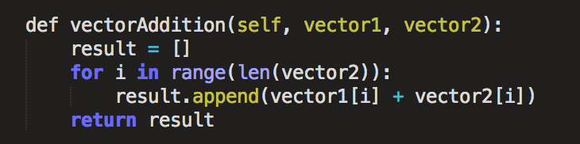

* Vector subtraction (Vector1 – Vector2)

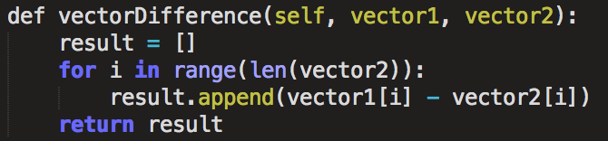

* Vector Dot Product (A · B)

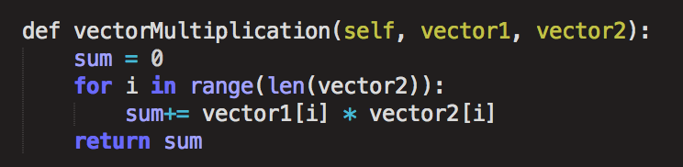

* 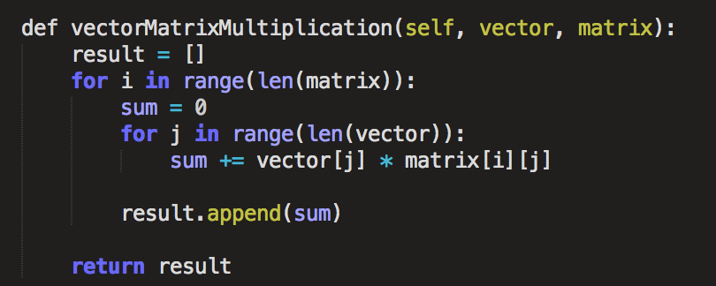Vector · Matrix
* Scale Matrix (a · Matrix)

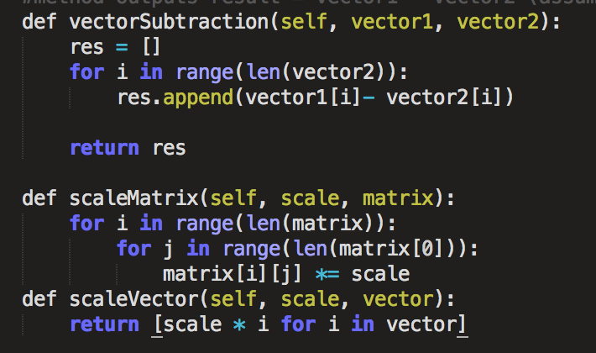

* Transpose Matrix (result = *AT*)

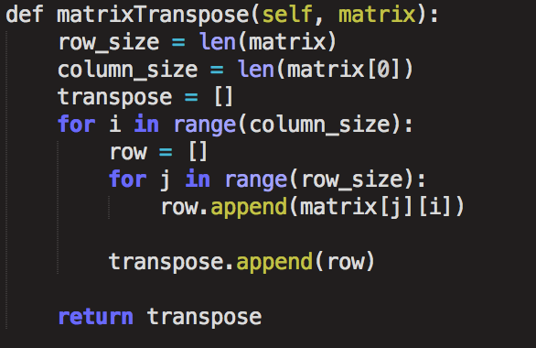

## First Order Class

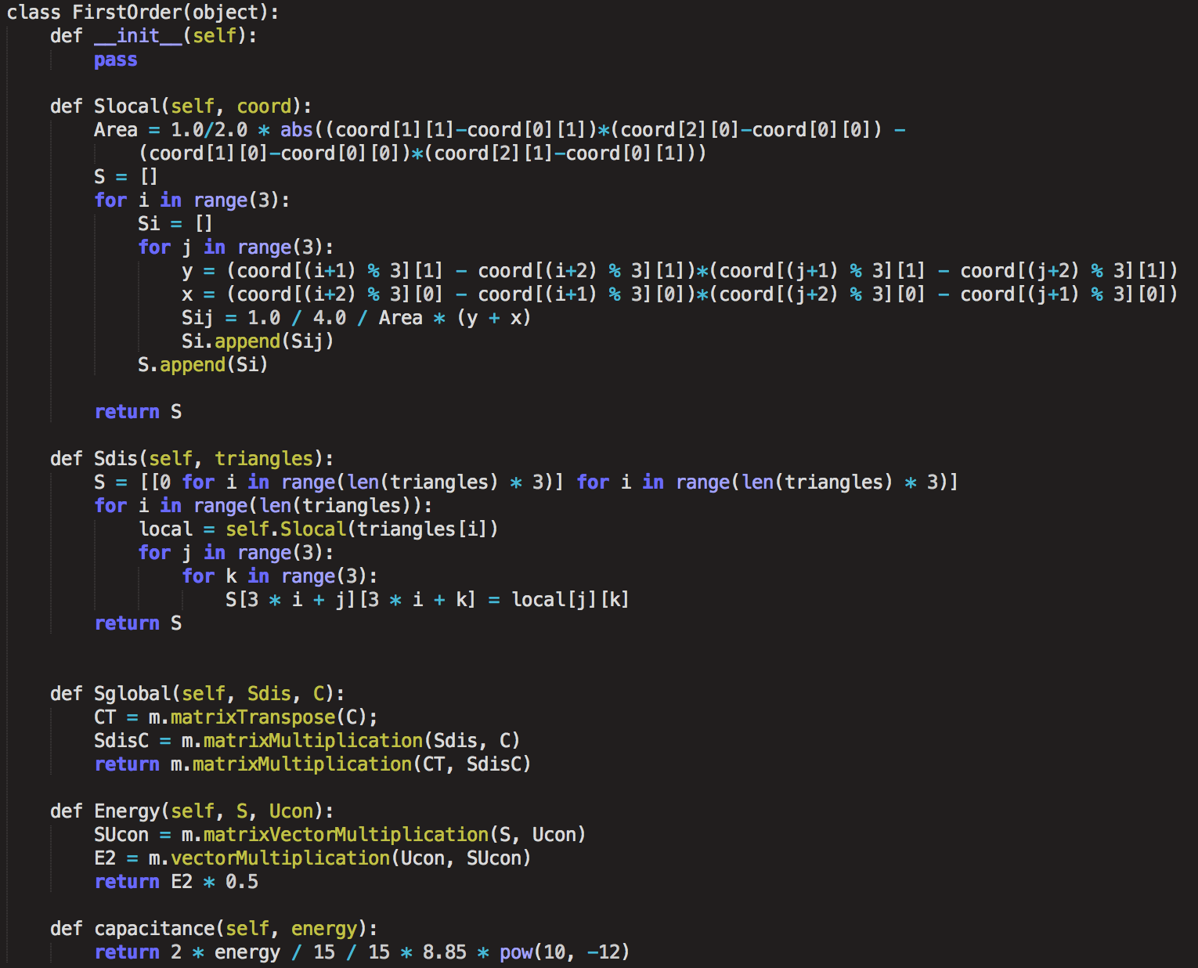Includes: Local S matrix generator, Disjoint S matrix generator, conjoint S matrix generator, Energy calculator, Capacitance calculator

* Five points difference matrix generator

(for the specific quarter coaxial cable)

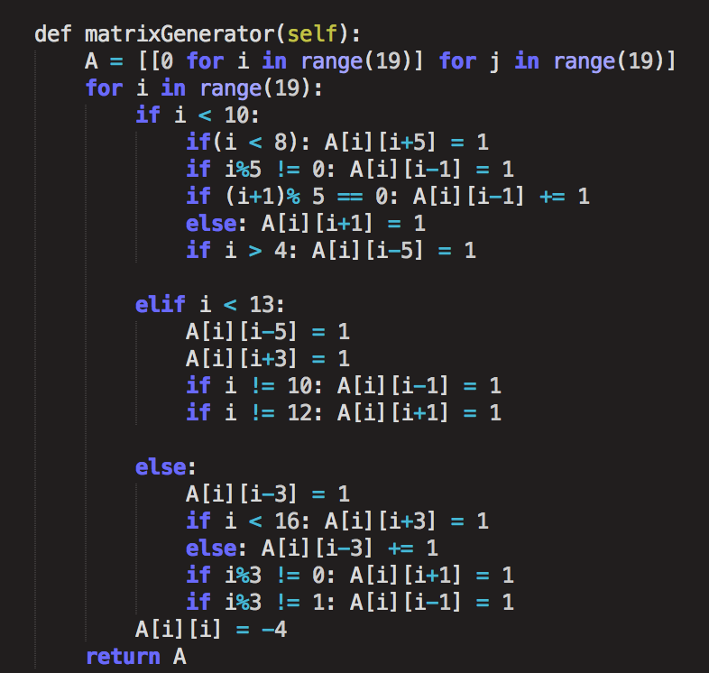

* resulting b vector generator

(for the specific quarter coaxial cable)

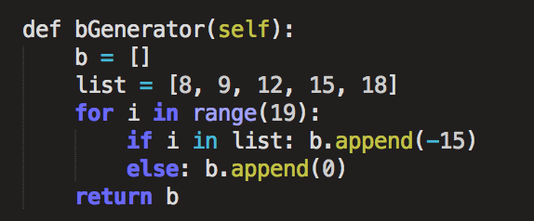

## Conjugate Gradient approximation method

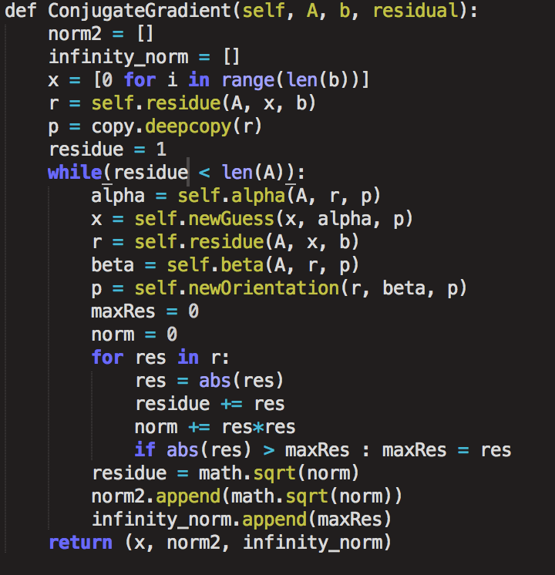

* first arrangement coefficient (alpha)

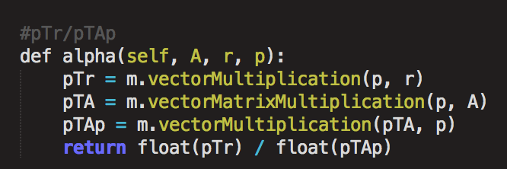

* Residue vector r calculator

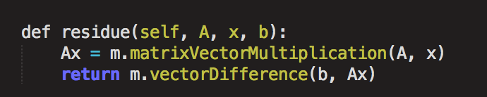

* Next approximation (new guess) calculator

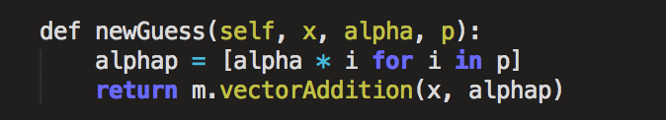

* New rearrangement coefficient calculator

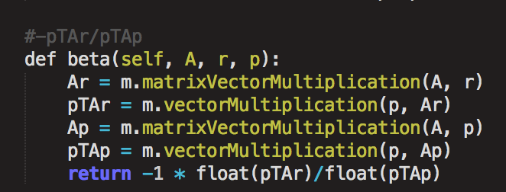

* new orientation vector generator

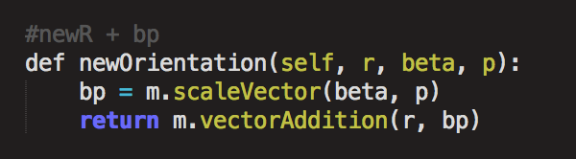

* File reader to parse element (coordinates, triangle, fixed potentials) into lists

