Tiffany Allen

Josh Chang

Mounish Savier

HW 5 Findings Report

Performance Testing: Baseline Numbers through webpagetest.org

Home page:



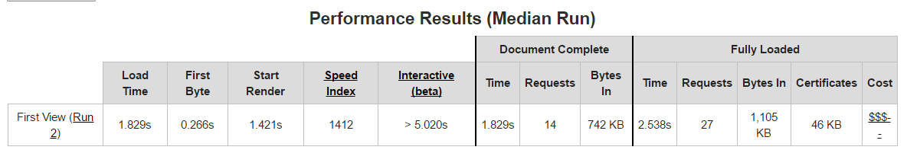

Character Page:

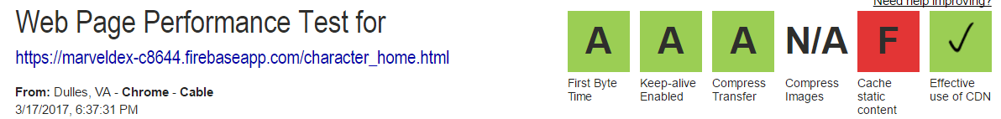

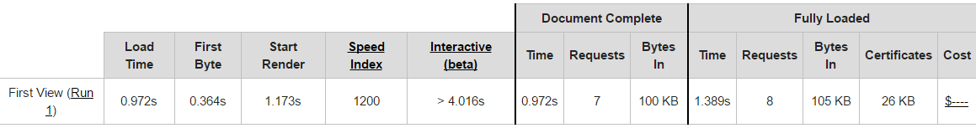

Movie Page:



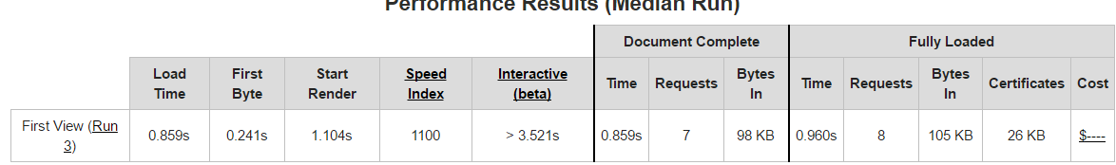

Profile Page:



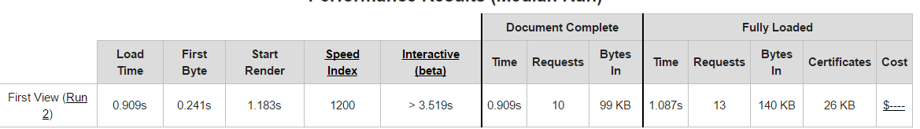

Github link: <https://github.com/tiffallen/CSE134B>

Live link (from the log in page): <https://marveldex-c8644.firebaseapp.com/login.html>?

Provided Link: <https://marveldex-c8644.firebaseapp.com/>

* This link provides a variety of links to different aspects of the course including our open hosting documentation, the team page, web application, bootstrap implementation of our web app, testing pages, and our example Users CRUD page. To access our completed application, please click on the web app button or click on the live link provided above.

Application Introduction

We wanted to create an application that gives avid Marvel fans the ability to create discussion thread posts about their favorite characters, as well see all the characters and movies in the marvel universe. Our initial demo application allows the user to see a subset of the Marvel movies, a subset of the Marvel characters, as well as create posts about specific characters and movies.

Application Walk Through:

Given the provided link, the user is taken to this base page featured in figure 1. The link to our final web application is circled in red. Once, the user clicks on this link, they are taken to the login page for the application (figure 2). There is a variety of options for the user from here. If they are an already registered user, they are given the opportunity to log in (the first section). If they have a google account, they can sign in with their gmail account. Lastly, they are able to sign up to be a user if they are unregistered. We keep track of all of the users, so if an unregistered user tries to log in, our application will alert the user that they have not registered and they are given the opportunity to sign up for the application (figure 3). Additionally, it will alert other error messages (invalid email address, invalid password, etc)

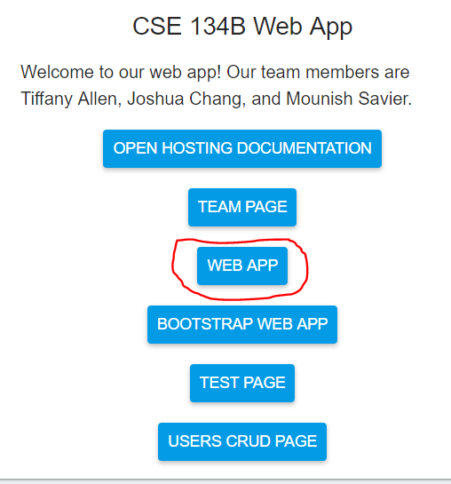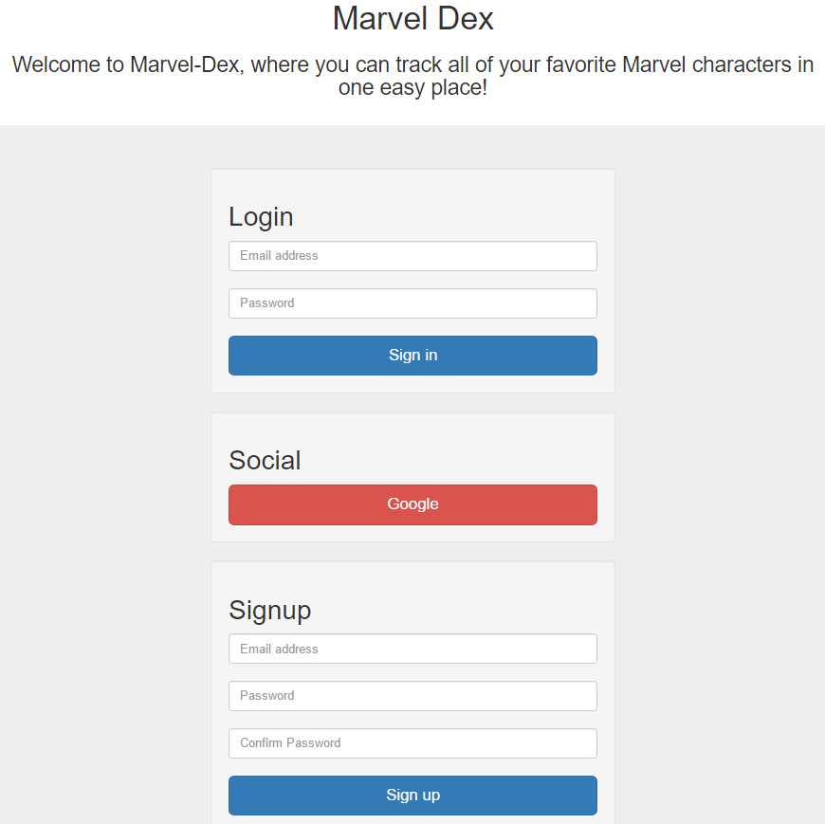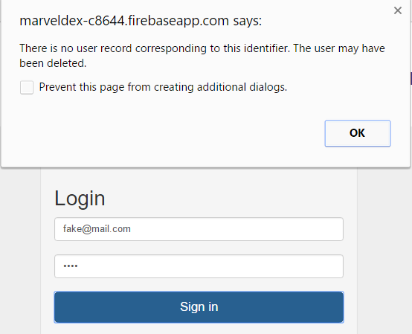

Figure 1: base page. Figure 2: Login page Figure 3: log in error

Once the user is registered and logged in, the user is taken to the marvel home page (Figure 4/5). This is the base page for the application. The “Marvel-Dex” at the top of the page is constant throughout the web application and will link the user back to this home page once the user clicks on it. This home page is the “home base” of our application where the user can view the list of all of the movies in the Marvel-Dex as well as the list of all of the characters in the Marvel-Dex (In this demo application, we included a small subset of all of the characters and all of the movies). There is also a search bar at the top of the screen where the user can search through the Marvel-Dex for specific characters, movies, and discussion threads. In this demo application, we were unable to implement the search bar within the given time frame but we included the search bar to show what we would ideally implement. If the user tries to search right now, they are just navigated back to the home page. There are a variety of navigations from this page, we will go through each one individually.

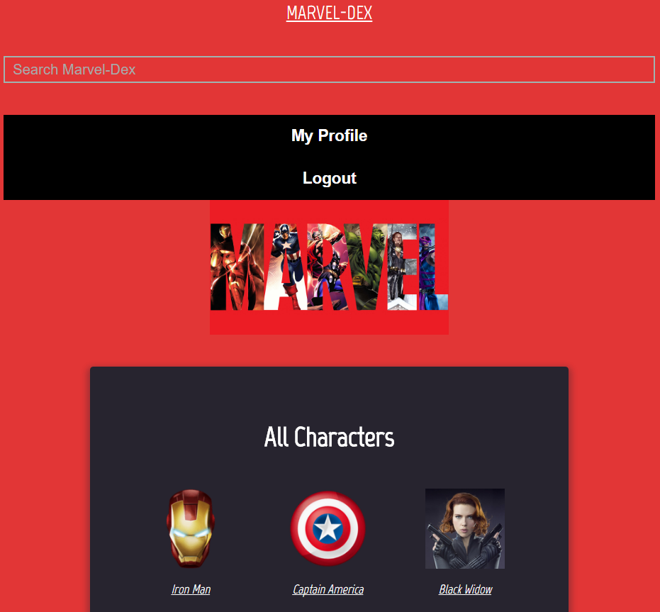 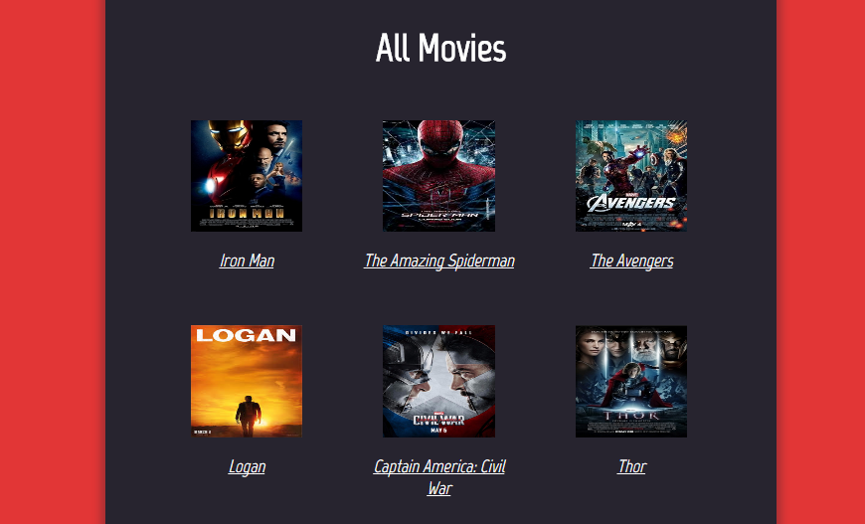

Figure 4: Top of the home page Figure 5: Bottom of the home page

From the Home Page, if you click on the “My Profile” Button, the user is taken to their user profile page (figure 6). From the user’s profile page, there are a variety of options as well. They can navigate back to the home page by clicking the “Marvel-Dex” at the top of the screen, search through the application using the search bar, log out, etc. There is also the option to create a thread. This is where the main functionality of our application is utilized. It is through this button that the user is able to create, edit, and delete their discussion threads. Once they click on “Create Thread” the application navigates to another screen (figure 7/8/9) where they are able to make threads (and also edit and delete previous threads). You can see in figures 7 and 8, that there are multiple fields that you can add to your discussion thread. You can add a post name, character name to associate the post to, add an image (with an image preview option, video URL, text description reflecting your thoughts, a numerical rating, movie tag to associate the post to, and add a privacy setting (public or private). Once the user fills in the desired fields, they submit the post and it has been created. However, if the user has made a mistake, they are also able to edit or delete their threads. This functionality is done on this page as well. As seen in figure 9, all of the user’s generated posts are listed at the bottom. The first icon (it looks like a pen in square and is light grey, enables the user to edit the threads. It would put all of the user’s inputted information in the fields in figures 7/8 and allow the user to edit it. If the user does not like their post and would like to delete it, they can press the grey trash can button next to the post’s title and delete it from there. The delete button permanently deletes their post. This is the full functionality of the Create Thread page.

Now if you click back to the User Profile button at the top of the Create Thread Page, we will continue to explore the User Profile. After the Create Thread Button, there is a list of “My Characters”. This is the list of characters that the user has chosen to follow. We were unable to fully implement the “Follow” function but we have kept the UI buttons to show what we would ideally add to the app given more time. At the bottom of the User Profile Page, there is a section titled “My Posts”, seen in figure 6 where the user’s posts are all displayed so that the user can see them (To edit or delete their posts they must go to the “Create Thread” button at the top”. This is the full functionality of the User Profile Page.

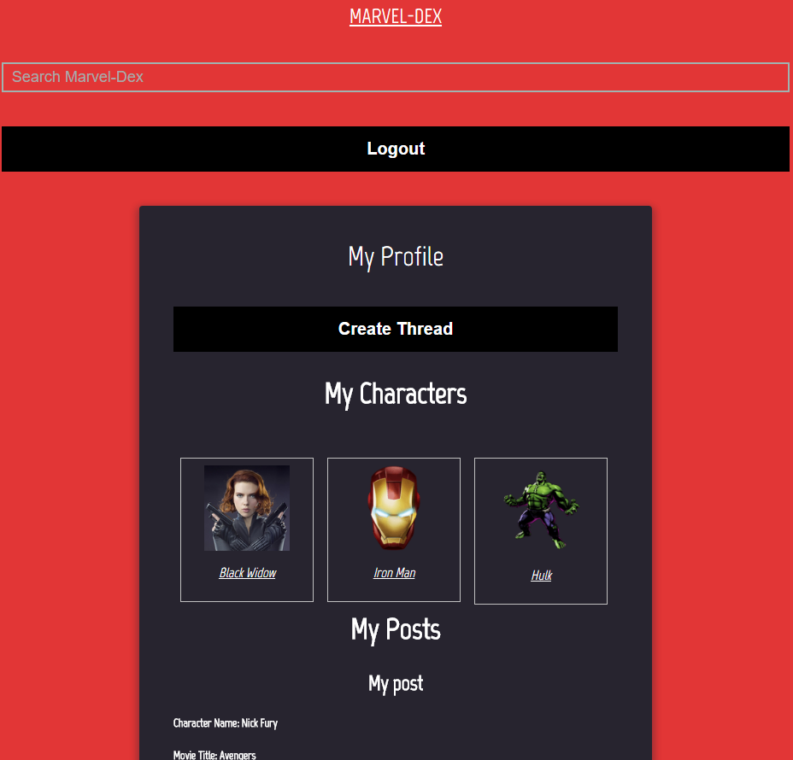 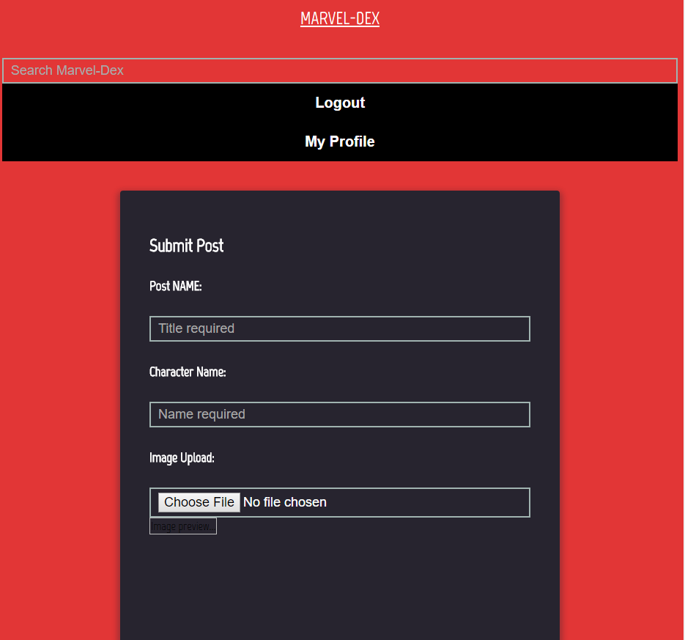

Figure 6: User Profile Page Figure 7: Upload Thread Page

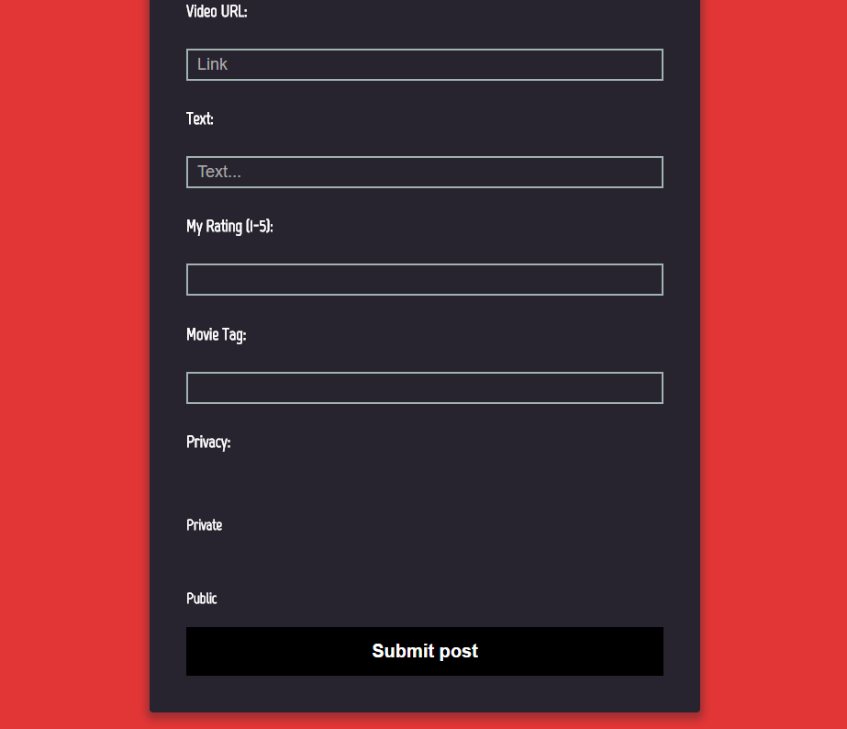 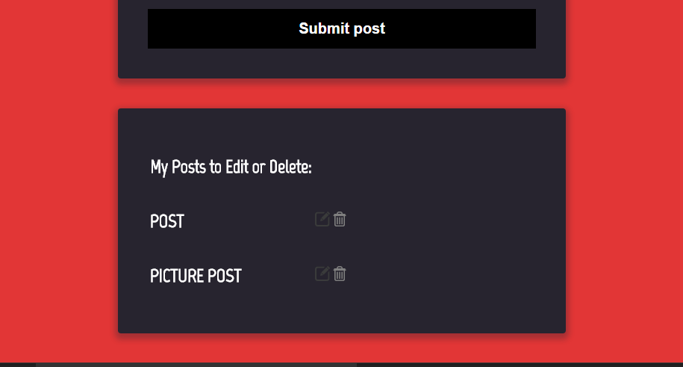

Figure 8: Upload Thread Page Figure 9: Bottom of Upload Thread Page

To continue with the walk through, click on the top of the page “Marvel-Dex” to continue onto the Home Page. As seen in figures 5 and 6, there is a list of characters and movies included in the “Marvel-Dex”. When the user clicks on a character or a movie, they are redirected to a corresponding information page detailing that movie or character (figure 10, 11 and 12). We will explore the character home page first. Once you click on a character, for example, Iron Man, you will be redirected to a screen that is like figure 10 where the user sees the name of the character, an image, a short description of the character, an option to create a thread (which would redirect the user to the create thread page, and an option to follow the character to list them on their user profile page. Additionally, there is a link at the bottom to the discussion threads so that the user can easily access all of the discussion threads. If the user goes back to the home page and clicks on a movie, such as Captain America: Civil War, they are redirected to a site similar to figure 11 and 12. Here, the title of the movie is displayed, as well as the movie poster (figure 11). At the bottom of the page, all of the characters in the movie are listed as well as a short description about each one (figure 12). If the user clicks on any of the characters, they are redirected to that character’s home page described above. Finally, once the user is done with their time on our web application, they can log out. This option is featured across all of the pages as the top button underneath the search bar.

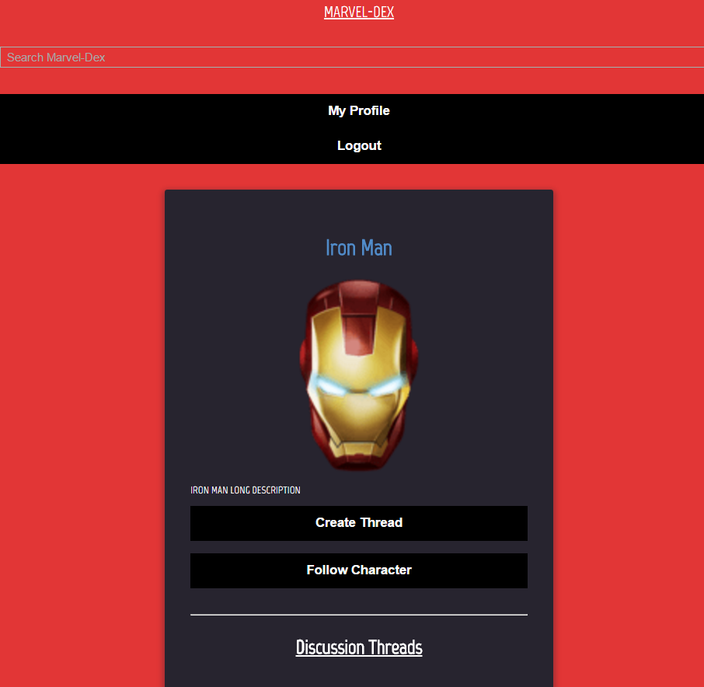 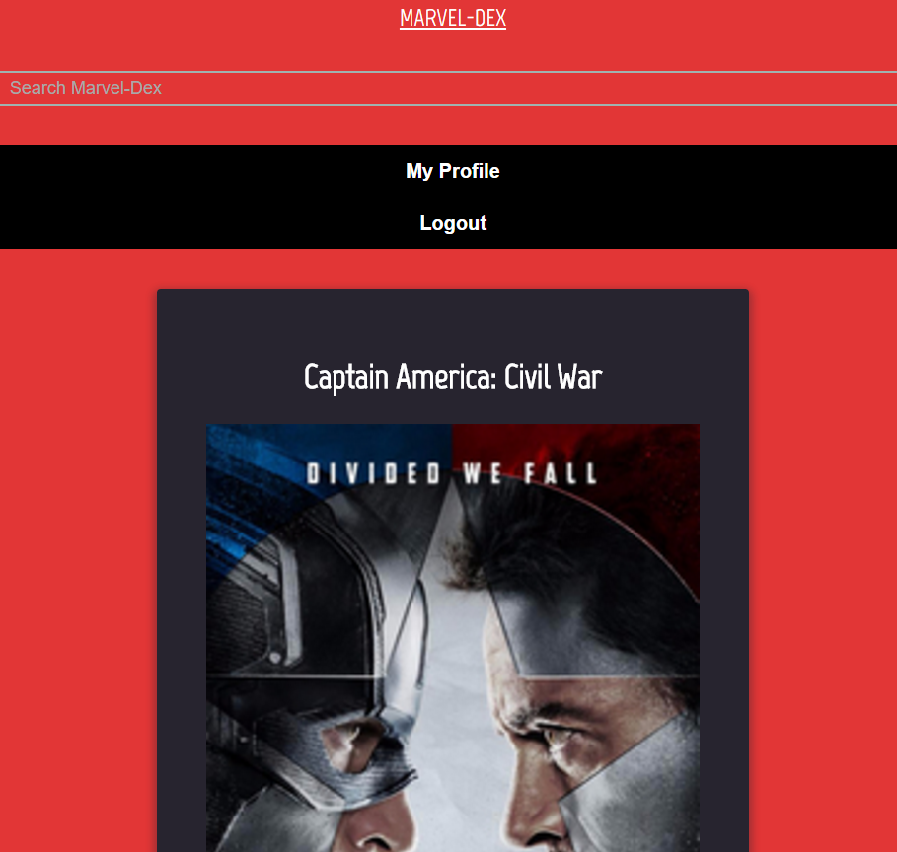

Figure 10: Character Home Page Figure 11: Movie Home Page (Top)

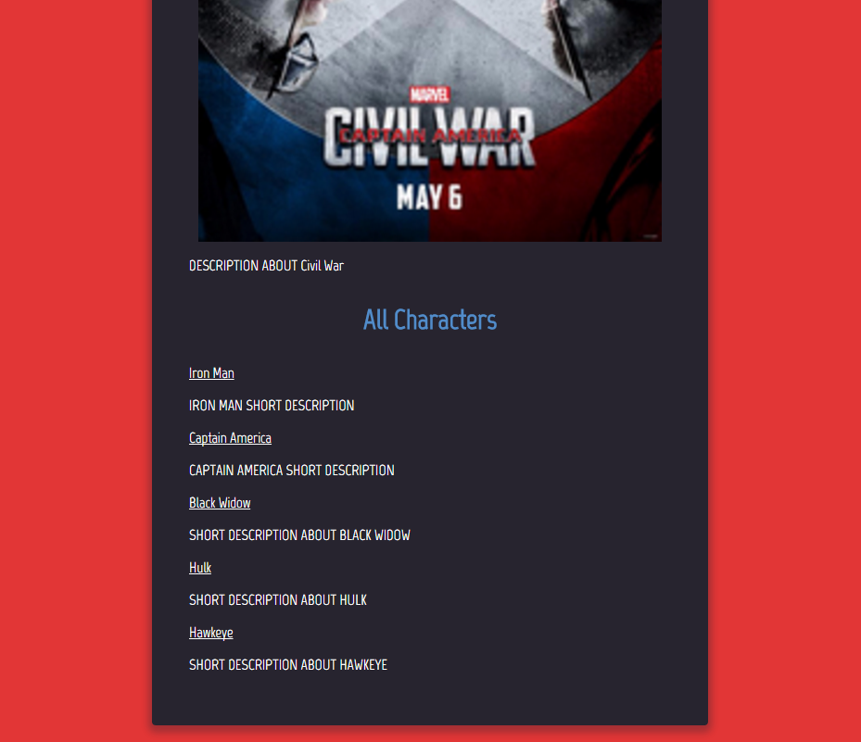

Figure 12: Movie Home Page (Bottom)

Architecture of the code:

As seen in our github repository, all of the necessary files are in the public folder. We have json files, css, html and a few javascript files. Most of our files required minimal javascript (not enough to create an entire file for that page), so the javascript needed for each file is included at the bottom of the corresponding html file. We only created one outside JS file (upload.js) for our upload_thread.html page because it was substantial javascript to implement the CRUD functionality. We also included a folder to keep all of the images in one place. Each of our html pages has it’s own separate css file.

Concerns/Limitations/Caveats/TODOS

Concerns and Limitations our group faced was the information and knowledge barrier. None of our group members had extensive knowledge of any of the libraries used (JQuery, html, javascript, css, etc) so when we would run into a problem integrating multiple disciplines, we were unsure what the problem would be and it would take a long time to solve the problem (if we were able to at all). It is understood that this is supposed to emulate real world group application, it was just hard to start the project when no group member had a strength in a specific area (it felt like we were beginning on the same page) and by the time we started getting the hang of things we were running out of time to implement all of the things that we wanted to accomplish for this application. So our main limitation was our own limited knowledge of the technologies to begin with, and how the time it took to learn the basic technologies slowed down our development process.

The things that we wanted to do, but were unable to implement were:

- Allowing the user to follow characters of their choice (we ran into a javascript bug here where it would only sometimes call the onclick function, or it would call it but not modify the corresponding json file)

- Filtering out threads about characters on the character home page (at this time, it lists all of the threads) (time constraing)

- Allow users to comment on another user’s thread if they would like to (time constraint)

-search bar at the top of the screen (time constraint)

-adding more movies and characters to our database

-following movies