It’s our board - <https://stackedinvest.atlassian.net/jira/software/c/projects/STK/boards/17>  
In the “QA TO DO” column located new task (or fixed)  
You can open the issue/bug and assign the issue to yourself (using search)  
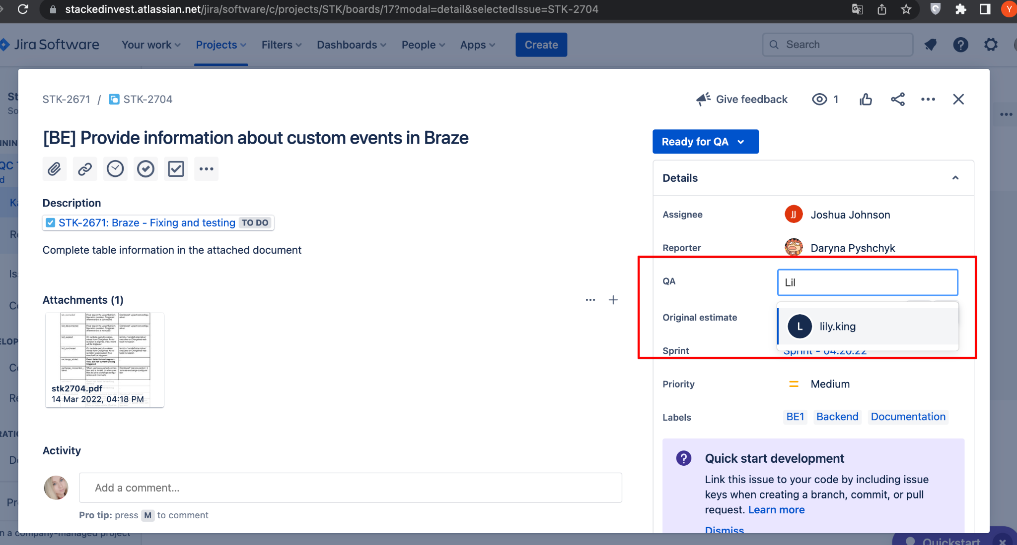

then moved task to the next column and start working on it

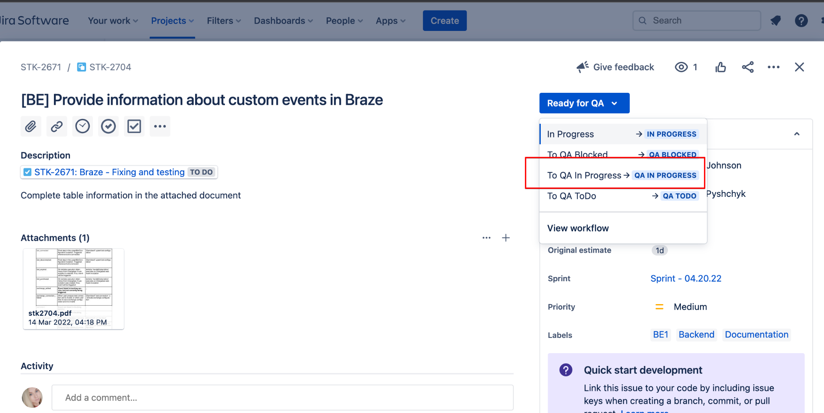

*//QA Blocked - if something else task prevent test current task  
//In Progress - if you find inconsistencies with the task description. Need to select this status and describe the problem in the comment. Then developer will fix task*

Then we open the stage (<https://stage.stackedinvest.com>) and test the task. You can ask the developers about some things you don't understand.

Developers also write how to test the task. How to find:

click on the pull requests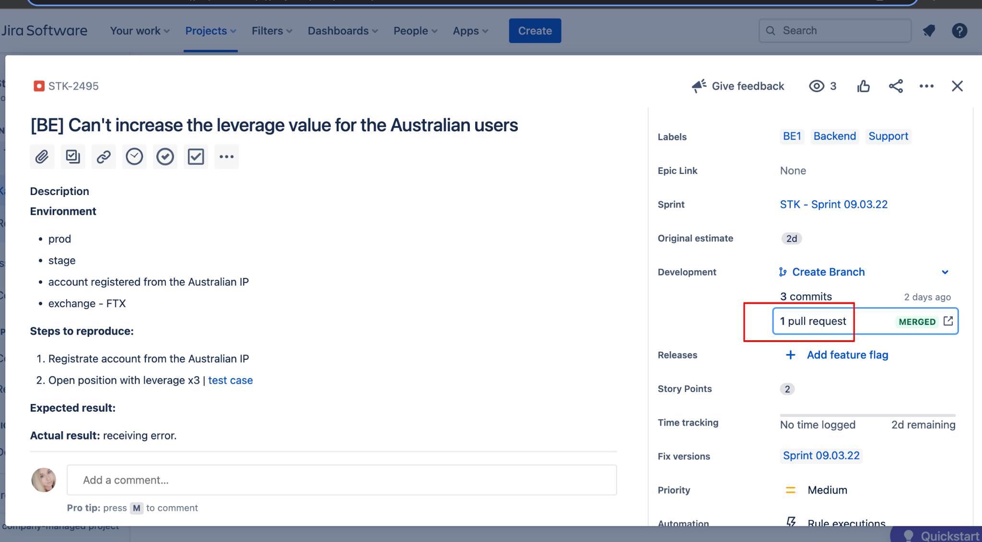

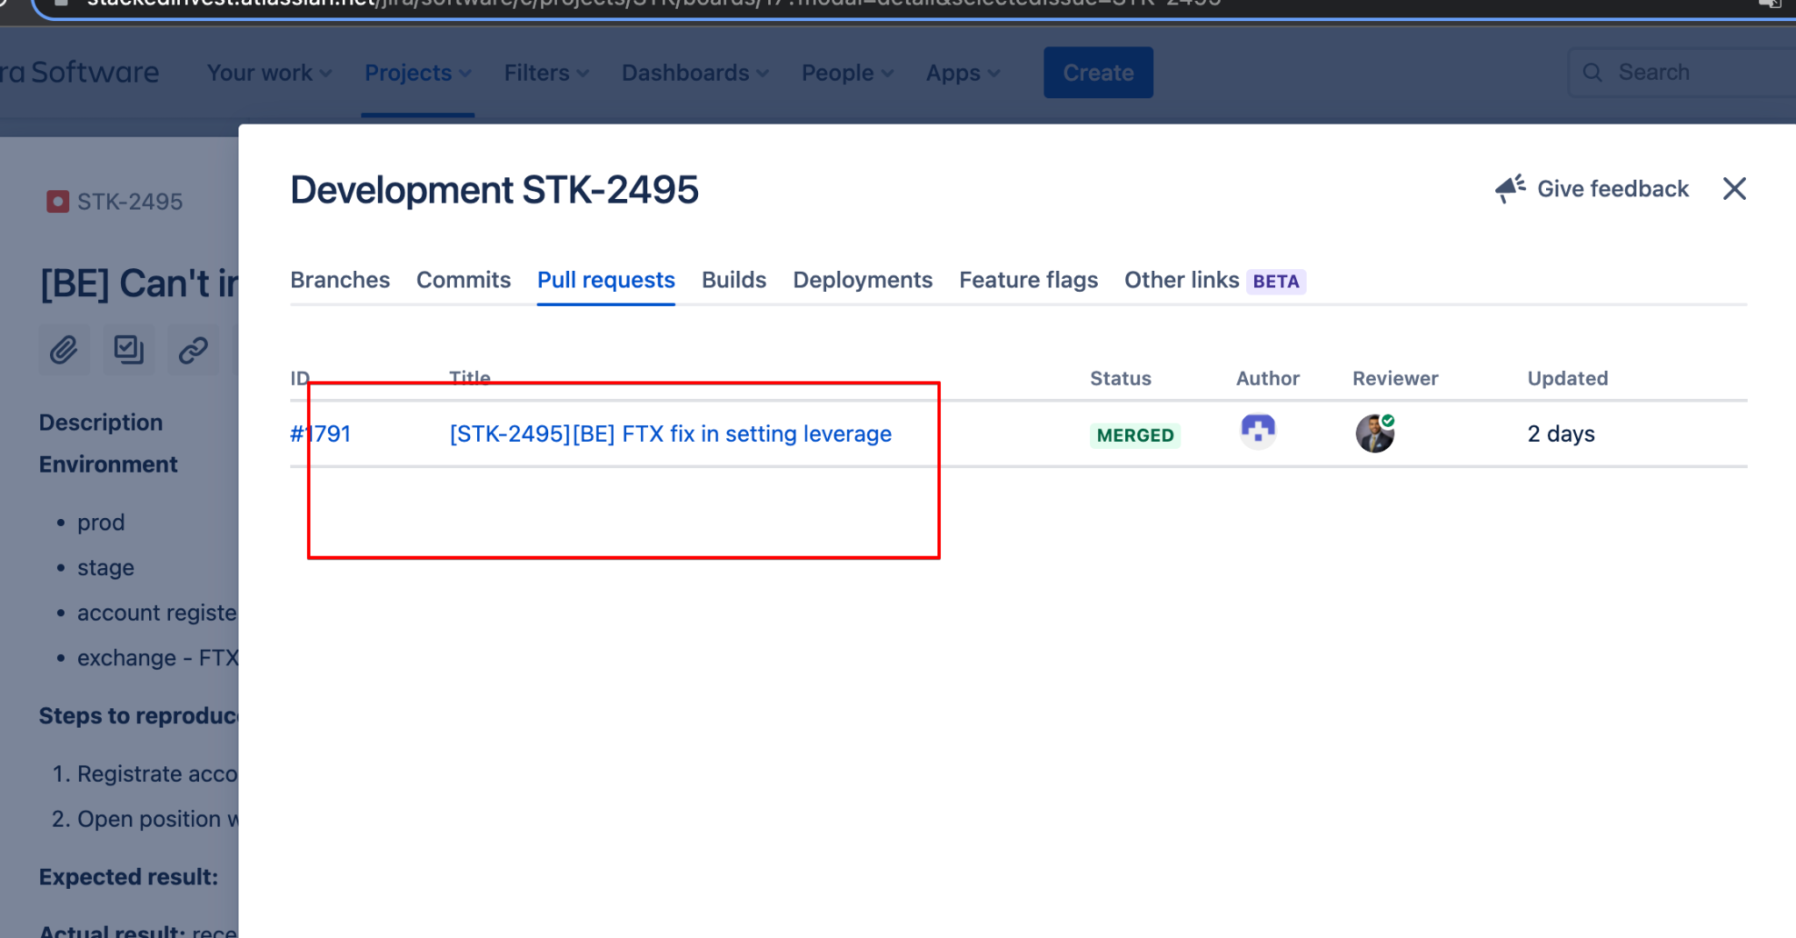

There will be block how to test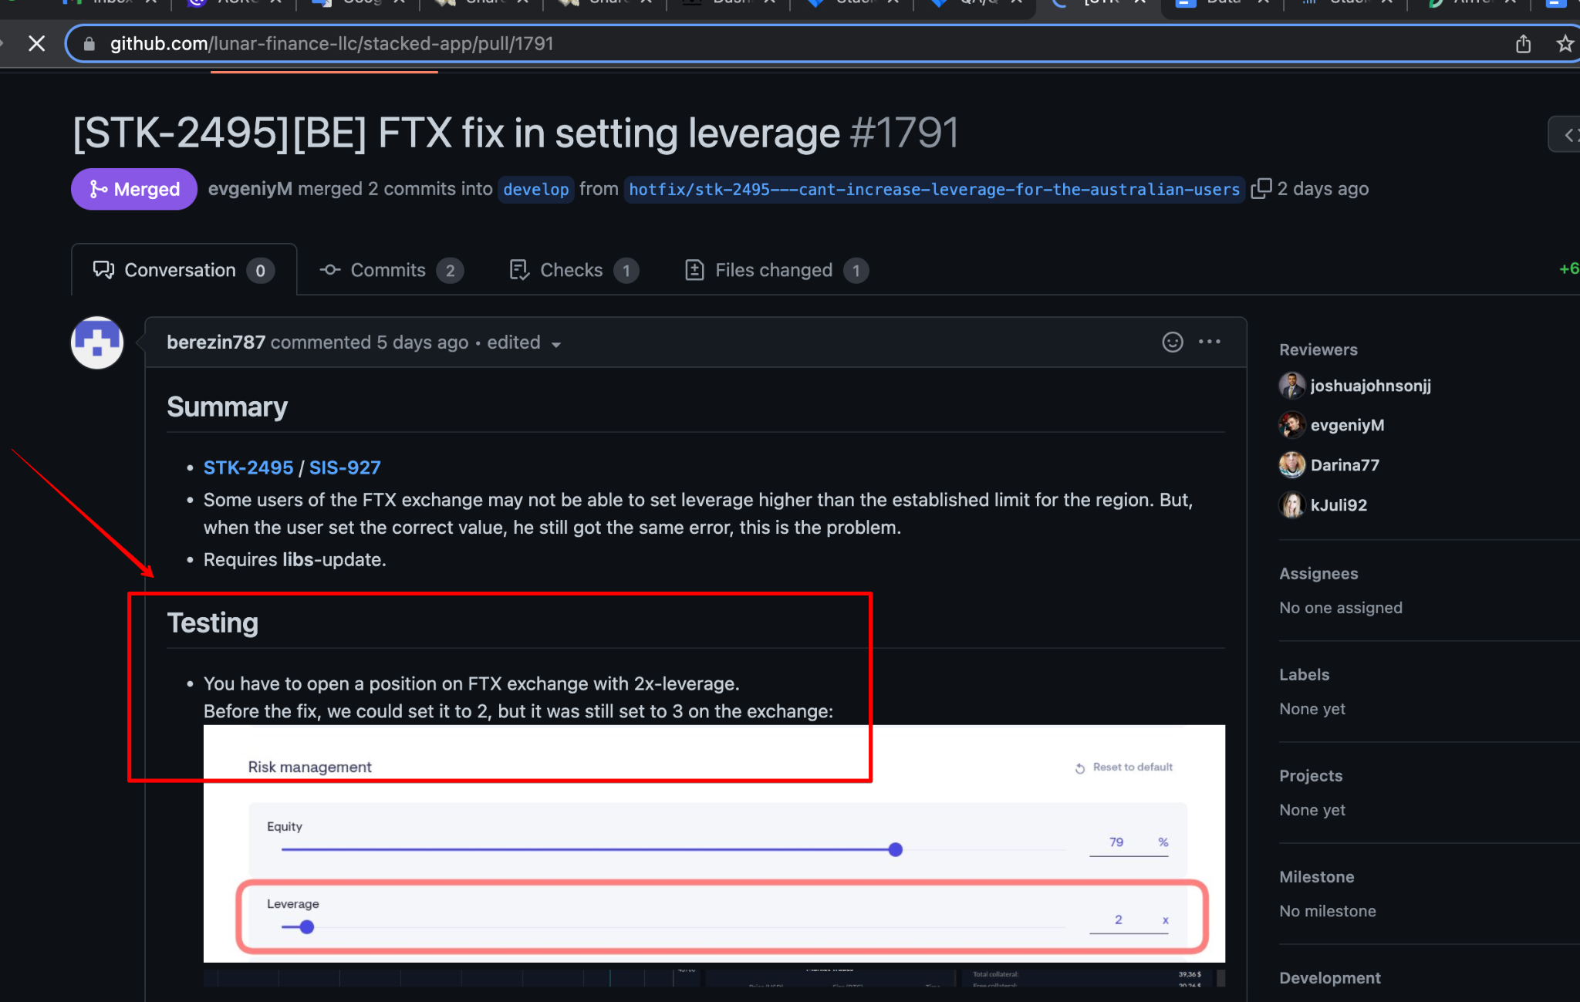

* We create test cases for task here <https://www.notion.so/stackedinvest/Test-Cases-81291b7858744e4e93ccbd5e85cf75b8>

But sometimes there are specific tasks related to the database or scripts - it is almost impossible to describe test cases for them. For such tasks, we do not create cases.

If with task all OK - we moved it to the “DONE”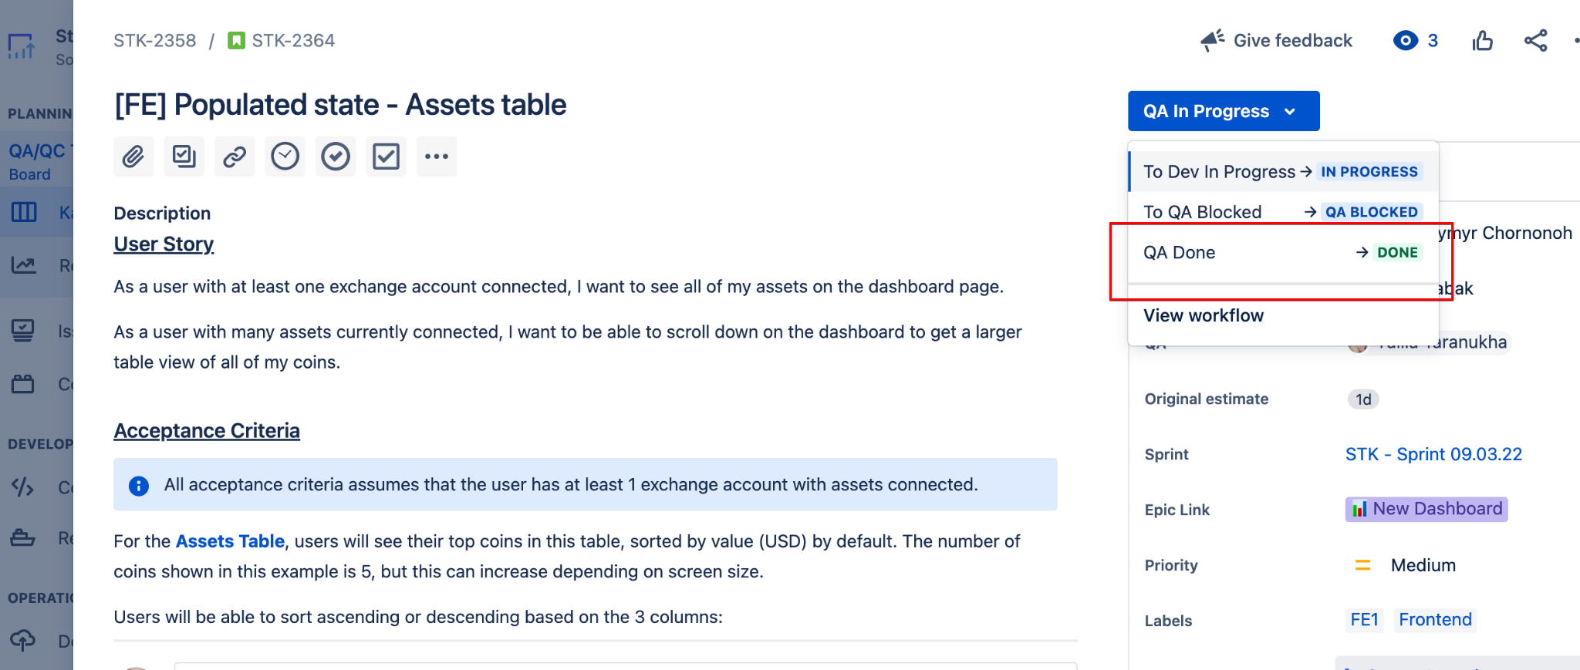

For all tasks/bug reports before moving to the Done we left a comment.  
if test case created

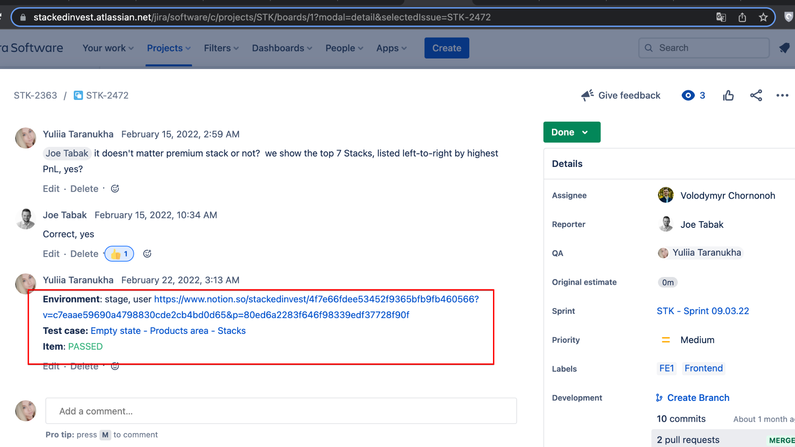

Or if test cases wasn't created - paste image of result

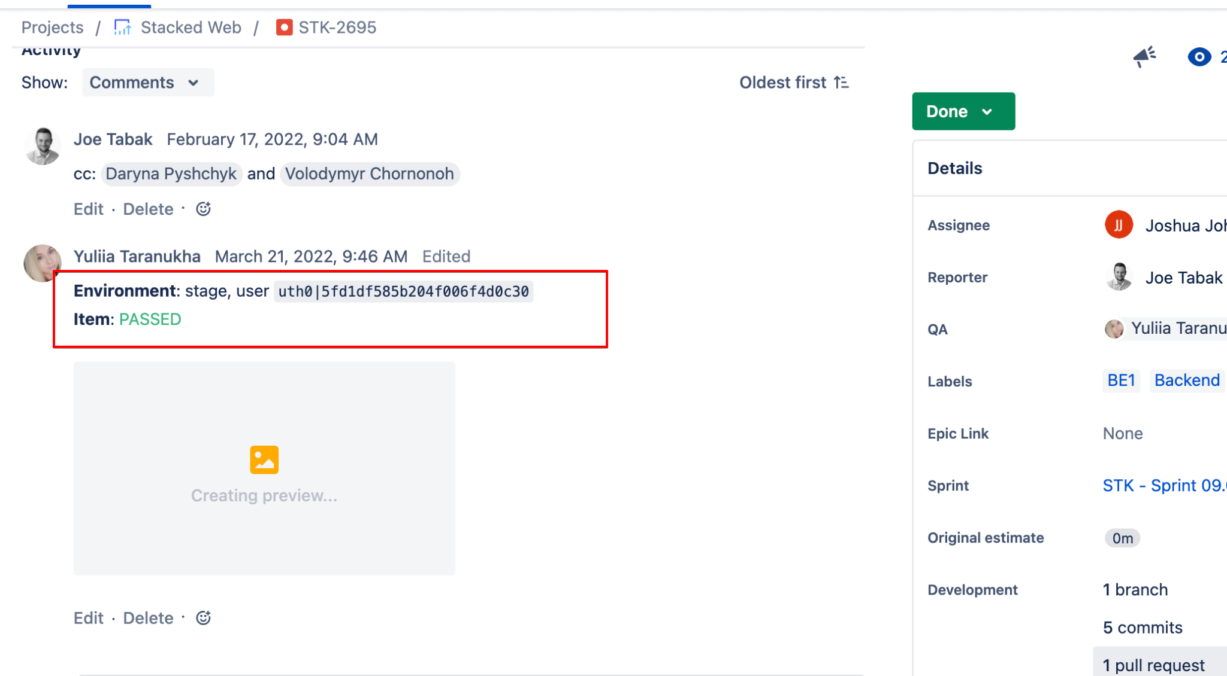

**Useful links:**  
Exchange accounts for testing - <https://www.notion.so/stackedinvest/4fcbf2e2c06d44e780f70b1249db60a4?v=eeb96fdde3bf4dca95904329e1a4a68c>

Some users which you can use for testing - <https://www.notion.so/stackedinvest/4f7e66fdee53452f9365bfb9fb460566?v=c7eaae59690a4798830cde2cb4bd0d65>