PROJECT 2 for MATH 4753.

#### Due: Second to Last Week of semester (Week before dead week).

#### This is what you must do:

1. Analyse some SLR data using R (refer to labs 3 and 4)
2. Produce a 10 page “write-up” in RMD and knit to HTML.
3. From the write up you must distil a powerpoint (or equivalent – Beamer etc) document to be used in a presentation
4. Present the analysis using the ppt and record with BBFLASH (<10min) or some other software (make sure not to produce massive files – you need only produce < 12 meg files)
5. Upload to canvas the following files.
   1. Rmd
   2. Html
   3. Slides (ppt, slidy, ioslides, beamer etc)
   4. Data file .csv
   5. Video file (.fbr or .mov)

#### Rmd of write-up – knit into html.

The document should have as a minimum (Use the template file provided):

1. Title
2. Abstract (paragraph explaining what the analysis is about)
3. Introduction explaining the story behind the data. The variables should be explained (units etc) what sort of variables (Categorical, discrete or continuous etc). Describe the problem that you are trying to solve. Appropriate pictures.
4. Theoretical Basis of SLR
5. Data analysis with appropriate plots.
6. Assumptions satisfied or not (ALL assumptions of SLR are addressed)
7. Conclusion. The research question answered.

The above should cover 10 pages with at least two full pages of text at 11 pt fonts. (Pictures and output will take up the rest of the 10 pages.

#### Beamer

Use the RStudio to make a pdf Beamer slide presentation (Or equivalent- see below picture)

1. A Title slide
2. A conclusion slide
3. Approximately 20 slides (1/2 min per slide)
4. Few words per slide
5. Use pictures and graphs

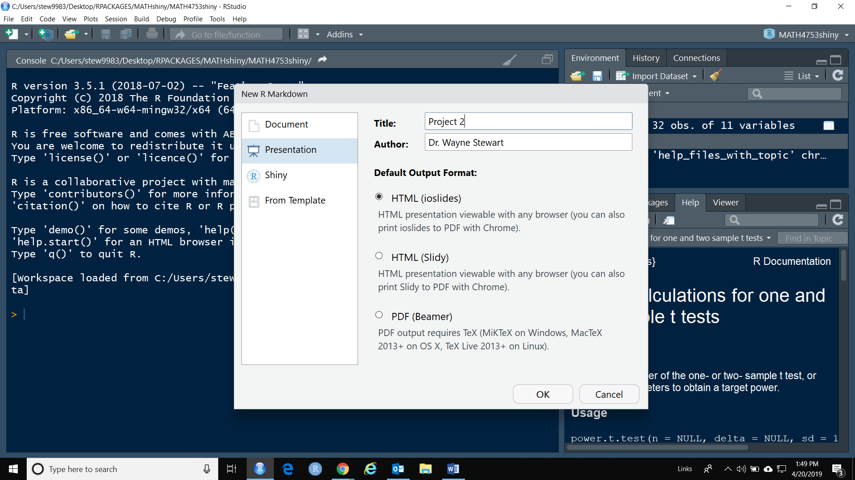

#### Data

Make sure you upload the csv file you used for the analysis.

#### Movie

Present the ppt as if you are talking to me.

Record both slides and your voice.

Make sure the file size is small < 25 meg